ADVANCED DATABASES PROJECT

ORACLE PL/SQL TRIGGERS HOLIDAY COTTAGE RENTAL



**Name: ADITYA CHANDRA**

**Student ID: A00268811**

**Course: M.Sc. in Data Analytics**

**Date of Submission: 11 May 2020**

Table of Contents

Introduction 2

Extended Entity Relationship Diagram for the Database 2

Question 1 (Before Insert, Update and Delete on Cottage_Rental) 3

Question 2 (After Insert, Update and Delete on Cottage_Cleaning) 7

Appendix 12

(a) Link to YouTube Screencast 12

(b) Links to Referred Websites 12

# Introduction

The PL/SQL triggers, like stored procedures, are stored programs that automatically executes when certain events take place and they can be invoked repeatedly as long as the trigger conditions are met. Triggers can be explicitly enabled or disables through command, but they cannot be invoked explicitly unless the conditions for the trigger arise. In this regard, PL/SQL triggers are different from PL/SQL procedures, which can be invoked explicitly using an *Execute* command.

Triggers can be programmed to invoke for any of the following events:

* A database manipulation (DML) statement such as Insert, Update or Delete
* A database definition statement (DDL) statement such as Create, Alter or Drop
* A database operation such as Servererror, Logon, Logoff, Statrtup or Shutdown

This report will focus on DML triggers that will execute when certain conditions specified for insertion, modification or deletion of records in the database are fulfilled. Triggers can be written to fire before any DML event occurs, called a **Before Trigger,** or they can be written to fire after any DML event occur, called an **After Trigger**. In this report, we will discuss about both types of triggers, one which executes before a DML event and one which executes after a DML event with examples of each type in response to insertion, modification or deletion of records in the database.

Triggers can be programmed to execute once for each transaction, known as a **statement-level trigger**, or they can be programmed to execute for each row in a transaction, known as **row-level trigger**. In this report we will discuss in detail about row-level triggers that will execute for each insert, update or delete operation that meets the conditions for the trigger.

# Extended Entity Relationship Diagram for the Database

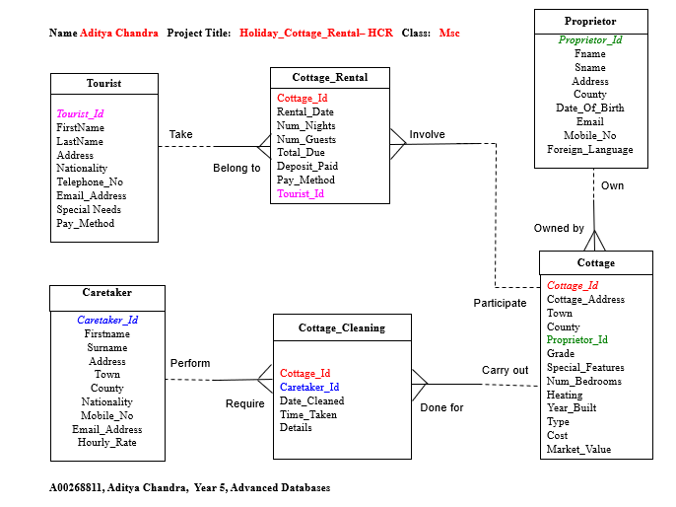

# Question 1 (Before Insert, Update and Delete on Cottage_Rental)

In advance of a row being **added**, **modified** or **removed** from the Cottage_Rental table, certain regulations must be fulfilled with respect to the tourists and cottages that the cottage rental associates to. They are as follows:

a) A rental with due amount in excess of 500 can only be booked in Cottage_Rental table provided that the nationality of the tourist is Irish.

b) The deposit paid of a rental can only be increased provided the rental is booked for a cottage located in Cork county and the deposit paid of a rental can only be decreased provided the cottage is located in Donegal county and has less than 30 bedrooms.

c) A rental from Cottage_Rental table with more than 5 nights may only be removed from the database provided that there are no special features in the cottage, or the cottage was built before 1950.

*Clear Screen*

*Set Serveroutput On Size 1000000*

*Drop Trigger Cottage_Rental_IUD_Approval;*

Create Or Replace Trigger **Cottage_Rental_IUD_Approval**

Before **Insert** Or **Update** Or **Delete** On Cottage_Rental

For Each Row

**Declare**

**V_Tourist_Nationality** Tourist.Nationality%Type;

**V_Cottage_County** Cottage.County%Type;

**V_Cottage_Num_Bedrooms** Cottage.Num_Bedrooms%Type;

**V_Cottage_Special_Features** Cottage.Special_Features%Type;

**V_Cottage_Year_Built** Cottage.Year_Built%Type;

**Begin**

/* (a) Due amount > 500 can only be booked in Cottage_Rental table provided that the nationality of the tourist is Irish*/

**If** **Inserting** **Then**

Select Nationality Into **V_Tourist_Nationality**

From Tourist

Where Tourist.Tourist_Id = **:New**.Tourist_Id;

**If** **:New.Total_Due** > 500 And **V_Tourist_Nationality** <> 'Irish' **Then**

Raise_Application_Error(-20101, 'A) New rental with due amount > 500 must have tourist nationality as Irish');

**End If;**

/*(b) Rental deposit may be increased if cottage is in Cork + Deposit may decrease if cottage is in Donegal and bedrooms < 30 */

**Elsif** **Updating** **Then**

Select County, Num_Bedrooms Into **V_Cottage_County, V_Cottage_Num_Bedrooms**

From Cottage

Where Cottage.Cottage_Id = **:New**.Cottage_Id;

**If** **:New.Deposit_Paid** > **:Old.Deposit_Paid** And **V_Cottage_County** <> 'Cork' **Then**

Raise_Application_Error(-20101, 'B1) Deposit paid may be increased if cottage county is Cork');

**End If;**

**If** **:New.Deposit_Paid** < **:Old.Deposit_Paid** And (**V_Cottage_County** <> 'Donegal' Or **V_Cottage_Num_Bedrooms** >= 30) **Then**

Raise_Application_Error(-20101, 'B2) Deposit paid may be decreased if cottage county is Donegal and number of bedrooms < 30');

**End If;**

/* (c) Rental with more than 5 nights may be removed if cottage has no special features or it was built before 1950 */

**Elsif** **Deleting** **Then**

Select Special_Features, Year_Built Into **V_Cottage_Special_Features, V_Cottage_Year_Built**

From Cottage

Where Cottage.Cottage_Id = **:Old.**Cottage_Id;

**If** **:Old.Num_Nights** > 5 And (**V_Cottage_Special_Features** Is Not NULL And **V_Cottage_Year_Built** > 1950) **Then**

Raise_Application_Error(-20101, 'C) Rental with more than 5 nights may be removed if cottage has no special features or it was built before 1950');

**End If;**

**End If;**

**End** **Cottage_Rental_IUD_Approval**;

/

Sho Err

--TEST CASES*/

--INSERT*/

--(a) Due amount > 500 can only be booked in Cottage_Rental table provided that the nationality of the tourist is Irish*/

--Invalid insert (Nationality is French)*/

Insert Into Cottage_Rental (Cottage_Id, Total_Due, Tourist_Id) Values (111, 650, 2);

--Valid insert*/

Insert Into Cottage_Rental (Cottage_Id, Total_Due, Tourist_Id) Values (110, 650, 3);

--UPDATE*/

--(b) Rental deposit may be increased if cottage is in Cork + Deposit may decrease if cottage is in Donegal and bedrooms < 30 */

--Invalid update for increase, cottage is not in Cork (It is in Kildare)*/

Update Cottage_Rental

Set Deposit_Paid = Deposit_Paid + 10

Where Cottage_Id = 101;

--Valid update for increase, cottage is in Cork*/

Update Cottage_Rental

Set Deposit_Paid = Deposit_Paid + 10

Where Cottage_Id = 108;

--Invalid update for decrease, cottage is not in Donegal (It is in Cork) and bedrooms < 30 (It is 20)*/

Update Cottage_Rental

Set Deposit_Paid = Deposit_Paid - 20

Where Cottage_Id = 108;

--Invalid update for decrease, cottage is in Donegal and bedrooms >= 30 (It is 30)*/

Update Cottage_Rental

Set Deposit_Paid = Deposit_Paid - 20

Where Cottage_Id = 104;

--Valid update for decrease, cottage is in Donegal and bedrooms < 30*/

Update Cottage_Rental

Set Deposit_Paid = Deposit_Paid - 20

Where Cottage_Id = 110;

--DELETE*/

--(c) Rental with more than 5 nights may be removed if cottage has no special features or it was built before 1950 */

--Invalid delete, cottage rental has more than 5 nights and cottage has special features (Internet) and built after 1950 (1961)*/

Delete

From Cottage_Rental

Where Cottage_Id = 112;

--Valid delete, cottage rental more than 5 nights and it was built after 1950 (1965) but cottage has no special features */

Delete

From Cottage_Rental

Where Cottage_Id = 109;

--Valid delete, cottage rental more than 5 nights and has a special feature (TV) but it was built before 1950 (1926)*/

Delete

From Cottage_Rental

Where Cottage_Id = 110;

Rollback;

Drop Trigger **Cottage_Rental_IUD_Approval**;

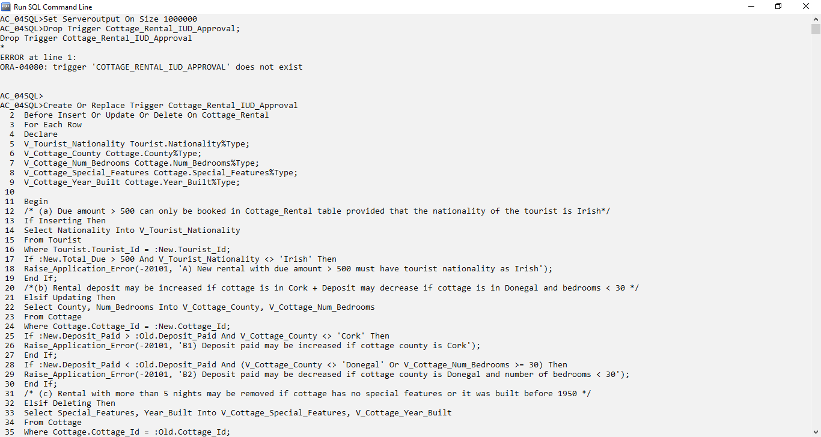

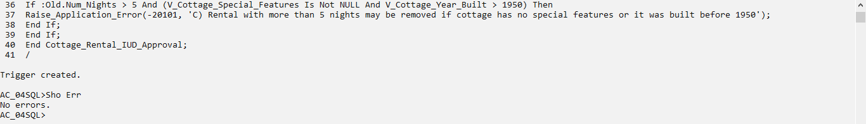

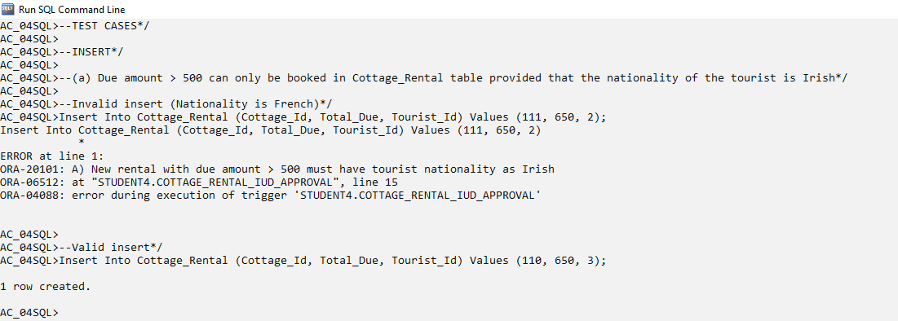

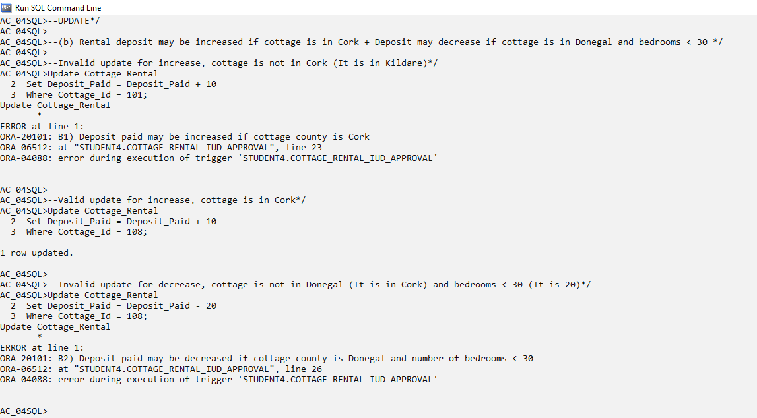

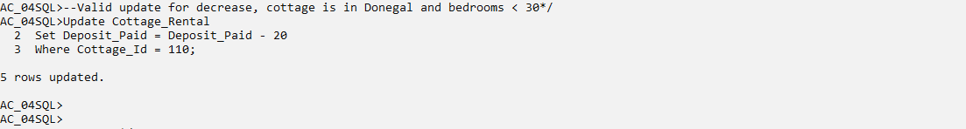

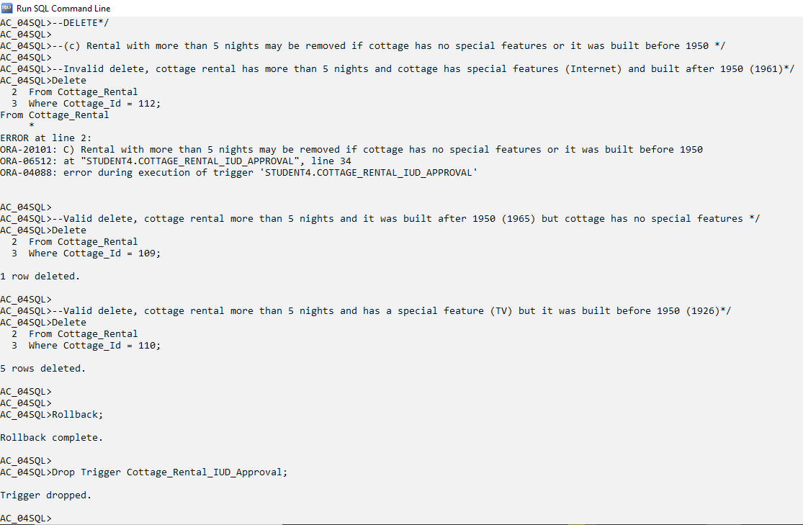

# Question 2 (After Insert, Update and Delete on Cottage_Cleaning)

After a record in the Cottage_Cleaning table is **added**, **modified** or **removed**, certain adjustments to related data must be fulfilled with respect to the caretaker and cottage that the cleaning is associated to. They are as follows:

a) If a cottage cleaning record with time taken less than 10 hours is added to the Cottage_Cleaning table, the associated caretaker gets a 10% increase in hourly rate.

b) If the details of a cleaning is updated to ‘Property damage’, then the associated caretaker gets a 10% reduction in the hourly rate provided the caretaker’s town is Tullamore. Otherwise, the hourly rate of the caretaker is reduced by 5%.

c) If a cleaning record with time taken in excess of 15 hours is removed from the Cottage_Cleaning table, the cost of associated cottage will drop by 10%.

*Clear Screen*

*Set Serveroutput On Size 1000000*

*Drop Trigger Cleaning_IUD_Completion;*

Create Or Replace Trigger **Cleaning_IUD_Completion**

After **Insert** Or **Update** Or **Delete** On Cottage_Cleaning

For Each Row

**Declare**

**V_Caretaker_Town** Caretaker.Town%Type;

**V_Caretaker_Hourly_Rate** Caretaker.Hourly_Rate%Type;

**Begin**

/* (a) Cottage cleaning is added and the time taken < 10, the caretaker gets a 20% increase in hourly rate */

**If** **Inserting** **Then**

**If** **:New.Time_Taken** < 10 **Then**

Update Caretaker

Set Hourly_Rate = Hourly_Rate + (Hourly_Rate * 0.2)

Where Caretaker.Caretaker_Id = **:New.**Caretaker_Id;

**End If;**

/*(b) Details updated as property damage - reduce caretaker's hourly rate by 10% if town is Tullamore + Otherwise hourly rate is decreased by 5% */

**Elsif** **Updating** **Then**

**If** **:New.Details** = 'Property damage' **Then**

Select Town, Hourly_Rate Into **V_Caretaker_Town, V_Caretaker_Hourly_Rate**

From Caretaker

Where Caretaker.Caretaker_Id = **:New**.Caretaker_Id;

**If** **V_Caretaker_Town** = 'Tullamore' **Then**

Update Caretaker

Set Hourly_Rate = Hourly_Rate - (Hourly_Rate * 0.1)

Where Caretaker.Caretaker_Id = **:New**.Caretaker_Id;

**Else**

Update Caretaker

Set Hourly_Rate = Hourly_Rate - (Hourly_Rate * 0.05)

Where Caretaker.Caretaker_Id = **:New**.Caretaker_Id;

**End If;**

**End If;**

/* (c) Cleaning record with time taken more than 15 hours is removed - the cost for the associated cottage will drop by 10%.*/

**Elsif** **Deleting** **Then**

**If** **:Old.Time_Taken** > 15 **Then**

Update Cottage

Set Cost = Cost - (Cost * 0.1)

Where Cottage.Cottage_Id = **:Old.**Cottage_Id;

**End If;**

**End If;**

**End** **Cleaning_IUD_Completion**;

/

Sho Err

--TEST CASES*/

--INSERT*/

--(a) Cottage cleaning is added and the count of cleanings for the caretaker exceeds 5, the caretaker gets a 20% increase in hourly rate */

--Before Insert

Select Hourly_Rate

From Caretaker

Where Caretaker_Id = 300;

--Insert

Insert Into Cottage_Cleaning (Cottage_Id, Caretaker_Id, Time_Taken) Values (101, 300, 8);

--After Insert

Select Hourly_Rate

From Caretaker

Where Caretaker_Id = 300;

--UPDATE*/

--(b) Details updated as property damage - reduce caretaker's hourly rate by 10% if town is Tullamore + Otherwise hourly rate is decreased by 5% */

--Test1 (Caretaker town is Tullamore)

--Before Update

Select Town, Hourly_Rate

From Caretaker

Where Caretaker_Id = 800;

--Update

Update Cottage_Cleaning

Set Details = 'Property damage'

Where Cottage_Id = 107

And Caretaker_Id = 800

And Date_Cleaned = '23-Jul-19';

--After Update

Select Town, Hourly_Rate

From Caretaker

Where Caretaker_Id = 800;

--Test2 (Caretaker town is Cork)

--Before Update

Select Town, Hourly_Rate

From Caretaker

Where Caretaker_Id = 1100;

--Update

Update Cottage_Cleaning

Set Details = 'Property damage'

Where Cottage_Id = 109

And Caretaker_Id = 1100

And Date_Cleaned = '12-Jun-19';

--After Update

Select Town, Hourly_Rate

From Caretaker

Where Caretaker_Id = 1100;

--DELETE*/

--(c) Cleaning record with time taken more than 15 hours is removed - the cost for the associated cottage will drop by 10%.*/

-- Example where time taken is 19 hours

--Before Delete

Select Cost

From Cottage

Where Cottage_Id = 103;

--Delete

Delete

From Cottage_Cleaning

Where Cottage_Id = 103

And Caretaker_Id = 300

And Date_Cleaned = '02-Feb-19';

--After Delete

Select Cost

From Cottage

Where Cottage_Id = 103;

Rollback;

Drop Trigger **Cleaning_IUD_Completion**;

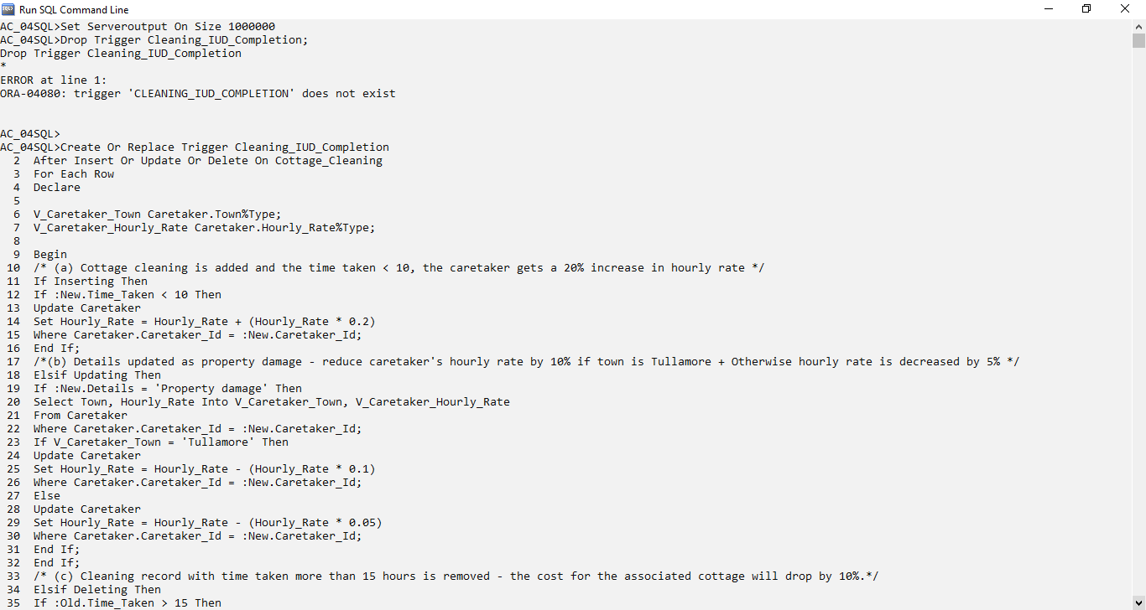

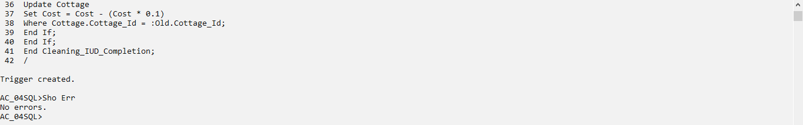

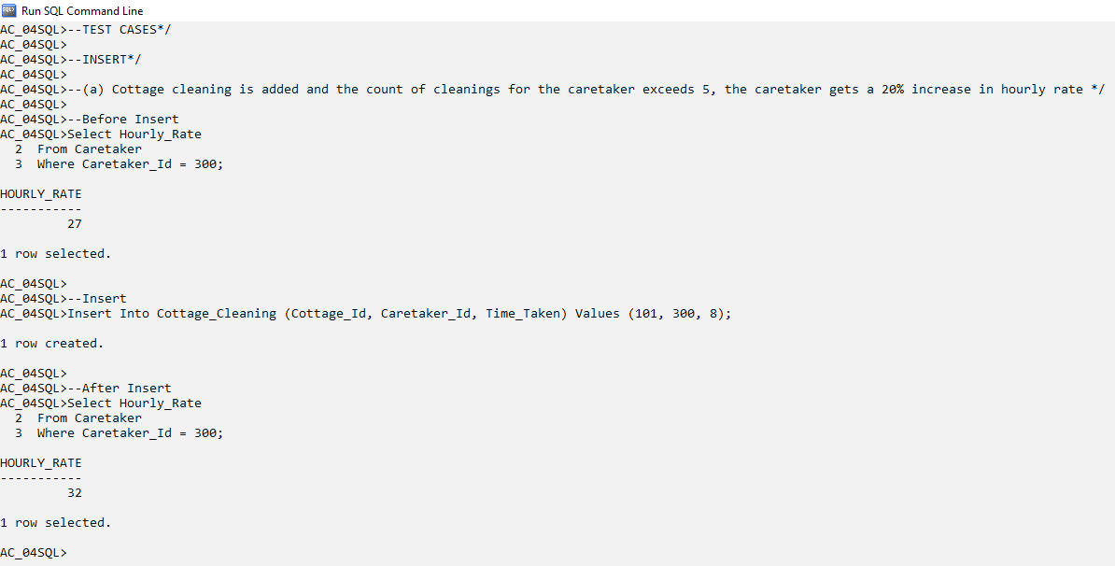

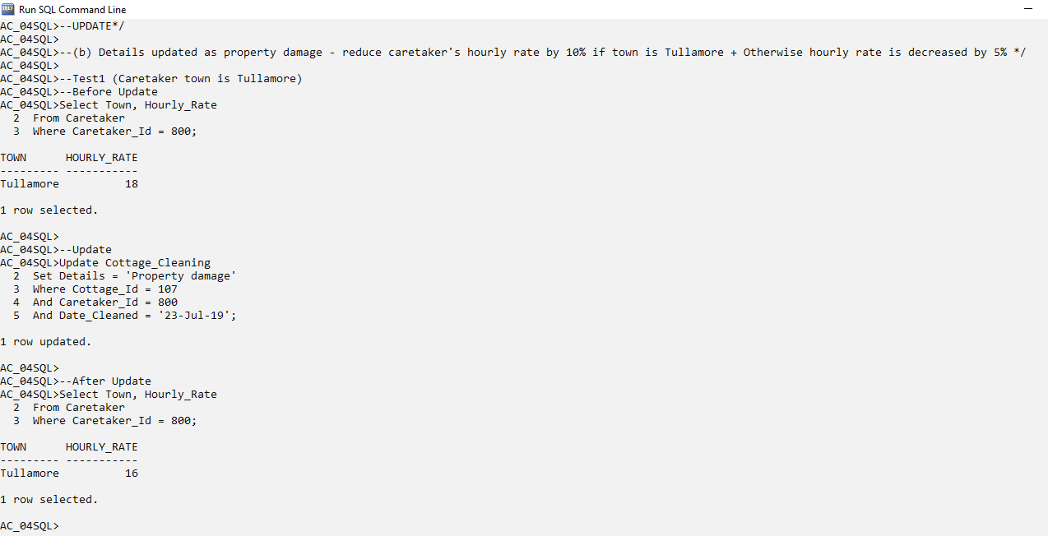

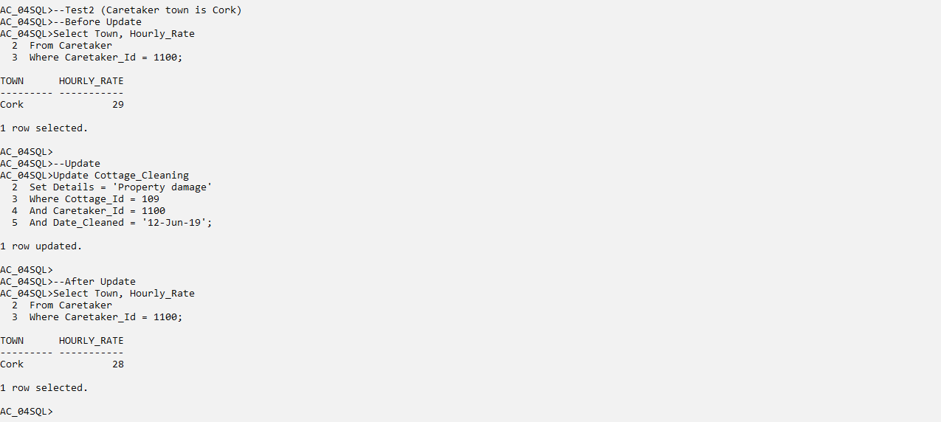

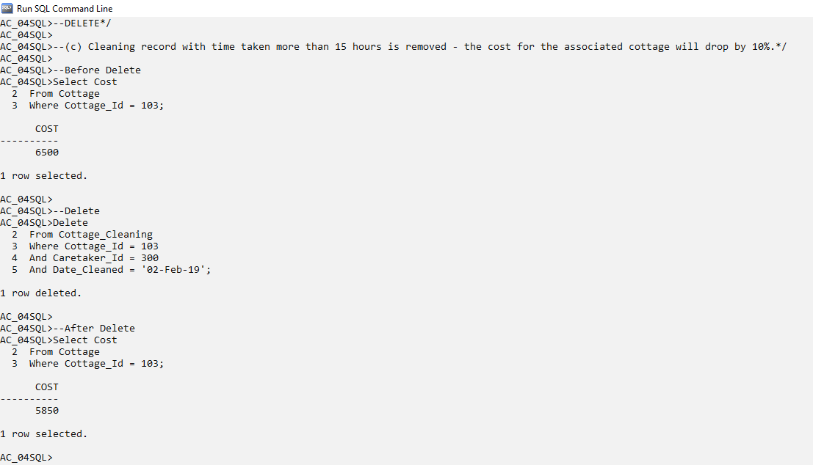

# Appendix

## Link to YouTube Screencast

Pl/SQL Trigger (Before Insert, Update or Delete). Available at: <https://www.youtube.com/watch?v=T3NH2p3aVMs>

## Links to Referred Websites

[1] Tutorials Point (n.d.). *PL/SQL Triggers*. Available at: <https://www.tutorialspoint.com/plsql/plsql_triggers.htm> [Accessed: 6 May 2020]

[2] Oracle Help Center (n.d.). *Database PL/SQL Language Reference*. Available at: <https://docs.oracle.com/cd/E11882_01/appdev.112/e25519/triggers.htm#LNPLS020> [Accessed: 6 May 2020]

[3] cs.uh (n.d.). *Triggers*. Available at: <http://www2.cs.uh.edu/~ceick/6340/lab/Labs/Lab9/Triggers.htm> [Accessed: 7 May 2020]

[4] Tech Differences (2016). *Difference Between Trigger and Procedure*. Available at: <https://techdifferences.com/difference-between-trigger-and-procedure.html> [Accessed: 8 May 2020]

[5] Aditya Chandra (2019). *Holiday_Cottage_Rental*. Available at: <https://2019.elearning.ait.ie/pluginfile.php/35506/assignsubmission_file/submission_files/32828/Holiday_Cottage_Rental_A_Chandra_2019.zip?forcedownload=1> [Accessed: 6 May 2020]