RELATIONAL DATABASES PROJECT

HOLIDAY COTTAGE RENTAL

**Aditya Chandra**

**a00268811**

**M.Sc. in Data Analytics**

Contents

1.Introduction 2

2. Original Data 3

2.1. Entities: 4

2.2. Entities with Attributes: 4

3. Entity Relationship Diagram (ERD) 5

4. Extended ERD 6

5. Create Table Statements 7

6. Insert Statements 13

7. Tables 19

8. Queries 22

8.1. Single Table Query 22

8.2. Queries involving Joins 23

8.3. Queries involving Joins (2) 24

8.4. Queries involving Joins (3) 25

8.5. Join involving more than 2 Tables and Non-Equi Join 26

8.6. Queries involving Sub-Query 27

8.7. Sub-Query with Summary Query 28

8.8. Queries involving Self-Join 29

8.9. Queries involving Summary Query and Group By 30

8.10. Queries involving Sub-Query and Exists 31

8.11. Multi-Legged Subqueries 32

8.12. Update Statement 34

8.13. Delete Statement 36

8.14. Queries using Union 38

8.15. Views involving Sub-Queries and Read-Only Condition 39

8.16. Query to retrieve data from View 40

8.17. Query involving Rollup with Group By 41

8.18. Alter-Table Command 42

# 1.Introduction

The aim of this project is to study the data related to holiday cottage rentals by creating a data base in Oracle SQL. With the help of provided table names and column names, the relationship between the entities and attributes were established and an Entity Relationship Diagram (ERD) was devised. An extended ERD was designed to display the attributes within each entity and the primary and foreign keys were highlighted.

After creating the ERD, a script was generated to create all the tables and populate them with data using the insert statement. Once the data base is successfully created in Oracle SQL, we were ready to retrieve and manipulate the data using SQL queries.

The report aims to incorporate all the aspects of SQL command set which include:

Data Definition Language (DDL)

Data Manipulation Language (DML)

Data Control Language (DCL)

This project tries to traverse through all the features of the SQL that can be used during and after the creation and implementation of a data base.

# 2. Original Data

|  |  |  |  |  |
| --- | --- | --- | --- | --- |
| **4** | **Aditya** | **Chandra** | **Holiday_Cottage_Rental** | **HCR** |

A Database required to co-ordinate the services offered by a group of proprietors that want to rent holiday cottages that they individually own. A proprietor may own several cottages around the country. The cottages are rented to Tourists. The Tourists (both native and overseas) may rent the same cottage on a number of different occasions, or rent a different cottage. Some cottages have not yet been rented. There are a number of caretakers that work for the proprietor group and they can be called upon by any proprietor to clean a cottage. A caretaker may clean several cottages. Some caretakers clean cottages for several proprietors.

**A proprietor may own many cottages and a cottage is owned by one and only one proprietor.**

**A cottage may participate in many cottage rentals and a cottage rental involves one and only one cottage.**

**A caretaker may perform many cottage cleanings and a cottage cleaning involves one and only one caretaker.**

**A tourist may participate in many cottage rentals and a cottage rental involves one and only one tourist.**

**Tourist** (Tourist_Id, FirstName, Lastname, Address, Nationality, Telephone_No, Email_Address, Special_Needs, Pay_Method)

**Cottage_Rental** (Cottage_Id, Rental_Date, Num_Nights, Num_Guests, Total_Due, Deposit_Paid, Pay_Method (*Cheque, Cash, Credit Card)*), Tourist_Id)

**Caretaker** (Caretaker_Id, FirstName, Surname, Address, Town, County, Nationality, Mobile_No, Email_Address, Hourly_Rate)

**Cottage_Cleaning** (Cottage_Id, Caretaker_Id, Date_Cleaned, Time_Taken *(Hours),* Details *(Note of any Damage, Items Stolen, etc))*

**Proprietor** (Proprietor_Id, FName, Sname, Address, County, Date_Of_Birth, Email, Mobile_No, Foreign_Language (*French, German, Italian, Dutch*))

**Cottage** (Cottage_Id, Cottage_Address, Town, County, Proprietor_Id, Grade (*2 star, etc*), Special_Features (*TV, Internet Point, Sauna*), Num_Bedrooms, Heating (*Oil, Gas, Solid Fuel),* Year_Built, Type (*Dormer, Bungalow, Two Storey*), Cost, Market_Value)

## 2.1. Entities:

Tourist

Proprietor

Cottage

Cottage_Rental

Caretaker

Cottage_Cleaning

## 2.2. Entities with Attributes:

**Tourist** (*Tourist_Id*, FirstName, Lastname, Address, Nationality, Telephone_No, Email_Address, Special_Needs, Pay_Method)

**Proprietor** (*Proprietor_Id*, FName, Sname, Address, County, Date_Of_Birth, Email, Mobile_No, Foreign_Language (*French, German, Italian, Dutch*))

**Cottage** (*Cottage_Id*, Cottage_Address, Town, County, Proprietor_Id, Grade (*2 star, etc*), Special_Features (*TV, Internet Point, Sauna*), Num_Bedrooms, Heating (*Oil, Gas, Solid Fuel),* Year_Built, Type (*Dormer, Bungalow, Two Storey*), Cost, Market_Value)

**Cottage_Rental** (Cottage_Id, Rental_Date, Num_Nights, Num_Guests, Total_Due, Deposit_Paid, Pay_Method (*Cheque, Cash, Credit Card)*), Tourist_Id)

**Caretaker** (*Caretaker_Id*, FirstName, Surname, Address, Town, County, Nationality, Mobile_No, Email_Address, Hourly_Rate)

**Cottage_Cleaning** (Cottage_Id, Caretaker_Id, Date_Cleaned, Time_Taken *(Hours),* Details *(Note of any Damage, Items Stolen, etc))*

# 3. Entity Relationship Diagram (ERD)

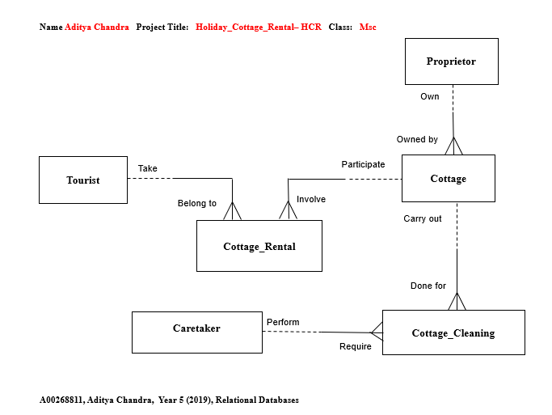

# 4. Extended ERD

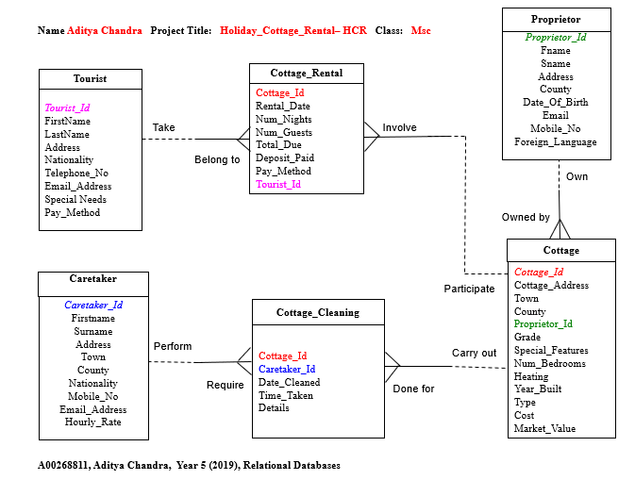

# 5. Create Table Statements

Tables are created in hierarchical order meaning parent tables are created before their respective child tables due to the usage of primary keys and foreign keys.

Drop Table Cottage_Cleaning;

Drop Table Caretaker;

Drop Table Cottage_Rental;

Drop Table Cottage;

Drop Table Proprietor;

Drop Table Tourist;

Drop Table Tourist;

Create Table Tourist(

Tourist_Id Number (2) ,

FirstName Varchar2 (10) Constraint Tourist_FirstName_Nn Not Null,

LastName Varchar2 (10) Constraint Tourist_LastName_Nn Not Null,

Address Varchar2 (20),

Nationality Varchar2 (7),

Telephone_No Number (10),

Email_Address Varchar2 (25),

Special_Needs Varchar2 (17) ,

Pay_Method Varchar2 (11),

Constraint Tourist_Tourist_Id_Pk Primary Key (Tourist_Id),

Constraint Tourist_Telephone_No_Uq Unique (Telephone_No),

Constraint Tourist_Email_Address_Uq Unique (Email_Address),

Constraint Tourist_Pay_Method_Ck Check (Pay_Method In ('Cash', 'Cheque', 'Credit Card')));

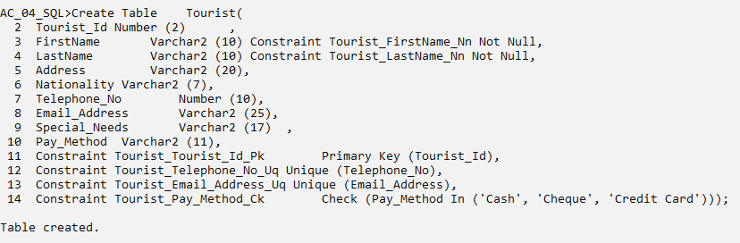

Drop Table Proprietor;

Create Table Proprietor(

Proprietor_Id Number (4),

Fname Varchar2 (9) Constraint Proprietor_FName_Nn Not Null,

Sname Varchar2 (10) Constraint Proprietor_SName_Nn Not Null,

Address Varchar2 (22),

County Varchar2 (7),

Date_Of_Birth Date,

Email Varchar2 (27),

Mobile_No Number (10),

Foreign_Language Varchar2 (7),

Constraint Proprietor_Proprietor_Id_Pk Primary Key (Proprietor_Id),

Constraint Proprietor_Email_Uq Unique (Email),

Constraint Proprietor_Mobile_No_Uq Unique (Mobile_No));

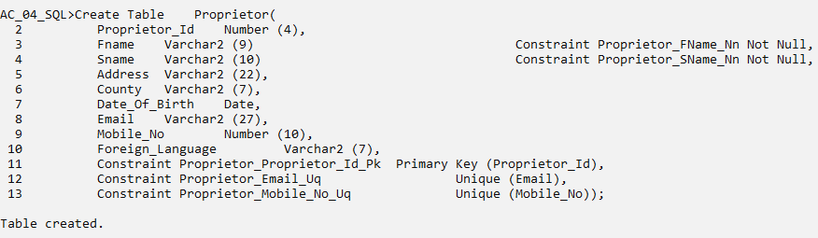

Drop Table Cottage;

Create Table Cottage(

Cottage_Id Number (3),

Cottage_Address Varchar2 (21),

Town Varchar2 (10),

County Varchar2 (9),

Proprietor_Id Number (4),

Grade Varchar2 (6) Constraint Cottage_Grade_Nn Not Null,

Special_Features Varchar2 (8),

Num_Bedrooms Number (2),

Heating Varchar2 (10),

Year_Built Number (4),

Type Varchar2 (10),

Cost Number (4),

Market_Value Number (4),

Constraint Cottage_Proprietor_Id_Fk Foreign Key (Proprietor_Id) References Proprietor (Proprietor_Id),

Constraint Cottage_Cottage_Id_Pk Primary Key (Cottage_Id),

Constraint Cottage_Special_Features_Ck Check (Special_Features In ('TV', 'Internet', 'Sauna')),

Constraint Cottage_Heating_Ck Check (Heating In ('Oil', 'Gas', 'Solid Fuel')),

Constraint Cottage_Type_Ck Check (Type In ('Dormer', 'Bungalow', 'Two Storey')));

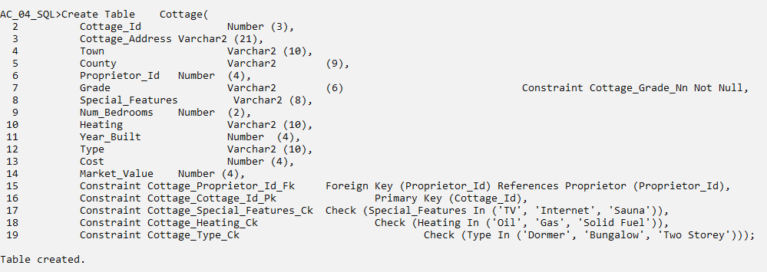

Drop Table Cottage_Rental;

Create Table Cottage_Rental (

Cottage_Id Number (3),

Rental_Date Date Constraint Cottage_Rental_Rental_Date_Nn Not Null,

Num_Nights Number (2) Constraint Cottage_Rental_Num_Nights_Nn Not Null,

Num_Guests Number (2) Constraint Cottage_Rental_Num_Guests_Nn Not Null,

Total_Due Number (3),

Deposit_Paid Number (2),

Pay_Method Varchar2 (11),

Tourist_Id Number (2),

Constraint Cottage_Rental_Cottage_Id_Fk Foreign Key (Cottage_Id) References Cottage (Cottage_Id),

Constraint Cottage_Rental_Tourist_Id_Fk Foreign Key (Tourist_Id) References Tourist (Tourist_Id),

Constraint Cottage_Rental_Pay_Method_Ck Check (Pay_Method In ('Cash', 'Cheque', 'Credit Card')));

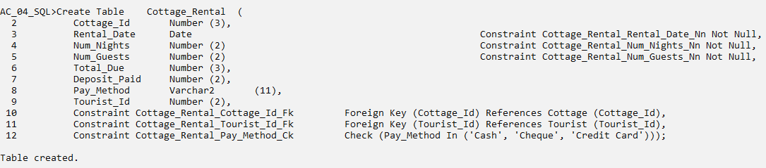

Drop Table Caretaker;

Create Table Caretaker(

Caretaker_Id Number (4),

Firstname Varchar2 (7) Constraint Caretaker_Firstname_Nn Not Null,

Surname Varchar2 (9) Constraint Caretaker_Surname_Nn Not Null,

Address Varchar2 (19),

Town Varchar2 (9),

County Varchar2 (9),

Nationality Varchar2 (7),

Mobile_No Number (10),

Email_Address Varchar2 (31),

Hourly_Rate Number (2),

Constraint Caretaker_Caretaker_Id_Pk Primary Key (Caretaker_Id),

Constraint Caretaker_Mobile_No_Uq Unique (Mobile_No),

Constraint Caretaker_Email_Address_Uq Unique (Email_Address));

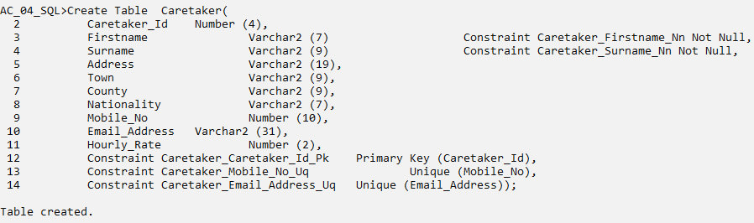

Drop Table Cottage_Cleaning;

Create Table Cottage_Cleaning(

Cottage_Id Number (3),

Caretaker_Id Number (4),

Date_Cleaned Date,

Time_Taken Number (2),

Details Varchar2 (20),

Constraint Cottage_Cleaning_Cottage_Id_Fk Foreign Key (Cottage_Id) References Cottage (Cottage_Id),

Constraint CC_Caretaker_Id_Fk Foreign Key (Caretaker_Id) References Caretaker (Caretaker_Id));

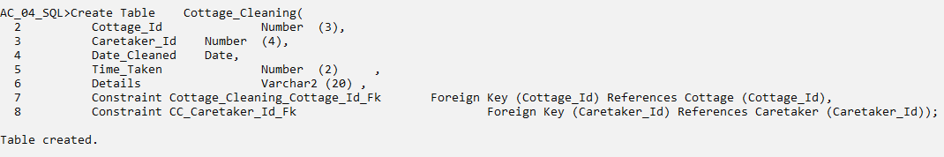

# 6. Insert Statements

/* Table Name: Tourist */

/* Tourist_Id, FirstName, Lastname, Address, Nationality, Telephone_No, Email_Address, Special_Needs, Pay_Method */

Insert Into Tourist Values(1, 'Desirae', 'Peck', '3966 Aliquet. Av.', 'German', 8337292640, 'Dese_Peck@sitamet.org', 'Extra bed', 'Cheque');

Insert Into Tourist Values(2, 'Mercedes', 'Rasemussen', '6943 Tempus Av.', 'French', 7215847686, 'Merc_Rasmu@enim.net', 'Wheelchair', 'Cheque');

Insert Into Tourist Values(3, 'Rina', 'English', '2420 Semper Rd.', 'Irish', 4715423628, 'R_English@egestas.net', 'Extra bed', 'Cash');

Insert Into Tourist Values(4, 'Lyle', 'Boyer', '5718 Ante Ave', 'German', 5266592878, 'Lyle_Br@Crassed.com', 'Extra bed', 'Cheque');

Insert Into Tourist Values(5, 'Jada', 'Maxwell', '7181 Trist Avenue', 'Italian', 4907498568, 'Jada_Max@dictum.net', NULL, 'Credit Card');

Insert Into Tourist Values(6, 'Raya', 'Hall', '92 Eleifend Rd.', 'Irish', 9142515033, 'Raya_Hall@Nulla.org', 'Vehicle with ramp', 'Cash');

Insert Into Tourist Values(7, 'Vanna', 'Alvarez', '4596 Sit Rd.', 'German', 2174944039, 'Van_Alvarez@vulputa.ca', 'Vehicle with ramp', 'Credit Card');

Insert Into Tourist Values(8, 'Wesley', 'Berg', '3460 Enim, Rd.', 'British', 9326779684, 'Wes_Berg@nectem.net', NULL, 'Cheque');

Insert Into Tourist Values(9, 'Ashely', 'Bolton', '368 Molestie St.', 'German', 4609697717, 'Ash_Bolt@mussit.com', NULL, 'Cash');

Insert Into Tourist Values(10, 'Mohammad', 'Wheeler', '1934 Quisque Road', 'British', 9988096309, 'Wheeler@atarcu.org', 'Tour guide', 'Cash');

Insert Into Tourist Values(11, 'Quinttessa', 'Morton', '9216 Quam. Rd.', 'Irish', 7124517004, 'Q_Morton@dolorvit.ca', 'Extra bed', 'Credit Card');

Insert Into Tourist Values(12, 'Julian', 'Blackwell', '9645 In St.', 'British', 6706703498, 'Julian@vulputi.edu', 'Wheelchair', 'Credit Card');

Insert Into Tourist Values(13, 'Ivan', 'Grimes', '8421 Nunc Ave', 'German', 5179841869, 'Ivan_Grimes@vlorem.com', NULL, 'Cash');

Insert Into Tourist Values(14, 'Karen', 'Thornton', '9411 Euismode Street', 'Irish', 7778492771, 'Karen_Thornton@infelis.ca',NULL, 'Credit Card');

Insert Into Tourist Values(15, 'Joan', 'Logan', '8657 Nunc Street', 'British', 3513894564, 'Joan_Logan@hendrer.edu', NULL, 'Cheque');

Insert Into Tourist Values(16, 'Florence', 'Mckenzie', '96 Diam St.', 'French', 6078715616, 'Flo_Mckenzie@arcuSed.com', NULL, 'Credit Card');

Insert Into Tourist Values(17, 'Nita', 'Graves', '990 Nullam Rd.', 'Italian', 2284399520, 'Nita_Graves@justo.net', 'Tour guide', 'Credit Card');

Insert Into Tourist Values(18, 'Raya', 'Carr', '150 Arcu. Road', 'British', 9531150264, 'Raya@sed.net', 'Extra bed', 'Cash');

/* Table Name: Proprietor */

/* Proprietor_Id, Fname, Sname, Address, County, Date_Of_Birth, Email, Mobile_No, Foreign_Language */

Insert Into Proprietor Values(1001, 'Brady', 'Pollard', '6107 Egestas Rd.', 'Clare', '26-Aug-1966', 'BradyPollard@adipiscing.ca', 7956962931, 'Dutch');

Insert Into Proprietor Values(1002, 'Anne', 'Lambert', '2324 Non, Street', 'Kildare', '09-Sep-1995', 'AnneLambert@pharetra.edu', 3081559496, 'French');

Insert Into Proprietor Values(1003, 'Cade', 'Rivas', '951-5328 At Av.', 'Donegal', '18-Oct-1959', 'CadeRivas@nonum.com', 1859454051, 'French');

Insert Into Proprietor Values(1004, 'Geraldine', 'Wall', '4937 Sit Av.', 'Cork', '09-Jul-1978', 'GeraldineWall@amet.edu', 2168667111, 'Italian');

Insert Into Proprietor Values(1005, 'Zelda', 'Logan', '8307 Neque Road', 'Mayo', '02-Apr-1965', 'ZeldaLogan@eueuis.co.uk', 8768223359, 'German');

Insert Into Proprietor Values(1006, 'Pascale', 'Huffman', '524-5772 Et St.', 'Mayo', '20-Feb-1960', 'PascaleHuffman@lacinia.ca', 4198079528, 'French');

Insert Into Proprietor Values(1007, 'Nicole', 'Whitley', '7308 Eu Av.', 'Donegal', '18-Jan-1974', 'NicoleWhitley@egestas.co.uk', 1024624547, NULL);

Insert Into Proprietor Values(1008, 'Mary', 'Byrd', '889 Non Av.', 'Kildare', '12-Oct-1993', 'MaryByrd@semper.org', 2746680478, 'German');

Insert Into Proprietor Values(1009, 'Chase', 'Tyson', '7111 Laoreet Rd.', 'Cork', '27-Aug-1974', 'ChaseTyson@neque.co.uk', 9101901194, 'Dutch');

Insert Into Proprietor Values(1010, 'Zephania', 'Roy', '2771 Vehicula St.', 'Donegal', '26-Dec-1993', 'ZephaniaRoy@sodales.org', 2147498486, 'German');

Insert Into Proprietor Values(1011, 'Sandra', 'Lynn', '3190 Interdum. Ave', 'Clare', '30-Oct-1995', 'SandraLynn@pellen.net', 2954244225, 'Italian');

Insert Into Proprietor Values(1012, 'Eleanor', 'Golden', '358-2682 Curabitur St.', 'Mayo', '06-Jun-1988', 'EleanorGolden@orci.com', 8855282211, 'German');

Insert Into Proprietor Values(1013, 'Adria', 'Montgomery', '6336 Ligula. Avenue', 'Donegal', '28-Nov-1975', 'AdriaMontgomery@eget.org', 7383462382, NULL);

Insert Into Proprietor Values(1014, 'Judith', 'Graves', '6102 Dictum Road', 'Kildare', '11-Jun-1998', 'JudithGraves@sem.org', 7935972556, 'French');

/* Table Name: Cottage */

/* Cottage_Id, Cottage_Address, Town, County, Proprietor_Id, Grade, Special_Features, Num_Bedrooms, Heating, Year_Built, Type, Cost, Market_Value */

Insert Into Cottage Values(101, '8967 Massa. Rd.', 'Newbridge', 'Kildare', 1004, '1 star', NULL, 10, 'Solid Fuel', 1920, 'Two Storey', 3000, 3400);

Insert Into Cottage Values(102, '4000 Euismod Ave', 'Youghal', 'Cork', 1004, '5 star', 'TV', 50, 'Oil', 1968, 'Two Storey', 3000, 2200);

Insert Into Cottage Values(103, '9932 Placerat. St.', 'Athlone', 'Westmeath', 1002, '5 star', 'Internet', 20, 'Gas', 1985, 'Dormer', 6500, 3400);

Insert Into Cottage Values(104, '8354 Donec Road', 'Letterkeny', 'Donegal', 1007, '4 star', 'Sauna', 30, 'Gas', 1875, 'Dormer', 7000, 8400);

Insert Into Cottage Values(105, '8616 Vestibulum St.', 'Letterkeny', 'Donegal', 1009, '3 star', 'Sauna', 30, 'Solid Fuel', 1986, 'Bungalow', 3000, 3600);

Insert Into Cottage Values(106, '7493 Iaculis Av.', 'Newbridge', 'Kildare', 1006, '4 star', 'TV', 20, 'Gas', 1915, 'Two Storey', 1000, 2200);

Insert Into Cottage Values(107, '310-5914 Mauris St.', 'Athlone', 'Westmeath', 1010, '2 star', 'Internet', 40, 'Solid Fuel', 1908, 'Bungalow', 2000, 3600);

Insert Into Cottage Values(108, '4643 Cursus Road', 'Youghal', 'Cork', 1012, '2 star', NULL, 20, 'Gas', 1960, 'Bungalow', 1500, 2400);

Insert Into Cottage Values(109, '6311 Cursus, Road', 'Mullingar', 'Westmeath', 1004, '1 star', NULL, 20, 'Gas', 1965, 'Two Storey', 6000, 5500);

Insert Into Cottage Values(110, '6167 Nulla Avenue', 'Lifford', 'Donegal', 1011, '1 star', 'TV', 10, 'Oil', 1926, 'Dormer', 1500, 3000);

Insert Into Cottage Values(111, '7853 Elementum Street', 'Mullingar', 'Westmeath', 1010, '5 star', 'Sauna', 50, 'Solid Fuel', 1961, 'Dormer', 5000, 2600);

Insert Into Cottage Values(112, '5305 At, Rd.', 'Lifford', 'Donegal', 1008, '4 star', 'Internet', 10, 'Solid Fuel', 1961, 'Dormer', 1000, 2200);

/* Table Name: Cottage_Rental */

/* Cottage_Id, Rental_Date, Num_Nights, Num_Guests, Total_Due, Deposit_Paid, Pay_Method, Tourist_Id */

Insert Into Cottage_Rental Values(101, '14-Dec-2018', 1, 3, 699, 87, 'Cash', 10);

Insert Into Cottage_Rental Values(107, '03-Jun-2019', 6, 9, 161, 62, 'Cash', 5);

Insert Into Cottage_Rental Values(101, '12-Feb-2019', 5, 4, 901, 88, 'Cheque', 15);

Insert Into Cottage_Rental Values(104, '06-Jul-2019', 2, 7, 588, 88, 'Cheque', 5);

Insert Into Cottage_Rental Values(105, '16-May-2019', 4, 4, 298, 78, 'Credit Card', 2);

Insert Into Cottage_Rental Values(110, '04-Oct-2018', 8, 2, 657, 65, 'Cheque', 12);

Insert Into Cottage_Rental Values(111, '14-Jan-2019', 2, 8, 963, 63, 'Credit Card', 6);

Insert Into Cottage_Rental Values(108, '27-Jan-2019', 9, 10, 879, 77, 'Credit Card', 4);

Insert Into Cottage_Rental Values(109, '23-Oct-2019', 6, 3, 657, 67, 'Cheque', 5);

Insert Into Cottage_Rental Values(110, '19-Mar-2019', 6, 8, 776, 54, 'Credit Card', 9);

Insert Into Cottage_Rental Values(111, '17-Mar-2019', 9, 5, 149, 84, 'Cheque', 18);

Insert Into Cottage_Rental Values(112, '27-Jul-2019', 10, 8, 549, 84, 'Credit Card', 8);

Insert Into Cottage_Rental Values(110, '21-Nov-2019', 8, 8, 497, 75, 'Cash', 12);

Insert Into Cottage_Rental Values(111, '25-Jul-2019', 10, 3, 607, 95, 'Cash',6);

Insert Into Cottage_Rental Values(105, '04-Aug-2019', 10, 1, 404, 78, 'Cash', 9);

/* Table Name: Caretaker */

/* Caretaker_Id, FirstName, Surname, Address, Town, County, Nationality, Mobile_No, Email_Address, Hourly_Rate */

Insert Into Caretaker Values(100, 'Ivana', 'Murray', '2394 Magnis St.', 'Belfast', 'Antrim', 'French', 2044034174, 'Ivana_Murray@non.com', 11);

Insert Into Caretaker Values(200, 'Isadora', 'Hamilton', '5560 Vivamus Rd.', 'Lifford', 'Donegal', 'Italian', 5958812126, 'Isadora_Hamilton@velsapien.com', 28);

Insert Into Caretaker Values(300, 'Brynne', 'Morgan', '781-8597 Dictum Rd.', 'Naas', 'Kildare', 'British', 8894509557, 'Brynne_Morgan@Donec.net', 27);

Insert Into Caretaker Values(400, 'Pearl', 'Contreras', '9548 Amet, Street', 'Cork', 'Cork', 'Italian', 8924305239, 'Pearl_Contreras@etnetuset.co.uk', 11);

Insert Into Caretaker Values(500, 'Zelenia', 'Barry', '4872 Placerat St.', 'Lifford', 'Donegal', 'French', 889736247, 'Zelenia_Barry@sem.ca', 30);

Insert Into Caretaker Values(600, 'Lionel', 'Huffman', '6224 Id, Rd.', 'Ennis', 'Clare', 'Italian', 136447526, 'Lionel_Huffman@Curab.co.uk', 10);

Insert Into Caretaker Values(700, 'Judah', 'Coffey', '744 Eu Rd.', 'Mullingar', 'Westmeath', 'French', 5552745031, 'Judah_Coffey@augueut.com', 5);

Insert Into Caretaker Values(800, 'Fatima', 'Ellis', '222 Cras Rd.', 'Tullamore', 'Offaly', 'British', 4813677667, 'Fatima_Ellis@ante.co.uk', 18);

Insert Into Caretaker Values(900, 'Slade', 'Peters', '2299 Nunc St.', 'Belfast', 'Antrim', 'British', 3509879905, 'Slade_Peters@primisin.ca', 21);

Insert Into Caretaker Values(1000, 'Brenda', 'Hess', '8738 Magnis St.', 'Naas', 'Kildare', 'Italian', 7116732046, 'Brenda_Hess@massarutru.com', 14);

Insert Into Caretaker Values(1100, 'Keith', 'Welch', '832-1634 A, Rd.', 'Cork', 'Cork', 'French', 9854771831, 'Keith_Welch@ultric.edu', 29);

Insert Into Caretaker Values(1200, 'Giacomo', 'Huffman', '2071 Dignissim St.', 'Lifford', 'Donegal', 'Irish', 2007498283, 'Giacomo_Huffman@amet.com', 19);

/* Table Name: Cottage_Cleaning */

/* Cottage_Id, Caretaker_Id, Date_Cleaned, Time_Taken, Details */

Insert Into Cottage_Cleaning Values(101, '1000', '09-Dec-2019', 12, 'Not cleaned properly');

Insert Into Cottage_Cleaning Values (110, '600', '16-Jun-2019', 5,'Property damage');

Insert Into Cottage_Cleaning Values (107, '800', '23-Jul-2019', 19, NULL);

Insert Into Cottage_Cleaning Values (102, '300', '02-May-2019', 10, 'Property damage');

Insert Into Cottage_Cleaning Values (109, '1100', '12-Jun-2019', 20, 'Item stolen');

Insert Into Cottage_Cleaning Values (105, '200', '15-Jun-2019', 7, 'Item stolen');

Insert Into Cottage_Cleaning Values (108, '300', '30-Jun-2019', 9, 'Item stolen');

Insert Into Cottage_Cleaning Values (109, '200', '20-Jun-2019', 7, NULL);

Insert Into Cottage_Cleaning Values (111, '300', '17-May-2019', 14, NULL);

Insert Into Cottage_Cleaning Values (101, '500', '18-Jul-2019', 7, 'Property damage');

Insert Into Cottage_Cleaning Values (107, '100', '14-Jul-2019', 6, 'Property damage');

Insert Into Cottage_Cleaning Values (112, '300', '07-Apr-2019', 12, NULL);

Insert Into Cottage_Cleaning Values (106, '600', '26-Apr-2019', 19, 'Item stolen');

Insert Into Cottage_Cleaning Values (110, '900', '31-Dec-2019', 7, 'Not cleaned properly');

Insert Into Cottage_Cleaning Values (101, '900', '07-Oct-2019', 17, 'Item stolen');

Insert Into Cottage_Cleaning Values (109, '700', '20-Aug-2019', 10, NULL);

Insert Into Cottage_Cleaning Values (109, '900', '08-Jun-2019', 7, 'Property damage');

Insert Into Cottage_Cleaning Values (103, '300', '02-Feb-2019', 19, NULL);

# 7. Tables

Tourist

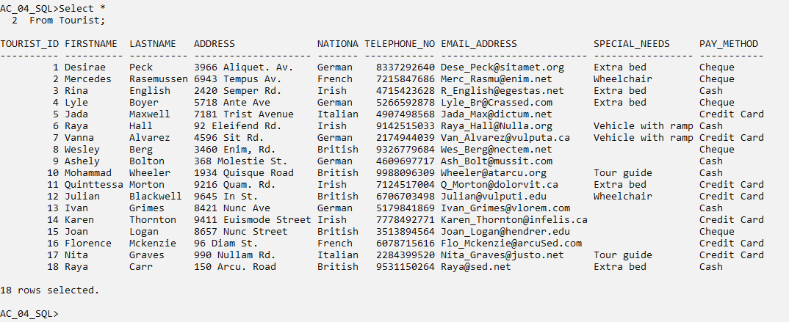

Proprietor

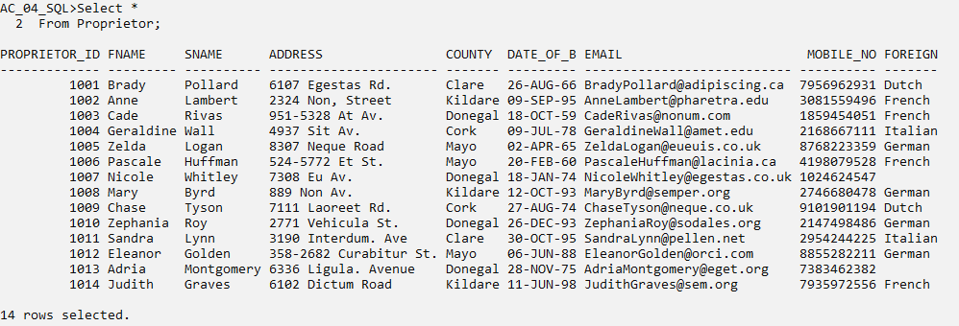

Cottage

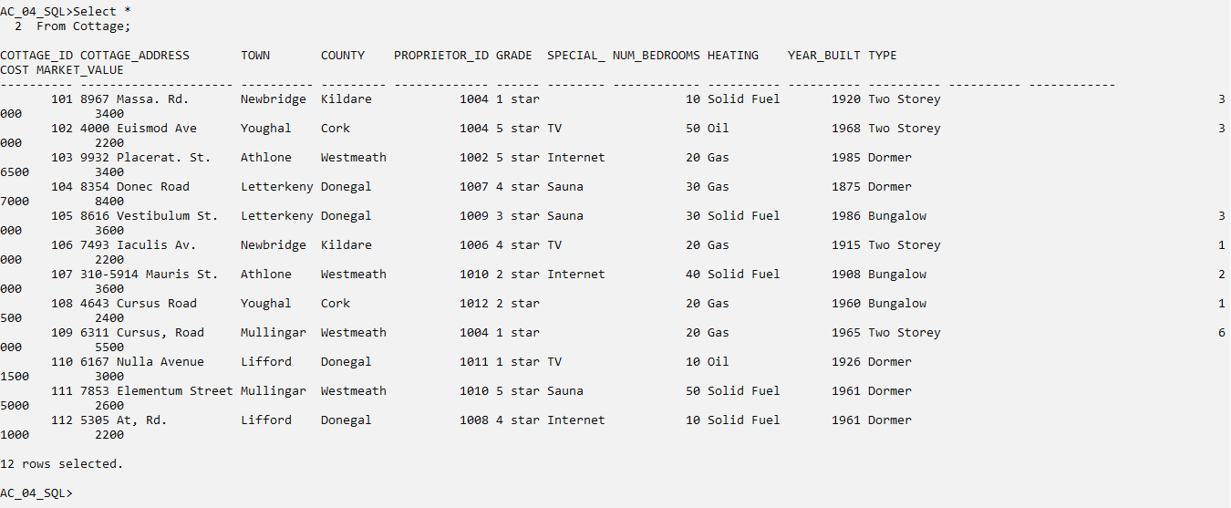

Cottage_Rental

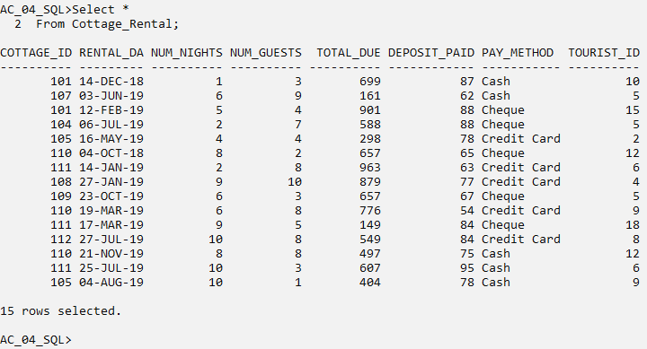

Caretaker

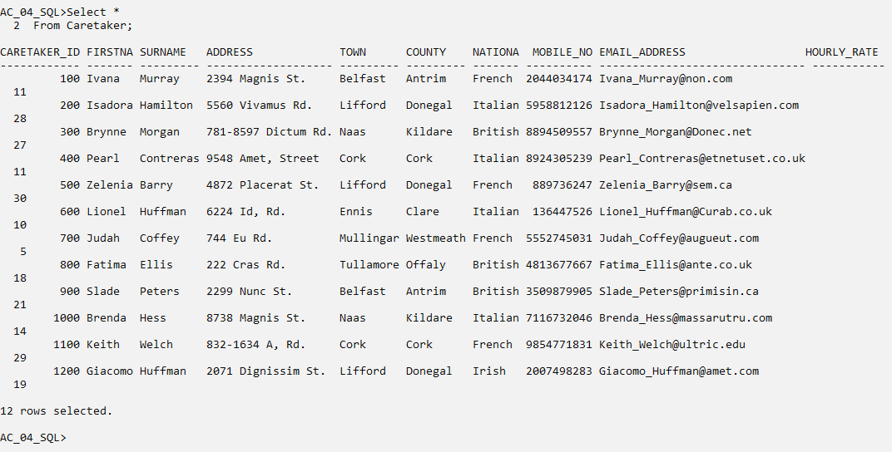

Cottage_Cleaning

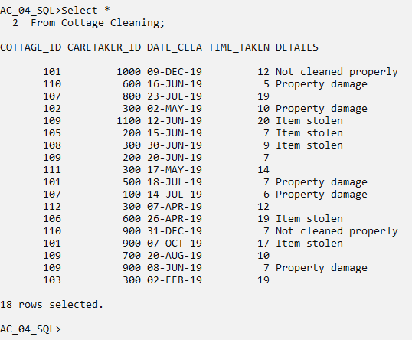

# 8. Queries

## 8.1. Single Table Query

Spool F:\A00268811_SQL_Project_Query.txt

Q1. Show the first name, last name, phone number, nationality and special needs of tourists who requested extra bed or tour guide and whose payment method is “Cash”. Sort the result by nationality.

Cl scr

Select FirstName, LastName, Telephone_No, Nationality, Special_Needs, *Pay_Method*

From Tourist

Where Special_Needs In ('Extra bed', 'Tour guide')

And Pay_Method = 'Cash'

Order By Nationality;

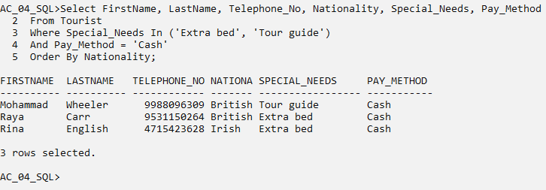

## 8.2. Queries involving Joins

Q2. Show the cottage Id, town, grade, market value, proprietor forename and email for those cottages whose proprietor’s forename starts with letter A. Sort the result by proprietor forename.

Cl scr

Select C.Cottage_Id, C.Town, C.Grade, C.Market_Value, P.Fname, P.Email

From Proprietor P, Cottage C

Where P.Proprietor_Id = C.Proprietor_Id

And P.Fname Like 'A%'

Order By P.Fname;

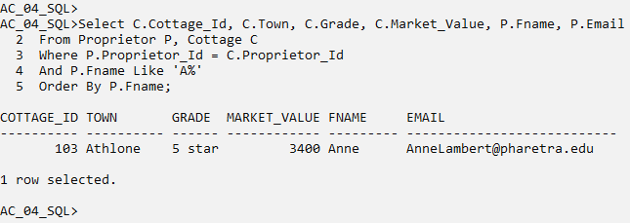

## 8.3. Queries involving Joins (2)

Q3. Give the firstname, surname, town and hourly rate of those caretakers who takes more than 10 hours for cleaning a cottage and where some items were stolen. Arrange the result in reverse order of surname.

Cl scr

Select CT.Firstname, CT.Surname, CT.Town, CT.Hourly_Rate, *CC.Time_Taken, CC.Details*

From Caretaker CT, Cottage_Cleaning CC

Where CT.Caretaker_Id = CC.Caretaker_Id

And CC.Time_Taken > 10

And CC.Details = 'Item stolen'

Order By CT.Surname Desc;

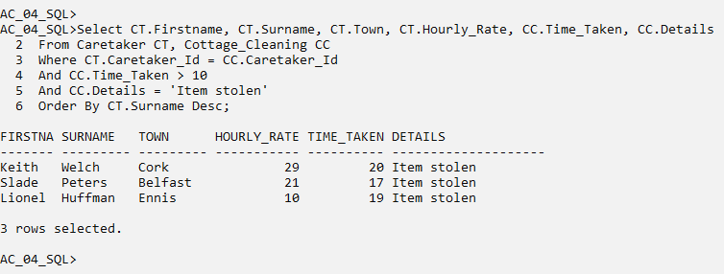

## 8.4. Queries involving Joins (3)

Q4. List the cottage id, cleaning date, number of bedrooms and heating method of those cottages that have at least 30 bedroom. Also list the surname and county of the proprietor for those cottages. Limit the result to those cottages whose proprietor hails from “Donegal” or “Cork” county. Arrange the result in increasing order of number of bedrooms and then by the cleaning date.

Cl scr

Select CC.Cottage_Id, CC.Date_Cleaned, C.Num_Bedrooms, C.Heating, P.Sname, P.County

From Proprietor P, Cottage C, Cottage_Cleaning CC

Where P.Proprietor_Id = C.Proprietor_Id

And C.Cottage_Id = CC.Cottage_Id

And C.Num_Bedrooms >= 30

And P.County In ('Donegal', 'Cork')

Order By C.Num_Bedrooms, CC.Date_Cleaned;

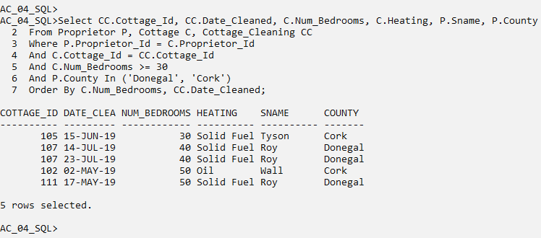

## 8.5. Join involving more than 2 Tables and Non-Equi Join

Q5. Show the first name, mobile number and hourly rate of those caretakers whose hourly rate is less than as number of bedrooms in a cottage they cleaned. Arrange the result in reverse order of hourly rate.

Cl scr

Select CT.Firstname, CT.Mobile_No, CT.Hourly_Rate, *C.Num_Bedrooms*

From Caretaker CT, Cottage C, Cottage_Cleaning CC

Where CT.Caretaker_Id = CC.Caretaker_Id

And CC.Cottage_Id = C.Cottage_Id

And CT.Hourly_Rate < C.Num_Bedrooms

Order By CT.Hourly_Rate Desc;

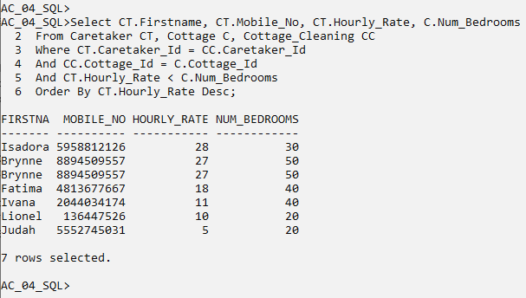

## 8.6. Queries involving Sub-Query

Q6. Give the Id, address, town, county, grade, special features, number of bedrooms, heating and type of those cottages where grade is higher than “2 star”, whose proprietor can speak either “Dutch” or “German” and is born after 01-Jan-1990. Sort the result in descensing order of grade.

Cl scr

Select Cottage_Id, Cottage_Address, Town, County, Grade, Special_Features, Num_Bedrooms, Heating, Type

From Cottage

Where Grade Not In ('1 star', '2 star')

And Proprietor_Id In

(Select Proprietor_Id

From Proprietor

Where Foreign_Language In ('Dutch', 'German')

And Date_Of_Birth > '01-Jan-1990')

Order By Grade Desc;

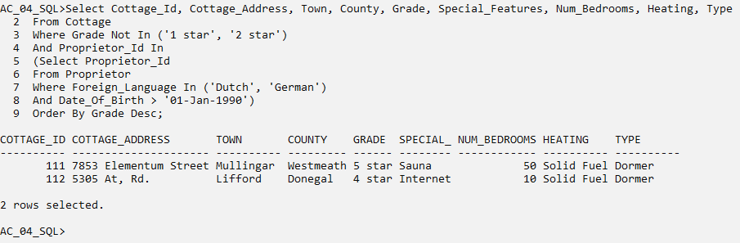

## 8.7. Sub-Query with Summary Query

Q7. List the first name, last name, special needs, deposit paid and the payment method for the rental for those tourists who have paid the highest deposit through cash.

Cl scr

Select T.FirstName, T.LastName, T.Special_Needs, CR.Deposit_Paid, CR.Pay_Method

From Tourist T, Cottage_Rental CR

Where T.Tourist_Id = CR.Tourist_Id

And CR.Pay_Method = 'Cash'

And CR.Deposit_Paid =

(Select Max(Deposit_Paid)

From Cottage_Rental

Where Pay_Method = 'Cash');

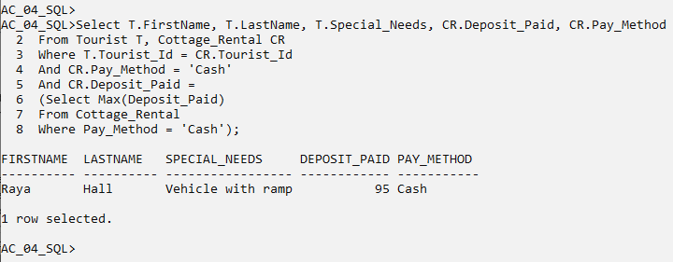

## 8.8. Queries involving Self-Join

Q8. Give the last name, nationality and special needs for pair of tourists who come from same country. Ignore those tourists who do not have a special need.

Cl scr

Select T1.LastName, T1.Nationality, T1.Special_Needs, T2.LastName, T2.Nationality, T2.Special_Needs

From Tourist T1, Tourist T2

Where T1.Nationality = T2.Nationality

And T1.Special_Needs Is Not Null

And T2.Special_Needs Is Not Null

And T1.Tourist_Id < T2.Tourist_Id

Order By T1.LastName;

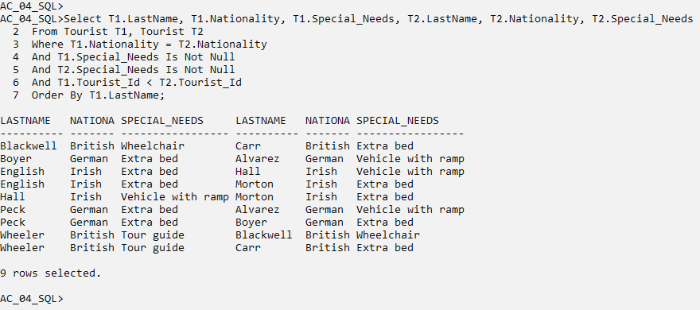

## 8.9. Queries involving Summary Query and Group By

Q9. For tourists of each nationality, show the minimum deposit paid, the average deposit paid, the maximum deposit paid and the difference between maximum and minimum deposit paid as range of deposit. Limit the output of average deposit paid to 2 decimal places and sort the result in ascending order of nationality.

Cl scr

Select T.Nationality, Min(CR.Deposit_Paid) As Min_Deposit, Round(Avg(CR.Deposit_Paid), 2) As Avg_Deposit, Max(CR.Deposit_Paid) As Max_Deposit, Max(CR.Deposit_Paid) - Min(CR.Deposit_Paid) As Range

From Tourist T, Cottage_Rental CR

Where T.Tourist_Id = CR.Tourist_Id

Group By T.Nationality

Order By T.Nationality;

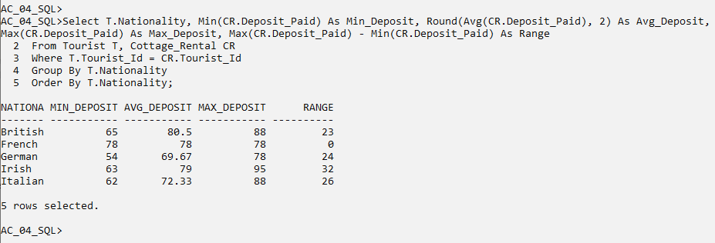

## 8.10. Queries involving Sub-Query and Exists

Q10. Show the first name and last name of those proprietors who own a cottage with exactly 20 bedrooms, whose cost is less than 6500 euros and which are involved in any cottage rental.

Cl scr

Select Fname, Sname

From Proprietor

Where Proprietor_Id In

(Select Proprietor_Id

From Cottage

Where Num_Bedrooms = 20

And Cost < 6500

And Exists

(Select *

From Cottage_Rental

Where Cottage.Cottage_Id = Cottage_Rental.Cottage_Id));

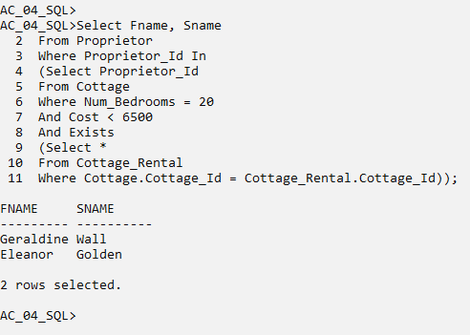

## 8.11. Multi-Legged Subqueries

Q11. Select cottage id, grade and cost of those cottages where the cost is higher than 2000 euros and

1. a tourist has rented the cottage for more than 5 nights and total due amount is less than average total due amount and
2. the cleaning of the cottage had no issue and took longer than average cleaning time and
3. is owned by a proprietor from “Donegal” or “Kildare” county and whose name starts with letter other than ‘C'.

Cl scr

Select Cottage_Id, Grade, Cost

From Cottage

Where Cost > 2000

And Cottage_Id In

(Select Cottage_Id

From Cottage_Rental

Where Num_Nights > 5

And Total_Due <

(Select Avg(Total_Due)

From Cottage_Rental))

And Cottage_Id In

(Select Cottage_Id

From Cottage_Cleaning

Where Details Is Null

And Time_Taken >

(Select Avg(Time_Taken)

From Cottage_Cleaning))

And Proprietor_Id In

(Select Proprietor_Id

From Proprietor

Where County In ('Donegal', 'Kildare')

And Fname Not Like 'C%');

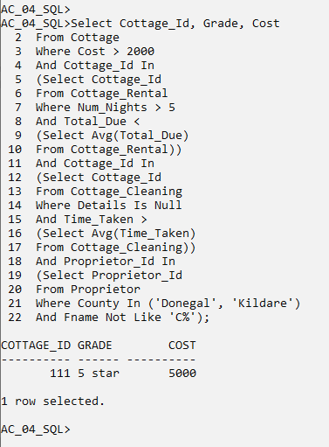

## 8.12. Update Statement

Q12. Increase the hourly rate by 10 euros for those caretakers where the count of issues found during cleaning is at most 1 and whose nationality is “French” or “Italian”.

Cl scr

Select Caretaker_Id, Hourly_Rate, Nationality

From Caretaker

Where Caretaker_Id In

(Select Caretaker_Id

From Cottage_Cleaning

Group By Caretaker_Id

Having Count(Details) <= 1)

And Nationality In ('French', 'Italian');

Update Caretaker

Set Hourly_Rate = Hourly_Rate + 10

Where Caretaker_Id In

(Select Caretaker_Id

From Cottage_Cleaning

Group By Caretaker_Id

Having Count(Details) <= 1)

And Nationality In ('French', 'Italian');

Select Caretaker_Id, Hourly_Rate, Nationality

From Caretaker

Where Caretaker_Id In

(Select Caretaker_Id

From Cottage_Cleaning

Group By Caretaker_Id

Having Count(Details) <= 1)

And Nationality In ('French', 'Italian');

Rollback;

Select Caretaker_Id, Hourly_Rate, Nationality

From Caretaker

Where Caretaker_Id In

(Select Caretaker_Id

From Cottage_Cleaning

Group By Caretaker_Id

Having Count(Details) <= 1)

And Nationality In ('French', 'Italian');

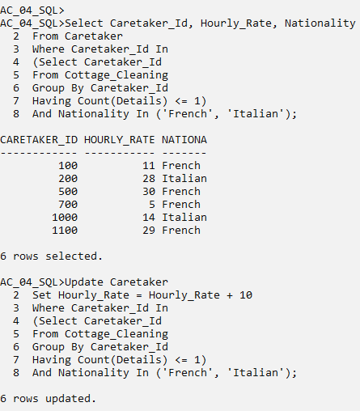

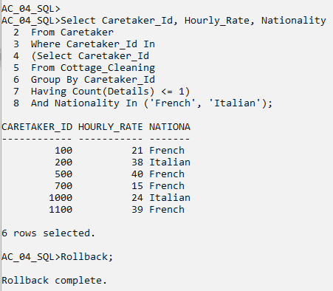

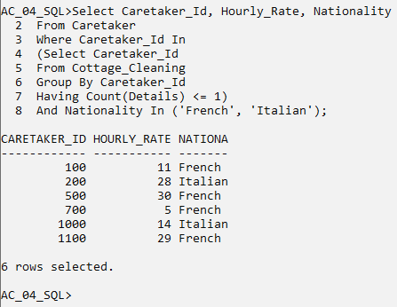

## 8.13. Delete Statement

Q13. Remove those cottage rentals where deposit paid is less than 75 and the cottage do not provide any special feature.

Cl scr

Select *

From Cottage_Rental

Where Deposit_Paid < 75

And Cottage_Id In

(Select Cottage_Id

From Cottage

Where Special_Features Is Null);

Delete

From Cottage_Rental

Where Deposit_Paid < 75

And Cottage_Id In

(Select Cottage_Id

From Cottage

Where Special_Features Is Null);

Select *

From Cottage_Rental

Where Deposit_Paid < 75

And Cottage_Id In

(Select Cottage_Id

From Cottage

Where Special_Features Is Null);

Rollback;

Select *

From Cottage_Rental

Where Deposit_Paid < 75

And Cottage_Id In

(Select Cottage_Id

From Cottage

Where Special_Features Is Null);

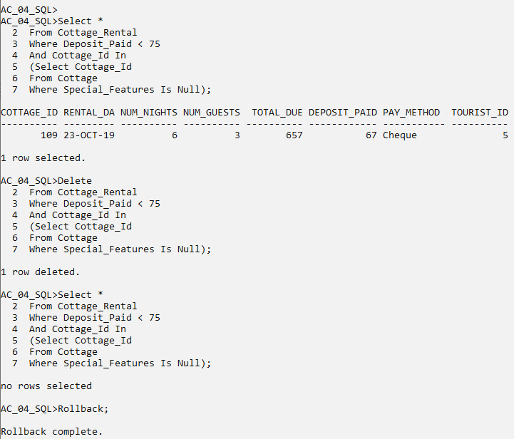

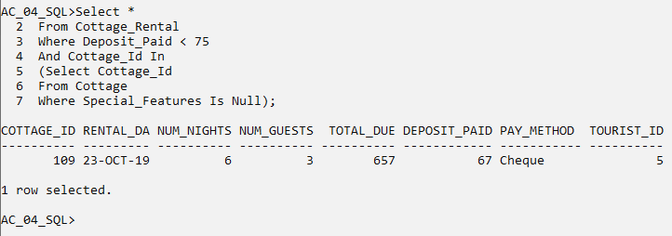

## 8.14. Queries using Union

Q14. Select first name, last name and address (or their equivalent columns i.e., columns having similar information with different names) of tourist, proprietor and caretaker where proprietor and caretaker are from “Cork” county. Duplicate results should not appear in the output. Arrange the result by alphabetical order of first name.

Cl scr

Select FirstName, LastName, Address

From Tourist

Union

Select Fname, Sname, Address

From Proprietor

Where County = 'Cork'

Union

Select Firstname, Surname, Address

From Caretaker

Where County = 'Cork'

Order By 1;

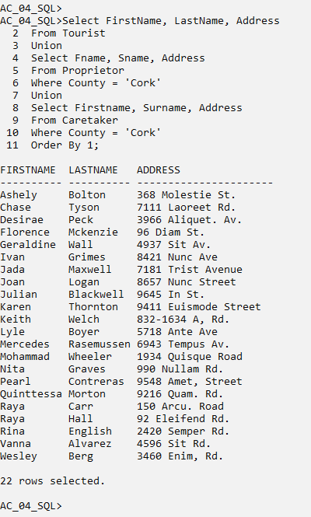

## 8.15. Views involving Sub-Queries and Read-Only Condition

Q15. Devise a permanently stored query that stores the cottage id, tourist id, total due, deposit paid and their sum as total amount for tourists from Germany and France and for cottages in Westmeath and Kildare counties. Ensure that users are not able to carry out any DML operation on the view.

Cl scr

Drop View Rental1;

Create View Rental1 As

Select Cottage_Id, Tourist_Id, Total_Due, Deposit_Paid, Total_Due + Deposit_Paid As Total_Amt

From Cottage_Rental

Where Tourist_Id In

(Select Tourist_Id

From Tourist

Where Nationality In ('German', 'French'))

And Cottage_Id In

(Select Cottage_Id

From Cottage

Where County Not In ('Westmeath', 'Kildare'))

With Read Only;

Select *

From Rental1;

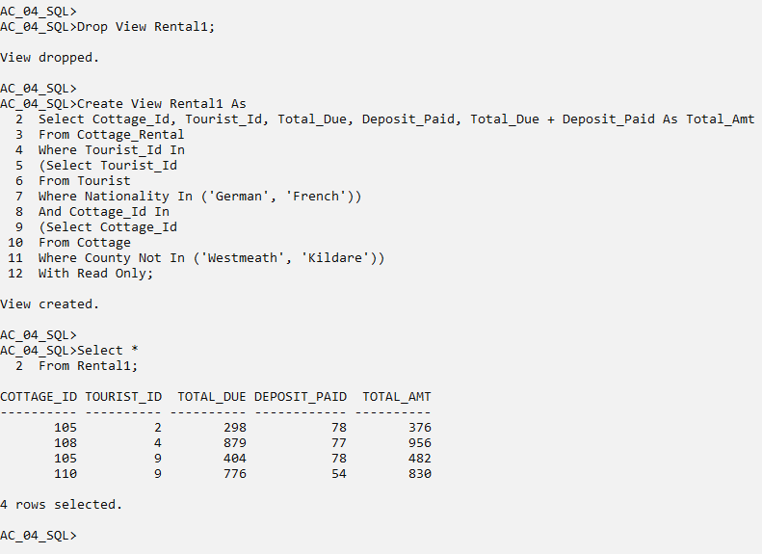

## 8.16. Query to retrieve data from View

Q16. From the view created in previous question, show result for those cottage rentals where total amount is greater than 500.

Cl scr

Select *

From Rental1

Where Total_Amt > 500;

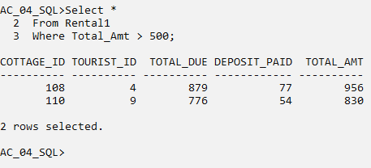

## 8.17. Query involving Rollup with Group By

Q17. For those proprietors whose first name ends “e”, list the firstname, cost of each cottage owned by the proprietor and the total cost of all the cottages owned by the proprietor.

Cl scr

Select P.Fname, C.Cottage_Id, Sum(C.Cost)

From Proprietor P, Cottage C

Where P.Proprietor_Id = C.Proprietor_Id

And P.Fname Like '%e'

Group By Rollup (P.Fname,C.Cottage_Id)

Order By P.Fname;

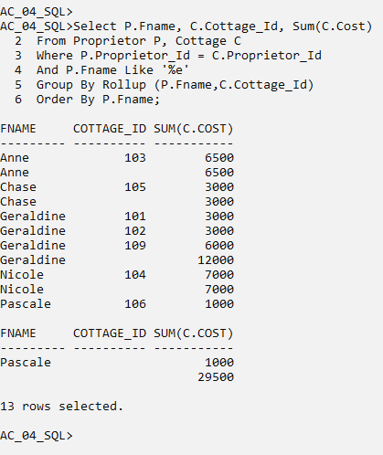

## 8.18. Alter-Table Command

Q18. Add a column named ‘Age’ to proprietor table and populate it with age of the proprietor based on his/her date of birth.

Cl scr

Alter Table Proprietor

Add Age Number(3);

Update Proprietor

Set Age = Months_Between(SysDate,Date_Of_Birth)/12;

Select Proprietor_Id, Date_Of_Birth, Age

From Proprietor;

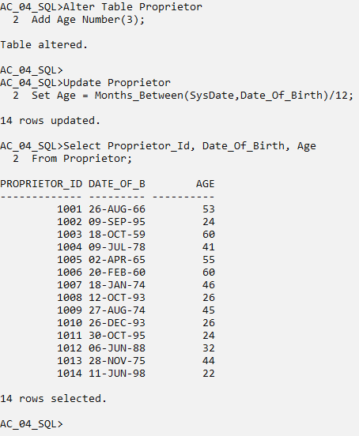

Spool off