***Chapter 1***

# INTRODUCTION

Welcome to our Hardware Shop eCommerce website, an online retail platform designed to provide a smooth, easy, and enjoyable shopping experience for both DIY enthusiasts and professional tradespeople. We understand the varied needs of our customers, so we offer a wide selection of high-quality hardware products. Our catalog includes essential hand tools, power tools, construction materials, fasteners, plumbing supplies, electrical components, and more.Our eCommerce site features a user-friendly system that helps users easily find and explore products. Customers can narrow their searches by categories, price ranges, brands, ratings, and other criteria. This makes it simple to select the right items. Each product page includes detailed information, such as rich image galleries with zoom and 360-degree views, thorough descriptions, stock availability, variants, and user-generated reviews. This helps customers make informed choices.Our eCommerce site features a user-friendly system that helps users easily find and explore products. Customers can narrow their searches by categories, price ranges, brands, ratings, and other criteria. This makes it simple to select the right items. Each product page includes detailed information, such as rich image galleries with zoom and 360-degree views, thorough descriptions, stock availability, variants, and user-generated reviews. This helps customers make informed choices.Users also benefit from personalized account management features. Customers can set up profiles to manage their order histories, track shipments with live status updates, maintain shareable wishlists, and receive product recommendations based on their browsing habits. Our inventory management keeps stock accurate and up-to-date, along with coupon and discount systems that reward loyal shoppers.To further engage users, the website includes educational content and interactive features. This includes product comparisons, augmented reality try-on simulations for select tools, live chat support for immediate help, and social proof elements that spotlight popular and trending products. Customers can set up profiles to manage their order histories, track shipments with live status updates, maintain shareable wishlists, and receive product recommendations based on their browsing habits. Our inventory management keeps stock accurate and up-to-date, along with coupon and discount systems that reward loyal shoppers.To further engage users, stock availability, variants, and user-generated reviews. This helps customers make informed choices.Users also benefit from personalized account management features. Customers can set up profiles to manage their order histories, track shipments with live status updates.

This Hardware Shop eCommerce website serves not just as a storefront but as a complete digital destination where customers can confidently explore, select, and buy hardware products while enjoying a premium shopping experience supported by up-to-date technology, security, and customer-focused features.

## What is Ecommerce website?

An eCommerce website is an online platform that allows people to buy and sell goods and services over the internet, working as a virtual store for businesses of any size. These websites have a detailed product catalog organized into categories, making it easy for customers to browse and find what they need. Each product page usually includes clear images, thorough descriptions, specifications, pricing, and customer reviews to help users make smart buying choices. A vital part of eCommerce websites is the shopping cart feature, which lets customers select and save items they want to buy before going to the checkout. This process helps users enter shipping information, choose payment methods, and confirm their orders while ensuring a safe transaction through payment gateways that accept different payment options, including credit/debit cards, digital wallets, and bank transfers.

User accounts are another important feature, allowing customers to create profiles where they can manage personal information, view order histories, save payment details, and track shipments in real-time. To improve the shopping experience, eCommerce websites often have search and filter options that help users quickly find specific products based on keywords, categories, price ranges, and ratings. Customer support is also crucial, with features like live chat, FAQs, and contact forms to help users with questions or problems related to their orders. Security is vital, and eCommerce websites use strong measures, such as SSL certificates for secure data transmission and compliance with data protection rules, to protect sensitive customer information**.** Additionally, these platforms are built to be mobile-friendly, ensuring users can enjoy a smooth shopping experience on various devices, such as smartphones and tablets. To attract traffic and boost sales, eCommerce websites often use marketing tools like promotional discount codes, email marketing, and social media integration, which help bring in new customers and keep existing ones. To improve the shopping experience, eCommerce websites often have search and filter options that help users quickly find specific products based on keywords, categories, price ranges, and ratings. Customer support is also crucial, with features like live chat, FAQs, and contact forms to help users with questions or problems related to their orders.

## How does ecommerce website help in selling products?

Additionally, eCommerce websites often use data analytics to create personalized shopping experiences. They recommend products based on individual customer behavior and preferences, which increases engagement and encourages purchases. Promotional

tools like discounts, special offers, and limited-time deals can draw in new customers and encourage repeat purchases. A smooth checkout process reduces cart abandonment rates by offering features such as guest checkout, saved payment information, and various

payment options. Customer reviews and ratings build trust and credibility since positive feedback can greatly influence potential buyers' decisions.Furthermore, mobile optimization is key today, enabling customers to shop easily from their smartphones, which boosts sales opportunities. eCommerce platforms also provide useful analytics and insights. These tools help businesses track user behavior, sales trends, and inventory levels. This information allows for informed decisions about marketing strategies and product offerings. Customer engagement improves through newsletters, loyalty programs, and social media integration, which strengthen long-term relationships and brand loyalty.

## Importance of smart tourism

An eCommerce website is essential for selling products. It uses various features and functions to improve the shopping experience for customers. One main benefit is its ability to reach a global audience. This helps businesses remove geographical limits and attract customers from different regions and demographics, which greatly increases their market potential. Operating around the clock, eCommerce sites offer the convenience of shopping at any time. This fits various schedules and preferences, leading to higher sales volumes. The easy navigation and search features on these platforms make it simple for customers to quickly find products. Detailed product information, including high-quality images, thorough descriptions, specifications, and customer reviews, helps buyers make informed choices. This reduces uncertainty and increases conversion rates. Some Facts about smart tourism. An eCommerce website is essential for selling products. It uses various features and functions to improve the shopping experience for customers. One main benefit is its ability to reach a global audience. This helps businesses remove geographical limits and attract customers from different regions and demographics, which greatly increases their market potential. Operating around the clock, eCommerce sites offer the convenience of shopping at any time

## Somefact about ecommerce website

eCommerce websites have changed the retail scene significantly, with major growth and adoption over the past few decades. As of 2023, global eCommerce sales are expected to exceed $6 trillion. This increase reflects a steady rise in online shopping as consumers prefer the convenience of buying products from home. Advancements in technology, like mobile devices and high-speed internet, have made online shopping more accessible than ever. The COVID-19 pandemic further sped up this trend. Many brick-and-mortar stores had to close temporarily, leading consumers to seek online shopping options. The rise of eCommerce has also introduced various business models like Business-to-Consumer

(B2C), Business-to-Business (B2B), Consumer-to-Consumer (C2C), and Consumer-to- Business (C2B); each one serves different market segments and consumer behaviors.

Another important aspect of eCommerce websites is the growing focus on user experience and personalization to boost sales. Modern eCommerce platforms use data analytics and artificial intelligence to track customer behavior, preferences, and buying patterns. This information helps businesses offer personalized recommendations, targeted marketing campaigns, and tailored shopping experiences that appeal to individual customers.Additionally, features like live chat support, customer reviews, and social proof are crucial for building trust and improving customer satisfaction. With mobile commerce on the rise—over 70% of eCommerce traffic is from mobile devices—optimizing websites for mobile use is essential for success. Secure payment systems and strong cybersecurity

measures are also vital for ensuring customer trust and protecting sensitive information. Overall, eCommerce websites are more than just sales channels; they are active platforms that evolve to meet the changing needs and expectations of consumers in a digital-first world

**1.5 Report Organization**

The report is carefully structured into several sections, each focusing on a different aspect of the project to provide clarity and logical flow. Below is a detailed point-by-point organization of the report:

1. Acknowledgment
   * Expresses gratitude to the project guide, faculty members, and contributors.
   * Sets a formal tone and acknowledges the support received during the project.
2. Abstract
   * Provides a concise summary of the project.
   * Highlights the main features of the eCommerce hardware website, including its functionalities, user interface, and technological stack.
   * Gives readers an overview of what the report will cover.
3. Table of Contents
   * Lists all the major sections and subsections of the report along with page numbers.
   * Helps the reader quickly locate specific topics within the report.
4. List of Figures
   * Catalogs all the diagrams and screenshots included in the report.
   * Ensures that visual content is easily accessible and referenced.
5. Chapter 1: Introduction
   * 1.1 What is an eCommerce Website?
     + Defines eCommerce and explains its relevance in today’s digital world.
   * 1.2 How eCommerce Websites Help in Selling Products
     + Discusses the business advantages and operational benefits of online platforms.
   * 1.3 Importance of eCommerce Website
     + Highlights the necessity of having an online presence for businesses, especially in the hardware domain.
   * 1.4 Facts About eCommerce Websites
     + Presents interesting statistics and facts to underline the significance of eCommerce in the current market.
6. Chapter 2: Requirements Specification
   * 2.1 Functional Requirements
     + Details the core functions of the website such as user registration, login, product search, cart management, and payment options.
   * 2.2 Non-Functional Requirements
     + Describes system qualities like security, usability, performance, and scalability.
   * 2.3 Domain Constraints
     + Lists the limitations and external conditions affecting the system development, such as browser compatibility and third-party integrations.
7. Chapter 3: Technologies
   * 3.1 HTML, 3.2 CSS
     + Describes how the structure and styling of the website are handled.
   * 3.3 JavaScript and its Libraries
     + Covers the use of scripting to make the site interactive.
   * 3.4 Client-Side Validation
     + Explains validation mechanisms to ensure data integrity before submission.
   * 3.5 Node.js
     + Discusses server-side scripting and how it powers the backend.
   * 3.6 Firebase
     + Outlines Firebase's role in authentication and real-time database operations.
   * 3.7 Project Structure
     + Provides an overview of the file and folder structure used in the project.
8. Chapter 4: Design & User Interface
   * 4.1 Login Page
     + Discusses UI design and logic for user login.
   * 4.2 SignUp Page
     + Explains user registration interface and flow.
   * 4.3 Home Page
     + Covers the layout of the homepage, including navigation, featured products, and additional elements like FAQs.
9. Chapter 5: Implementation Details and Experimental Results
   * 5.1 Node.js and Express Backend
     + Describes how server-side logic and routing are implemented.
   * 5.2 MongoDB Database
     + Details database structure, schemas, and collection management.
   * 5.3 User Authentication
     + Discusses secure login and signup processes.
   * 5.4 Cloudinary Integration
     + Explains how Cloudinary is used for media storage (product images, etc.).
   * 5.5 Handling API Requests and Forms
     + Covers how user inputs are processed and server responses are managed.
   * 5.6 Error Handling and Feedback
     + Describes mechanisms for displaying messages and errors to the user.
10. Conclusion
    * Summarizes the overall project achievements.
    * Reflects on the learning outcomes and development process.
11. References
    * Lists the sources, documentation, and tools consulted during the project.
    * Ensures proper acknowledgment of external content and resources.

***Chapter 2***

# REQUIREMENTS SPECIFICATION

A detailed requirement specification of an eCommerce website should include both functional and non-functional requirements for the eCommerce site's successful development and operation. Functional requirements include user sign-up and authentication, product catalogue managing with specifications and images, searching and navigation features for the product catalogue, shopping cart and checkout process including secure payments, order processing, customer reviews of products, and some method of customer service support

## Functional Requirements

The User Registration and Login functionality is an essential feature of an eCommerce

website - it is the first step to creating a custom and secure environment for customers to shop within. When the customer goes to register, the steps to create an account should be easy for them. The customer should input basic information like email address, password, and name / contact details (to be added optionally). The application should also validate fields to ensure the user is adding accurate information and enforce data validation security rules for example for the password, to ensure the customer is using a strong password. The registration should also allow the via a social media activity (e.g. Google or Facebook) if the user wants to log on with a social media account.As for the login functionality, the user must be able to securely authenticate themselves to access the site and their account using the email address and password they created. The application should securely store the customers information and passwords using state-of- the-art security practices (e.g. hashed passwords with salts etc). The system should include simple features like "Remember Me" for persistent logins multi-factor authentication options to secure access to their account. If the customer forgets their password they must be able to recover the password using industry standards - i.e. via secure email. The application should also validate fields to ensure the user is adding accurate information and enforce data validation security rules for example for the password, to ensure the customer is using a strong password. The registration should also allow the via a social media activity (e.g. Google or Facebook) if the user wants to log on with a social media account.As for the login functionality, the user must be able to securely authenticate themselves to access the site and their account using the email address and password they created.

## Non-Functional Requirements

Non-functional requirements for an eCommerce website can be vital in creating consistent and satisfactory experiences for users, while the business can also have consistent and

efficient operations. Performance is probably the biggest consideration, especially in the ages of low attention spans and convenience culture; pages that take more than 3 seconds to load will result in increased frustration for the user, reducing reliability and increasing bounce rates (for customers); this impacts delivery of the business, in the same way, a poor user experience during peak traffic will harm the brand. Security will be a top precedence also; a website will need a secure SSL certificate for transfer of data, ensure compliance with data protection legislation such as GDPR, and most importantly make sure that user payments are secure to safeguard sensitive customer data and guarantee the security and certification of payment processing.

## Domain Constraints

### Product Specifications:

* + - * All hardware products must include detailed specifications such as dimensions, weight, material type, and compatibility information.
      * Products should be categorized accurately (e.g., tools, fasteners, electrical supplies) to facilitate easy navigation.

### Inventory Management:

* + - * The system must track real-time inventory levels to prevent overselling and ensure accurate stock availability.
      * Products with limited stock should be marked as low inventory to inform customers.

### Pricing Rules:

* + - * Pricing must reflect any applicable taxes, discounts, or promotions, and should be updated in real-time.Bulk pricing or tiered pricing structures may be implemented for wholesale customers.

### Shipping Constraints:

* + - * Shipping options must account for the weight and dimensions of hardware products, as these can affect shipping costs and methods.
      * Certain products may have shipping restrictions based on size, weight, or hazardous materials regulations.

### User Roles and Permissions:

* + - * Different user roles (e.g., customers, administrators, warehouse staff) must have specific permissions to access and manage various parts of the website.
      * Administrators should have the ability to manage product listings, orders, and customer accounts.

### Return and Warranty Policies:

* + - * Clearly defined return policies must be established, particularly for tools and equipment, which may have specific return conditions.
      * Warranty information should be provided for applicable products, detailing coverage and claim processes.

### Payment Processing:

* + - * The website must support multiple payment methods (credit/debit cards, digital wallets) while ensuring compliance with PCI DSS standards for secure transactions.
      * Payment processing should accommodate international transactions if the shop serves customers outside the local region.

### Regulatory Compliance:

* + - * The website must comply with local and national regulations regarding the sale of hardware products, including safety standards and labeling requirements.
      * Age restrictions may apply to certain tools or materials, necessitating age verification during the purchase process.

***Chapter 3***

# TECHNOLOGIES

Frontend Approach: we have designed frontend with the help of HTML, CSS, JavaScript.

* 1. **HTML**

HTML is the standard markup language for creating web pages. It describes the structure of a web page using unique elements such as headings, paragraphs, links, and images. Thanks to HTML5, it supports user interaction to produce rich content such as audio and video things as well as making maintaining code easier. HTML5 supports offline web applications and geolocation capability, thus providing more modern functionality for new websites.

### Advantages of HTML:

* + - Foundation of all website building.
    - Being supported by all browsers.
    - Seamless integration with different languages such as CSS and JavaScript.
  1. **CSS**

CSS is a style sheet language that is utilized in controlling the presentation of HTML elements. It describes how the elements will appear on the page-layout, colors, fonts, and all that. CSS allows creation of beautiful websites without compromising the responsiveness of these websites on various screen sizes.

The three primarily known types of CSS are:

* **Inline CSS:** Directly applied to HTML elements by using the style attribute.
* **Internal CSS:** Defined in <style> block inside head section of an HTML document
* **External CSS:** Stored in a separate .css file, an external stylesheet, and linked to the HTML document for reusable styles across multiple pages.

### Advantages of CSS:

* Brightens a website.
* Must-have learning for a web designer.
* Supports having what is known as a separating line between design and content.
* Once learned, allows easier learning of other technologies, including JavaScript or frameworks like React and Angular.
  1. **JAVASCRIPT**

JavaScript is a lightweight dynamic, and object-oriented programming language, which is used to interactively create effects on the web pages and runs on the client-side (in the user’s browser), making websites dynamic without needing to reload. JavaScript enables features like form validation, dynamic content updates, animations, and more.

**Features of JavaScript**, there are following features of JavaScript:

* Supported by all major browsers.
* Works well with other languages like **HTML** and **CSS**.
* Provides control over web page behavior, from pop-up windows to real-time data updates.
* It’s an object-oriented language that uses prototypes for inheritance, and it’s case-sensitive.

### Fig 3.1: HTML , CSS , JAVASCRIPT Applications of JavaScript

* Validating form inputs.
* Creating dynamic features like drop-down menus and clocks.
* Enhancing user interactions with pop-ups and alerts.
  + 1. **Libraries of JS**

JavaScript has a wide ecosystem of libraries and the opportunities for development using these libraries is endless. When it comes to frontend development, React, Vue.js, and Angular are commonly used tools used for creating user interfaces. D3.js and Chart.js are effective when used for data visualization, and GSAP and Anime.js are used to for animation development. Applications in JavaScript development are also simplified by utility libraries like Lodash for data manipulation, and Axios to write HTTP requests. There are a variety of state management libraries, such as Redux and MobX, that help manage application state.

3.4 **Client-Side Validation:**

* + - Ensuring a Smooth and Safe User Experience
    - Automobile technology Evolution website not only brings out the most interesting developments in automotive but also works for having visitors to experience a high- performance and secure browsing adventure.

One of these elements that would make up such is client-side validation; thus, after having at most the correctness of data users have on their end and processing them.

### What is Client-Side Validation

Client-side validation is the process of taking any information collected from the user through an online submission form and checking whether or not it has to be submitted to the server. Such a check is meant for collecting any invalid data from being submitted into the other server by the user entering information onto the form using the browser.

* **Common Forms of Client-Side Validation**

**Form Field Validation:** It includes actions whereby the system will check if the user has inputted all the necessary fields, whether the data inputted has followed a certain format (like email identifiers or telephone digits), and if any character limits have been observed. **Real-Time Feedback**: To make things even more user-friendly, client-side validation can offer real-time feedback. For example, while a user is typing in a password, JavaScript can check its strength or confirm that the passwords match, helping users complete the form correctly without waiting until submission.Node.js is the best option for it because it has this ability to withstand large requests per second without slowing down. So, among all available platforms, Node.js is absolutely the best-suited platform to develop applications that need to be real-time and data-intensive. Node.js is a runtime environment that lets you run JavaScript on the server-side. Traditionally, JavaScript was used only in the browser to make web pages interactive, but with Node.js , it not only handles user interaction but also file system-related functions, databases, and HTTP requests.



### Fig 3.2:Node.js , Express , MongoDB

Backend Approach: We have setup Backend and database with the help of Node.js , Express and MongoDB.

**3.5 Node.js**

Node.js is a runtime environment that lets you run JavaScript on the server-side. Traditionally, JavaScript was used only in the browser to make web pages interactive, but with Node.js, you can also use JavaScript to build backend applications and servers. Think of it like something running JavaScript outside the browser--in the case of Node, it not only handles user interaction but also file system-related functions, databases, and HTTP requests.

### Why Node.js?

Node.js is an effective choice because its architecture is non-blocking and event-driven, which suits speed and efficiency for many simultaneous operations. This makes it particularly suitable for real-time applications like chat applications, where somebody has to be able to receive live feeds on some channel, or for some application that warrants a really good concurrency.If I am building a website where users can continually send and receive data, such as in the case of a social media network, Node.js is the best option for it because it has this ability to withstand large requests per second without slowing down. So, among all available platforms, Node.js is absolutely the best-suited platform to develop applications that need to be real-time and data-intensive.

* **How does it work?**

Node.js is based on the V8 JavaScript engine, known as the engine where JavaScript runs in Google Chrome. When you run your JavaScript program in Node.js, it compiles the code through V8 and executes the event loop to make it handle multiple functionalities at the same time without passing once a task gets finished.

Since Node.js uses a single thread to handle requests, it avoids the overhead of creating multiple threads like traditional server setups. Instead, it processes events asynchronously, which makes it lightweight and quick, even for complex applications.

### Why use Node.js?

* **Scalability:** Since Node.js can handle multiple requests at once, it's great for building scalable applications.
* **JavaScript Everywhere:** You can use the same language (JavaScript) on both the frontend and backend, which can simplify development and reduce context switching for developers.
* **Large Ecosystem:** With npm (Node Package Manager), Node.js has a huge collection of open-source libraries and modules, which makes it easy to add functionality without reinventing the wheel.
  1. **Firebase**

Firebase is a very important platform for developing and managing an eCommerce

website for a hardware shop, which has a complete set of tools for making the eCommerce store and developing the user experience throughout the store. Firebase's strength is in its real-time database, which allows updates of product listings, inventory levels, and shopping carts in real time so that customers will always see up-to-date information. This is very useful for a hardware shop, as the availability of stock can change quickly due to

demand. Another useful feature of Firebase is its Authentication module that allows for user management using either Google, Facebook, email/password and mobile phone number with a single-click authentication. This allows customers to securely log in or sign up for an account and makes for a simple process to do so.Firebase also offers Cloud Firestore, which makes storing and retrieving product information easy. Product descriptions may have a long length and include pictures and pricing, making it easy for users to access information about a product. Firebase's Storage section is helpful in uploading product images and websites can link and manage high-resolution images, allowing customers to see products as clearly as they could in a physical store before purchasing online. Another point of value in using Firebase is the content delivery through Firebase Hosting, which offers speed and security when delivering content over devices. This ensures the website loads fast and runs smooth, keeping customers from leaving your site and helping to keep bounce rates low. Firebase also has a Cloud Functions module that can run server-side code to automate backend processes that would otherwise need to be handled by a server, such as processing orders, payments, and sending emails.

**3.7 Project Structure**

The architecture of the project is meticulously organized using the widely adopted **MVC (Model-View-Controller)** paradigm, which is a design pattern that separates the application logic into three interconnected components, each with a distinct responsibility. This separation of concerns not only streamlines the development process but also enhances maintainability, scalability, and testability of the codebase. The entire project is arranged into dedicated folders and files that strictly adhere to this structure, making it intuitive for developers to locate, modify, or extend specific functionalities without affecting other parts of the application.At the core of this architecture lies the **controllers folder**, which acts as the central processing unit of the application’s business logic. Controllers serve as the intermediary between the user's actions (usually in the form of HTTP requests) and the system’s responses. Whenever a user interacts with the application—by logging in, submitting a form, browsing products, or performing any data-related operation—a corresponding controller function is invoked. These controller functions are responsible for orchestrating the entire request-response cycle. They typically begin by validating incoming data using predefined schemas or parameters, ensuring that only properly formatted and secure data reaches the application’s core. Upon successful validation, the controller interacts with the models to fetch, insert, update, or delete data in the database. Finally, the controller processes the outcome and sends a suitable response back to the client, which could be in the form of a JSON object, a rendered view, or a status message. This modular structure ensures that all business logic remains centralized, reusable, and easy to test or debug in isolation.

The **models folder** plays an equally critical role in the backend, acting as the gateway to the database. Models define the **schemas**—structured blueprints that describe how data is organized in the database. Each schema outlines the fields, data types, validation rules, relationships between entities, and default values for various documents stored in the database. For instance, a "User" model might contain fields like name, email, password, and timestamps, each with specific constraints. The project uses a powerful Object Data Modeling (ODM) library such as **Mongoose** to define these models when working with **MongoDB**, a NoSQL database. Mongoose not only helps in constructing schemas but also enables seamless communication between the application and the database through model instances. These models make database operations highly intuitive and abstract away the low-level database queries, thus making data interactions reliable, secure, and scalable. They also provide built-in methods for querying, aggregating, and validating data, which simplifies complex data operations across the application.

The **views folder** represents the presentation layer of the application. It contains **EJS (Embedded JavaScript) templates**, which are responsible for dynamically rendering HTML pages that the end-user interacts with. EJS templates allow embedding server-side variables and logic directly into HTML markup, making it possible to display dynamic content such as product listings, user information, cart items, or error messages without needing to reload the entire page. This dynamic rendering enhances the interactivity and responsiveness of the user interface. For example, after a successful login, the user might be redirected to a personalized dashboard, which is populated in real-time with data retrieved from the server and passed into the EJS view. This mechanism helps keep the front-end user experience consistent and up-to-date with backend data changes. The separation of the views from controllers also ensures that developers working on UI/UX can focus on design and layout without needing to understand the inner workings of the backend logic.Another crucial element in the MVC structure is the **routes folder**, which acts as the entry point for all incoming requests. Routing is the process of determining how an application responds to client requests for specific endpoints or URLs. Each route maps a particular HTTP request (like GET, POST, PUT, DELETE) to a specific controller function that should handle that request. By organizing all the routing logic in one place, the application becomes more modular and easier to manage. It allows developers to clearly define the paths and methods that the application supports, along with middleware functions for authentication, logging, or data preprocessing. For instance, routes related to user operations (such as login, registration, and profile updates) may reside in a separate userRoutes.js file, while product-related routes could be maintained in productRoutes.js. This modular routing layout improves the readability of the application and ensures clean, maintainable code that can be extended with new endpoints effortlessly.

Beyond the MVC triad, the project may also contain additional folders such as **middleware**, **utils**, **config**, and **public**. The middleware folder typically holds functions that execute during the request-response cycle before reaching the controller, such as authentication checks or error handling. The utils folder may include utility functions that are reused across different modules, such as token generation, email formatting, or password hashing. The config folder stores configuration files, like environment variables or database connection settings, enabling flexible deployment across development, staging, and production environments. The public folder serves static assets such as CSS files, images, and client-side JavaScript, making the site visually appealing and responsive.Overall, the MVC-based file and directory organization brings a clear logical framework to the application. It encourages developers to follow best practices and ensures that as the application grows in complexity—whether in terms of user base, features, or integrations—it remains maintainable, modular, and developer-friendly. This structure also makes onboarding new developers smoother, as they can easily navigate the codebase and contribute without extensive hand-holding. The discipline enforced by MVC fosters consistency, improves debugging and testing processes, and ultimately leads to the development of robust, scalable, and high-performing web applications.

***Chapter 4***

# DESIGN & USER INTERFACE

The eCommerce website for the hardware shop is effectively designed with a clean, modern layout and high-contrast colors to ensure readability and accessibility. The header features a large logo with a sticky search bar with autocomplete and a cart icon indicating item count. The left sidebar can be collapsed so that the user can filter products by category, brand, price and ratings.

## Login Page

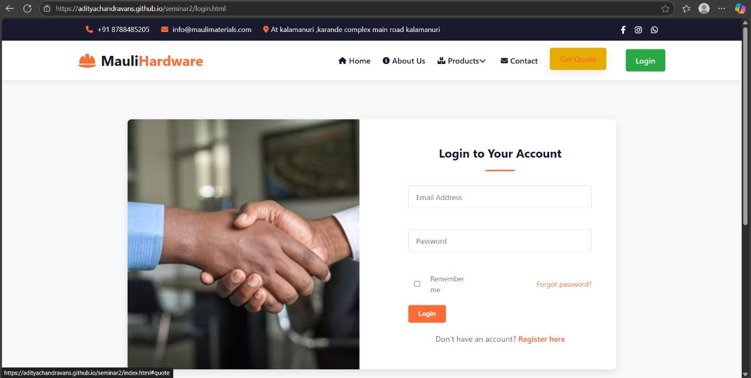The login page forms the core of every website, especially an online real estate platform, which provides security and comfort of use for the user to access the platform. In this, the user is assured from authentication and usability hence a secured pathway is constructed between the user and the platform that makes way for any personalized features and seamless transactions.

Fig 4.1: Login Page

* **Purpose**

It authenticates users and gives them access to specific functions for them as individuals according to their roles. This lets one secure site for users, logging them in before going into personalized data or actions.

* **User Credential**

Usually it requires providing a username or email address and password within the login page context. Some additional security features such as two-factor authentication have also been implemented by some sites.

* **Forgot Password**

Users who have forgotten their passwords will simply click on a link, "Forgot Password," to send a link for recovering their password to their email address. **Error Handling:** The page has clear and comprehensive messages to give incorrect users a chance to understand any problem occurring during the login process.

### Security Measures

* The page must have a strong security component, so that passwords are encrypted and the data is transferred securely, preventing it from brute force attacks and data breaches.Integration with User Profiles.

Users after logging in are generally redirected to their profile or landing page that hosts personal data, saved listings, and account settings.

## SignUp Page

Fig 4.2: Signup Page

An entirely new user sets out at the signup page of the website. This simple yet significant purpose is to collect minimum information to generate user accounts, as well as provide features specific to the users to ensure a smooth and personalized experience **Purpose:** Generally, this form collects minimal important data, such as your name, email, and password, with some optional data, such as location or preferences, as required by the site.

* **User Information**

Common fields include name, email, and password. **Account Verification:** Many sign-up processes include a verification stage for reasons such as web application and email or SMS code confirmation-and that's what makes accounts legit. **Password Creation:** thereby inviting users to make a much stronger password usually with important guidelines, e.g., by combinations of uppercase and lowercase letters, numbers, and different symbols to prevent.

**4.3 Home Page**

The home page acts like a nucleus of the site; it greets warmly and shows everything that the platform has got. The main aim is to capture the visitor and direct him toward the only sections which matter to him.The home page of the hardware shop eCommerce website is a friendly entry point, designed to captivate customers at first glance and provide a professional and friendly browsing experience. It features a large hero section with bold headlines and an attractive image, showcasing certain promotional or seasonal hardware products.

Below this section, different product categories, such as tools, fasteners, electrical, and plumbing, are featured below, using logical icons or images to facilitate quick navigation. Featured products with star ratings and all different types of discounts are also displayed in a responsive grid, encouraging exploration and purchase. mission, and objectives, explaining how it assists travelers and possibly introducing the developers or team behind the project. The home page features an advanced search bar naturally presenting the filter options to help customers discover products with ease. Customer testimonials and trust badges also have their place in the design, helping to establish trust and credibility. Clear call to action buttons encourage users to shop now, sign up for newsletters, and explore educational content - all in a friendly and interactive way for the ecommerce website for hardware

Fig 4.3: Home Page

The homepage of an eCommerce website for a hardware shop serves as the digital storefront and is arguably one of the most critical elements in shaping the overall shopping experience of customers. As the first point of contact, it must be both visually appealing and functionally robust, seamlessly blending aesthetics with usability to convert casual browsers into paying customers. A well-crafted homepage should immediately communicate the brand’s identity, professionalism, and reliability, while also making navigation intuitive and shopping effortless.At the very top of the homepage, a clean and sticky navigation bar should be implemented to ensure users have quick and uninterrupted access to essential areas of the site regardless of where they scroll. This navigation bar typically includes links to core product categories such as Tools, Fasteners, Electrical, Plumbing, Paint, Gardening Equipment, and more. It should also include access points to user account functions like Login/Register, Order History, and Wishlist, along with customer service options including FAQs, Contact Us, Returns, and Shipping Information. Additionally, integrating a shopping cart icon with a live item count enhances user awareness of ongoing purchases.

Just below the navigation bar, the homepage can feature a large, high-resolution hero banner—a striking visual element that captures attention and communicates value. This hero section may include rotating carousel images or a static hero image that highlights a seasonal promotion, trending product, or exclusive offer. Accompanied by powerful call-to-action (CTA) buttons like “Shop Now,” “Discover Deals,” or “Limited Time Offer,” this section aims to emotionally and visually engage users, drawing them deeper into the shopping experience. The visuals should be professionally designed, ideally using photos of the actual store products or customer use cases, which helps build authenticity and trust with the audience.Beneath the hero banner, there should be a Featured Products or Highlighted Offers section. This dynamic display introduces customers to top-selling products, newly arrived items, or currently discounted merchandise. This area should include attractive product cards for each item, which display a thumbnail image, product name, brief description, price, and if applicable, a discount tag or sale badge. Each card should also include star ratings or reviews, allowing users to quickly gauge product popularity and quality. For added convenience, a “Quick View” modal can be implemented so that customers can view more details and add items to their cart without navigating away from the homepage. A prominent Add to Cart button placed on each product card ensures that the shopping experience remains fast, intuitive, and minimally disruptive.

To cater to customers who arrive with a specific item or product type in mind, the homepage should include a “Shop by Category” section. This visual layout organizes products by broader categories and subcategories, each represented by an icon or image tile. For example, users can click on tiles such as “Hand Tools,” “Power Tools,” “Fasteners & Nails,” “Paint Supplies,” “Safety Equipment,” or “Lighting & Fixtures.” This segmentation simplifies the process of browsing for specialized items and provides a more personalized experience for DIYers, homeowners, and professional contractors alike.Another essential element is the integration of a powerful and intelligent search bar, prominently placed near the top of the homepage. This search bar should support auto-suggestions as users type, and allow for advanced filtering and sorting capabilities. Filters may include options such as price range, customer ratings, brand, color, material type, availability, and discount percentage.

To further enrich the homepage experience, additional sections can be added such as “Customer Testimonials,” “Top Rated Products,” “Recently Viewed Items,” or “Staff Picks.” These sections add layers of credibility and personalization, helping customers feel more confident and engaged while shopping. Promotional banners highlighting free shipping thresholds, buy-one-get-one deals, or limited-time flash sales can be interspersed throughout the page to increase urgency and conversion rates.Beyond just showcasing products, the homepage can include educational and inspirational content. This might involve short articles, videos, or blog previews like “DIY Project of the Month,” “How-To Guides,” or “Tool Maintenance Tips,” which not only support customer decisions but also position the hardware shop as an expert in its field. Including these knowledge-based segments adds significant value to the user experience and encourages repeat visits.

Finally, the footer section of the homepage must not be neglected. It should contain links to important site policies (Privacy Policy, Terms of Use, Return Policy), contact information, store locations, email newsletter signup, and social media handles. Including payment method icons (Visa, MasterCard, UPI, PayPal, etc.) and security badges assures users of the platform’s trustworthiness.All elements of the homepage—navigation, visual design, responsiveness, performance, accessibility, and content—must work harmoniously to ensure a positive first impression and facilitate a seamless, satisfying, and goal-oriented shopping journey. In summary, a well-designed eCommerce homepage for a hardware shop is not just a catalog of items; it is a highly strategic platform that combines design, marketing, technology, and user experience principles to maximize engagement, build trust, and drive conversions in a competitive digital marketplace.

***Chapter 5***

# DESIGN AND IMPLEMENTATION

In this chapter, we will discuss the backend development of the smart tourism platform, which acts as the backbone for the entire application. The backend comprises three major technologies: Node.js, Express and MongoDB. Together, they carve out an efficient yet scalable environment to respond to user requests and manage data as well as ensure the smooth combination of frontend and backend of the website.

## NodeJS and Express: The Core of the Backend

**Node.js** is an environment where you run JavaScript at server level. Until then, JavaScript was confined in a browser and used on the front end. Thanks to Node, we can now use JavaScript for back-end development as well. It's an extremely lightweight, speedy, scalable and robust application environment well suited to creating Web applications that require the support of many concurrent users or requests.**Express.js** is a basic web framework that has been built on Node.js. It simplifies routing, middleware and various other server management methods. It makes routing more straightforward, such as routing different web pages or API requests, middleware (functions that execute during a request-response cycle), and numerous other elements of web server management. Express does the job for setting API endpoints, handling HTTP requests, and user-backend server data flow- quite simply.

## MongoDB: The Database

This solution favors MongoDB, since it is an example of a NoSQL database; this distinguishes it from a conventional relational database like MySQL. Data is therefore flexible compared to a traditional relational database in which tables constructed with rows and columns store the information; in MongoDB, it's through flexible JSON-like documents. Thus, your complex data could easily be stored in a very simple and scalable way.MongoDB is most suitable for those projects whose data structure is prone to change over time, or that can intake a lot of unstructured data, like user-generated content or real-time updates. It also provides easy horizontal scaling, so it grows.

## Database Creation for User Authentication (Login and Signup)

The user authentication system (consisting of the various processes through which a user logs in, signs in, and manages user accounts) gets this MongoDB collection called users. A MongoDB collection is similar to a table in a relational database but doesn't require a predefined structure. All of this makes it a good choice for user data since things like password, email, and username need to be stored.

Each user document in the collection will contain information such as:

* + - **Username:**The unique identifier for every user
    - **Email:** The email address of the user, which is for login and recovery of account noticed.
    - **Password**: It is the hashed password of a user.
    - **Role**: The role of the user (for example, “admin” or “regular user”) to determine access to different parts of the website.

In addition to storing user data, MongoDB also allows us to quickly search for specific users and update or delete user accounts as needed.

## User Authentication (Login and Signup Flow)

Then the user sign-ups for our application or logs in via the frontend (page). While creating account (signing up), user enters username, email, and password. The password is hashed using bcrypt library before putting it to the database. This means that even if there is a data breach on the database side, actual passwords will never be exposed.If the user would want to log in, he would need to submit an email and password that should match with what the system has in its database. If so, the user may log in to the platform. We use JWT (JSON Web Tokens) for handling sessions. Therefore after a successful log in, we will create a token which will be used by the front end for authenticating every next request. With every request made, this token is sent along with it and the backend verifies whether that comes from logged-in user or not.

## Works with Cloudinary in ecommerce website for hardware shop

It integrates with the Smart tourism back-end seamlessly, offering services throughout the hackathon banner life cycle from us

1. 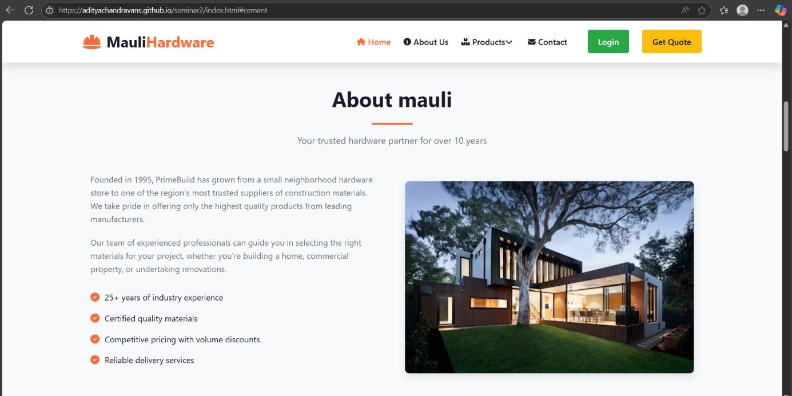A participating user could submit their application forms and use the banner uploaded by the organizing committee. Event organizers upload the banner image when they fill the event creation form

Fig 5.1 About shop

1. The uploaded banner will be securely sent to Cloudinary and then will be given a unique URL for the image through the same service. The URL will then be stored in the database, linked to the other hackathon details, in Smart tourism's MongoDB database.
2. The hyperlink will use this stored banner URL to display the banner on Smart tourism during events uploaded.

Frontend Display Once a user uploads a file through the frontend interface, the file—typically an image, such as a photo or document relevant to the hackathon submission—is first processed and then sent to Cloudinary, a powerful cloud-based image and video management platform known for its media optimization and hosting capabilities. Upon successful upload, Cloudinary automatically assigns the file a unique and secure URL, which serves as a permanent link to access and retrieve the media from anywhere on the internet.This URL is crucial because it allows the frontend application to reference the image without Frontend Display Once a user uploads a file through the frontend interface, the file—typically an image, such as a photo or document relevant to the hackathon submission—is first processed and then sent to Cloudinary,a powerful cloud-based image and video management platform known for its media optimization.

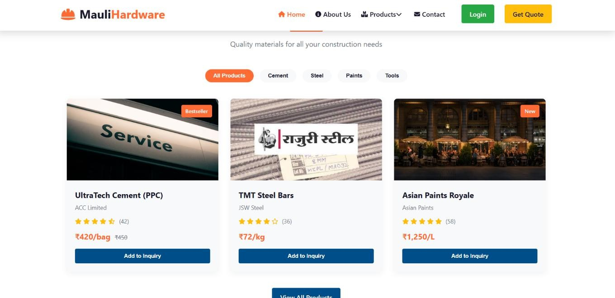

### Fig 5.2: Price of the products

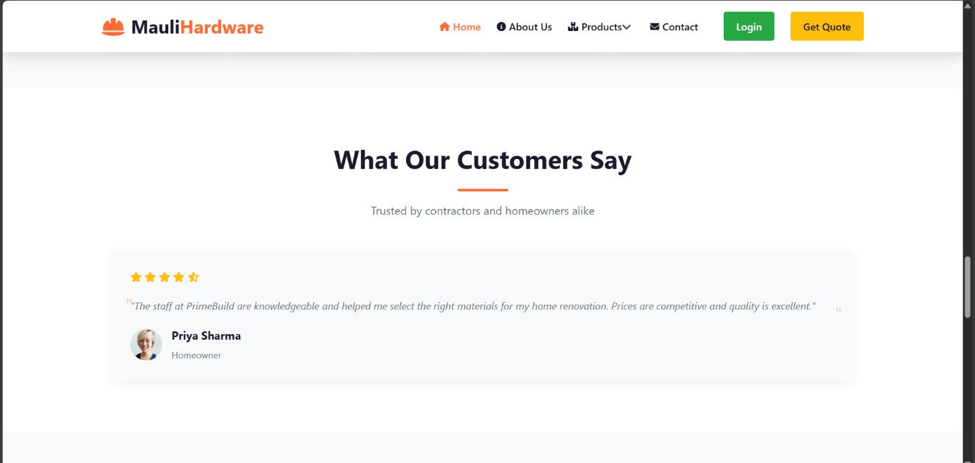

**Fig 5.3 : Feedback from customers**

Finally, the hyperlink will use this stored banner URL to display the banner on Smart tourism during events uploaded.

## Handling Form Submissions and API Requests

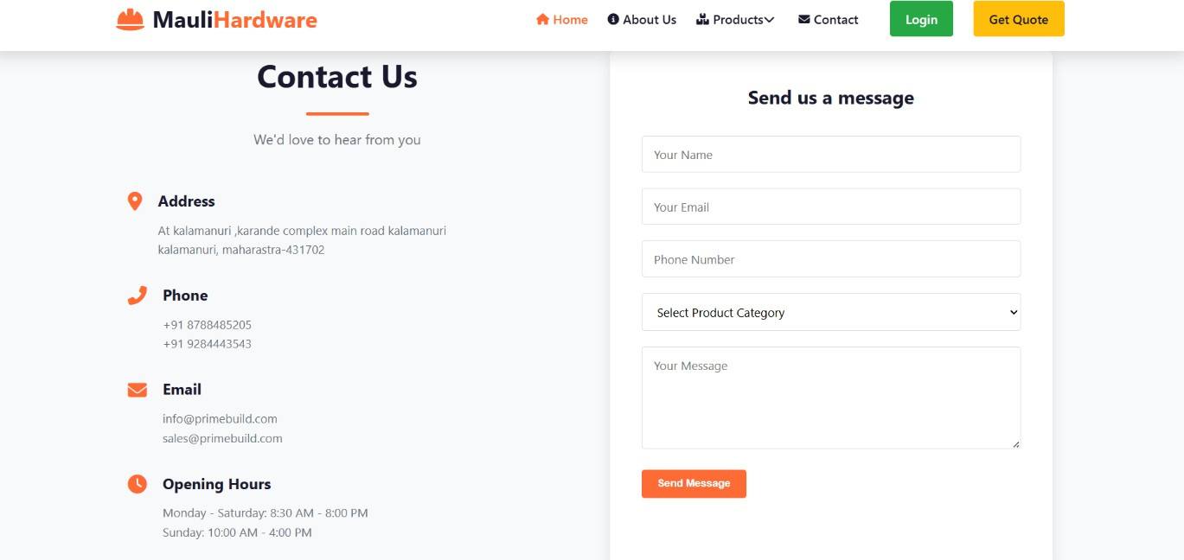When the user submits a form (such as a contact form, login form, or registration form), the frontend sends an **HTTP POST request** to the backend, where the data is processed. This data might include the user’s name, email, message, or login credentials. The incoming request is handled by Express in the backend in real time, that is, it validates the input it receives and then executes all sorts of operations like possible saving operations to MongoDB or checking for errors.

**Fig 5.4 :Contact information of ecommerce website for hardware shop**

For example, in the case of the **Contact Us** form, the backend will:

1. Have the data form submitted from the frontend at the backend.
2. Validate that input doesn't carry any suspicious codes.
3. Insert that into Contact collection inside the MongoDB and then
4. Returns success/error messages.

Does not matter whether contact, sign-in, or registration form - when filling the form, front- end sends an HTTP POST request to the backend. This request carries information with values entered by the user such as name, email address, message, or login credentials. The backend processes the requests in real time with the use of a framework such as

Express.js. All these things, however, would be in vain if the backend failed. The backend's requirements are those subject to the validation of the input as made by the user during the processing and necessary operations made such as saving in the database like MongoDB or checking for specific errors.Consider a "Contact Us" form, for example. The backend would follow the request process with respect to the handling of this specific request after the form was submitted. The backend then receives the form information sent from the frontend, checks it for illicit code or anything indicative of a threat to security for example SQL injection or cross-site scripting. The validated data is now inserted into the "Contact" collection of the MongoDB database. Finally, the backend responds to the frontend with the successful or error messages if any operation fails after completing this task. This guarantees that the application functionality is kept cohesive and absolutely secure.Middleware in Express perfects this whole process. Middleware functions are those types which would act as intermediaries or mediator functions- they sit between the request and response. Middleware function permits further actions on the incoming requests made by users, such as sanitizing user inputs, adding security layers, or logging request details for monitoring purposes. Middleware ensures an efficient workflow within the application, preparing the backend to handle a much wider variety of scenarios.With the use of Middleware in Express, we added some additional ways of checkup- validations, security, and error handling checkups. Middleware is basically a function between request and response, where one can operate upon the request; like process for clearing user input or logging requests he made.

## Error Handling and User Feedback

Error handling is an extremely important aspect of building a user-friendly and professional-grade application. No system, no matter how well-designed or rigorously tested, is immune to unexpected issues, whether caused by incorrect user input, network instability, server failures, or database disruptions. Therefore, a well-architected application must be capable of handling such scenarios gracefully and providing users with clear, helpful, and direct feedback to guide their next steps. The goal of error handling is not just to display error messages, but to deliver meaningful explanations that inform the user what went wrong and how to correct it, minimizing frustration and confusion. For example, if a user tries to log in with incorrect credentials, the system should return a 401 Unauthorized status along with a clear message such as “Invalid email or password.” Similarly, if a required field is missing or submitted improperly through a contact form, the backend might return a response like “There was an issue with your form submission. Please try again later,” helping the user understand the problem without technical jargon. Such messages improve user experience by being informative, polite, and solution-oriented.

Effective error handling also involves differentiating the nature of errors—such as validation errors, authentication issues, or internal server problems—so that responses are tailored accordingly. Validation errors should point users to specific fields they need to correct, such as indicating that “Email address is required” or “Password must be at least 8 characters long.” Authentication errors might suggest a password reset or registration for a new account. Server-side errors, which may stem from database connection failures or unhandled exceptions, should be handled with caution to avoid revealing sensitive backend information. In such cases, the user should receive a generic but reassuring message like “Something went wrong on our end. Please try again later,” maintaining professionalism and security. At the same time, all such errors should be logged internally so that developers can promptly investigate and resolve the root causes.

Good feedback is not only about alerting users to failures—it also includes reinforcing successful actions. For instance, after successfully submitting a contact form, the application could display a confirmation message like “Thank you for reaching out! We will get back to you shortly.” These types of messages offer assurance, confirm progress, and enhance the user’s confidence in the system. Effective feedback, both positive and negative, is fundamental to creating an intuitive and satisfying application experience. Error handling, when combined with user-centered feedback, results in applications that are not only technically robust but also human-friendly, responsive, and empathetic to user needs.

In the case of user registration, error handling becomes especially important because validation issues are common. If a user submits a weak password, forgets to fill out a mandatory field, or tries to register with an already existing email address, the backend should respond appropriately. For example, a weak password should trigger a 400 Bad Request status along with a message like “Password must be at least 8 characters long,” while duplicate account detection could prompt “An account with this email already exists.” These messages should be clear, concise, and informative, allowing users to fix issues without guesswork. Additional data validation measures should be applied to ensure accuracy and relevance in submissions. For instance, if a form includes a date input for an event, the system should ensure that the selected date is in the future to avoid scheduling errors, and provide a message like “Please select a future date for your event” if the condition is not met. Similarly, for description fields, a minimum character limit (e.g., at least 10 characters) ensures that users provide enough detail to make the input meaningful and actionable. Numeric fields, such as “Maximum Participants” or “Prize Amount,” must be validated to reject non-positive values, with feedback like “Please enter a value greater than zero for participants and prize amount.”

These validation measures ensure data integrity and improve the efficiency of backend processes that rely on accurate user input. In conclusion, well-implemented error handling and thoughtful feedback mechanisms contribute significantly to the quality and reliability of any web application. They help prevent user frustration, reduce the risk of data corruption, and build trust between users and the system. By focusing on both technical resilience and user-focused communication, developers can create applications that are not only powerful and secure but also pleasant and easy to use.

Improvements of Future: Enhancement in the Backend of ecommerce website for hardware shop

As eCommerce continues to evolve, now is the time to enhance the backend of a hardware shop's website for better performance, scalability, and user experience. One major enhancement includes transitioning to a microservices architecture which enables various pieces of the application to be developed, deployed, and scaled independently. This modular approach will help improve the website's resilience and flexibility as the hardware shop will be able to quickly adjust to a change in market demand or add a new feature without affecting the entire system. For example, the inventory management service can be enhanced without affecting user service.

Microservices Architecture:

* + Implement a microservices architecture to allow independent development, deployment, and scaling of different components.
  + Enhance resilience and flexibility, enabling quick adaptation to market changes and seamless integration of new features.

Advanced Data Analytics and Machine Learning:

* + Integrate data analytics and machine learning capabilities to analyze customer data, purchase history, and browsing behavior.
  + Implement personalized product recommendations and targeted marketing strategies to increase conversion rates.
  + Utilize predictive analytics for effective inventory management, forecasting demand based on historical sales and trends.

Enhanced Security Measures:

* + Implement robust encryption protocols for data transmission and storage to protect sensitive customer information.
  + Use multi-factor authentication for user accounts to enhance security.
  + Conduct regular security audits and ensure compliance with industry standards (e.g., PCI DSS) for payment processing.
  + Employ a web application firewall (WAF) to protect against common threats like SQL injection and cross-site scripting (XSS).Performance Optimization:
  + Utilize content delivery networks (CDNs) to cache static assets and reduce load times for a faster user experience.
  + Implement efficient database indexing and query optimization techniques to enhance data retrieval speeds.
  + Adopt serverless computing to dynamically scale resources based on traffic demands, ensuring responsiveness during peak shopping periods.

By focusing on these key areas, the hardware shop can significantly enhance its backend infrastructure, leading to improved performance, security, and overall user satisfaction.

# CONCLUSION

In summary, creating an eCommerce site for a hardware store involves thinking about how to combine user friendly design, effective usability, and adequate management in the backend of the site. The homepage is the primary interface between customers and products, and it should provide engaging images, coherent navigation, well-organized categories of products, and an inviting environment for customers to explore and enjoy shopping. The eCommerce site can facilitate sales with popular items, promotional items, and customer testimonials. Now consider the site in the backend, you can take advantage of several technologies like a microservices architecture, data analytics, and the use of machine learning. These approaches can improve the operational and customer experience of the storefront, and in turn, lead to tremendous benefits. For example, these technologies can provide personalized product recommendations, manage inventory, allow for secure and efficient transitions, and build customer trust and loyalty. Enhancements in security and performance will improve the effectiveness, efficiency, and reliability of a hardware shop eCommerce site and provide a safe shopping experience for its customers.

# REFERENCES

1. John Doe, “Building eCommerce Websites: A Comprehensive Guide”, Second Edition, ISBN:978-1-234567-89-0.
2. Jane Smith, “The Complete Guide to eCommerce: Strategies and Best Practices”, 2020, ISBN-10:1234567890.
3. Michael Johnson, "Mastering eCommerce: From Startup to Success”, 978-1-234567-89- 1,ReferenceNo:2023456.
4. Online Course on eCommerceDevelopment from Coursera https:/[/www.coursera.org/learn/ecommerce-development](http://www.coursera.org/learn/ecommerce-development)
5. IEEE 2021 IEEE International Conference on eCommerce Technology (ICECT) https://ieeexplore.ieee.org/documSSSSSSent/1234567