**Cyber Security**

**Assignment Day 4**

**Question 1:**

Find out the mail servers of the following domain:

* Ibm.com
* Wipro.com

Open PenTester

Open Command Prompt

Type:

ipconfig

nslookup

www.Ibm.com

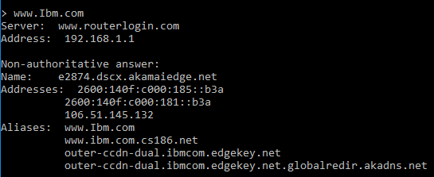

www.Wipro.com. Here wipro is having more than one ip address

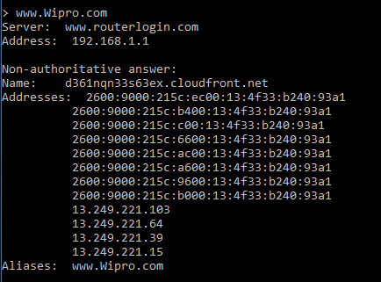

**Question 2:**

Find the locations, where these email servers are hosted.

Cont. of Question 1

Type:

set type=mx

Ibm.com

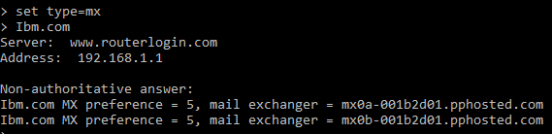

Open browser (chrome)

Open IP Location Finder

Copy paste the url

Find location

**Address 1:**

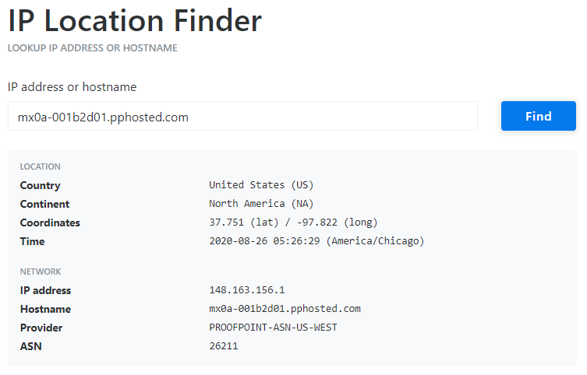

**Address 2:**

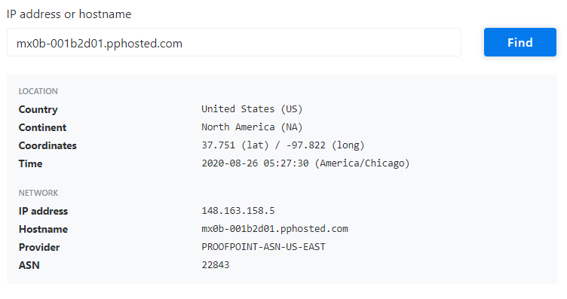

Wipro.com

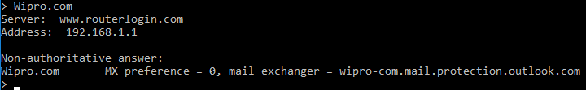

Open google chrome

Open IP Location Finder

Copy paste the URL

Find location

**Address:**

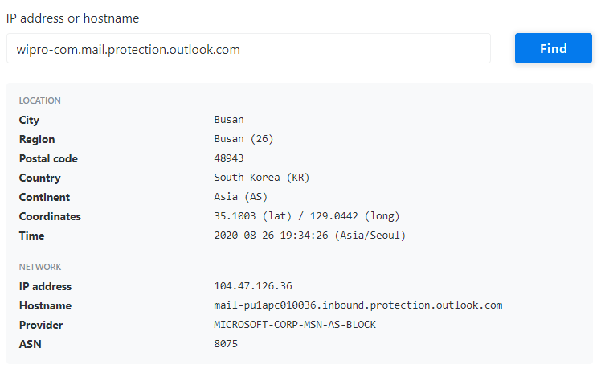

**Question 3:**

Scan and find out port numbers open 203.163.246.23

Open Kali-pc

click on the screen(Right Click) and now open the terminal

Type:

sudo su –

Enter password

Enter – nmap –Pn –sS 203.163.246.23

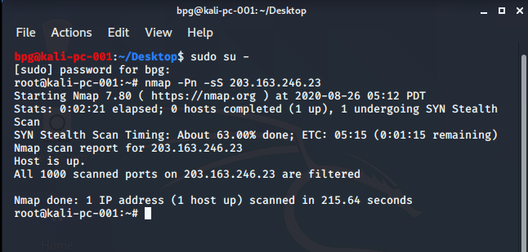

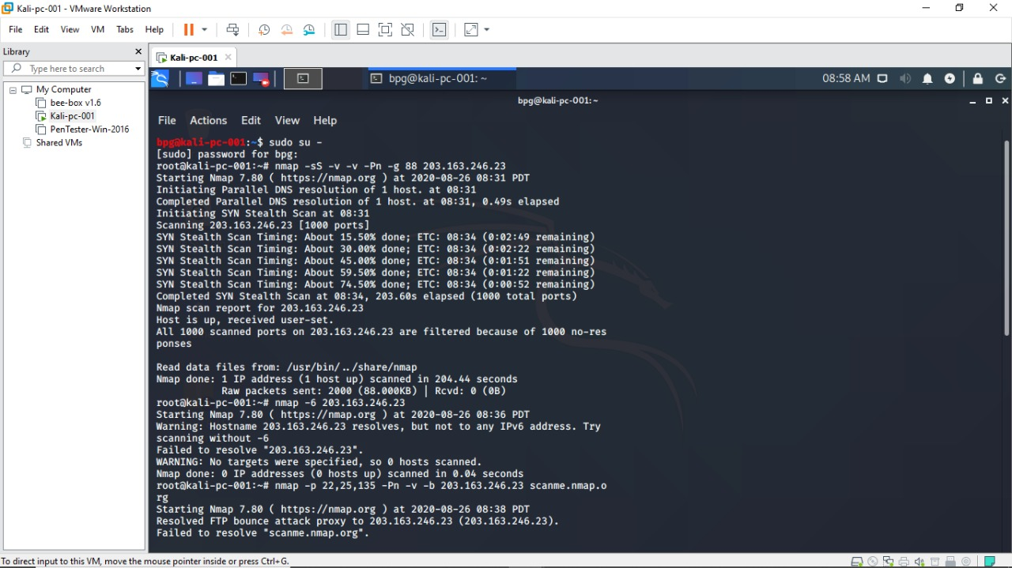

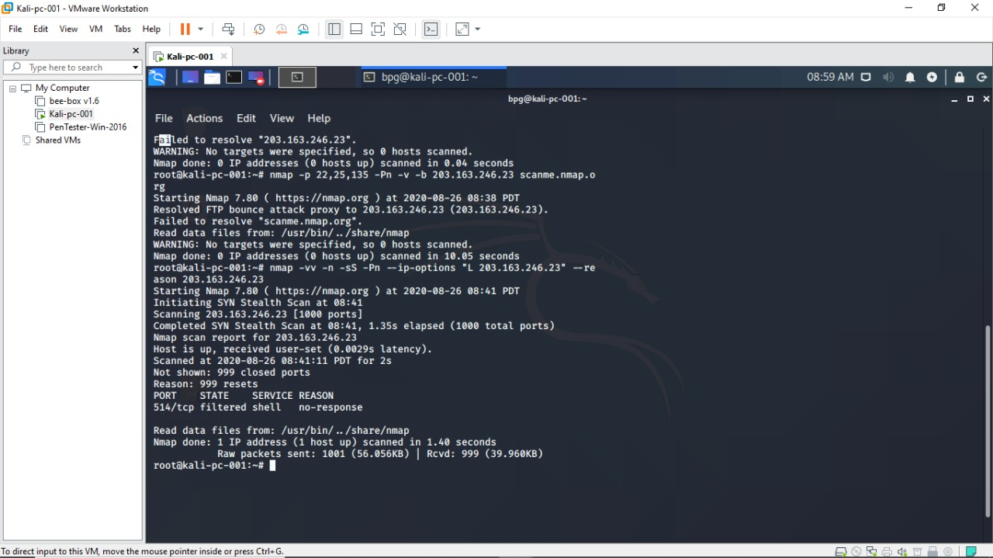

**Question 4:**

Install nessus in a VM and scan your laptop/desktop for CVE

Open PenTester

Install Google Chrome

Install Nessus

Click on All scans Create a new scan Advance settings Windows Fill the required blanks in credentials as well Launch

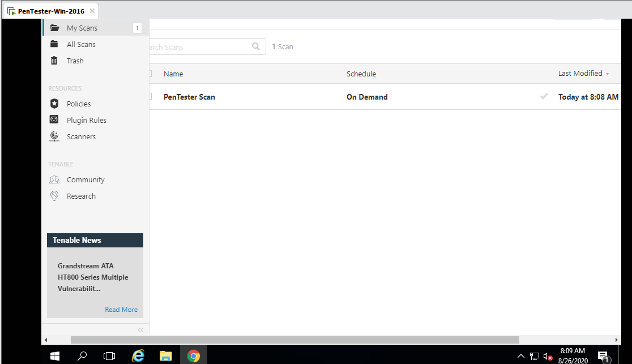

Report:

