Project Wafa — Architecture Design Document
A Customer Retention Intelligence Platform for Falcon Bank UAE
MAIB AI 115 · NLP and Models · Final Group Project — Deliverable 1 · July 2026
Rakshanda Dhote · Krishn Patel · Atharva Soundekar · Sarth Malankar · Aditya Chitale · Advait Dalvi · Darshit · Anurag Devarkonda · Karan Baid

1. Design philosophy
The platform follows the course’s spine: learned models for fuzzy language, transparent rules where money and trust are decided, and a human in the loop where stakes are high. Text and behaviour are fused because either alone misleads: a customer can look healthy on paper while telling us they are leaving (our smoke tests surfaced exactly this case — behaviour score 0.8%, message: “I have already resigned and am moving back home”). We chose a multilingual-native pipeline with no translation step: Hindi arrives romanized (“mera card decline ho gaya”), which breaks off-the-shelf hi→en translators and language detectors; training directly on the four languages side-steps that failure mode and handles code-switched text for free.

2. End-to-end flow
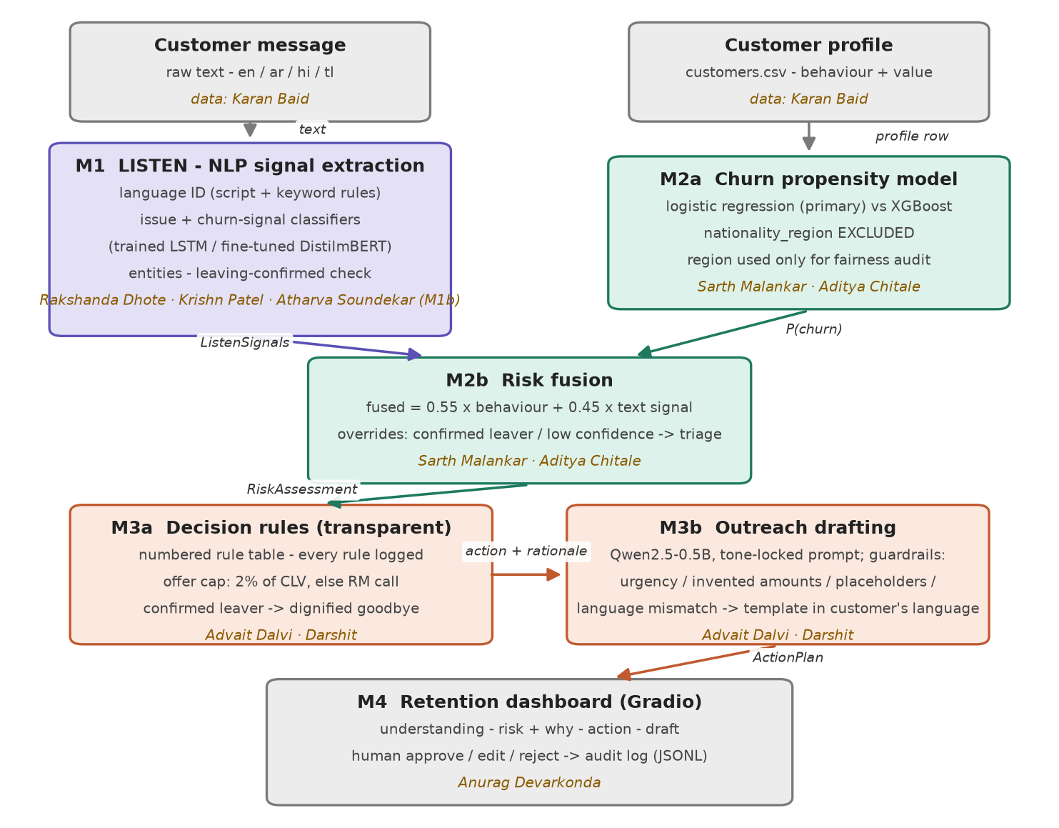

3. Modules and ownership
Module | Key files | Owner
M1 Listen — language ID, LSTM classifiers, entities | wafa/m1_listen.py; training/train_lstm_classifier.py | Rakshanda Dhote, Krishn Patel
M1b Fine-tuned transformer + model bake-off | training/finetune_distilmbert_colab.py; training/evaluate_models.py | Atharva Soundekar
M2 Understand — churn model, fusion, fairness audit | wafa/m2_understand.py; training/train_churn_model.py | Sarth Malankar, Aditya Chitale
M3 Act — decision rules, LLM drafting, guardrails | wafa/m3_act.py; training/check_outreach_quality.py | Advait Dalvi, Darshit
M4 Dashboard + audit log | app.py; wafa/audit.py | Anurag Devarkonda
Data & evaluation — generator extension, unseen-template tests | data/generate_wafa_data.py; training/make_unseen_testset.py | Karan Baid
Nine members across six modules: the heavy modules (M1, M2, M3) are pair-owned; every member owns at least one module, and the same owners appear on the flow diagram above.

4. Interface contracts
Every arrow in the flow diagram carries exactly one of the dictionaries below (defined with mock factories in wafa/contracts.py). Each module is developed and tested against these mocks, so no member is ever blocked by another’s unfinished code.

M1 → M2: ListenSignals
Field | Type / values | Meaning
message_id / customer_id | str | message ref; customer_id joins to profile
text | str | the raw message
language | en | ar | hi | tl | detected language + language_confidence (0–1)
issue_type | 7-class str | issue class + issue_confidence (0–1)
churn_signal | High | Medium | Low | text churn intent + churn_signal_confidence
leaving_confirmed | bool | explicit relocation statement detected
entities | dict | amounts_aed, dates, destinations, products
classifier | lstm | finetuned | heuristic | which model produced the prediction

M2 → M3: RiskAssessment
Field | Type / values | Meaning
behaviour_score | float 0–1 | churn probability from the tabular model
text_score | float 0–1 | churn signal mapped High=0.9 / Med=0.55 / Low=0.15
fused_risk / risk_band | float / str | 0.55·behaviour + 0.45·text; Critical≥.75, High≥.55, Med≥.35
reasons | list[str] | plain-English drivers, most important first
needs_human_triage | bool | true when classifier confidence < 0.5
segment / clv_estimate_aed | str / float | customer value context; CLV caps offer spend
profile_found | bool | false → neutral behaviour prior, text carries the call

M3 → M4: ActionPlan
Field | Type / values | Meaning
action / action_label | str | action code + human-readable name
rationale | list[str] | every fired rule, line by line (auditable)
offer_value_aed | float | 0 when no monetary offer; offer_within_budget flag
draft_message | str | outreach text awaiting human review
draft_language / draft_source | str | language of draft; llm or template
guardrail_flags | list[str] | non-empty when the LLM draft violated a check
prompt_used | str | null | the exact LLM prompt (shown in dashboard, ethics)

5. Model selection and justification
Task | Choice | Why (quality · size · languages · hardware)
Issue + churn-signal classifier (trained #1) | Bidirectional LSTM, Keras, from scratch | Multilingual-native incl. romanized Hindi; the exact architecture family built in the course; <2 MB, trains in ~1 min on CPU
Issue + churn-signal classifier (trained #2) | DistilmBERT fine-tune | 104 languages incl. Arabic and Tagalog; ~2 min on free Colab T4 (also CPU-feasible); bake-off vs the LSTM decides which serves the app
Language identification | Rule-based (script range + keyword scoring) | Romanized Hindi defeats off-the-shelf detectors; rules are transparent and testable; fasttext-lid is the upgrade path
Entity extraction | Regex + gazetteers | Transparent and reliable at 252-message scale; spaCy NER optional for English
Churn propensity | Logistic regression (primary), XGBoost benchmarked | Coefficients give the per-customer ‘why’ shown on the dashboard; nationality_region excluded by design (fairness)
Outreach generation | Qwen2.5-0.5B-Instruct | Brief’s own guidance: best small-model Arabic; runs on laptop CPU; tone-locked prompt + guardrails; curated-template fallback means the demo never depends on it
Two models are trained by the team (LSTM from scratch, DistilmBERT fine-tuned), exceeding the one-trained-model minimum. The bake-off (training/evaluate_models.py) compares both against a zero-shot Qwen classifier on the same held-out split and on an unseen-template test set, because the provided messages are template-generated and random-split scores are upper bounds. Results and per-language quality go in the business report, honestly, whichever model wins.

6. Feasibility budget — proof it runs free
Component | Size | Runs on | Time | Fallback
BiLSTM classifier | < 2 MB | laptop CPU | train ~1 min; infer < 0.1 s | keyword heuristic (built in)
DistilmBERT fine-tune | ~540 MB | train: free Colab T4; infer: laptop CPU | train ~2 min (T4); infer ~0.2 s | LSTM remains the serving model
Churn model (sklearn) | < 1 MB | laptop CPU | train in seconds | —
Qwen2.5-0.5B-Instruct | ~1 GB cached | laptop CPU | 30–60 s per draft | curated templates (WAFA_USE_LLM=0)
Gradio dashboard | — | laptop, localhost | instant | screen-recording backup
Total disk footprint ≈ 2 GB, total cost AED 0. No paid API is required at any point; every component has a fallback that keeps the live demo running offline once models are cached.

7. Risks and fallbacks
- Live-demo failure (wifi, re-download, timeout): all models pre-cached locally; WAFA_USE_LLM=0 gives an instant template-only mode; a 2-minute screen recording is the break-glass backup.
- Template leakage: near-perfect random-split metrics are reported as upper bounds; the honest evaluation runs on generator-extended unseen phrasings.
- LLM hallucination and language failure: guardrails catch urgency language, invented amounts, unfilled placeholders and drafts in the wrong language (all observed in testing — see models/outreach_language_check*.json) and fall back to curated templates in the customer's language; no draft reaches a customer without human approval.
- Fairness: nationality_region is never a model feature; it is used solely to audit that predicted risk does not skew by region (audit passing; see models/churn_eval.json).
- Draft quality at 0.5B: acceptable but plain; if demo hardware allows, Qwen2.5-1.5B is a drop-in upgrade — the bake-off template covers this comparison.

