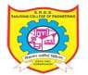 | Sanjivani Rural Educational Society’s SANJIVANI COLLEGE OF ENGINEERING  (An Autonomous Institution) Kopargaon – 423 603, Maharashtra. | ACAD-F-15H
Academic Year: 2026- 2027 | CIA Part B- PBL Project Title | IoT
SEM-V | Department: Computer Engineering | Date of Preparation:  21/07/2026
Group ID:
Activity Title: InfraSense - AI-Enhanced Dual Layer Structural Health Monitoring System
Introduction:
The “InfraSense: AI-Enhanced Dual Layer Structural Health Monitoring System” is designed to demonstrate the concepts of embedded systems, sensor integration, edge AI, IoT communication, and cloud-based predictive monitoring in the civil infrastructure sector. In traditional structural inspection, assessment of bridges, buildings, dams and flyovers is performed manually at scheduled intervals, which is slow, costly, and often fails to catch early-stage damage.

This project focuses on developing a dual-layer sensor node that measures critical structural health parameters such as vibration, tilt, strain/crack growth, corrosion, displacement, temperature and moisture using integrated sensors. The collected data is processed at the edge using a lightweight TinyML anomaly-detection model running directly on the ESP32, transmitted to the cloud via Wi-Fi, and displayed through a live Digital Twin web dashboard for real-time monitoring, trend forecasting and analysis.

The system provides a practical understanding of how IoT-based smart sensing combined with edge AI improves structural health monitoring, enables predictive maintenance instead of reactive alarms, reduces false alerts, and supports safer, data-driven decision-making for infrastructure management.

Existing System:
In traditional structural inspection practices, structural health assessment is mainly done through:

- Manual visual inspection by engineers
- Scheduled periodic inspection (annual/bi-annual)
- Basic threshold-based sensor alarms without predictive capability
- Standalone sensors without visual or trend-based confirmation

Maintenance teams often rely on delayed manual inspection or simple fixed-threshold sensor alarms, which may not detect gradually developing damage or distinguish genuine structural risk from noise/false triggers.

Limitations of the Existing Approach:
- No real-time, continuous structural monitoring
- Manual inspection is slow, costly and infrequent
- Basic threshold alarms trigger only after damage has already occurred
- No predictive/forecasting capability to plan maintenance in advance
- High false-alarm rate reduces trust in automated systems
- No unified visual representation of overall structural health
- Poor traceability and historical trend analysis

Traditional and basic sensor-threshold methods are not suitable for modern infrastructure that requires real-time monitoring, predictive maintenance, and reliable, low-false-alarm automated alerts.

Proposed System:
The proposed InfraSense system uses a dual-layer sensor network combined with Edge AI and a Digital Twin dashboard to monitor and predict structural health in real time.

It demonstrates:

- Multi-parameter sensing (Vibration, Tilt, Strain/Crack, Corrosion, Displacement, Temperature, Moisture)
- Embedded system data processing using ESP32 / Arduino Nano
- TinyML-based edge anomaly detection (Edge Impulse) replacing simple fixed thresholds
- Predictive trend forecasting to estimate time-to-critical-threshold
- Cloud database storage (Firebase/ThingSpeak)
- Real-time Digital Twin dashboard visualization
- Alert generation for abnormal and predicted-abnormal conditions

The system ensures reliable monitoring by processing sensor data at the edge using a trained anomaly-detection model, validating readings against learned normal behaviour instead of fixed thresholds, and securely transmitting structured data to the cloud for storage, trend analysis and Digital Twin visualization.

Objectives:
The main objectives of this project are:

- To understand IoT and Edge AI applications in civil infrastructure monitoring
- To integrate multiple structural sensors with a microcontroller
- To implement a TinyML anomaly-detection model for smarter fault detection
- To develop a cloud-based Digital Twin monitoring dashboard
- To ensure accurate and stable sensor readings through calibration
- To enable predictive maintenance through trend-based forecasting

Scope:
The scope of this project includes:

- Educational demonstration of IoT, embedded systems and Edge AI applications
- Real-time structural health monitoring on a scaled model structure
- Edge-based anomaly detection reducing dependence on fixed thresholds
- Cloud-based data storage, trend analysis and Digital Twin visualization
- Alert-based monitoring system with predictive forecasting
- Support for scalable deployment from a single structure to multiple structures across a smart city network

This project focuses on technical demonstration on a small-scale model and can be extended for real-world bridge, building and dam monitoring applications.

Importance of Project:
IoT and Edge-AI-based structural monitoring is becoming essential in modern civil infrastructure and smart city industries. Many real-world sectors such as bridge management, building safety, disaster risk reduction, and smart city infrastructure rely on sensor-based monitoring and predictive analytics.

This project is important because:

- It builds strong knowledge in IoT, embedded systems, Edge AI and cloud computing
- It improves understanding of multi-sensor integration and real-time data acquisition
- It enhances practical skills in TinyML model deployment and dashboard development
- It supports smart infrastructure monitoring and public safety systems
- It prepares students for careers in IoT, civil-tech, Edge AI and smart city automation

Expected Input:
The system accepts inputs from integrated sensors and configuration parameters. Sensor Inputs:
- Vibration sensor readings (MPU6050)
- Tilt sensor angle output
- Strain gauge / crack sensor analog signal
- Corrosion sensor electrochemical output
- Ultrasonic displacement sensor data
- Temperature and moisture sensor readings
User-defined Inputs:
- Device ID
- Wi-Fi credentials
- Cloud platform / dashboard details
- Calibration constants
- Threshold and anomaly-sensitivity limits for alerts

These inputs allow the system to collect raw data, preprocess signals, apply calibration formulas, run the TinyML anomaly check, and generate structured data for cloud transmission.

Expected Output:
The system provides the following outputs:

- Real-time display of structural health parameters on LCD/OLED screen
- Cloud-stored sensor readings in database
- Digital Twin web dashboard with live, color-coded structural visualization
- Historical trend graphs (minimum 30 days)
- Structural health grade (Safe / Warning / Critical classification)
- Predictive alert notifications forecasting time-to-critical-threshold
- Performance indicators such as anomaly-detection accuracy and system response time

The dashboard shows a graphical representation of vibration trends, tilt variation, corrosion levels and other structural indicators, overlaid on a simple Digital Twin model of the structure. The system also displays messages related to sensor initialization, data transmission status, cloud connection, and alert generation.

These outputs help users understand structural health conditions, ensure safety standards, and demonstrate how IoT combined with Edge AI improves monitoring efficiency and predictive maintenance.

Step-by-Step Block Diagram:
The working of InfraSense follows six sequential steps, from raw sensor data collection to predictive alerting, as shown below:

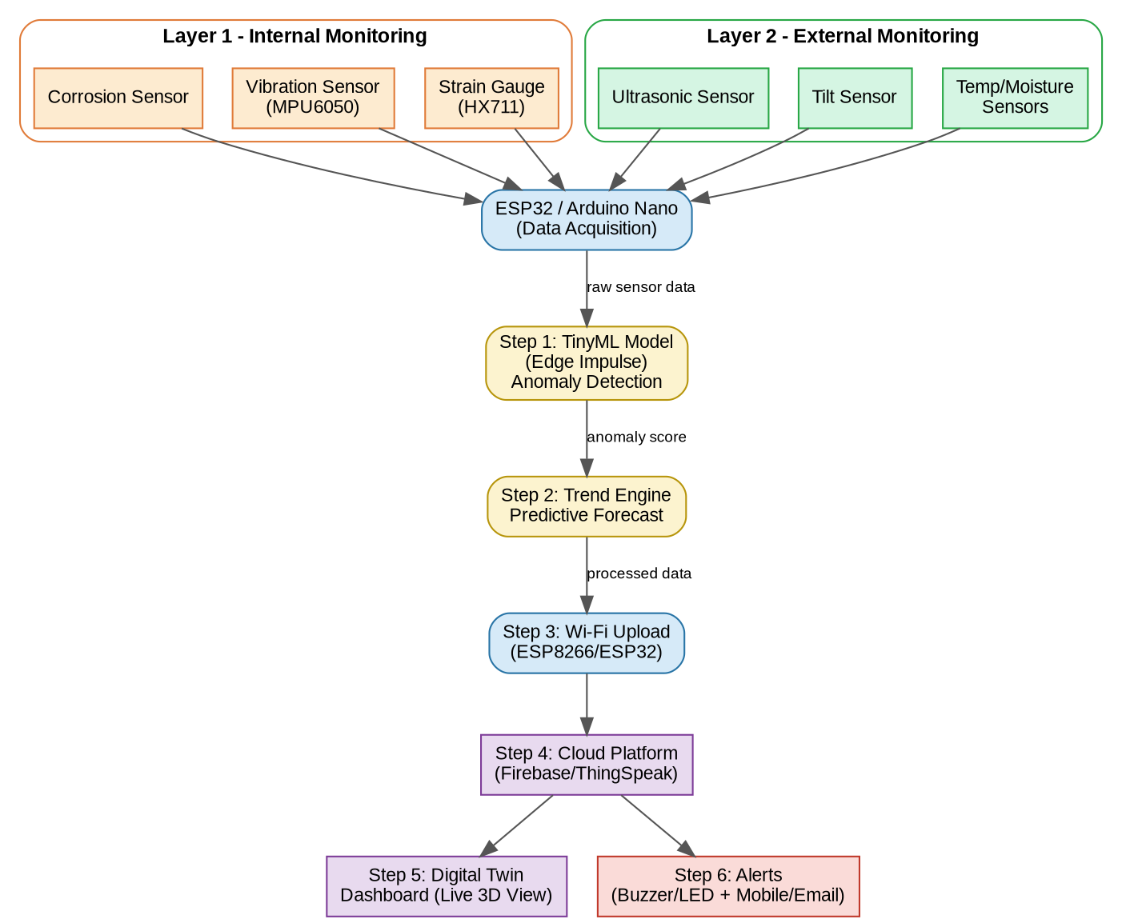

Step 1 - Sensors (Layer 1: corrosion, vibration, strain; Layer 2: ultrasonic, tilt, temperature/moisture) continuously collect raw structural data.
Step 2 - ESP32/Arduino Nano acquires and pre-processes this sensor data.
Step 3 - A TinyML model running on the edge device checks the data against learned normal behaviour and produces an anomaly score, replacing simple fixed thresholds.
Step 4 - A trend-forecasting engine estimates how many days remain before a monitored value is likely to cross a critical threshold.
Step 5 - Processed data is transmitted over Wi-Fi to a cloud platform (Firebase/ThingSpeak) for storage.
Step 6 - The cloud drives a live Digital Twin dashboard showing color-coded structural health, plus buzzer/LED and mobile/email alerts when needed.

Roll no | PRN | NAME | SIGN
62 | 0124UCSM1062 | Dabhade Aditya Ramesh
64 | 0124UCSM1064 | Sambare Rohit Nanasaheb
158 | 0125UCSF2007 | Borale Samiksha Ravindra

Course Teacher
Prof. N. Y. Siddiqui

