INTERNET OF THINGS (MDCO321)
IoT Project Report
ON
“IoT-Based Dual-Layer Structural Health Monitoring System”
Internet of Things (IoT) – Group ID: 6
Submitted By
Dabhade Aditya Ramesh | 0124UCSM1062
Sambare Rohit Nanasaheb | 0124UCSM1064
Borale Samiksha Ravindra | 0125UCSF2007
(T.Y. BTech Computer Engineering)

SAVITRIBAI PHULE PUNE UNIVERSITY
In the academic year 2026-27
Department of Computer Engineering
Sanjivani Rural Education Society’s
Sanjivani College of Engineering
Kopargaon - 423603.

(AN AUTONOMOUS INSTITUTE)
DEPARTMENT OF COMPUTER ENGINEERING
CERTIFICATE
THIS IS TO CERTIFY THAT THE PROJECT ENTITLED
“IoT-Based Dual-Layer Structural Health Monitoring System”
Submitted By
Dabhade Aditya Ramesh | 0124UCSM1062
Sambare Rohit Nanasaheb | 0124UCSM1064
Borale Samiksha Ravindra | 0124UCSF2007
(T.Y. BTech Computer Engineering)
IS A BONAFIDE WORK CARRIED OUT BY STUDENTS UNDER THE SUPERVISION OF PROFESSOR N. Y. SIDDIQUI AND IT IS SUBMITTED TOWARDS THE PARTIAL FULFILLMENT OF THE REQUIREMENT OF INTERNET OF THINGS (IOT) – PROJECT BASED LEARNING OF T.Y. BACHELOR OF TECHNOLOGY (COMPUTER ENGINEERING) DURING THE ACADEMIC YEAR 2026-27.
Prof. N. Y. Siddiqui
[PROJECT GUIDE]
DR. M. A. JAWALE  HOD | DR. R. A. KAPGATE  DIRECTOR

Table of Contents
Sr. No. | Content | Page No.
01 | Introduction | 4
02 | Literature Survey | 5
03 | Objective | 6
04 | Hardware Requirements | 7
05 | Data Tools / Software Tools | 7
06 | Methodology | 8
07 | Testing and Performance Evaluation | 12
08 | Implementation Details | 14
09 | Outcomes | 15
10 | Program Summary | 16
11 | Conclusion and Future Work | 17
12 | References | 17
Sustainable Development Goals (SDGs)
SDG 9 – Industry, Innovation and Infrastructure: Uses IoT sensors, ESP32 and cloud monitoring to develop an innovative system for observing the condition of bridge infrastructure.
SDG 11 – Sustainable Cities and Communities: Supports early detection of abnormal structural conditions, which can help keep bridges and other civil structures safer for the community.
SDG 12 – Responsible Consumption and Production: Supports condition-based maintenance, so that inspection and repair effort can be directed where it is needed. No measurable impact is claimed.

1. Introduction

Abstract / Problem Description
INFRA SENSE is an Internet of Things (IoT) based dual-layer Structural Health Monitoring (SHM) system developed on a laboratory-scale bridge prototype. Bridges are exposed to loads, vibrations, moisture, temperature changes and corrosion throughout their service life, and these factors can gradually cause cracks, tilt and deformation. Conventional inspection is periodic and depends largely on manual observation, so changes that develop between two inspections can remain unnoticed. The proposed system aims to provide a low-cost and integrated solution that continuously observes structural and environmental conditions and reports them in real time.
The system uses an ESP32 as the central controller. It is interfaced with structural sensors (a 5 kg load cell with an HX711 module, an SW-420 vibration sensor, an ADXL345 tilt sensor and a flex/crack sensor) and with environmental/material sensors (a soil moisture sensor, corrosion electrodes, a DS18B20 temperature sensor and a DHT11 temperature-humidity sensor). A character LCD, green/yellow/red LEDs and an active buzzer give local status indication. The ESP32 can read the sensors and share the data over Wi-Fi, which enables continuous monitoring [5], [6].
The architecture has two layers. Layer 1, the physical/sensing layer, collects and processes the data on site. Layer 2, the cloud/software layer, receives the processed data through 2.4 GHz Wi-Fi on a ThingSpeak or Blynk platform, where it is shown as numerical values, graphs and historical records and where threshold-based alerts are raised. The data flow therefore has five stages: the sensors measure, the ESP32 acquires and processes, Wi-Fi transmits, the cloud platform stores and displays, and the alerts are generated.
INFRA SENSE assists routine structural observation by reducing continuous manual inspection. It supports, but does not replace, the judgement of a qualified engineer. The project is a student prototype; its alert thresholds are experimental, it does not represent the load capacity of an actual bridge, and no real-world safety claim is made.

Problem Statement
Bridges are continuously exposed to loads, vibrations, environmental conditions and structural stresses that may gradually cause cracks, corrosion, excessive vibration, tilt and deformation. Traditional inspection methods are periodic and largely dependent on manual observation, making it difficult to identify structural abnormalities that develop between inspections.
The following needs are identified:
- Structural conditions need regular observation.
- Abnormal changes may go unnoticed between periodic manual inspections.
- Several parameters (load, vibration, tilt, cracks, moisture, temperature, corrosion) have to be observed together.
- Inspection requires time, effort and resources, and may require physical presence.
- A timely warning is needed when an abnormal condition appears.
A continuous and reliable monitoring system is therefore required to detect abnormal structural changes at an early stage. INFRA SENSE targets this problem at prototype scale with multi-sensor monitoring, local alerts and a cloud dashboard.

Research Gap
Existing research uses wireless sensor networks and multiple sensors for bridge monitoring [1], [2], and advanced systems use deep learning, anomaly detection and Digital Twin technologies [3], [4]. Many of these advanced approaches can involve higher system complexity and implementation requirements. INFRA SENSE targets a low-cost, practical multi-sensor IoT prototype that integrates structural monitoring, environmental monitoring and wireless cloud monitoring in one ESP32-based system, with AI-based analysis kept as future scope.

Key Features
- Integrated monitoring of structural parameters (load, vibration, tilt, crack/bending) and environmental/material parameters (moisture, corrosion-related change, temperature, humidity) in one ESP32-based system.
- Dual-layer architecture: a physical sensing layer and a cloud/software layer.
- Local status indication with an LCD, green/yellow/red LEDs (SAFE, CAUTION, DANGER) and an active buzzer.
- Real-time cloud dashboard (ThingSpeak/Blynk) with values, graphs and historical data.
- Threshold-based early warning through the buzzer and the monitoring platform.
- Student-budget design using widely available boards and sensors.

2. Literature Survey
A literature survey of bridge Structural Health Monitoring was carried out to understand the sensing technologies, communication methods and intelligent analysis used in related work, and to position INFRA SENSE against them. Four recent papers and one foundational paper were studied. They cover wireless sensor networks, a review of SHM methods and applications, deep learning for bridge monitoring, and an edge-cloud Digital Twin architecture. The findings in Table 1 are as reported by the respective authors.
Table 1. Literature survey
Sr. | Paper / study (author, year) | Method / technology and main finding (as reported) | Relevance / limitation
1 | Towards the Structural Health Monitoring of Bridges Using Wireless Sensor Networks: A Systematic Study [1] – O. S. Sonbul and M. Rashid, 2023 | Systematic study of wireless sensor networks for bridge SHM: WSN, sensor deployment, wireless communication and energy constraints. | Supports wireless multi-sensor monitoring with the ESP32. A study-level work, not a ready circuit.
2 | A Review of Methods and Applications in Structural Health Monitoring (SHM) for Bridges [2] – B. Zhang et al., 2025 | Review of sensing technologies, wireless transmission, data preprocessing, damage identification and early warning. | Supports the sensing, wireless transmission and alert parts. A review; no prototype.
3 | The Application of Deep Learning in Bridge Health Monitoring: A Literature Review [3] – G.-Q. Zhang, B. Wang, J. Li and Y.-L. Xu, 2022 | Deep learning for vibration-based and vision-based SHM using CNN, LSTM and Autoencoder models. | Foundation for future AI/TinyML anomaly detection; AI is not implemented in INFRA SENSE.
4 | Edge-Cloud Collaborative Digital Twin Architecture for Bridge Structural Health Monitoring: Multi-Sensor Fusion and Anomaly Detection Algorithm Design [4] – Y. Liu, 2026 | Edge-cloud collaboration, multi-sensor fusion, anomaly detection and Digital Twin. | Guides future multi-sensor fusion and intelligent cloud monitoring; Digital Twin is beyond the present prototype.
5 | An Introduction to Structural Health Monitoring [5] – C. R. Farrar and K. Worden, 2007 | Foundational description of the SHM concept and its role in damage identification. | Basic definition and motivation of SHM used in this project.
6 | ESP32 Series Datasheet [6] – Espressif Systems | Dual-core Wi-Fi / Bluetooth microcontroller; official platform reference. | Hardware basis of INFRA SENSE.

Comparison with Existing Systems
Table 2. Reviewed work vs INFRA SENSE
Parameter | Reviewed work [1]–[4] | INFRA SENSE
Nature of work | Systematic study [1], review [2], literature review [3] and architecture design [4] | Working low-cost laboratory prototype
Communication | Wireless sensor networks and wireless transmission discussed in [1] and [2] | ESP32 with 2.4 GHz Wi-Fi to a ThingSpeak/Blynk platform
Intelligence | Deep learning [3]; anomaly detection and Digital Twin [4] | Threshold-based status; no AI in the present version (future scope)
Complexity | Advanced approaches can involve higher system complexity and implementation requirements | Off-the-shelf sensors and a single ESP32 controller
Early warning | Early warning discussed in [2] | SAFE / CAUTION / DANGER indication with LEDs, buzzer and cloud alert
Parameters | Multi-sensor monitoring in [1], [2] and [4] | Load, vibration, tilt, crack/bending, moisture, corrosion-related change, temperature and humidity

Summary of the Survey
The survey shows that wireless, multi-sensor bridge monitoring is well established and that advanced work moves towards deep learning, anomaly detection and Digital Twin architectures. These advanced approaches can be complex to implement. INFRA SENSE therefore combines structural and environmental sensing, local alerts and wireless cloud monitoring in a simple ESP32-based prototype, and keeps AI-based analysis and Digital Twin integration as future work.

3. Objective
The objectives of this project are:
- To develop a low-cost IoT-based Structural Health Monitoring system using an ESP32.
- To monitor structural parameters (load, vibration, tilt and crack/bending) using multiple sensors.
- To monitor environmental and material conditions (moisture, corrosion-related change, temperature and humidity).
- To identify unusual sensor readings and generate timely warnings through local and cloud-based alerts.
- To transmit the sensor data wirelessly to a cloud dashboard (ThingSpeak/Blynk) for real-time visualization.
- To provide immediate local status indication using an LCD, LEDs and a buzzer.
- To test the individual modules and evaluate the overall system.
The objectives state the intended goals; the outcomes achieved are reported separately in Section 9.

Scope of the Project
- In scope: embedded sensor integration (ESP32 with the load cell, SW-420, ADXL345, flex/crack sensor, soil moisture sensor, corrosion electrodes, DS18B20 and DHT11).
- In scope: data acquisition, validation, filtering/averaging and threshold comparison on the ESP32.
- In scope: Wi-Fi transmission, cloud dashboard visualization and alert indication on a laboratory-scale bridge model.
- Future scope: AI/TinyML-based anomaly detection, Digital Twin integration, multi-sensor fusion, power backup and mobile alerts.
- Out of scope: certified structural measurement; use on real bridges; real-world safety limits; automated structural decisions.

4. Hardware Requirements
INFRA SENSE is a sensor-driven IoT project. Instead of relying on a public dataset, the data are acquired directly from the sensors connected to the ESP32, and the processed values are sent to a cloud platform for display and history. This section lists the inputs of the system and the hardware used; the outputs, data-handling steps and software are given in Section 5.

Key Input Features
- Load cell with HX711: applied load on the deck.
- SW-420 vibration sensor: vibration of the structure.
- ADXL345 accelerometer: tilt and acceleration of the deck.
- Flex / crack sensor: bending, deformation and crack-related change.
- Soil moisture sensor: moisture at the foundation (base).
- Corrosion electrodes: corrosion-related change in a liquid test container.
- DS18B20 and DHT11: temperature and humidity.
Table 3. Hardware Requirements
# | Category | Component / Tool | Purpose / Description
1 | Microcontroller | ESP32 development board [6] | Central controller; reads the sensors, runs the threshold logic, drives the indicators and handles Wi-Fi communication.
2 | Load sensing | 5 kg load cell with HX711 amplifier [9] | Measures the applied load; the HX711 amplifies and digitizes the signal.
3 | Vibration sensing | SW-420 vibration sensor [9] | Detects structural vibration.
4 | Tilt sensing | ADXL345 3-axis accelerometer [9] (MPU6050 can be used as an alternative) | Measures tilt and acceleration of the deck.
5 | Crack / bending sensing | Flex / crack sensor [9] | Detects bending, deformation and abnormal structural changes.
6 | Environmental sensors | Soil moisture sensor, corrosion electrodes, DS18B20, DHT11 [9] | Measure moisture, corrosion-related change, temperature and humidity.
7 | Local indication | Character LCD, green / yellow / red LEDs, active buzzer | Show system status and give a local warning.
8 | Prototype structure | Plywood base, two wooden pillars and bridge roadway | Laboratory-scale bridge model that carries the sensors.
9 | Power and wiring | Power supply, breadboard, jumper wires | Power the boards and sensors and connect them together.

5. Data Tools / Software Tools

Expected Output
- Measured values: load, vibration, tilt, crack/bending, moisture, corrosion-related, temperature and humidity readings.
- System status: SAFE, CAUTION or DANGER, shown on the LCD and with the LEDs.
- Warning: audible alert from the buzzer and an alert indication on the monitoring platform.
- Cloud dashboard: current values, graphs and historical data.

Data Handling Steps
- Reading and conversion: sensor signals are read through GPIO, ADC, I²C, 1-Wire and HX711 interfaces; the sensors need calibration for dependable readings.
- Validation and processing: the ESP32 performs unit conversion, data validation and basic filtering/averaging.
- Threshold comparison: processed values are compared with predefined experimental thresholds to decide the status.
- Transmission: the ESP32 sends the processed data to the cloud platform over Wi-Fi.
- Display: the dashboard shows values, graphs and history.
- Invalid or missing data: invalid or missing readings must be handled without a false alarm or a crash (test T11).
Table 4. Software Tools and Communication
# | Category | Component / Tool | Purpose / Description
1 | Embedded programming | Embedded C/C++, ESP32 board package, Arduino IDE [8] | Firmware development and uploading of the code to the ESP32; serial monitor for debugging.
2 | Cloud platform | ThingSpeak / Blynk [7] | Receives the sensor data and provides the real-time dashboard, graphs, history and alerts.
3 | Communication | IEEE 802.11 b/g/n Wi-Fi, 2.4 GHz | Transfers data between the ESP32 and the cloud platform.
The exact software versions and libraries are taken from the final source code of the project and are not fixed in this report. The following diagram illustrates the complete workflow of the project.
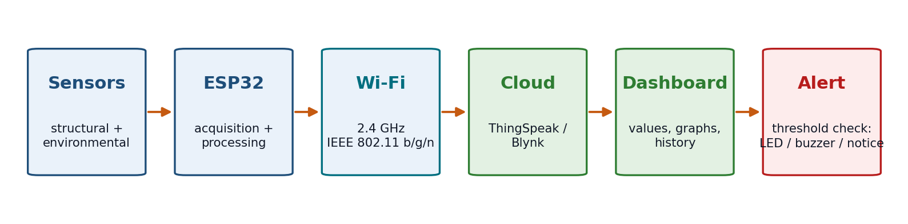
Fig. 1. Workflow of the INFRA SENSE system

6. Methodology
The methodology followed for this project can be divided into the following steps:

Step 1 – System Design and Requirement Analysis
The need for continuous observation of structural conditions was studied, existing work on bridge SHM was reviewed in the literature survey (Section 2) and the components were selected. The system was then designed as a dual-layer IoT architecture:
- Layer 1 – Physical / Sensing layer: the structural sensors, the environmental/material sensors and the ESP32, which collects the readings, processes basic data, triggers the local alert and connects to Wi-Fi.
- Layer 2 – Cloud / Software layer: the ThingSpeak/Blynk platform with the real-time dashboard, data storage and visualization of historical data, and threshold-based alerts.
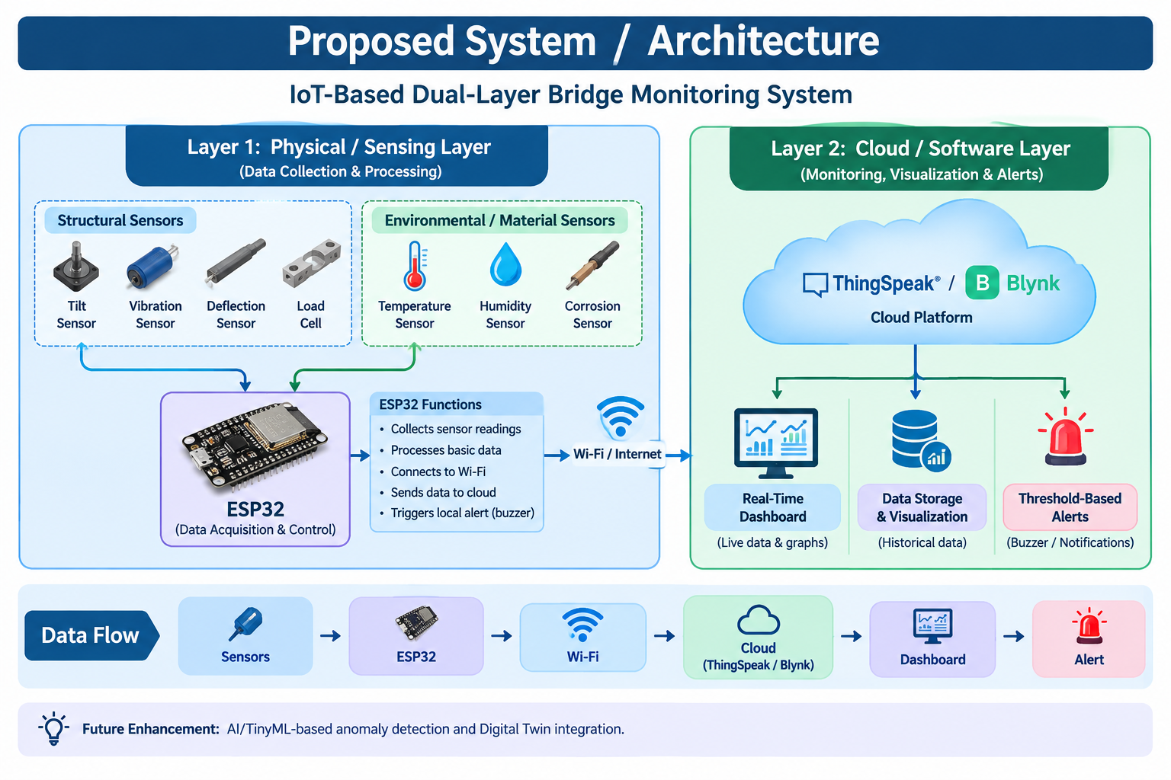
Fig. 2. System architecture of INFRA SENSE

Step 2 – Sensor Deployment and Hardware Integration
A laboratory-scale bridge model was built with a plywood base of 3 ft × 2 ft (91.5 cm × 61.5 cm), two solid wooden support pillars of 1 ft (30 cm) height and a bridge roadway of 2 ft × 8 inch (61.5 cm × 20.3 cm). The sensors are placed according to the parameter they monitor, and all of them are connected to the ESP32. Table 5 lists the components with their functions and locations, and Fig. 3 shows the assembled prototype.
Table 5. Components connected to the ESP32, their functions and placement
Component | Parameter / function | Placement
Load cell + HX711 | Applied load | Under the deck (under-deck support)
SW-420 | Vibration | Top bridge deck
ADXL345 | Tilt / acceleration | Top bridge deck
Flex / crack sensor | Bending and crack-related change | Top bridge deck
Soil moisture sensor | Moisture / wetness | Base of the model (right-side test zone)
Corrosion electrodes + DS18B20 | Corrosion-related change and temperature | Right-side test zone, in a liquid container
ESP32, LCD, LEDs, buzzer | Processing and local indication | Base enclosure

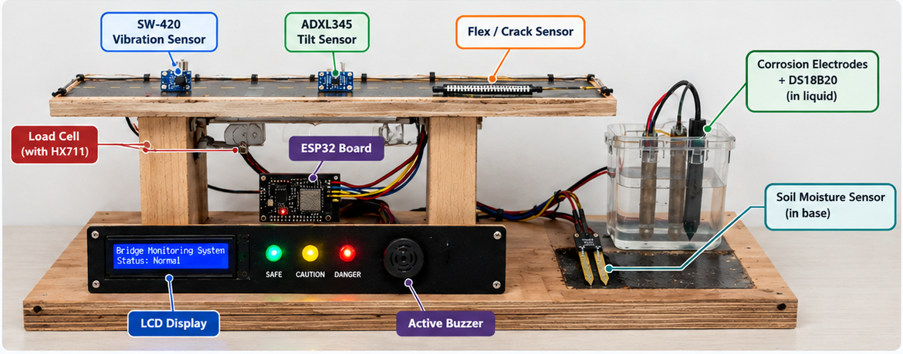
Fig. 3. Assembled prototype with labelled sensors and control unit

Step 3 – Data Acquisition and Processing
- The ESP32 acts as the central controller and collects readings from the connected sensors through GPIO, I²C and ADC interfaces at sensor-specific sampling intervals.
- The readings are processed on the ESP32 through unit conversion, data validation, basic filtering/averaging and threshold comparison to identify unusual changes in sensor values.
- Calibration of the sensors is needed for dependable readings.

Step 4 – Status Classification and Local Indication
The processed values are compared with predefined experimental threshold values and the condition is classified as SAFE, CAUTION or DANGER (Table 6). The ESP32 then updates the LCD, the LEDs and the buzzer. The complete program flow is shown in Fig. 4.
Table 6. System status and indication
Status | Condition | LED | Buzzer / alert | LCD / cloud
SAFE | All readings within limits | Green ON | No alarm | Status: Normal; values logged
CAUTION | A reading is approaching its limit | Yellow ON | Warning indication | Warning status shown; values logged
DANGER | A threshold is exceeded | Red ON | Buzzer ON; alert through the platform | Danger status shown; alert generated

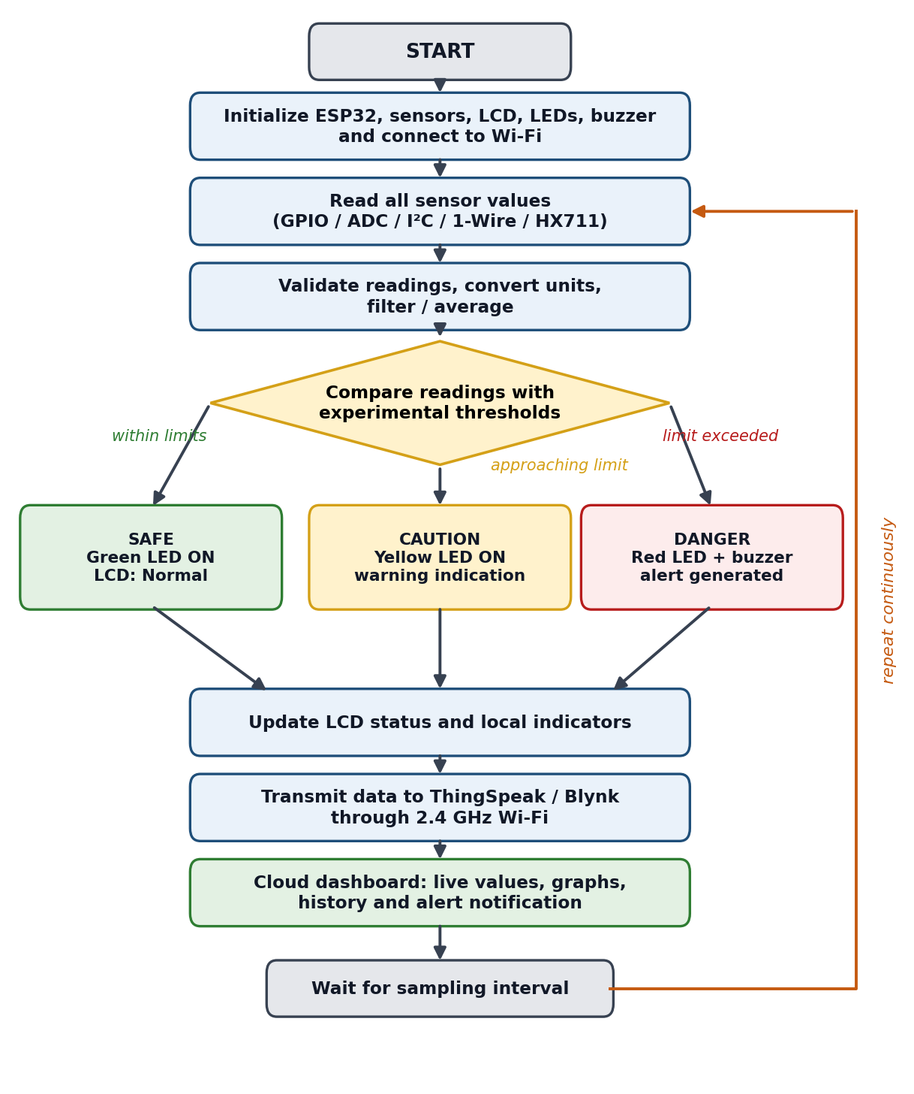
Fig. 4. Flowchart of the working of the system

Step 5 – IoT Communication and Cloud Monitoring
- The ESP32 transmits the processed data using IEEE 802.11 b/g/n Wi-Fi in the 2.4 GHz band to the cloud platform.
- ThingSpeak/Blynk shows the data as numerical values, graphs and historical data for real-time visualization.
- When an abnormal reading is detected, a warning/alert indication is generated through the monitoring platform and/or the local buzzer.

Step 6 – Project Timeline / Work Plan
The work was planned over approximately twelve weeks (W1 to W12), as shown in Table 7. The plan is approximate and the shaded cells show the weeks in which each phase was scheduled.
Table 7. Project timeline / work plan (approximate)
Phase | W1 | W2 | W3 | W4 | W5 | W6 | W7 | W8 | W9 | W10 | W11 | W12
Problem identification
Requirement analysis
Literature survey
Component selection
System architecture design
Prototype structure fabrication
Sensor integration
ESP32 firmware development
Cloud dashboard configuration
Local indication and alert integration
Testing and debugging
Documentation
Final presentation preparation

7. Testing and Performance Evaluation
Each module is tested individually and the overall system is then evaluated. The planned tests and their expected results are listed in Table 8; the actual results are to be recorded in Table 11.
Table 8. Planned tests and expected results
Test ID | Module tested | Test procedure | Expected result
T01 | Sensors | Power the ESP32 and read each sensor on the serial monitor. | Valid values are printed.
T02 | Load cell | Place known weights (within 5 kg) on the deck. | The reading changes with the load and matches the reference after calibration.
T03 | Vibration | Tap or vibrate the deck. | The SW-420 output changes and vibration is detected.
T04 | Tilt | Tilt the deck gently. | The ADXL345 values change with the orientation.
T05 | Crack / bending | Bend the flex sensor. | The reading changes with the bending.
T06 | Environmental sensors | Wet the moisture sensor, place the electrodes in liquid and change the temperature. | The moisture, corrosion-related and temperature readings respond.
T07 | Threshold and status | Create normal, near-limit and over-limit conditions. | The status changes between SAFE, CAUTION and DANGER.
T08 | Local indication | Trigger each status. | The correct LED lights, the buzzer sounds in DANGER and the LCD shows the status.
T09 | Wi-Fi transmission | Run the ESP32 connected to the network. | The cloud platform receives the data.
T10 | Cloud dashboard | Open the dashboard with data flowing. | Values, graphs and history are shown correctly.
T11 | Invalid / missing data | Disconnect a sensor or send an invalid reading. | Handled without a crash or a false alert.
T12 | Integrated system | Run all sensors together for a continuous period. | Stable operation with correct status and data flow.

8. Implementation Details
The system is implemented as seven modules. Table 9 gives the purpose, the input and process, and the output of each module.
Table 9. Implementation modules of INFRA SENSE
# | Module | Purpose | Input and process | Output
1 | Structural Sensing | Observe the mechanical behaviour of the bridge | Input: signals from the load cell + HX711, SW-420, ADXL345 and flex/crack sensor. Process: read and convert on the ESP32. | Load, vibration, tilt and bending values
2 | Environmental Sensing | Observe environmental and material conditions | Input: soil moisture sensor, corrosion electrodes, DS18B20 and DHT11. Process: read through ADC and digital interfaces. | Moisture, corrosion-related, temperature and humidity values
3 | ESP32 Processing | Acquire, validate and compare data | Input: sensor values. Process: firmware loop in Embedded C/C++ with unit conversion, filtering/averaging and threshold comparison. | Status (SAFE / CAUTION / DANGER)
4 | Local Indication and Alert | Show status and warn on site | Input: status from the ESP32. Process: update LCD, LEDs and buzzer. | Status display, LED colour, audible warning
5 | Wi-Fi Communication | Send data to the cloud | Input: processed data. Process: transmission over 2.4 GHz Wi-Fi. | Data on the cloud platform
6 | Cloud Dashboard | Remote monitoring | Input: data from the ESP32. Process: ThingSpeak/Blynk stores and visualizes. | Values, graphs, history and alerts
7 | Prototype Structure | Carry the sensors and electronics | Plywood base, two wooden pillars and bridge roadway. | Laboratory-scale bridge model

The interface of each sensor with the ESP32 and the outputs are shown in Fig. 5.
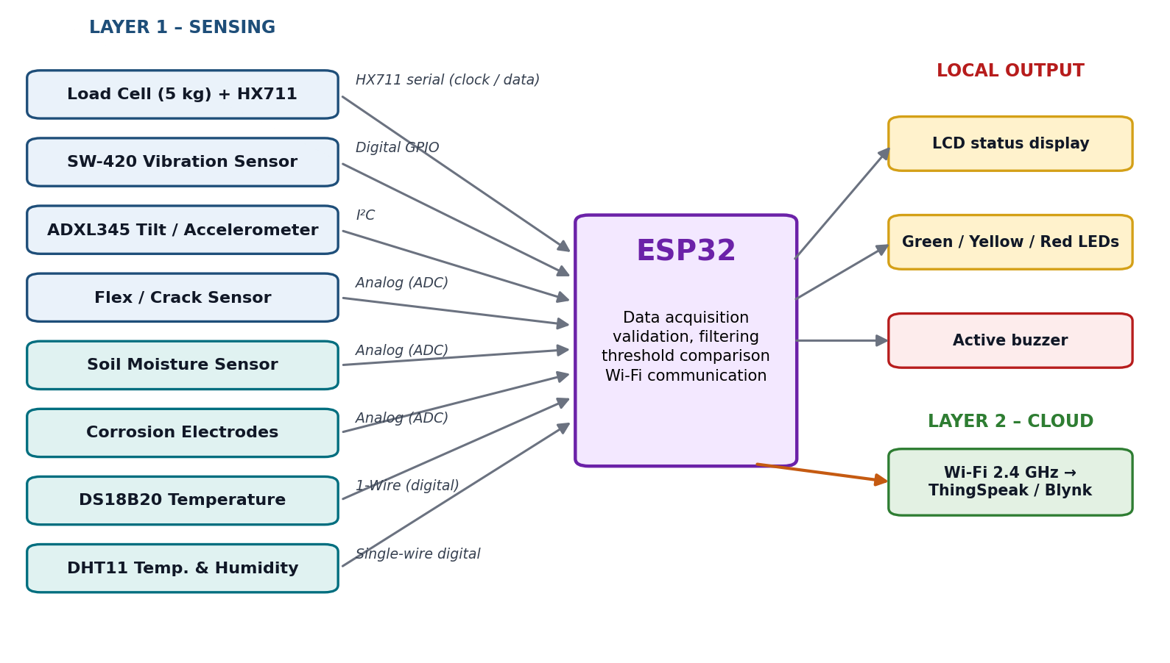
Fig. 5. Interface block diagram of sensors, ESP32, outputs and cloud
The firmware is written in Embedded C/C++ with the Arduino IDE. In its main loop it initializes the hardware and Wi-Fi, reads all sensors, validates and filters the readings, compares them with the thresholds, updates the LCD, LEDs and buzzer, uploads the data to the cloud and waits for the next sampling interval.

9. Outcomes
The INFRA SENSE prototype demonstrates how multi-sensor structural and environmental monitoring can be combined with an ESP32 and a cloud dashboard. The main outputs of the system are as follows.
- Local status display: the LCD shows “Bridge Monitoring System” and the status, for example “Status: Normal”.
- Status LEDs and buzzer: green for SAFE, yellow for CAUTION, red for DANGER, with an audible warning during abnormal conditions.
- Cloud dashboard: current values, real-time graphs and historical data of the monitored parameters.
- Alert generation: warning indication through the monitoring platform and the local buzzer.
- Integrated IoT prototype: demonstration of multi-sensor bridge health monitoring using the ESP32.
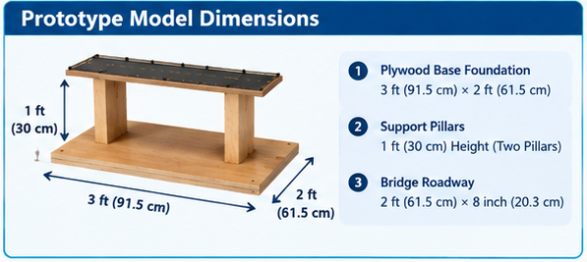
Fig. 6. Prototype model dimensions
The results described here are the expected outputs of the prototype under the test conditions in Section 7; they are not claimed as validated measurements of a real structure.
Table 10. Expected results of the prototype
No. | Result | Expected outcome
1 | Structural monitoring | Vibration, tilt, crack/bending and load monitoring; detection of abnormal structural conditions
2 | Environmental monitoring | Temperature, moisture and corrosion-related monitoring
3 | Real-time data collection | ESP32 collects and processes sensor readings; data is transmitted through Wi-Fi
4 | Cloud-based monitoring | Sensor values displayed on the dashboard; real-time status and historical data visualization
5 | Alert generation | Green/Yellow/Red status indication; buzzer alert during abnormal conditions
6 | Integrated IoT prototype | Demonstration of multi-sensor bridge health monitoring using ESP32

Table 11. Outcomes achieved and the evidence required
Outcome | Evidence required | Status
Sensor integration with ESP32 | Firmware and serial-monitor readings | To be confirmed
Acquisition of structural and environmental readings | Logged sensor values | To be confirmed
Threshold-based status (SAFE / CAUTION / DANGER) | LED, LCD and buzzer test photos / video | To be confirmed
Wi-Fi transmission | Data received on the cloud platform | To be confirmed
Cloud dashboard | Dashboard screenshots with values and graphs | To be confirmed
Alert generation | Alert screenshot / buzzer test | To be confirmed

10. Program Summary
Bridges and other structures change gradually, and periodic manual inspection can delay awareness of such changes. INFRA SENSE addresses this by combining multi-sensor structural and environmental sensing with local alerts and a cloud dashboard, so that the condition of the structure can be followed continuously and remotely. It assists routine structural observation; it supports, but does not replace, the judgement of a qualified engineer.
Compared with the advanced systems found in the literature, which use deep learning, anomaly detection and Digital Twin architectures [3], [4], INFRA SENSE is a simple, low-cost ESP32-based prototype that integrates structural monitoring, environmental monitoring and wireless cloud monitoring. This advantage has to be confirmed against the final implementation. Fig. 7 shows the prototype implementation overview with the prototype assembly steps, the sensor placement, the model dimensions and the control unit.
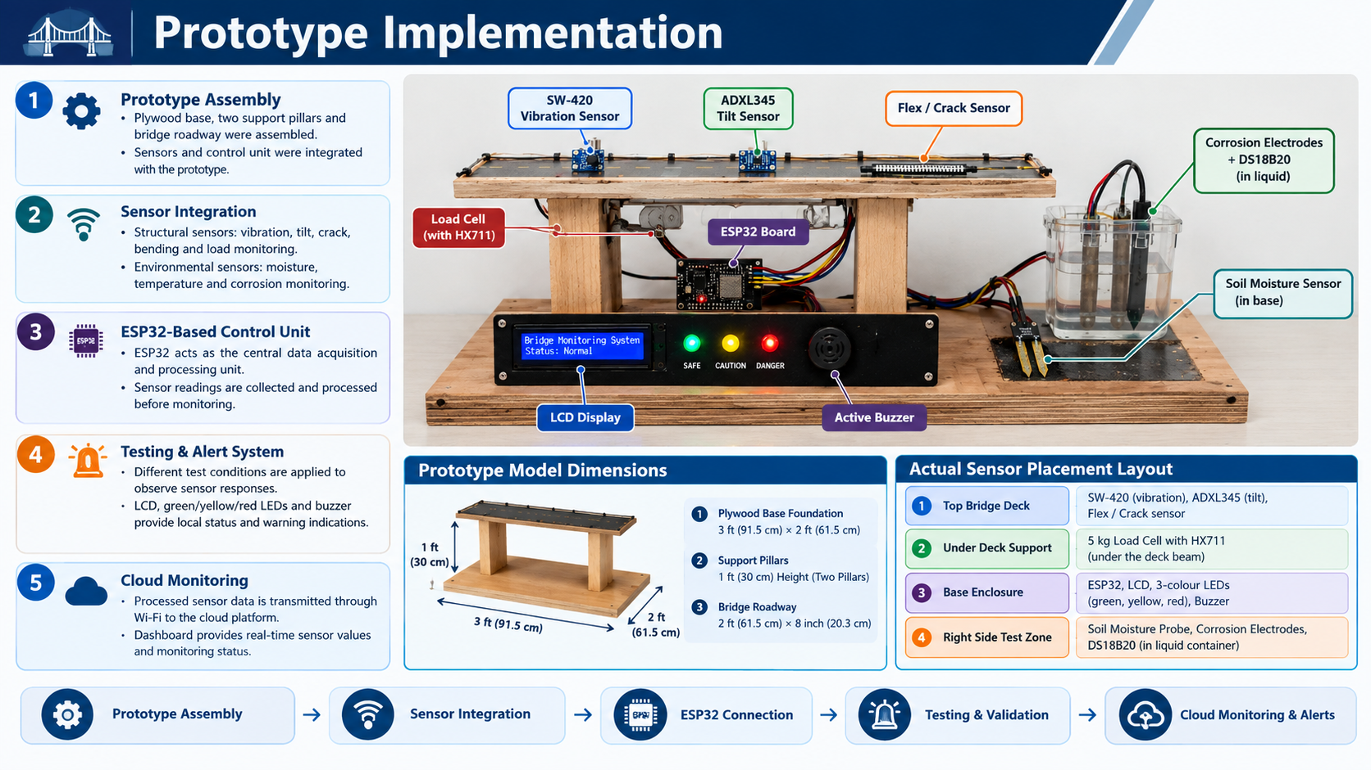
Fig. 7. Prototype implementation overview of INFRA SENSE

Feasibility Study
- Technical: the ESP32 and the sensors are widely available, and ThingSpeak/Blynk can be used with basic accounts. Sensor calibration, reliable Wi-Fi and threshold tuning need practical care.
- Economic: the components suit a student budget. The actual component costs are to be added from the project bills.
- Operational: the status is understood locally through the LCD, LEDs and buzzer and remotely through the dashboard; the workflow is simple to follow.
- Maintenance: periodic sensor cleaning and calibration (especially the moisture and corrosion electrodes), connection and power checks, and software updates. The system is not maintenance-free.
- Limitations: it depends on Wi-Fi, it is a small-scale prototype (5 kg load cell), it needs a reliable power supply, and its alert thresholds are experimental and cannot be treated as real-world bridge safety limits.

11. Conclusion and Future Work
This project presents INFRA SENSE, an IoT-based dual-layer Structural Health Monitoring system that combines an ESP32 with structural sensors (load, vibration, tilt and crack/bending), environmental sensors (moisture, corrosion-related change, temperature and humidity), local indication (LCD, LEDs and buzzer) and a ThingSpeak/Blynk cloud dashboard. It reduces the need for continuous manual observation and helps to follow the condition of a bridge model locally and remotely, while the engineer’s judgement remains in charge. INFRA SENSE is a student prototype: its limitations, including experimental thresholds and its small scale, are stated in Section 10, and the future items below are proposals, not completed work.

Future Work
- AI/TinyML-based anomaly detection on the edge device, building on deep-learning methods [3].
- Digital Twin integration and edge-cloud collaboration for intelligent monitoring [4].
- Multi-sensor fusion: combining structural and environmental readings into a single health indicator.
- Improved power arrangements: battery backup or solar charging for continuous operation.
- Mobile alerts and notification channels for remote warnings.
- Historical data visualization and trend analysis of the stored readings.
- Additional sensors, such as strain gauges, for more detailed structural observation.
- Field calibration of thresholds on a real structure in cooperation with civil engineers.

12. References
[1] O. S. Sonbul and M. Rashid, “Towards the structural health monitoring of bridges using wireless sensor networks: A systematic study,” Sensors, vol. 23, no. 20, Art. no. 8468, 2023, doi: 10.3390/s23208468.
[2] B. Zhang, Y. Ren, S. He, Z. Gao, B. Li, and J. Song, “A review of methods and applications in structural health monitoring (SHM) for bridges,” Measurement, vol. 245, Art. no. 116575, 2025, doi: 10.1016/j.measurement.2024.116575.
[3] G.-Q. Zhang, B. Wang, J. Li, and Y.-L. Xu, “The application of deep learning in bridge health monitoring: A literature review,” Advances in Bridge Engineering, vol. 3, Art. no. 22, 2022, doi: 10.1186/s43251-022-00078-7.
[4] Y. Liu, “Edge-cloud collaborative digital twin architecture for bridge structural health monitoring: Multi-sensor fusion and anomaly detection algorithm design,” Discover Applied Sciences, vol. 8, Art. no. 938, 2026, doi: 10.1007/s42452-026-08991-6.
[5] C. R. Farrar and K. Worden, “An introduction to structural health monitoring,” Philosophical Transactions of the Royal Society A, vol. 365, pp. 303–315, 2007.
[6] Espressif Systems, “ESP32 Series Datasheet.” [Online]. Available: https://www.espressif.com
[7] MathWorks, “ThingSpeak – IoT analytics platform.” [Online]. Available: https://thingspeak.com
[8] Arduino, “Arduino IDE Documentation.” [Online]. Available: https://docs.arduino.cc/software/ide/
[9] Manufacturer datasheets for the HX711 load-cell amplifier, the SW-420 vibration sensor, the ADXL345 accelerometer, the DS18B20 and DHT11 sensors, the soil moisture sensor and the flex sensor.
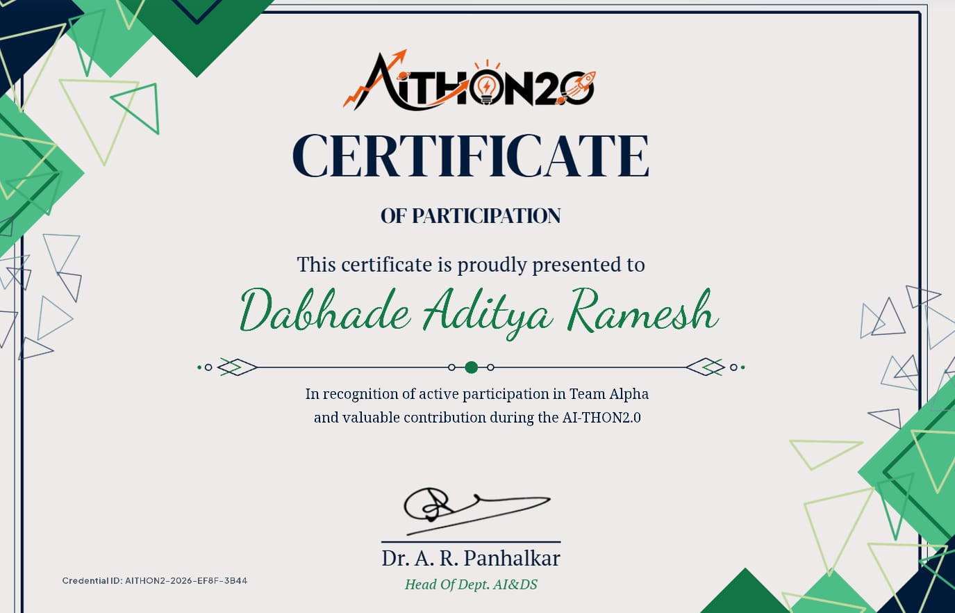
Fig. 8. AI-THON 2.0 participation certificate – Dabhade Aditya Ramesh
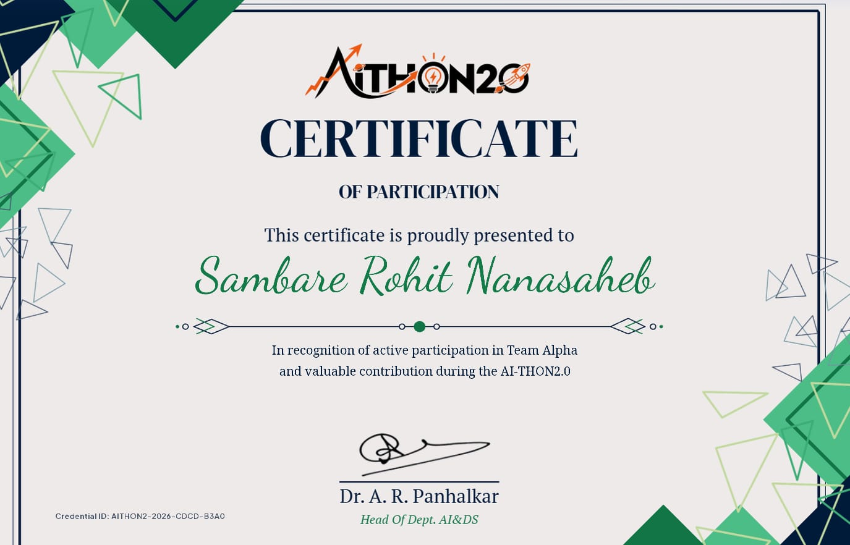
Fig. 9. AI-THON 2.0 participation certificate – Sambare Rohit Nanasaheb
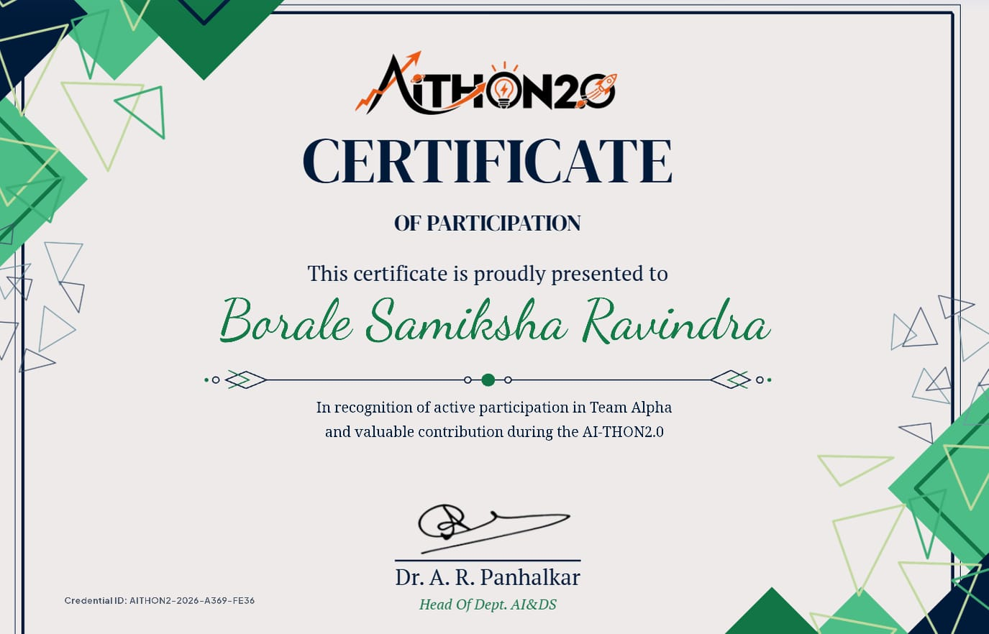
Fig. 10. AI-THON 2.0 participation certificate – Borale Samiksha Ravindra

[ Insert photograph of the project presentation here ]
Fig. 11. Photograph of the project presentation

