ADITYA DASGUPTA || A20410523

CS450 || Spring 2020

Francis Leung

Homework #1 Documentation

**whatif User Program**

The whatif program can be run on the default shell of the xv6. If called without an argument, the user must enter text in the console and press enter after every line. If a user does not wish to write any more lines, they can press CTL+D.If called with an argument (test.txt in our case), the program exits immediately. For both cases, to check “child.txt” or “parent.txt” use the “cat” program.

Known Bugs

**Sometimes, user has to press CTL-D multiple times for the shell to exit the program.**

Test Runs

1) Without Argument : -

1. Run make clean qemu-nox to start the default shell
2. type ./whatif
3. Enter text and hit enter to enter next line of text. To stop, press CTL-D.

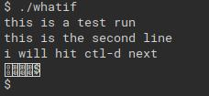

Output :

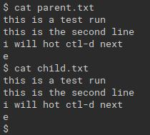

2) With Argument : -

1. Run make clean qemu-nox to start the default shell
2. type ./whatif test.txt

Output :

