Now I have a complete picture of all files. Let me put together a thorough flow review.Here's a thorough flow review of your system. I'll walk through it module by module, then flag the issues I found.

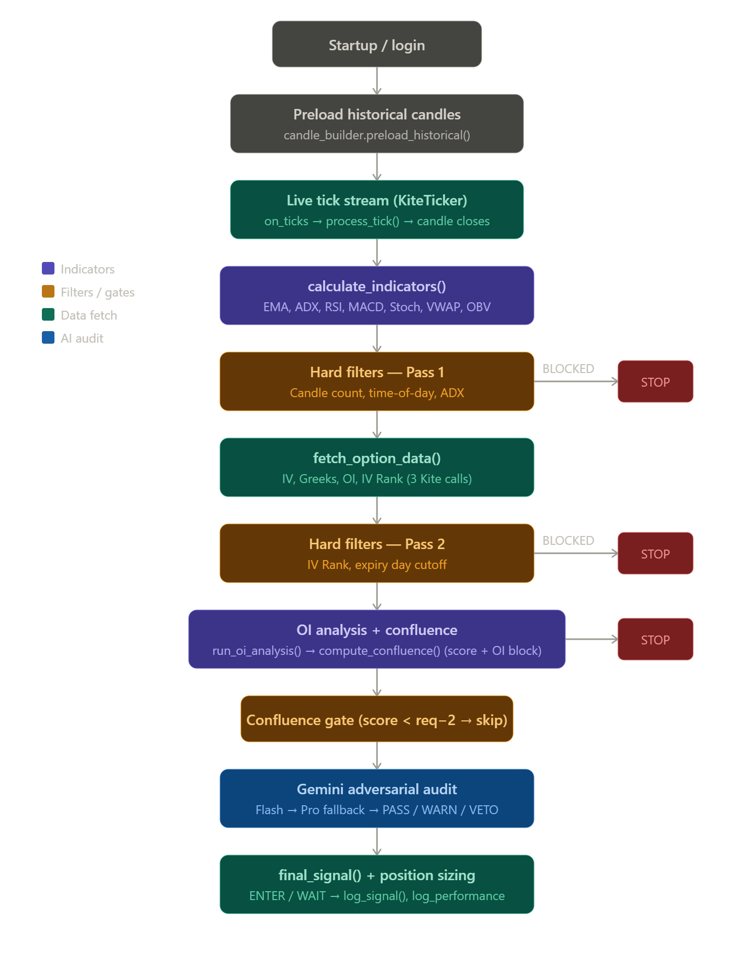

The overall architecture is solid and well-thought-out. Here's a complete breakdown — what's working well and what has real bugs or risks.

What's working correctly
The two-pass filter design is smart. Pass 1 catches cheap time-of-day and ADX blocks before making any API calls; Pass 2 handles the expensive IV Rank and expiry checks after fetch_option_data(). The OI analysis runs before confluence so its score actually counts toward the gate — the integration guide explicitly calls out that this was a prior bug and it's now fixed. The Gemini fail-closed policy (any invalid JSON or API error becomes a VETO) is the right default for a trading system. The OI baseline cache that snapshots on first fetch of the day, avoiding the stale oi_day_high problem, is well-engineered.

Bugs and issues found
1. compute_trade_levels() uses option LTP as "price" for SL/target math (gemini_brain.py, line ~90)
indicators['current_price'] comes from calculate_indicators(), which is built on the option's candle data. So the SL and targets are computed from the option premium's price, not the underlying spot. This is intentional for option buyers, but the swing low in recent_candles[-4:] is also option lows — the SL will be very tight and arbitrary. Most traders compute targets in underlying points and translate them to option levels. Right now a 10-pt underlying move could mean 50+ pts in the option premium, but your SL is capped at price * 0.015 regardless. This may be too tight for OTM options. Worth revisiting.
2. filter_dead_market runs twice but only catches ADX in Pass 1 (hard_filters.py)
In Pass 1 you call run_all_filters(option_data=None, ...). In Pass 2 you call it again with option_data=. But ADX filter and time filters also run again in Pass 2 — they already passed, so this is harmless but wasteful. A cleaner design would split the function into two separate callables rather than running the full suite twice.
3. _last_volume is not reset on reconnection (candle_builder.py)
If the WebSocket disconnects and reconnects mid-day, _last_volume holds the last seen cumulative value. On reconnect, the first tick's vol_delta will be computed correctly only if the cumulative counter continued. But if the connection drops and resumes after a gap, Kite might send a fresh volume_traded that's lower than the stored _last_volume (e.g., reset at reconnect). max(volume - self._last_volume, 0) handles the zero floor, but it silently drops real volume rather than warning. Not catastrophic but invisible.
4. compute_oi_confluence gives 0.5 for neutral PCR but score is rounded to int at the end (indicators.py)
At the bottom: score = min(round(score), 3). If PCR is neutral (0.5 added) and everything else hits cleanly, you get fractional scores mid-function. round() will snap 4.5 → 4 or 5 depending on Python's banker's rounding. This is a subtle edge case but could occasionally cause a confluence pass/fail flip. Using math.floor or int() instead would be more predictable.
5. performance_tracker.log_outcome() matches by time string only (performance_tracker.py)
If two ENTER signals fire in the same minute (unlikely given the 5-min candle gate, but possible if run_analysis is somehow called twice), log_outcome will update the first matching row it finds from the end, not necessarily the right one. Adding the symbol or entry price as a secondary match key would make this safer.
6. oi_baseline_cache resets on date change but not on run_login.py re-execution (oi_analysis.py)
If the user runs run_login.py and then main.py on the same day, the cache starts fresh correctly. But if main.py crashes and is restarted mid-session, the baseline will be re-snapshotted to the current mid-session OI rather than the opening OI. This means oi_change_pct will undercount changes for the rest of the day after a restart. Low-severity but worth a comment in the code.
7. Missing confluence_required key in log_signal (performance_tracker.py)
In log_signal, the row sets "confluence_required": signal.get("confluence_required", ""). But in analyse() in gemini_brain.py, the returned dict has the key confluence_required correctly populated. However in main.py's log_signal() (the separate one, not the performance tracker), it logs signal.get('confluence_required', '') — and the analyse() return dict does include this key. This one is actually fine, but confusingly the same field name exists in both log functions for different purposes.

Minor observations
- get_instrument_token in kite_client.py always picks the nearest expiry (sort_values('expiry').iloc[0]). This is correct for weekly options but if you want to trade monthly, you'd need to parameterise it. Currently config has no EXPIRY_TYPE field.
- compare_iv_direction uses a fixed threshold of 0.3 for rising/falling. This is reasonable for NIFTY IV (typically 10–25 range) but hardcoded — probably worth a config constant.
- The Gemini prompt sends level_distances computed from price - level, where price is the option LTP. So "PDH distance" in the prompt means how far the option premium is from PDH, not how far the underlying is from PDH. Gemini is being asked to reason about structural levels using option price distances, which is conceptually wrong. The distance calculation should use underlying_spot instead of option_info['ltp'].
The last point in the minor observations is actually the most important one to fix — Gemini's structural reasoning (PDH proximity, VWAP failure, etc.) is built on option LTP distances rather than underlying spot distances, which makes those checks meaningless.

