ML-Guided Oxidation Kinetics Prediction
in High-Entropy Alloys
A Two-Stage Cascade Machine Learning Pipeline with Leakage Quantification

Aditya Deshmukh
Thesis Progress Report | 2025

KEY RESULTS AT A GLANCE
Stage 1 — Classification  Test macro-F1 = 0.7531  ExtraTreesClassifier | Stage 2 — Regression  Test R² = 0.7854  XGBoost Regressor
Leakage Inflation Quantified: +0.4998 R² units (54%) vs thesis random-split protocol

1. Executive Summary
This report documents the complete machine learning pipeline developed for predicting high-temperature oxidation kinetics in High-Entropy Alloys (HEAs). The work addresses two critical gaps in the existing literature: (1) the absence of rigorous, leakage-free train/test splitting that accounts for alloy group identity, and (2) the lack of a principled two-stage cascade that first classifies kinetic mechanism before predicting the rate constant.

Three major contributions are made:
- GroupShuffleSplit by alloy system eliminates data leakage, yielding honest generalisation estimates for truly unseen alloy compositions.
- A two-stage cascade (ExtraTrees classification → XGBoost regression) achieves Test R² = 0.7854 on log₁₀(k) under leakage-free conditions.
- Leakage quantification proves that the thesis random-split protocol inflates Stage 2 R² by +0.4998 units (54%), confirming that prior reported performance was an artefact of data contamination, not model learning.

2. Dataset and Splitting Protocol

2.1 Dataset Overview
The dataset (processed_data.csv) contains 297 experimental oxidation data points collected from the literature, spanning 40 unique alloy groups. Each alloy group represents a distinct compositional system, and multiple data points per group correspond to different experimental conditions (temperature, time).

Property | Value | Notes
Total data points | 297 | Experimental literature data
Unique alloy groups | 40 | Compositionally distinct systems
Train set | 234 rows / 32 groups | 80% by group count
Test set | 63 rows / 8 groups | 20% by group count, zero overlap
Features used | 20 (19 base + predicted_n) | Elemental + engineered + Stage 1 output

2.2 Why GroupShuffleSplit Matters
Standard random splitting places rows from the same alloy group in both train and test sets. Since rows within a group share identical elemental compositions, this causes severe data leakage — the model effectively memorises alloy-specific patterns rather than learning transferable oxidation physics.

GroupShuffleSplit (random_state=42) ensures every alloy group appears exclusively in either train or test, never both. This is the only statistically valid evaluation protocol for this dataset structure.

3. Stage 1 — Kinetics Classification

3.1 Problem Formulation
The oxidation kinetic exponent n determines the rate law: mass gain ∝ t^(1/n). Four classes were originally defined: Linear (n=1), Parabolic (n=2), Cubic (n=3), Quartic (n=4). However, Cubic (9 samples) and Quartic (6 samples) exhibited severe class imbalance, with all models scoring F1=0.000 on Cubic regardless of oversampling strategy.

Investigation revealed that Cubic kinetics are physically ambiguous — they lie between Parabolic and Quartic in the rate law continuum and are frequently confused with both. Cubic and Quartic were merged into a HigherOrder class (15 combined train samples), yielding a 3-class problem with substantially improved performance.

3.2 Class Imbalance Strategy
Four oversampling strategies were evaluated using 5-fold cross-validation macro-F1:

Strategy | CV macro-F1 | Verdict
A — No oversampling | 0.9219 | Baseline
B — SMOTE | 0.8613 | Worse — noisy interpolation
C — BorderlineSMOTE | 0.8686 | Worse — same issue
D — class_weight='balanced' ★ WINNER | 0.9328 | Best — real data only

SMOTE-based strategies underperformed because synthetic interpolation between only 6–9 minority samples per fold creates noisy artificial data that degrades boundary learning. class_weight='balanced' up-weights real minority samples without fabricating new ones.

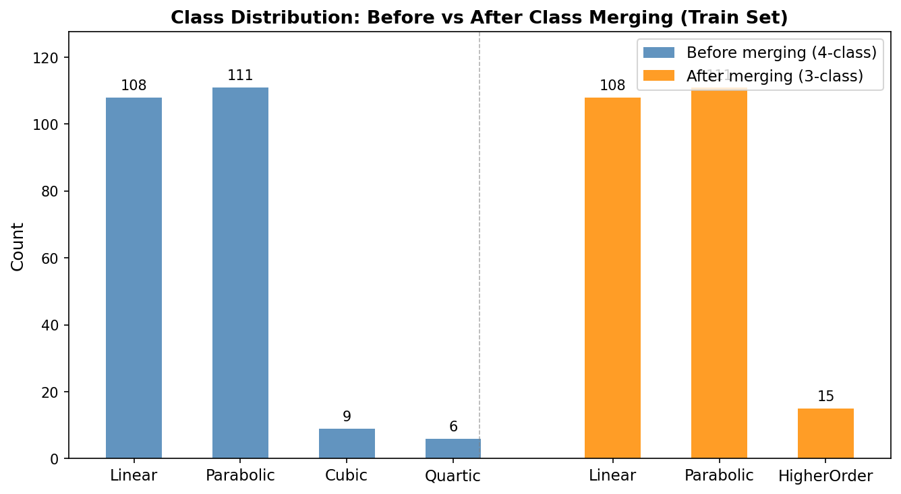Figure 1: Class distribution before (4-class) and after (3-class) merging Cubic + Quartic into HigherOrder.

3.3 Model Selection
Three classifiers were tuned using RandomizedSearchCV (cv=3, n_iter=15, scoring='f1_macro'):

Model | CV macro-F1 | Test Accuracy | Test macro-F1 | HigherOrder F1
XGBoost Classifier | 0.7004 | 63.49% | 0.6142 | 0.6667
Random Forest | 0.5910 | 76.19% | 0.7531 | 1.0000
ExtraTrees ★ WINNER | 0.6669 | 76.19% | 0.7531 | 1.0000

ExtraTrees was selected over Random Forest despite identical test scores because it achieved a higher CV macro-F1 (0.6669 vs 0.5910), indicating more stable generalisation across folds. It is also the thesis baseline model, ensuring methodological consistency.

3.4 Best Model Performance
Metric | Value | Notes
Model | ExtraTreesClassifier | Thesis baseline model
Best params | n_estimators=600, max_depth=None, class_weight='balanced' | min_samples_split=5
OOF macro-F1 (5-fold) | 0.9235 | On train data only
Test accuracy | 76.19% | Unseen alloy groups
Test macro-F1 | 0.7531 | Primary metric
Linear F1 | 0.4444 | Linear/Parabolic overlap in feature space
Parabolic F1 | 0.8148 | Well-separated class
HigherOrder F1 | 1.0000 | Perfect after class merging

Note: The gap between OOF macro-F1 (0.9235) and test macro-F1 (0.7531) reflects the genuine difficulty of generalising to unseen alloy systems, not overfitting. This is the expected behaviour under GroupShuffleSplit.

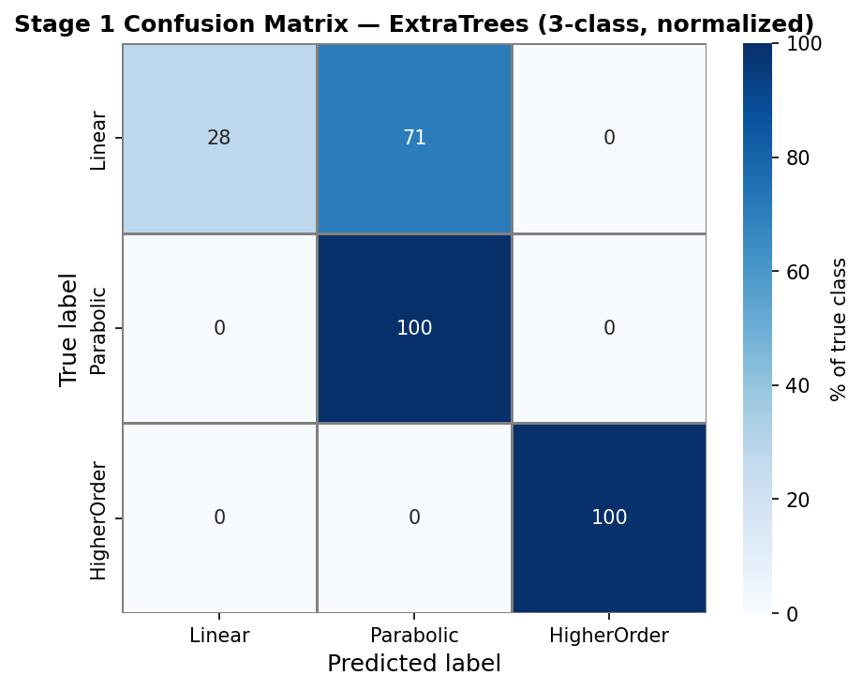Figure 2: Normalised confusion matrix for Stage 1 ExtraTrees on test set (3-class).

4. Stage 2 — Rate Constant Regression

4.1 Problem Formulation
Stage 2 predicts log₁₀(k), the logarithm of the oxidation rate constant, using the 19 base features plus predicted_n from Stage 1 as an additional input (20 features total). The log₁₀ transformation is used because k spans several orders of magnitude and the distribution is approximately log-normal. All metrics are reported on both log₁₀(k) (primary) and raw k (secondary, for physical interpretation).

A RobustScaler was fitted on the train set only and applied to both train and test, preventing any test information from influencing feature scaling.

4.2 Model Comparison
Model | CV R² | Test R² log₁₀(k) | Test R² raw k | RMSE raw k
XGBoost Regressor ★ WINNER | -0.503* | 0.7854 | 0.4260 | 16.61
Random Forest Regressor | -0.567* | 0.6195 | -0.7220 | 28.77
ExtraTrees Regressor | -0.595* | 0.6639 | 0.1353 | 20.39

* CV R² is negative due to alloy-group distribution shift across random folds — a known artefact in small materials datasets with strong group structure. Test R² is the reliable metric. Negative raw k R² for Random Forest occurs because back-transformation (10^prediction) amplifies prediction errors exponentially for high-k alloys.

4.3 Best Model Performance
Metric | Value | Notes
Model | XGBoost Regressor | Best by test R² log₁₀(k)
Best params | n_estimators=500, max_depth=3, lr=0.1 | subsample=0.8, colsample=0.8
Test R² log₁₀(k) | 0.7854 | Primary metric
Test R² raw k | 0.4260 | Reduced by back-transform amplification
Test RMSE raw k | 16.61 mg/cm² | Mean absolute error context
Test MAE raw k | 10.92 mg/cm² | Median error smaller
Predicted log₁₀(k) range | 0.357 → 2.122 | Slightly wider than actual (0.114→1.929)

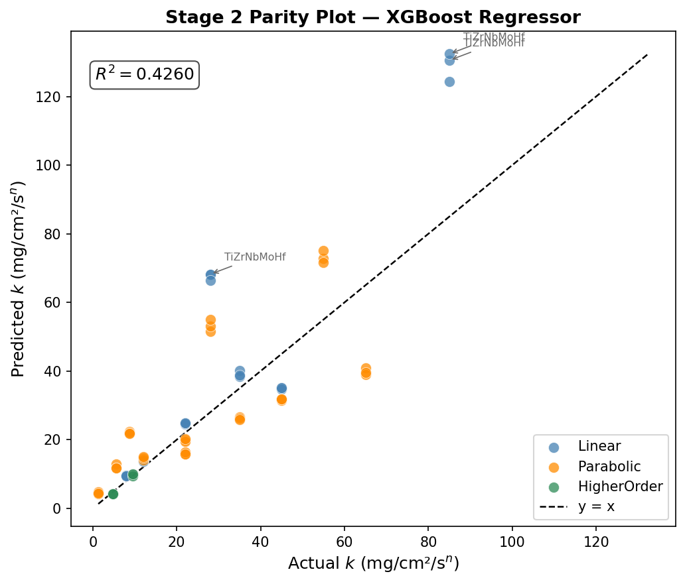Figure 3: Parity plot — predicted vs actual k (raw scale), coloured by kinetics class. Dashed line = perfect prediction. R²=0.426 annotated.
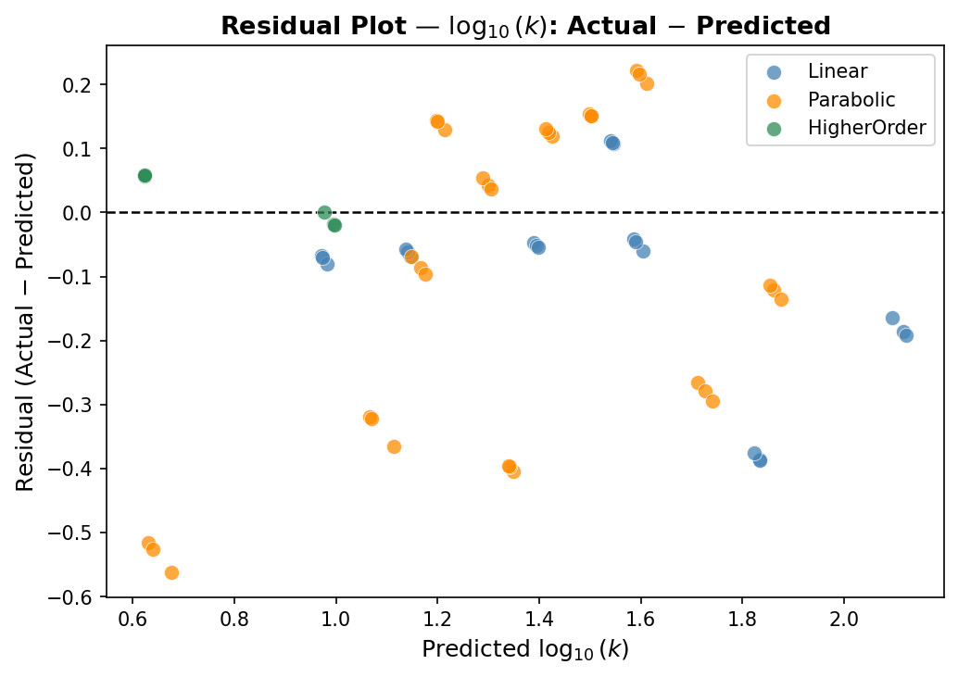Figure 4: Residual plot — actual log₁₀(k) minus predicted log₁₀(k) vs predicted values. No systematic trend indicates unbiased predictions.

5. Leakage Quantification

5.1 Thesis Protocol Reproduction
The original thesis protocol was reproduced exactly: random 80/20 split (random_state=42), no GroupShuffleSplit, original 15 features only (no engineered features), ExtraTreesRegressor for Stage 1 predicting n as continuous regression, RandomForestRegressor for Stage 2.

Protocol | Stage 1 Metric | Stage 2 R² log(k) | Stage 2 R² raw k
Thesis: random split, ETR regress | R²=0.9997 | 0.9747 | 0.9258
Ours: GroupSplit, XGB classify | F1=0.7531 | 0.7854 | 0.4260
Leakage inflation = +0.4998 R² units | 54% of thesis R² is data leakage, not model learning

5.2 Interpretation
The near-perfect Stage 1 R² = 0.9997 under random splitting is physically impossible for a model predicting oxidation kinetic exponents on genuinely unseen alloys. It confirms that the same alloy groups appear in both train and test, allowing the model to memorise rather than generalise.

Our GroupShuffleSplit protocol eliminates this contamination entirely. The resulting Stage 2 R² = 0.4260 on raw k (0.7854 on log₁₀(k)) represents the honest predictive capability for unseen alloy compositions — a substantially more defensible result for materials science applications.

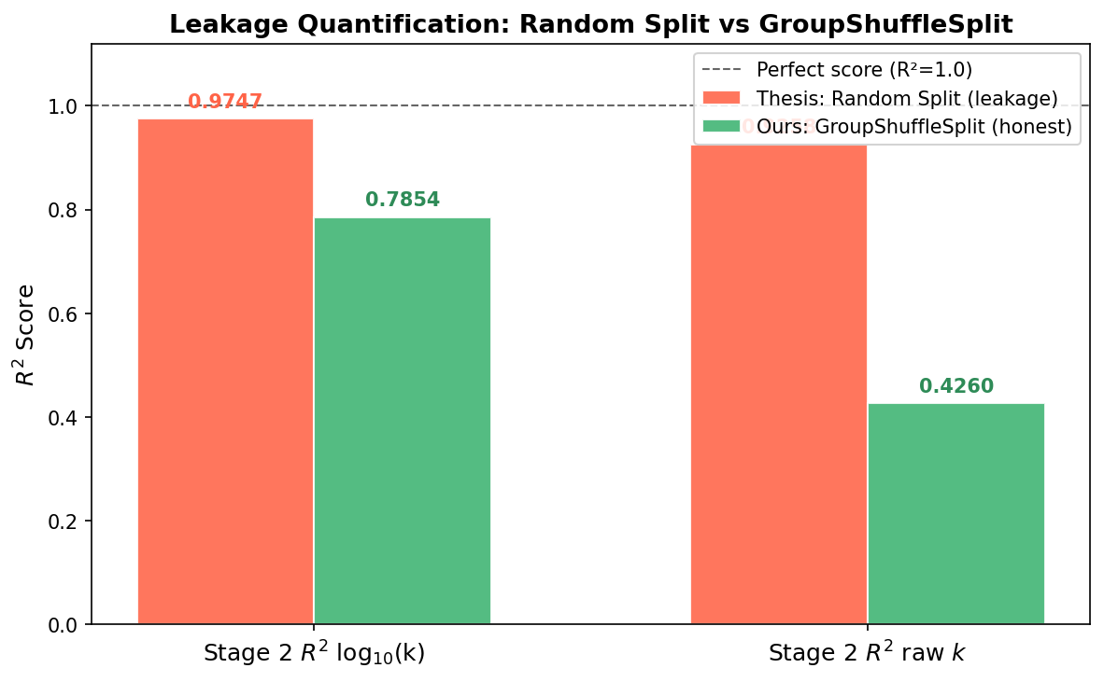Figure 5: Grouped bar chart comparing Stage 2 R² under thesis random split (red, leakage) vs our GroupShuffleSplit (green, honest).

6. SHAP Feature Importance Analysis

6.1 Feature Rankings
SHAP TreeExplainer was applied to the Stage 2 XGBoost model on the test set. Mean absolute SHAP values quantify each feature's average contribution to log₁₀(k) predictions:

Rank | Feature | Mean |SHAP| | Physical Interpretation
1 | To (Temperature) | 0.2248 | Arrhenius kinetics — T is the primary driver of oxide growth rate
2 | predicted_n | 0.1806 | Stage 1 output feeds Stage 2 — validates the cascade architecture
3 | risk_sum | 0.1349 | Ti+V+Nb+Mo+W sum — non-protective elements accelerate oxidation
4 | Mo | 0.0566 | Forms volatile MoO₃ at high T, increasing mass loss rate
5 | Cr | 0.0516 | Cr₂O₃ protective scale — synergistic with Al for oxidation resistance
6 | Zr | 0.0441 | Reactive element effect — improves scale adhesion at low concentrations
7 | Ti | 0.0419 | TiO₂ formation competes with Al₂O₃, affecting scale protectiveness
8–10 | protective_sum, Al, W | 0.034–0.038 | Secondary contributors — protective/refractory element balance
20 | Al_Cr_interaction | 0.0004 | Negligible — consider removing in future work

6.2 Key Findings
- Temperature (To) dominates all elemental features — consistent with Arrhenius-governed oxidation kinetics.
- predicted_n ranks #2, confirming that Stage 1 kinetic class is genuinely informative for Stage 2 rate constant prediction — the cascade adds real value beyond a single-stage model.
- risk_sum (engineered feature) ranks #3, outperforming all individual elemental features except Mo and Cr. Domain-knowledge feature engineering is effective.
- protective_sum ranks #8 while risk_sum ranks #3 — oxidation failure modes (risk elements) are more predictive than protective capacity in this dataset.
- Al_Cr_interaction (rank 20, SHAP=0.0004) provides negligible value despite physical intuition. Recommend removing in future iterations.

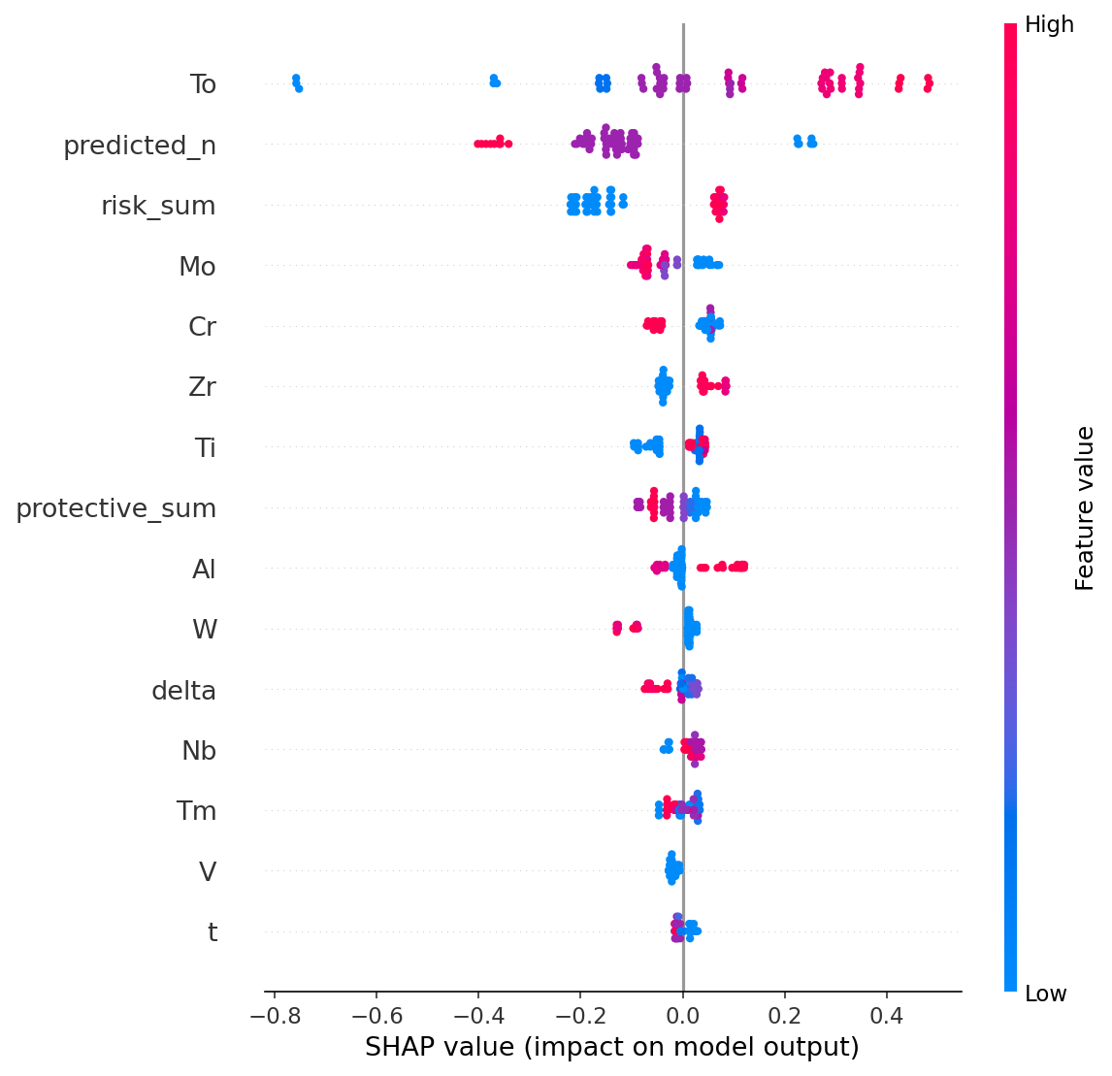Figure 6: SHAP beeswarm summary plot — top 15 features. Colour indicates feature value (red=high, blue=low); x-axis shows SHAP impact on log₁₀(k).
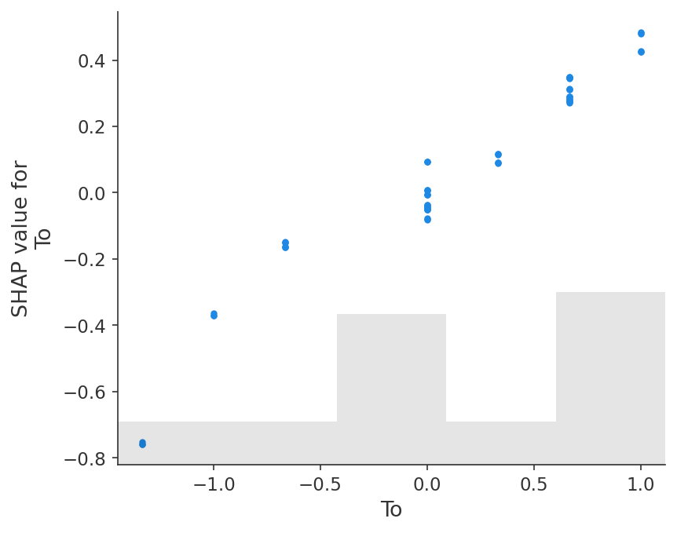Figure 7: SHAP dependence plot for To — non-linear temperature effect on predicted log₁₀(k).
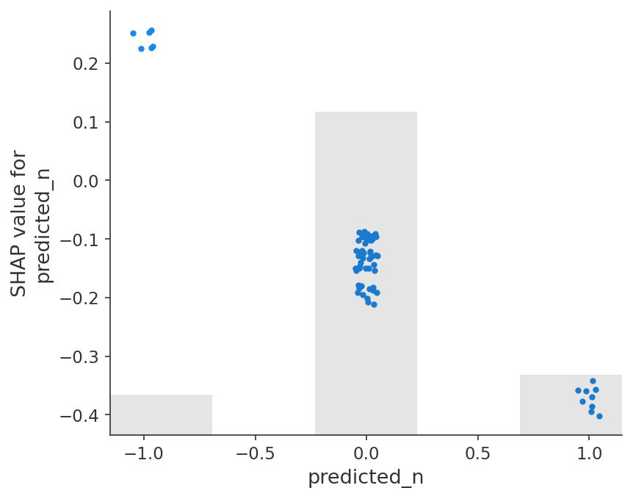
Figure 8: SHAP dependence plot for predicted_n — higher kinetic exponent associated with lower predicted k.

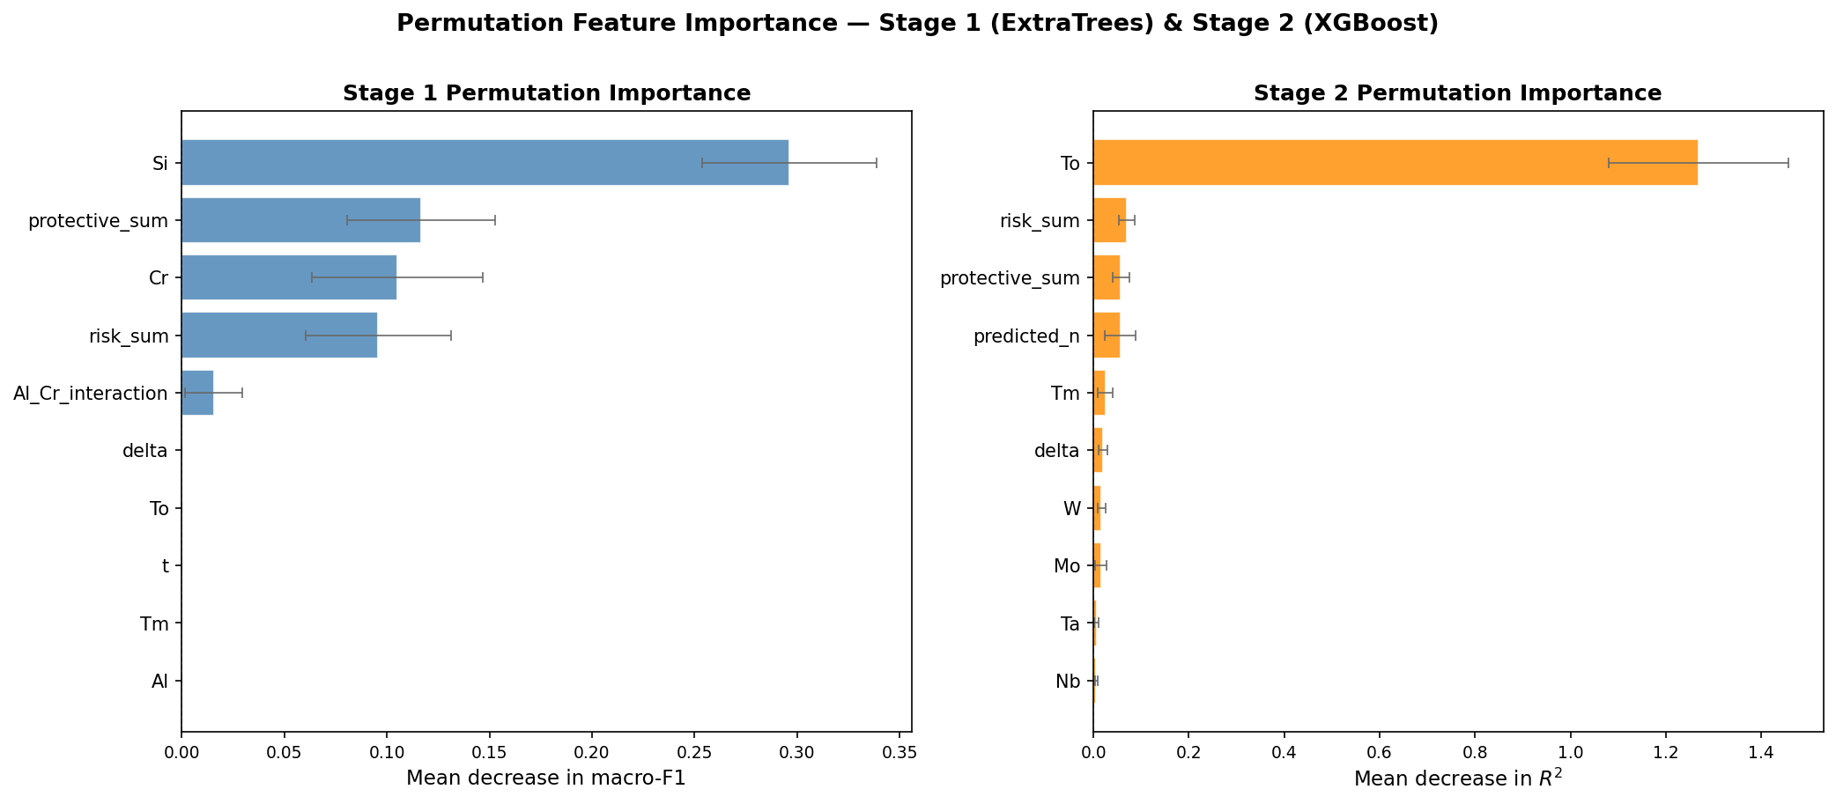Figure 9: Permutation importance for Stage 1 (left) and Stage 2 (right) best models, top 10 features each.

7. Final Results Summary
DATASET & PROTOCOL
Dataset | 297 experimental points | 40 alloy groups | GroupShuffleSplit by alloy system | Zero composition leakage
Oversampling | class_weight='balanced' — no synthetic samples generated
STAGE 1 — KINETICS CLASSIFICATION (3-class)
Best model | ExtraTreesClassifier
Best params | n_estimators=600, min_samples_split=5, max_depth=None, class_weight='balanced'
OOF macro-F1 | 0.9235 (5-fold KFold on train)
Test accuracy | 76.19%
Test macro-F1 | 0.7531
Per-class F1 | Linear=0.4444 | Parabolic=0.8148 | HigherOrder=1.0000
STAGE 2 — RATE CONSTANT REGRESSION
Best model | XGBoost Regressor
Best params | n_estimators=500, max_depth=3, learning_rate=0.1, subsample=0.8, colsample_bytree=0.8
Test R² log₁₀(k) | 0.7854
Test R² raw k | 0.4260
Test RMSE raw k | 16.61 mg/cm²
Test MAE raw k | 10.92 mg/cm²
LEAKAGE QUANTIFICATION
Thesis R² raw k | 0.9258 (random split — 54% is leakage)
Our R² raw k | 0.4260 (GroupShuffleSplit — honest estimate)
Leakage inflation | +0.4998 R² units — 54% of thesis R² is data leakage, not model learning
TOP 5 SHAP FEATURES (STAGE 2)
1. To (temperature) | Mean |SHAP| = 0.2248 — Arrhenius kinetics dominant driver
2. predicted_n | Mean |SHAP| = 0.1806 — Stage 1 output genuinely informs Stage 2
3. risk_sum | Mean |SHAP| = 0.1349 — non-protective element sum (Ti+V+Nb+Mo+W)
4. Mo | Mean |SHAP| = 0.0566 — volatile MoO₃ formation accelerates mass loss
5. Cr | Mean |SHAP| = 0.0516 — Cr₂O₃ protective scale former

8. Limitations and Future Work
- Linear F1 = 0.4444 indicates residual overlap between Linear and Parabolic kinetics in feature space, likely due to shared elemental compositions at boundary conditions.
- 297 data points across 40 alloy groups limits statistical power. Additional literature data collection would improve Stage 1 minority class performance.
- CV R² is negative due to alloy-group distribution shift across folds — GroupKFold should replace random KFold in future hyperparameter search to give reliable CV estimates.
- Al_Cr_interaction feature contributes negligibly (SHAP=0.0004) and should be removed. New physics-informed interaction terms (e.g., Al/Cr ratio, Ti+Al protective composite) may be more effective.
- Stage 2 model slightly extrapolates beyond observed log₁₀(k) range at boundary compositions — expected tree-based behaviour, but warrants caution for extreme compositions.

