AWS Cloud Lab 2 Documentation
Build Your VPC and Launch a Web Server

Name | ____________MD ADNAN____________________________
Roll No. | ________13071025052________________________________
Course / Semester | ___________3_____________________________
Date | __________18/09/2026______________________________

1. Aim
To create a custom Amazon VPC with public and private subnets, configure routing and HTTP security, launch an Amazon EC2 instance, and deploy a web server that can be accessed through the public Internet.

2. Objectives
The practical uses Amazon Virtual Private Cloud (VPC) to build a custom virtual network and configure AWS resources within it. The lab creates a VPC, public and private subnets, route tables, an Internet Gateway, a NAT Gateway, a security group, and an Amazon EC2 web server.
- Create a VPC with a defined IPv4 CIDR block.
- Create public and private subnets across Availability Zones.
- Configure public and private route tables.
- Create and configure a VPC security group for HTTP access.
- Launch an EC2 instance into the VPC and configure it as a web server.
- Verify the deployed web server using its Public IPv4 DNS.

3. Lab Environment
Parameter | Value
AWS Region | N. Virginia (us-east-1)
VPC CIDR | 10.0.0.0/16
Initial AZ | us-east-1a
Second AZ | us-east-1b (example used in lab)
EC2 AMI | Amazon Linux 2023
Instance Type | t2.micro
Key Pair | vockey

4. Planned AWS Architecture
The completed architecture contains one VPC spanning two Availability Zones, with one public and one private subnet in each Availability Zone. The public subnets use the Internet Gateway for Internet-bound traffic, while the private subnets use the NAT Gateway for outbound Internet access.
Resource | Name | CIDR / Configuration
VPC | lab-vpc | 10.0.0.0/16
Public Subnet 1 | lab-subnet-public1-us-east-1a | 10.0.0.0/24
Private Subnet 1 | lab-subnet-private1-us-east-1a | 10.0.1.0/24
Public Subnet 2 | lab-subnet-public2 | 10.0.2.0/24
Private Subnet 2 | lab-subnet-private2 | 10.0.3.0/24
Internet Gateway | lab-igw | Attached to VPC
NAT Gateway | lab-nat-public1-us-east-1a | Public subnet
Security Group | Web Security Group | HTTP / TCP 80
EC2 Instance | Web Server 1 | Amazon Linux 2023, t2.micro

5. Procedure

1. Access the AWS Management Console
- Start the lab and wait until the AWS console link becomes available.
- Open the AWS Management Console using the AWS link in the lab environment.
- Arrange the console and lab instructions so that both can be viewed conveniently.
- In the AWS console, search for and open VPC.
Screenshot 1 — AWS Management Console / VPC console
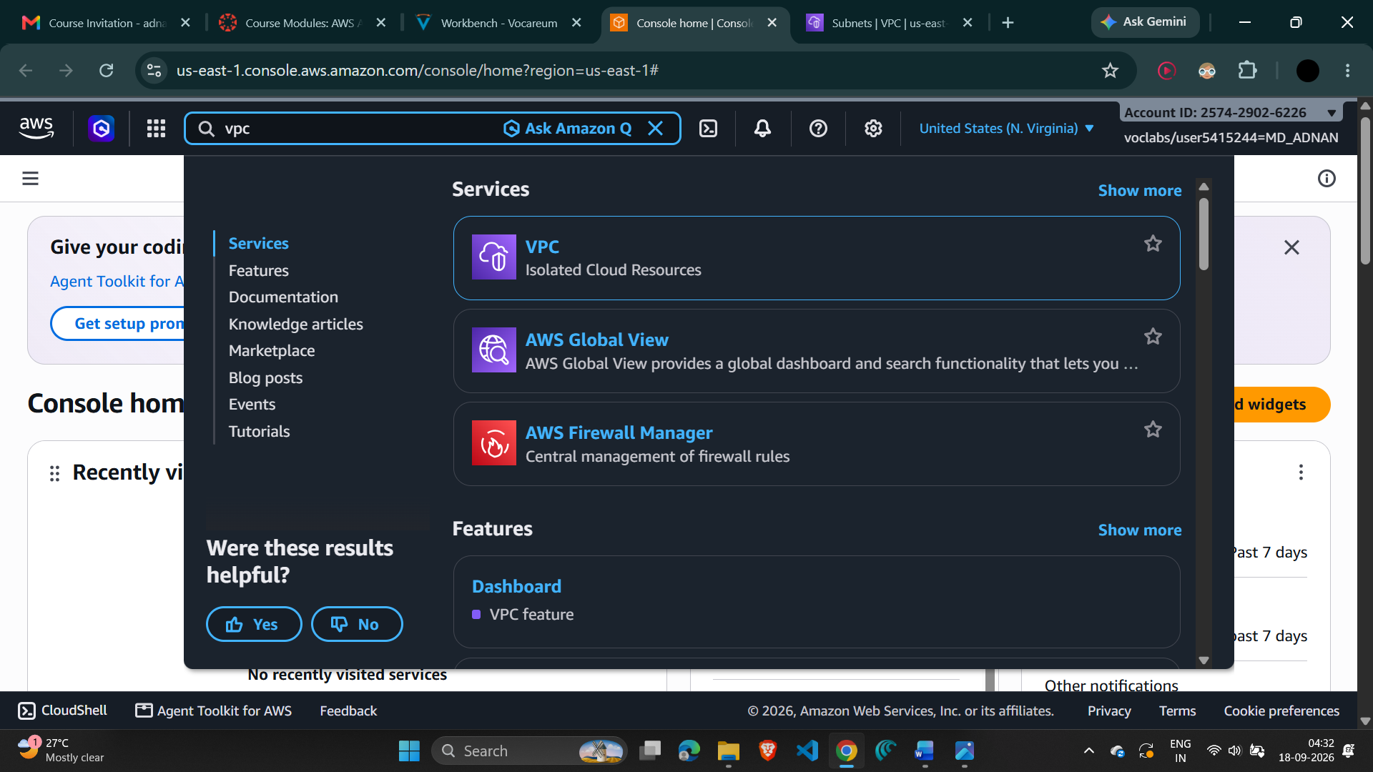

2. Create the VPC
- Confirm the AWS Region is N. Virginia (us-east-1).
- Open the VPC dashboard and choose Create VPC.
- Choose VPC and more.
- Keep the IPv4 CIDR block as 10.0.0.0/16.
- Set Number of Availability Zones to 1 initially.
- Set Number of public subnets to 1 and Number of private subnets to 1.
- Under Customize subnets CIDR blocks, set the public subnet to 10.0.0.0/24 and the private subnet to 10.0.1.0/24.
- Set NAT gateways to 1 in 1 AZ, VPC endpoints to None, and keep DNS hostnames and DNS resolution enabled.
- Review the preview and create the VPC.
- Verify the created resources and choose View VPC.
Screenshot 2 — VPC creation settings / preview
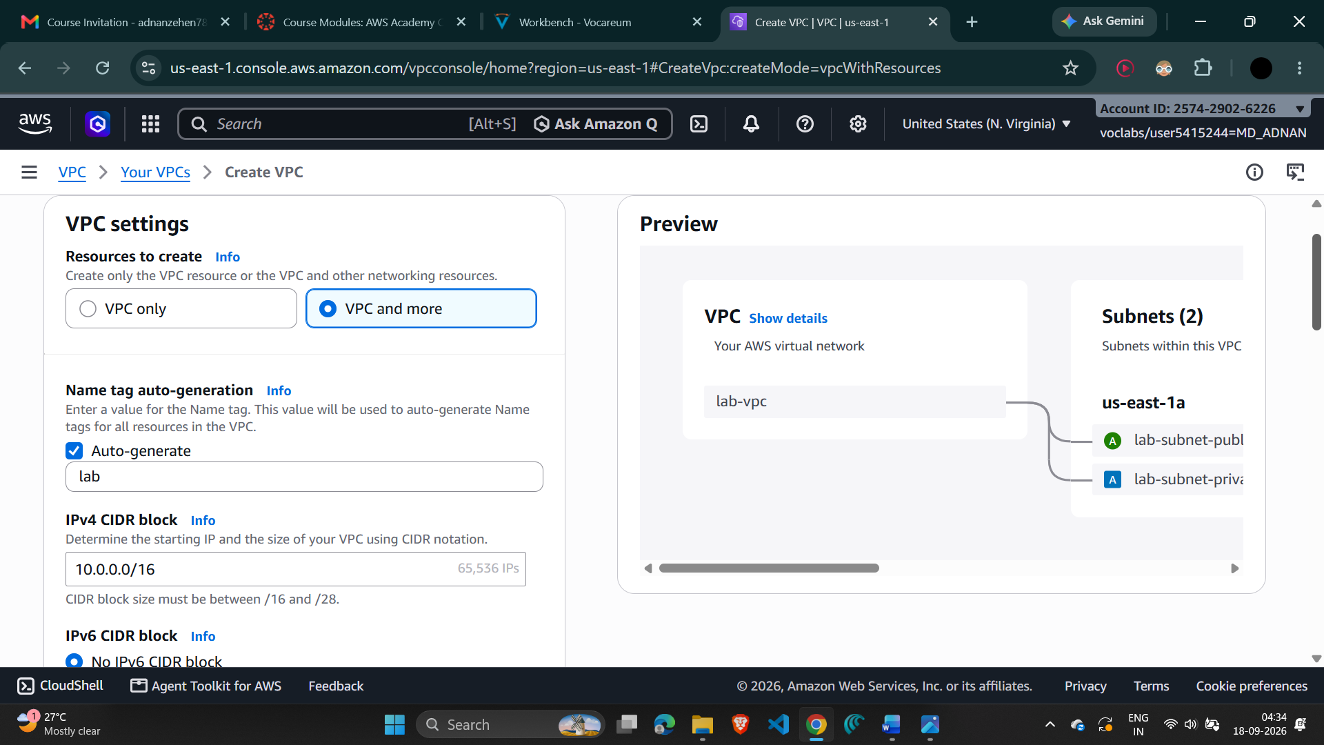
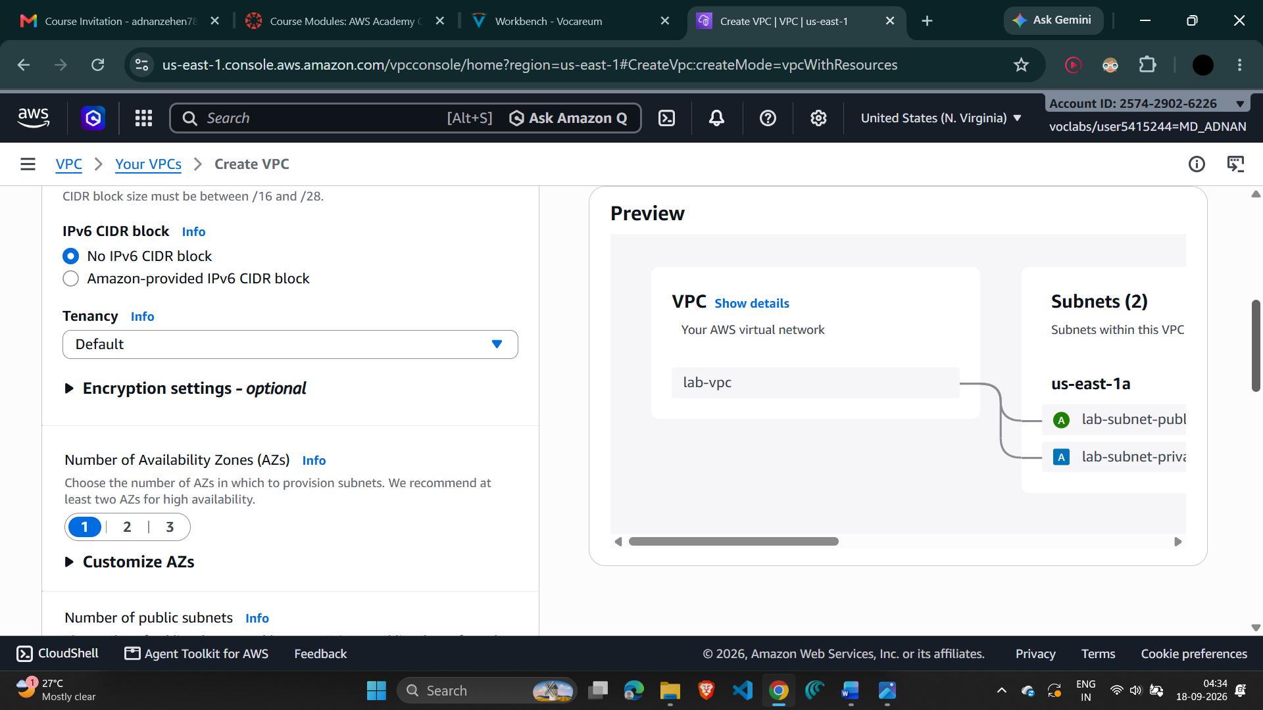
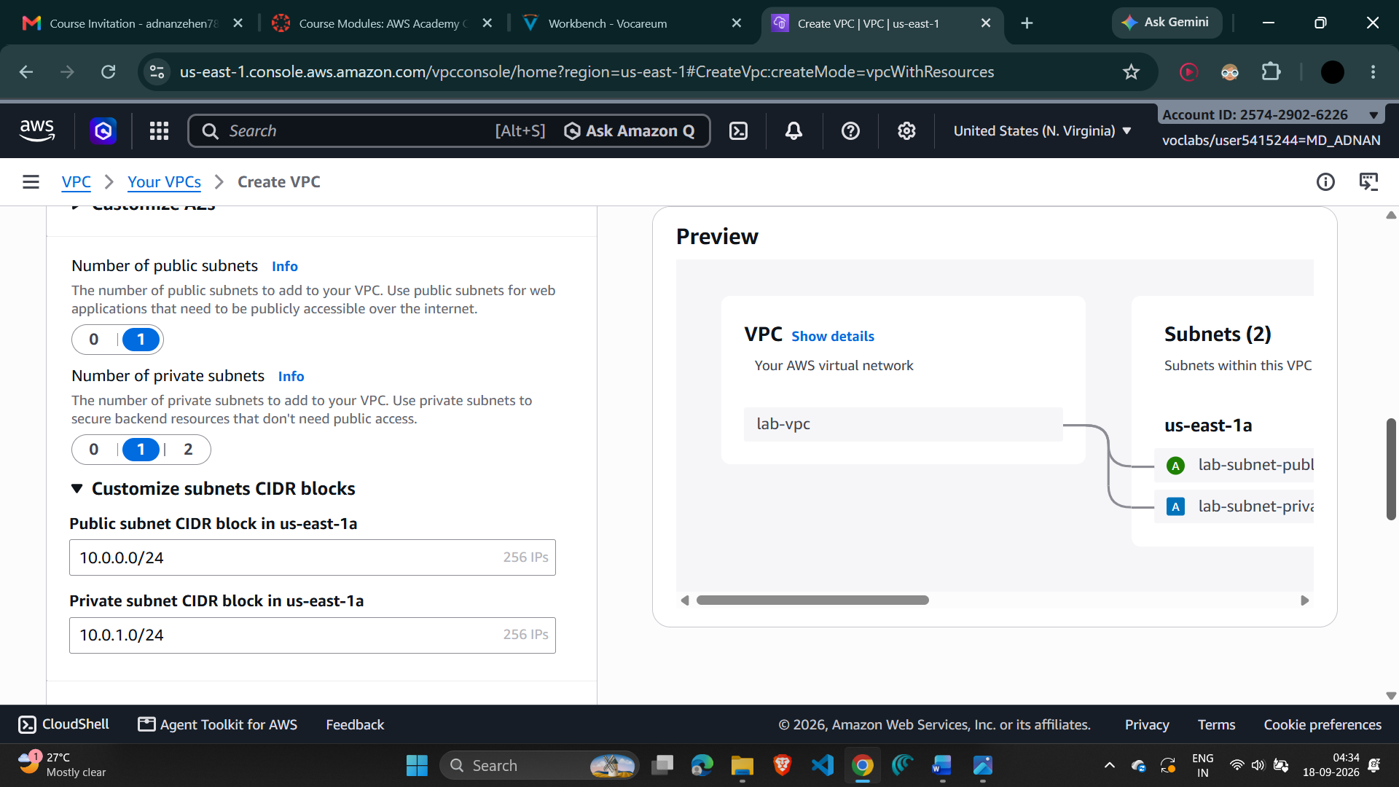
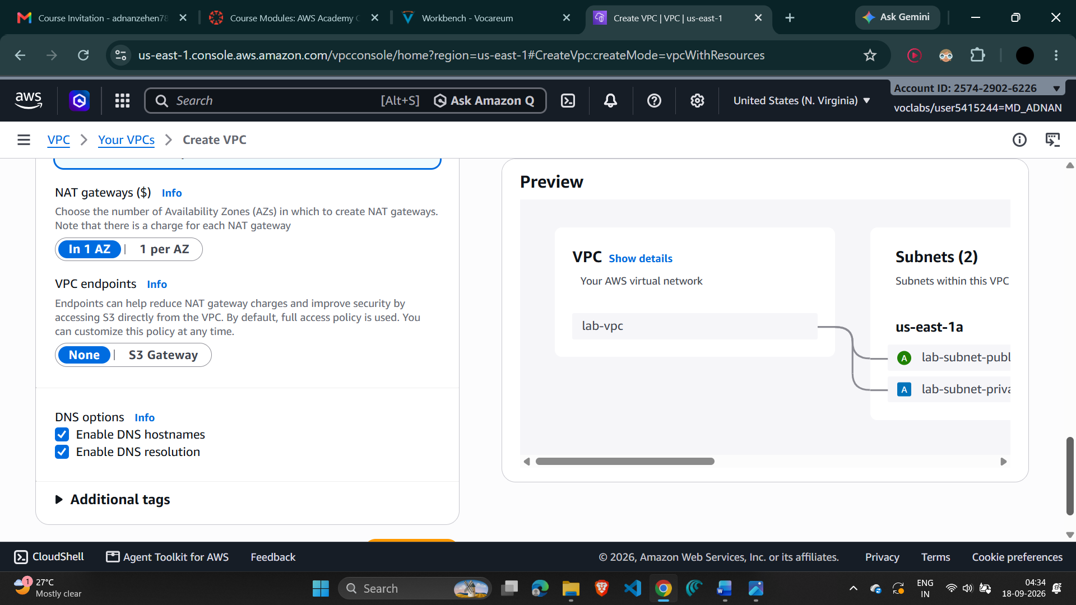

3. Verify the Initial VPC Resources
- Verify that the VPC is named lab-vpc.
- Confirm the initial public and private subnets are present in us-east-1a.
- Confirm the public and private route tables were created.
- Confirm the Internet Gateway and NAT Gateway were created.
Screenshot 3 — VPC resources after creation
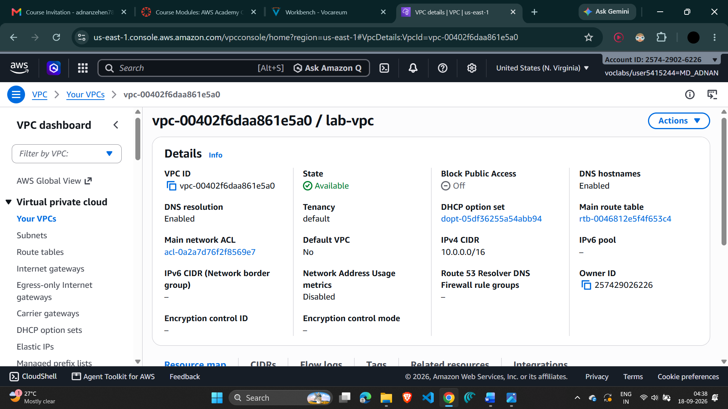

4. Create the Additional Subnets
- Open Subnets in the VPC console.
- Create the second public subnet with VPC ID lab-vpc, name lab-subnet-public2, the second Availability Zone (for example us-east-1b), and IPv4 CIDR 10.0.2.0/24.
- Create the second private subnet with VPC ID lab-vpc, name lab-subnet-private2, the second Availability Zone, and IPv4 CIDR 10.0.3.0/24.
Screenshot 4 — Both public and private subnets across two Availability Zones
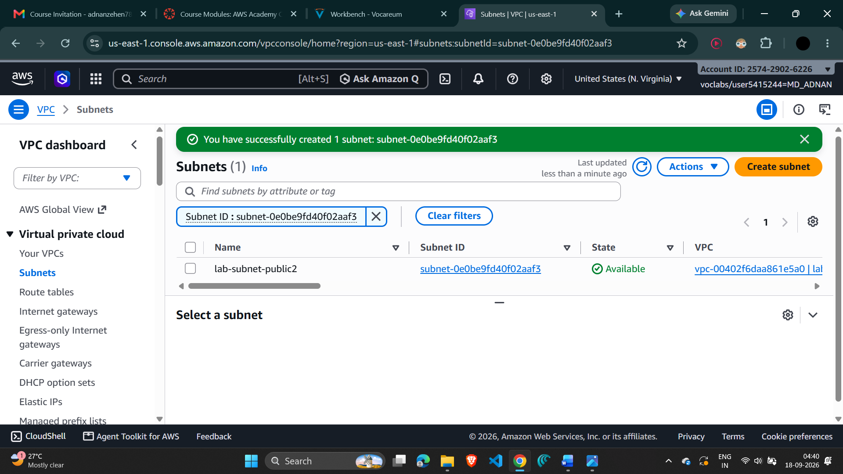
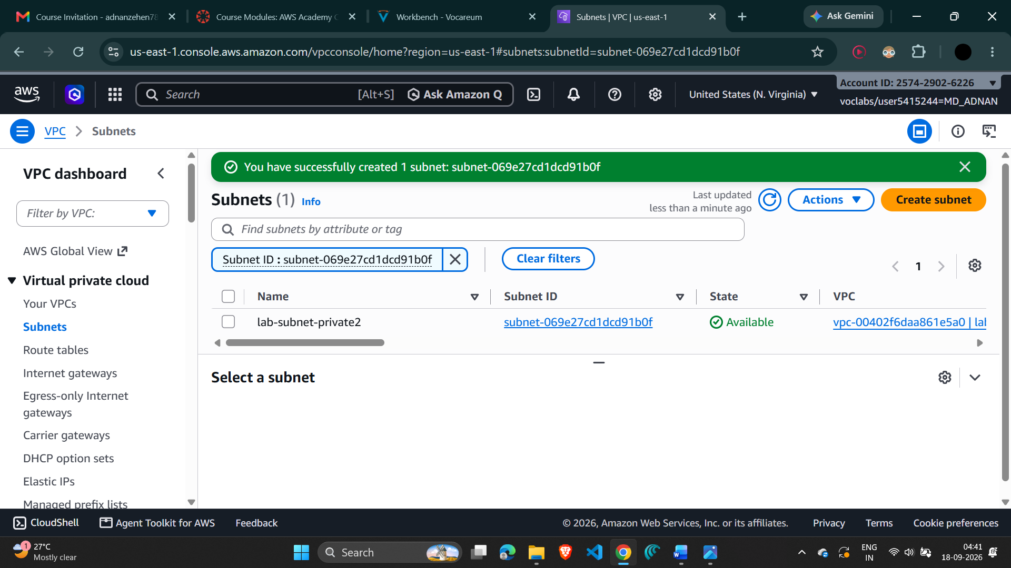

5. Configure the Private Route Table
- Open Route tables and select lab-rtb-private1-us-east-1a.
- Open the Routes tab and verify that 0.0.0.0/0 points to the NAT Gateway.
- Open Subnet associations and choose Edit subnet associations.
- Keep lab-subnet-private1-us-east-1a selected and also select lab-subnet-private2.
- Save the associations.
Screenshot 5 — Private route table and subnet associations
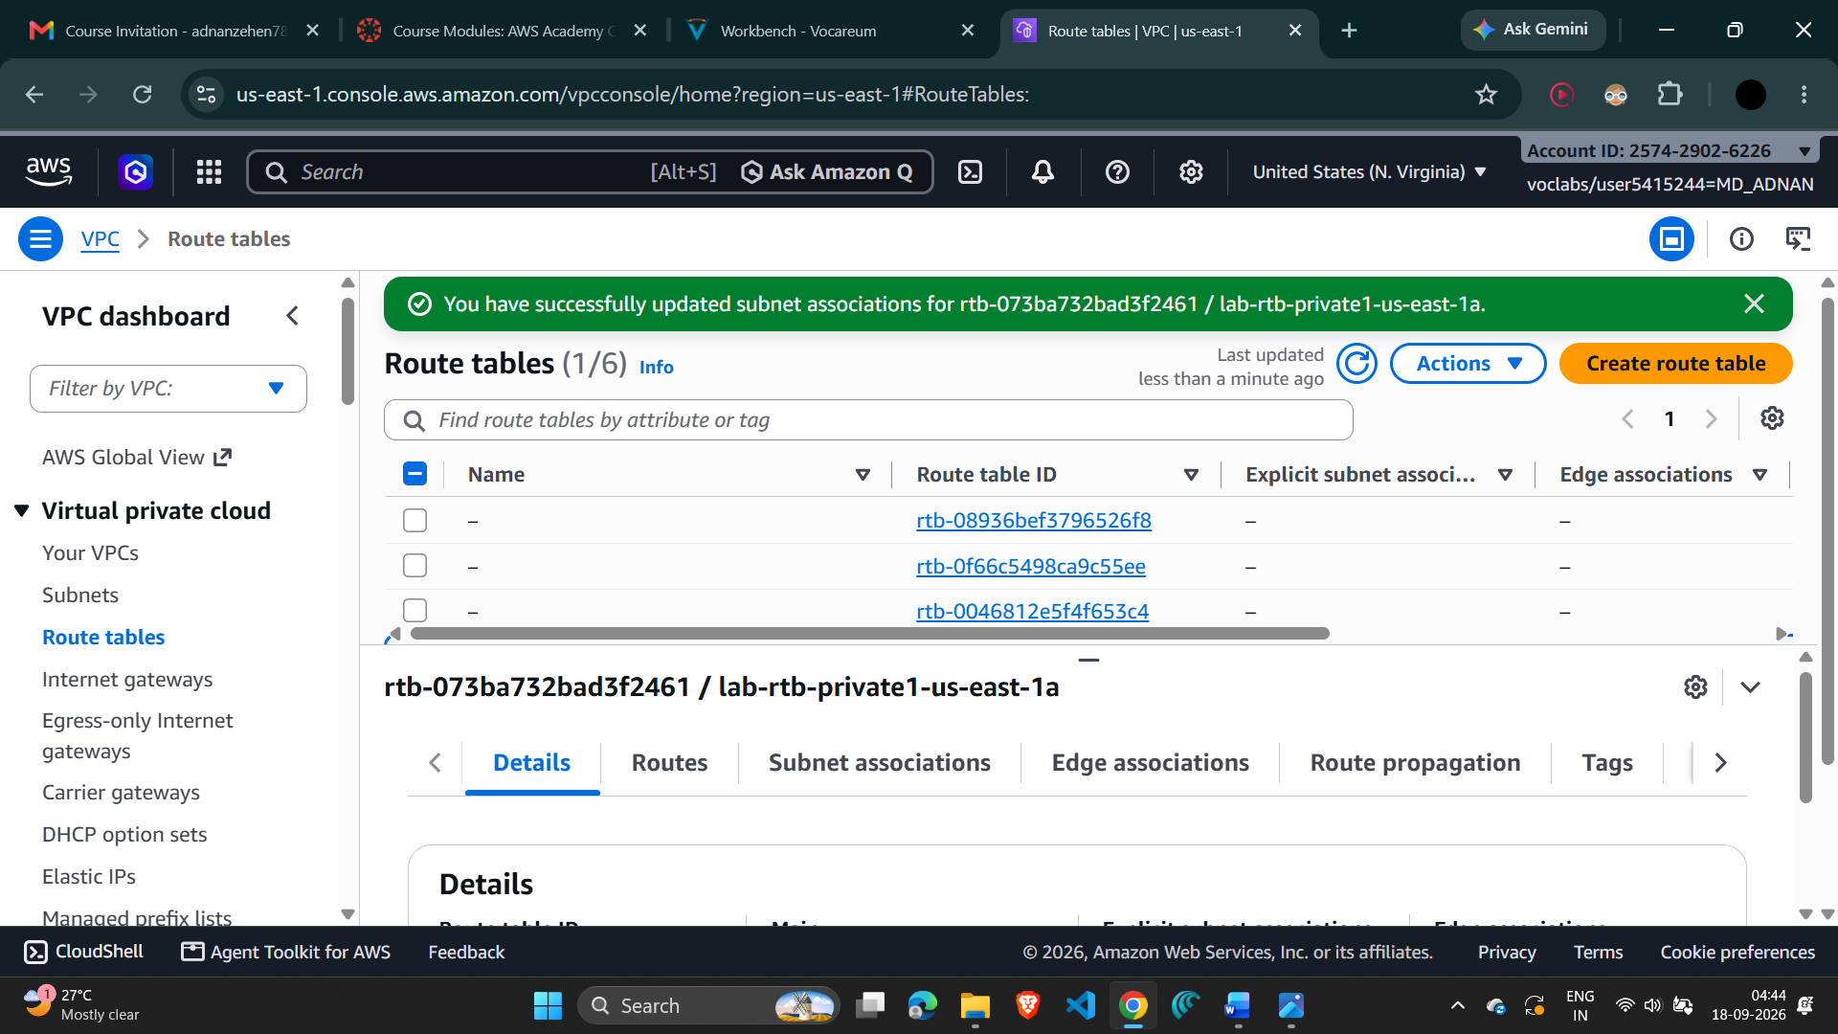

6. Configure the Public Route Table
- Select the lab-rtb-public route table.
- Open the Routes tab and verify that 0.0.0.0/0 points to the Internet Gateway.
- Open Subnet associations and choose Edit subnet associations.
- Keep lab-subnet-public1-us-east-1a selected and also select lab-subnet-public2.
- Save the associations.
Screenshot 6 — Public route table and subnet associations
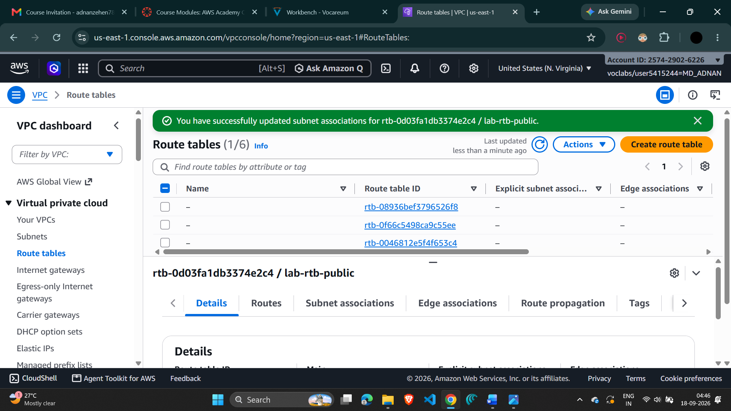

7. Create the VPC Security Group
- Open Security groups and choose Create security group.
- Security group name: Web Security Group.
- Description: Enable HTTP access.
- Select lab-vpc as the VPC.
- Add an inbound rule with Type HTTP, Source Anywhere-IPv4, and description Permit web requests.
- Create the security group.
Screenshot 7 — Web Security Group with HTTP inbound rule
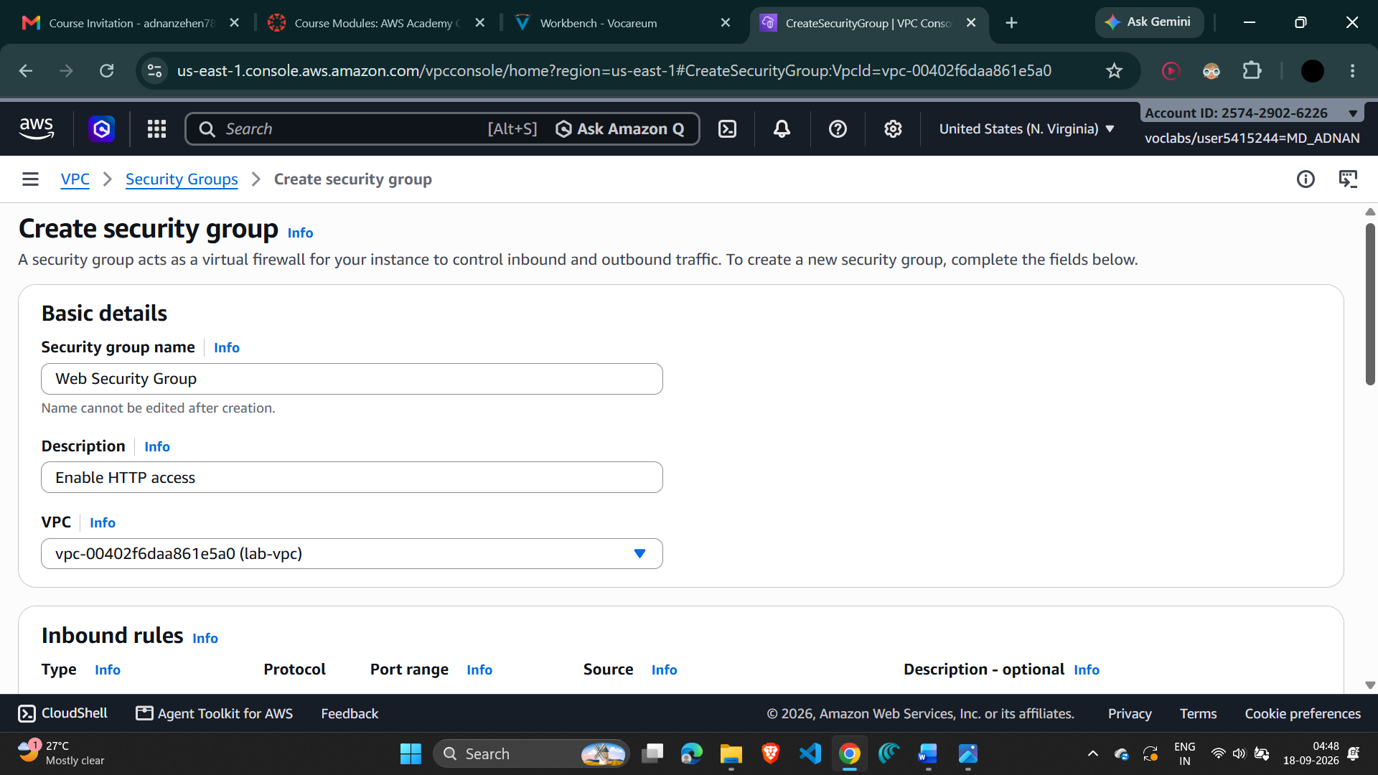
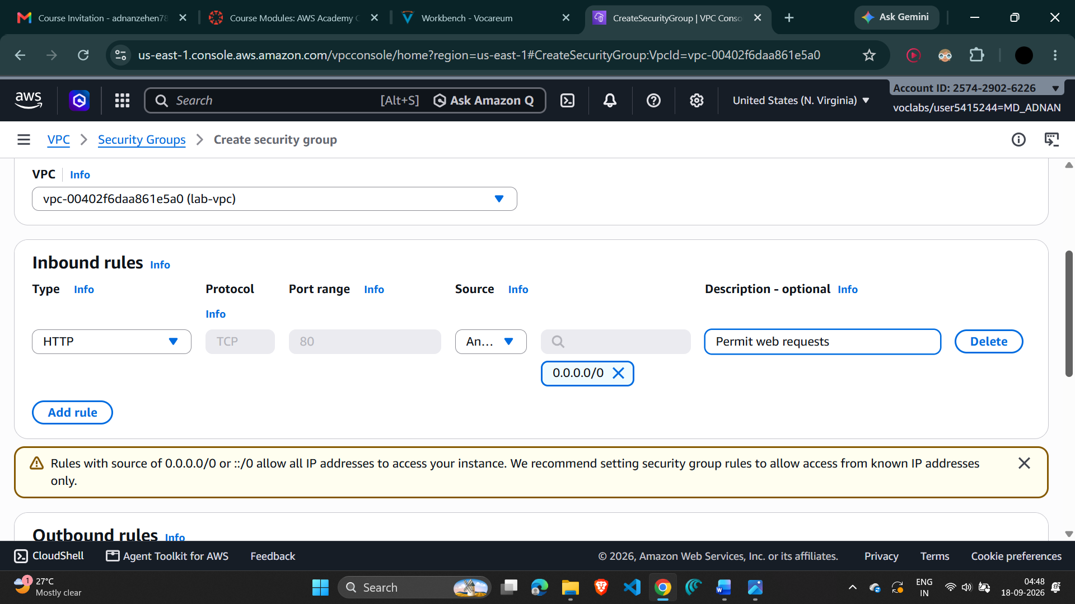

8. Launch the Web Server EC2 Instance
- Open the EC2 console and choose Launch instance.
- Set the instance name to Web Server 1.
- Keep the default Amazon Linux AMI selected and select Amazon Linux 2023 AMI.
- Keep the instance type as t2.micro.
- Select the existing key pair vockey.
- Under Network settings, choose Edit and set Network to lab-vpc.
- Set Subnet to lab-subnet-public2 and enable Auto-assign public IP.
- For Firewall, select Select existing security group and choose Web Security Group.
- Keep the default storage settings.
Screenshot 8 — EC2 instance configuration / Network settings
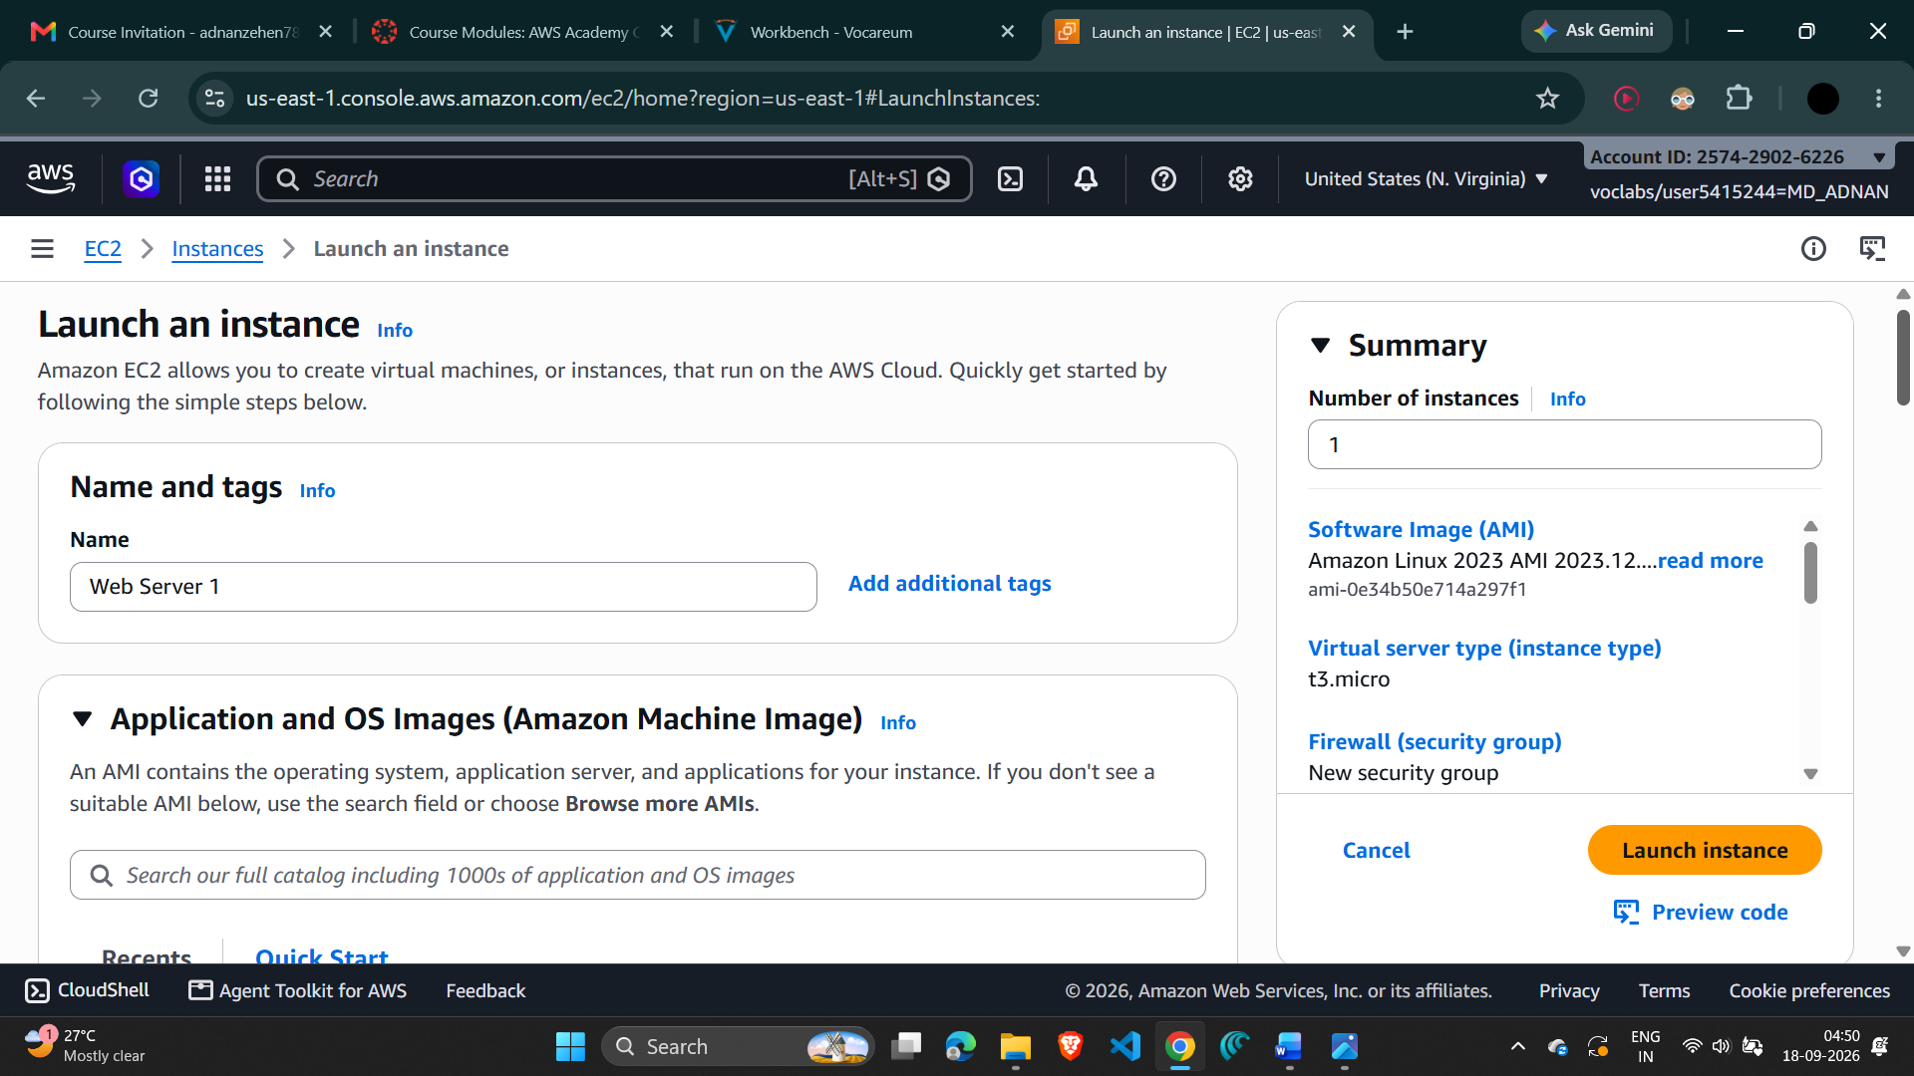
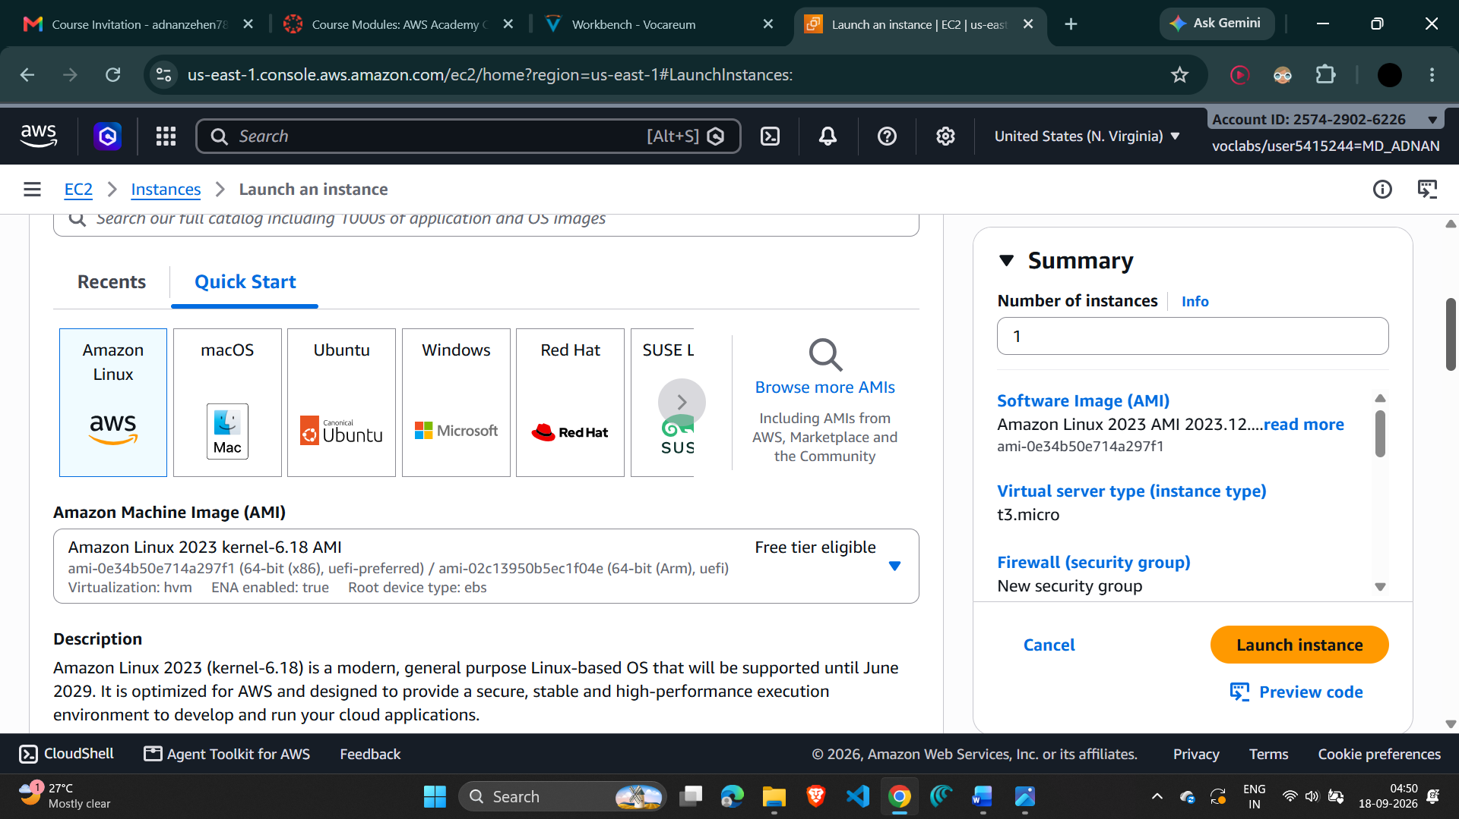

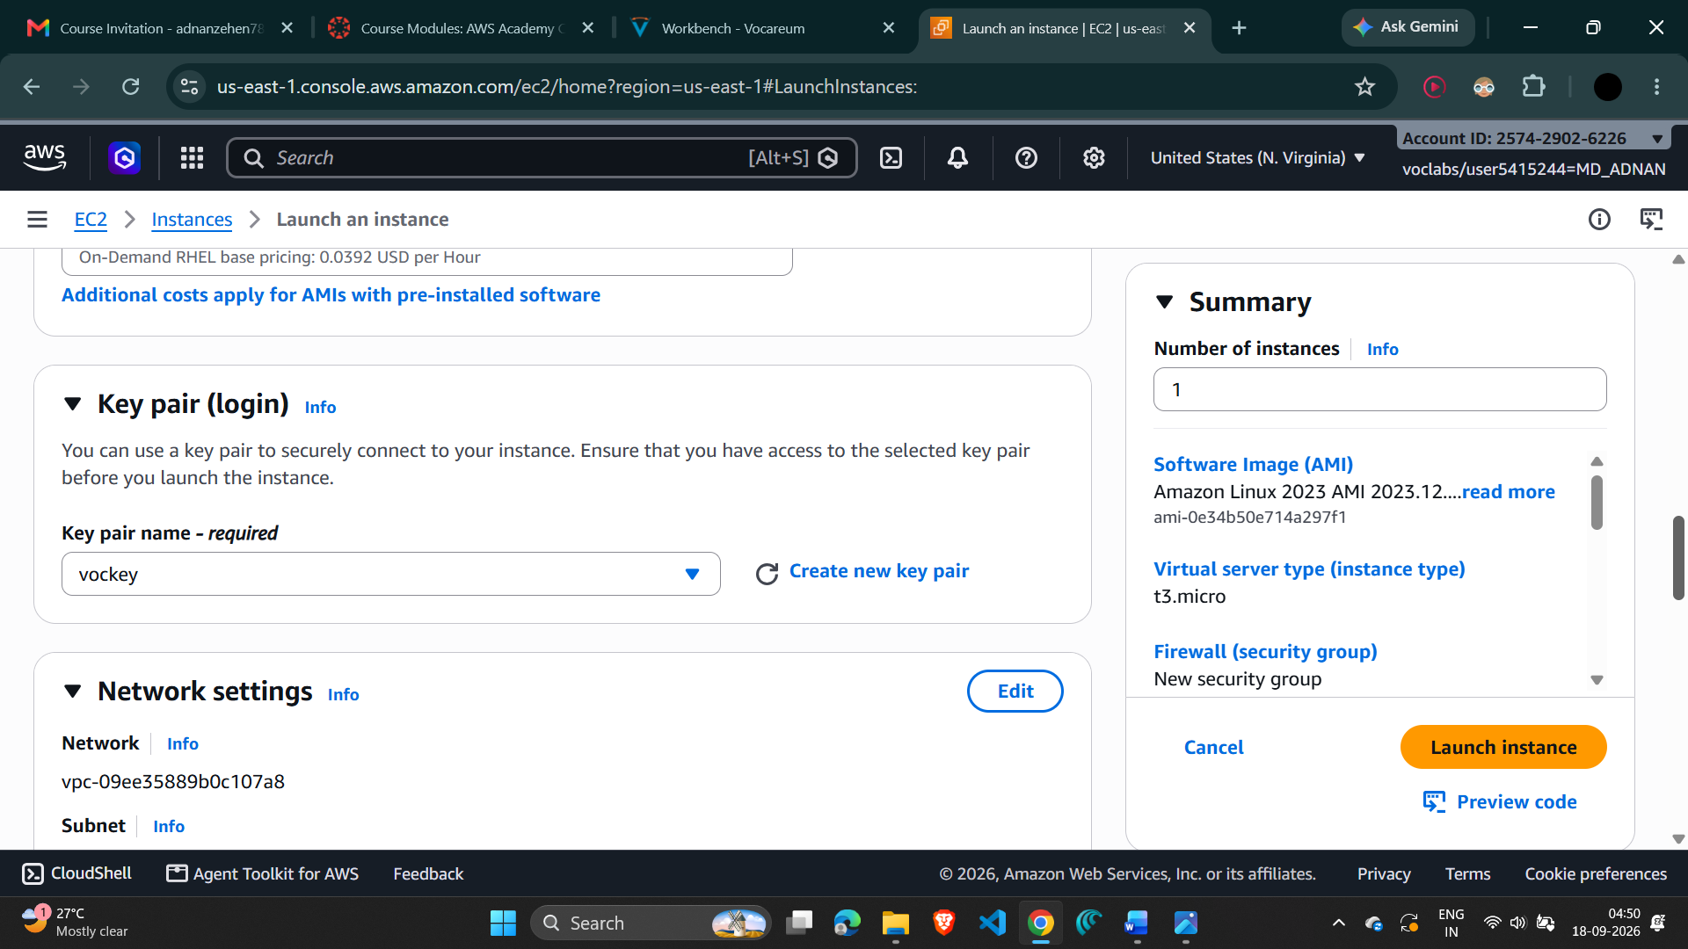
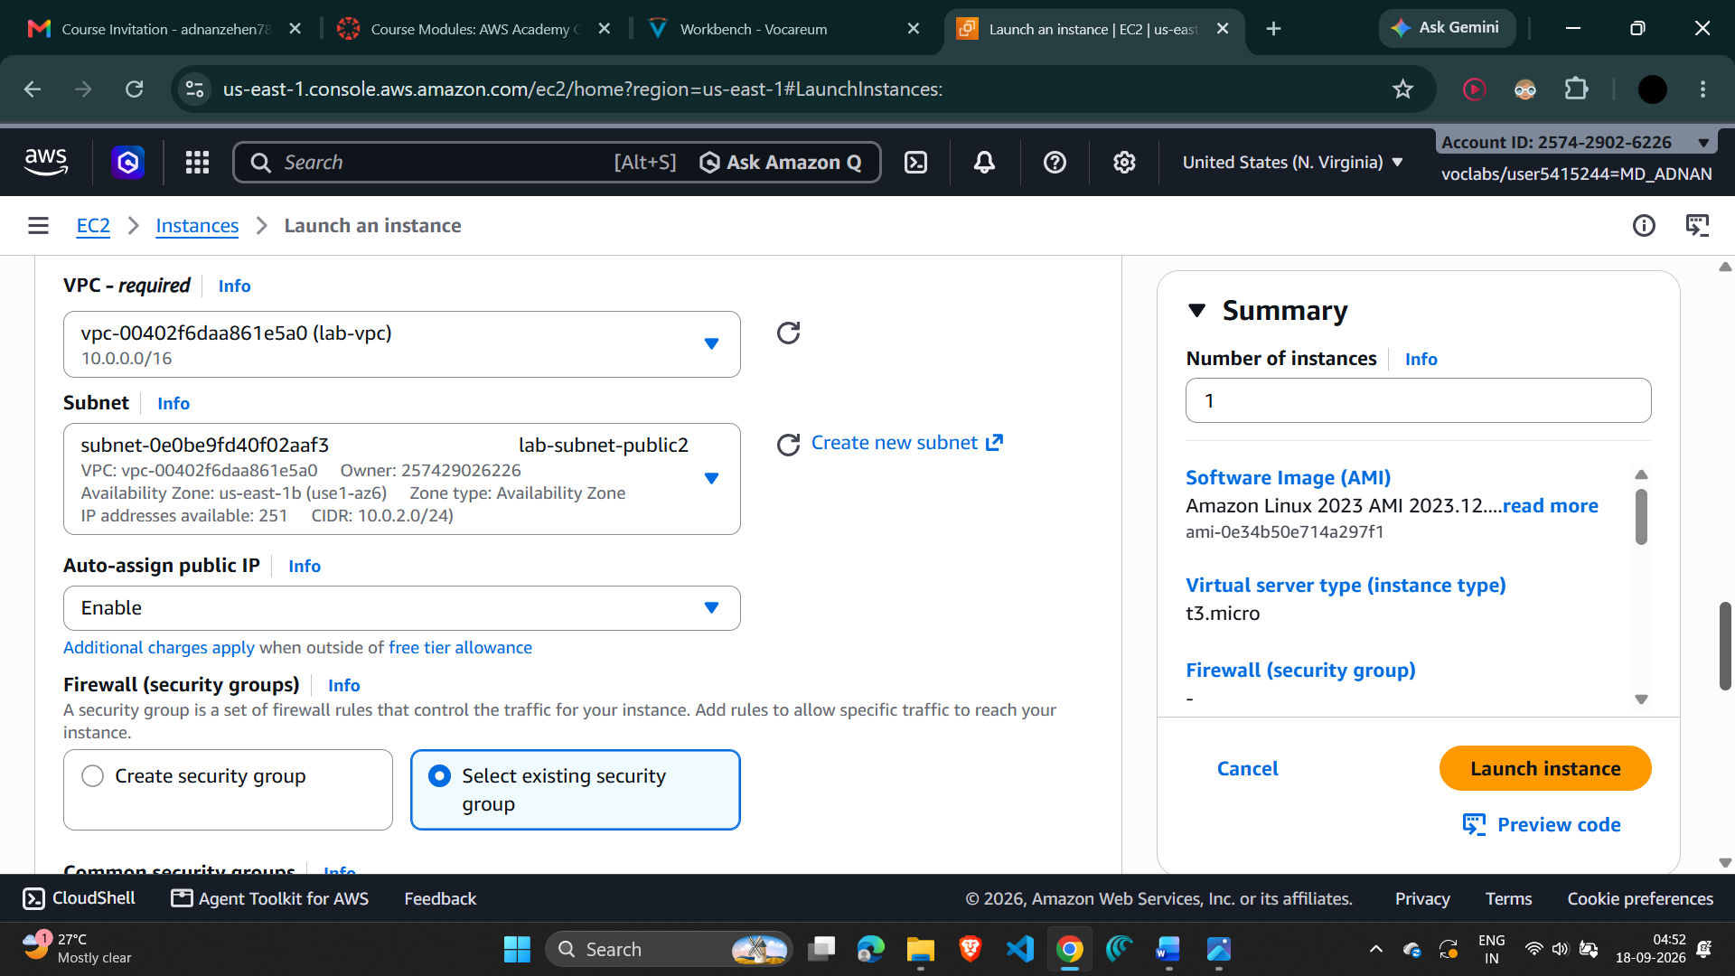

9. Add the User Data Script
- Expand Advanced details in the EC2 launch form.
- Paste the following script into the User data box:
#!/bin/bash
# Install Apache Web Server and PHP
dnf install -y httpd wget php mariadb105-server
# Download Lab files
wget https://aws-tc-largeobjects.s3.us-west-2.amazonaws.com/CUR-TF-100-ACCLFO-2-2/lab2-vpc/s3/lab2.zip
unzip lab2.zip -d /var/www/html/
# Turn on web server
chkconfig httpd on
service httpd start
Screenshot 9 — User data script entered in Advanced details
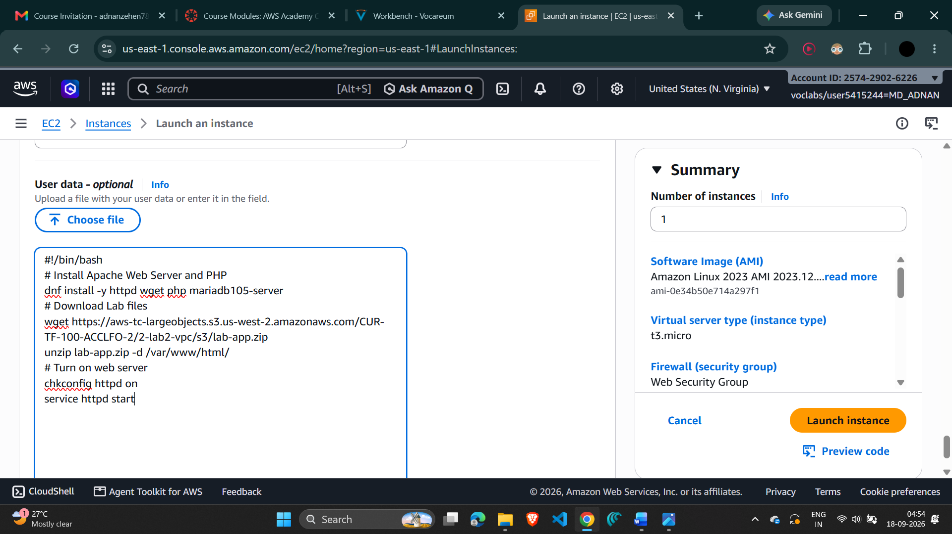

10. Launch and Verify the Web Server
- Choose Launch instance.
- Choose View all instances.
- Wait until Web Server 1 shows 2/2 checks passed.
- Select Web Server 1 and copy the Public IPv4 DNS value from the Details tab.
- Open a new browser tab, paste the Public IPv4 DNS value, and press Enter.
- Verify that the web page displays the AWS logo and instance metadata values.
Screenshot 10 — Web Server 1 showing 2/2 status checks passed
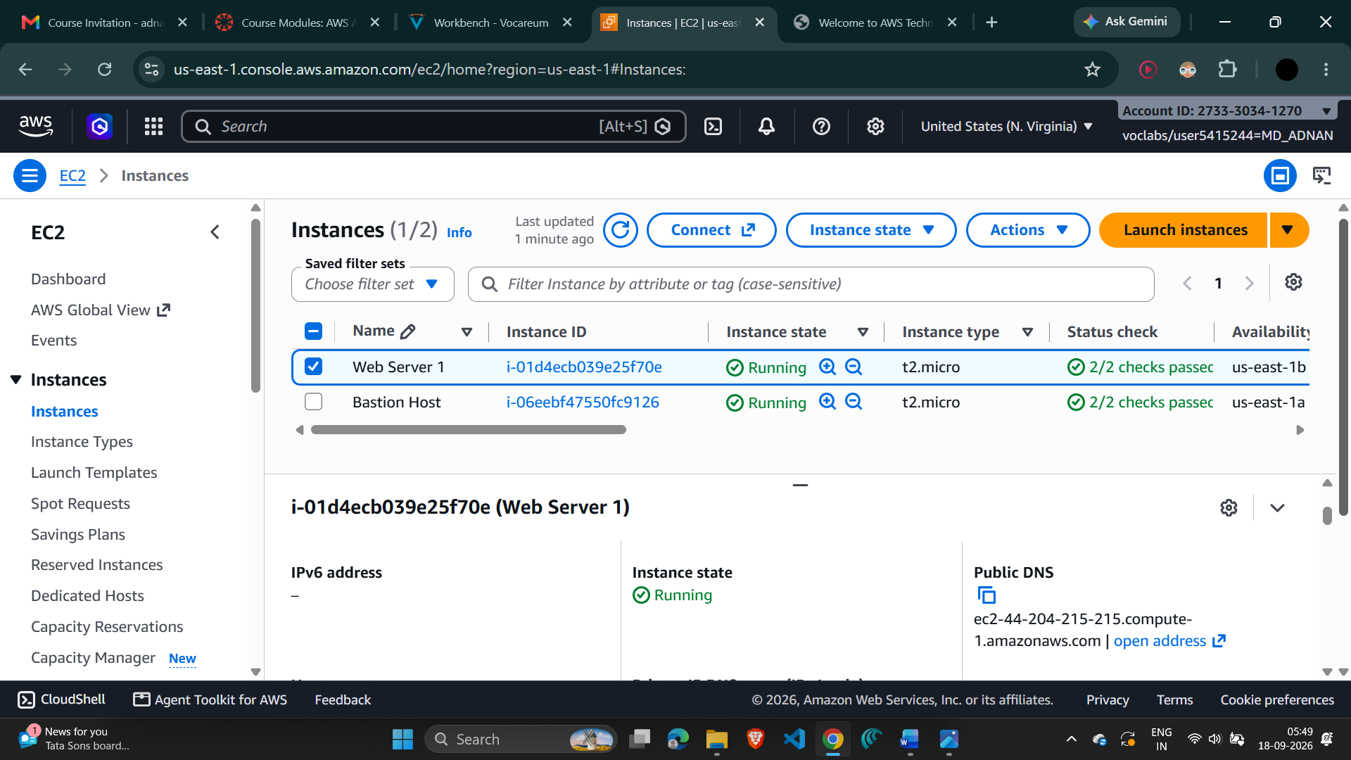

11. Verify the Web Page
- Open the Public IPv4 DNS address in a browser.
- Confirm that the deployed web application/web page loads successfully.
- Record the Public IPv4 DNS value in the result section of this documentation.
Screenshot 11 — Successfully loaded web server page
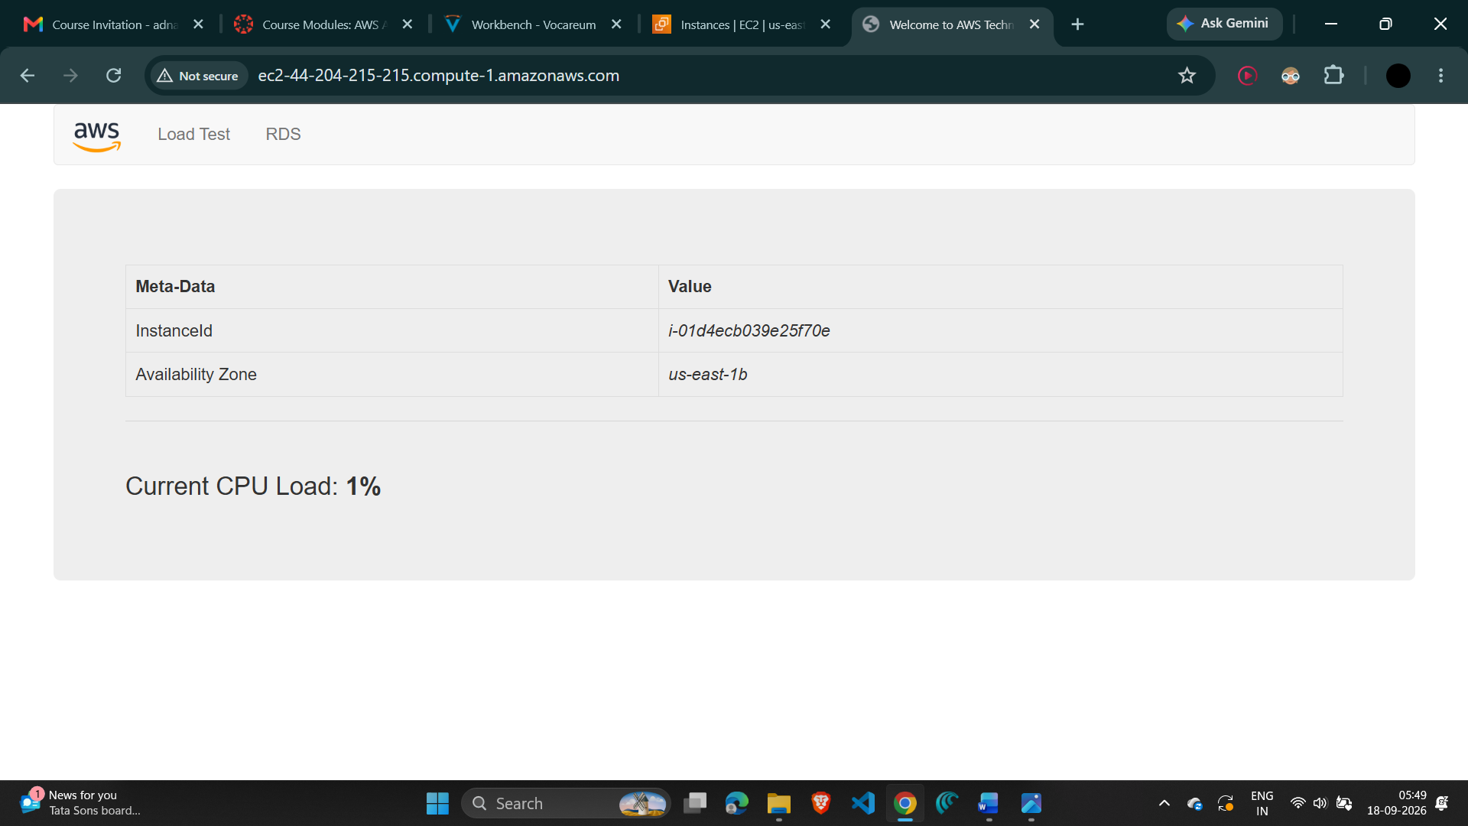

12. Submit and Complete the Lab
- Choose Submit at the top of the lab instructions.
- When prompted, choose Yes.
- Review the grades panel and, if required, open Submission Report for detailed feedback.
- Choose End Lab and confirm by selecting Yes.
Screenshot 12 — Lab submission / completion confirmation
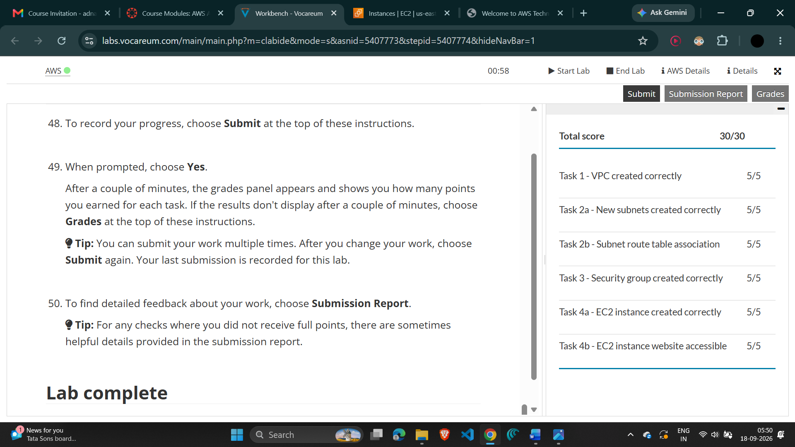

6. Result
The VPC and its networking components were created successfully. The Web Security Group was configured to permit HTTP requests, and the EC2 instance Web Server 1 was launched in the public subnet. After the instance passed its status checks, the Public IPv4 DNS was used to access the web server.
VPC | lab-vpc
EC2 Instance | Web Server 1
Public IPv4 DNS | _______________ec2-44-204-215-215.compute-1.amazonaws.com_________________________
Final Status | ____Lab completed successfully – 30/30____________________________________

7. Conclusion
The practical demonstrates how Amazon VPC networking can be designed using subnets, route tables, an Internet Gateway, and a NAT Gateway. A security group was used as the instance-level network firewall, and an Amazon EC2 instance was configured as a web server using user data. Successful access through the instance's Public IPv4 DNS confirms the deployment.

