AWS CLOUD LAB – 1
Introduction to AWS IAM
Detailed Practical Documentation

Student Name | _________MD ADNAN_______________________________
Roll / Registration No. | ________13071025052________________________________
Course / Subject | ___________Cloud Computing_____________________________
Semester | ______3__________________________________
Date | _______18/09/2026________________________________

1. Lab Overview and Objectives
AWS Identity and Access Management (IAM) is a web service that enables AWS customers to manage users and their permissions in AWS. In this lab, IAM users, groups and policies are explored, users are assigned to groups according to job responsibilities, and the effect of permissions is tested by signing in as different IAM users.
The lab demonstrates:
- Exploring pre-created IAM Users and Groups.
- Inspecting IAM policies as applied to the pre-created groups.
- Following a real-world scenario by adding users to groups with specific capabilities enabled.
- Locating and using the IAM sign-in URL.
- Experimenting with the effects of policies on service access.

AWS Service Restrictions
The lab environment restricts access to AWS services and service actions that are not required for completing the lab. Attempts to use other services or perform actions outside the documented instructions may result in access errors.

AWS Identity and Access Management
Manage IAM Users and their access: Users can be created and assigned individual security credentials such as access keys, passwords and multi-factor authentication devices. Permissions control the operations a user can perform.
Manage IAM Roles and their permissions: An IAM Role is similar to a user, but it is an AWS identity without a password. A role contains policies that determine what the identity can and cannot do in AWS.
Manage federated users and their permissions: Identity federation can allow existing enterprise users to access AWS resources without creating a separate IAM user for every identity.

Duration
The lab instructions indicate an approximate completion time of 40 minutes.

2. Accessing the AWS Management Console
1. At the top of the lab instructions, choose Start Lab. The lab session starts and a timer displays the remaining session time. Before the session expires, the session can be refreshed by choosing Start Lab again as instructed.
2. Choose the AWS link in the upper-left corner of the lab instructions. A new browser tab opens and connects to the AWS Management Console.
3. Arrange the AWS Management Console browser tab beside the lab instructions so that both can be viewed while completing the practical.
Screenshot 1 – Start Lab / AWS Management Console
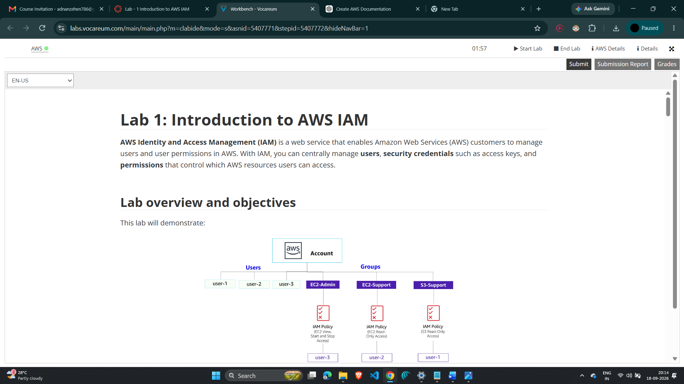
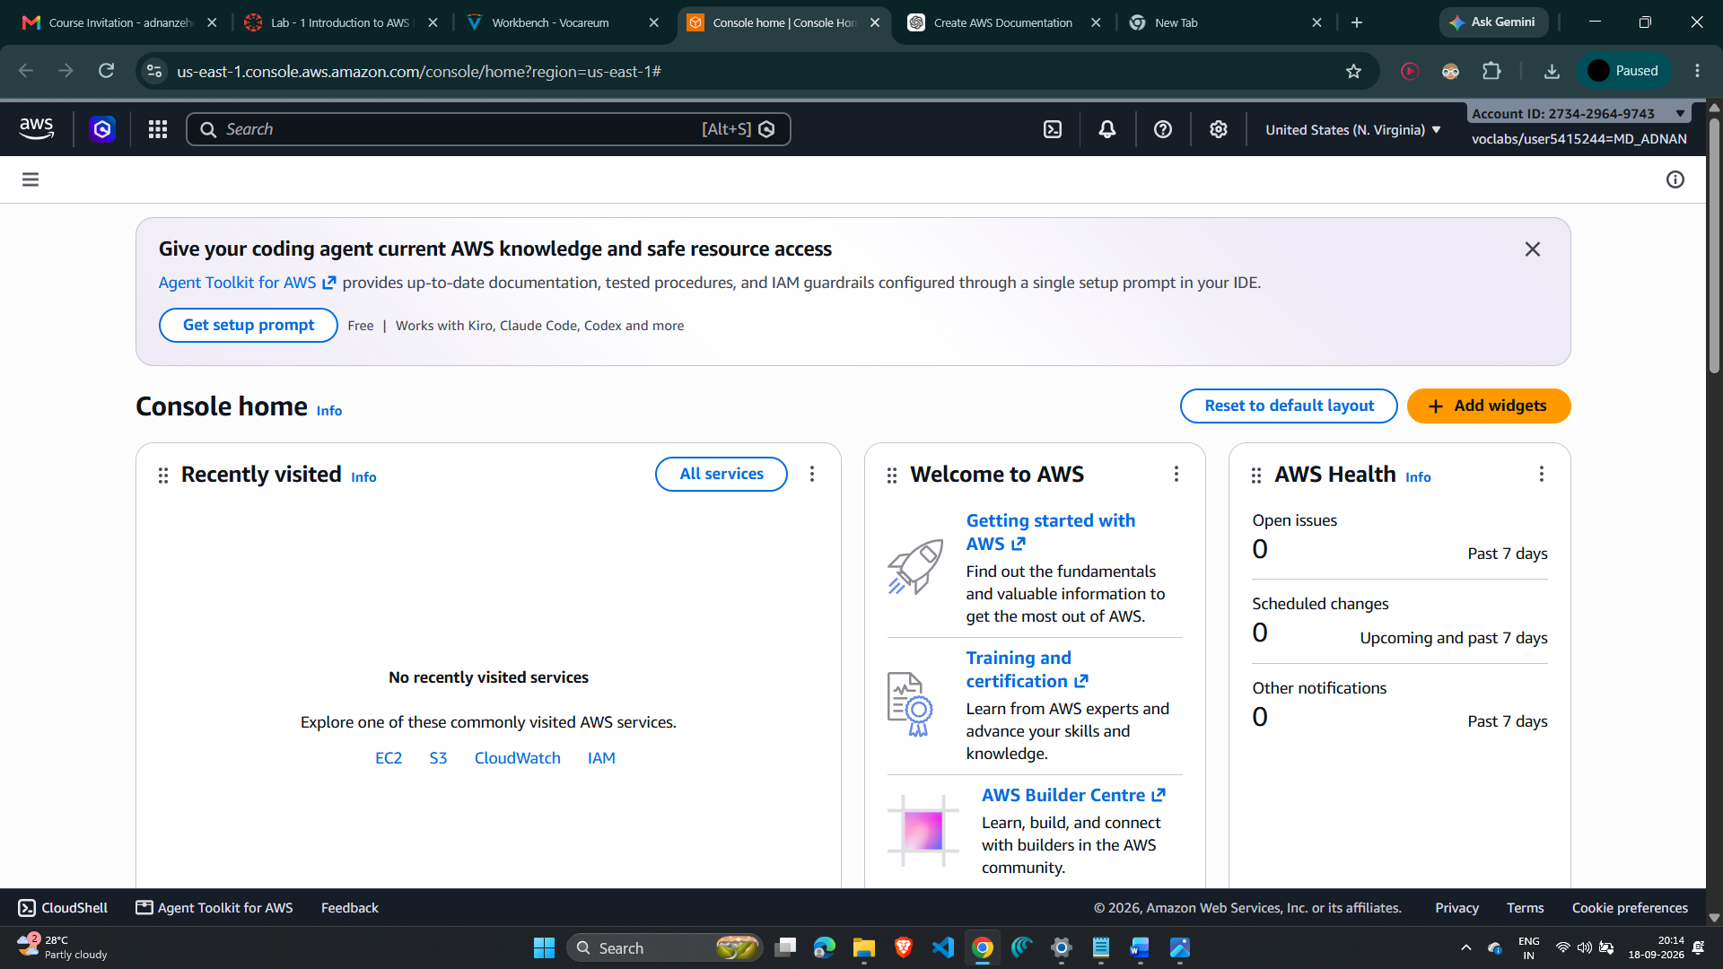

Getting Credit for Your Work
At the end of the lab, the work is submitted through the Submit button. The lab checks the names of resources and configurations, so values should be entered exactly as specified in the instructions.

3. Task 1: Explore the Users and Groups
In this task, the pre-created IAM users and groups are inspected before any assignments are made.
4. In the AWS Management Console search box to the right of Services, search for and choose IAM to open the IAM console.
5. In the navigation pane on the left, choose Users. Confirm that the pre-created users user-1, user-2 and user-3 are present.
6. Choose the user-1 link. This opens the user-1 summary page with the Permissions tab displayed.
7. Observe that user-1 does not have any permissions at this stage.
8. Choose the Groups tab. Observe that user-1 is not a member of any group initially.
9. Choose the Security credentials tab. Observe that user-1 has been assigned a console password.
Screenshot 2 – IAM Users List / user-1 User Details
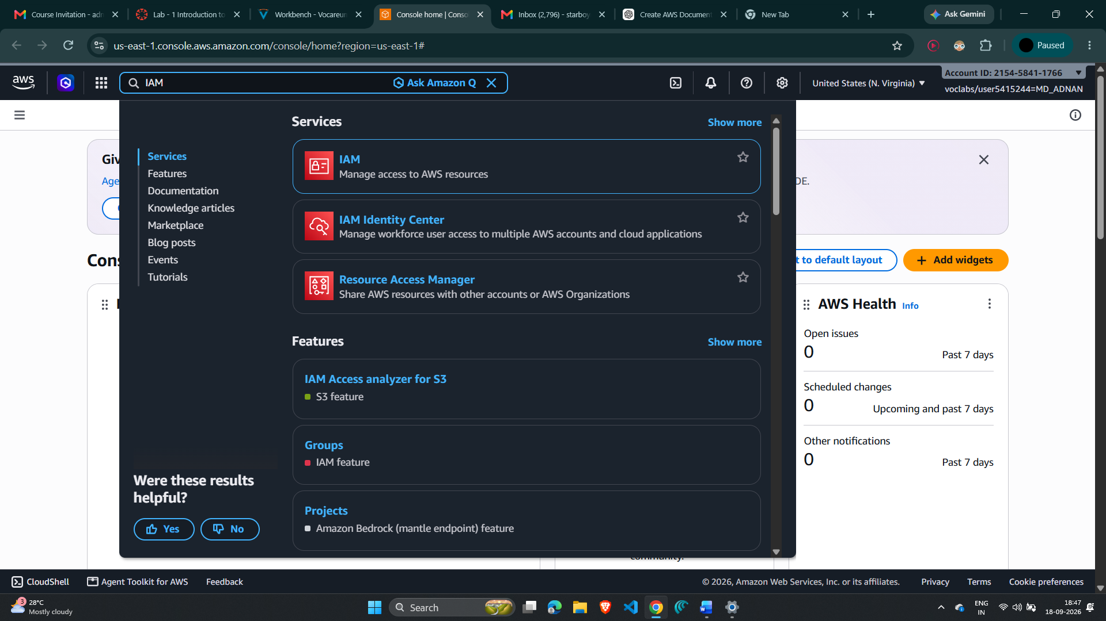
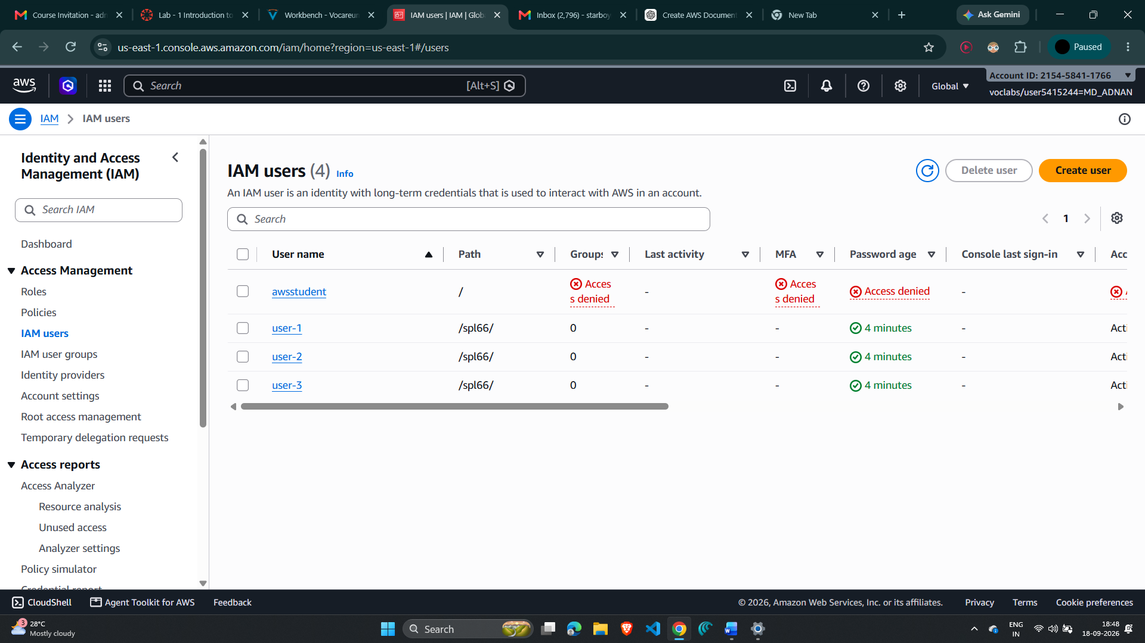

10. In the navigation pane, choose User groups. Confirm that the pre-created groups are EC2-Admin, EC2-Support and S3-Support.

Inspect the EC2-Support Group and Policy
11. Choose the EC2-Support group link to open its summary page.
12. Choose the Permissions tab. Observe that the group has the managed policy AmazonEC2ReadOnlyAccess attached.
13. Choose the plus (+) icon beside AmazonEC2ReadOnlyAccess to view the policy details. The policy permits List and Describe actions for Amazon EC2, Elastic Load Balancing, CloudWatch and Auto Scaling resources. Note the basic IAM policy structure: Effect determines Allow or Deny, Action specifies the API actions, and Resource defines the scope of the permissions.
Screenshot 3 – EC2-Support Group and AmazonEC2ReadOnlyAccess Policy
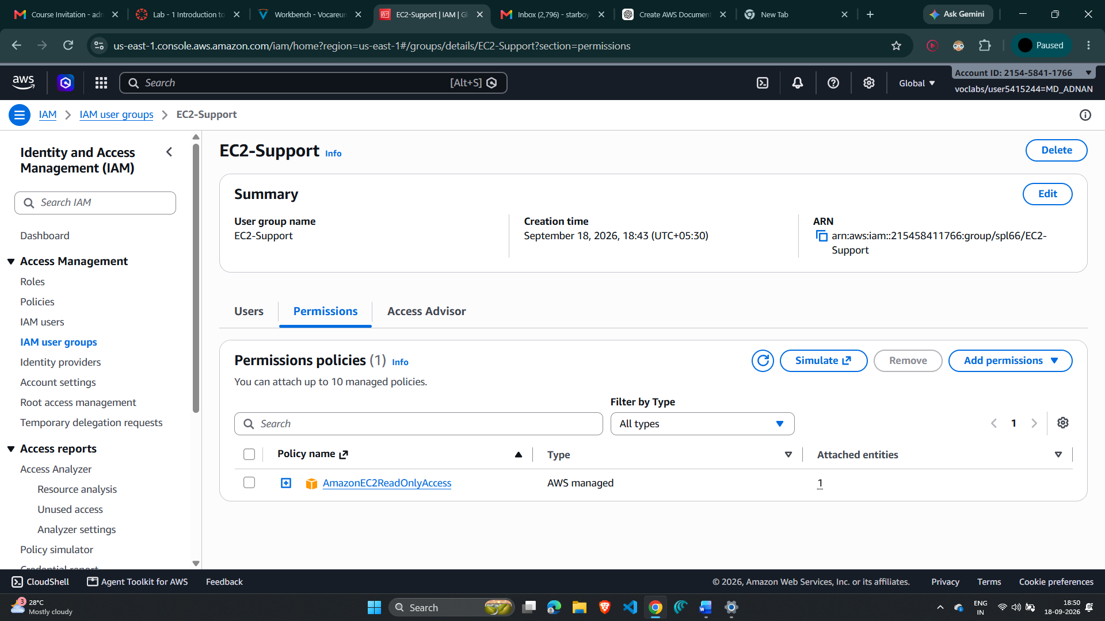
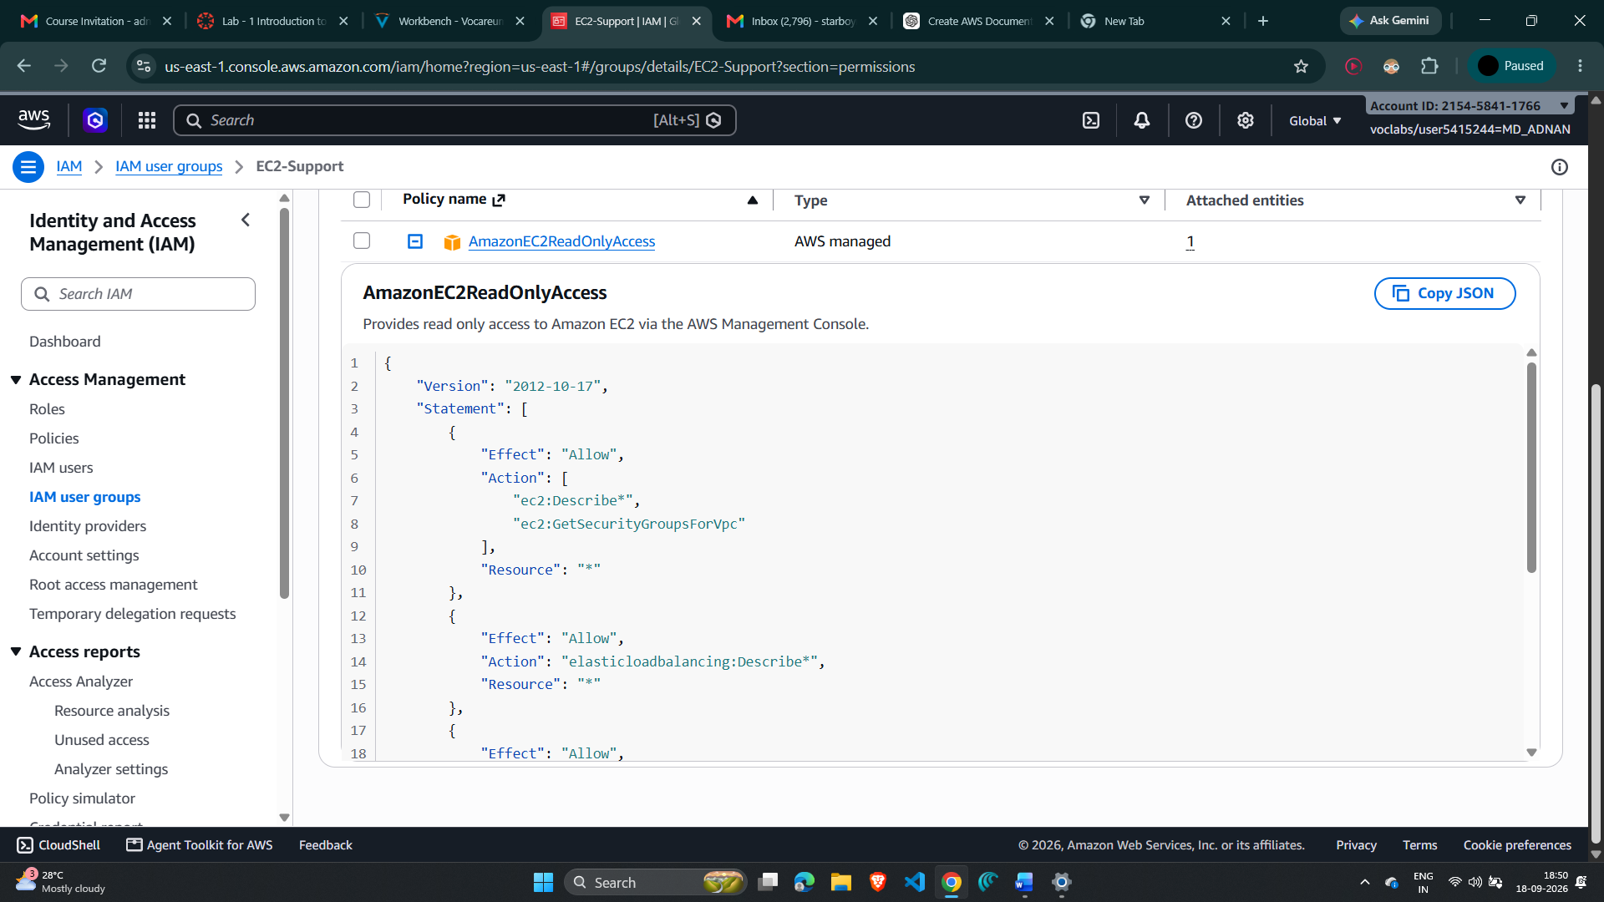

14. Choose the minus (-) icon to hide the policy details.

Inspect the S3-Support Group and Policy
15. In the navigation pane, choose User groups.
16. Choose the S3-Support group link and then choose the Permissions tab. Observe that AmazonS3ReadOnlyAccess is attached.
17. Choose the plus (+) icon to view the policy details. This policy grants Get and List permissions for resources in Amazon S3.
Screenshot 4 – S3-Support Group and AmazonS3ReadOnlyAccess Policy
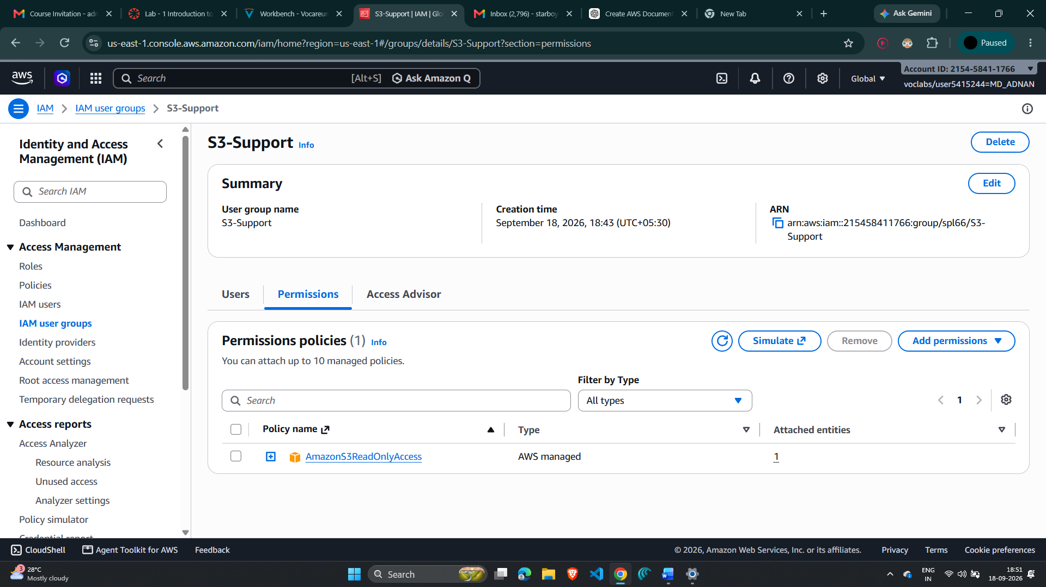
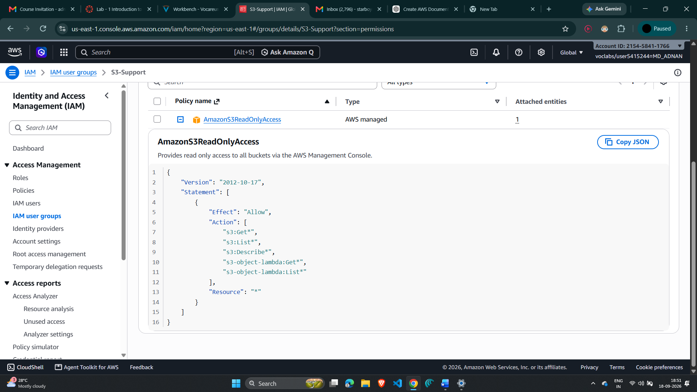
18. Choose the minus (-) icon to hide the policy details.

Inspect the EC2-Admin Group and Policy
19. In the navigation pane, choose User groups.
20. Choose the EC2-Admin group link and then choose the Permissions tab. Observe that this group uses an Inline Policy rather than a Managed Policy.
21. Choose the plus (+) icon to view the policy details. The policy grants permission to view EC2 information using Describe actions and to Start and Stop Amazon EC2 instances.
Screenshot 5 – EC2-Admin Inline Policy
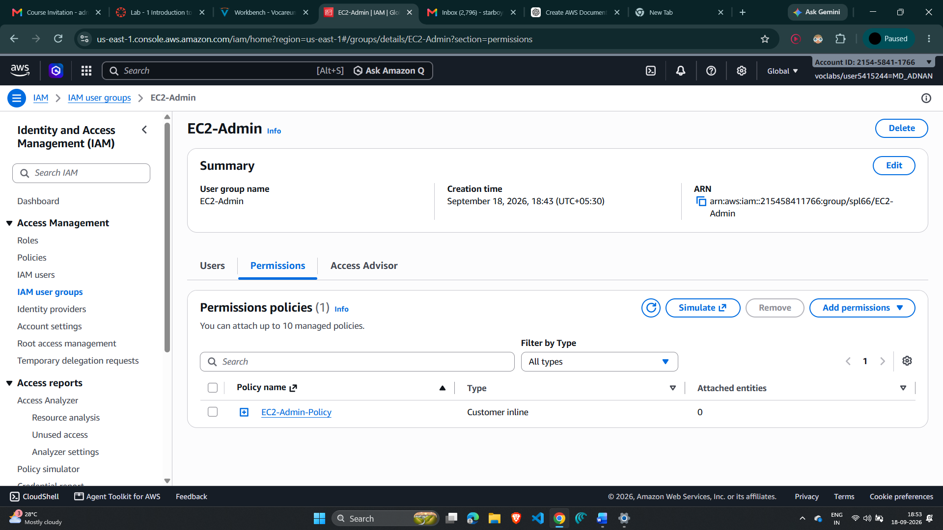
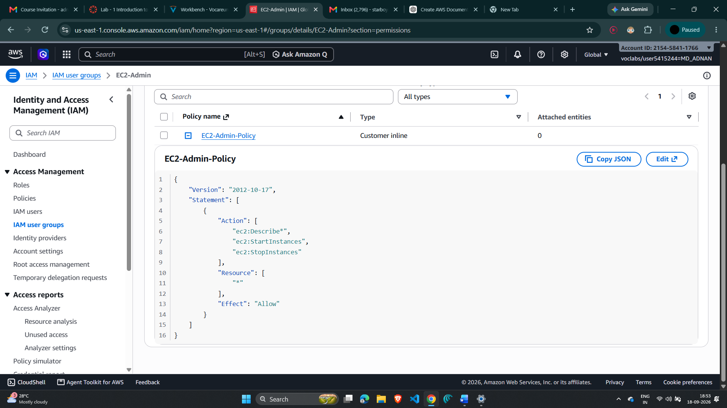
22. Choose the minus (-) icon to hide the policy details.

4. Business Scenario
For the remainder of the lab, the pre-created users and groups are configured to support different job functions. The target permission mapping is:
User | In Group | Permissions
user-1 | S3-Support | Read-Only access to Amazon S3
user-2 | EC2-Support | Read-Only access to Amazon EC2
user-3 | EC2-Admin | View, Start and Stop Amazon EC2 instances

5. Task 2: Add Users to Groups
The purpose of this task is to assign each user to the group corresponding to the user's job role so that the user inherits the permissions attached to that group.

Add user-1 to the S3-Support Group
23. In the left navigation pane, choose User groups.
24. Choose the S3-Support group link.
25. Choose the Users tab.
26. In the Users tab, choose Add users.
27. In the Add Users to S3-Support window, select user-1 and then choose Add users at the bottom of the screen. Verify that user-1 appears in the group's Users tab.
Screenshot 6 – user-1 Added to S3-Support
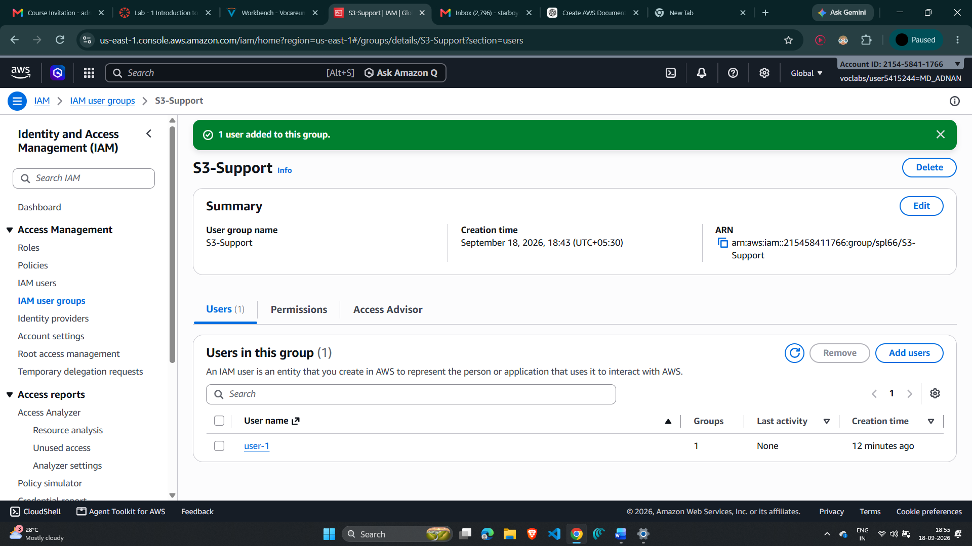

Add user-2 to the EC2-Support Group
28. Using the same workflow, add user-2 to the EC2-Support group. Verify that user-2 is listed as a member of EC2-Support.
Screenshot 7 – user-2 Added to EC2-Support
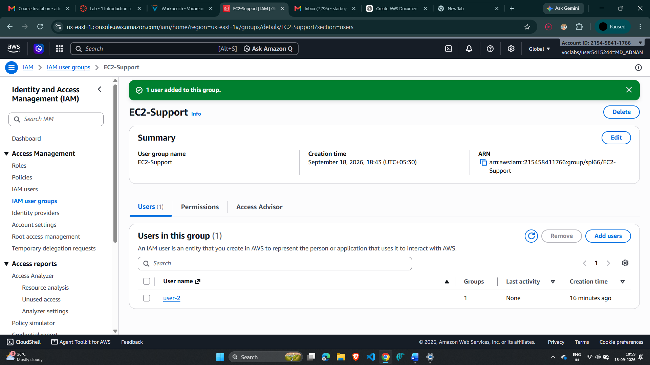

Add user-3 to the EC2-Admin Group
29. Using the same workflow, add user-3 to the EC2-Admin group. Verify that user-3 is listed as a member of EC2-Admin.
30. In the navigation pane, choose User groups. Each group should now show one user. If a group does not show one user, revisit the assignment steps and correct the membership.
Screenshot 8 – user-3 Selected for EC2-Admin Group
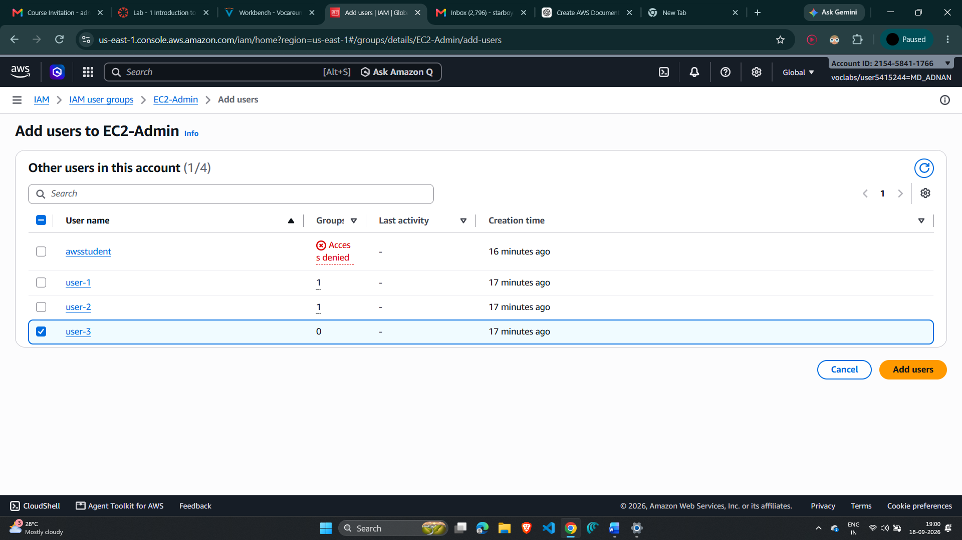

6. Task 3: Sign-In and Test Users
In this task, each IAM user's permissions are tested by signing in with the IAM users' sign-in URL and attempting actions appropriate to the assigned role.

Test user-1 – S3 Support
31. In the navigation pane, choose Dashboard. Locate the Sign-in URL for IAM users in this account on the right side of the page.
32. Copy the Sign-in URL for IAM users in this account into a text editor so it can be reused.
33. Open a private/incognito browser window. In Google Chrome, use the menu and choose New Incognito Window.
34. Paste the IAM users' sign-in link into the address bar of the private browser session and press Enter. The next login will use user-1.
35. Sign in with IAM user name user-1 and the lab-provided password for user-1.
36. In the AWS Console search box, search for and choose S3 to open the Amazon S3 console.
37. Choose the bucket that exists in the account and browse its contents. Because user-1 is a member of S3-Support, the user can view the list of Amazon S3 buckets and their contents. The lab notes that the bucket does not contain objects.
38. Search for and choose EC2 to open the Amazon EC2 console.
39. In the EC2 navigation pane, choose Instances. The user cannot see or manage the EC2 instances and receives an authorization message because user-1 has not been granted EC2 permissions.
Screenshot 9 – user-1 S3 Access / EC2 Access Restriction
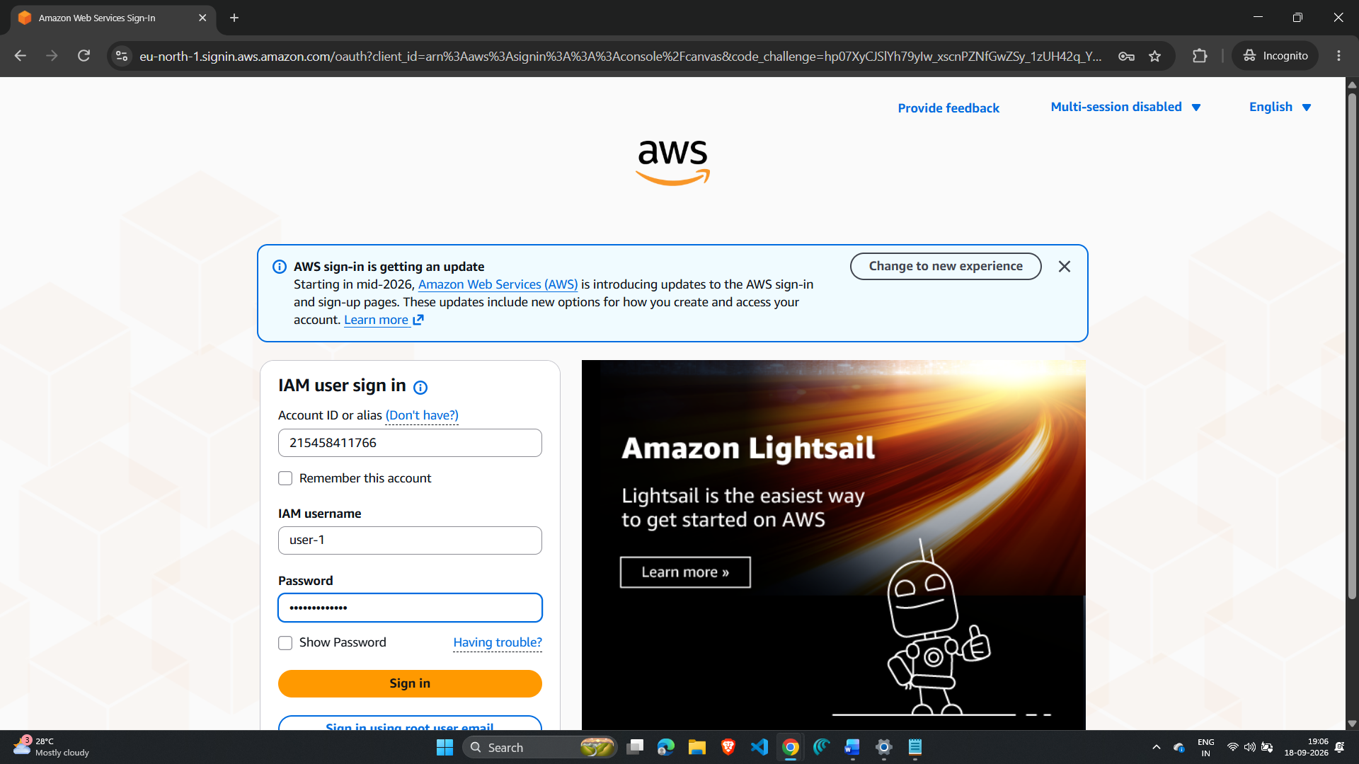
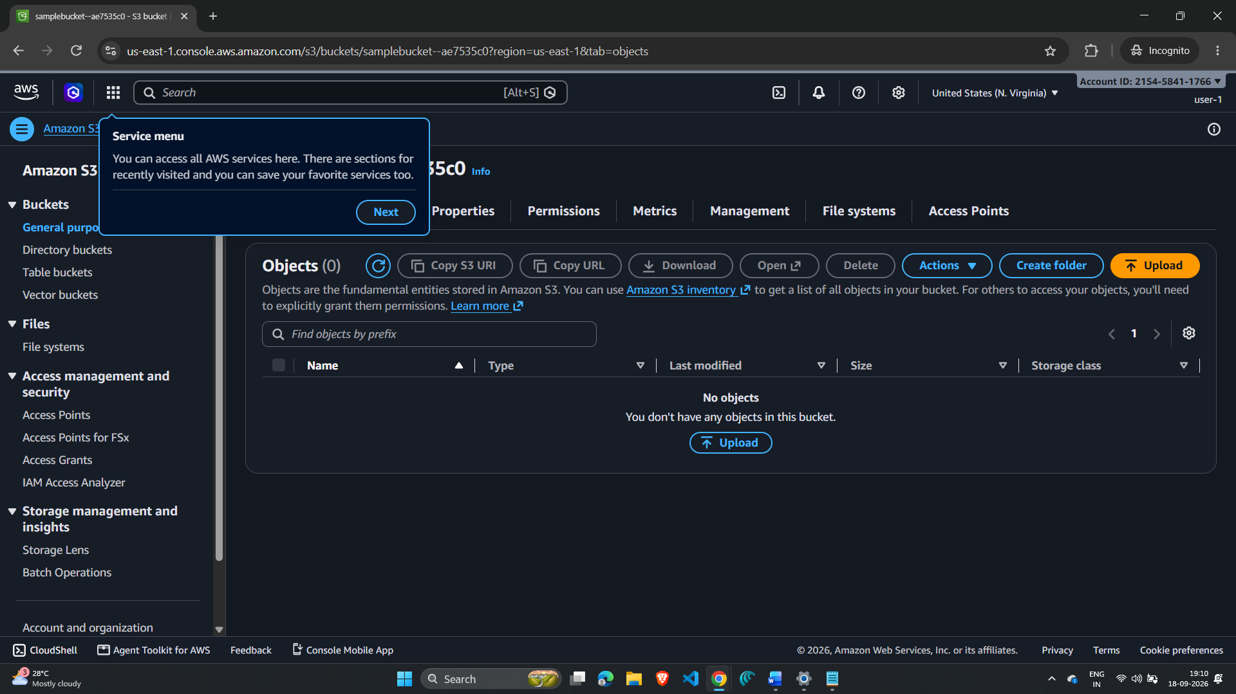
\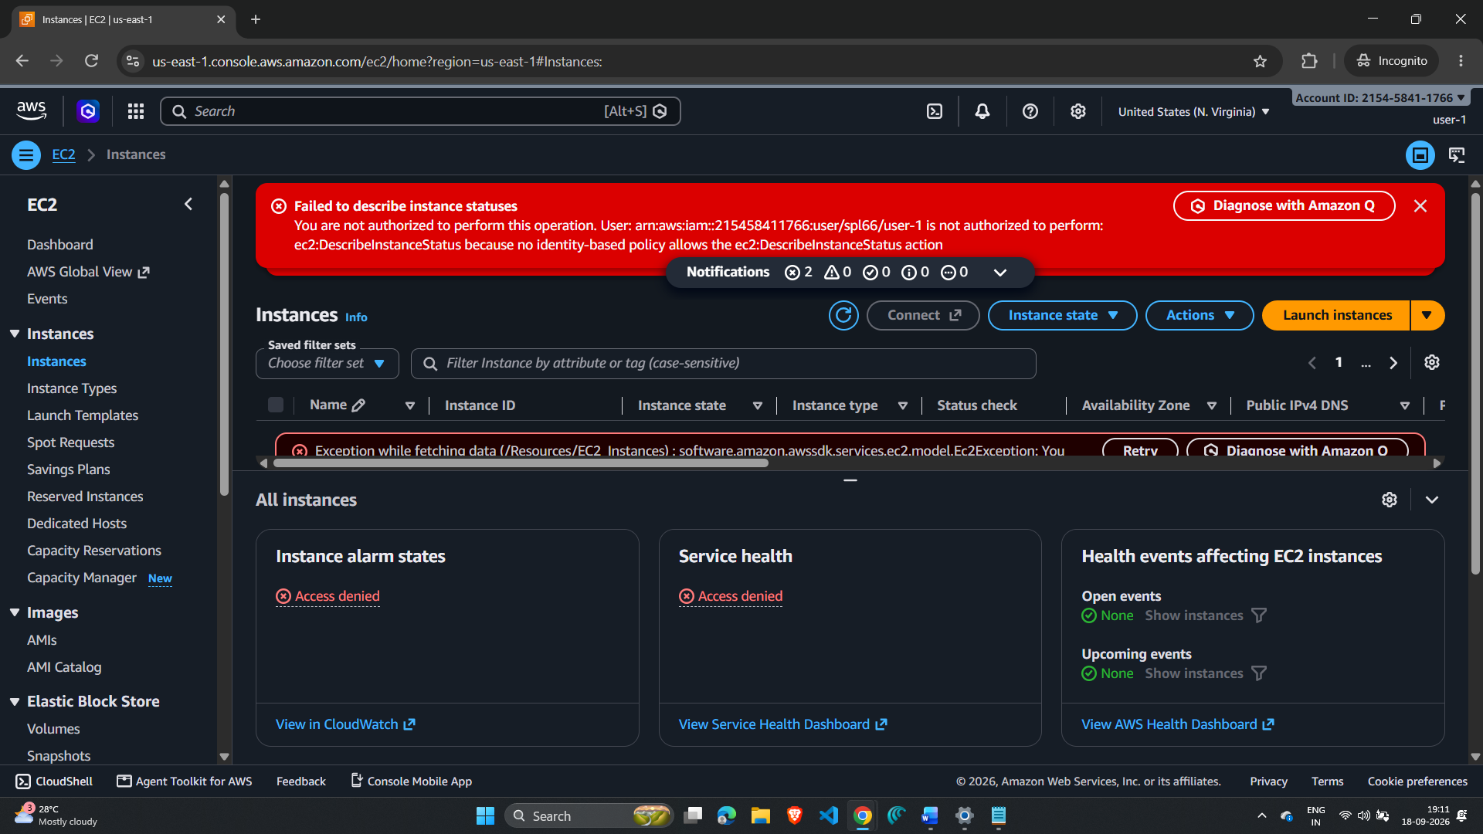
40. Sign user-1 out of the AWS Management Console by choosing user-1 at the top of the screen and then choosing Sign Out.

Test user-2 – EC2 Support
41. Paste the IAM users' sign-in link into the private browser tab's address bar and press Enter.
42. Sign in with IAM user name user-2 and the lab-provided password for user-2.
43. In the AWS Console search box, search for and choose EC2 to open the EC2 console.
44. In the navigation pane, choose Instances. Because user-2 has Read Only permissions, the LabHost EC2 instance can be viewed, but changes to EC2 resources are not permitted. Select the instance named LabHost and confirm the correct AWS Region if necessary.
45. In the Instance state menu, select Stop instance.
46. In the Stop Instance window, select Stop. An authorization error should appear because the EC2-Support policy permits viewing information but does not permit stopping the instance.
Screenshot 10 – user-2 Stop Instance Attempt / Access Denied
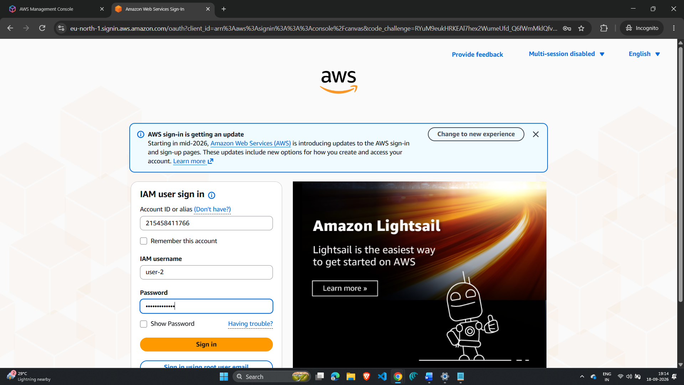
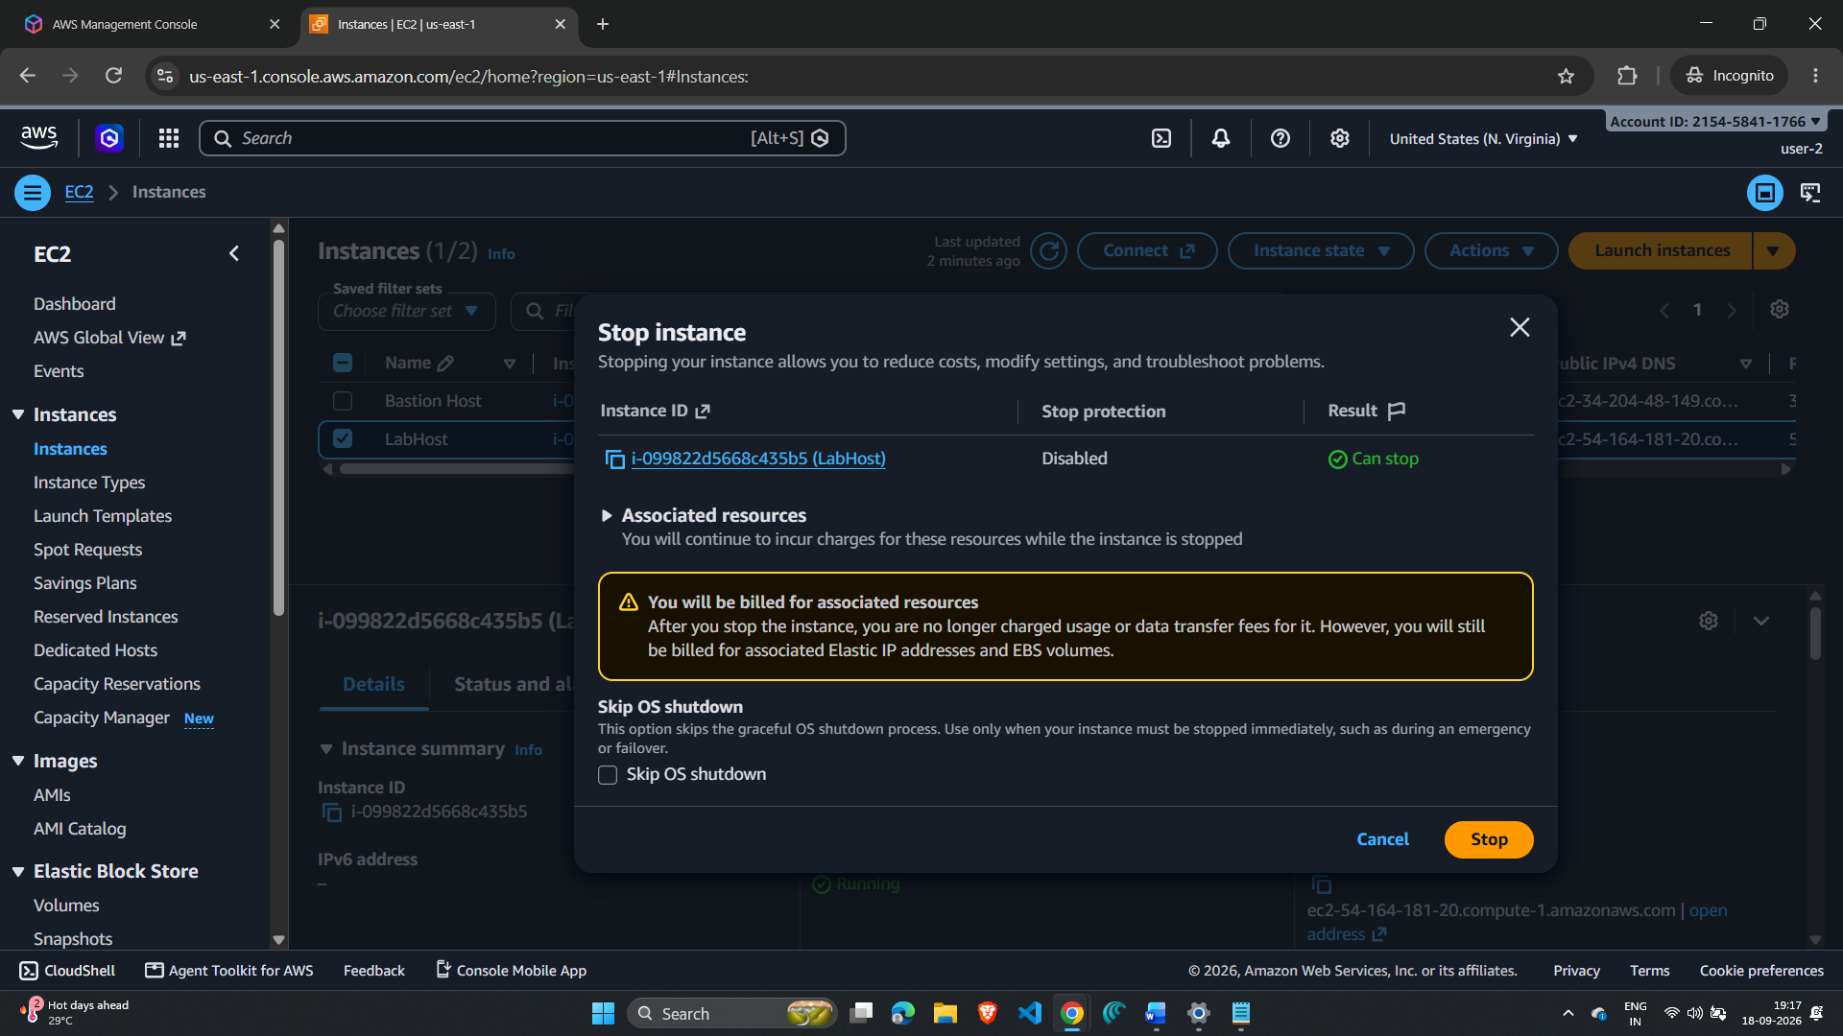
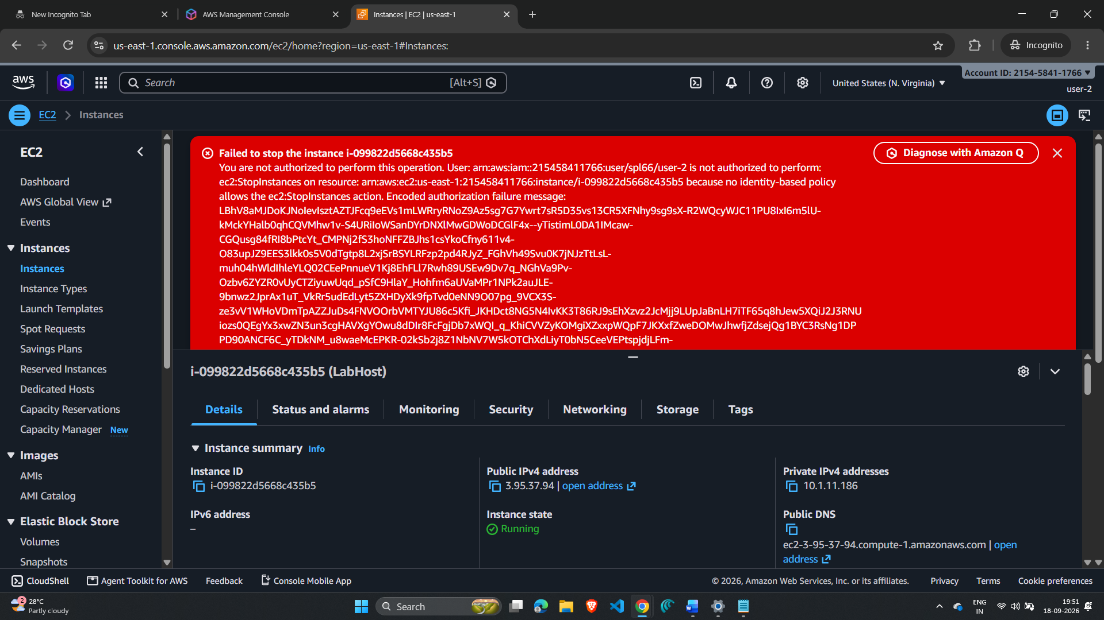

47. Choose the X to close the Failed to stop the instance message.
48. Open Amazon S3. The lab indicates that user-2 does not have permission to list S3 buckets, demonstrating that the user's permissions are limited to the assigned EC2-support role.
49. Sign user-2 out of the AWS Management Console by choosing user-2 at the top of the screen and then choosing Sign Out.

Test user-3 – EC2 Administrator
50. Paste the IAM users' sign-in link into the private browser and press Enter.
51. If required, paste the sign-in link into the address bar again, retrieving it from the text editor where it was saved.
52. Sign in with IAM user name user-3 and the lab-provided password for user-3.
53. In the AWS Console search box, search for and choose EC2 to open the EC2 console.
54. In the navigation pane, choose Instances. As an EC2 Administrator, user-3 should have permission to stop the Amazon EC2 instance. Select the instance named LabHost and confirm the correct Region if necessary.
55. In the Instance state menu, choose Stop instance.
56. In the Stop instance window, choose Stop. The instance enters the stopping state and then shuts down.
Screenshot 11 – user-3 Successfully Stops LabHost
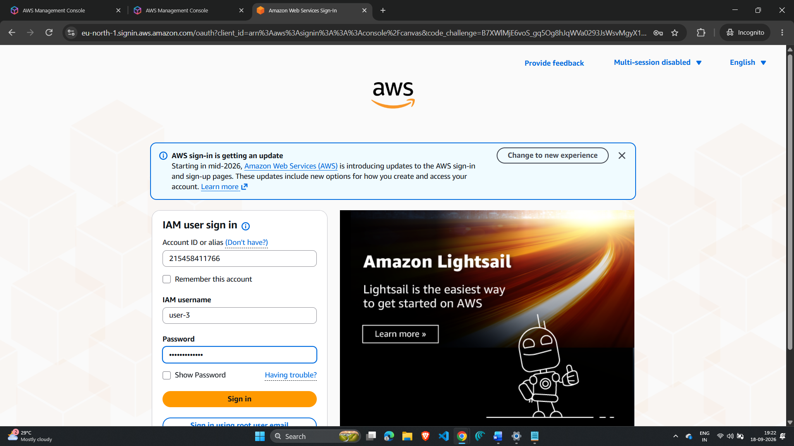
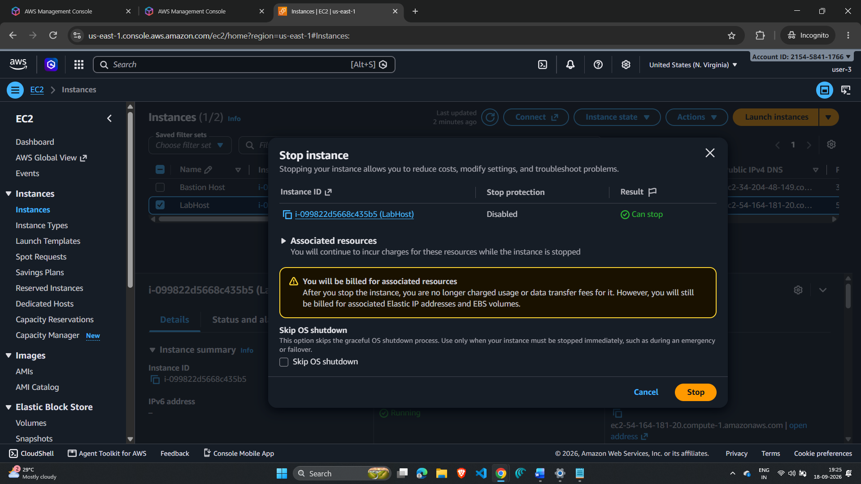
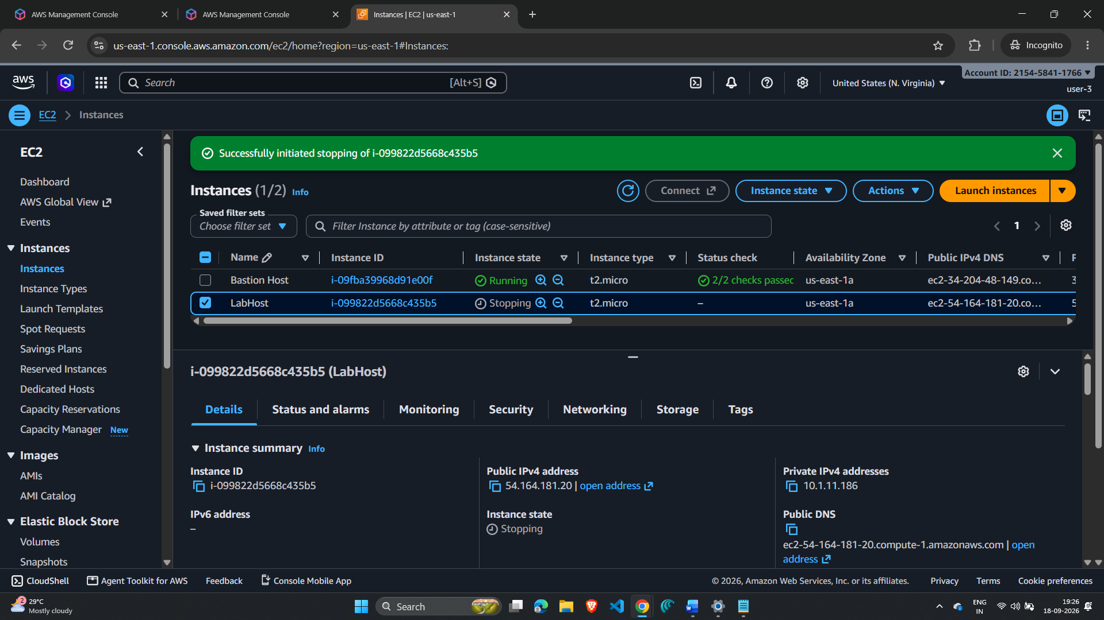
57. Close the private browser window.

7. Submitting Your Work
58. To record your progress, choose Submit at the top of the lab instructions. Some checks may require several minutes after completion before they receive credit.
59. When prompted, choose Yes to confirm submission.
After submission, wait for the grading panel to appear. The lab instructions indicate that the grades panel shows the points earned for each task. If the results do not appear immediately, wait a few minutes and check again.
Screenshot 12 – Submission Confirmation
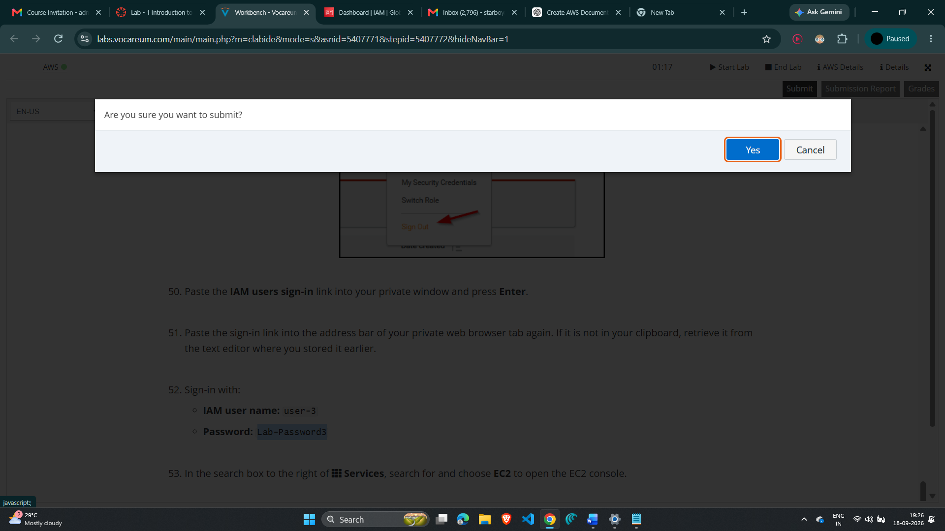
60. For detailed feedback about the work, choose Submission Report. This report can provide details for checks that did not receive full points.

8. Lab Completion
Once the lab has been successfully completed and the required score is recorded, the lab can be ended according to the final instructions.
61. Choose End Lab at the top of the lab page and then select Yes to confirm that you want to end the lab.
62. Select the X in the top-right corner to close the confirmation panel/message.
Screenshot 13 – Lab Complete / Final Result
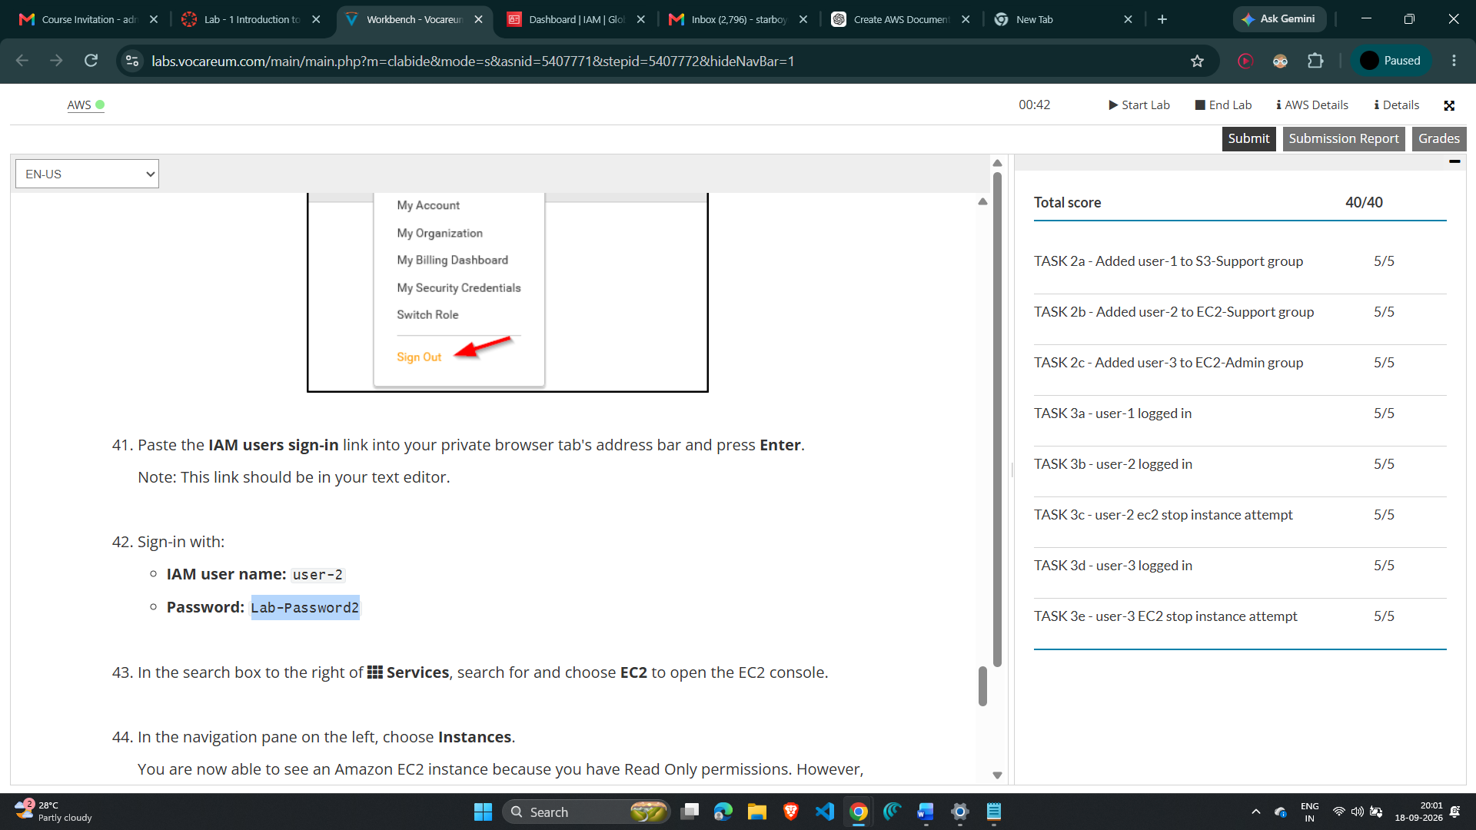

9. Result
The AWS IAM lab was completed by exploring the pre-created IAM users and groups, inspecting the policies attached to the groups, assigning users to the appropriate groups, and testing the resulting permissions through separate IAM user sign-ins.
Final permission mapping:
IAM User | Group | Verified Access
user-1 | S3-Support | Read-Only access to Amazon S3
user-2 | EC2-Support | Read-Only access to Amazon EC2
user-3 | EC2-Admin | View, Start and Stop Amazon EC2 instances

Final Score: __________40______ / 40
Final Status: Lab completed successfully / ______________Lab completed successfully________________

10. Conclusion
The practical demonstrated how AWS IAM can be used to control access to AWS resources through users, groups and policies. The lab showed that permissions inherited through groups determine which AWS actions a user can perform. user-1 was assigned S3 read-only access, user-2 was assigned EC2 read-only access, and user-3 was assigned EC2 administrative permissions that include starting and stopping instances. The practical verification showed the difference between read-only and administrative permissions.

