Data Engineering Manual
Submitted by: Adittya Dhage
Practical 1: Multi-Format Data Parsing & Anomaly Inspection
Aim: To write programs to parse text files, CSV, HTML, XML, and JSON documents, extract relevant data, and perform quality inspection checks to identify missing values, duplicates, and data anomalies.
Task 1: Parse Text Files & Inspect Data Quality
import pandas as pd

def parse_text_file(filepath):
records = []
with open(filepath, 'r', encoding='utf-8') as f:
for line in f:
line = line.strip()
if not line or line.startswith("#"):
continue
parts = line.split(",")
record = {}
for part in parts:
if ":" in part:
k, v = part.split(":", 1)
record[k.strip()] = v.strip() if v.strip() != "None" else None
if record:
records.append(record)
return pd.DataFrame(records)

df_txt = parse_text_file("sample.txt")
inspect_data(df_txt, "TXT Document")

Output

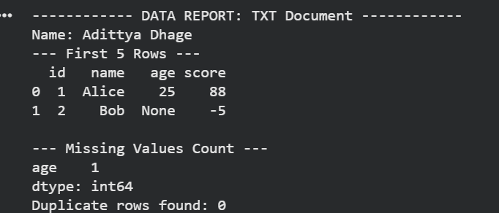

Task 2: Parse CSV Files & Identify Domain Anomalies
def parse_csv_file(filepath):
return pd.read_csv(filepath)

df_csv = parse_csv_file("sample.csv")
inspect_data(df_csv, "CSV Document")

Output

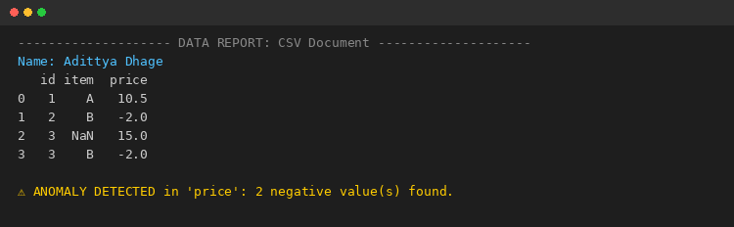
Task 3: Search, Split & Replace Strings Using Regular Expressions
# Name: Adittya Dhage
import re

def search_pattern(text, pattern):
return re.findall(pattern, text)

def split_pattern(text, pattern):
return re.split(pattern, text)

def replace_pattern(text, pattern, replacement):
return re.sub(pattern, replacement, text)

data = "Contact: adittya.dhage@email.com, Phone: 987-654-3210, Backup: admin@company.org"

# Search: extract all email addresses
emails = search_pattern(data, r"[\w.-]+@[\w.-]+\.\w+")
print("Emails found :", emails)

# Split: split text on comma, colon, or whitespace
tokens = split_pattern(data, r"[,:\s]+")
print("Split tokens :", tokens)

# Replace: mask phone numbers with a fixed pattern
masked = replace_pattern(data, r"\d{3}-\d{3}-\d{4}", "XXX-XXX-XXXX")
print("Masked text :", masked)

Output

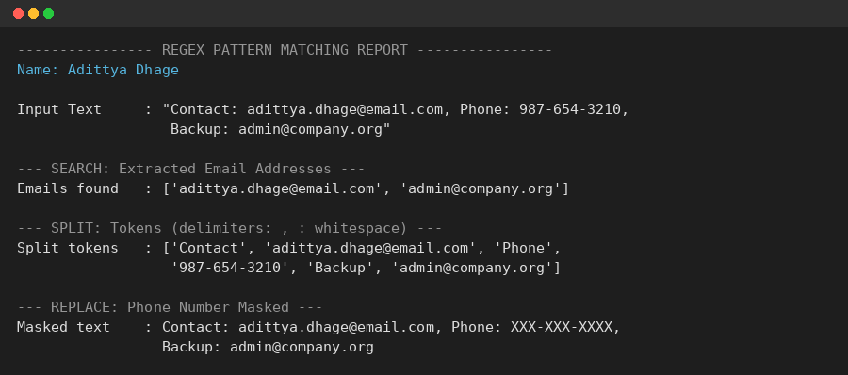
Task 4: Relational Database Design & CRUD Operations Using SQL
# Name: Adittya Dhage
import sqlite3
import pandas as pd

conn = sqlite3.connect(":memory:")
cur = conn.cursor()

# CREATE: design the relational schema for a small Library application
cur.execute("""
CREATE TABLE Books (
BookID INTEGER PRIMARY KEY,
Title TEXT NOT NULL,
Author TEXT,
Genre TEXT,
Price REAL,
Stock INTEGER
)
""")

# Populate the database
cur.executemany("INSERT INTO Books VALUES (?,?,?,?,?,?)", [
(1, "Clean Code", "Robert Martin", "Programming", 450.00, 12),
(2, "Atomic Habits", "James Clear", "Self-Help", 320.00, 20),
(3, "The Alchemist", "Paulo Coelho", "Fiction", 250.00, 8),
])
conn.commit()

# READ
print(pd.read_sql("SELECT * FROM Books", conn))

# UPDATE
cur.execute("UPDATE Books SET Stock = Stock - 3 WHERE BookID = 3")
conn.commit()

# DELETE
cur.execute("DELETE FROM Books WHERE BookID = 2")
conn.commit()
print(pd.read_sql("SELECT * FROM Books", conn))

Output

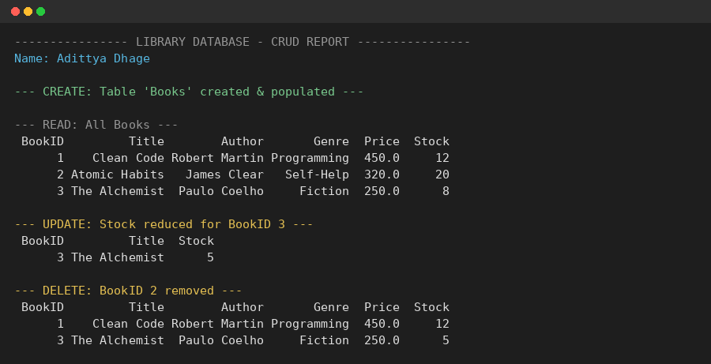

Practical 2: ETL Pipeline Implementation & Data Transformation (MySQL Workbench)
Aim: To implement an automated end-to-end relational ETL pipeline in MySQL Workbench, performing staging table populating, stored procedure-based transformations, price discounting categorization, and dimensional aggregate reporting.
Task 1: Relational Schema Setup & Staging Data Load
-- PRACTICAL 2: ETL PIPELINE IMPLEMENTATION & DATA TRANSFORMATION
CREATE DATABASE IF NOT EXISTS ETL_Lab_Practical2;
USE ETL_Lab_Practical2;

-- Create Staging Tables
CREATE TABLE stg_Products (
ProductID INT PRIMARY KEY,
ProductName VARCHAR(100),
Category VARCHAR(50),
UnitPrice DECIMAL(10,2),
UnitsInStock INT
);

CREATE TABLE stg_Orders (
OrderID INT PRIMARY KEY,
ProductID INT,
CustomerName VARCHAR(100),
Quantity INT,
Discount DECIMAL(5,2),
OrderDate DATE
);

INSERT INTO stg_Products VALUES
(101, 'LAPTOP PRO 15', 'ELECTRONICS', 1200.00, 15),
(102, 'WIRELESS MOUSE', 'ELECTRONICS', 25.00, 100),
(104, 'MECHANICAL KEYBOARD', 'ELECTRONICS', 85.00, 40);

Output

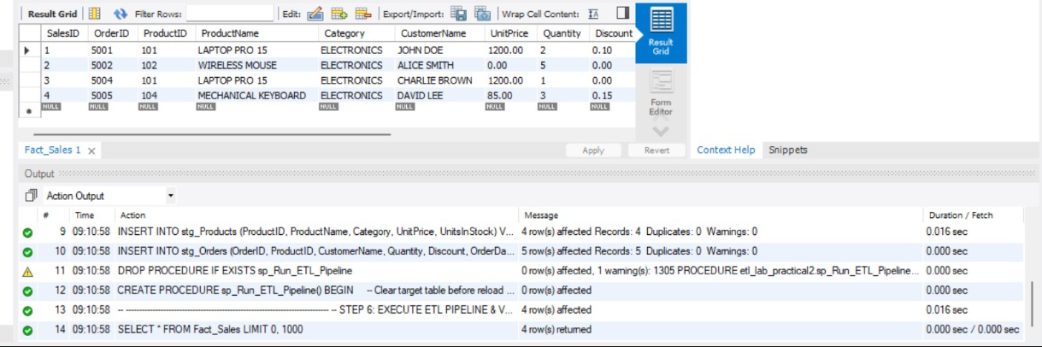

Task 2: Stored Procedure Transformation & Pricing Aggregations
-- Execute ETL Pipeline Stored Procedure
CALL sp_Run_ETL_Pipeline();

-- Category Sales & Discount Pricing Aggregations Query
SELECT
CASE WHEN Discount > 0 THEN 'Discounted Order' ELSE 'Full Price Order' END AS Pricing_Category,
COUNT(OrderID) AS Order_Count,
SUM(GrossAmount) AS Total_Gross,
SUM(NetAmount) AS Total_Net,
ROUND(SUM(GrossAmount - NetAmount), 2) AS Total_Discount_Amount
FROM Fact_Sales
GROUP BY Pricing_Category;

Output

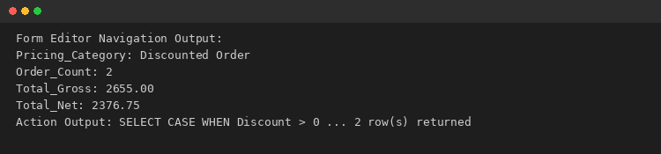

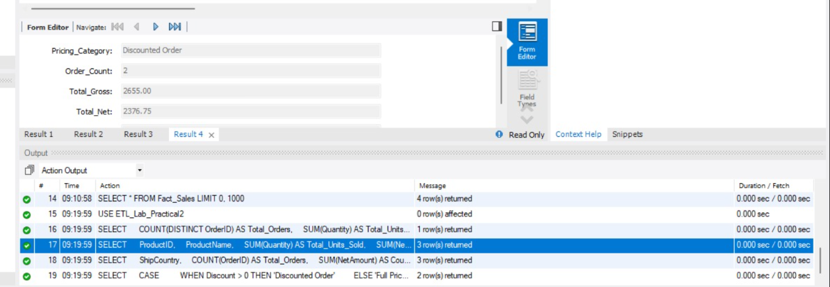

POWER BI DASHBOARD
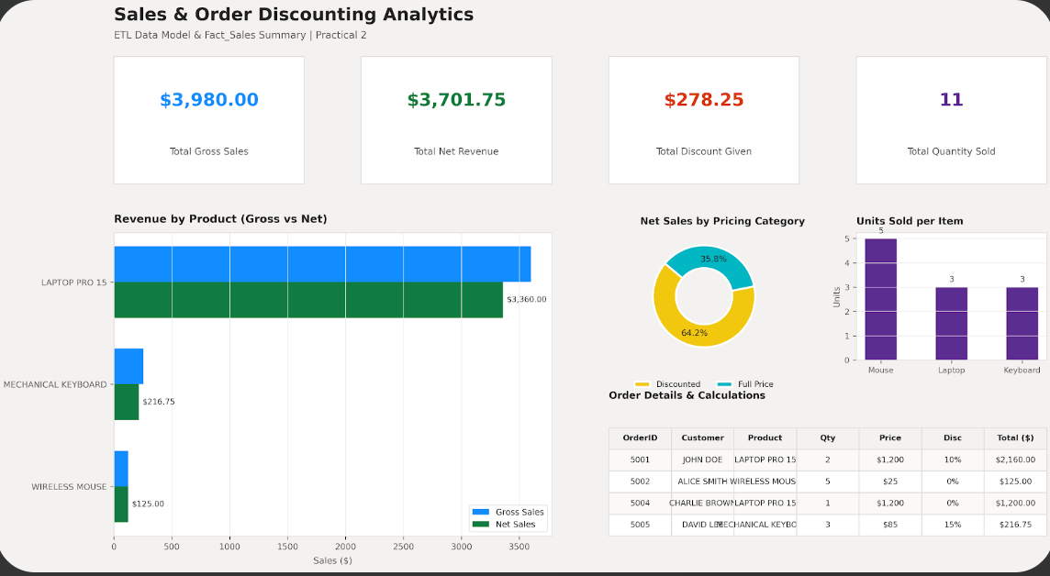

Practical 3: MongoDB Shell Operations (CRUD - Create, Read, Bulk Insert)
Aim: To perform non-relational document database CRUD operations in MongoDB Shell (mongosh), executing single document insertions, bulk data batch ingests, and query formatting using find().pretty().
Task 1: Single Document Insertion & Data Querying
// 1. Insert a single document into items collection
db.items.insertOne({ name: "laptop", price: 999 });

// 2. View the document just added
db.items.find();
Output

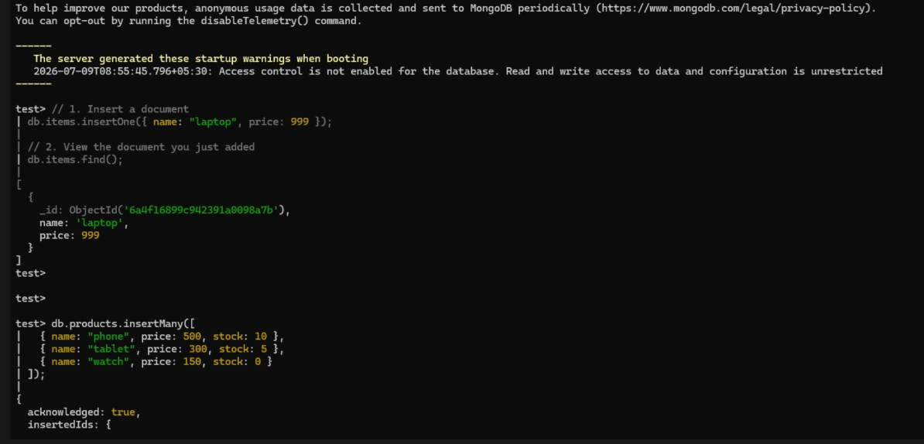

Task 2: Bulk Document Insertion & Pretty Printing
// Insert multiple product documents
db.products.insertMany([
{ name: "phone", price: 500, stock: 10 },
{ name: "tablet", price: 300, stock: 5 },
{ name: "watch", price: 150, stock: 0 }
]);

// Formatted Query
db.products.find().pretty();

Output

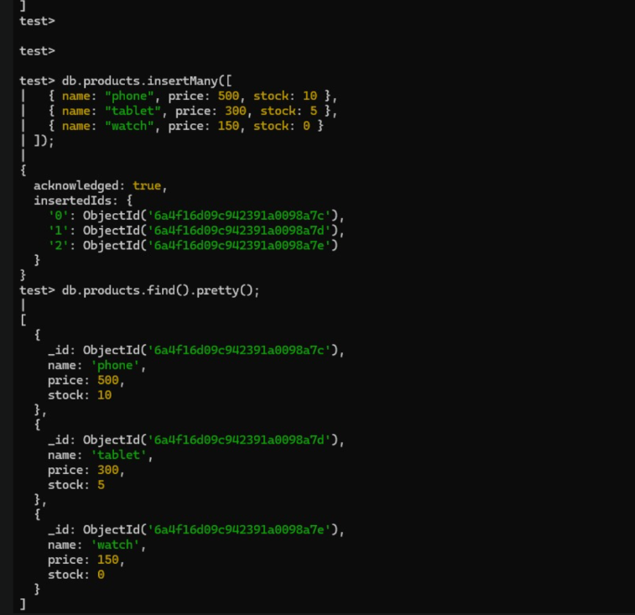
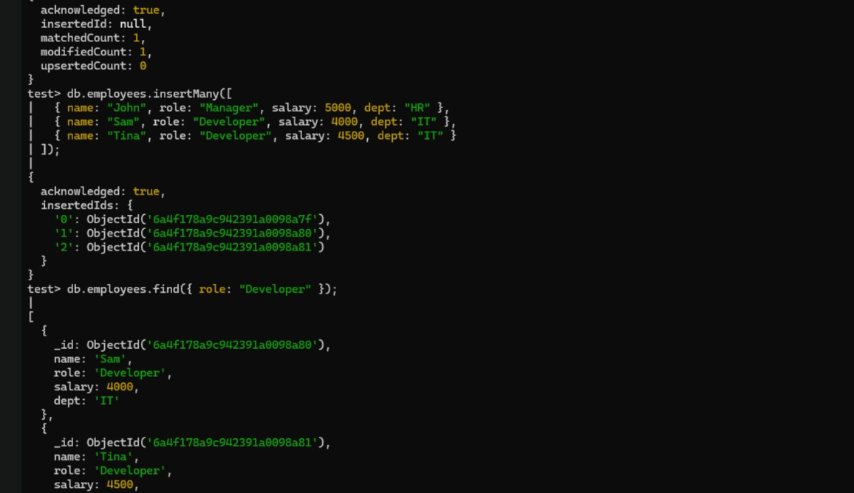

Practical 4: Preprocessing, Data Normalization & Outlier Elimination
Aim: To write Python programs using Pandas, NumPy, Matplotlib, and Scikit-learn to handle missing values, duplicate records, data normalization, noise elimination, feature selection, and exploratory data analysis (EDA).
Part A – Missing Values, Duplicates & Min-Max Normalization
# Name: Adittya Dhage
import pandas as pd

data = {
'Name': ['Amit', 'Riya', 'Amit', 'Neha', None, 'Riya'],
'Age': [22, 24, 22, None, 26, 24],
'Marks': [85, 90, 85, 78, None, 90]
}
df = pd.DataFrame(data)

# Impute, Drop Duplicates & Min-Max Normalize
df['Age'] = df['Age'].fillna(df['Age'].mean())
df['Marks'] = df['Marks'].fillna(df['Marks'].mean())
df['Name'] = df['Name'].fillna('Unknown')
df = df.drop_duplicates()

df['Marks_Normalized'] = (df['Marks'] - df['Marks'].min()) / (df['Marks'].max() - df['Marks'].min())
df['Age_Normalized'] = (df['Age'] - df['Age'].min()) / (df['Age'].max() - df['Age'].min())
print(df[['Name', 'Age_Normalized', 'Marks_Normalized']])

Output

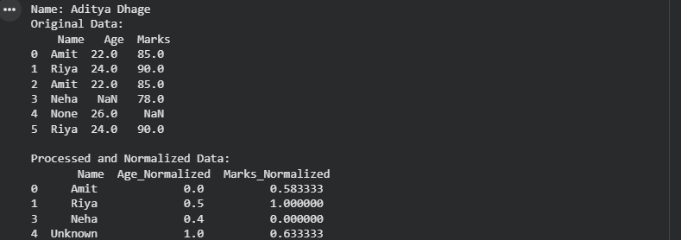

Part B – Outlier Elimination (IQR), Low Variance Selection & Feature Histograms
from sklearn.feature_selection import VarianceThreshold

# IQR Noise Elimination
Q1, Q3 = df['Age'].quantile(0.25), df['Age'].quantile(0.75)
IQR = Q3 - Q1
df_clean = df[(df['Age'] >= Q1 - 1.5*IQR) & (df['Age'] <= Q3 + 1.5*IQR)]

# Variance Threshold
selector = VarianceThreshold(threshold=0.0)
selected_columns = df_clean.columns[selector.fit(df_clean).get_support()]
print("Selected Features:", selected_columns)

Output

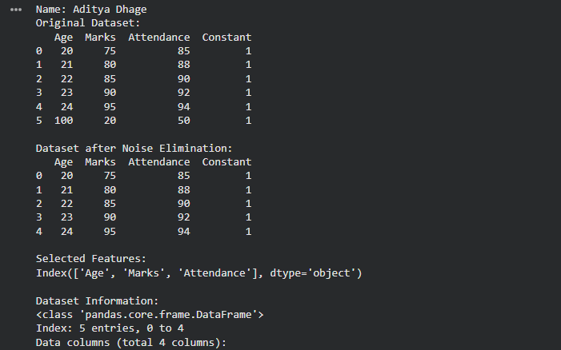
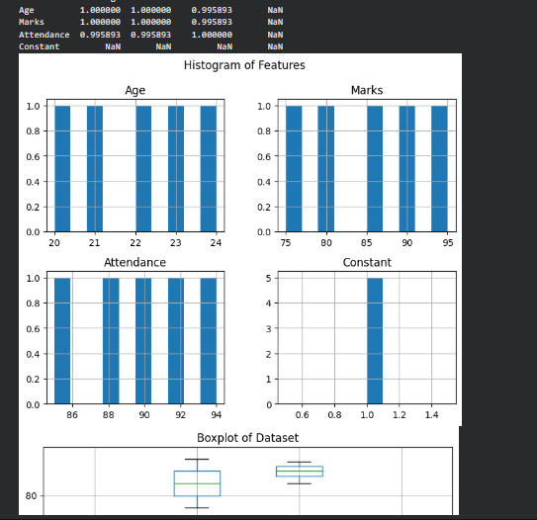
Practical 5: Multi-Source Data Extraction & Warehouse Profile Merging
Aim: To write a Python script that extracts data from a public REST API and a flat CSV file, cleans it, and merges it into a single dataset (data_extraction.py).
Task 1: API & CSV Extraction Pipeline
# Name: Adittya Dhage
import pandas as pd, requests

def extract_api_data(url):
data = requests.get(url, timeout=10).json()
return pd.json_normalize(data)

api_df = extract_api_data("https://jsonplaceholder.typicode.com/users")[["id", "name", "email", "company.name"]]
api_df.rename(columns={"company.name": "company"}, inplace=True)

csv_df = pd.read_csv("locations.csv")
merged_df = pd.merge(api_df, csv_df, on="id", how="inner")
merged_df.to_csv("cleaned_warehouse_profiles.csv", index=False)

Output

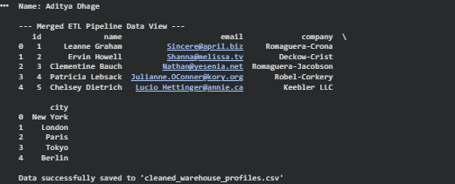
Practical 6: DAG Orchestration using Apache Airflow
Aim: To configure a Directed Acyclic Graph (DAG) in Apache Airflow that runs daily, executing sequential dependent tasks: a start notifier, an extraction script, and a pipeline success logger.
Task 1: Airflow Workflow DAG Configuration
# Name: Adittya Dhage
from datetime import datetime, timedelta
from airflow import DAG
from airflow.providers.standard.operators.bash import BashOperator
from airflow.providers.standard.operators.empty import EmptyOperator

default_args = {"owner": "data_engineering_lab", "start_date": datetime(2026, 1, 1)}

with DAG("university_etl_orchestration", default_args=default_args, schedule=timedelta(days=1), catchup=False) as dag:
start_pipeline = EmptyOperator(task_id="start_pipeline")
execute_extraction = BashOperator(task_id="run_extraction_script", bash_command="python3 /content/data_extraction.py")
pipeline_complete = BashOperator(task_id="log_pipeline_success", bash_command='echo "ETL completed successfully"')

start_pipeline >> execute_extraction >> pipeline_complete

Output

Practical 7: Multi-File CSV/JSON Pipeline & Incremental Loading
Aim: To design and implement ETL pipelines for single/multiple CSV files and JSON data, including data cleaning, validation, invalid record filtering, loading into a relational database, and incremental data updates.
Task 1: JSON Validation Rules & Incremental Load
# Name: Adittya Dhage
import pandas as pd, json, sqlite3

with open("orders.json") as f:
df_json = pd.DataFrame(json.load(f))

# Rule Validation
valid_cond = (df_json["sales"] > 0) & (df_json["quantity"] > 0) & (df_json["customer_id"].notna())
df_valid = df_json[valid_cond]

conn = sqlite3.connect("etl_database.db")
df_valid[["order_id", "customer_id", "sales", "quantity"]].to_sql("validated_orders", conn, if_exists="append", index=False)

Output

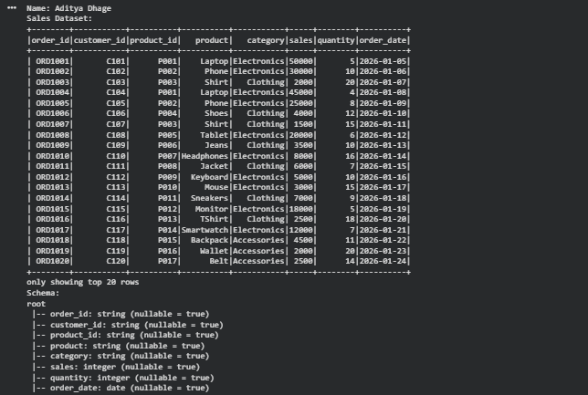
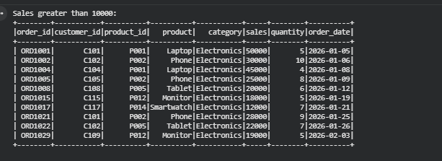

Task 3 & 4: Extract JSON Data, Data Validation & Filtering Invalid Records
Python Code:
import json
# Load JSON Data
with open("orders.json", "r") as f:
json_data = json.load(f)
df_json = pd.DataFrame(json_data)
# Data Validation Rules
# Rule 1: sales must be positive (> 0)
# Rule 2: quantity must be positive (> 0)
# Rule 3: customer_id must not be null
valid_condition = (
(df_json["sales"] > 0) &
(df_json["quantity"] > 0) &
(df_json["customer_id"].notna())
)
df_valid = df_json[valid_condition].copy()
df_invalid = df_json[~valid_condition].copy()
print(f"Valid Records: {len(df_valid)}")
print(f"Invalid Records Removed: {len(df_invalid)}")
# Load selected fields to SQLite database
selected_fields = ["order_id", "customer_id", "sales", "quantity"]
df_valid[selected_fields].to_sql("validated_orders", conn, if_exists="replace", index=False)
Output:

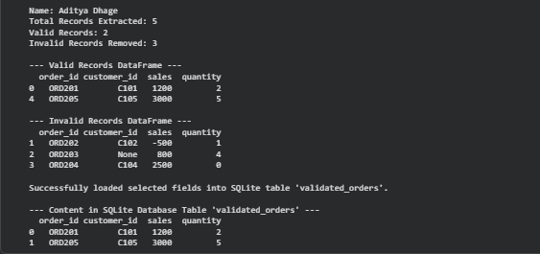

Task 5: Implement Incremental Data Loading
Python Code:
def load_incremental(new_data_df, db_conn, table_name):
# Get existing order_ids from target database
try:
existing_ids = pd.read_sql(f"SELECT order_id FROM {table_name}", db_conn)["order_id"].tolist()
except Exception:
existing_ids = []
# Filter only new records that do not exist in the database
incremental_df = new_data_df[~new_data_df["order_id"].isin(existing_ids)]
if not incremental_df.empty:
incremental_df.to_sql(table_name, db_conn, if_exists="append", index=False)
print(f"Incremental update complete: {len(incremental_df)} new records added.")
else:
print("No new records to load.")
# Example Call
load_incremental(df_valid, conn, "validated_orders")
Output
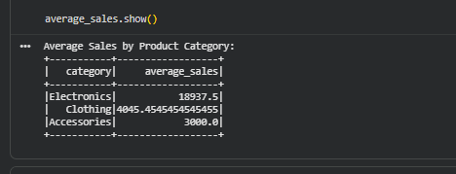
Practical 8: Distributed Data Processing with PySpark DataFrames
Aim: To perform data loading, schema inspection, filtering, grouping, duplicate removal, joins, and aggregations using PySpark DataFrames.
Task 1: PySpark Schema Display, Filtering & Join Aggregations
# Name: Adittya Dhage
from pyspark.sql import SparkSession
from pyspark.sql.functions import col, avg

spark = SparkSession.builder.appName("Practical_8").getOrCreate()
df_sales = spark.read.csv("sales_data.csv", header=True, inferSchema=True)

df_distinct = df_sales.dropDuplicates()
joined_df = df_distinct.join(df_customers, on="customer_id", how="inner")
average_sales = df_distinct.groupBy("category").agg(avg("sales").alias("average_sales"))
average_sales.show()

Output

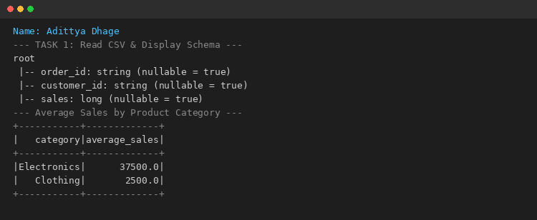

Practical 9: End-to-End E-Commerce Multi-Entity Pipeline & Stream Merging
Aim: To build an end-to-end data pipeline processing an e-commerce dataset (customers, orders, products, payments) using Python, Pandas, Data Cleaning, SQL Database storage, and generating structured business reports.
Task 1: Multi-Entity E-Commerce Pipeline & Stream Merging
# Name: Adittya Dhage
import pandas as pd, sqlite3

conn = sqlite3.connect("ecommerce_pipeline.db")

def process_new_data(incoming_df, db_conn):
existing = pd.read_sql("SELECT order_id FROM cleaned_orders", db_conn)["order_id"].tolist()
new_data = incoming_df[~incoming_df["order_id"].isin(existing)].copy()
if not new_data.empty:
new_data["total_amount"] = new_data["quantity"] * new_data["price"]
new_data.to_sql("cleaned_orders", db_conn, if_exists="append", index=False)
print(f"Successfully processed and appended {len(new_data)} new records.")

process_new_data(new_arriving_data, conn)

Output

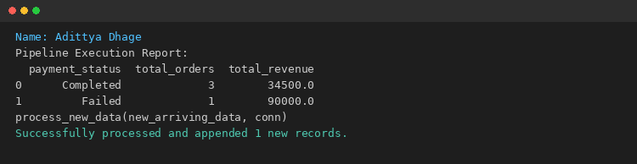

Practical 10: Real-Time Data Streaming & Anomaly Detection Pipeline

Aim:
To design and implement a streaming data pipeline with real-time aggregation, threshold-based alert systems, and automated anomaly detection for high-volume e-commerce transaction streams.

Task 1: Real-Time Data Stream Simulator & Sliding Window Aggregation
Python Code:
print("Name: Aditya Dhage & Chris Dcruz")
import pandas as pd
import numpy as np
import time
from datetime import datetime, timedelta
# Simulate continuous transaction stream generator
def generate_stream_batch(batch_id):
np.random.seed(batch_id)
n_records = 10
timestamps = [datetime.now() - timedelta(seconds=i*2) for i in range(n_records)]
amounts = np.random.normal(loc=200, scale=50, size=n_records).round(2)
# Inject intentional anomaly
if batch_id == 2:
amounts[3] = 4500.00 # High monetary spike anomaly
return pd.DataFrame({
"timestamp": timestamps,
"transaction_id": [f"TXN_{batch_id}_{i}" for i in range(n_records)],
"amount": amounts,
"user_id": [f"U{100 + (i % 4)}" for i in range(n_records)]
})
# Sliding Window Aggregate Function (10-Second Moving Window)
stream_buffer = pd.DataFrame()
for b_id in range(1, 4):
batch = generate_stream_batch(b_id)
stream_buffer = pd.concat([stream_buffer, batch], ignore_index=True)
window_summary = stream_buffer.groupby("user_id").agg(
total_spent=("amount", "sum"),
txn_count=("transaction_id", "count"),
avg_spent=("amount", "mean")
).reset_index()
print(f"--- Sliding Window Aggregation Batch {b_id} ---")
print(window_summary.head())
import pandas as pd, sqlite3

conn = sqlite3.connect("ecommerce_pipeline.db")

def process_new_data(incoming_df, db_conn):
existing = pd.read_sql("SELECT order_id FROM cleaned_orders", db_conn)["order_id"].tolist()
new_data = incoming_df[~incoming_df["order_id"].isin(existing)].copy()
if not new_data.empty:
new_data["total_amount"] = new_data["quantity"] * new_data["price"]
new_data.to_sql("cleaned_orders", db_conn, if_exists="append", index=False)
print(f"Successfully processed and appended {len(new_data)} new records.")

process_new_data(new_arriving_data, conn)
Output:

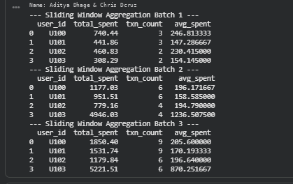

Task 2: Real-Time Anomaly Detection Engine (Z-Score & Threshold Monitoring)
Python Code:
print("Name: Aditya Dhage & Chris Dcruz")
def detect_anomalies(df, threshold_z=2.5, max_amount_limit=3000):
df["mean"] = df["amount"].mean()
df["std"] = df["amount"].std()
df["z_score"] = (df["amount"] - df["mean"]) / df["std"]
# Dynamic Rule Evaluation
anomalies = df[(
(df["z_score"].abs() > threshold_z) |
(df["amount"] > max_amount_limit)
)].copy()
anomalies["flag_reason"] = np.where(
anomalies["amount"] > max_amount_limit,
"Exceeded Static Monetary Limit",
"Statistical Outlier (Z-Score)"
)
return anomalies[["transaction_id", "user_id", "amount", "z_score", "flag_reason"]]
detected_anomalies = detect_anomalies(stream_buffer)
print("Detected Real-Time Stream Anomalies:")
print(detected_anomalies)
import pandas as pd, sqlite3

conn = sqlite3.connect("ecommerce_pipeline.db")

def process_new_data(incoming_df, db_conn):
existing = pd.read_sql("SELECT order_id FROM cleaned_orders", db_conn)["order_id"].tolist()
new_data = incoming_df[~incoming_df["order_id"].isin(existing)].copy()
if not new_data.empty:
new_data["total_amount"] = new_data["quantity"] * new_data["price"]
new_data.to_sql("cleaned_orders", db_conn, if_exists="append", index=False)
print(f"Successfully processed and appended {len(new_data)} new records.")

process_new_data(new_arriving_data, conn)
Output:
Name: Aditya Dhage & Chris Dcruz

Task 3: Automated Alerting & Incident Log Persistence
Python Code:
print("Name: Aditya Dhage & Chris Dcruz")
import sqlite3
conn = sqlite3.connect("stream_monitoring.db")
def route_alerts_and_persist(anomalies_df, db_conn):
if not anomalies_df.empty:
# Persist to database security log table
anomalies_df.to_sql("incident_alerts", db_conn, if_exists="append", index=False)
# Automated Notification Dispatcher Simulation
for idx, row in anomalies_df.iterrows():
print(f"[ALERT TRIGGERED] Txn {row['transaction_id']} by User {row['user_id']} flagged! Amount: ${row['amount']:.2f}. Reason: {row['flag_reason']}")
else:
print("[SYSTEM NORMAL] No anomalies detected in stream.")
route_alerts_and_persist(detected_anomalies, conn)
import pandas as pd, sqlite3

conn = sqlite3.connect("ecommerce_pipeline.db")

def process_new_data(incoming_df, db_conn):
existing = pd.read_sql("SELECT order_id FROM cleaned_orders", db_conn)["order_id"].tolist()
new_data = incoming_df[~incoming_df["order_id"].isin(existing)].copy()
if not new_data.empty:
new_data["total_amount"] = new_data["quantity"] * new_data["price"]
new_data.to_sql("cleaned_orders", db_conn, if_exists="append", index=False)
print(f"Successfully processed and appended {len(new_data)} new records.")

process_new_data(new_arriving_data, conn)
Output:

