

IMPACT OF STORE-TO-ONLINE SALES MIGRATION ON PROFITABILITY: A CASE OF NEXT PLC

Student Number – 19380096

Dissertation submitted to Oxford Brookes University for the partial fulfilment of the requirements for the degree of MASTER'S OF MANAGEMENT AND BUSINESS ANALYTICS

September 2026
Word Count: 11,990

ACKNOWLEDGEMENTS
I would like to express my sincere gratitude to Dr Chengbo Wang and Dr Mohamad Abou-Foul for the guidance, feedback and support provided throughout this research. Their advice helped me to develop the study, refine the analysis and improve the overall direction of the dissertation. I would also like to thank the academic staff at Oxford Brookes University for the knowledge and support provided throughout my MSc programme. The learning gained during the course has contributed significantly to the development of this research. I am especially grateful to my family and friends for their constant encouragement, patience and support throughout my studies. Their motivation helped me remain focused during the more demanding stages of the dissertation. Finally, I would like to acknowledge NEXT plc for making its annual reports and financial information publicly available, which provided the main data used in this study.

EXECUTIVE SUMMARY
This dissertation examines how NEXT plc’s shift from offline sales to online/Directory sales was linked to profitability between FY2015 and FY2026. The store composition of sales channels, segment operating margin and segment operating profit data, Group APM PBT margin, distribution cost intensity, and the number of stores were analysed to assess whether online growth supported strong financial performance.
The findings show a clear shift towards Online/Directory. Online/Directory sales share increased from 39.62% in FY2015 to 68.40% in FY2026. On a reported/restated basis as presented in this study, operating profit for Online/Directory increased by £345.2m, and operating profit for the Retail segment declined by £157.8m. However, the increase in absolute segment operating profit was not accompanied by a corresponding improvement in Group APM PBT margin. Higher Online/Directory sales share was also linked with greater distribution-cost intensity.
The findings suggest that the outcome of sales growth and profitability should be treated differently. NEXT plc became more Online/Directory-led with higher absolute operating profit from the channel, while no improvement was shown in wider Group-level profitability. This suggests not assessing the financial benefits of the store-to-online shift just through sales growth, but through margin quality and the cost pressures linked with serving a more online-led business.

CONTENTS
Chapter Page
ACKNOWLEDGEMENTS i
EXECUTIVE SUMMARY ii
CONTENTS iii
LIST OF TABLES vi
LIST OF FIGURES vii
LIST OF ABBREVIATIONS viii
CHAPTER 1. INTRODUCTION 1
CHAPTER 2. LITERATURE REVIEW 4
2.1 How Retail Has Shifted from Stores to Online 4
2.2 What the Omnichannel Literature Has Focused On 5
2.3 Evidence on the Financial Effects of Channel Change 6
2.4 Why Online Growth Can Either Strengthen or Weaken Profitability 7
2.5 The Research Gap 9
2.5.1 Alignment Between Research Gaps and Research Objectives 10
2.6 NEXT plc as the Research Context 10
2.7 Conceptual Framework 11
CHAPTER 3. METHODOLOGY 15
3.1 Research design and approach 15
3.2 Data Sources and Secondary Research 16
3.3 Data preparation 17
3.3.1 Variable construction and measurement 17
3.3.2 Treatment of structural breaks 18
3.4 Analytical Methods 19
3.5 Validity and reliability 21
3.5.1 Reliability 21
3.5.2 Construct validity 22
3.5.3 Content validity 23
3.5.4 Internal validity 23
3.5.5 External validity 24
3.6 Ethical considerations 24
CHAPTER 4. FINDINGS 26
4.1 The store-to-online migration 26
4.2 Segment profitability and compensation 29
4.3 Online/Directory sales share and Group profitability 33
4.4 Online migration and distribution-cost intensity 36
4.5 Retail store count and profitability 39
4.6 UK supporting evidence 41
4.7 Summary of findings 43
CHAPTER 5. DISCUSSION 45
5.1 Introduction to the Discussion 45
5.2 Discussion of Key Findings 45
5.2.1 Store-to-online migration as a structural shift 45
5.2.2 Segment profitability and compensation 46
5.2.3 Online/Directory share and Group profitability 47
5.2.4 Distribution-cost pressure and store count 48
5.2.5 UK supporting evidence 49
5.3 Overall Interpretation and Research Question Response 50
CHAPTER 6. CONCLUSION 51
6.1 Implications and Recommendations 52
6.1.1 Theoretical implications 52
6.1.2 Practical implications and recommendations 54
6.2 Limitations of the Study 55
6.3 Future Research Scope 56
REFERENCES 57
Acknowledgements 63
AI-use statements 63
APPENDIX 64
Appendix 4A: Sales migration and market context 64
Appendix Figure 4A.1: Python output for sales migration 64
Appendix Figure 4A.2: STATISTA GRAPH 64
Appendix Figure 4A.3: ONS GRAPH 65
Appendix 4B: Segment profitability and compensation 66
Appendix Table 4B.1: Compensation analysis 66
Appendix Table 4B.2: Online/Directory margin reporting-break regression 66
Appendix 4C: Correlation, regression and cost analysis 67
Appendix Table 4C.1: Pearson correlation matrix 67
Appendix Table 4C.2: OLS regression of Group APM PBT margin on Online/Directory sales share 67
Appendix Table 4C.3: Annual-Change Regression for Distribution-Cost Intensity 68
Appendix Table 4C.4: Objective 4 correlations and p-values 68
Appendix 4D: UK Supporting Evidence 69
Appendix Table 4D.1: UK Online sales share and segment margins 69

LIST OF TABLES
Table | Title | page
Table I | Summary of analytical variables | 18
Table II | Structural breaks considered in the analysis | 19
Table III | Sales mix, FY2015 against FY2026 | 26
Table IV | Segment operating profit in FY2015 and FY2026 | 29
Table V | Exploratory reporting-break model for Online/Directory margin | 32
Table VI | Online/Directory share and Group margin | 34
Table VII | Key distribution-cost relationships | 36
Table VIII | Annual-change model | 37
Table IX | Store count and profitability correlations | 39
Table X | UK Online sales share and segment operating margins | 42
Appendix Table 4A.1 | Python output for sales migration | 64
Appendix Table 4B.1 | Compensation analysis | 66
Appendix Table 4B.2 | Online/Directory margin reporting-break regression | 66
Appendix Table 4C.1 | Pearson correlation matrix | 67
Appendix Table 4C.2 | OLS regression of Group APM PBT margin on Online/Directory sales share | 67
Appendix Table 4C.3 | Annual-change regression for distribution-cost intensity | 68
Appendix Table 4D.1 | UK Online sales share and segment margins | 69

LIST OF FIGURES
Figure | Title | page
Figure 1 | Conceptual Framework: Store-to-Online Migration, Cost-to-Serve and Profitability at NEXT plc | 12
Figure 2 | Methodological framework of the study | 16
Figure 3 | Retail and Online/Directory sales, FY2015–FY2026 | 27
Figure 4 | Sales mix shares with the fifty per cent crossover, FY2015 to FY2026 | 28
Figure 5 | Segment-wise operating profit, FY2015 to FY2026 | 30
Figure 6 | Segment profit margins with reporting breaks marked, FY2015 to FY2026 | 31
Figure 7 | Combined segment operating profit change compared with FY2015 | 33
Figure 8 | Online/Directory sales share and NEXT Group APM PBT margin, with the fitted line excluding FY2021 | 35
Figure 9 | Online/Directory sales share and Group distribution-cost intensity, FY2015 to FY2026 | 37
Figure 10 | Distribution-cost intensity and NEXT Group APM PBT margin, FY2015 to FY2026 | 38
Figure 11 | Retail store count and NEXT Group APM PBT margin, FY2015 to FY2026 | 40
Figure 12 | UK Retail Stores and Online operating margins, FY2023 to FY2026 | 42
Appendix Figure 4A.2 | Statista graph | 64
Appendix Figure 4A.3 | ONS graph | 65
Appendix Figure 4D.2 | UK Online sales share, FY2023 to FY2026 | 69

LIST OF ABBREVIATIONS

Abbreviations | Full Term
APM | Alternative Performance Measure
COVID-19 | Coronavirus Disease 2019
FY | Financial Year
IFRS | International Financial Reporting Standards
OLS | Ordinary Least Squares
ONS | Office for National Statistics
PBT | Profit Before Tax
UK | United Kingdom

CHAPTER 1. INTRODUCTION
There have been many changes in retail, with sales moving from physical to online and omnichannel methods. Verhoef, Kannan and Inman (2015) explain omnichannel retailing as the integrated management of different channels and customer touchpoints, and Herhausen et al. (2015) state that online-offline channel integration can create synergy rather than only channel cannibalisation. Channel integration affects the way retailers work, establishes cost pressures, and influences the financial results.
However, higher online sales do not always result in higher profitability. Online fulfilment, warehousing, delivery and returns are all factors that increase the cost pressure for retailers. Hübner, Holzapfel and Kuhn (2016) explain that the significance of delivery and returns is crucial in omnichannel distribution, while the cost and margin pressure linked with online fulfilment is mentioned by Ishfaq and Bajwa (2019). The financial outcome of moving sales online depends on whether enough profit is generated from additional sales after considering all these costs.
NEXT plc is a suitable case because it has a long period where it reports on its Retail and Online/Directory performance. Between FY2015 and FY2026, the business became increasingly Online/Directory-led while continuing to maintain a physical store estate. This allows the study to check if the change in sales mix had positively increased profitability or if it was cancelled out by weaker margins and higher distribution costs.
The main research problem is that when sales are measured, the online growth can be seen as positive and successful. Higher Online/Directory sales share shows that the channel has become more important, but it does not show whether profitability has improved. Ailawadi and Farris (2017) state that multichannel and omnichannel performance should be studied using different measures rather than just one indicator. This is important as sales share, operating profit and profit margin can give different views of the same change. A channel might be producing less profit from every pound of sales but may become larger and generate more absolute profit. Similarly, when segment profit goes up, group profit does not necessarily go up. Past research has focused on customer behaviour, channel integration and sales consequences, whereas limited research has investigated long-term segment-level profitability evidence, based on a company's audited financial statements.
This dissertation addresses this gap by studying NEXT plc from FY2015 to FY2026 using its Retail and Online/Directory sales, sales share, segment operating profit, segment margins, group profitability, distribution cost intensity and store count evidence. When all of these measures are combined, it is possible to identify channel growth and profit contribution as well as profit efficiency.
The overall aim of this dissertation is to study how NEXT plc’s shift from store-based to Online/Directory sales was linked with profitability between FY2015 and FY2026.
The research question is:
How has NEXT plc’s store-to-online sales shift been associated with profitability between FY2015–FY2026?
The study follows five research objectives:
- The first is to analyse the shift in NEXT plc’s sales channel composition between FY2015 and FY2026 through the changing share of Retail and Online/Directory sales.
- The second is to compare the profitability of the Retail and Online/Directory segments using operating profit and profit margin.
- The third is to examine the relationship between Online/Directory sales share and group profitability using correlation and simple regression analysis.
- The fourth is to examine the relationship between Online/Directory sales share, distribution-cost intensity, store count and profitability over the study period.
- The fifth is to determine if Online/Directory operating profit growth compensated for the decline in Retail operating profits over time.
The study is a longitudinal single-company quantitative design, extracted from the annual reports of NEXT plc. It uses trend, segment, correlation, regression and compensation analysis. Because of the one company and twelve annual observations, the results of the statistical analysis are only considered to be associations, not causal effects. The key value of this dissertation is that the transition from store to online is analysed based on profitability as well as on sales growth, and not only on sales growth.

CHAPTER 2. LITERATURE REVIEW

2.1 How Retail Has Shifted from Stores to Online
The shift from physical stores to online platforms is one of the major changes in the retail sector and has been visible over the past 20 years. Online sales represented 3.4% of retail sales in 2007 and increased to 27.4% of retail sales by 2025 in the UK (Office for National Statistics, 2026). The share reached 30.7% in 2021 during COVID-19, but it remained above its pre-pandemic level. This shows that this expansion was not just due to the pandemic.
Brynjolfsson and Smith (2000) found that the prices of books and CDs on the online platforms were 9 – 16% lower than conventional retailers. They linked the smaller price adjustments to lower menu costs. However, their evidence is based on standardised products such as books and CDs. The results may not be directly applicable in the fashion retail context, since there are other pressures such as sizing in fashion and returns in retail.
According to Brynjolfsson, Hu and Simester (2011), sales were less focused on the Internet channel than on the traditional channels, and they found that niche products had a larger share of the sales in the Internet channel. This difference was even found when prices and products were equal in both channels. The authors connected the part with lower search costs and online search and recommendation tools.
Brynjolfsson, Hu and Rahman (2013) argued that technology was reducing the boundary between physical and online retail, as consumers standing in the store could scan barcodes and purchase the product from a competitor without leaving the store. Verhoef, Kannan, and Inman (2015) described omnichannel retailing as involving the movement of the customers across different channels throughout their shopping journey.

2.2 What the Omnichannel Literature Has Focused On
Research on omnichannel retail has been significant for the last two decades. Most of the studies focus on customer experience, customer management and channel coordination. Area which is still less developed is the question of what each channel contributes to profit at the firm level over time. A framework was created by Neslin et al. (2006) that helped future research by identifying five main problems faced by retailers while managing multiple channels. These problems include combining data, understanding how shoppers behave, measuring the success of each channel, allocating resources, and organising overall strategies. The literature reviewed gives less attention to whether a long-term shift in sales from stores to online is accompanied by stronger profitability.
Grewal, Roggeveen and Nordfält (2017) identified analytics and profitability as important areas for future retail research, whereas Verhoef (2021) stated that digital retailing, COVID-19 and new technologies are developments that are ongoing in omnichannel research. Zhang et al. (2010) demonstrated that the performance metrics most commonly used by retailers were not necessarily consistent across channels, making it difficult to measure how actions in one channel affected sales, profit and customer satisfaction in another channel. This implies that channel performance should not be assessed based on one metric, as sales, profit and customer outcomes might present different views of the same channel change.
Neslin and Shankar (2009) show that the value of customers using multichannel should not be interpreted too simply. Multichannel customers are generally the ones who tend to buy more and are more valuable than single-channel customers. This does not mean that spending more in multiple channels leads to higher spending. The authors point out that it could also be attributed to self-selection, as customers categorised as those spending more are likely to be more inclined to use different channels. This means that higher multichannel activity should not automatically be interpreted as evidence that the channel itself created additional value.
This creates a problem for retailers because they need to understand if channel migration creates additional value or if it simply reflects the behaviour of already valuable customers. Neslin and Shankar, therefore, call for better models and decision-support systems to measure how one channel affects sales in another. This is consistent with the current research strategy that takes into account channel shift not just in terms of sales but also cross-channel evidence in the form of financial data.

2.3 Evidence on the Financial Effects of Channel Change
A few studies that tried to measure the financial effects of different channels revealed a problem that was consistent. Revenue and operational results became easy to track in comparison to the outcomes of the level of profit at the segment level. Avery et al. (2012) did a study on a retailer that added physical stores to its online operations and found that opening the store actually cannibalised its catalogue sales in the short run, but it did not reduce internet sales, and it generated a long-run increase in sales in both channels together. The study is unable to offer evidence on long-term operating profit, so its findings are interpreted as evidence on cross-channel sales effects rather than profitability.
Both customer behaviour and operating economics can be influenced by channel integration (Gao and Su 2017). Their model of buy-online-and-pick-up-in-store explains that real-time inventory information and lower shopping inconvenience can also affect the choice of the channel, while store fulfilment can reduce margins when it is less cost-effective than online fulfilment. Therefore, the process of channel integration should not only be analysed based on customer use, but also the manner in which fulfilment is handled can have an impact on the financial results.
Forman, Ghose and Goldfarb (2009) stated that local store entry led to fewer people purchasing books online, and Brynjolfsson, Hu and Rahman (2009) stated that the extent of competition between the online and offline segments is dependent on the product and local context. Bell, Gallino and Moreno (2014) also state that omnichannel retail depends on how information and fulfilment of orders are managed across channels. All this research shows that channel interactions depend on the context and that a shift to online sales is not necessarily 'pure cannibalisation' or 'pure synergy'. This implies that channel integration cannot be studied only from a customer perspective, as handling the fulfilment process differently can have an impact on the financial result of the channel.

2.4 Why Online Growth Can Either Strengthen or Weaken Profitability
As the evidence used in the previous section is limited to sales and cannibalisation and linked with segment profit, the question if online growth strengthens or weakens margin has to be reasoned from the cost structure of every channel, and that runs into two different directions.
Hübner, Holzapfel and Kuhn (2016) explain that building a distribution system can serve both store and online orders. Establishing a distribution system presents numerous decisions that the store network has never faced: Where should each order go for pick-up, and how should delivery and return be managed? Larke, Kilgour and O'Connor (2018) explain the challenges that come with moving to omnichannel retailing. Their case shows that changes in fulfilment and coordination are needed, more than just moving the sales from one channel to another, for channel integration to take place. If the goal with online growth is to become profitable, this is important, as the benefit of online growth is related to the operating requirements required for it. This means Online expansion needs to be examined together with the cost structure supporting the variations in sales mix.
The most useful evidence exists between these two positions and shows that the outcome is dependent on external factors. Fisher, Gallino and Xu (2019) examined the financial effect of opening a second distribution centre to improve delivery speed. In their analysis, they considered revenue and fixed facility costs, inventory holding costs, and shipping savings. Fisher, Gallino and Xu (2019) show that measuring revenue growth alone is not enough to determine the financial value of fulfilment investments because fixed, inventory, and shipping costs affect the bottom line.
In addition, fashion retail may be bound to face other cost pressures, as buying fashion sometimes includes sizing, fashion choices and returns. Returns also create further distribution and processing demands by way of transportation, checking, reprocessing and reintegration in sellable inventory (Hübner, Holzapfel and Kuhn, 2016). These expenses are not necessarily visible from a comparison of sales growth. Higher online sales may boost revenue and gross profit, while extra fulfilment and returns expenses may weaken the operating profitability, so this is crucial. However, sales and gross margin may be incomplete measures of the impact of online growth on the financial results. Operating profit by segment is also significant since it indicates the operating profit remaining after providing for the operating costs of the segment.
If the growth of Online/Directory is linked with stronger profitability, this may be reflected in segment margins and wider Group profitability over time. However, Group performance may also be affected due to other business activities and costs. Moreover, the pattern should appear across the twelve years up to FY2026. If the fulfilment cost burden dominates, the same migration should mean that online sales increase but distribution cost increases at a higher rate and the segment margin is stagnant or deteriorates. The existing research cannot clearly show which effect is stronger in a long-term fashion retail setting using long-term audited financial data.

2.5 The Research Gap
Based on everything that has been covered till now, three things stand out about what it has not covered.
The first gap is the lack of long-term financial evidence at the segment level in the literature reviewed. Some studies look at real company-level sales data, like Gallino and Moreno (2014), but they look at short durations, like weeks and months, after the change has been introduced. When examining the literature reviewed, the longer-term evidence is found less frequently based on audited companies' financial data at the segment level. This matters because the profitability of the store-to-online shift is not the same from year one to year ten, as retailers do carry the full cost of the offline network along with online operations at the start, because of which the margin varies. Such long-term information can tell whether or not pressure is getting reduced over time, or if it is becoming a fixed cost of the business.

The second gap is related to cost. The cost of distribution and fulfilment of online retail is well stated in theory, but usually does not reconcile with the retailer's profit. Hübner, Holzapfel and Kuhn (2016) show that omnichannel distribution and fulfilment lead to some difficult choices about whether online orders need to be served from a store, a warehouse or dedicated sites, and these choices make online fulfilment more expensive than just a simple store cost comparison suggests. According to Fisher, Gallino and Xu (2019), where the data and the costs can be accounted for, investment in fulfilment can enhance both revenues and net profit.

The third gap is about the financial result that is being taken into account. Instead of long-term segment operating profitability, Pauwels and Neslin (2015) looked at the revenue impact of physical store growth – such as increased purchase frequency, returns and exchanges. Accordingly, their study features in-depth evidence for the cross-channel impacts on revenues, but it does not directly discuss the profit impacts of individual online and in-store channels in the long run. This study addresses all three gaps by using audited segment-level financial data yearly for a period of 12 years from FY2015 to 2026 of NEXT plc.

2.5.1 Alignment Between Research Gaps and Research Objectives
The identified research gaps are linked with the research objectives as shown below:
- Gap 1: Limited long-term segment information providing financial information. This gap is investigated in Objectives 1, 2 and 5, which study sales migration, compare Retail profit performance and Online/Directory profit performance and determine if the Online/Directory profit growth made up for the Retail profit decline over the twelve years.
- Gap 2: Limited evidence of long-term profitability and cost pressure. Objective 4 addresses it through Online/Directory sales share, distribution-cost intensity, store count and relationships with profitability to address the gap.
- Gap 3: variance in the financial results of channel change measurements. Special focus is given to this gap in segments in Objectives 2 and 3, which look at the operating profit and margins of each segment, and the relationship between Online/Directory sales share and margin (and overall Group profitability).

2.6 NEXT plc as the Research Context
NEXT plc is a fashion and home retailer listed on the London Stock Exchange. NEXT plc conducts business both in the physical and online environment. Its Online business has been reported under different names during the study period, such as NEXT Directory and later NEXT Online.
From FY2015 through to FY2026, NEXT plc’s annual reports span over 12 years and present a long-term change in its business, with a gradual shift from store retail to Online/Directory retail sales. Online/Directory represented around 39 per cent of combined Retail and Online/Directory sales in FY2015, increasing to over 68 per cent by FY2026 (NEXT plc, 2015-2026). This time frame documents both the move and the later years of having a larger sales on Online/Directory channel, providing long-term segment-level evidence that was identified in Section 2.5.
Second, NEXT separately reports its sales and operating profit for its Retail and Online/Directory businesses. This disclosure is at the segment level and is the source for the present study, but is not available at this level for all comparable businesses. Unlike a single group figure, it enables the Retail and Online/Directory segments to be analysed separately.

2.7 Conceptual Framework
This study is based on the framework of three ideas. First is store-to-online migration, second is cost-to-serve and third is segment-level profitability. It draws on Porter's (1985) value chain framework and on omnichannel research to explain how the cost is turned into segment margin and to identify the cost pressures the online channel creates.
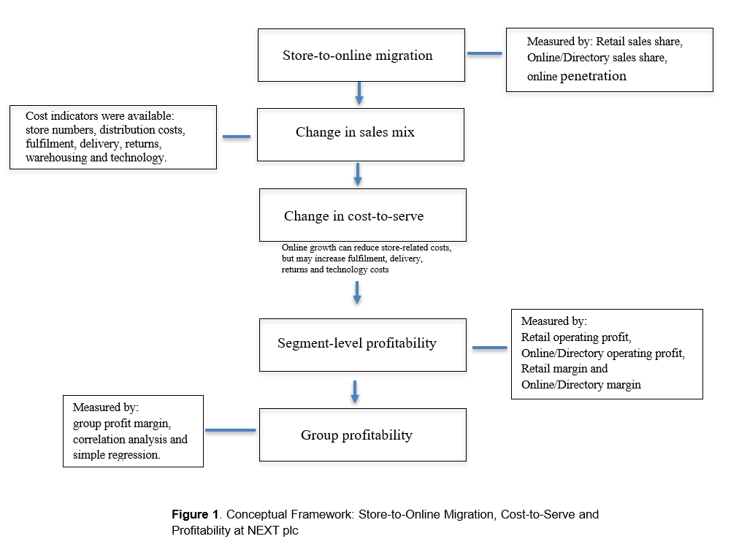
Figure 1 shows the conceptual framework used in this study. The framework does not presume that any increase in online growth will drive an increase in profit. It views online sales as an opportunity to shift the sources of sales. Profit might go up or down. It is subject to changes in the costs of serving those sales.
The first stage of the framework is store-to-online migration. This is an overall decrease in store sales and an increase in online sales. At NEXT plc, we follow it via the varying relationship between Retail and Online/Directory sales. When the share of the online product increases, it is an indicator of a change in the sales mix. It doesn't say if the Profit's improved. Migration is therefore seen as the beginning of the analysis rather than the outcome
The latter part of the framework is cost to serve. The fact that a business will be moving from stores to online has a change in what activities the business must conduct, and each one has its own cost. Hübner, Holzapfel and Kuhn (2016) consider the fulfilment, delivery and return processes as crucial components of omnichannel distribution. For a fashion and home business, it is especially important because products may be returned, which can include shipping, handling and markdown costs. So, online migration is not just about eliminating costs from the business. It moves the focus from store-based to fulfilment-based activities. Margin may be improved if online sales can be offered at a lower overall cost. Rising costs of fulfilment and returns, compared to revenues, could reduce margins. The third part is segment profitability. This is useful to consider with Porter's (1985) value chain framework, which suggests a firm consists of a series of interconnected activities that have costs, and the margin is the gap between the value generated and the cost of the activities. Store operations, store labour and physical selling space are more important to store retail, and warehousing, picking, packing, delivery, returns handling and technology are more important to online retail. These activities are not equally conducive to success in the Retail and Online/Directory segments, and the framework does not use only the group-level profit, it leaves the two segments separate. This is significant because the margin of some groups may not be affected as others weaken, and the others may be under increasing cost pressure.
The three components are linked thematically. A sales mix shift could result in a sales mix shift in the kinds of activities needed to meet the needs of the customers and the related cost-to-serve. These cost pressures could also have an impact on segment profitability and on the overall Group performance. The framework treats sales migration, costs and profitability as interrelated but does not take it for granted that one simply leads to the other.
This framework enables the research to go beyond the basic comparison between online and in-store. It supports a more analytical question than whether NEXT plc has more online presence, namely, if the online segment has been profitable enough to make up for the decline in the retail segment over the period. The framework thus provides direction for the subsequent twelve year period of Retail financial results and the Online/Directory financial results analysis. It enables the study to investigate if the fall in Retail profit was compensated by the growth in Online/Directory profit or whether the Online/sales growth by itself was a measure of financial success.

CHAPTER 3. METHODOLOGY

3.1 Research design and approach
This study investigates whether NEXT plc’s shift from offline to Online/Directory was linked with the change in profitability. It employs a quantitative, case design, a single firm, and an explanatory and longitudinal approach. The explanatory element is directed at relationships between sales mix and profitability, and the longitudinal design involves 12 years of observations, which help to differentiate long-term trends from the effects of the shocks occurring within that period. The methodological sequence is given in Figure 2.

The study is based on a positivist research philosophy, as the analysis is based on financial data that can be observed and measured, which are reported in the annually published reports of NEXT plc. Saunders, Lewis and Thornhill (2019) present positivism as research based on observable and measurable facts, which usually uses a structured and quantitative data analysis approach. This is suitable for the present study, which uses predetermined financial variables and statistics to identify relationships in the data rather than a subjective understanding of the data. The study also follows a deductive approach as the conceptual framework is developed from existing literature and then used to examine the relationships expected to exist in NEXT plc's financial evidence. Saunders, Lewis and Thornhill (2019) state that a deductive approach begins with theory, typically derived from academic publications or research and moves to the investigation of the theory. The results are not considered formal results of causal theory testing, though the study was only conducted in 1 company and 12 annual observations were made.

In case research, it is noted that the tasks of theory generation, theory testing and theory elaboration differ distinctly, as noted by Ketokivi and Choi (2014). In the present study, an explanatory approach was taken, where the relationships were analysed based on a pre-constructed conceptual framework, supported by a theory. Analysis is not used for formal factoring and testing of theory because of the single-company design and limited number of observations involved in an annual time frame.

NEXT plc is chosen because of its relatively detailed disclosures under the Retail and Online/Directory segment for the relatively long period for which the data are available for presentation in that segment. The kind of information available in comparable segments is not the same for all retailers
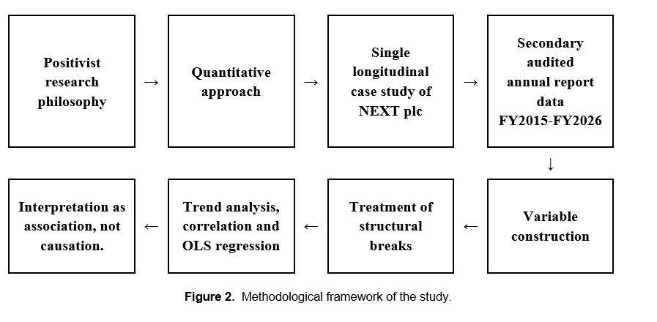

3.2 Data Sources and Secondary Research
The study is of the secondary documentary type of research, mainly information obtained from NEXT plc annual reports and results statements from FY2015 to FY2026. Main secondary data were sourced from the annual reports and results statements of NEXT plc for the period of FY2015 to FY2026 from the company's Investor Archive.
Johnston (2014) states that secondary data analysis involves data already gathered for other reasons and that must be assessed systematically before analysis. In a named NEXT plc report, each financial statement was identified and recorded under the appropriate financial year, maintained in accordance with the appropriate summary information in the Group report, and verified against the appropriate Group summary information before entering the data set.

3.3 Data preparation

3.3.1 Variable construction and measurement
The raw figures taken from the financial reports are Retail sales, Online/Directory sales, segment operating profit, group profit before tax, store count and distribution costs. Calculated measures compare all the figures with a suitable base, which reflects the performance rather than overall growth of the business. Table I states all the definitions. Zhang et al. (2010) show that the performance measures retailers commonly use are not that consistent across channels, which makes it difficult to judge how a decision made in one channel affects the other channel. Each of them is defined in the same way for both channels and maps directly in the conceptual framework, which follows the same logic Ailawadi and Farris (2017) set out for multi-channel and omnichannel measurement: that the right variables should be chosen before a reliable comparison is possible. Returns, delivery failures, order picking, warehousing and technology costs cannot be separated for the twelve-year analysis from public accounts. For this reason, distribution-cost intensity is employed as an aggregate measure of cost pressure instead of an absolute measure of Online/Directory cost-to-serve.
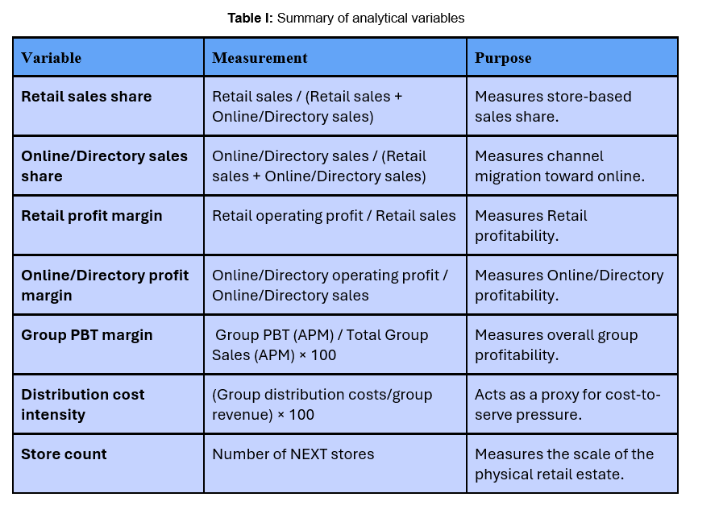

3.3.2 Treatment of structural breaks
Reporting and trading breaks, which impact the comparability of the period, are included in Table II. The introduction of IFRS 16 in FY2020 had an impact on the accounting for leases and reduced comparability with preceding years. For this reason, IFRS16 is considered a structural reporting break when longitudinal results are interpreted (IFRS Foundation, 2016).
There is another challenge relating to NEXT Finance and Total Platform. Items that were included in Online/Directories in the earlier years are reported separately in later years. So the study does not consider the full-period movement in the Online/Directory margin as a simple like-for-like trading trend. FY2021 was disrupted by the pandemic. FY2026 contains a 53rd week, which the company states added 111 million pounds to turnover and 24 million pounds to pre-tax profit, and is taken on a reported basis because the FY2027 report has not yet been published (NEXT plc, 2026). Moers (2007) argues that access to archival data can easily lead to uncritical use and also that archival data are not mainly gathered for academic research, and that identifying these breaks before analysis is the response.
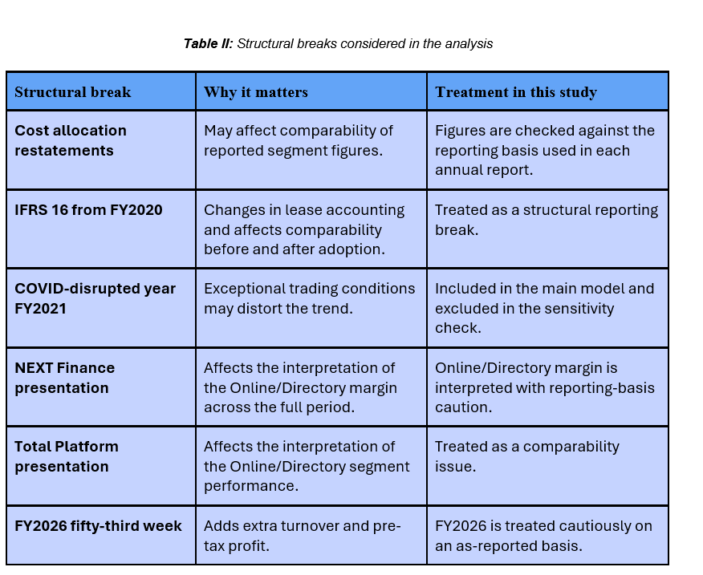

3.4 Analytical Methods
The analysis is conducted around the five research objectives, and it follows the logic of the conceptual framework as discussed. The purpose is not just to show that online/directory sales increased, but also to study whether this movement was associated with the changes in segment profitability, group profitability, distribution cost and store count. The analysis combines trend analysis, correlation, regression, segment comparison, compensation analysis and sensitivity checks. This links well with Ailawadi and Farris’s (2017) argument that multi-channel and omni-channel distribution analysis should start by selecting specific metrics which allow the relationship between distribution activity and marketing objective to be analysed reliably
The first stage involves descriptive trend analysis and compares the changes in Retail and Online/Directory sales with their relative amounts as a share of combined retail and online sales. This helps in identifying if the business became more Online/Directory led over the period.
The second stage involves comparing segment operating profit and operating margin and considering if the operating profit improvements in Online/Directory were enough to recover the decline in operating profit in Retail. Profit in pounds is important, profit margin is important, and this is because a segment can earn more profit even if the profit margin earned for each pound of sales in the segment has decreased.
Changes in the presentation of the segment in the annual statements were also a reason for the difference between Online/Directory and Other margin, because of this, an exploratory regression for reporting breaks was used. A time trend and step indicators for FY2018 and FY2023 were used as explanatory variables, while the operating margin (Online or Directory) was used as the dependent variable. The selection of these two years was made because there was a change in reporting as well as classification of the Online/Directory segment around these years. The model was used to study if the Online/Directory margin pattern remained after allowing for the identified reporting changes in FY2018 and FY2023. These reporting adjustments were not reported to conclude that the margin changes observed were the consequence of these reporting changes. Results and the full model are given in Appendix Table4B.2.
For the third stage, analysis of the association between the variables Online/Directory sales share and Group APM PBT margin is performed using the method of Pearson correlation and OLS regression. A sensitivity model excludes FY2021 due to the significantly larger shifts in channel mix and profitability caused by closures due to COVID-19. The regression is not taken as causation, and it is only evidence of association.
The fourth stage is to assess distribution-cost intensity as a Group-level proxy for cost pressure. In addition, both Online/Directory sales share and the intensity of distribution have grown over time, so an annual-change model is also used to assess how both of these variables have moved from year to year, avoiding the risk of common long-term trends. The number of stores is considered a supportive measure of store performance and is not used alone to evaluate store performance.
The final stage is to consider and judge the evidence from segments of the UK for FY2023 to FY2026, to determine if the UK behaviour 2023 to 2026 follows the pattern of the wider Group. Since the period of time is shorter, these results are not used as statistical tests but rather as descriptive supporting evidence.
Python was used for the statistical analysis via Jupyter Notebook. The pandas package was used for data preparation and calculation, matplotlib was used to produce the figures, scipy.stats was used for Pearson correlation analysis, and statsmodels was used for the OLS regression models.

3.5 Validity and reliability
According to Heale and Twycross (2015), validity is the degree to which a method measures what it is designed to measure, and reliability is the consistency of the measurement.

3.5.1 Reliability
It was important to take source reliability and procedural reliability into account and to do sensitivity testing for analytical robustness.

Source level:
Figures have been pre-tested against the appropriate Group Summary for segment figures before being added to the data set. This minimised the chances of figures and data being entered incorrectly and without support.

Procedural level:
In terms of the process, raw transcribed figures were not included in variables calculated by the author. Derived measures like sales share, profit margin and distribution cost intensity were automatically computed, instead of typing them in. This resulted in the process being more transparent and enabled another researcher to replicate the steps from published accounts to the final dataset. This is a solution to the reliability problem indicated by Moers (2007) in the archival accounting study.

Analytical level:
Sensitivity testing is used at the analytical level to support reliability. Online/Directory sales share is analysed against Group APM PBT margin for the full 12-year model and a second model without FY 2021. This examines the consistency of the direction of the relationship even after the COVID-19 disrupted year is dropped. The data in this study are from only 12 annual observations and are therefore viewed with caution and in conjunction with trend and segment-level evidence.

3.5.2 Construct validity
Construct validity explains whether the variables being used reflect the concepts that they are supposed to measure. According to Cronbach and Meehl (1955), construct validation is required when there is no one perfect measurement for a concept. This is an important point to consider here because channel migration, cost-to-serve pressure and profitability are not directly observed and are instead measured through financial indicators.
The definitions of the key variables are provided in Table I: Online/Directory sales share, segment operating margins, Group APM PBT margin, store count and distribution-cost intensity. The use of predefined rules limited the chances of altering the measurement approach once the results were seen.
The data breaks identified in Table II are therefore considered when interpreting the results. Ittner and Larcker (2001) have pointed out that variables in the archive might contain measurement noise and systematic bias. This relates with special emphasis to distribution-cost intensity being used as an indicator of cost-to-serve pressure.

3.5.3 Content validity
Almanasreh, Moles and Chen (2019) describe content validity as the relevance and representativeness of selected measures. Content validity is addressed by aligning the selected financial measures to the research objective.
However, cost coverage is not complete. There is no consistent disclosure of detailed returns, delivery failure, order picking, technology and warehousing costs for the entire period from FY2015 to FY2026. Thus, there are no estimated values included in the data. It would have undermined confidence in the entire set of estimates, as it would not have been audited. The statement of data limitation was then clearer, and it was more appropriate to take distribution-cost intensity as an aggregate proxy.

3.5.4 Internal validity
The study used observational data from multiple years, and as a result, this approach does have some limitations in terms of internal validity. Correlation and regression can reveal statistical associations with direction and strength but cannot prove that Online/Directory migration led to changes in profitability. This common time trend can be a misleading association, because the intensity of Online/Directory sales and distribution increased with time.
Profitability measures may also be impacted by reporting change but not a trade change. These reporting and trading breaks take precedence for this reason and therefore are part of the considerations when interpreting the findings in Table II. FY2021 is excluded from the sensitivity regression due to COVID-induced store closures and trading conditions.
Zimmerman (2001) argues that empirical managerial accounting research has remained too focused on describing practice rather than developing and testing theory. In the present study, the risk is mitigated by associating statistical tests with the conceptual framework, but not enough due to the small sample size to make any causal inferences. Also, over time, there was growing revenue from online/directory sales, which could have contributed to the level regression. This does not eliminate this restriction if FY2021 is excluded, as this will exclude the influence of the pandemic year

3.5.5 External validity
There are also some limitations regarding the external validity of the study. It is based on one company and twelve annual observations. The Online/Directory channel was relatively developed in NEXT plc before the study period, partly due to its Directory business. As a result, its experience will vary from the e-commerce retailers who started later or had more bricks-and-mortar locations.
The results are not intended to be used as a general rule for other retailers. These are most applicable to the same type of business, with a store estate, an established online presence, fashion-related or home-related products and a need to see distribution-cost pressure.

3.6 Ethical considerations
The study uses only data that was publicly available, secondary data and involves no human participants, so there are no issues of consent, privacy or harm. No figures are manipulated or chosen to prove a point, and the evidence is laid out clearly and fairly, with supporting evidence and refuting evidence

CHAPTER 4. FINDINGS
This chapter presents the findings from the analysis done of NEXT plc for twelve financial years from FY2015 to FY2026. All the financial figures were taken from the company’s audited reports. ONS and Statista data are also used to provide the wider market context. The chapter begins by studying the store-to-online sales migration before considering segment profitability, Group profitability, distribution costs, the store estate and the available United Kingdom segment figures.

4.1 The store-to-online migration
The first research objective studies how NEXT plc’s sales mix changed during the study period. Table III compares the opening year, FY2015, with the closing year, FY2026. (The related Python code and results are provided in Appendix 4A).
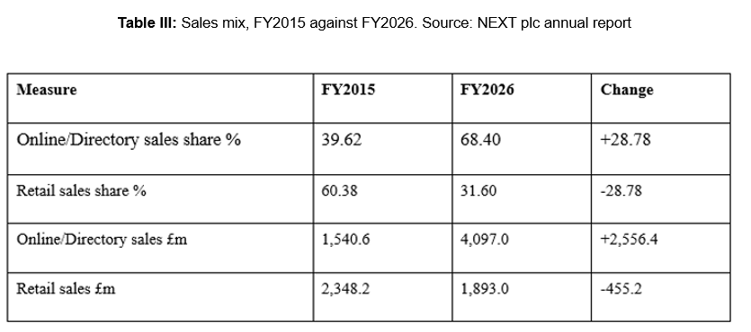
- Online/Directory sales share increased from 39.62 per cent to 68.40 per cent, which was a gain of 28.78 percentage points.
- Online/Directory sales grew by 2,556.4 million pounds, whereas Retail sales declined by 455.2 million pounds.

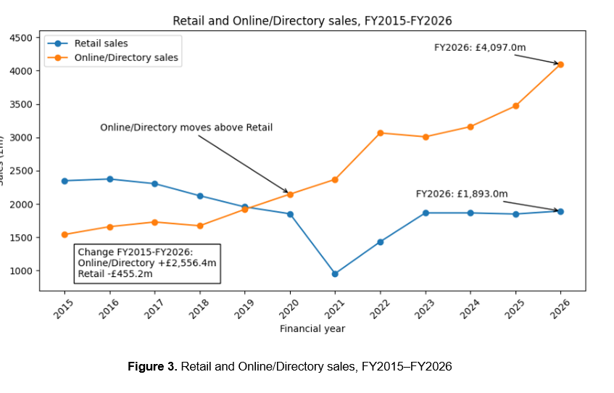Figure 3 shows that the shift towards Online/Directory sales occurred over several years. Retail sales remained higher than Online/Directory sales during the first part of the period. Online/Directory sales then moved above Retail sales around FY2020 and continued to grow after that point.
The largest change happened in FY2021. Retail sales declined as stores were closed for part of the year, while Online/Directory sales increased. Sales of the retail sector recovered when stores reopened, but they remained below the level which was reported at the beginning of the study. Online/Directory sales also remained above their pre-pandemic level.
It is important to note the difference between the two changes. Growth in the sales of Online/Directory was approximately 5.62 times the value of the decline in Retail sales. This shows that the movement was not just a basic movement from stores to online. The value of both the channels combined increased across the study period.
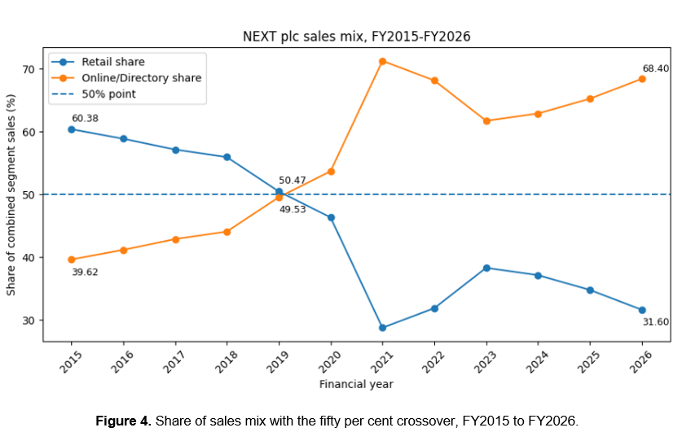Figure 4 shows the same movement as a percentage of combined segment sales. Retail represented 60.38% of sales in FY2015, compared with 39.62% for Online/Directory. By FY2019, both channels were close to equal. Online/Directory became the larger sales channel by FY2026 as it reached 68.40%

Online/Directory share reached an exceptional level in FY2021, when physical stores were struggling due to pandemic-related restrictions. However, it remained above 60% in every later year. This clearly shows that the movement towards Online/Directory sales was not limited to the period of store closures. The pandemic boosted a change that had already started before FY2021.

The insights from UK data are useful for NEXT plc's channel shift. Measures by the ONS for the UK retail sales market indicate that online sales increased from 18% of total sales in the UK to 30.7% in 2021, significantly falling to 27.4 per cent in 2025. Although this decrease is evident, the percentage in 2025 was 9.4 percentage points higher than the figure in 2018 (Office for National Statistics, 2026). E-commerce accounted for 31% of UK apparel sales in 2018 and 55% in 2020 (Eversheds Sutherland, 2021). This clearly shows that the channel shift and UK movement towards the online sector were happening at the same time. But period-on-period comparison is not possible due to differences in the reporting periods. However, growth in sales alone does not show if the channel shift improved profitability. The next section therefore examines the operating profits and margins of the two segments.

4.2 Segment profitability and compensation
The second and fifth objectives mainly ask: how profitable each channel was and if online profit growth offset the retail decline. Table IV shows the change in segment operating profit throughout the years (Refer to Appendix 4B for code and Python results)
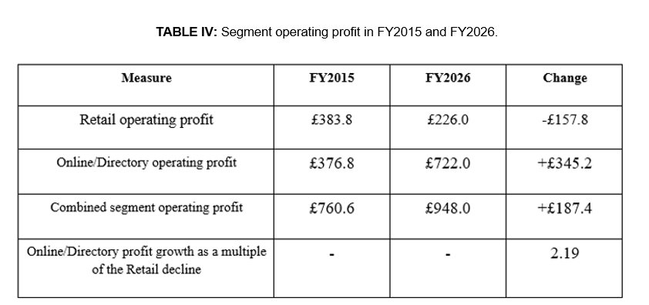Between FY2015 and FY2026, there was a decline of £157.8m in retail operating profit, while there was an increase of £345.2m in Online/Directory operating profit. As a combined result, the operating profit of both segments increased by £187.4m.

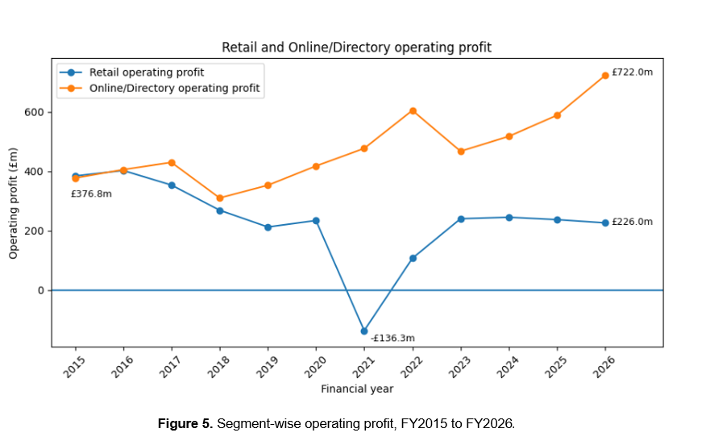
Figure 5 shows that Online/Directory became a larger source of segment operating profit from FY2016. Retail Operating profit recorded a loss of £136.3m in FY2021 and did recover after that, but its FY2026 profit of £226.0 m was below the opening year level. Online/Directory remained profitable throughout the period and did increase from £376.8m in FY2015 to £722.0m in FY2026.
Profit figures indicate that Online/Directory became the bigger contributor of segment operating profit. However, profit in pounds does not account for differences in the level of sales. The margins of the two segments were therefore examined separately.
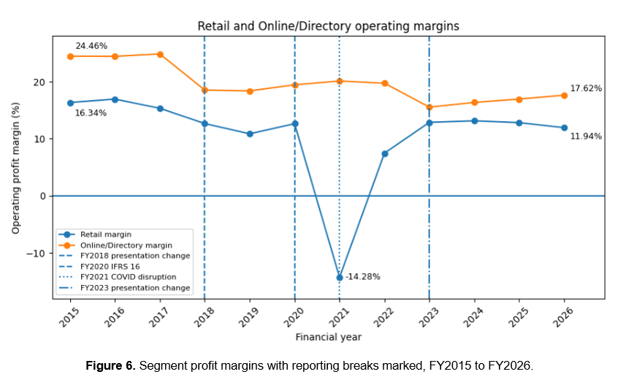Figure 6 shows the operating margins across the study period. Online/Directory had a higher operating margin than Retail in every year. However, its reported margin declined from 24.46% in FY2015 to 17.62% in FY2026. Retail margin declined from 16.34% to 11.94%, with a sharp temporary fall to −14.28% in FY2021.
To make the margin results cleaner, an exploratory model of reporting breaks was used. It checks whether the margin decline in Online/directory was a normal decline or if some of the change is linked to reporting changes in FY2018 or FY2023.
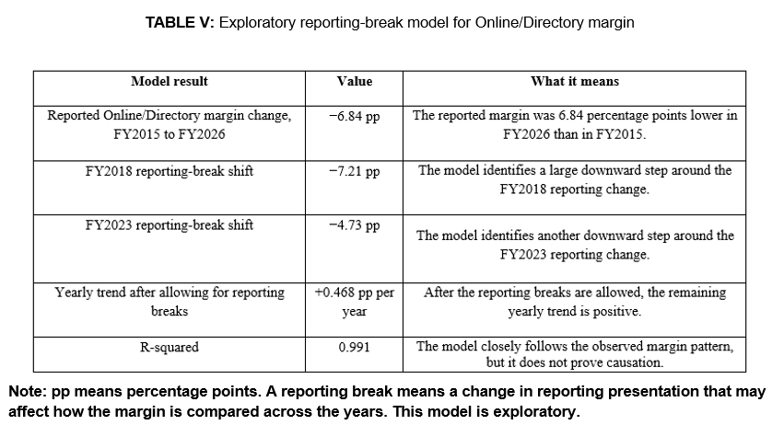
The Online/Directory margin did not decline steadily over the whole period. Table V shows that the reported margin declined by 6.84 percentage points between FY2015 and FY2026, but the largest decline occurred around FY2018 and FY2023 when the reporting pattern changed. After these two reporting breaks were included in the model, the remaining time trend became positive at 0.468 percentage points per year. This suggests that the decline in reported margin should not be read as a simple year-by-year trend of declining performance of Online/Directory. However, the model is exploratory and does not prove that margin movements were caused by any reporting changes (Refer to Appendix 4B for full model, equation, code and output)

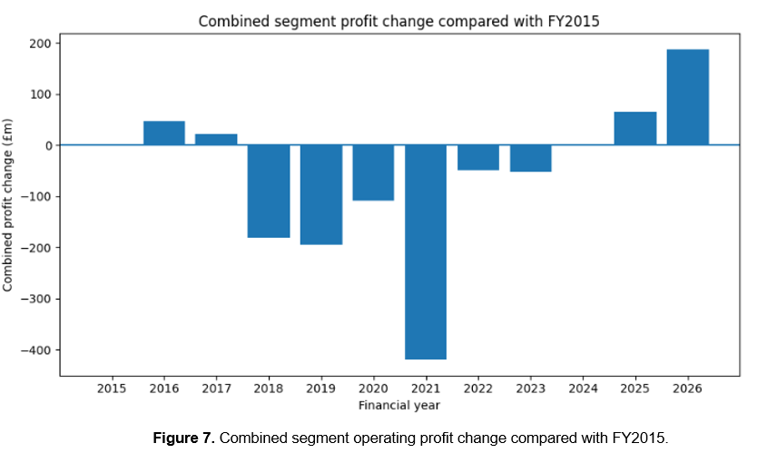Figure 7 shows that combined segment operating profit remained below its FY2015 level between FY2018 and FY2023. It moved a bit above the starting position in FY2024 and reached £187.4m above it by FY2026. Online/directory compensated for the decline in Retail, but the improvement was uneven.
These findings answer the second and fifth research objectives. Online/Directory profit growth exceeded the fall in Retail profit by FY2026. The next section examines whether the increase in Online/Directory sales share was associated with NEXT Group profitability.

4.3 Online/Directory sales share and Group profitability
The third research objective is to find out if the increase in the percentage of Online/Directory sales is correlated with NEXT Group profitability. The profitability of the group is determined by NEXT Group PBT margin on an Alternative Performance Measure (APM) basis.
Online/Directory sales share was found to have a strong negative relationship with NEXT Group APM PBT margin, as evident from the Pearson correlation. The correlation was −0.761 with a p-value of 0.004. This indicates that those years with a greater Online/Directory sales percentage tended to have a lower Group margin. However, correlation does not indicate that a change in sales mix brought about a change in profitability.
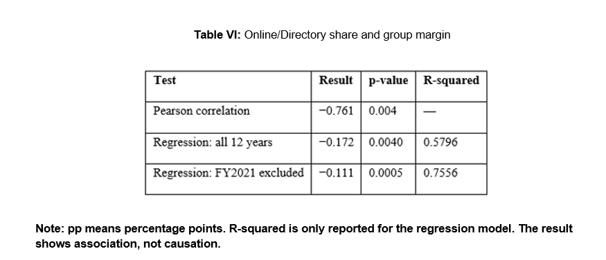
The regression coefficient was −0.172, indicating that a one percentage point higher Online/Directory sales share was associated with an estimated 0.172 percentage point lower Group APM PBT margin

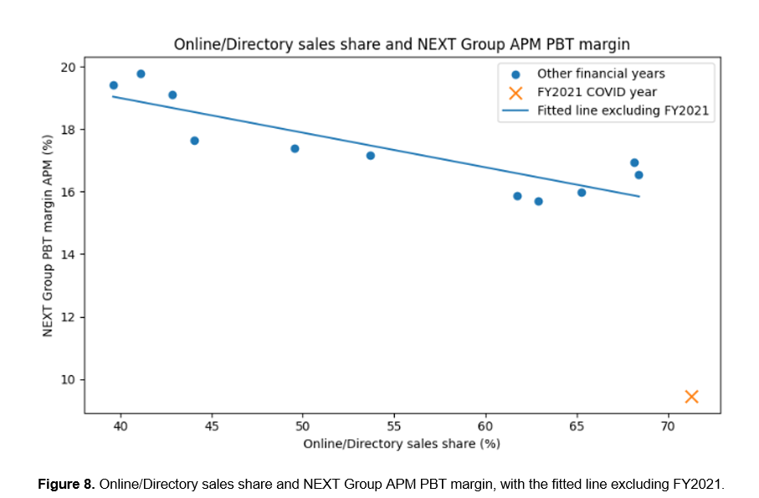Figure 8 shows that FY2021 was clearly separated from the other observations. It combined the highest Online/Directory sales share with the lowest Group margin. This shows the exceptional trading conditions during the pandemic, when store closures and other disruptions affected both channel composition and profitability.
The regression was repeated without FY2021 as a sensitivity check. The coefficient stayed negative, but was smaller in absolute value, from −0.172 to −0.111. The p-value came down to 0.0005, and R-squared went up to 0.756. The negative relationship exists even after excluding FY2021, suggesting that the pandemic year was not the only factor behind the negative correlation. The full twelve-year regression is, however, the primary model, with the model without FY2021 offering supportive evidence.
These findings address the third research objective, which was to determine if there was a statistically significant negative relationship between Online/Directory sales share and NEXT Group APM PBT margin. This finding was in the same direction when FY2021 was removed. The result should be taken as a statistical, non-causal association. While the relationship was negative when FY2021 was excluded, other time-related and business factors could also have had an impact on Group profitability. (Refer to Appendix 4C for the full correlation, regression and sensitivity-check results). This section, then, will explore the link between Online/Directory growth and distribution-cost intensity.

4.4 Online migration and distribution-cost intensity
The fourth research objective studies the relationship between the shift to Online/Directory sales and distribution costs. Distribution-cost intensity was defined as Group distribution costs to statutory revenue.
There is a strong association between Online/Directory sales share and distribution cost intensity. The correlation coefficient is 0.985, which indicates that the two measures varied closely together over the 12 years. The correlation was statistically significant at the 1% level. Table VII summarises the key distribution cost relationship.

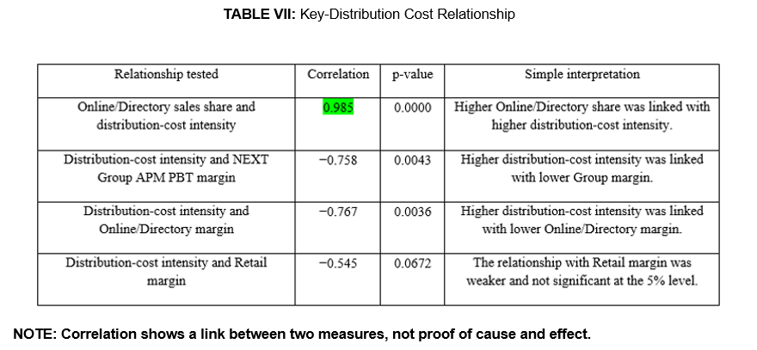

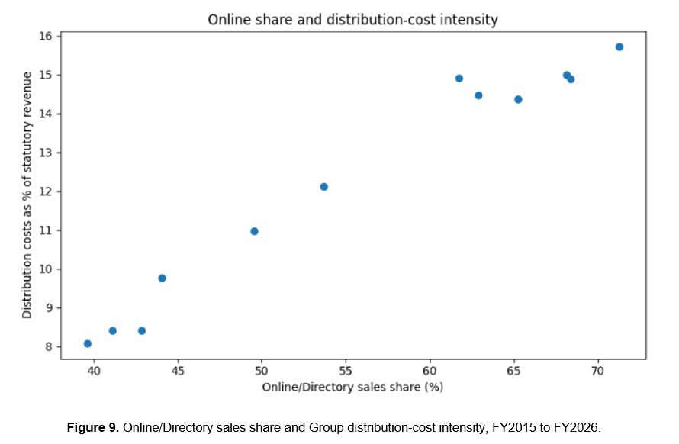
Figure 9 shows that higher distribution-cost intensity was generally reported at higher levels of Online/Directory sales share. Both measures increased over time as well. This means that a strong/positive correlation may reflect a shared long-term trend rather than a direct relationship, and because of this, an annual-change model was used additionally.
The annual-change model measured changes in distribution cost intensity, as well as changes in the share of Online/Directory sales over the year. It was done to minimise the risk that the result was only caused by both variables rising over time. Table VIII shows the annual change model.
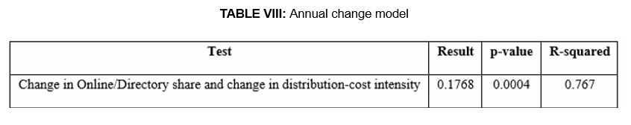The annual-change model provides additional support than the correlation model since it focuses on year-by-year change instead of overall long-term change. The coefficient was 0.1768, with a p-value of 0.0004 and an R-squared of 0.767. This states that a one percentage point annual increase in Online/Directory sales share was associated with a 0.1768 percentage point annual increase in distribution-cost intensity. This interpretation should be made with caution, as there were only 11 changes annually and FY2021 had some unusual changes related to the pandemic. Hence, their findings are regarded as evidence that there is an association but no proof that an increase in Online/Directory sales share led to an increase in distribution-cost intensity.

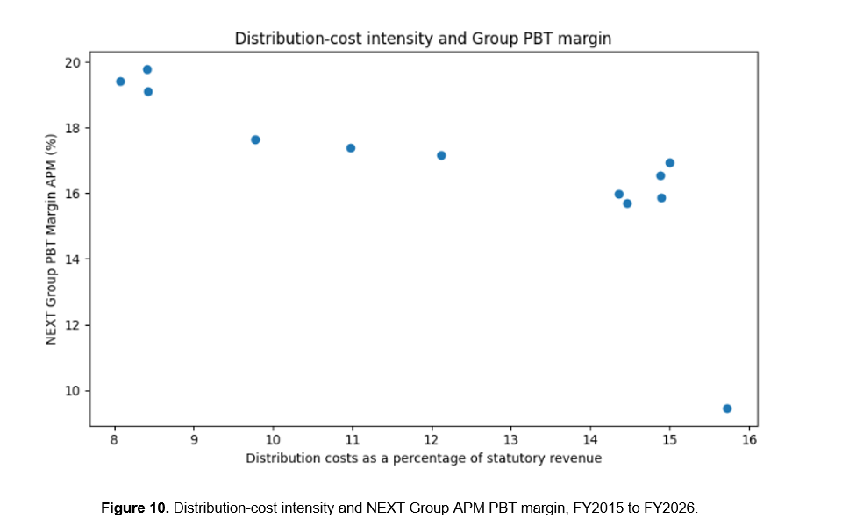Distribution-cost intensity was negatively associated with both Group and Online/Directory profitability. Its correlation with NEXT Group APM PBT margin was −0.758, while its correlation with Online/Directory margin was −0.767. Both relationships were statistically significant. By comparing the numbers, we can say that the relationship with Retail margin was weaker and did not reach the 5% significance level. Figure 10 shows the relationship between NEXT Group APM PBT and distribution- cost intensity.
These results clearly indicate that higher distribution-cost pressure is linked with lower reported Group and Online/Directory margins. However, the cost measure is reported at Group level. It may include the effects of overseas growth, inflation, business expansion and other operational changes. It cannot be interpreted as a direct measure of the cost created only by Online/Directory sales.
These findings address the cost-related part of the fourth research objective. Distribution-cost intensity was strongly positively linked with Online/Directory sales share and negatively linked with Group and Online/Directory margins. However, the cost measure is reported at Group level and should be considered as an overall cost-pressure measure and not a direct measure of Online/Directory fulfilment costs. The full correlation matrix, annual-change regression code and output are provided in Appendix 4C. The next section examines the relationship between Retail store count and profitability.

4.5 Retail store count and profitability
The second part of the fourth research objective examines whether the size of NEXT’s Retail store estate was associated with profitability.
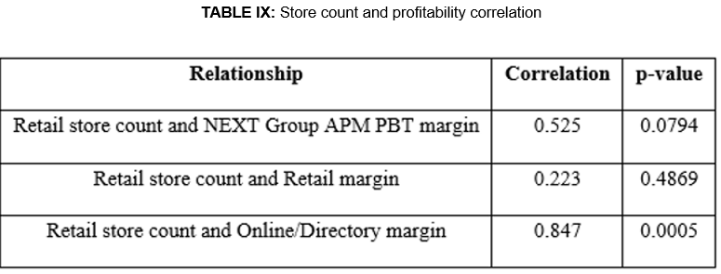
The NEXT Group APM PBT margin showed a moderate positive correlation of 0.525 with the number of retail stores. The p-value was 0.079, however, this was above the 5% significance level. Its relationship with Retail margin was weaker at 0.223 and was also not statistically significant. The analysis therefore does not provide sufficient statistical evidence of a relationship between store count and either Group or Retail profitability.
Online/Directory margin was more highly correlated with retail store count at 0.847 and had a p-value of 0.0005. All of these series experienced a decrease in store count and an Online/Directory margin decrease over this period, along with reporting changes to the margin series. The positive correlation thus indicates that the two measures went in the same direction. It does not demonstrate that larger stores increased the Online/Directory margin.
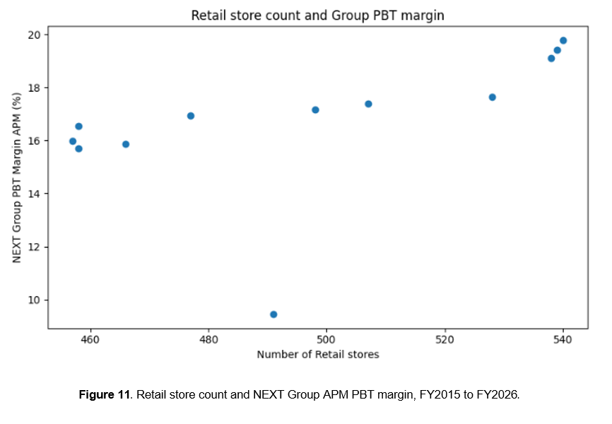A broad positive, although not statistically significant, relationship is indicated in Figure 11. Count of stores is also an incomplete measure since it does not account for variation in store size, store location, productivity or the operations of the store. The data available cannot therefore distinguish between individual stores that facilitated broader activities like collections, returns and customer service.
This may help explain why the relationship between store count and Group margin was moderate and not statistically significant. Store Count alone does not show the number of stores that collected/returned, fulfilled or provided customer service. The process of these roles cannot be separated out in the data available. Therefore, store count alone does not provide a clear picture of whether the store estate improved or reduced profitability.
They provide evidence to address the fourth research objective along with Section 4.4. Distribution-cost intensity was more closely related to profitability than was the number of stores. However, store numbers were not significantly related to Group or Retail margin, but there was a strong relationship with Online/Directory margin, which should be treated with caution due to common time patterns and reporting changes. (Refer to Appendix 4C for correlation results and p-values)

4.6 UK supporting evidence
Finally, the UK segment figures that are available for each year between FY2023 and FY2026 are provided to offer some recent descriptive evidence regarding Online growth and segment profitability. UK Online sales share was calculated by dividing Online UK sales by total UK product sales. Retail Stores and Online UK operating margins were calculated by dividing segment operating profit by segment sales. The related code and outputs are provided in Appendix 4D
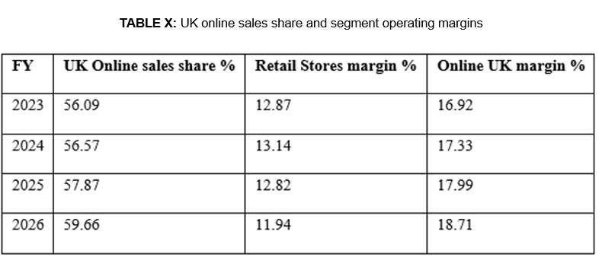UK Online sales share rose from 56.09% in FY2023 to 59.66% in FY2026, an increase of 3.57 percentage points. During the same timeframe, Online UK margin rose from 16.92% to 18.71%, whereas Retail Stores margin decreased from 12.87% to 11.94%. The share increase in UK Online was coupled with a better reported Online UK margin.
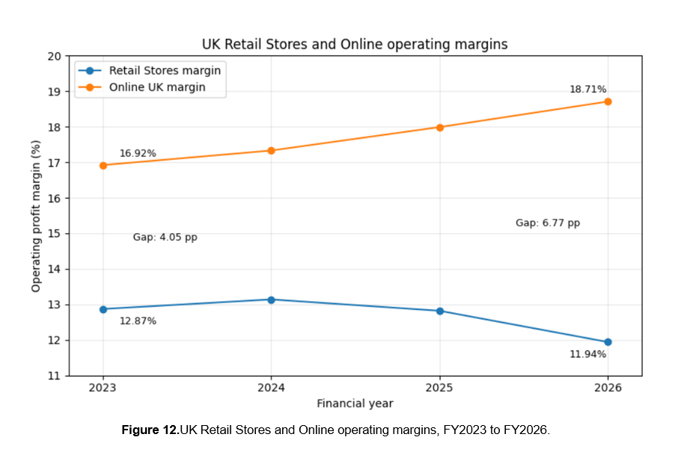
Figure 12 shows that the Online UK margin was higher than the Retail Stores margin over the four years. The gap widened for both years, from 4.05 percentage points during FY2023 to 6.77 percentage points during FY2026. The widening gap was due to the increase in Online UK margin and the drop in Retail Stores margin.
This finding is presented to balance the wider group-level finding that is presented in the UK evidence. In the twelve-year group analysis, a higher Online/Directory sales share was linked with a lower NEXT group APM PBT margin. However, the UK segment analysis shows that in the recent four years, UK online growth happened along with an improving online UK margin. These results do not contradict each other as they measure different things. The Group analysis uses twelve years of Group-level profitability, while this UK evidence focuses only on recent UK segment margins.
So the UK evidence should be used to support the evidence, rather than as a separate statistical test. It reveals that Online/Directory growth should not be said to be just positive or negative. The results of its finances are related to the time frame, the degree of analysis and the sales cost base.

4.7 Summary of findings
The analysis shows that NEXT plc changed from a Retail-led business to an Online/Directory-led business between FY2015 and FY2026. Online/Directory sales increased by significantly more than Retail sales declined, while Online/Directory profit growth was more than twice the decline in Retail profit. This compensation, however, took place in an uneven manner, and there were more or less distinct moves around the reporting changes in the long-term margin series.
A higher Online/Directory share was linked with a lower NEXT plc group APM PBT margin, and the negative relationship was still there when FY2021 was excluded. Online/Directory share was also strongly linked with high distribution cost intensity, while cost intensity was higher, group margins were lower at the same time. Store count showed no significant relationship with Group or Retail profitability.
Overall, the migration contributed positively to the sales reporting and operating profit on the segments but not so clearly to the Group margin. The results suggest that financial outcome is not only dependent on the channel growth but also on the cost linked with the change in sales mix.

CHAPTER 5. DISCUSSION

5.1 Introduction to the Discussion
This chapter analyses the findings in relation to the research question, objectives, literature review and conceptual framework. The main issue is not if NEXT plc became more on Online/Directory led business, but if there is improvement from this shift in terms of profitability when segment profit, group margin and distribution cost pressure are considered together. The finding shows mixed results.

5.2 Discussion of Key Findings

5.2.1 Store-to-online migration as a structural shift
The findings show that the shift from retail to Online/Directory was a long-term effect rather than only a pandemic effect. Online/Directory sales share increased from 39.62% in FY2015 to 68.40% in FY2026, while Online/Directory sales increased by £2,556.4m and retail sales declined by £455.2m. This was not a simple shift of existing retail sales to Online/Directory because Online/Directory growth increased by a large amount, which exceeded the decline in retail sales, suggesting wider growth in the combined business.
The pattern is consistent with the possibility of channel synergy. Herhausen et al. (2015), report that the combination of online and offline channels can generate back-to-back "channel synergies" instead of “channel cannibalisation”. However, higher growth in Online/Directory sales shouldn't be interpreted as proof that channel integration generated the additional sales. NEXT plc data can not directly measure channel interaction but indicate the direction and scale of the sales movements. This may be due to wider growth within firms. Objective 1 does, however, outline a structural change in the sales mix, but not whether the sales mix change increased profitability.

5.2.2 Segment profitability and compensation
The findings chapter shows that there was a decline of £157.8m in retail operating profit between FY2015 and FY2026, while Online/Directory operating profit increased by £345.2m. (Refer to Table IV and Figure 5 of Findings)
Maier et al. (2023) study the financial effect of adding an offline channel to an online retailer and find increases in both overall sales and profit in their setting. Although the direction of channel expansion differs from NEXT plc, their study shows the importance of studying profit outcomes along with sales when assessing channel change. However, Ishfaq and Bajwa (2019) state that the fulfilment process can affect the profitability of the channel, which means that absolute profit growth alone does not confirm improved efficiency.
The result should not be considered a smooth success, combined segment operating profit stayed below the FY2015 level from FY2018 to FY2023, which means that the benefit developed slowly rather than immediately. Online/Directory margin also declined from 24.46% to 17.62%, even though Online/Directory profit increased in pounds. The segment became larger and more profit was generated, but the profit that was earned from each pound of sales became weaker on a reported basis.
The margin result should also be studied closely as it was not a smooth operating trend. The exploratory margin break model showed that the Online/Directory margin trend was negative. After considering the reporting breaks for FY2018 and FY2023, the estimated trend became positive at 0.468 percentage points per year (refer to Appendix 4B.2 for full regression). This indicates that the decline in the part of the reported margin may reflect the reporting changes rather than a continued decline in performance.
There's also a difference between profit contribution and profit efficiency. Online/Directory produced more Operating profit as its size increased, but reported margin decreased. Thus, there was not a direct relationship between scale and efficiency. This is a straightforward evaluation of channel success based on absolute profit only, and demonstrates the need to take into account both margin performance as well as reporting changes for the period as part of the compensation outcome.

5.2.3 Online/Directory share and Group profitability
The third objective studied the relationship between Online/Directory sales and group profitability, as well as the broader financial impact at Group level rather than simply segment operating profit.
The Findings chapter shows that a higher Online/Directory sales share was linked with a lower NEXT Group APM PBT margin. The full-period regression showed that a one percentage point increase in Online/Directory sales share was linked with a 0.172 percentage point reduction in Group APM PBT margin. Removal of FY2021 results in a smaller coefficient, and the relationship remains negative. (Refer to section 4.3 and figure 8, and appendix table 4C.2)
Online/Directory became a larger channel of sales and profit without improvement in group margin at the same time, this does not mean that growth in Online/Directory caused lower group profitability. It shows that increasing share of Online/Directory was not aligned with stronger group margins.
This fits with Ailawadi and Farris (2017), as different measures were linked with different assessments: sales share captures migration, segment profit captures compensation, and group margin captures the overall profit outcome. This helps to illustrate the conceptual framework because the profitability impact of a sales mix change depends partly on the cost of serving that sales mix.
The Group-level result should be broken down into the performance of the Online/Directory segment. Group APM PBT margin reflects the wider business and can be influenced by costs/activities not included in Online/Directory sales share alone. After excluding FY2021, it shows that the pandemic year was not the negative driver, but it does not isolate the channel shift from other changes over time. The contribution was thus more of an analytical type than a causal type, that is, there may have been an increase in channel activity, but no change to Group profitability.

5.2.4 Distribution-cost pressure and store count
The fourth research objective studied whether the distribution cost intensity and store count were linked with profitability. Online/Directory sales share was strongly linked with high distribution cost intensity, as discussed in the findings chapter. The annual change model showed that a one percentage point annual increase in Online/Directory sales share was linked with a 0.177 percentage point annual increase in distribution cost intensity. This helps in explaining why Online/Directory growth did not lead to an improvement in group margin (Refer Section 4.4, Figure 9 and Appendix 4C)
Hübner, Holzapfel and Kuhn (2016) and Bijmolt et al. (2021) state that fulfilment, delivery, returns and sales are affected by omnichannel growth. This is where NEXT plc's result fits in, as distribution cost intensity increased as the Online/Directory share increased.
The first-difference result strengthens the cost pressure argument. The correlation done earlier may partly be because Online/Directory sales share and distribution cost intensity both increased over time, but the annual change model shows that the year-to-year increase in Online/Directory share was also linked to a year-to-year increase in distribution cost intensity. This does not show that Online/Directory growth caused higher costs, but the relationship may be hard to explain as a general time trend.
No statistically significant correlation between the number of stores and Group or Retail margin is shown in the Findings chapter (refer to section 4.5 and figure 11). This should not be read as an indication that there are no stores with economic value. Store size, location, productivity, collections, returns, customer service, etc., are not included in store count. Ishfaq et al. (2016) and Pauwels and Neslin (2015) document that stores can provide fulfilment, acquisition and returns for their customers.
The cost evidence backs this up, but does not suggest a direct mechanism. The annual-change model minimises the threat of relying only on two variables increasing as the study progresses – but other changes at the Group level can also impact both measures. Distribution-cost intensity should thus not be viewed as an accurate reflection of the cost of Online/Directory fulfilment, but rather as evidence of broader cost pressure. This ensures that the same interpretation is maintained as in the non-causal design of the study.

5.2.5 UK supporting evidence
The UK supporting evidence adds a clear balance to the findings at group level. From FY2023 to FY2026, UK online sales share increased from 56.09% to 59.66%. During the same period, the online UK margin improved from 16.92% to 18.71%, and the retail store margin declined from 12.87% to 11.94%. (Refer to Section 4.6, figure 12 and appendix 4D)
The recent UK results provide a more positive view of online profitability. Online share increased, and online UK margin improved while the margin in the retail stores segment decreased. This indicates that UK Online growth has been coupled with better Online margin performance in recent times.
The difference between the online UK and retail store margin performance also shows that the online channel became stronger financially as compared to stores during this period. This does not match the overall scenario at the group level, where online/directory share was not linked with stronger group margin and the pressure of distribution cost increased. The UK evidence adds an important aspect that online growth can support the segment profitability at some levels, but it does not mean that the same benefit happens at the group level. The UK evidence only covers FY2023 to FY2026, so it should be used as supporting evidence, not as a substitute for a twelve-year analysis.
The result is neither positive nor negative when combined. A high amount of sales and segment profit was created by Online/Directory, but the results were weak when examined through reported margin, group profitability and distribution cost intensity. Central issues, therefore, are where the financial benefits of online shift appear and whether there is any financial cost that reduces some of those benefits.

5.3 Overall Interpretation and Research Question Response
The research question that was studied was the relationship between NEXT plc’s shift from store-based sales to online/directory sales and profitability from FY2015 to FY2026. Overall, there were mixed results when it came to financial outcomes, depending on the variables. By FY2026, growth in Online/Directory operating profit exceeded the decline in retail operating profit, as per the reported/restated segment basis. However, this did not result in an improvement in Group APM PBT margin. Higher Online/Directory sales share was also linked with higher distribution cost intensity. The results do not provide evidence that Online/Directory growth brought changes in group profitability. It demonstrates that different perspectives of a channel shift can be gathered through sales migration, absolute profit contribution, margin performance and cost pressure. The store-to-online shift at NEXT plc needs to be viewed in terms of profit contribution, margin quality and distribution-cost pressure, in the context of sales share.

CHAPTER 6. CONCLUSION
The dissertation studies how NEXT plc's shift from store to online sales affected profitability between FY2015 and FY2026. The study was based on the argument that online growth should not be judged based on just sales share, because a higher online sales share does not mean that profitability improves. For this reason, the analysis includes sales migration, segment operating profit, profit margins, Group profitability, distribution-cost intensity and store count.
The study concludes that NEXT plc’s store-to-online shift had a mixed financial effect. Online/Directory sales share increased from 39.62% in FY2015 to 68.40% in FY2026. The Online/Directory sales increased by £2,556.4m, and retail sales declined by £455.2m. NEXT plc became a more Online/Directory led business within a wider growing sales base.
Online/Directory operating profit increased by £345.2m, whereas retail operating profit declined by £157.8m. This means that Online/Directory profit growth compensated for the decline in retail operating profit by FY2026. This was developed slowly and steadily, as combined segment operating profit was below FY2015 level for many years before it improved. Online/Directory margin remained higher than retail margin across the period but declined from 24.46% to 17.62%. This clearly shows that Online/Directory was a strong contributor to absolute segment, but from each pound of sales, the reported profit earned got weaker.
There was a negative relationship between Online/Directory sales and Next Group APM PBT margin, even if FY2021 was removed from the equation. This does not show that Online/Directory growth led to poorer Group profitability. However, it shows that the shift towards Online/Directory was not accompanied by a corresponding improvement in Group margin.
The distribution cost result helps explain this mixed result. Online/Directory sales share was strongly associated with higher Group distribution-cost intensity. The annual-change analysis also showed that year-to-year increases in Online/Directory share were associated with increases in distribution-cost intensity. This supports the concept developed in the conceptual framework of the cost-to-serve argument. Distribution cost intensity is, however, reported at group level, and should be interpreted as broader evidence of cost pressure, not as a measure of Online/Directory fulfilment cost.
The store count and UK evidence add balance. The number of stores was not significantly related to group or retail margin, which means that the number of stores alone does not explain profitability. The UK evidence showed that from FY2023 to FY2026, the UK sales share increased and the margin also improved. This indicates that higher segment margins were associated with rapid growth in the UK, but the UK data of just the last four years does not affect the Group-level findings of over the last twelve years.
Overall, this Dissertation finds that although NEXT plc made significant progress in being more Online/Directory-led, and improved its absolute Online/Directory operating profit, there was no corresponding improvement in its Group APM PBT margin. Additionally, distribution-cost intensity was related to higher Online/Directory sales share, but this does not establish a causal link. Profit contribution and margin performance and cost pressure are therefore the key metrics for measuring online growth, rather than sales share.

6.1 Implications and Recommendations

6.1.1 Theoretical implications
Results have implications for interpreting the omnichannel findings. Herhausen et al. (2015) stated that integrating online and offline channels can generate channel synergies instead of channel cannibalisation. Findings of NEXT plc qualify this financially: Online/Directory was the bigger sales and operating-profit channel, but the Group profitability did not follow it. Profit contribution and margin quality, and cost-to-serve pressures should be taken into account with channel growth.
The findings also add to those of Ailawadi and Farris (2017), who argue for the need for using specific measures in multichannel and omnichannel analysis. The shift in the channel seemed to have different views, with sales share, segment operating profit, margins, Group APM PBT margin and distribution-cost intensity providing a differing perspective. Thus, the performance of a company's omnichannel strategy needs to be measured at a broader financial level rather than just of a of sales share.
The study also helps contribute to the subject of cost-to-serve. Previous studies identify fulfilment, delivery, returns and coordination as important activities in omnichannel, and it is therefore noted that there is pressure on the margins from fulfilment costs (Hübner, Holzapfel and Kuhn, 2016, Bijmolt et al., 2021, Ishfaq and Bajwa, 2019). In NEXT plc, there is a positive relationship between the higher online/directory sales share and the distribution-cost intensity. While this does not constitute proof of cause, it shows that channel migration should be taken into account and coupled with the cost of service to that growth.
Finally, the result of the number of stores helps develop insight into the role of the physical store. Pauwels and Neslin (2015) show that stores can affect the purchase frequency, return, exchanges, and cross-sales. A lack of statistical significance between the number of stores and the Group or Retail margin actually does not imply that stores are not useful, since they can provide support for collections, returns and customer service, as well as act as a repository for brand visibility and trust. They should not be evaluated solely by the number of stores or Retail sales.

6.1.2 Practical implications and recommendations

6.1.2.1 Use balanced performance measures and segment reporting
NEXT plc should assess Online/Directory performance with a balanced indicator comprising various factors. Ittner, Larcker and Randall (2003) provide the argument that a blending of "financial" and "non-financial" measures could alleviate the danger of missing key indicators of performance.
When evaluating the performance of the online and/or Directory lines, the following metrics should be considered together: Online/Directory sales share, segment operating profit, segment margins, Group APM PBT margin and distribution-cost intensity. Retail and Online/Directory figures reporting should also be maintained separately where possible so that sales growth, contribution to profit, margin performance and any impact by changes in cost pressure can be distinguished.

6.1.2.2 Treat distribution-cost intensity as a key control measure
Distribution-cost intensity should be used by NEXT plc as an important control measure because higher Online/Directory share was strongly linked with higher cost intensity. Hübner, Holzapfel and Kuhn (2016) and Ishfaq and Bajwa (2019) highlight delivery, returns and fulfilment-cost pressures in omnichannel retailing. However, the figure presented in this Section of the Group-level measure is not segregated to indicate which activity within the Group created the pressure. In future, NEXT plc should track individual warehousing/delivery or returns tracking, tracking on picking and packing in addition to the tracking of fulfilment efficiency and tracking of cost per online order if available. This would enable to see if Online/Directory sales are profitable post the cost-to-serve.

6.1.2.3 Examine stores through their wider channel role
NEXT plc should evaluate its stores based on the wider omnichannel perspective and not just based on the number of stores or Retail sales. There was no significant correlation between store counts and Group or Retail margin, but there may be an indirect relationship through collections and returns, through customer service and fulfilment. This is in line with the findings of Pauwels and Neslin (2015), and Ishfaq et al. (2016). NEXT plc therefore needs to be looking at sales per store, profit per store, collection activity, return handling and support of Online/Directory customers to outline a wider perspective of the store value.

6.2 Limitations of the Study
The results must be considered with five possible limitations in mind.
- First, this is a case of one company. NEXT plc is appropriate as it is experiencing Retail and Online/Directory performance over a longer timeframe, but results should be interpreted with caution because the findings are not necessarily applicable to all retailers and are specific to NEXT plc due to the nature of its brand position, store estate, Directory history and reporting structure.
- Second, only twelve annual observations were used in the research, and this limits the power of the statistical analysis. The difference in level between the PBT margin in Online/Directory sales and the Group APM PBT margin could be explained, in part, by the change over time. FY2021 is excluded to reduce the impact of the pandemic, but this is not sufficient to remove the limitation. The findings from the statistical tests must therefore be interpreted as associations and not as causality.
- Third, distribution-cost intensity is a wide category, as there is no disaggregation between delivery costs, returns, warehouse costs, picking costs, packing and technology costs.
- Fourth, the store count is a simple indicator as it doesn't account for size, location, productivity, returns handling, or customer service of the store.
- Fifth and last, the limitations due to COVID-19, IFRS 16 and reporting changes, combined with FY2026 reported on an as-reported basis, limit the comparability over time.

6.3 Future Research Scope
Future research can extend this study by comparing NEXT plc with other UK fashion brands and home retailers. This would help in studying if the relationship between online sales growth, segment profitability and distribution cost pressure is specific to NEXT plc or visible across the wider retail sector
Internal cost data can also be used in future research. Due to the lack of separating out delivery, returns, warehousing, picking and packing and technology costs in the financial reports, this study used the distribution cost intensity as a broad proxy. With access to internal data, it would be possible to determine which cost most impacts Online/Directory profitability.
Another area for future research is the role of stores in an omnichannel model. This study is based on the store count but not on the size or location of the store, collections, return processing or customer service activity. Future research can be done on returns, click-and-collect, customer trust, and broader channel support, and their impact on store profitability.
Finally, an additional study could examine the post-FY2026 period. This would be beneficial for later restated numbers and also for seeing if 'Online/Directory' margin is improving as the business grows.

REFERENCES
Ailawadi, K.L. and Farris, P.W. (2017) ‘Managing multi- and omni-channel distribution: metrics and research directions’, Journal of Retailing, 93(1), pp. 120–135. Available at: https://doi.org/10.1016/j.jretai.2016.12.003
Almanasreh, E., Moles, R. and Chen, T.F. (2019) ‘Evaluation of methods used for estimating content validity’, Research in Social and Administrative Pharmacy, 15(2), pp. 214–221. Available at: https://doi.org/10.1016/j.sapharm.2018.03.066
Avery, J., Steenburgh, T.J., Deighton, J. and Caravella, M. (2012) ‘Adding bricks to clicks: predicting the patterns of cross-channel elasticities over time’, Journal of Marketing, 76(3), pp. 96–111. Available at: https://doi.org/10.1509/jm.09.0081
Bell, D.R., Gallino, S. and Moreno, A. (2014) ‘How to win in an omnichannel world’, MIT Sloan Management Review, 56(1), pp. 45–53. Available at: https://sloanreview.mit.edu/article/how-to-win-in-an-omnichannel-world/
Bijmolt, T.H.A., Broekhuis, M., de Leeuw, S., Hirche, C., Rooderkerk, R.P., Sousa, R. and Zhu, S.X. (2021) ‘Challenges at the marketing–operations interface in omni-channel retail environments’, Journal of Business Research, 122, pp. 864–874. Available at: https://doi.org/10.1016/j.jbusres.2019.11.034
Brynjolfsson, E. and Smith, M.D. (2000) ‘Frictionless commerce? A comparison of internet and conventional retailers’, Management Science, 46(4), pp. 563–585. Available at: https://doi.org/10.1287/mnsc.46.4.563.12061
Brynjolfsson, E., Hu, Y.J. and Rahman, M.S. (2009) ‘Battle of the retail channels: how product selection and geography drive cross-channel competition’, Management Science, 55(11), pp. 1755–1765. Available at: https://doi.org/10.1287/mnsc.1090.1062
Brynjolfsson, E., Hu, Y.J. and Rahman, M.S. (2013) ‘Competing in the age of omnichannel retailing’, MIT Sloan Management Review, 54(4), pp. 23–29. Available at: https://sloanreview.mit.edu/article/competing-in-the-age-of-omnichannel-retailing/
Brynjolfsson, E., Hu, Y.J. and Simester, D. (2011) ‘Goodbye Pareto principle, hello long tail: the effect of search costs on the concentration of product sales’, Management Science, 57(8), pp. 1373–1386. Available at: https://doi.org/10.1287/mnsc.1110.1371
Cronbach, L.J. and Meehl, P.E. (1955) ‘Construct validity in psychological tests’, Psychological Bulletin, 52(4), pp. 281–302. Available at: https://doi.org/10.1037/h0040957
Eversheds Sutherland (2021) ‘E-commerce as percentage of total apparel sales in the United Kingdom (UK) from 2018 to 2025’, Statista. Available at: https://www.statista.com/statistics/1276760/e-commerce-share-apparel-sales-uk/
Fisher, M.L., Gallino, S. and Xu, J.J. (2019) ‘The value of rapid delivery in omnichannel retailing’, Journal of Marketing Research, 56(5), pp. 732–748. Available at: https://doi.org/10.1177/0022243719849940
Forman, C., Ghose, A. and Goldfarb, A. (2009) ‘Competition between local and electronic markets: how the benefit of buying online depends on where you live’, Management Science, 55(1), pp. 47–57. Available at: https://doi.org/10.1287/mnsc.1080.0932
Gallino, S. and Moreno, A. (2014) ‘Integration of online and offline channels in retail: the impact of sharing reliable inventory availability information’, Management Science, 60(6), pp. 1434–1451. Available at: https://doi.org/10.1287/mnsc.2014.1951
Gao, F. and Su, X. (2017) ‘Omnichannel retail operations with buy-online-and-pick-up-in-store’, Management Science, 63(8), pp. 2478–2492. Available at: https://doi.org/10.1287/mnsc.2016.2473
Grewal, D., Roggeveen, A.L. and Nordfält, J. (2017) ‘The future of retailing’, Journal of Retailing, 93(1), pp. 1–6. Available at: https://doi.org/10.1016/j.jretai.2016.12.008
Heale, R. and Twycross, A. (2015) ‘Validity and reliability in quantitative studies’, Evidence-Based Nursing, 18(3), pp. 66–67. Available at: https://doi.org/10.1136/eb-2015-102129
Herhausen, D., Binder, J., Schoegel, M. and Herrmann, A. (2015) ‘Integrating bricks with clicks: retailer-level and channel-level outcomes of online–offline channel integration’, Journal of Retailing, 91(2), pp. 309–325. Available at: https://doi.org/10.1016/j.jretai.2014.12.009
Hübner, A., Holzapfel, A. and Kuhn, H. (2016) ‘Distribution systems in omni-channel retailing’, Business Research, 9(2), pp. 255–296. Available at: https://doi.org/10.1007/s40685-016-0034-7
IFRS Foundation (2016) IFRS 16 Leases. London: IFRS Foundation. Available at: https://www.ifrs.org/issued-standards/list-of-standards/ifrs-16-leases/
Ishfaq, R. and Bajwa, N. (2019) ‘Profitability of online order fulfilment in multi-channel retailing’, European Journal of Operational Research, 272(3), pp. 1028–1040. Available at: https://doi.org/10.1016/j.ejor.2018.07.047
Ishfaq, R., Defee, C.C., Gibson, B.J. and Raja, U. (2016) ‘Realignment of the physical distribution process in omni-channel fulfilment’, International Journal of Physical Distribution & Logistics Management, 46(6/7), pp. 543–561. Available at: https://doi.org/10.1108/IJPDLM-02-2015-0032
Ittner, C.D. and Larcker, D.F. (2001) ‘Assessing empirical research in managerial accounting: a value-based management perspective’, Journal of Accounting and Economics, 32(1–3), pp. 349–410. Available at: https://doi.org/10.1016/S0165-4101(01)00026-X
Ittner, C.D., Larcker, D.F. and Randall, T. (2003) ‘Performance implications of strategic performance measurement in financial services firms’, Accounting, Organisations and Society, 28(7–8), pp. 715–741. Available at: https://doi.org/10.1016/S0361-3682(03)00033-3
Johnston, M.P. (2014) ‘Secondary data analysis: a method of which the time has come’, Qualitative and Quantitative Methods in Libraries, 3(3), pp. 619–626. Available at: https://qqml-journal.net/index.php/qqml/article/view/169
Ketokivi, M. and Choi, T. (2014) ‘Renaissance of case research as a scientific method’, Journal of Operations Management, 32(5), pp. 232–240. Available at: https://doi.org/10.1016/j.jom.2014.03.004
Larke, R., Kilgour, M. and O'Connor, H. (2018) ‘Build touchpoints, and they will come: transitioning to omnichannel retailing’, International Journal of Physical Distribution & Logistics Management, 48(4), pp. 465–483. Available at: https://doi.org/10.1108/IJPDLM-09-2016-0276
Maier, E., Bornschein, R., Manss, R. and Hesse, D. (2023) ‘Financial consequences of adding bricks to clicks’, International Journal of Research in Marketing, 40(3), pp. 609–628. Available at: https://doi.org/10.1016/j.ijresmar.2023.06.003
Moers, F. (2007) ‘Doing archival research in management accounting’, in Chapman, C.S., Hopwood, A.G. and Shields, M.D. (eds.) Handbook of Management Accounting Research. Vol. 1. Amsterdam: Elsevier, pp. 399–414. Available at: https://doi.org/10.1016/S1751-3243(06)01016-9
Neslin, S.A. and Shankar, V. (2009) ‘Key issues in multichannel customer management: current knowledge and future directions’, Journal of Interactive Marketing, 23(1), pp. 70–81. Available at: https://doi.org/10.1016/j.intmar.2008.10.005
Neslin, S.A., Grewal, D., Leghorn, R., Shankar, V., Teerling, M.L., Thomas, J.S. and Verhoef, P.C. (2006) ‘Challenges and opportunities in multichannel customer management’, Journal of Service Research, 9(2), pp. 95–112. Available at: https://doi.org/10.1177/1094670506293559
NEXT plc (2015–2026) Annual reports and accounts, FY2015–FY2026. Leicester: NEXT plc. Available at: https://www.nextplc.co.uk/investors/reports-and-presentations/archive
NEXT plc (2026) Annual Report and Accounts for the year ended January 2026. Leicester: NEXT plc. Available at: https://www.nextplc.co.uk/investors/reports-and-presentations/2025-26
NEXT plc (n.d.-a) Reports and Presentations – 2022/23. Available at: Reports and Presentations – NEXT plc
NEXT plc (n.d.-b) Reports and Presentations – 2023/24. Available at: Reports and Presentations – NEXT plc
NEXT plc (n.d.-c) Reports and Presentations – 2024/25. Available at: Reports and Presentations – NEXT plc
NEXT plc (n.d.-d) Reports and Presentations – 2026/27. Available at: Reports and Presentations – NEXT plc
Office for National Statistics (2026) Internet sales as a percentage of total retail sales (ratio) (%): Retail Sales Index time series, Series J4MC. Available at: https://www.ons.gov.uk/businessindustryandtrade/retailindustry/timeseries/j4mc/drsi
Pauwels, K. and Neslin, S.A. (2015) ‘Building with bricks and mortar: the revenue impact of opening physical stores in a multichannel environment’, Journal of Retailing, 91(2), pp. 182–197. Available at: https://doi.org/10.1016/j.jretai.2015.02.001
Porter, M.E. (1985). Competitive advantage: creating and sustaining superior performance. New York: Free Press.https://ebookcentral.proquest.com/lib/brookes/reader.action?docID=4934923&c=RVBVQg&ppg=1
Saunders, M., Lewis, P. and Thornhill, A. (2019) Research methods for business students. 8th edn. Harlow: Pearson.(PDF) "Research Methods for Business Students" Chapter 4: Understanding research philosophy and approaches to theory development
Verhoef, P.C. (2021) ‘Omni-channel retailing: some reflections’, Journal of Strategic Marketing, 29(7), pp. 608–616. Available at: https://doi.org/10.1080/0965254X.2021.1892163
Verhoef, P.C., Kannan, P.K. and Inman, J.J. (2015) ‘From multi-channel retailing to omni-channel retailing’, Journal of Retailing, 91(2), pp. 174–181. Available at: https://doi.org/10.1016/j.jretai.2015.02.005
Zhang, J., Farris, P.W., Irvin, J.W., Kushwaha, T., Steenburgh, T.J. and Weitz, B.A. (2010) ‘Crafting integrated multichannel retailing strategies’, Journal of Interactive Marketing, 24(2), pp. 168–180. Available at: https://doi.org/10.1016/j.intmar.2010.02.002
Zimmerman, J.L. (2001) ‘Conjectures regarding empirical managerial accounting research’, Journal of Accounting and Economics, 32(1–3), pp. 411–427. Available at: https://doi.org/10.1016/S0165-4101(01)00023-4

Acknowledgements

AI-use statements
I used Grammarly and ChatGPT for proofreading and to identify grammatical, spelling, and sentence-structure errors.
I used the built-in Gemini tool in google Colab to support parts of my coding, including troubleshooting code and improving graph presentation.
I used ChatGPT to support my research process by providing guidance and help on conceptual parts. The final selection and use of academic sources were checked and decided by me.

APPENDIX

Appendix 4A: Sales migration and market context

Appendix Figure 4A.1: Python output for sales migration
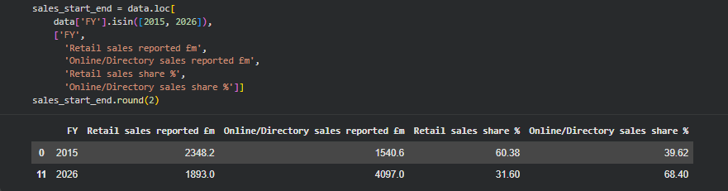

Appendix Figure 4A.2: STATISTA GRAPH
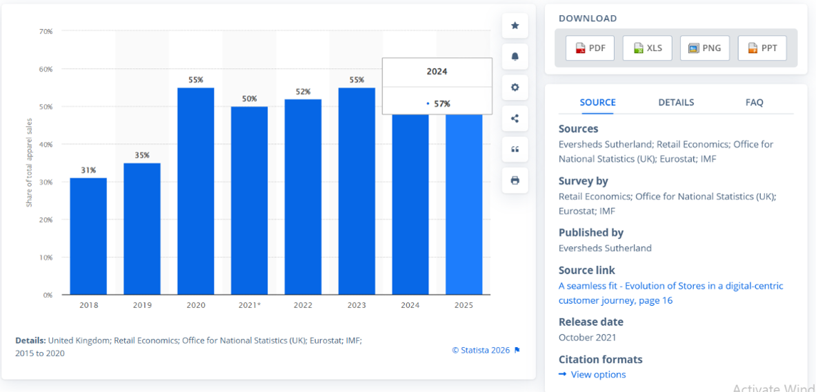

Appendix Figure 4A.3: ONS GRAPH
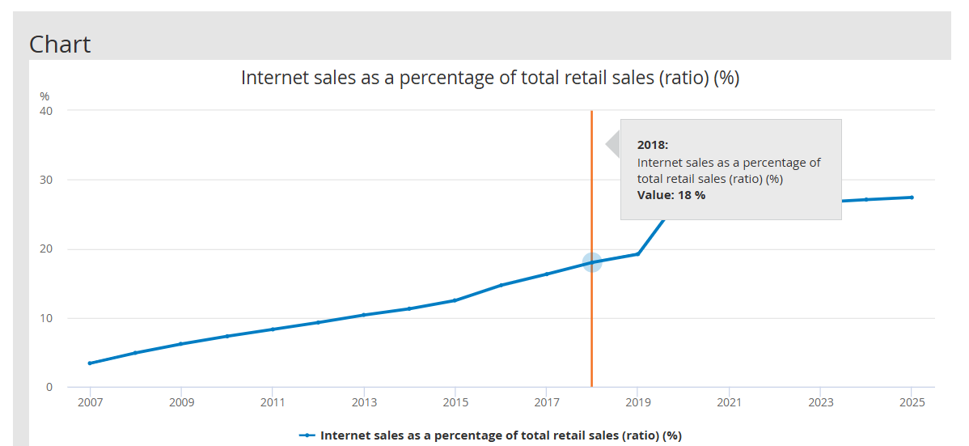

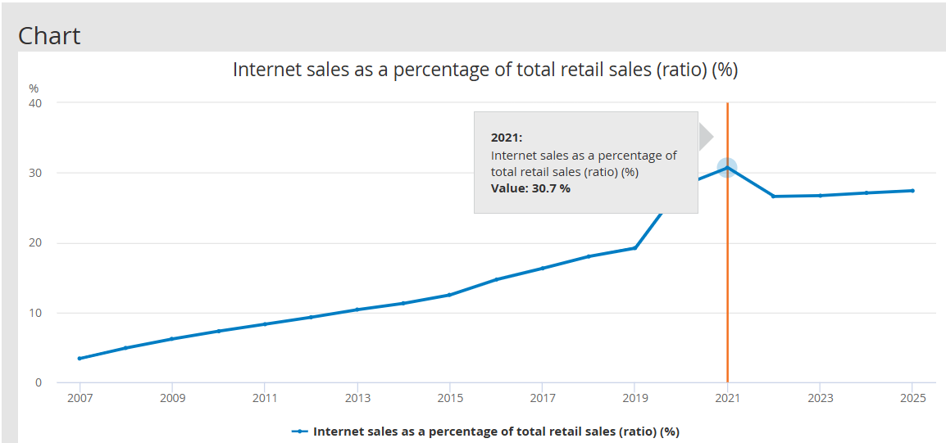

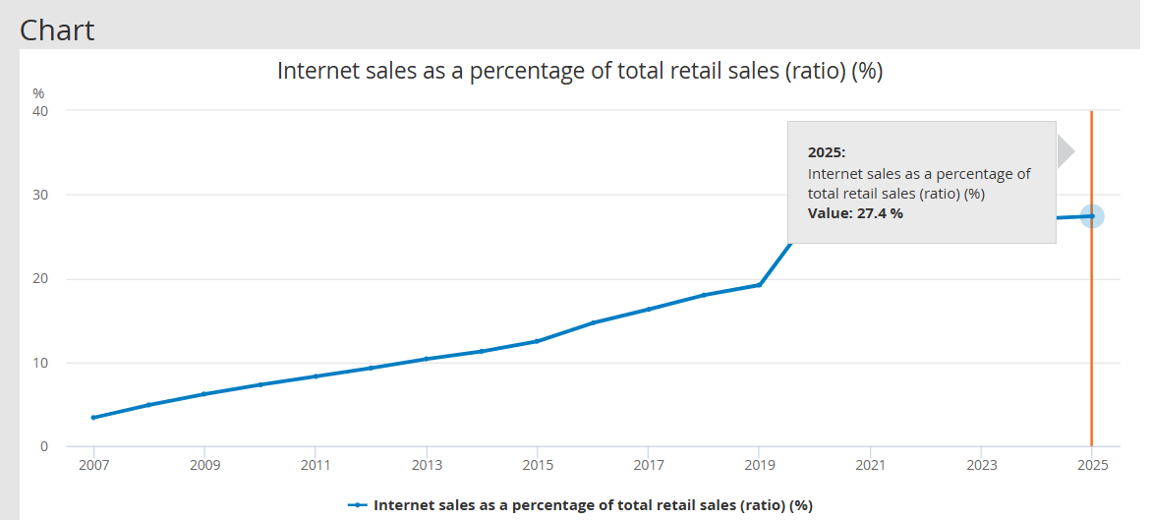

Appendix 4B: Segment profitability and compensation

Appendix Table 4B.1: Compensation analysis
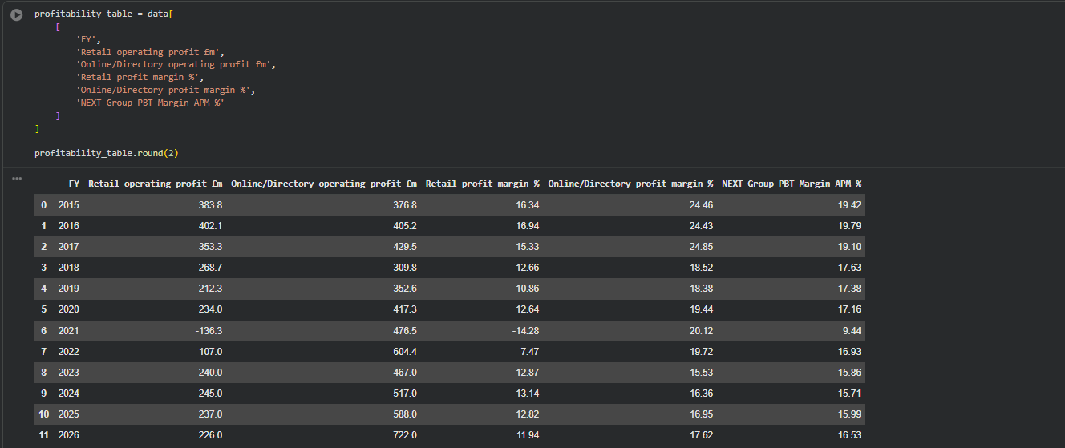

Appendix Table 4B.2: Online/Directory margin reporting-break regression
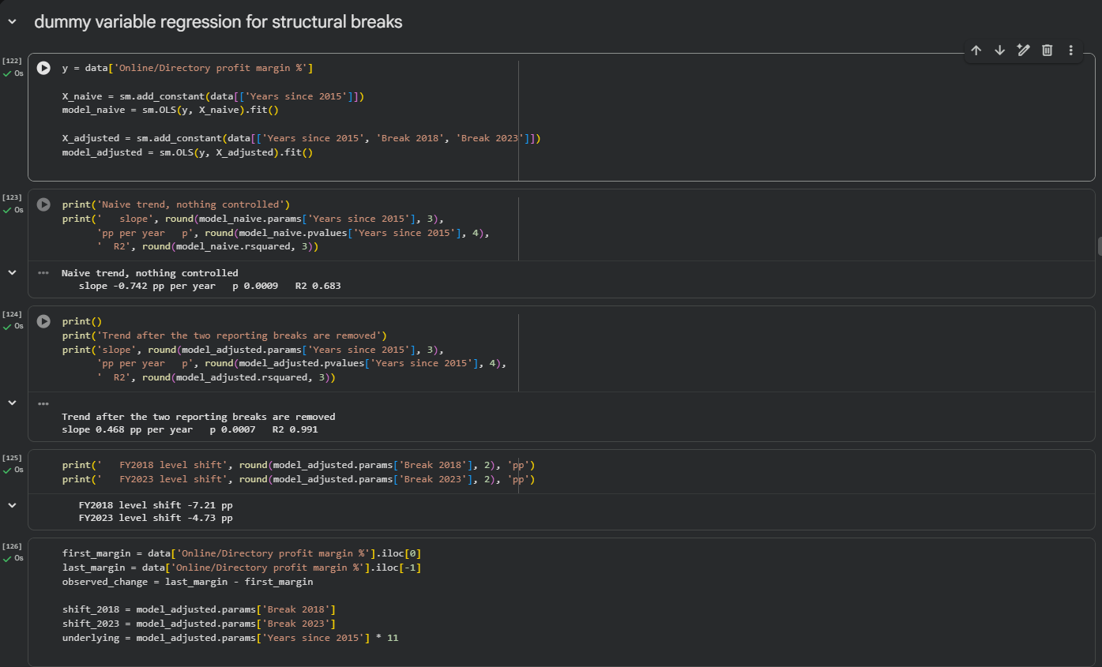
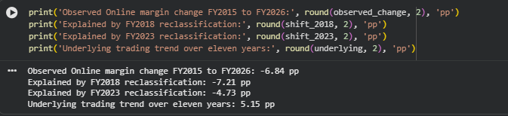

Appendix 4C: Correlation, regression and cost analysis

Appendix Table 4C.1: Pearson correlation matrix
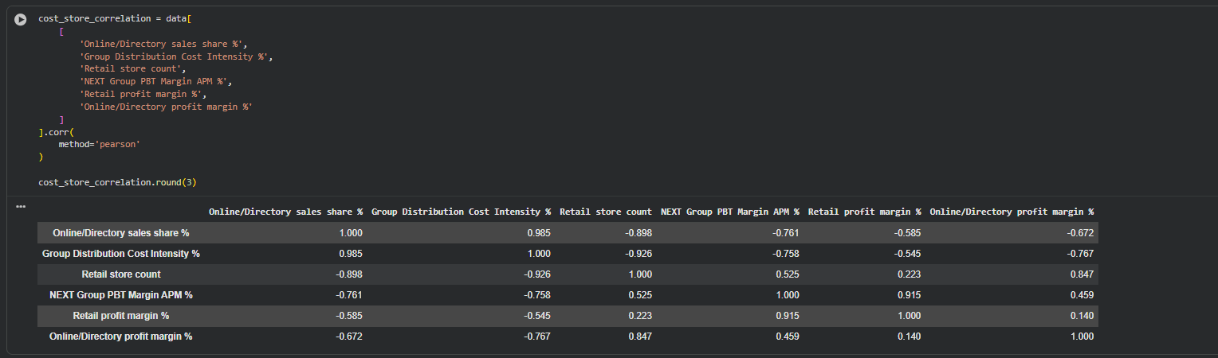
Appendix Table 4C.2: OLS regression of Group APM PBT margin on Online/Directory sales share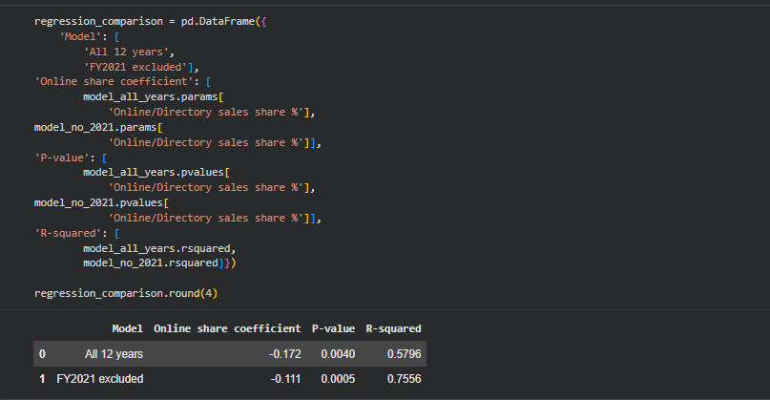

Appendix Table 4C.3: Annual-Change Regression for Distribution-Cost Intensity 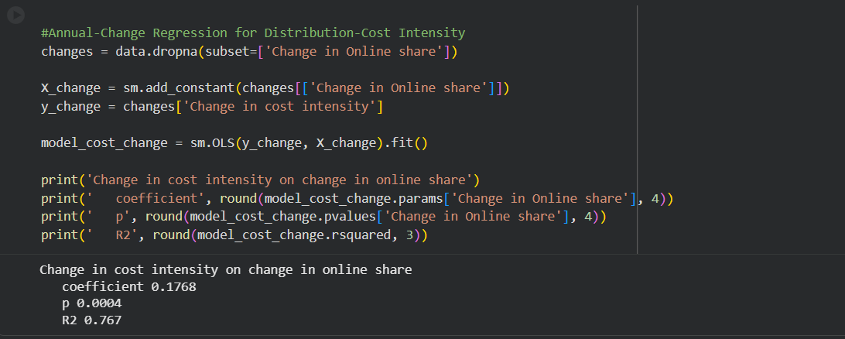

Appendix Table 4C.4: Objective 4 correlations and p-values
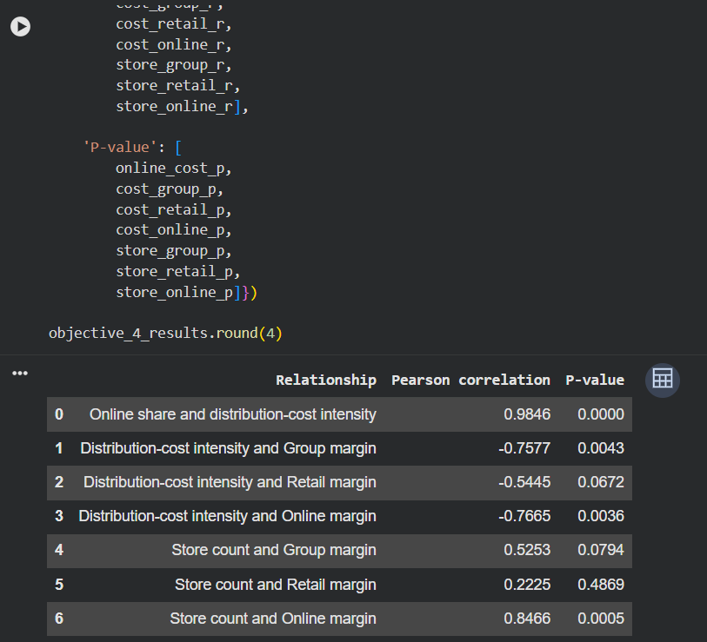

Appendix 4D: UK Supporting Evidence
Appendix Table 4D.1: UK Online sales share and segment margins
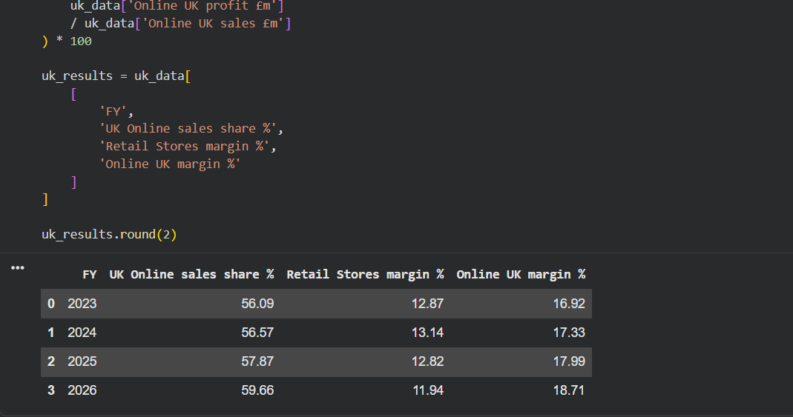Appendix Figure 4D.2: UK Online sales share, FY2023 to FY2026
