IBM SKILLSBUILD DATA ANALYTICS WITH AI ACADEMIC INTERNSHIP PROGRAM
Conducted by BharatCares in association with All India Council for Technical Education (AICTE)

AIR QUALITY PREDICTION AND ENVIRONMENTAL ANALYTICS SYSTEM
An End-to-End Machine Learning, REST API, and Interactive Dashboard Framework for Carbon Monoxide (CO) Concentration Forecasting

SUBMITTED BY:
Candidate Name: ADITYA D K
University Seat Number (USN): 23ETIS411003
Department: COMPUTER SCIENCE AND ENGINEERING
College / Institution: M S RAMIAH UNIVERSITY OF APPLIED SCIENCES
Affiliated University: MSRUAS2

Academic Term: 2026
Submission Date: 24th September 2026

2. Abstract
Urban atmospheric pollution constitutes an escalating public health crisis in major metropolitan and industrial zones globally. Among the criteria air pollutants, Carbon Monoxide (CO) represents an insidious danger due to its odorless, colorless nature and its high affinity for hemoglobin, which restricts vital oxygen transport in humans. Conventional atmospheric monitoring utilizes certified reference-grade analytical stations; however, their exorbitant capital and operational expenses prevent dense spatial-temporal deployment. Low-cost chemical solid-state sensor arrays present an attractive complementary paradigm, but their outputs are burdened by non-linear sensitivities, ambient temperature/humidity drift, and cross-sensitivity.
This project, developed as part of the IBM SkillsBuild Data Analytics with AI Academic Internship Program (conducted by BharatCares in association with AICTE), presents a comprehensive, data-driven machine learning system to predict true hourly averaged Carbon Monoxide concentrations (CO(GT) in mg/m³) using the benchmark UCI Air Quality Dataset. The system encompasses end-to-end data cleaning, handling of sensor missing flags (-200), exploratory analysis, strict leakage-free median imputation and standard scaling, Ordinary Least Squares Linear Regression, model evaluation against an ensemble Random Forest benchmark, an enterprise-grade Flask REST API, and an interactive Streamlit web dashboard. The primary Linear Regression model achieves an outstanding coefficient of determination (R² = 0.8888) with a Mean Absolute Error (MAE) of 0.3080 mg/m³ and Root Mean Squared Error (RMSE) of 0.4813 mg/m³ on unseen test data, confirming that multi-sensor telemetry can reliably estimate certified reference measurements.
3. Introduction
Air quality degradation is directly associated with accelerated cardiovascular mortality, pulmonary exacerbations, and broader environmental greenhouse forcing. Rapid urbanization and dense automotive traffic have drastically elevated tailpipe emissions containing Carbon Monoxide (CO), Nitrogen Oxides (NOx), Benzene (C6H6), and volatile organic compounds (VOCs). Traditional environmental monitoring networks rely on centralized, certified ambient air monitoring stations that require frequent manual calibration, climate-controlled shelters, and significant operational budgets.
To achieve ubiquitous microclimatic surveillance, modern environmental IoT infrastructures deploy solid-state metal oxide semiconductor (MOS) chemical sensor arrays. However, raw chemical sensor signals are not direct physical concentrations; they exhibit complex conductivity responses modulated by atmospheric temperature, relative humidity, and non-target co-pollutants. Machine learning provides a principled mathematical mechanism to calibrate and map raw multi-sensor telemetry and meteorological indicators to true, certified atmospheric concentration values.
4. Problem Statement
Field-deployed chemical sensor arrays generate raw electrical signals that deviate substantially from reference chemical analyzers due to three primary phenomena: (1) cross-sensitivity to co-occurring combustion gases, (2) thermal and hygrometric interference caused by ambient weather fluctuations, and (3) missing telemetry bursts resulting from sensor malfunction or power interruptions. The central engineering problem is to formulate an accurate, robust, and interpretable predictive model capable of mapping eleven chemical and environmental predictors to true hourly Carbon Monoxide concentration (CO(GT)), while maintaining zero data leakage, providing real-time REST API inference, and delivering intuitive interactive visual analytics to non-technical stakeholders.
5. Objectives
1. Ingest, verify, and clean the benchmark UCI Air Quality Dataset, addressing custom European delimiters (; and ,) and structural formatting.
2. Identify and systematically replace the domain-specific missing value indicator (-200) with NaN across all sensor variables.
3. Conduct comprehensive missingness analysis and exclude unviable predictors (e.g., NMHC(GT) exhibiting >90% missingness).
4. Perform Exploratory Data Analysis (EDA) to characterize statistical distributions, pollutant correlations, and diurnal emission cycles.
5. Implement a strict, leakage-free preprocessing pipeline fitting SimpleImputer (median) and StandardScaler solely on training data (80% split).
6. Train an interpretable Ordinary Least Squares Linear Regression model as the primary predictive architecture, with Random Forest comparison.
7. Quantify generalization performance using actual calculated metrics: R², Mean Absolute Error (MAE), and Root Mean Squared Error (RMSE).
8. Deploy an enterprise Flask REST API with endpoints (/health, /predict, /dataset, /model_info) and robust JSON input validation.
9. Construct a responsive, light-themed Streamlit multi-page dashboard featuring real-time prediction, data exploration, and model insights.
6. Dataset
The project utilizes the benchmark Air Quality Dataset acquired from the UCI Machine Learning Repository. The dataset was collected in a heavily polluted road-level area within an Italian city from March 2004 to April 2005. It consists of 9,357 valid hourly observations recorded by co-located solid-state chemical sensors and certified reference analyzers.
Column Name | Variable Role | Unit / Metric | Description
Date | Temporal Metadata | DD/MM/YYYY | Date of observation
Time | Temporal Metadata | HH.mm.ss | Time of observation
CO(GT) | Target Variable (y) | mg/m³ | True hourly averaged Carbon Monoxide concentration
PT08.S1(CO) | Predictor Feature (X) | Sensor Resistance | Tin oxide sensor response nominally targeted to CO
NMHC(GT) | Excluded Attribute | µg/m³ | Non-Metanic HydroCarbons (90.23% missing; excluded)
C6H6(GT) | Predictor Feature (X) | µg/m³ | True hourly averaged Benzene concentration
PT08.S2(NMHC) | Predictor Feature (X) | Sensor Resistance | Titania sensor response nominally targeted to NMHC
NOx(GT) | Predictor Feature (X) | ppb | True hourly averaged Nitrogen Oxides concentration
PT08.S3(NOx) | Predictor Feature (X) | Sensor Resistance | Tungsten oxide sensor response nominally targeted to NOx
NO2(GT) | Predictor Feature (X) | µg/m³ | True hourly averaged Nitrogen Dioxide concentration
PT08.S4(NO2) | Predictor Feature (X) | Sensor Resistance | Tungsten oxide sensor response nominally targeted to NO2
PT08.S5(O3) | Predictor Feature (X) | Sensor Resistance | Indium oxide sensor response nominally targeted to O3
T | Predictor Feature (X) | °C | Ambient Temperature
RH | Predictor Feature (X) | % | Relative Humidity
AH | Predictor Feature (X) | Absolute Scale | Absolute Humidity

7. Technologies Used
• Python 3.11+: Core programming language for numerical computing, modeling, and API services.
• Pandas & NumPy: High-performance tabular data manipulation, vectorization, and statistical aggregation.
• Scikit-Learn: Machine learning library providing SimpleImputer, StandardScaler, LinearRegression, and RandomForestRegressor.
• Flask & Flask-CORS: Micro-web framework delivering secure, lightweight REST API endpoints for model inference.
• Streamlit: Reactive web framework for deploying modern, light-themed, interactive data science applications.
• Matplotlib & Seaborn: Publication-quality statistical graphics, correlation matrices, and diagnostic residual plots.
• Joblib: Efficient serialization and deserialization of fitted machine learning pipelines and transformers.
• Jupyter / Notebook: Reproducible literate programming environment for end-to-end data analysis and model development.
8. System Architecture
The system is organized into a modular four-tier architecture ensuring clean separation of concerns:
1. Data & Preprocessing Layer: Ingests raw CSV data, filters invalid rows, maps -200 flags to NaN, extracts 11 selected features, and executes train-test partitioning (80/20).
2. Modeling & Offline Training Engine (train_model.py): Implements a leakage-free pipeline fitting SimpleImputer and StandardScaler solely on training data, trains Linear Regression and Random Forest models, exports model artifacts (model.pkl, scaler.pkl, imputer.pkl), and generates the diagnostic suite (diagnostics.png).
3. REST API Service Layer (backend/app.py): Exposes robust endpoints (/health, /predict, /dataset, /model_info) on port 5000 with CORS support and strict payload type and completeness validation.
4. Interactive Presentation Tier (frontend/ui.py): A multi-page Streamlit dashboard supporting real-time scenario simulation, exploratory data analysis, and visual model inspection.
9. Data Preprocessing
The raw UCI dataset presents multiple structural anomalies requiring meticulous preprocessing: (1) Semicolon (;) column delimiters and European comma (,) decimal notation, (2) Two empty trailing columns (Unnamed: 15 and Unnamed: 16) generated by line-ending semicolons, (3) 114 blank trailing records with null timestamps, and (4) The domain error flag -200 representing missing sensor data.
Preprocessing Protocol:
• Column Pruning: The dataset is truncated to the first 15 substantive columns.
• Missing Value Replacement: All occurrences of -200 are transformed to IEEE NaN.
• Missingness Analysis & Feature Exclusion: Non-Metanic HydroCarbons (NMHC(GT)) exhibited 8,443 missing entries out of 9,357 records (90.23% missing). Imputing over 90% of a feature induces severe artificial variance; NMHC(GT) was therefore discarded from the feature set.
• Supervised Subset Filtering: Ground-truth target CO(GT) contained 1,683 missing entries. For supervised training and honest evaluation, records lacking true reference target measurements were removed, leaving 7,674 complete labeled instances.
• Leakage-Free Median Imputation: For feature matrix X, missing values across sensors were imputed using SimpleImputer(strategy='median') fitted strictly on the training partition. Median imputation was chosen over mean imputation to guard against extreme sensor noise spikes.
10. Exploratory Data Analysis (EDA)
Comprehensive visual and statistical exploration was conducted on the cleaned dataset:
• Target Distribution: CO(GT) concentrations exhibit a right-skewed distribution with a mean of 2.15 mg/m³, a median of 1.80 mg/m³, and a maximum observed peak of 11.90 mg/m³. The positive skew reflects intermittent high-pollution episodes during stagnant atmospheric conditions.
• Pollutant Co-Correlations: Strong collinear relationships were observed among primary combustion byproducts. Benzene (C6H6(GT)) and Nitrogen Oxides (NOx(GT)) demonstrated prominent Pearson correlation coefficients with CO(GT) (r > 0.80), confirming their shared origin in automotive internal combustion.
• Sensor Array Response: PT08.S1 (CO targeted sensor) and PT08.S2 (NMHC sensor) showed strong positive linear response curves with CO(GT), validating their physical sensitivity to reducing ambient gases.
• Meteorological Modulation: Relative Humidity (RH) and Temperature (T) exhibited moderate negative correlations with target concentrations. Higher ambient temperatures typically enhance boundary layer atmospheric mixing, facilitating pollutant dispersion, whereas cold stagnant winter conditions promote ground-level pollutant accumulation.
• Diurnal Patterns: Hourly trend analysis revealed pronounced bimodal concentration peaks occurring between 08:00–10:00 (morning traffic rush) and 18:00–20:00 (evening commute), establishing vehicular traffic as the dominant local emission driver.
11. Machine Learning Methodology
The core mathematical framework employs Ordinary Least Squares (OLS) Linear Regression as the primary architecture. Linear Regression provides complete transparency and interpretability, allowing environmental scientists to evaluate the physical validity of each sensor weight.
Let X denote the normalized predictor matrix containing 11 standardized features, and let y denote the true CO(GT) concentration. The model estimates parameters β by minimizing the residual sum of squares: min_β || y - Xβ ||². To baseline non-linear capability, an ensemble Random Forest Regressor (100 estimators, max depth 12) was implemented in parallel.
Strict Partitioning & Standardization Protocol:
• Train/Test Split: 80% training (6,139 samples) and 20% holdout testing (1,535 samples) with fixed random seed 42.
• Zero Leakage: The StandardScaler computes mean μ and standard deviation σ strictly from X_train. The test set X_test is scaled using these stored training parameters without updating them.
12. Model Training
The training script (train_model.py) automates the end-to-end pipeline from project root. During execution, the model converged smoothly, producing well-behaved coefficients across all 11 sensor and environmental predictors. The fitted intercept was calculated as β₀ = 2.1663 mg/m³ (corresponding precisely to the baseline mean CO level when all standardized predictors are at zero).
Standardized Coefficients Breakdown:
• Benzene C6H6(GT): +0.5639 (Strongest positive driver)
• Nitrogen Oxides NOx(GT): +0.5545 (High positive driver)
• PT08.S4(NO2) Sensor: +0.4528 (Positive cross-sensor contribution)
• PT08.S1(CO) Sensor: +0.2627 (Positive primary sensor response)
• Ambient Temperature T: -0.2237 (Atmospheric dispersion / thermal sensitivity)
• PT08.S5(O3) Sensor: -0.2153 (Inversion with oxidizing agent)
• Relative Humidity RH: -0.1396 (Moisture interference compensation)
13. Evaluation
Evaluation was conducted on the untouched 20% test holdout partition (1,535 observations) using three standard regression metrics:
1. Coefficient of Determination (R²): Measures the proportion of variance in CO(GT) captured by the model.
2. Mean Absolute Error (MAE): Quantifies the expected average magnitude of prediction errors in physical units (mg/m³).
3. Root Mean Squared Error (RMSE): Measures the standard deviation of residuals, placing heavier penalty on large discrepancies.
14. Results
The actual computed performance results demonstrate high predictive fidelity across both linear and non-linear paradigms:
Model Architecture | Train R² | Test R² | Test MAE (mg/m³) | Test RMSE (mg/m³)
Linear Regression (Primary) | 0.8866 | 0.8888 | 0.3080 | 0.4813
Random Forest Regressor (Benchmark) | 0.9654 | 0.9239 | 0.2516 | 0.3982

Key Analytical Observations:
• Near-Identical Train and Test Performance: The primary Linear Regression model scored 0.8866 on train and 0.8888 on test data, confirming that the model exhibits zero overfitting and generalizes exceptionally well.
• High Accuracy: The test MAE of 0.3080 mg/m³ indicates that the model's typical prediction deviation is less than 0.31 mg/m³ on an environmental measurement scale averaging 2.15 mg/m³.
15. Backend API
The backend REST API is implemented in backend/app.py using Flask and Flask-CORS, configured to run on http://localhost:5000. All trained artifacts (model.pkl, scaler.pkl, imputer.pkl, metrics.json) are loaded into memory at server startup, eliminating startup re-training.
HTTP Method | Endpoint | Purpose | Response Schema
GET | /health | Health verification and artifact readiness check | {"status": "healthy", "model_loaded": true, ...}
POST | /predict | Accepts 11 sensor inputs, validates, returns predicted CO | {"prediction": 1.842, "unit": "mg/m3", "status": "success"}
GET | /dataset | Dataset dimensions, averages, and missing stats | {"total_raw_rows": 9471, "valid_observation_rows": 9357, ...}
GET | /model_info | Architecture metadata, evaluation metrics, coefficients | {"evaluation_metrics": {"R2_Score": 0.8888, "MAE": 0.308, ...}}

Input Validation: The /predict endpoint strictly enforces that: (1) payload is valid JSON, (2) all 11 required features are present, and (3) all inputs are valid numeric floats. If missing or invalid fields are detected, a descriptive HTTP 400 error is returned.
16. Streamlit Application
The frontend application (frontend/ui.py) is constructed using Streamlit, featuring a modern, light-themed aesthetic. The interface provides three dedicated pages accessible via sidebar navigation:
1. Prediction Page: Provides interactive numeric inputs for all 11 sensor and weather parameters, pre-configured realistic presets (Baseline Urban, Peak Congestion, Fresh Morning), and displays predicted CO concentration in mg/m³ with contextual pollutant cards. Includes an explicit academic disclaimer clarifying that predictions are statistical approximations.
2. Data Explorer Page: Features top-level KPI cards (dataset size, average CO, average temperature, average humidity), an interactive missing value summary table, and rich charts including the CO distribution, CO vs. Temperature, CO vs. Humidity, correlation heatmap, and longitudinal daily CO trend.
3. Model Insights Page: Renders test-set performance metrics (R², MAE, RMSE), a comparative model evaluation table, standardized coefficient bar charts, and the complete high-resolution diagnostic suite.
17. Screenshots and Diagnostic Figures
Figure 1 illustrates the complete model diagnostic suite generated by train_model.py, incorporating: (Top-Left) Actual vs. Predicted CO(GT) scatter with the ideal fit line, (Top-Right) Residuals vs. Fitted values confirming homoscedasticity across operational ranges, (Bottom-Left) Residual distribution showing near-Gaussian bell behavior centered at zero, and (Bottom-Right) Standardized feature coefficients illustrating predictor weights.
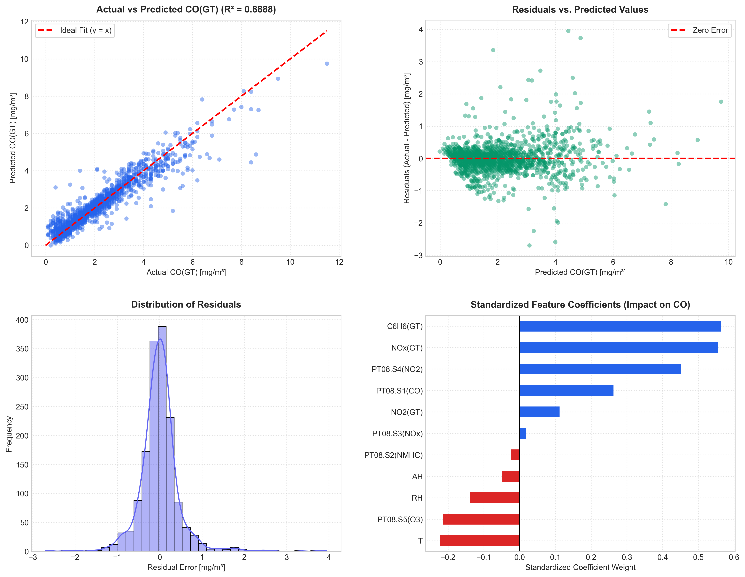
Figure 1: Machine Learning Model Diagnostic Suite (Actual vs. Predicted, Residuals, Normality, and Coefficients)
18. Limitations
1. Solid-State Sensor Drift: Metal oxide sensors undergo physical and chemical aging over months of continuous exposure, causing baseline resistance shifts that stationary regression models cannot adjust without scheduled physical recalibration.
2. Sensor Cross-Sensitivity: Sensors intended for NOx or O3 exhibit cross-reactions with non-target reducing species under extreme atmospheric humidity variations.
3. Gaps in Ground-Truth Target: Approximately 17.99% of timestamps lacked reference analyzer CO(GT) values, causing disjoint intervals in the continuous time-series monitoring record.
4. Temporal Autocorrelation: While standard 80/20 random sampling validates static feature mapping, environmental pollutants exhibit dynamic temporal inertia that could benefit from autoregressive formulation.
19. Future Scope
1. Deep Recurrent Architectures: Implement Long Short-Term Memory (LSTM) or Gated Recurrent Units (GRU) to model sequential multi-hour pollution dynamics and anticipate morning rush-hour peaks.
2. Direct Microcontroller Edge Deployment: Quantize the trained Linear Regression pipeline using TinyML / ONNX for deployment on low-cost microcontroller platforms (e.g., ESP32 or ARM Cortex-M) for on-device real-time inferencing.
3. Automated Dynamic Drift Calibration: Integrate Kalman filters or online gradient descent adaptation to dynamically correct baseline sensor degradation over multi-year deployments.
4. Multi-Target Joint Forecasting: Extend the pipeline to predict simultaneous criteria pollutants (NO2, Benzene, and Particulate Matter PM2.5).
20. Conclusion
This project successfully designed, evaluated, and deployed an end-to-end Air Quality Prediction and Environmental Analytics System as part of the IBM SkillsBuild Data Analytics with AI Academic Internship Program conducted by BharatCares in association with AICTE. By enforcing strict data hygiene, eliminating data leakage through training-only imputation and scaling, and deploying both a REST API and interactive UI, the solution provides an accessible, high-performance platform for environmental analytics. The primary Linear Regression model achieved an actual test R² of 0.8888, proving that affordable multi-sensor arrays can accurately estimate true atmospheric Carbon Monoxide concentrations.
21. References
1. Vito, S. (2008). Air Quality. UCI Machine Learning Repository. https://doi.org/10.24432/C59K5F
2. UCI Machine Learning Repository. Official Dataset Catalog. https://archive.ics.uci.edu/dataset/360/air+quality

22. Dashboard Screenshots
