WORKSHEET-3

**SQL**

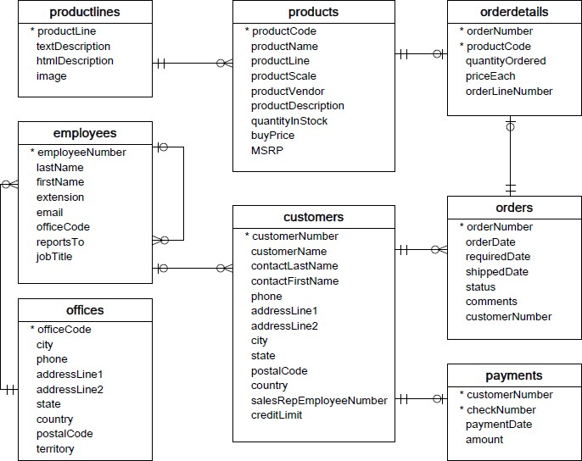**Refer the following ERD and answer all the questions in this worksheet. You have to write the queries using mysql for the required Operation.**

* **Customers**: stores customer’s data.
* **Products**: stores a list of scale model cars.
* **ProductLines**: stores a list of product line categories.
* **Orders**: stores sales orders placed by customers.
* **OrderDetails**: stores sales order line items for each sales order.
* **Payments**: stores payments made by customers based on their accounts.
* **Employees**: stores all employee information as well as the organization structure such as who reports to whom.
* **Offices**: stores sales office data.
  1. Write SQL query to create table **Customers.**

Ans- create table customers

( customernumber int(6),

Customername varchar(225),

Contactlastname varchar(45),

Contactfirstname varchar(45),

Phone varchar(20),

Addressline1 varchar (225),

Addressline2 varchar(225),

City varchar(20),

State varchar(30),

Country varchar(45),

Salesrepemployeenumber int(20),

Creditlimit flot(7,3))

* 1. Write SQL query to create table Orders.

Ans- create table orders

(

ordernumber int,

orderdate date,

requireddate date,

shippeddate date,

status varchar(3),

comments varchar(400),

customernumber int(6))

* 1. Write SQL query to show all the columns data from the Orders Table.

Ans- select * from orders

* 1. Write SQL query to show all the comments from the Orders Table.

Ans- select comments from orders

* 1. Write a SQL query to show orderDate and Total number of orders placed on that date, from Orders table.

Ans- select orderDate ,count(ordernumber) from Orders group by orderDate

* 1. Write a SQL query to show employeNumber, lastName, firstName of all the employees from employees table.

Ans- select employeNumber, lastName, firstName from employees

* 1. Write a SQL query to show all orderNumber, customerName of the person who placed the respective order.

Ans- select orderNumber, customerName from customers, orders

where customers. Customernumber = orders.Customernumber

* 1. Write a SQL query to show name of all the customers in one column and salerepemployee name in another column.

Ans- select Customername,(select Customername from Customers where Customernumber is not null) salerepemployee from Customers

* 1. Write a SQL query to show Date in one column and total payment amount of the payments made on that date from the payments table.

Ans – select paymentdate,sum(amount) from payments group by paymentdate

* 1. Write a SQL query to show all the products productName, MSRP, productDescription from the products table.

Ans- select productName, MSRP, productDescription from products

* 1. Write a SQL query to print the productName, productDescription of the most ordered product.

Ans- select productName, productDescription from products,orderdetails

Where products.productcode= orderdetails.productcode

Group by productName, productDescription

Order by sum(quantityordered) desc

Limit 5

* 1. Write a SQL query to print the city name where maximum number of orders were placed.

Ans- select city from orders, Customers

Where customers. Customernumber = orders.Customernumber

Group by city

Order by count(ordernumber) desc

Limit 10

* 1. Write a SQL query to get the name of the state having maximum number of customers.

Ans- select State from Customers

Group by State

Order by count(customernumber) desc

Limit 1

* 1. Write a SQL query to print the employee number in one column and Full name of the employee in the second column for all the employees.

Ans- select employeenumber ,firstname||’ ‘||lastname enployeename from employees

* 1. Write a SQL query to print the orderNumber, customer Name and total amount paid by the customer for that order (quantityOrdered × priceEach).

Ans – select orderNumber, Customername, sum((quantityOrdered × priceEach) )

from orders,orderdetails, Customers

where orders. Ordernumber = orderdetails .ordernumber

and orders.customernumber= Customers .customernumber

group by orderNumber, Customername, quantityOrdered , priceEach