Spotter Machine Learning Engineer Assessment
Freight Rate Prediction — Technical Submission Report

Executive Summary
The development set contains 48,000 labeled loads from January through October 2025, while the final validation set contains 12,000 future loads from November and December. I therefore used chronological validation and a robust rate-per-mile modeling strategy.
Primary holdout: MAE $104.46, RMSE $633.92, MAPE 4.42%, R² 0.827. October stress test: MAE $96.68.

Data Quality
- 292 negative weights were converted to absolute values.
- 300 development weights were missing and imputed with the development median.
- 374 development market-index values were missing and imputed with the development median.
- 772 development observations had rate-per-mile outside 0.30–3.00; they were retained and handled with a log target and L1 objective.

Feature Engineering
The pipeline uses route and route-equipment categories, distance, cleaned weight, weight-per-mile, calendar features, seasonal terms, geographic features including haversine distance and directional deltas, and market/quote interactions.

Validation
Random splitting was rejected because the assessment validation period is strictly later than the development period. The primary split trains on January–August and validates on September–October. A January–September to October stress test emphasizes the most recent regime.

Final Model
The final validation predictor is a 70/30 blend of a market-aware LightGBM model and a market-agnostic LightGBM model. Both use a robust L1 objective and predict log rate-per-mile. The final models are retrained on all 48,000 development rows.

December Scenario
The December chart inputs do not contain market or quote variables, so a chart-safe model is used for that scenario rather than fabricating unavailable covariates.
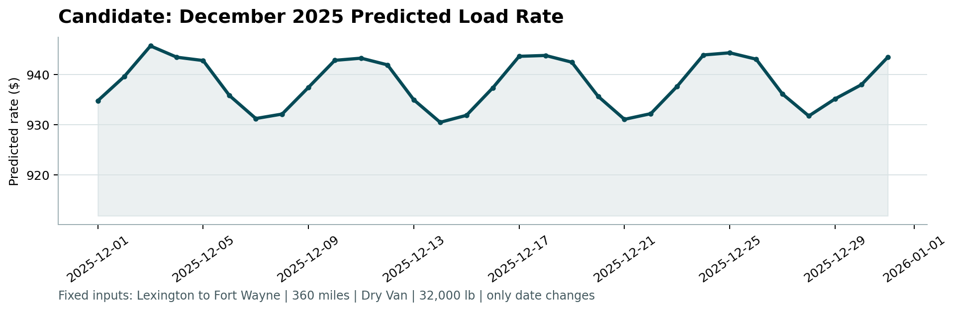
The comparable Lexington → Fort Wayne Dry Van lane history in development contains 10 matching observations in the relevant distance/weight band, with a median posted rate of approximately $809.43.

Reproducibility
Run: python -m pip install -r requirements.txt; python src/train_predict.py; python score.py --predictions validation_predictions.csv --december-predictions data/december_chart_inputs.csv

Limitations
The true rates for the 12,000 final validation loads are hidden, so the final Spotter score cannot be calculated locally. The reported metrics are internal historical holdout metrics used for model selection.

