COMPILER DESIGN

ADITYA AGARWAL ROLL NO. - 14 REG NO. - 220905106

LAB3 - CONSTRUCTION OF TOKEN GENERATOR

Q1 - Write functions to identify the following tokens.
a. Arithmetic, relational and logical operators.
b. Special symbols, keywords, numerical constants, string literals and identifiers.

CODE:

#include <stdio.h>
#include <string.h>
#include <ctype.h>

// Function to identify arithmetic operators
void identifyArithmeticOperators(char c) {
if (c == '+' || c == '-' || c == '*' || c == '/' || c == '%') {
printf("Arithmetic Operator: %c\n", c);
}
}

// Function to identify relational operators
void identifyRelationalOperators(char c, FILE *fp) {
if (c == '=' || c == '<' || c == '>' || c == '!') {
char nextChar = fgetc(fp);
if (nextChar == '=') {
printf("Relational Operator: %c%c\n", c, nextChar); // For operators like <=, >=, !=, ==
} else {
ungetc(nextChar, fp); // Push back the character if it's not part of a two-char operator
printf("Relational Operator: %c\n", c); // For operators like <, >, =
}
}
}

// Function to identify logical operators
void identifyLogicalOperators(char c, FILE *fp) {
if (c == '&' || c == '|') {
char nextChar = fgetc(fp);
if (nextChar == c) {
printf("Logical Operator: %c%c\n", c, nextChar); // For && or ||
} else {
ungetc(nextChar, fp); // Push back the character if it's not part of a two-char operator
}
} else if (c == '!') {
printf("Logical Operator: %c\n", c); // For !
}
}

// Function to identify special symbols
void identifySpecialSymbols(char c) {
if (c == '(') printf("Special Symbol: ( \n");
if (c == ')') printf("Special Symbol: ) \n");
if (c == '{') printf("Special Symbol: { \n");
if (c == '}') printf("Special Symbol: } \n");
if (c == '[') printf("Special Symbol: [ \n");
if (c == ']') printf("Special Symbol: ] \n");
if (c == ';') printf("Special Symbol: ; \n");
if (c == ',') printf("Special Symbol: , \n");
if (c == '#') printf("Special Symbol: # \n"); // Handle the '#' symbol as part of preprocessor directives
}

// Function to identify preprocessor directives (like #include)
void identifyPreprocessorDirective(char *lexeme) {
if (lexeme[0] == '#') {
printf("Preprocessor Directive: %s\n", lexeme);
}
}

// Function to identify keywords
void identifyKeywords(char *lexeme) {
char *keywords[] = {"int", "char", "if", "else", "return", "for", "while", "void"};
for (int i = 0; i < 8; i++) {
if (strcmp(lexeme, keywords[i]) == 0) {
printf("Keyword: %s\n", lexeme);
return;
}
}
}

// Function to identify numerical constants
void identifyNumericalConstants(char *lexeme) {
int isNumber = 1;
for (int i = 0; lexeme[i] != '\0'; i++) {
if (!isdigit(lexeme[i])) {
isNumber = 0;
break;
}
}
if (isNumber) {
printf("Numerical Constant: %s\n", lexeme);
}
}

// Function to identify string literals
void identifyStringLiterals(char *lexeme) {
if (lexeme[0] == '"' && lexeme[strlen(lexeme)-1] == '"') {
printf("String Literal: %s\n", lexeme);
}
}

// Function to identify character constants (e.g., 'A')
void identifyCharacterConstants(char *lexeme) {
if (lexeme[0] == '\'' && lexeme[strlen(lexeme)-1] == '\'') {
printf("Character Constant: %s\n", lexeme);
}
}

// Function to identify identifiers
void identifyIdentifiers(char *lexeme) {
if (isalpha(lexeme[0]) || lexeme[0] == '_') {
int isValidIdentifier = 1;
for (int i = 1; lexeme[i] != '\0'; i++) {
if (!isalnum(lexeme[i]) && lexeme[i] != '_') {
isValidIdentifier = 0;
break;
}
}
if (isValidIdentifier) {
printf("Identifier: %s\n", lexeme);
}
}
}

// Main function to process the input file and identify all tokens
int main() {
FILE *fp = fopen("sample.c", "r"); // Open the source file
if (fp == NULL) {
printf("Cannot open file\n");
return 1;
}

char c;
char lexeme[100];
int lexemeIndex = 0;

// Process each character of the input file
while ((c = fgetc(fp)) != EOF) {
if (isspace(c)) {
continue; // Skip whitespaces
}

// Handle preprocessor directive (#include, etc.)
if (c == '#') {
lexeme[lexemeIndex++] = c;
while ((c = fgetc(fp)) != '\n' && c != EOF) {
lexeme[lexemeIndex++] = c;
}
lexeme[lexemeIndex] = '\0';
identifyPreprocessorDirective(lexeme);
lexemeIndex = 0;
}

// Handle identifiers and keywords
else if (isalpha(c) || c == '_') {
lexeme[lexemeIndex++] = c;
while (isalnum(c = fgetc(fp)) || c == '_') {
lexeme[lexemeIndex++] = c;
}
lexeme[lexemeIndex] = '\0';
ungetc(c, fp); // Push back the character after the identifier
identifyKeywords(lexeme);
identifyIdentifiers(lexeme);
lexemeIndex = 0;
}

// Handle numerical constants
else if (isdigit(c)) {
lexeme[lexemeIndex++] = c;
while (isdigit(c = fgetc(fp))) {
lexeme[lexemeIndex++] = c;
}
lexeme[lexemeIndex] = '\0';
ungetc(c, fp);
identifyNumericalConstants(lexeme);
lexemeIndex = 0;
}

// Handle string literals
else if (c == '"') {
lexeme[lexemeIndex++] = c;
while ((c = fgetc(fp)) != '"' && c != EOF) {
lexeme[lexemeIndex++] = c;
}
lexeme[lexemeIndex++] = c;
lexeme[lexemeIndex] = '\0';
identifyStringLiterals(lexeme);
lexemeIndex = 0;
}

// Handle character literals (e.g., 'A')
else if (c == '\'') {
lexeme[lexemeIndex++] = c;
while ((c = fgetc(fp)) != '\'' && c != EOF) {
lexeme[lexemeIndex++] = c;
}
lexeme[lexemeIndex++] = c;
lexeme[lexemeIndex] = '\0';
identifyCharacterConstants(lexeme);
lexemeIndex = 0;
}

// Handle special symbols and operators
else {
identifySpecialSymbols(c);
identifyArithmeticOperators(c);
identifyRelationalOperators(c, fp);
identifyLogicalOperators(c, fp);
}
}

fclose(fp);
return 0;
}

INPUT FILE :

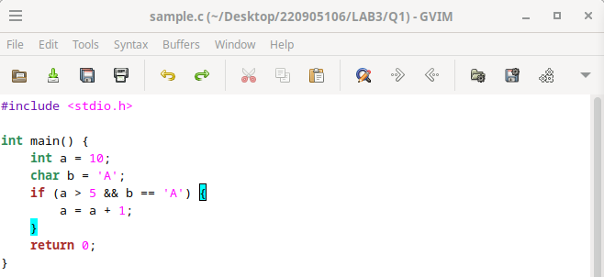

OUTPUT:

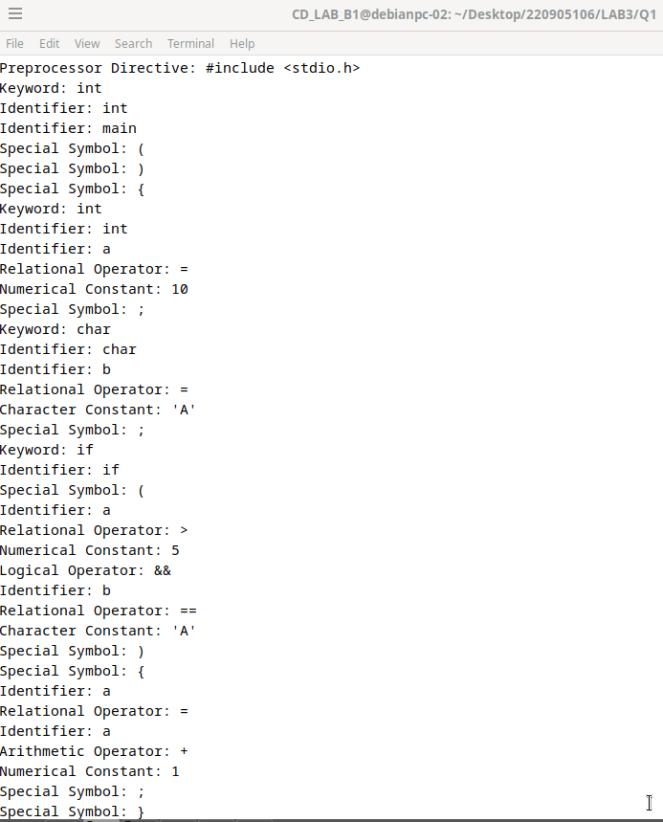
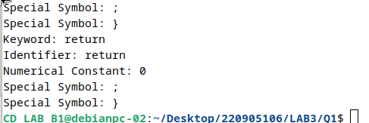

Q2 - Design a lexical analyzer that includes a getNextToken() function for processing a simple C program. The analyzer should construct a token structure containing the row number, column number, and token type for each identified token. The getNextToken() function must ignore tokens located within single-line or multi-line comments, as well as those found inside string literals. Additionally, it should strip out preprocessor directives.

CODE: #include <stdio.h>
#include <string.h>
#include <ctype.h>

// Define token types for better readability
#define KEYWORD 1
#define IDENTIFIER 2
#define OPERATOR 3
#define NUMERIC_CONSTANT 4
#define STRING_LITERAL 5
#define PREPROCESSOR 6
#define COMMENT 7

// Token structure to store row, column, type, and value
typedef struct {
int row;
int col;
int type;
char value[100];
} Token;

// Function to check if the token is a keyword
int isKeyword(char *lexeme) {
const char *keywords[] = {"int", "char", "if", "else", "return", "for", "while", "void"};
for (int i = 0; i < 8; i++) {
if (strcmp(lexeme, keywords[i]) == 0) {
return 1;
}
}
return 0;
}

// Function to print token information
void printToken(Token t) {
const char *types[] = {"Unknown", "Keyword", "Identifier", "Operator", "Numerical Constant", "String Literal", "Preprocessor Directive", "Comment"};
printf("Row: %d, Col: %d, Type: %s, Value: %s\n", t.row, t.col, types[t.type], t.value);
}

// Function to get the next token
Token getNextToken(FILE *fp, int *row, int *col) {
Token t = {-1, -1, 0, ""}; // Initialize token
char c;
char lexeme[100];
int lexemeIndex = 0;
int inStringLiteral = 0;
int inComment = 0;

while ((c = fgetc(fp)) != EOF) {
(*col)++;

// Skip whitespace and handle newlines for row counting
if (isspace(c)) {
if (c == '\n') {
(*row)++;
*col = 0;
}
continue;
}

// Skip preprocessor directives
if (c == '#' && *col == 1) {
t.type = PREPROCESSOR;
t.value[0] = c;
while ((c = fgetc(fp)) != '\n' && c != EOF) {
strncat(t.value, &c, 1);
}
(*row)++;
(*col) = 0;
return t;
}

// Handle comments
if (!inStringLiteral && c == '/') {
c = fgetc(fp);
if (c == '/') {
inComment = 1; // Single-line comment
t.type = COMMENT;
t.value[0] = '/';
t.value[1] = '/';
while ((c = fgetc(fp)) != '\n' && c != EOF) {
strncat(t.value, &c, 1);
}
(*row)++;
(*col) = 0;
return t;
} else if (c == '*') {
inComment = 1; // Multi-line comment
t.type = COMMENT;
t.value[0] = '/';
t.value[1] = '*';
while ((c = fgetc(fp)) != EOF) {
strncat(t.value, &c, 1);
if (c == '*' && (c = fgetc(fp)) == '/') {
strncat(t.value, &c, 1);
break;
}
}
(*row)++;
(*col) = 0;
return t;
}
}

// Handle string literals
if (c == '"' && !inComment) {
inStringLiteral = !inStringLiteral;
t.type = STRING_LITERAL;
t.value[0] = c;
while ((c = fgetc(fp)) != '"' && c != EOF) {
strncat(t.value, &c, 1);
}
t.value[strlen(t.value)] = '"'; // Closing quote
(*row)++;
(*col) = 0;
return t;
}

// Handle keywords and identifiers
if (isalpha(c) || c == '_') {
lexeme[lexemeIndex++] = c;
while (isalnum(c = fgetc(fp)) || c == '_') {
lexeme[lexemeIndex++] = c;
}
lexeme[lexemeIndex] = '\0';
ungetc(c, fp); // Put the non-identifier character back
t.row = *row;
t.col = *col;
if (isKeyword(lexeme)) {
t.type = KEYWORD;
} else {
t.type = IDENTIFIER;
}
strcpy(t.value, lexeme);
(*col) += lexemeIndex;
return t;
}

// Handle numerical constants
if (isdigit(c)) {
lexeme[lexemeIndex++] = c;
while (isdigit(c = fgetc(fp))) {
lexeme[lexemeIndex++] = c;
}
lexeme[lexemeIndex] = '\0';
ungetc(c, fp);
t.row = *row;
t.col = *col;
t.type = NUMERIC_CONSTANT;
strcpy(t.value, lexeme);
(*col) += lexemeIndex;
return t;
}

// Handle operators and special symbols
if (strchr("+-*/=<>!&|^%,;(){}", c)) {
t.row = *row;
t.col = *col;
t.type = OPERATOR;
t.value[0] = c;
t.value[1] = '\0';
return t;
}
}

t.row = *row;
t.col = *col;
t.type = 0;
strcpy(t.value, "EOF");
return t;
}

int main() {
FILE *fp = fopen("sample.c", "r"); // Open the source file
if (fp == NULL) {
printf("Cannot open file\n");
return 1;
}

int row = 1, col = 1;
Token t;

while ((t = getNextToken(fp, &row, &col)).type != 0) {
printToken(t); // Print the token details
}

fclose(fp);
return 0;
}

INPUT FILE :

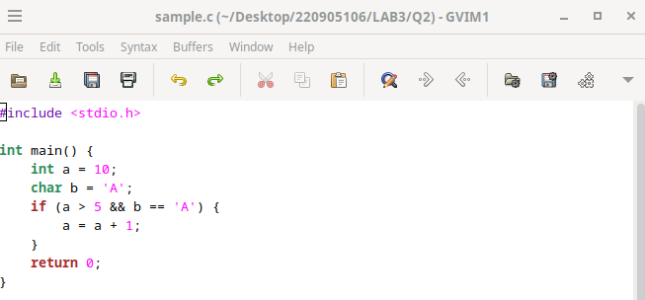

OUTPUT:

