Lab2 WEB PROGRAMMING

ADITYA AGARWAL 220905106 ROLL NO 14

Home Assignment

Q1 – Design an attractive 'train ticket booking form' using different bootstrap elements.

Code: <!DOCTYPE html>
<html lang="en">
<head>
<meta charset="UTF-8">
<meta name="viewport" content="width=device-width, initial-scale=1">
<title>Train Ticket Booking</title>
<link href="https://maxcdn.bootstrapcdn.com/bootstrap/4.4.1/css/bootstrap.min.css" rel="stylesheet">
</head>
<body>
<div class="container mt-5">
<h2 class="text-center">Train Ticket Booking</h2>
<form>
<div class="form-group">
<label for="name">Full Name:</label>
<input type="text" class="form-control" id="name" placeholder="Enter full name" required>
</div>
<div class="form-group">
<label for="email">Email Address:</label>
<input type="email" class="form-control" id="email" placeholder="Enter email" required>
</div>
<div class="form-group">
<label for="fromStation">From Station:</label>
<input type="text" class="form-control" id="fromStation" placeholder="Enter departure station" required>
</div>
<div class="form-group">
<label for="toStation">To Station:</label>
<input type="text" class="form-control" id="toStation" placeholder="Enter destination station" required>
</div>
<div class="form-group">
<label for="trainClass">Train Class:</label>
<select class="form-control" id="trainClass">
<option>First Class</option>
<option>Second Class</option>
<option>Sleeper Class</option>
</select>
</div>
<div class="form-group">
<label for="travelDate">Travel Date:</label>
<input type="date" class="form-control" id="travelDate" required>
</div>
<div class="form-group">
<label for="numTickets">Number of Tickets:</label>
<input type="number" class="form-control" id="numTickets" placeholder="Enter number of tickets" required>
</div>
<button type="submit" class="btn btn-primary btn-block">Book Ticket</button>
</form>
</div>
<script src="https://ajax.googleapis.com/ajax/libs/jquery/3.4.1/jquery.min.js"></script>
<script src="https://cdnjs.cloudflare.com/ajax/libs/popper.js/1.16.0/umd/popper.min.js"></script>
<script src="https://maxcdn.bootstrapcdn.com/bootstrap/4.4.1/js/bootstrap.min.js"></script>
</body>
</html>

Output:

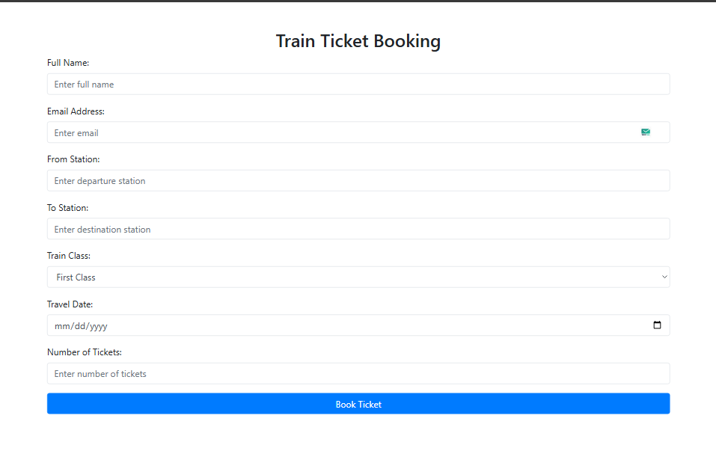

Q2 - Design an attractive 'magazine cover page' using different bootstrap elements.

Code: <!DOCTYPE html>
<html lang="en">
<head>
<meta charset="UTF-8">
<meta name="viewport" content="width=device-width, initial-scale=1.0">
<title>Apple Magazine</title>
<link href="https://maxcdn.bootstrapcdn.com/bootstrap/4.4.1/css/bootstrap.min.css" rel="stylesheet">
<style>
body, html {
margin: 0;
padding: 0;
height: 100%;
font-family: 'Helvetica Neue', Helvetica, Arial, sans-serif;
background-color: #000;
color: white;
}
.cover-page {
background-image: url('BG6.JPG'); /* Replace with a sleek Apple-themed image */
background-size: cover;
background-position: center;
height: 100vh;
position: relative;
overflow: hidden;
}
.cover-overlay {
position: absolute;
top: 0;
left: 0;
width: 100%;
height: 100%;
background: linear-gradient(180deg, rgba(0, 0, 0, 0.6), rgba(0, 0, 0, 0.9));
z-index: 1;
}
.cover-content {
position: relative;
z-index: 2;
display: flex;
flex-direction: column;
align-items: center;
justify-content: center;
text-align: center;
height: 100%;
padding: 0 15px;
}
.cover-logo img {
width: 80px;
margin-bottom: 1rem;
}
.cover-title {
font-size: 4rem;
font-weight: 700;
margin-bottom: 1rem;
text-transform: uppercase;
letter-spacing: 2px;
}
.cover-title span {
color: #a2aaad; /* Iconic Apple text color */
}
.cover-subtitle {
font-size: 1.8rem;
margin-bottom: 2rem;
font-weight: 300;
}
.cover-description {
font-size: 1.2rem;
line-height: 1.8;
margin-bottom: 2rem;
}
.btn-custom {
background-color: #a2aaad;
color: black;
font-size: 1.1rem;
font-weight: 600;
text-transform: uppercase;
padding: 12px 40px;
border: none;
border-radius: 50px;
transition: all 0.3s ease-in-out;
}
.btn-custom:hover {
background-color: white;
color: black;
}
.footer {
position: absolute;
bottom: 20px;
width: 100%;
text-align: center;
font-size: 0.9rem;
color: rgba(255, 255, 255, 0.8);
z-index: 2;
}
</style>
</head>
<body>
<div class="cover-page">
<div class="cover-overlay"></div>
<div class="cover-content">
<div class="cover-logo">
<img src="https://upload.wikimedia.org/wikipedia/commons/f/fa/Apple_logo_black.svg" alt="Apple Logo">
</div>
<h1 class="cover-title">Think <span>Different</span></h1>
<h3 class="cover-subtitle">The Future is Here</h3>
<p class="cover-description">
Welcome to the latest edition of the <strong>Apple Magazine</strong>. Discover groundbreaking innovation, design excellence, and the future of technology in this special issue.
</p>
<button class="btn btn-custom">Explore Now</button>
</div>
<div class="footer">&copy; 2025 Apple Inc. All rights reserved.</div>
</div>

<script src="https://ajax.googleapis.com/ajax/libs/jquery/3.4.1/jquery.min.js"></script>
<script src="https://cdnjs.cloudflare.com/ajax/libs/popper.js/1.16.0/umd/popper.min.js"></script>
<script src="https://maxcdn.bootstrapcdn.com/bootstrap/4.4.1/js/bootstrap.min.js"></script>
</body>
</html>
Output:



Q3 – Design your class timetable using bootstrap table and carousel.

Code: <!DOCTYPE html>
<html lang="en">

<head>
<meta charset="UTF-8">
<meta name="viewport" content="width=device-width, initial-scale=1.0">
<title>Class Timetable</title>
<link href="https://maxcdn.bootstrapcdn.com/bootstrap/4.5.2/css/bootstrap.min.css" rel="stylesheet">
<style>
.table th,
.table td {
vertical-align: middle;
text-align: center;
}

.carousel-inner img {
object-fit: cover;
height: 300px;
}

.carousel-caption {
background: rgba(0, 0, 0, 0.6);
padding: 10px;
border-radius: 5px;
}

.header-text {
text-align: center;
margin-bottom: 20px;
}
</style>
</head>

<body>
<div class="container mt-4">
<h3 class="header-text">Department of Computer Science and Engineering</h3>
<h5 class="text-center">Timetable: Jan - May 2025 (Semester: VI, Section: B)</h5>
<h6 class="text-center">Lecture Hall: AB5 210 (Effective from: Jan 3, 2025)</h6>

<!-- Timetable Table -->
<div class="table-responsive mt-4">
<table class="table table-bordered table-striped">
<thead class="thead-dark">
<tr>
<th>Day</th>
<th>8:00 - 9:00</th>
<th>9:00 - 10:00</th>
<th>10:00 - 10:30</th>
<th>10:30 - 11:30</th>
<th>11:30 - 12:30</th>
<th>12:30 - 1:00</th>
<th>1:00 - 2:00</th>
<th>2:00 - 3:00</th>
<th>3:00 - 3:30</th>
<th>3:30 - 4:30</th>
</tr>
</thead>
<tbody>
<tr>
<td>Monday</td>
<td>WP</td>
<td>PE-I</td>
<td>Break</td>
<td>EEFM</td>
<td>PE-II</td>
<td>Lunch Break</td>
<td colspan="3">PCAP Lab (B1)</td>
<td>CD Lab (B2)</td>
</tr>
<tr>
<td>Tuesday</td>
<td>EEFM</td>
<td>PE-II</td>
<td>Break</td>
<td>PCAP</td>
<td>OE</td>
<td>Lunch Break</td>
<td>WP Lab (B2)</td>
<td colspan="2">Break</td>
<td>Placement</td>
</tr>
<tr>
<td>Wednesday</td>
<td>EEFM</td>
<td>PE-II</td>
<td>Break</td>
<td>PCAP</td>
<td>OE</td>
<td>Lunch Break</td>
<td>WP Lab (B1)</td>
<td colspan="2">Break</td>
<td>CD</td>
</tr>
<tr>
<td>Thursday</td>
<td>CD Lab (B1)</td>
<td>CD</td>
<td>Break</td>
<td>PE-I</td>
<td>Lunch Break</td>
<td>PCAP</td>
<td colspan="4">Placement</td>
</tr>
<tr>
<td>Friday</td>
<td>WP</td>
<td>PE-I</td>
<td>Break</td>
<td>EEFM</td>
<td>PE-II</td>
<td>Lunch Break</td>
<td>OE</td>
<td colspan="3">WP Lab (B2)</td>
</tr>
</tbody>
</table>
</div>

<!-- Faculty Carousel -->
<div id="facultyCarousel" class="carousel slide mt-5" data-ride="carousel">
<ol class="carousel-indicators">
<li data-target="#facultyCarousel" data-slide-to="0" class="active"></li>
<li data-target="#facultyCarousel" data-slide-to="1"></li>
<li data-target="#facultyCarousel" data-slide-to="2"></li>
</ol>
<div class="carousel-inner">
<div class="carousel-item active">
<img src="bg6.jpg" class="d-block w-100" alt="Faculty">
<div class="carousel-caption">
<h5>Dr. Rajashree Krishna</h5>
<p>Teaching: Web Programming, Room: AB5 210</p>
</div>
</div>
<div class="carousel-item">
<img src="bg6.jpg" class="d-block w-100" alt="Faculty">
<div class="carousel-caption">
<h5>Ms. Deepthi S.</h5>
<p>Teaching: Compiler Design, Room: AB5 210</p>
</div>
</div>
<div class="carousel-item">
<img src="bg6.jpg" class="d-block w-100" alt="Faculty">
<div class="carousel-caption">
<h5>Dr. Radhika Kamath</h5>
<p>Teaching: Parallel Programming, Lab: Digital Systems</p>
</div>
</div>
</div>
<a class="carousel-control-prev" href="#facultyCarousel" role="button" data-slide="prev">
<span class="carousel-control-prev-icon" aria-hidden="true"></span>
<span class="sr-only">Previous</span>
</a>
<a class="carousel-control-next" href="#facultyCarousel" role="button" data-slide="next">
<span class="carousel-control-next-icon" aria-hidden="true"></span>
<span class="sr-only">Next</span>
</a>
</div>
</div>

<script src="https://code.jquery.com/jquery-3.5.1.slim.min.js"></script>
<script src="https://cdn.jsdelivr.net/npm/@popperjs/core@2.9.3/dist/umd/popper.min.js"></script>
<script src="https://stackpath.bootstrapcdn.com/bootstrap/4.5.2/js/bootstrap.min.js"></script>
</body>

</html>

Output:

