WEB PROGRAMMING LAB

ADITYA AGARWAL 2209015106 ROLL NO. 14

LAB4 – PYTHON BASICS

Q1 - Write a python program to reverse a content a file and store it in another file.

CODE:

def reverse_file_content(input_file, output_file):
try:
# Open the input file and read its content
with open(input_file, 'r', encoding='utf-8') as file:
content = file.read()

# Reverse the content
reversed_content = content[::-1]

# Write the reversed content to the output file
with open(output_file, 'w', encoding='utf-8') as file:
file.write(reversed_content)

print(f"Reversed content has been saved to {output_file}")

except FileNotFoundError:
print("Error: The input file does not exist.")
except Exception as e:
print(f"An error occurred: {e}")

# Example usage
input_filename = "input.txt"
output_filename = "output.txt"

reverse_file_content(input_filename, output_filename)

INPUT.txt:

Hello, Aditya!
Welcome to Python.

OUTPUT.txt:

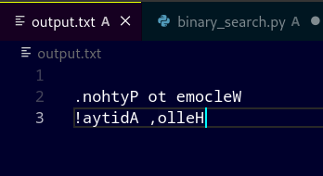

Q2 - Write a python program to implement binary search with recursion.

CODE:

def binary_search(arr, low, high, target):
if low > high:
return -1 # Base case: Element not found

mid = (low + high) // 2

if arr[mid] == target:
return mid # Found the target
elif target < arr[mid]:
return binary_search(arr, low, mid - 1, target) # Search in left half
else:
return binary_search(arr, mid + 1, high, target) # Search in right half

# Taking input from user
numbers = list(map(int, input("Enter sorted numbers (comma-separated): ").split(',')))
target = int(input("Enter the number to find: "))

# Performing binary search
result = binary_search(numbers, 0, len(numbers) - 1, target)

# Display result
if result != -1:
print(f"Element {target} found at index {result}")
else:
print(f"Element {target} not found")

OUTPUT:

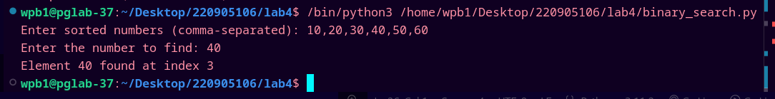

Q3 - Write a python program to sort words in alphabetical order.

CODE:

sentence = input("Enter a sentence: ")
words = sentence.split()
words.sort()
print("Sorted words:", " ".join(words))

OUTPUT:

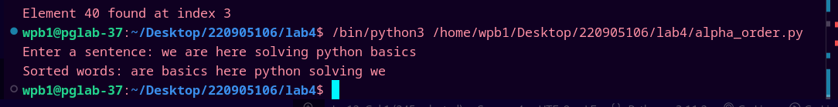

Q4 - Write a Python class to get all possible unique subsets from a set of distinct
integers.
Input:[4,5,6]
Output : [[], [6], [5], [5, 6], [4], [4, 6], [4, 5], [4, 5, 6]]

CODE:

class SubsetGenerator:
def __init__(self, nums):
self.nums = nums
self.result = []

def generate_subsets(self, index=0, current_subset=[]):
# Add the current subset to the result
self.result.append(current_subset[:])

# Iterate through the remaining elements
for i in range(index, len(self.nums)):
# Include nums[i] in the current subset
current_subset.append(self.nums[i])
# Recursively call for the next index
self.generate_subsets(i + 1, current_subset)
# Backtrack: Remove the last element to explore the next possibility
current_subset.pop()

def get_subsets(self):
self.generate_subsets()
return self.result

# Example Usage
nums = [4, 5, 6] # Input set
subset_gen = SubsetGenerator(nums)
unique_subsets = subset_gen.get_subsets()

# Print the output
print(unique_subsets)

OUTPUT:

Q5 - Write a Python class to find a pair of elements (indices of the two numbers)
from a given array whose sum equals a specific target number.
Input: numbers= [10,20,10,40,50,60,70], target=50
Output: 3, 4.

CODE:

class PairFinder:
def __init__(self, numbers, target):
self.numbers = numbers
self.target = target

def find_pair(self):
index_map = {} # Dictionary to store numbers and their indices

for i, num in enumerate(self.numbers):
complement = self.target - num # Find the required pair value

if complement in index_map:
return index_map[complement], i # Return indices of the pair

index_map[num] = i # Store the index of the current number

return None # Return None if no pair is found

# Example Usage
numbers = [10, 20, 10, 40, 50, 60, 70]
target = 50

finder = PairFinder(numbers, target)
result = finder.find_pair()

# Print the output
if result:
print(result[0] + 1, result[1] + 1) # Convert 0-based index to 1-based index
else:
print("No pair found")

OUTPUT:

Q6 - Write a Python class to implement pow(x, n).

CODE:

class Power:
def __init__(self, base, exponent):
self.base = base
self.exponent = exponent

def my_pow(self):
result = 1
# Handle negative exponent
if self.exponent < 0:
self.base = 1 / self.base
self.exponent = -self.exponent

# Loop to multiply the base 'exponent' times
for _ in range(self.exponent):
result *= self.base
return result

# Taking input from the user
x = float(input("Enter the base (x): ")) # Base (x)
n = int(input("Enter the exponent (n): ")) # Exponent (n)

# Creating an instance of Power class
power_calculator = Power(x, n)

# Calculating the result
result = power_calculator.my_pow()

# Displaying the result
print(f"The result of {x}^{n} is: {result}")

OUTPUT:
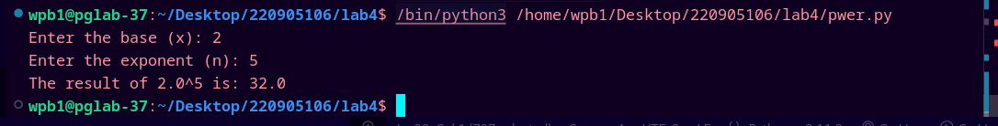

Q7 - Write a Python class which has two methods get_String and print_String. The get_String accept a string from the user and print_String print the string in uppercase.

CODE:

class StringManipulator:
def __init__(self):
self.input_string = ""

# Method to accept string input from the user
def get_String(self):
self.input_string = input("Enter a string: ")

# Method to print the string in uppercase
def print_String(self):
print(self.input_string.upper())

# Example Usage
string_manipulator = StringManipulator()
string_manipulator.get_String() # Get string input from user
string_manipulator.print_String() # Print the string in uppercase

OUTPUT:

