Lab1 WEB PROGRAMMING

ADITYA AGARWAL 220905106 ROLL NO 14

Q1 – Write a poem and highlight the rhyming words

Code: <!DOCTYPE html>
<html lang="en">
<head>
<meta charset="UTF-8">
<meta name="viewport" content="width=device-width, initial-scale=1.0">
<title>The Night's Embrace</title>
<style>
body {
font-family: Arial, Helvetica, sans-serif;
background-color: #253e54;
color: #fffafa;
text-align: center;
padding: 20px;
}
h1 {
color: #85bcf3;
}
p {
font-size: 1.2em;
line-height: 1.6;
margin: 20px 0;
}
.bold {
font-weight: bold;
color: rgb(179, 220, 233);
}
</style>
</head>
<body>

<h1>The Night's Embrace</h1>

<p>The <span class="bold">moon</span> shines bright, a glowing <span class="bold">star</span>,</p>
<p>It whispers secrets from <span class="bold">afar</span>.</p>
<p>The breeze is soft, it gently <span class="bold">blows</span>,</p>
<p>Through quiet woods where no one <span class="bold">knows</span>.</p>

<p>The night is still, the world in <span class="bold">sleep</span>,</p>
<p>A peaceful calm, a love so <span class="bold">deep</span>.</p>
<p>Stars twinkle high, a sparkling <span class="bold">glow</span>,</p>
<p>As dreams take flight and gently <span class="bold">flow</span>.</p>

</body>
</html>

Output:

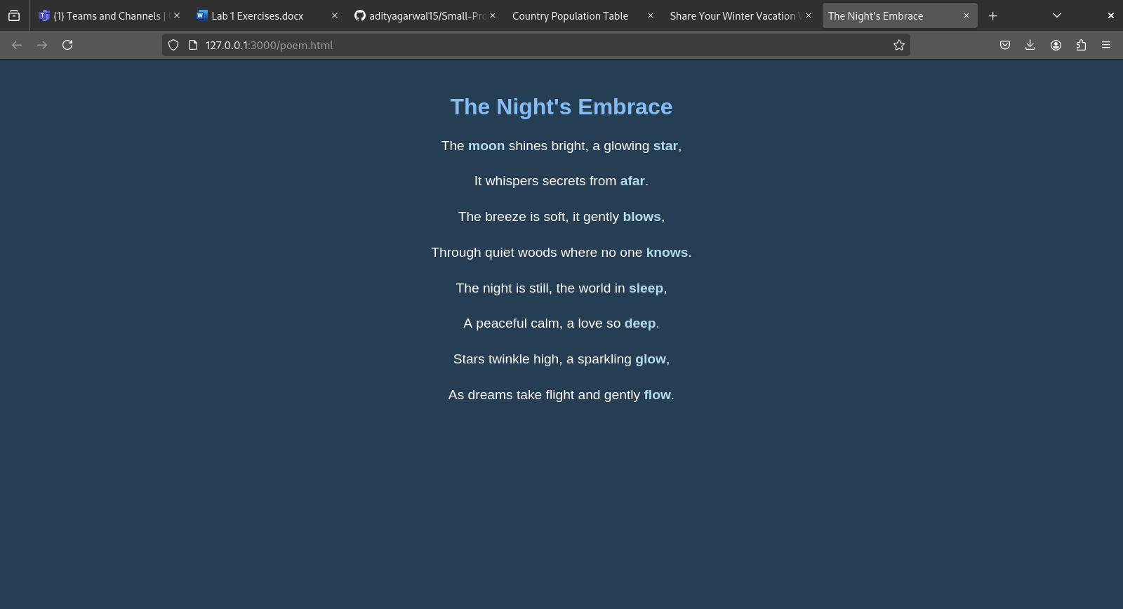

Q2 - Assume you have brought a new car. Write down the list of additional accessories you need for the car as an unordered list in HTML. Also, list the travel plans on the car as an ordered list.

Code: <!DOCTYPE html>
<html lang="en">
<head>
<meta charset="UTF-8">
<meta name="viewport" content="width=device-width, initial-scale=1.0">
<title>Car Accessories and Travel Plans</title>
</head>
<body>

<h2>Additional Car Accessories</h2>
<ul>
<li>Car seat covers</li>
<li>Car charger</li>
<li>Car perfume</li>
<li>Trunk organizer</li>
<li>GPS navigation system</li>
<li>Wheel locks</li>
<li>Rearview camera</li>
</ul>

<h2>Travel Plans</h2>
<ol>
<li>Weekend getaway to the Coorg</li>
<li>Road trip to the Malpe beach</li>
<li>Visit family in another city</li>
<li>Long-distance vacation to explore Europe</li>
<li>City tour with friends</li>
</ol>

</body>
</html>

Output:

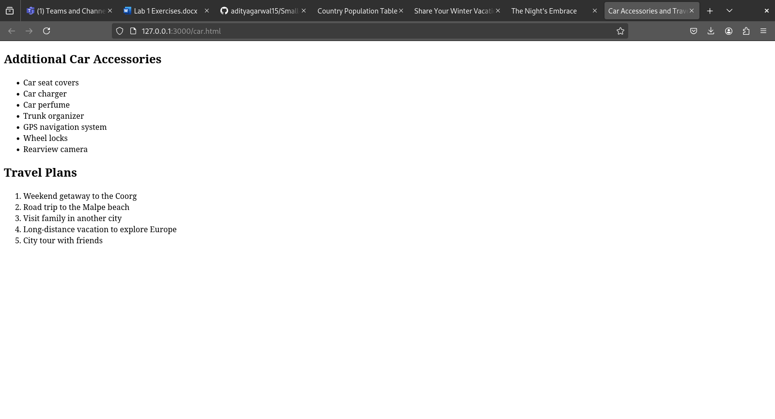

Q3 – Complete the following website name “ Share your winter vacation videos”. The required videos are located in the lab1 folder

Code: <!DOCTYPE html>
<html lang="en">
<head>
<meta charset="UTF-8">
<meta name="viewport" content="width=device-width, initial-scale=1.0">
<title>Share Your Winter Vacation Videos</title>
<style>
* {
margin: 0;
padding: 0;
box-sizing: border-box;
}

body {
font-family: Arial, sans-serif;
background: linear-gradient(to bottom, purple, lavender);
color: #fff;
min-height: 100vh;
}

.navbar {
width: 100%;
background-color: rgba(0, 0, 0, 0.6);
padding: 10px 20px;
position: fixed;
top: 0;
left: 0;
z-index: 1000;
}

.navbar h1 {
font-size: 24px;
color: #fff;
text-align: left;
}

main {
margin-top: 60px;
padding: 20px;
}

h2 {
text-align: center;
color: #fff;
padding: 50px;
}

.video-row {
display: flex;
justify-content: space-between;
flex-wrap: wrap;
gap: 10px;
}

.video-row figure {
flex: 1;
min-width: 300px;
text-align: center;
}

video {
width: 100%;
height: auto;
border: 2px solid #ccc;
}

figcaption {
color: #fff;
}
</style>
</head>
<body>

<div class="navbar">
<h1>Share Your Travels</h1>
</div>

<main>
<section>
<h2>Week 1 - Paris Trip</h2>
<div class="video-row">
<!-- Video 1 -->
<figure>
<video controls>
<source src="paris.mp4" type="video/mp4">
</video>
<figcaption>Paris - Video 1</figcaption>
</figure>

<!-- Video 2 -->
<figure>
<video controls>
<source src="paris.mp4" type="video/mp4">
</video>
<figcaption>Paris - Video 2</figcaption>
</figure>

<!-- Video 3 -->
<figure>
<video controls>
<source src="paris.mp4" type="video/mp4">
</video>
<figcaption>Paris - Video 3</figcaption>
</figure>
</div>
</section>
</main>
</body>
</html>

Output:

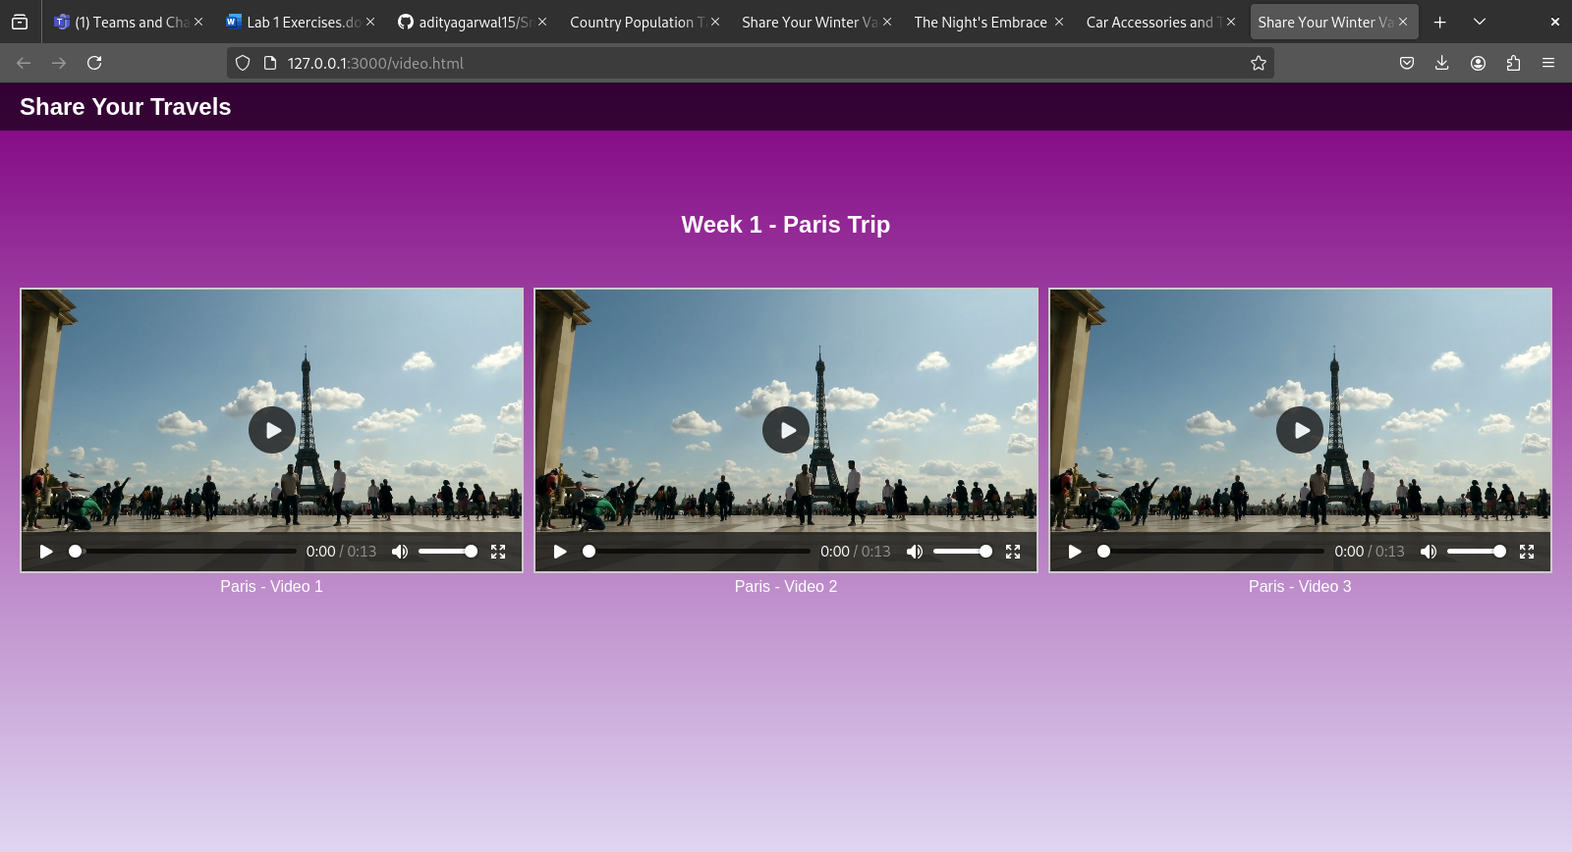

Q4 - Create the following output in HTML

Code: <!DOCTYPE html>
<html lang="en">
<head>
<meta charset="UTF-8">
<meta name="viewport" content="width=device-width, initial-scale=1.0">
<title>Country Population Table</title>
<style>
body {
font-family: Arial, sans-serif;
margin: 20px;
}

table {
width: 100%;
border-collapse: collapse;
margin-top: 20px;
}

th, td {
border: 1px solid black;
text-align: center;
padding: 8px;
}

th {
background-color: red;
color: white;
}

.country {
background-color: yellow;
font-weight: bold;
}

.year {
color: black;
background-color: rgb(106, 144, 206);
font-weight: bold;
}

.population {
background-color: rgb(134, 208, 134);
font-weight: bold;
}
</style>
</head>
<body>
<h1>Country Population Table</h1>
<table>
<tr class="main">
<th class="countrymain">Country</th>
<th class="yearmain">Year</th>
<th class="populationmain">Population (in crores)</th>
</tr>
<!-- India -->
<tr>
<td class="country" rowspan="3">India</td>
<td class="year">1998</td>
<td class="population">85</td>
</tr>
<tr>
<td class="year">1999</td>
<td class="population">90</td>
</tr>
<tr>
<td class="year">2000</td>
<td class="population">100</td>
</tr>
<!-- USA -->
<tr>
<td class="country" rowspan="3">USA</td>
<td class="year">1998</td>
<td class="population">30</td>
</tr>
<tr>
<td class="year">1999</td>
<td class="population">35</td>
</tr>
<tr>
<td class="year">2000</td>
<td class="population">40</td>
</tr>
<!-- UK -->
<tr>
<td class="country" rowspan="3">UK</td>
<td class="year">1998</td>
<td class="population">25</td>
</tr>
<tr>
<td class="year">1999</td>
<td class="population">30</td>
</tr>
<tr>
<td class="year">2000</td>
<td class="population">35</td>
</tr>
</table>

</body>
</html>

Output:

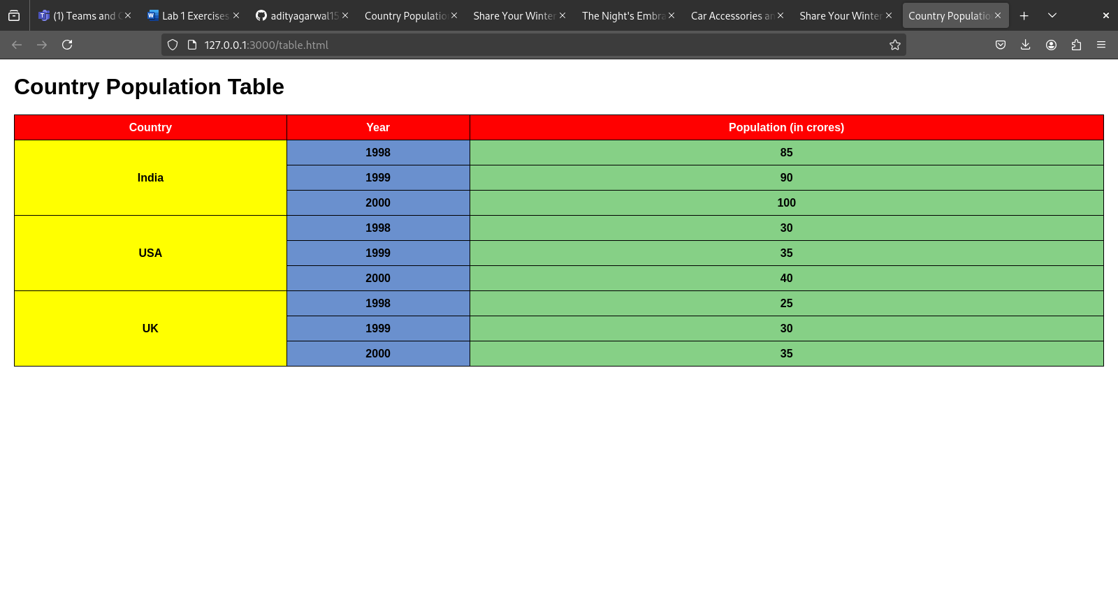
Q5 - Create an array of Javascript objects for the data in question 4 and display each row in the table form through Javascript code.

Code: <!DOCTYPE html>
<html lang="en">
<head>
<meta charset="UTF-8">
<meta name="viewport" content="width=device-width, initial-scale=1.0">
<title>Population Data</title>
</head>
<body>

<h1>Population Data</h1>
<!-- Create the table -->
<table id="population-table" border="1">
<thead>
<tr>
<th>Country</th>
<th>Year</th>
<th>Population</th>
</tr>
</thead>
<tbody>
<!-- Data will be inserted here by JavaScript -->
</tbody>
</table>

<script>
// JavaScript code
const populationData = [
{ country: "India", year: 1998, population: 85 },
{ country: "India", year: 1999, population: 90 },
{ country: "India", year: 2000, population: 100 },
{ country: "USA", year: 1998, population: 30 },
{ country: "USA", year: 1999, population: 35 },
{ country: "USA", year: 2000, population: 40 },
{ country: "UK", year: 1998, population: 25 },
{ country: "UK", year: 1999, population: 30 },
{ country: "UK", year: 2000, population: 35 }
];

// Get the table body
const tableBody = document.querySelector("#population-table tbody");

// Iterate through the populationData and add rows to the table
populationData.forEach(data => {
const row = document.createElement("tr");
row.innerHTML = `<td>${data.country}</td><td>${data.year}</td><td>${data.population}</td>`;
tableBody.appendChild(row);
});
</script>
</body>
</html>

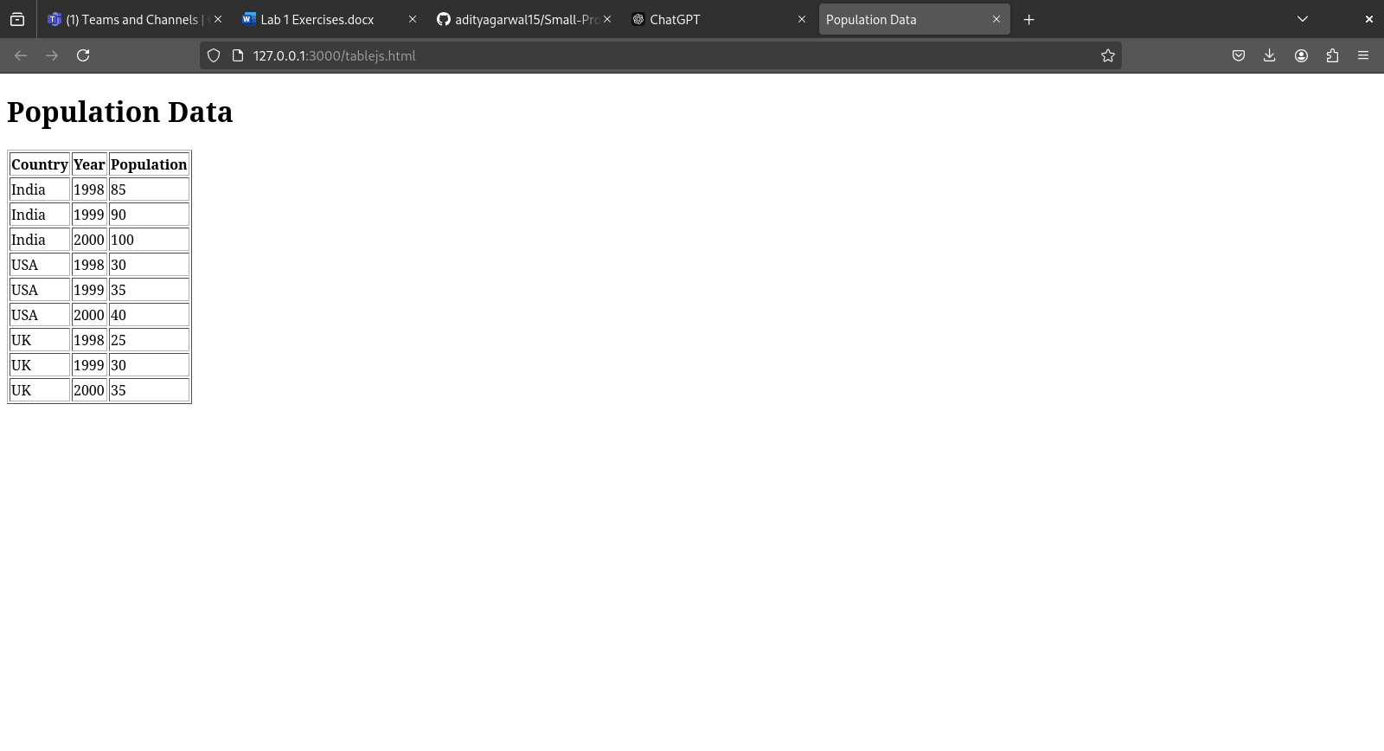
Output:

