LAB 8: Form Processing using Django – Part II
Aditya Agarwal – 220905106 – 14
- Create a Register page and Success page with the following requirements:
i. Register page should contain four input TextBoxes for UserName, Password, Email id and Contact Number and also a button to submit. Make the username as compulsory field and other fields as optional.
ii. On button click, Success page is displayed with message "Welcome {UserName}" and also his Email and Contact Number has to be displayed.
iii. Use secure technique to send details to the Success page (Hint: use csrftoken)
iv. Design a website with two pages.
q1/settings.py
import os
INSTALLED_APPS = [
'usersapp',
'django.contrib.admin',
'django.contrib.auth',
'django.contrib.contenttypes',
'django.contrib.sessions',
'django.contrib.messages',
'django.contrib.staticfiles',
]

MIDDLEWARE = [
'django.middleware.security.SecurityMiddleware',
'django.contrib.sessions.middleware.SessionMiddleware',
'django.middleware.common.CommonMiddleware',
'django.middleware.csrf.CsrfViewMiddleware',
'django.contrib.auth.middleware.AuthenticationMiddleware',
'django.contrib.messages.middleware.MessageMiddleware',
'django.middleware.clickjacking.XFrameOptionsMiddleware',
]
TEMPLATES = [
{
'BACKEND': 'django.template.backends.django.DjangoTemplates',
'DIRS': [os.path.join(BASE_DIR,'usersapp/templates')],
'APP_DIRS': True,
'OPTIONS': {
'context_processors': [
'django.template.context_processors.debug',
'django.template.context_processors.request',
'django.contrib.auth.context_processors.auth',
'django.contrib.messages.context_processors.messages',
],
},
},
]
q1/urls.py
from django.contrib import admin
from django.urls import path, include

urlpatterns = [
path('admin/', admin.site.urls),
path('users/', include('usersapp.urls')),
]
usersapp/urls.py
from django.urls import path
from . import views

urlpatterns = [
path('', views.register_view, name='register'),
path('success/', views.success_view, name='success'),
]
usersapp/forms.py
from django import forms

class RegistrationForm(forms.Form):
username = forms.CharField(max_length=100, required=True)
password = forms.CharField(widget=forms.PasswordInput, required=False)
email = forms.EmailField(required=False)
contact = forms.CharField(max_length=15, required=False)
usersapp/views.py
from django.shortcuts import render, redirect
from django.contrib import messages
from .forms import RegistrationForm

# Register Page View
def register_view(request):
if request.method == 'POST':
form = RegistrationForm(request.POST)
if form.is_valid():
# Get form data
username = form.cleaned_data['username']
password = form.cleaned_data['password']
email = form.cleaned_data['email']
contact = form.cleaned_data['contact']

# Save data in session
request.session['username'] = username
request.session['password'] = password
request.session['email'] = email
request.session['contact'] = contact

# Redirect to Success page
return redirect('success')
else:
# If form is invalid, display error messages
messages.error(request, 'Please correct the errors below.')
else:
form = RegistrationForm()

return render(request, 'register.html', {'form': form})

# Success Page View
def success_view(request):
username = request.session.get('username')
email = request.session.get('email')
contact = request.session.get('contact')

if username:
return render(request, 'success.html', {
'username': username,
'email': email,
'contact': contact,
})
else:
return redirect('register')
usersapp/templates/register.html
<!DOCTYPE html>
<html>
<head>
<title>Register</title>
</head>
<body>
<h2>Register</h2>

<form method="POST">
{% csrf_token %}
{{ form.as_p }} <!-- This will automatically render all form fields -->
<button type="submit">Submit</button>
</form>
</body>
</html>
usersapp/templates/success.html
<!DOCTYPE html>
<html>
<head>
<title>Success</title>
</head>
<body>
<h2>Welcome {{ username }}!</h2>
<p>Email: {{ email }}</p>
<p>Contact: {{ contact }}</p>
</body>
</html>
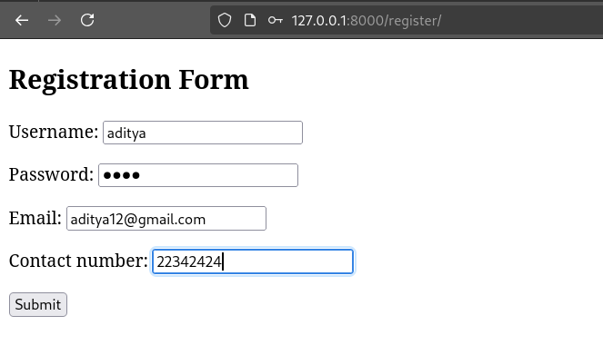
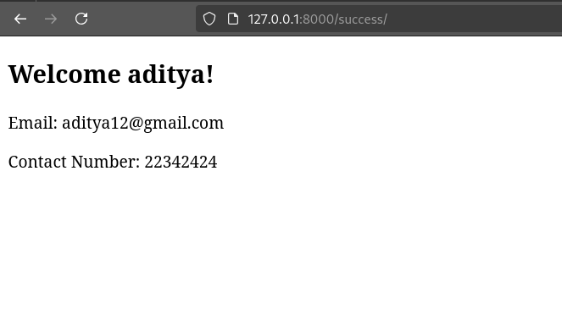
- “How is the book ASP.NET with c# by Vipul Prakashan?” Give the user three
choice: i) Good ii) Satisfactory iii) Bad. Provide a VOTE button. After user votes, present the result in percentage using labels next to the choice
q2/settings.py
import os
INSTALLED_APPS = [
'django.contrib.admin',
'django.contrib.auth',
'django.contrib.contenttypes',
'django.contrib.sessions',
'django.contrib.messages',
'django.contrib.staticfiles',
]

MIDDLEWARE = [
'django.middleware.security.SecurityMiddleware',
'django.contrib.sessions.middleware.SessionMiddleware',
'django.middleware.common.CommonMiddleware',
'django.middleware.csrf.CsrfViewMiddleware',
'django.contrib.auth.middleware.AuthenticationMiddleware',
'django.contrib.messages.middleware.MessageMiddleware',
'django.middleware.clickjacking.XFrameOptionsMiddleware',
]
TEMPLATES = [
{
'BACKEND': 'django.template.backends.django.DjangoTemplates',
'DIRS': [os.path.join(BASE_DIR,'voteapp/templates')],
'APP_DIRS': True,
'OPTIONS': {
'context_processors': [
'django.template.context_processors.debug',
'django.template.context_processors.request',
'django.contrib.auth.context_processors.auth',
'django.contrib.messages.context_processors.messages',
],
},
},
]
q2/urls.py
from django.contrib import admin
from django.urls import path, include

urlpatterns = [
path('admin/', admin.site.urls),
path('', include('voteapp.urls')), # Include the voteapp URLs here
]
voteapp/urls.py
from django.urls import path
from . import views

urlpatterns = [
path('', views.vote_view, name='vote'),
]
voteapp/views.py
from django.shortcuts import render
from django.http import HttpResponseRedirect
from .forms import VoteForm

def vote_view(request):
# Initialize votes in session if not already present
if 'votes' not in request.session:
request.session['votes'] = {'Good': 0, 'Satisfactory': 0, 'Bad': 0}
if request.method == "POST":
form = VoteForm(request.POST)
if form.is_valid():
vote = form.cleaned_data['vote']
# Increment the vote count in the session
request.session['votes'][vote] += 1
request.session.modified = True # Mark the session as modified to save it
else:
form = VoteForm() # Initialize an empty form when the page is first loaded
# Calculate percentages based on the votes in the session
total_votes = sum(request.session['votes'].values())
percentages = {}
if total_votes > 0:
for choice, count in request.session['votes'].items():
percentages[choice] = (count / total_votes) * 100
else:
percentages = {choice: 0 for choice in request.session['votes']}
return render(request, 'vote.html', {
'form': form,
'votes': request.session['votes'],
'percentages': percentages
})

voteapp/forms.py
from django import forms

class VoteForm(forms.Form):
VOTE_CHOICES = [
('Good', 'Good'),
('Satisfactory', 'Satisfactory'),
('Bad', 'Bad'),
]
vote = forms.ChoiceField(choices=VOTE_CHOICES, widget=forms.RadioSelect)

voteapp/templates/vote.html
<!DOCTYPE html>
<html lang="en">
<head>
<meta charset="UTF-8">
<meta name="viewport" content="width=device-width, initial-scale=1.0">
<title>Vote for the Book</title>
</head>
<body>
<p>How is the book "ASP.NET with C#" by Vipul Prakashan?<p>
<form method="post">
{% csrf_token %}
<label>
<input type="radio" name="vote" value="Good"> Good
{% if percentages.Good %}
({{ percentages.Good|floatformat:2 }}%)
{% endif %}
</label><br>
<label>
<input type="radio" name="vote" value="Satisfactory"> Satisfactory
{% if percentages.Satisfactory %}
({{ percentages.Satisfactory|floatformat:2 }}%)
{% endif %}
</label><br>
<label>
<input type="radio" name="vote" value="Bad"> Bad
{% if percentages.Bad %}
({{ percentages.Bad|floatformat:2 }}%)
{% endif %}
</label><br>
<button type="submit">Vote</button>
</form>
</body>
</html>
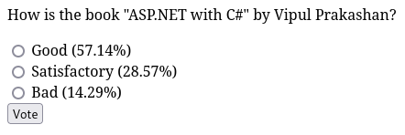

- Create a website with two pages. Page 1 has two TextBoxes (name and total marks) and one ‘Calculate’ Button as shown in the figure. On clicking the ‘Calculate’
Button, CGPA (total marks/50) along with the name should be displayed in thePage
Use Django sessions to store the information.
q3/settings.py
import os
INSTALLED_APPS = [
'cgpa_app',
'django.contrib.admin',
'django.contrib.auth',
'django.contrib.contenttypes',
'django.contrib.sessions',
'django.contrib.messages',
'django.contrib.staticfiles',
]

MIDDLEWARE = [
'django.middleware.security.SecurityMiddleware',
'django.contrib.sessions.middleware.SessionMiddleware',
'django.middleware.common.CommonMiddleware',
'django.middleware.csrf.CsrfViewMiddleware',
'django.contrib.auth.middleware.AuthenticationMiddleware',
'django.contrib.messages.middleware.MessageMiddleware',
'django.middleware.clickjacking.XFrameOptionsMiddleware',
]
TEMPLATES = [
{
'BACKEND': 'django.template.backends.django.DjangoTemplates',
'DIRS': [os.path.join(BASE_DIR,'cgpa_app/templates')],
'APP_DIRS': True,
'OPTIONS': {
'context_processors': [
'django.template.context_processors.debug',
'django.template.context_processors.request',
'django.contrib.auth.context_processors.auth',
'django.contrib.messages.context_processors.messages',
],
},
},
]
q3/urls.py
from django.contrib import admin
from django.urls import path, include

urlpatterns = [
path('admin/', admin.site.urls),
path('', include('cgpa_app.urls')),
]
cgpa_app/urls.py
from django.urls import path
from . import views

urlpatterns = [
path('', views.input_page, name='input_page'),
path('result/', views.result_page, name='result_page'),
]
cgpa_app/views.py
from django.shortcuts import render, redirect
from .forms import CGPAForm

def input_page(request):
if request.method == "POST":
# Process the form data when the form is submitted
form = CGPAForm(request.POST)
if form.is_valid():
# Get the cleaned data from the form
name = form.cleaned_data['name']
total_marks = form.cleaned_data['total_marks']

# Calculate CGPA
cgpa = total_marks / 50

# Store the name and CGPA in the session
request.session['name'] = name
request.session['cgpa'] = cgpa

# Redirect to the result page
return redirect('result_page')
else:
form = CGPAForm() # Create an empty form if the request is GET

return render(request, 'input_page.html', {'form': form})

def result_page(request):
# Retrieve the name and CGPA from the session
name = request.session.get('name')
cgpa = request.session.get('cgpa')

# If no data exists in the session, redirect back to the input page
if not name or not cgpa:
return redirect('input_page')

return render(request, 'result_page.html', {'name': name, 'cgpa': cgpa})
cgpa_app/forms.py
from django import forms

class CGPAForm(forms.Form):
name = forms.CharField(max_length=100, label='Name')
total_marks = forms.FloatField(label='Total Marks')
cgpa_app/templates/input_page.html
<!DOCTYPE html>
<html lang="en">
<head>
<meta charset="UTF-8">
<meta name="viewport" content="width=device-width, initial-scale=1.0">
<title>Enter Your Details</title>
</head>
<body>
<h1>Enter Your Name and Total Marks</h1>
<!-- Render the form using Django's form rendering -->
<form method="POST">
{% csrf_token %}
{{ form.as_p }} <!-- This will render the form fields as paragraphs -->
<button type="submit">Calculate</button>
</form>
</body>
</html>

cgpa_app/templates/result_page.html
<!DOCTYPE html>
<html lang="en">
<head>
<meta charset="UTF-8">
<meta name="viewport" content="width=device-width, initial-scale=1.0">
<title>CGPA Result</title>
</head>
<body>
<h1>CGPA Result</h1>
<p>Name: {{ name }}</p>
<p>Your CGPA: {{ cgpa|floatformat:2 }}</p>
</body>
</html>
