HackMatrix 2026
PROJECT DOCUMENTATION

Team Details
Team Name: Vmax
Team Leader Name: Gaurav Jain
Contact: gaurav.p054057@gmail.com
Team Members: Gaurav Jain, Aditya Gavane, Nishad Kulkarni

Event Details
Event Name: HackMatrix 2026 – Round 2
Problem Statement:
Web3 platforms lack real-time intelligent monitoring to detect suspicious blockchain activity and hidden fraud networks. Existing systems are largely reactive, allowing scams, money laundering, and malicious transactions to go undetected until financial losses occur. There is a need for an AI-driven, privacy-preserving security system that can analyze wallet behaviour, generate risk scores, and enable automated on-chain enforcement.

Links
GitHub Repository: GitHub Repo Link
Demo Video Link: Drive Link

1. Project Name / Title
Third Eye
A real-time, autonomous threat-detection and response system for DeFi protocols, built for the HackMatrix 2026 hackathon.

2. Platform Preview
The frontend is built around "3D Galaxy" view (React + Three.js) where every wallet the system knows about shows up as a node. Node size and colour track the wallet's risk level, from a calm green for safe wallets up to a pulsing red for confirmed attackers. Clicking a node opens a forensic sidebar with the wallet's risk score, its AI-written threat report, and a short list of recommended actions. A 2D "Wallet Explorer" is also available for tracing a wallet's immediate connections when the 3D view gets too busy to read.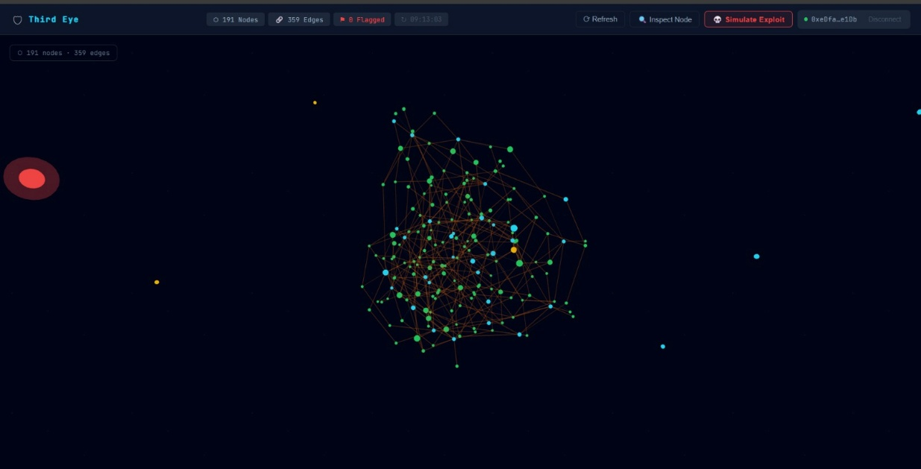 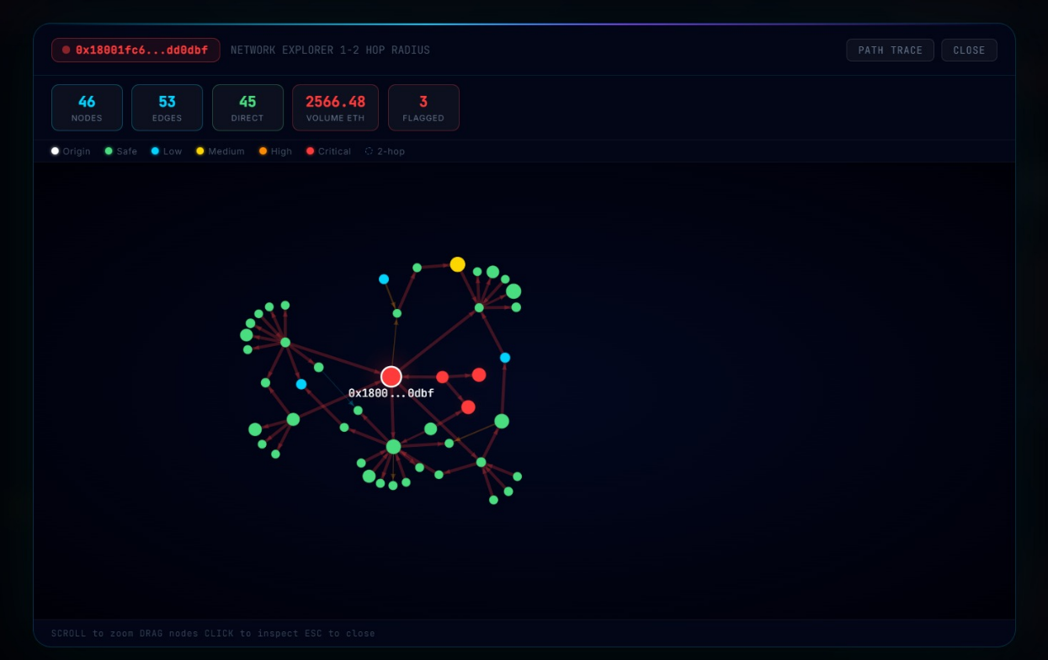
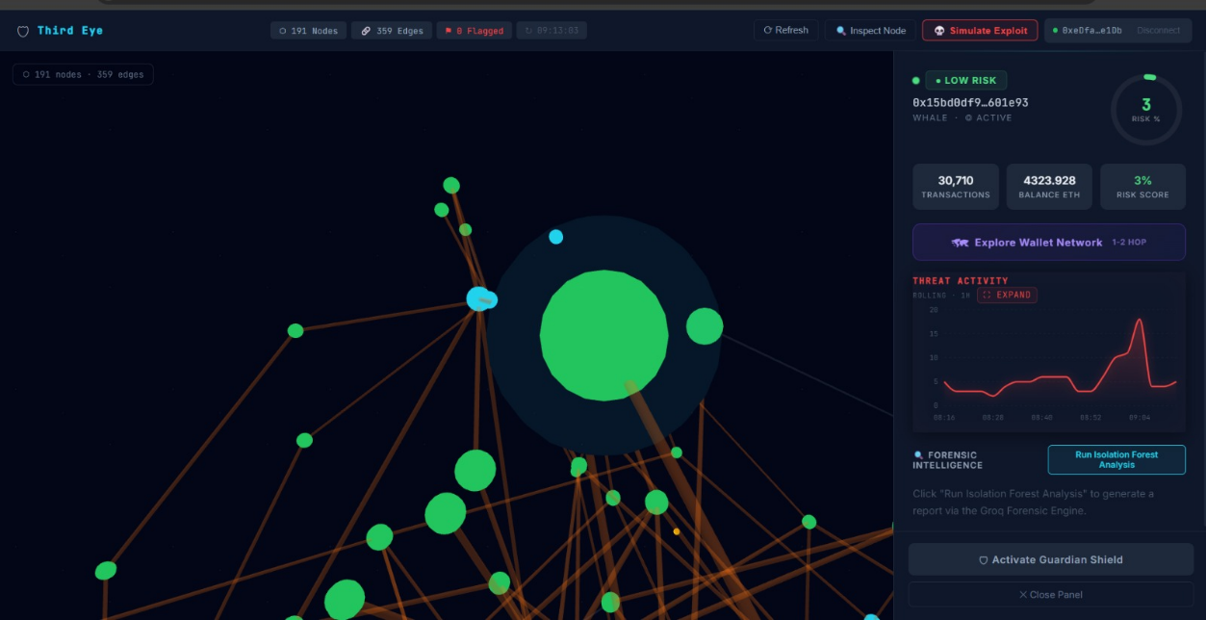

3. Summary
Third Eye watches wallet activity on Base Sepolia and tries to catch malicious behaviour before it can drain a protocol. Under the hood it is a six-stage pipeline: pull live transaction data for a wallet, build a transaction graph in Neo4j, score the wallet with an Isolation Forest model, check it against a small library of known exploit patterns, and, if the risk score clears a threshold, generate an AI forensic report and blacklist the wallet on-chain, automatically. None of these steps need a person to click a button. The system has already run this loop live against a real wallet on Base Sepolia, producing a verifiable blacklist transaction, and it can optionally attach a zero-knowledge proof showing the risk score was computed correctly without exposing the model weights or the wallet's raw feature data.

4. Problem Being Solved
Most DeFi exploits follow patterns that are already well documented: reentrancy, flash-loan price manipulation, sandwich attacks, governance takeovers, bridge double-spends. The issue isn't that these attacks are unpredictable, it's that protocols usually find out about them after the funds are gone. Monitoring today is mostly reactive and manual, someone has to notice an alert, investigate, and then act, and by that point the attacker has usually already moved the funds through a mixer or a bridge. Third Eye tries to close that gap by removing the human step between detection and response, so the time between "this wallet looks dangerous" and "this wallet is blocked" is measured in seconds rather than hours.

5. System Architecture & How It Works
The system is organised into six layers that hand off to one another in sequence, from raw chain data down to an on-chain enforcement action:
- Data layer — pulls live transaction history from the Etherscan V2 API (normal transactions, internal transactions, balance).
- Graph layer — stores wallets and transactions in Neo4j so that things like fund cycling and relay hubs can be found with graph queries rather than manual inspection.
- ML layer — an Isolation Forest model trained on 10 extracted features assigns each wallet an anomaly score.
- Intelligence layer — a Pattern-Signature Intelligence (PSI) engine checks the wallet against a hashed blacklist and five known exploit signatures.
- AI layer — wallets that score high enough get a forensic report written by Llama 3.1 via Groq.
- Enforcement layer — the ThirdEyeGuardian smart contract blacklists the wallet on Base Sepolia.

Step-by-step pipeline
- Ingestion — a wallet address is submitted to the backend, which fires off concurrent Etherscan calls for normal transactions, internal transactions, and balance.
- Graph construction — each wallet becomes a node and each transaction becomes an edge in Neo4j, which makes cycle detection and centrality analysis a graph query instead of custom code.
- Risk scoring — a 10-dimensional feature vector (transaction count, gas patterns, unique counterparties, flash-loan and reentrancy heuristics, value concentration, graph-cycle and betweenness scores, and velocity) feeds a 200-tree Isolation Forest. Its output is blended with the graph signals into one composite score:
R = 0.30 × IsolationForest + 0.25 × Cycle + 0.15 × Betweenness + 0.15 × CrossProtocol + 0.10 × Velocity + 0.05 × Time
- Pattern matching — the PSI engine checks the address against a salted-hash blacklist (so plaintext addresses are never compared directly) and against five structural signatures covering reentrancy, flash-loan oracle manipulation, governance attacks, sandwich MEV, and bridge exploits.
- Forensic reporting — wallets scoring above 0.65 get a short AI-written report (executive summary, threat narrative, recommended actions) from Llama 3.1 8B via Groq. If Groq is unreachable, a deterministic local template fills in instead, so a report is always produced.
- On-chain shielding — high-risk wallets are ABI-encoded, signed with the operator key, and broadcast to the ThirdEyeGuardian contract on Base Sepolia, which permanently flags the address.
- Optional ZK proof — when enabled, an SP1 zkVM program (or a simpler Circom circuit) re-runs the Isolation Forest scoring inside a proof system and certifies the result is correct without revealing the model weights or the wallet's features.

6. USP (Unique Selling Point)
What sets Third Eye apart isn't any single piece, it's that detection and enforcement are wired together into one loop with no manual step in between. Most hackathon security tools stop at a dashboard that flags a wallet and leaves a human to act on it; Third Eye actually blacklists the wallet on-chain by itself, and it has done this against a real transaction on Base Sepolia (block 45277823), not just in a demo mock.
- The detection side isn't a single model, it's an Isolation Forest combined with graph-topology signals from Neo4j and five hand-written exploit signatures, so a wallet has to look suspicious from multiple angles before it gets flagged.
- Blacklist matching uses salted SHA-256 hashing rather than comparing plaintext addresses, so the blacklist itself doesn't leak which addresses are being watched.
- The zero-knowledge layer is a genuine attempt at making the ML scoring auditable — an SP1 zkVM program re-executes the Isolation Forest and proves the result without exposing the model or the wallet's raw features.
- The forensic reporting has a fallback path, so a wallet still gets a written report even if the Groq API is down, which matters for a system that's supposed to run unattended.

7. Key Features
- Live on-chain data ingestion from the Etherscan V2 API.
- Graph-based wallet modelling in Neo4j for cycle detection, relay-hub identification, and neighbour exploration up to two hops.
- 200-tree Isolation Forest scoring with SHAP-style feature attribution, so a risk score comes with a reason, not just a number.
- Five structural exploit signatures (reentrancy, flash-loan manipulation, governance attacks, sandwich MEV, bridge exploits) layered on top of the ML score.
- AI forensic reports generated by Llama 3.1 8B through Groq, with a deterministic offline fallback.
- Automatic on-chain blacklisting through the ThirdEyeGuardian smart contract on Base Sepolia.
- Optional zero-knowledge proofs (SP1 zkVM or Circom/Groth16) that verify the ML scoring without revealing model or wallet data.
- Scheduled background sweeps via Celery + Redis, re-scanning wallets that haven't been analysed in the last hour.
- WORM-style audit logging — append-only, SHA-256 checksummed, covering nine distinct event types for tamper-evident record keeping.
- Interactive 3D wallet visualisation with a forensic sidebar, a 2D wallet explorer, and Privy-based wallet login.

8. Tech Stack

Backend & Data
Layer | Technology
API Framework | Python 3.11+, FastAPI, Uvicorn, Pydantic v2
Graph Database | Neo4j 5.x (async Python driver)
Task Queue | Celery 5.4 + Redis (broker & result backend)
ML Engine | scikit-learn (Isolation Forest), NumPy, joblib, ONNX / hummingbird-ml
AI Forensics | Groq API — Llama 3.1 8B Instant
Audit System | Custom WORM append-only JSON-Lines logger (SHA-256 checksums)

Blockchain & ZK
Layer | Technology
Smart Contract | Solidity 0.8.20, OpenZeppelin (Ownable, Pausable) — Base Sepolia (Chain ID 84532)
ZK Proofs | SP1 zkVM (Rust) for full Isolation Forest inference; Circom + Groth16 for threshold gating
Wallet Auth | Privy 1.60
Contract Interaction | ethers.js 6.12

Frontend
Layer | Technology
Framework | React 18.2, TypeScript 5.2, Vite 8.0
3D Visualisation | Three.js 0.163, react-force-graph-3d / -2d
Animation | Framer Motion 12.38
Charts | Recharts 3.8

9. Security Features
Feature | Implementation
HMAC middleware | SHA-256 signature check on internal routes, with a 300-second replay window
Rate limiting | Etherscan calls capped at 4 requests/second
Audit trail | Append-only JSON Lines, checksummed per entry, tamper-evident on read
Private set intersection | Salted SHA-256 hashing for blacklist matching, plaintext addresses never compared directly
Operator roles | Blacklist actions on-chain require an explicit OPERATOR_ROLE grant
Emergency pause | Contract owner can pause blacklist operations if something goes wrong
ZK proofs | Cryptographic proof that ML scoring was executed correctly, without revealing model or input data

10. Proven Live Transaction
The shielding step has been run against a real transaction on Base Sepolia, not just simulated:
Field | Value
Transaction Hash | 0x2e623e6ab41925d142ce7c469846c2b1e96391b825d4cc7fde746116a573611f
Block | 45277823
Status | Success
From (Operator) | 0xeDfa9415D1c9614631FBbC1Fba490dDF2411e1Db
To (Guardian Contract) | 0xd9145CCE52D386f254917e481eB44e9943F39138
Gas Used | 25,300 / 200,000 (12.65%)

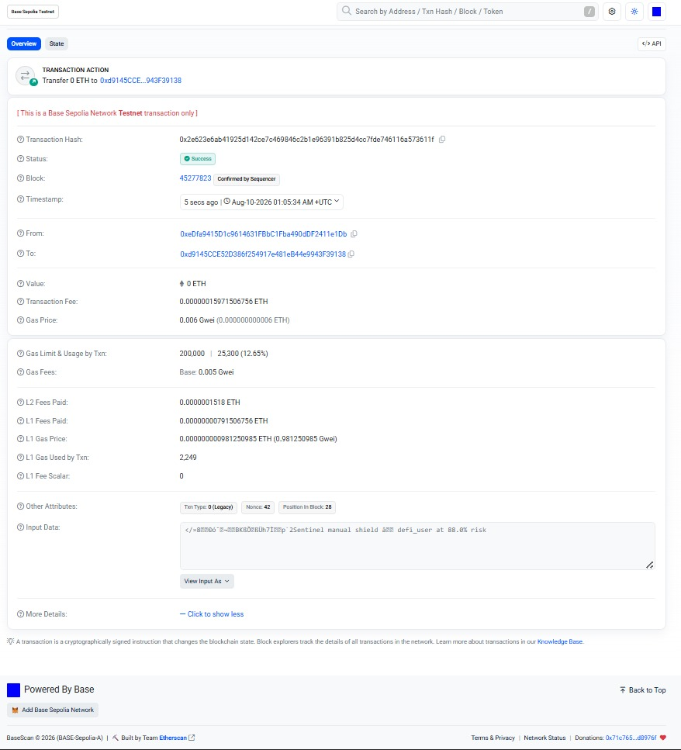

11. Future Scope

1. Real-Time Mempool & Multichain Ingestion
Currently, the system relies on polling Etherscan for confirmed block data.
The Upgrade: Transition the ingestion engine to monitor pending transactions directly from the mempool using WebSocket streams (via Infura, Alchemy, or a dedicated node).
Impact: By intercepting the mempool, your backend can analyze transactions and execute the blacklistWallet function before the attacker's transaction is even confirmed on-chain, creating a true pre-emptive shield.

2. Distributed Graph Architecture
Running a local Neo4j instance is perfect for a proof-of-concept, but mainnet transaction topologies expand exponentially.
The Upgrade: Migrate to a highly available graph database cluster like Neo4j Enterprise, Memgraph, or Amazon Neptune.
Impact: This allows for real-time, billion-edge traversals. As you tackle this phase, the kind of technical guidance and suggestions Himanshu Patil provided will be highly valuable for properly architecting the distributed graph layer to handle concurrent sub-second Cypher queries.

3. Streaming Isolation Forest & zkML Acceleration
To maintain low latency, the machine learning and zero-knowledge generation pipelines must be decoupled from the main backend thread.
Model Scaling: Rather than adopting generic AI, strictly focus on upgrading your Isolation Forest to an online/streaming implementation (like iForestASD), allowing the model to continuously fine-tune and adapt to new evasion tactics without full periodic retraining.
Proof Scaling: Generating cryptographic proofs locally bottlenecks the system. If using EZKL, you can offload execution to high-performance compute clusters like Lilith, which can dispatch proof jobs in under a millisecond across hundreds of workers. If using SP1, you can tap into the decentralized Succinct Prover Network, which uses proof sharding to distribute large workloads across global GPUs and ASICs for parallel processing.

4. Protocol Middleware & Automated Circuit Breakers
The Guardian contract currently acts as a global registry, but protocols need an easy way to consume this data.
The Upgrade: Build a lightweight Solidity SDK or middleware that DeFi protocols can integrate directly into their smart contracts (e.g., a modifier onlyClean(address) that checks the Guardian contract before allowing a flash loan or massive withdrawal).
Impact: Paired with Account Abstraction (ERC-4337) paymasters to sponsor the gas for your defense transactions, or Flashbots to guarantee MEV protection, you ensure the shield cannot be bypassed or front-run by sophisticated MEV bots.

