- https://docs.google.com/document/d/1mpKwPTDWbO3TvXVqALySOAugLqpEf7AgMxL2rDQSxbY/edit

Intuit | OA | New Grad - Discuss - LeetCode

https://www.youtube.com/watch?v=W5SmzsCxbNE

- https://www.desiqna.in/15111/intuit-oa-sde1-2023-may
https://docs.google.com/document/d/1cg-Z-jGL2HVjCdaxd_aq5GP2JUfuVpWLu-YKx6_nQtY/edit
Can use set as well

- https://leetcode.com/discuss/interview-question/4355676/help-needed
https://docs.google.com/document/d/1-USZp5_aApQUevmLVqru47A64o9QI0grLB5uC3KeddU/edit

- https://docs.google.com/document/d/1rWiHnNWlfLY7wZImucWTfw7wPcm2BlNamt-KrtZVNSs/edit

- https://docs.google.com/document/d/16d9ZNChbaeoBtKy23aqSnIjYu2P8k3c3pTJOxP7cR18/edit

- https://docs.google.com/document/d/1j_GcVecF7BEkGjmzYouWorFWGQ1vRmOoIe5UEowh0CI/edit

- Wizard harry -> https://www.desiqna.in/15561/intuit-oa-sde-2023-august-set-harry-potter-and-the-goblet-fire#google_vignette

https://ideone.com/4ogO4k
8)
#include<bits/stdc++.h>
using namespace std;

int main()
{
int t; cin>>t;
while(t--){
int n,m; cin>>n>>m;
int a[n][m];
for(int i=0;i<n;i++){
for(int j=0;j<m;j++) cin>>a[i][j];
}
int k; cin>>k;
int ans=0;
vector<pair<int,int>>v;
for(int i=0;i<n;i++){
for(int j=0;j<m;j++){
int row=(j+1)* (m-j), col=(i+1)* (n-i)-1;
int topLeft=i*j, topRight=(m-j-1)*i;
int bottomLeft=j*(n-i-1), bottomRight=(n-i-1)*(m-j-1);
int left=j*i*(n-i-1), right=(m-j-1)*i*(n-i-1);
int top=i*j*(m-j-1), bottom=(n-i-1)*j*(m-j-1);
int d1=topLeft*bottomRight, d2=topRight*bottomLeft;
int total=row+col+topLeft+topRight+bottomLeft+bottomRight+left+right+top+bottom+d1+d2;
v.push_back({total*a[i][j],a[i][j]});
}
}
sort(v.rbegin(),v.rend());
for(int i=0;i<n*m;i++){
// cout<<v[i].first<<" "<<v[i].second<<endl;
int ele=v[i].second;
if(k>=ele) v[i].second=0, k-=ele;
else if(k>=0){
v[i].second-=k;
k=0;
}
if(ele!=0){
int occ=v[i].first/ele;
ans +=occ*v[i].second;
}
}
cout<<ans<<endl;
}
return 0;
}
OR
int n,m;
cin>>n>>m;

vector<vector<int>> v(n,vector<int> (m));
for(int i=0;i<n;i++){
for(int j=0;j<m;j++) cin>>v[i][j];
}

int k;
cin>>k;

vector<pair<int,int>> vec;
for(int i=0;i<n;i++){
for(int j=0;j<m;j++){
int up=i,right=(m-j);
int down=(n-i),left=j;

int op1=(right*down);
int op2=(left*right)*down;
int op3=(up*down)*right;
int op4=up*(left*right)*down;
vec.push_back({op1+op2+op3+op4,v[i][j]});
}
}

sort(vec.begin(),vec.end(),[](pair<int,int> &p1,pair<int,int> &p2){
return p1.second*p1.first>p2.first*p2.second;
});

for(auto it:vec) cout<<it.first<<"->"<<it.second<<endl;
int ans=0;
for(int i=0;i<vec.size();i++){
if(vec[i].second<=k){
k-=vec[i].second;
}
else{
vec[i].second-=k;
k=0;
ans=((ans%mod)+(((vec[i].first%mod)*(vec[i].second%mod))%mod))%mod;
}
}

cout<<ans%mod<<endl;
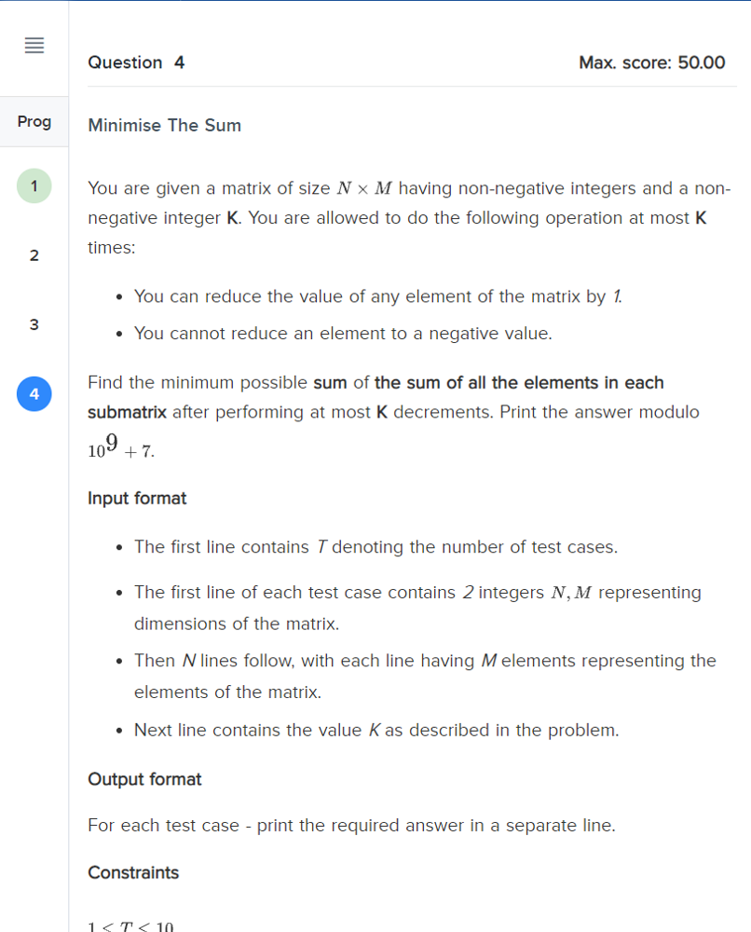

9 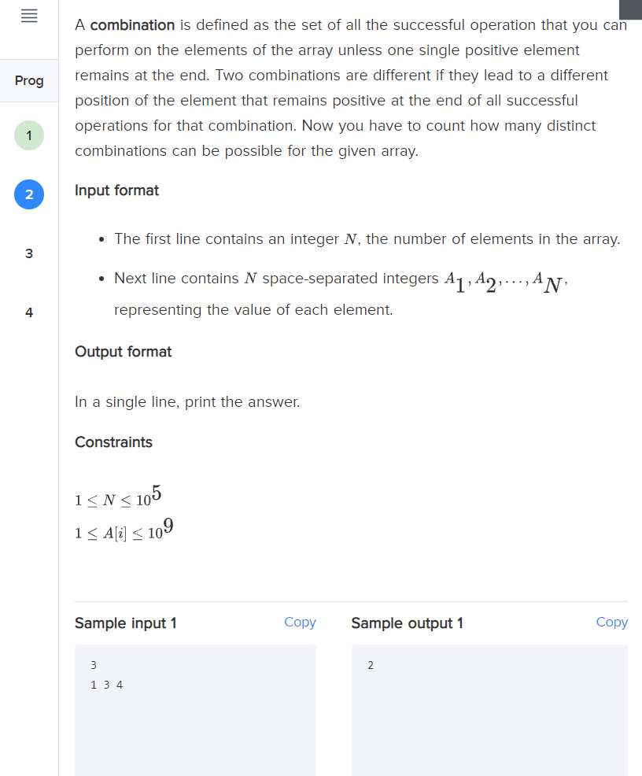

typedef long long int ll;
int solve(vector<ll> & nums){
ll tot=0;
for(auto num: nums)
tot+=num;
int ans=0;
for(int i=0;i<nums.size();i++){
if( 2*nums[i]>=(tot-nums[i]) )
ans++;
}
return ans;
}
int main(){
vector<ll> A={1,3,4};
cout<<solve(A);
}
https://leetcode.com/discuss/interview-question/1502231/intuit-oa-new-grad

tree vector<int> solve(vector<int> &arr,int n)
{
vector<int>ans(n);
map<int,int>first,last;
for(int i=0;i<arr.size();i++)
{
int id = arr[i];
id--;
if(first.count(id) == 0)
{
first[id] = i;
}
else{
last[id] = i;
}
}
for(int i = 0;i<n;i++)
{
ans[i] = (last[i]-first[i])/2;
ans[i]++;
}
return ans;
}

int main() {
std::cout << "Hello World!\n";
vector<int>arr= {1,2,5,5,6,6,7,7,2,3,3,4,4,1};
int n = 7;
vector<int>ans = solve(arr,n);
for(int i=0;i<n;i++)
{
cout<<ans[i]<<" ";
}
return 0;
}

TRIANGULAR FARMS

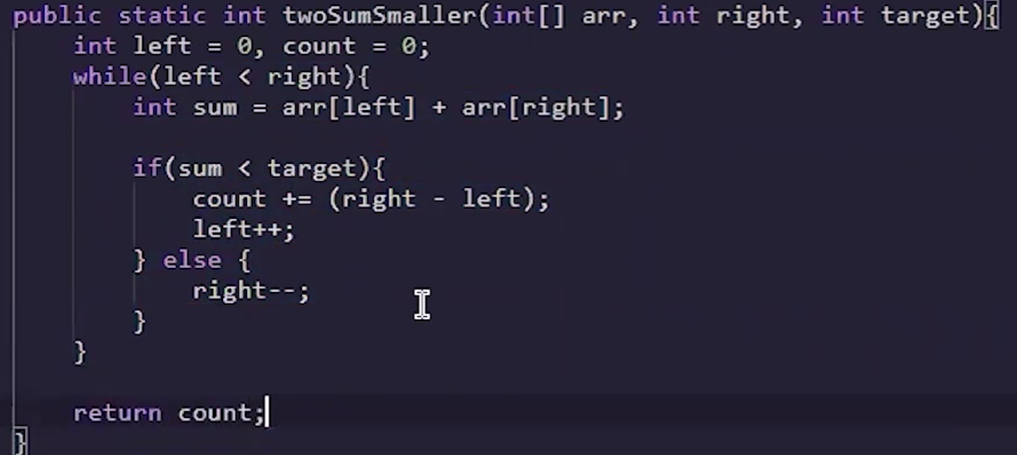

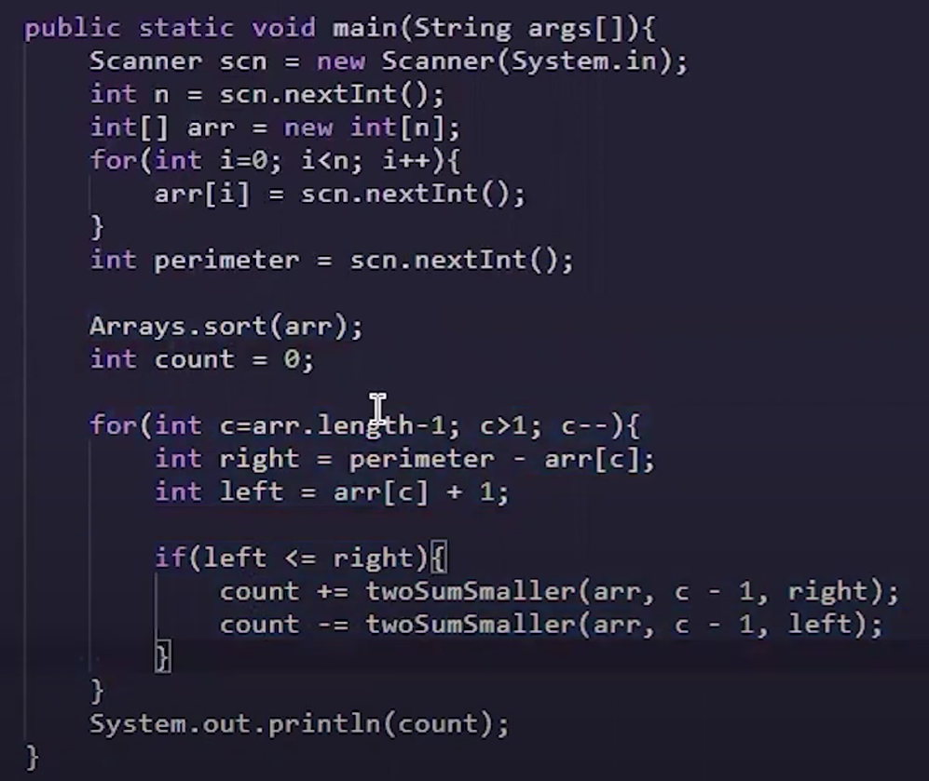

BINARY SEARCH

MATCHIMAKING-1
public static void solve() {
Scanner sc = new Scanner(System.in);

int n = sc.nextInt();
Map<String, Integer> experts = new HashMap<>();

for (int i = 0; i < n; i++) {
String topic = sc.next();
String lang = sc.next();
String key = topic + "|" + lang;
experts.put(key, experts.getOrDefault(key, 0) + 1);
}

int m = sc.nextInt();
int unhappy = 0;

for (int i = 0; i < m; i++) {
String topic = sc.next();
String lang = sc.next();
String key = topic + "|" + lang;

if (experts.containsKey(key) && experts.get(key) > 0) {
experts.put(key, experts.get(key) - 1);
} else {
unhappy++;
}
}

System.out.println(unhappy);
}

COOKIE MONSTER –
private static int minTime(char[][] grid, String weaknesses) {
int n = grid.length, m = grid[0].length;
Set<Character> weak = new HashSet<>();
for (char c : weaknesses.toCharArray()) weak.add(c);

// Dijkstra: distance to each cell
int[][] dist = new int[n][m];
for (int[] d : dist) Arrays.fill(d, INF);
dist[0][0] = 0;

PriorityQueue<Node> pq = new PriorityQueue<>(Comparator.comparingInt(a -> a.d));
pq.add(new Node(0, 0, 0));

while (!pq.isEmpty()) {
Node cur = pq.poll();
if (cur.d != dist[cur.r][cur.c]) continue;
if (cur.r == n - 1 && cur.c == m - 1) return cur.d; // reached 'Y'

for (int[] di : DIR) {
int nr = cur.r + di[0], nc = cur.c + di[1];
if (nr < 0 || nr >= n || nc < 0 || nc >= m) continue;
int w = enterCost(grid[nr][nc], weak);
int nd = cur.d + w;
if (nd < dist[nr][nc]) {
dist[nr][nc] = nd;
pq.add(new Node(nr, nc, nd));
}
}
}
return -1; // should not happen given problem guarantees
}

// Cost to MOVE INTO a cell
private static int enterCost(char cell, Set<Character> weak) {
if (cell == 'M' || cell == 'Y' || cell == '.') return 1;
// A-Z cookie cell
return weak.contains(cell) ? 5 : 2;
}

static class Node {
int r, c, d;
Node(int r, int c, int d) { this.r = r; this.c = c; this.d = d; }
}

Robber on Tree

import java.util.*;

public class Main {
static long ans = Long.MIN_VALUE;

static boolean dfs(int src, int par, int target, int t,
ArrayList<Integer>[] graph, int[] timeTaken) {
if (src == target) {
timeTaken[src] = t;
return true;
}

for (int c : graph[src]) {
if (c != par) {
if (dfs(c, src, target, t + 1, graph, timeTaken)) {
timeTaken[c] = t + 1;
return true;
}
}
}
return false;
}

static void dfs2(int src, int par, int t, long sum,
ArrayList<Integer>[] graph, int[] timeTaken, long[] coins) {
if (t < timeTaken[src]) {
sum += coins[src];
}
if (t == timeTaken[src]) {
sum += (coins[src] / 2);
}

int child = 0;
for (int c : graph[src]) {
if (c != par) {
child++;
dfs2(c, src, t + 1, sum, graph, timeTaken, coins);
}
}
if (child == 0) {
ans = Math.max(ans, sum);
}
}

public static void main(String[] args) {
Scanner sc = new Scanner(System.in);

int n = sc.nextInt();
int R = sc.nextInt();

@SuppressWarnings("unchecked")
ArrayList<Integer>[] graph = new ArrayList[n + 1];
for (int i = 1; i <= n; i++) graph[i] = new ArrayList<>();

for (int i = 0; i < n - 1; i++) {
int a = sc.nextInt(), b = sc.nextInt();
graph[a].add(b);
graph[b].add(a);
}

long[] coins = new long[n + 1];
for (int i = 1; i <= n; i++) coins[i] = sc.nextLong();

int[] timeTaken = new int[n + 1];
Arrays.fill(timeTaken, Integer.MAX_VALUE);
timeTaken[R] = 0;

dfs(R, -1, 1, 0, graph, timeTaken);
dfs2(1, -1, 0, 0, graph, timeTaken, coins);

System.out.println(ans);
}
}

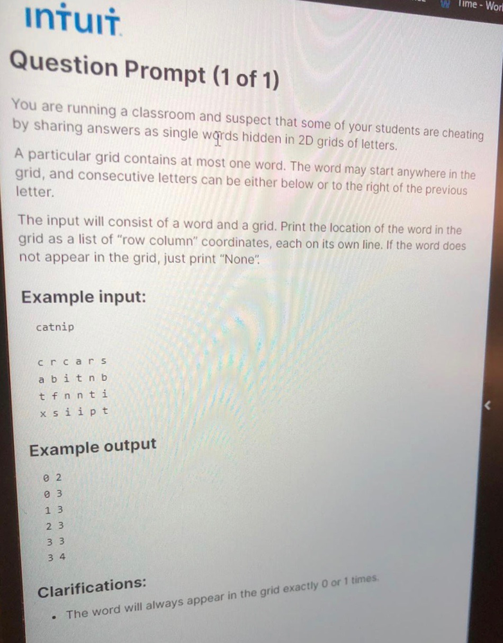

public class Solution {
// If you need extra classes, you can define them privately here within class Solutionc
static class Pair{
int x, y;
public Pair(int x, int y){
this.x = x;
this.y = y;
}
public String toString(){
return x+" " + y;
}
}
static void findWord(String word, String[][] grid) {
for(int i=0;i<grid.length;i++){
for(int j =0;j<grid[0].length;j++){
findWordRecur(grid, i, j, 0, word, new ArrayList<>());
if(answer.size()!=0){
for(int k=0;k<answer.size()/2;k++){
System.out.println(answer.get(k));
}
return;
}
}
}
System.out.println("None");
}
static List<Pair> answer = new ArrayList<>();
static void findWordRecur(String [][] grid, int x, int y, int pointer, String word, List<Pair> path){
if(pointer==word.length()){
answer.addAll(path);
return;
}
if(x < 0 || x>= grid.length || y<0 || y >= grid[0].length){
return;
}
if(grid[x][y].equals(""+word.charAt(pointer))){
path.add(new Pair(x,y));
findWordRecur(grid, x+1, y, pointer+1, word, path);
findWordRecur(grid, x, y+1, pointer+1, word, path);
path.remove(path.size()-1);
}
}

WALL-e
import java.util.*;

public class Main {
public static void main(String[] args) {
Scanner sc = new Scanner(System.in);

int n = sc.nextInt(); // number of positions
int p = sc.nextInt(); // WALL-E position (1-based)

int[] a = new int[n + 1]; // 1-based array of 0/1

// Read the 0/1 sequence, supporting both "0 1 1 0" and "0110" styles.
String first = sc.next();
if (first.length() == n && isBinaryString(first)) {
for (int i = 1; i <= n; i++) a[i] = first.charAt(i - 1) - '0';
} else {
a[1] = Integer.parseInt(first);
for (int i = 2; i <= n; i++) a[i] = sc.nextInt();
}

int ans = 0;

// distance 0 (position p itself)
if (a[p] == 1) ans++;

// distances >= 1
int maxD = Math.max(p - 1, n - p);
for (int d = 1; d <= maxD; d++) {
int L = p - d, R = p + d;
boolean inL = (L >= 1), inR = (R <= n);

if (inL && inR) {
// If both sides exist, pick garbage only when BOTH are 1
if (a[L] == 1 && a[R] == 1) ans += 2;
} else if (inL) {
// Only left side exists
if (a[L] == 1) ans++;
} else if (inR) {
// Only right side exists
if (a[R] == 1) ans++;
}
}

System.out.println(ans);
sc.close();
}

private static boolean isBinaryString(String s) {
for (int i = 0; i < s.length(); i++) {
char c = s.charAt(i);
if (c != '0' && c != '1') return false;
}
return true;
}
}
FIND THE NUMBER