Week 1 · Strategic Planning and Data Exploration in Logistics

Strategic planning report with Python illustrations
Track: Data Analytics / Logistics & Supply Chain · Prepared by: ______________ · Date: October 2026

Executive summary
This report plans a data-driven improvement project for the outbound logistics of a mid-sized omnichannel retailer, modelled on the public DataCo Smart Supply Chain dataset. The business has three linked problems: orders arrive late, demand swings leave stock in the wrong place, and delivery routes are not planned for efficiency.
The plan defines six KPIs (led by On-Time Delivery Rate and Average Delivery Delay), maps each problem to a data science technique (classification, regression/forecasting, clustering and optimisation), and sets out a six-phase roadmap from data collection to a decision dashboard. Short, runnable Python illustrations in Section 6 show how each phase will be carried out.
Section | Content
1 | Project definition: scenario, problem statement, objectives, scope
2 | Key performance indicators
3 | Background research: literature and public data sources
4 | How data science techniques apply
5 | Strategic roadmap, pipeline pseudocode, feasibility and risks
6 | Python code illustrations
7 | Expected outcomes and impact on decision-making
8 | Conclusion
9 | References

1. Project definition

1.1 Logistics scenario
DataCo Global is a mid-sized omnichannel retailer that sells sports, apparel and electronics products to consumer, corporate and home-office customers in several world regions. Orders are fulfilled from regional distribution centres and shipped under one of four service levels: Standard Class, Second Class, First Class or Same Day. Each order carries a scheduled number of shipping days (the promise made to the customer) and an actual number of days (what really happened).
The scenario mirrors the structure of the public DataCo Smart Supply Chain dataset (Section 3), so the plan can be tested on openly available data rather than on invented numbers.

1.2 Business problems
- Late deliveries. Orders that arrive after the promised date hurt customer satisfaction and repeat purchases, and it is not clear which regions, shipping modes or periods cause most of the delay.
- Demand and inventory mismatch. Demand varies by week and category. Without forecasts, stock is either too low (lost sales, expedited shipping) or too high (holding cost).
- Unplanned delivery routes. Without route optimisation, vehicles cover more distance than necessary, which raises cost and delays.
- No single KPI view. Delivery, demand and cost data sit in separate reports, so managers cannot see trade-offs.

1.3 Problem statement
How can DataCo use its order, shipment and demand history to (a) predict and reduce late deliveries, (b) forecast demand so that inventory is positioned correctly, and (c) plan delivery routes that cut distance, while tracking progress with a small set of agreed KPIs?

1.4 Project objectives
# | Objective | Measured by
O1 | Baseline: build one trusted view of delivery performance from the raw order data | KPI table (Section 6.3)
O2 | Diagnose: find which lanes (region x shipping mode), categories and periods drive lateness | Late-rate breakdowns and lane clusters
O3 | Predict: estimate late-delivery risk at the time an order is placed, and forecast weekly demand per category | ROC-AUC (classifier), WAPE (forecast)
O4 | Optimise: set inventory parameters (EOQ, safety stock, reorder point) and plan capacity-constrained routes | Cost and distance saved versus a naive plan
O5 | Communicate: deliver a KPI dashboard and clear recommendations to operations managers | Stakeholder review

1.5 Scope, assumptions and stakeholders
- In scope: outbound fulfilment (warehouse to customer), historical order data, offline analysis in Python.
- Out of scope: real-time tracking systems, inbound procurement, carrier contract negotiation.
- Assumptions: the public dataset is representative enough to demonstrate the method; where the data has no inventory or cost fields, clearly labelled planning assumptions are used (Section 6.8).
Stakeholder | What they need from the analysis
Operations manager | Where and when deliveries fail; which shipping modes to fix
Inventory planner | Weekly demand forecasts, safety stock and reorder points
Customer service lead | Early warning of orders likely to be late
Finance | Revenue at risk and cost-to-serve trends

2. Key performance indicators
Six KPIs cover service quality, demand planning, inventory and cost. The first four can be computed directly from the DataCo columns; the last two come from the optimisation steps.
# | KPI | Definition | Why it matters | Source columns | Proposed target*
1 | On-Time Delivery Rate (OTD) | Share of orders delivered within the scheduled days: 1 - late orders / total orders | It is the promise made to the customer and the main driver of satisfaction | Days for shipping (real), Days for shipment (scheduled), Late_delivery_risk | at least 95%
2 | Average Delivery Delay | Mean of actual days - scheduled days over late orders | Shows how severe lateness is, not just how frequent | same as KPI 1 | at most 1 day
3 | Demand Forecast Accuracy (WAPE) | sum(abs(actual - forecast)) / sum(actual) per category-week | Forecast quality decides where stock is positioned | order date, Order Item Quantity | at most 20%
4 | Revenue at Risk | Sales on late orders as a share of total sales | Turns service failures into a money figure for Finance | Sales, lateness flag | falling trend
5 | Cycle Service Level (stockout risk) | Probability of not stocking out in a replenishment cycle, set through the safety-stock policy | Balances availability against holding cost | weekly demand mean and variability, lead time (assumed) | 95%
6 | Route Distance Saved | 1 - optimised route distance / naive route distance | Direct link to transport cost and delivery time | stop coordinates and demands | to be measured on pilot routes
*Targets are proposed planning values to be agreed with stakeholders once the baseline is measured. They are not findings.

3. Background research: literature and public data

3.1 Why delivery performance is the central measure
The World Bank's Logistics Performance Index (LPI), published for countries on a scale of 1 (worst) to 5 (best), scores trade logistics on six components: customs clearance, quality of transport and IT infrastructure, ease of arranging shipments, logistics service competence, ability to track shipments, and timeliness of delivery (Rodrigue, The Geography of Transport Systems, LPI 2023 summary; World Bank LPI). The same summary notes that scores below 3.0 point to significant problems in the distribution system and that high-income economies lead the ranking.
The LPI works at country level, but it supports the design choice here: timeliness and tracking are first-class logistics measures, so the company-level KPIs in Section 2 start with on-time delivery and delay.

3.2 Public datasets considered
Dataset | Source | Contents | Role in this project
DataCo Smart Supply Chain for Big Data Analysis (Constante, Silva & Pereira, 2019, v5) | Mendeley Data, also on Kaggle | Structured order data in CSV plus unstructured clickstream data, covering provisioning, production, sales and commercial distribution for clothing, sports and electronics products | Primary dataset. It has scheduled and actual shipping days, shipping mode, region, sales and profit in one table
Olist Brazilian E-Commerce Public Dataset | Kaggle: olistbr/brazilian-ecommerce | About 100,000 marketplace orders from 2016 to 2018 in 9 related CSV tables (orders, items, payments, reviews, customers, sellers, products, geolocation) | Secondary dataset. A second marketplace for validating the delivery model, with geolocation data usable for real routing later
World Bank LPI | lpi.worldbank.org | Country-level logistics scores | Benchmark context only
Community analyses of DataCo have already explored it. One exploratory analysis reports that Standard Class has the most orders and also the most late deliveries (Medium EDA of the DataCo dataset). This is treated as a hypothesis to test, not as a fact.
Limitations to plan for. DataCo has no inventory levels, no shipping cost and no vehicle or route data. The inventory step therefore uses explicit planning assumptions, and the routing step is demonstrated on a small toy problem first, to be extended later with geolocation data (for example from Olist).

3.3 Methods literature
- Inventory: the Economic Order Quantity model (Harris, 1913) gives the order size that minimises ordering plus holding cost. Safety stock adds a buffer for demand variability during the replenishment lead time.
- Routing: the Vehicle Routing Problem was introduced by Dantzig and Ramser (1959) as the "truck dispatching problem". Google's OR-Tools solves it in Python through a data model, a distance callback, dimensions such as capacity or route length, and search parameters.
- Forecasting: Hyndman and Athanasopoulos, Forecasting: Principles and Practice, recommend benchmarking any model against simple baselines such as the naive and moving-average forecasts, which is the approach used in Section 6.6.

4. How data science techniques apply
Logistics challenge | Technique | Python tools | What it produces | KPI affected
Which orders will be late? | Classification (logistic regression, random forest) | scikit-learn | A late-delivery risk score per order and the main risk drivers | OTD, Revenue at Risk
How many units will we sell next week? | Regression / time-series forecasting (lag features, Ridge regression) | pandas, scikit-learn | Weekly demand forecast per category | Forecast accuracy, Service Level
Which lanes behave alike? | Clustering (k-means on region x mode lanes) | scikit-learn | Lane groups such as "reliable", "slow" or "problem" lanes for targeted action | OTD, Average Delay
How much stock to hold and when to reorder? | Optimisation (EOQ, safety stock, reorder point) | numpy, pandas | Order quantity and reorder point per category | Cycle Service Level, holding cost
In what order should vehicles visit customers? | Optimisation (capacitated vehicle routing) | OR-Tools | Routes that minimise total distance within vehicle capacity | Route Distance Saved
Where does performance vary? | Exploratory analysis and visualisation | pandas, matplotlib, seaborn | KPI baseline, heatmaps, seasonality charts | all

5. Strategic roadmap
The analysis follows six phases. Results from the last phase feed back into the earlier ones: monitored KPIs show where models need retraining and where new data should be collected.
import warnings
from pathlib import Path
import numpy as np
import pandas as pd
import matplotlib.pyplot as plt
import matplotlib.ticker as mtick
from matplotlib.colors import LinearSegmentedColormap
from matplotlib.patches import FancyBboxPatch
import seaborn as sns
warnings.filterwarnings("ignore")
pd.set_option("display.max_columns", 30)
pd.set_option("display.float_format", "{:,.2f}".format)
# Colour-blind-safe categorical order, one-hue sequential ramp
BLUE, ORANGE, AQUA, YELLOW, MAGENTA = "#2a78d6", "#eb6834", "#1baf7a", "#eda100", "#e87ba4"
CATEGORICAL = [BLUE, ORANGE, AQUA, YELLOW, MAGENTA]
INK, MUTED, GRID = "#0b0b0b", "#52514e", "#e1e0d9"
SEQ = LinearSegmentedColormap.from_list("seq_blue", ["#cde2fb", "#2a78d6", "#0d366b"])
plt.rcParams.update({
"figure.dpi": 110, "font.size": 11,
"axes.spines.top": False, "axes.spines.right": False,
"axes.edgecolor": "#c3c2b7", "axes.labelcolor": MUTED,
"axes.grid": True, "axes.axisbelow": True,
"grid.color": GRID, "grid.linewidth": 0.8,
"xtick.color": MUTED, "ytick.color": MUTED,
"axes.titlesize": 13, "axes.titleweight": "bold", "axes.titlelocation": "left",
})
# ---- End-to-end process flow -------------------------------------------------
phases = [
("1 Collect", "Download DataCo / Olist\nLPI benchmarks\nData dictionary"),
("2 Clean", "Types, duplicates,\nmissing values, outliers\nValidation checks"),
("3 Explore", "KPI baseline\nLane and category\nanalysis"),
("4 Model", "Late-delivery classifier\nDemand forecast\nLane clustering"),
("5 Optimise", "EOQ and safety stock\nVehicle routing\nScenario tests"),
("6 Decide", "KPI dashboard\nRecommendations\nMonitoring"),
]
box_w, gap, box_y, box_h = 2.2, 0.36, 1.0, 2.1
fig, ax = plt.subplots(figsize=(15, 3.8))
ax.set_xlim(-0.1, 15.1); ax.set_ylim(0, 3.8); ax.axis("off")
centres = []
for i, (title, body) in enumerate(phases):
x = i * (box_w + gap)
ax.add_patch(FancyBboxPatch((x, box_y), box_w, box_h, boxstyle="round,pad=0.02,rounding_size=0.12",
fc="#cde2fb", ec=BLUE, lw=1.5))
ax.text(x + box_w / 2, box_y + box_h - 0.38, title, ha="center", va="center", fontsize=12, fontweight="bold", color=INK)
ax.text(x + box_w / 2, box_y + 0.8, body, ha="center", va="center", fontsize=9.5, color=INK, linespacing=1.5)
centres.append(x + box_w / 2)
if i < len(phases) - 1:
ax.annotate("", xy=(x + box_w + gap, box_y + box_h / 2), xytext=(x + box_w, box_y + box_h / 2),
arrowprops=dict(arrowstyle="-|>", color=MUTED, lw=1.6))
fb_y = 0.55 # feedback loop runs underneath the boxes: down from phase 6, left, then up into phase 3
ax.plot([centres[5], centres[5], centres[2]], [box_y, fb_y, fb_y], color=ORANGE, lw=1.6, solid_capstyle="round")
ax.annotate("", xy=(centres[2], box_y), xytext=(centres[2], fb_y),
arrowprops=dict(arrowstyle="-|>", color=ORANGE, lw=1.6))
ax.text((centres[2] + centres[5]) / 2, fb_y - 0.2, "Feedback: monitor KPIs, retrain models, collect missing data",
ha="center", va="top", fontsize=10, color=MUTED)
ax.set_title("End-to-end analysis process flow")
plt.tight_layout()
plt.show()
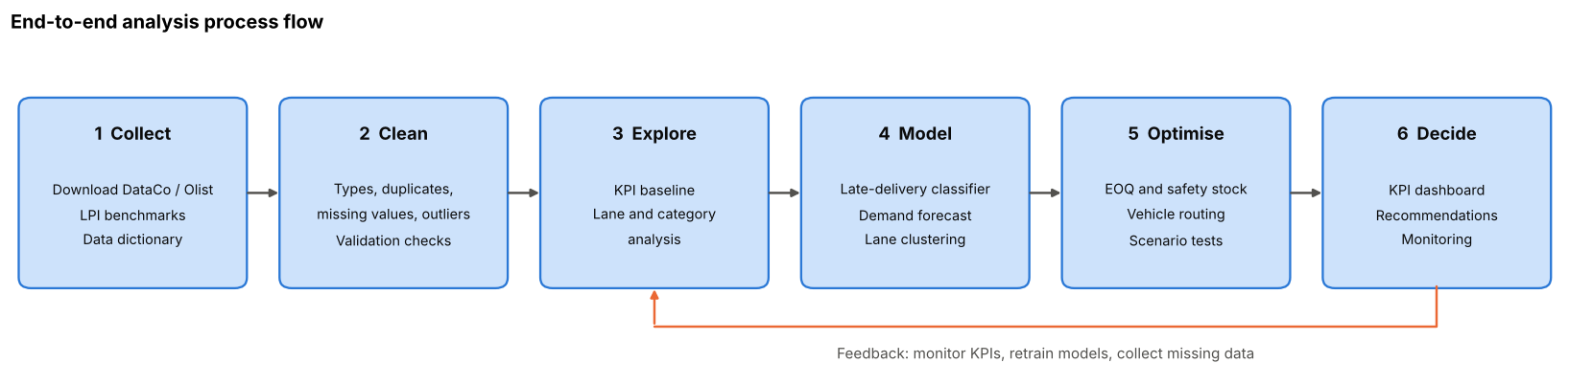

5.1 Pipeline pseudocode
The whole project is organised as one pipeline. Each function is implemented in Section 6.
def run_pipeline(data_path):
raw = load_data(data_path) # 1. collect (Section 6.1)
orders = clean_orders(raw) # 2. clean (Section 6.2)
baseline = kpi_table(orders) # 3. explore (Sections 6.3, 6.4)
late_model, auc = train_late_delivery_model(orders) # 4. model (Section 6.5)
forecast, wape = backtest_demand(orders) # (Section 6.6)
lanes = cluster_lanes(orders) # (Section 6.7)
stock_policy = eoq_and_safety_stock(orders) # 5. optimise (Section 6.8)
routes = solve_cvrp(stops, demands, fleet) # (Section 6.8)
return build_dashboard(baseline, late_model, forecast, lanes, stock_policy, routes) # 6. decide

5.2 Phase plan
Phase | Key activities | Python tools | Output | Indicative timing
Plan | Define scenario, KPIs, data sources (this report) | markdown, pandas | Strategic planning report | Week 1
1 Collect | Download the datasets, write a data dictionary, check licences and size | pandas, requests | Raw files and data dictionary | Week 2
2 Clean | Standardise names and types, remove cancelled orders and duplicates, handle missing values, validate against the dataset's own flags | pandas | Clean analysis table and a data-quality log | Week 2
3 Explore | Compute the KPI baseline, late rate by lane, category and month, correlation checks | pandas, matplotlib, seaborn | Baseline KPI table and charts | Week 3
4 Model | Train and compare the late-delivery classifiers, forecast demand against baselines, cluster lanes | scikit-learn | Models with validation metrics | Weeks 4-5
5 Optimise | Compute EOQ, safety stock and reorder points, solve a capacitated routing problem | numpy, OR-Tools | Stock policy and route plan | Week 6
6 Decide | Build the KPI dashboard and write recommendations | matplotlib, Jupyter | Final report and dashboard | Week 7

5.3 Feasibility and risks
The approach is feasible with free tools: all libraries are open source, the primary dataset is public, and a 100,000-row table runs comfortably on a laptop.
Risk | Effect | Mitigation
Target leakage, such as using actual shipping days to predict lateness | Unrealistically good model scores | Use only fields known when the order is placed; split train and test by date
Class imbalance between on-time and late orders | Models that ignore the minority class | Use class weights and report precision, recall and ROC-AUC rather than accuracy alone
Missing inventory, cost and route data | The inventory and routing steps rest on assumptions | State every assumption, replace with company data when available, run sensitivity checks
Seasonality and drift | Models become stale | Time-based validation, regular retraining, monitor the KPIs
Single-company data | Findings may not generalise | Validate on a second dataset such as Olist

6. Python code illustrations
These sections show how each phase will be carried out. Everything here runs end to end.
Data note. The code expects the public DataCo file (DataCoSupplyChainDataset.csv, from Mendeley Data or Kaggle) next to this notebook, using the dataset's own column names. If the file is not found, the notebook generates a small illustrative sample with the same columns so that every cell still runs. Numbers printed from the sample show that the code works; they are not findings about real logistics performance. Drop in the real file and re-run to get real results.

6.1 Phase 1: data acquisition
DATA_PATH = "DataCoSupplyChainDataset.csv" # <- the public DataCo file goes here
def make_sample_dataco(n=20000, seed=7):
# Illustrative sample with the same column names as the DataCo file. Not real data.
rng = np.random.default_rng(seed)
sched = {"Standard Class": 4, "Second Class": 2, "First Class": 1, "Same Day": 0}
modes = list(sched)
mode_extra = {"Standard Class": 0.7, "Second Class": 1.0, "First Class": 0.6, "Same Day": 0.35}
region_factor = {"Western Europe": 0.8, "Central America": 1.0, "South America": 1.15, "Oceania": 1.3,
"Southeast Asia": 1.25, "South Asia": 1.2, "Eastern US": 0.7, "Western US": 0.85}
catalog = {"Cleats": 60, "Men's Footwear": 110, "Women's Apparel": 45,
"Indoor/Outdoor Games": 80, "Fishing": 150, "Camping & Hiking": 95}
cats = list(catalog)
days = pd.date_range("2015-01-01", "2017-12-31")
month_w = {1: .8, 2: .85, 3: .95, 4: 1.0, 5: 1.0, 6: 1.0, 7: .95, 8: .95, 9: 1.0, 10: 1.1, 11: 1.5, 12: 1.7}
w = np.array([month_w[d.month] * (1 + 0.1 * (d.year - 2015)) for d in days])
dates = pd.to_datetime(rng.choice(days.to_numpy(), n, p=w / w.sum()))
mode = rng.choice(modes, n, p=[0.60, 0.20, 0.15, 0.05])
region = rng.choice(list(region_factor), n)
cat = rng.choice(cats, n, p=[.16, .20, .22, .14, .12, .16])
segment = rng.choice(["Consumer", "Corporate", "Home Office"], n, p=[.52, .30, .18])
qty = rng.integers(1, 6, n)
price = np.array([catalog[c] for c in cat]) * rng.uniform(0.85, 1.15, n)
sales = (qty * price).round(2)
profit = (sales * rng.normal(0.12, 0.18, n)).round(2)
scheduled = np.array([sched[m] for m in mode])
peak = np.where(np.isin(dates.month, [11, 12]), 1.4, 1.0)
lam = np.array([mode_extra[m] for m in mode]) * np.array([region_factor[r] for r in region]) * peak
early = rng.binomial(1, 0.12, n) * (scheduled > 0)
actual = np.maximum(0, scheduled + rng.poisson(lam) - early)
status = np.where(actual > scheduled, "Late delivery", np.where(actual < scheduled, "Advance shipping", "Shipping on time"))
return pd.DataFrame({
"Order Id": np.arange(1, n + 1), "order date (DateOrders)": dates,
"Shipping Mode": mode, "Days for shipment (scheduled)": scheduled, "Days for shipping (real)": actual,
"Late_delivery_risk": (actual > scheduled).astype(int), "Delivery Status": status,
"Order Region": region, "Category Name": cat, "Customer Segment": segment,
"Order Item Quantity": qty, "Sales": sales, "Order Profit Per Order": profit,
})
if Path(DATA_PATH).exists():
try:
raw = pd.read_csv(DATA_PATH)
except UnicodeDecodeError:
raw = pd.read_csv(DATA_PATH, encoding="latin-1") # the public DataCo file is latin-1 encoded
USING_SAMPLE = False
print(f"Loaded real file: {DATA_PATH}")
else:
raw = make_sample_dataco()
USING_SAMPLE = True
print(f"'{DATA_PATH}' not found -> using the ILLUSTRATIVE SAMPLE (not real logistics data).")
print(f"Raw table: {raw.shape[0]:,} rows x {raw.shape[1]} columns")
raw.head()
'DataCoSupplyChainDataset.csv' not found -> using the ILLUSTRATIVE SAMPLE (not real logistics data).
Raw table: 20,000 rows x 13 columns
Order Id order date (DateOrders) Shipping Mode \
0 1 2016-12-24 Standard Class
1 2 2017-10-20 First Class
2 3 2017-06-11 Standard Class
3 4 2015-10-30 Second Class
4 5 2015-12-29 Standard Class
Days for shipment (scheduled) Days for shipping (real) \
0 4 5
1 1 3
2 4 4
3 2 3
4 4 4
Late_delivery_risk Delivery Status Order Region Category Name \
0 1 Late delivery Southeast Asia Women's Apparel
1 1 Late delivery Western Europe Women's Apparel
2 0 Shipping on time Western Europe Fishing
3 1 Late delivery Oceania Women's Apparel
4 0 Shipping on time Central America Women's Apparel
Customer Segment Order Item Quantity Sales Order Profit Per Order
0 Consumer 4 190.50 25.20
1 Home Office 2 91.36 -11.17
2 Home Office 1 166.06 1.00
3 Home Office 3 148.78 27.28
4 Consumer 1 46.67 7.91

6.2 Phase 2: data cleaning and validation
KEEP = ["order_id", "order_date", "shipping_mode", "sched_days", "actual_days", "late_delivery_risk",
"delivery_status", "order_region", "category_name", "customer_segment",
"order_item_quantity", "sales", "order_profit_per_order"]
def clean_orders(raw):
d = raw.copy()
# 1. tidy column names: "Days for shipping (real)" -> days_for_shipping_real
d.columns = d.columns.str.strip().str.lower().str.replace(r"[^a-z0-9]+", "_", regex=True).str.strip("_")
d = d.rename(columns={"order_date_dateorders": "order_date",
"days_for_shipment_scheduled": "sched_days",
"days_for_shipping_real": "actual_days"})
missing = [c for c in KEEP if c not in d.columns]
if missing:
raise KeyError(f"Columns not found: {missing}")
d = d[KEEP]
n_in = len(d)
# 2. types, missing values, cancelled orders, duplicates, invalid values
d["order_date"] = pd.to_datetime(d["order_date"], errors="coerce")
d = d.dropna(subset=["order_date", "sched_days", "actual_days"])
d = d[d["delivery_status"] != "Shipping canceled"]
d = d.drop_duplicates()
d = d[(d["sales"] > 0) & (d["order_item_quantity"] > 0)]
# 3. engineered fields used by every later step
d["delay_days"] = d["actual_days"] - d["sched_days"]
d["is_late"] = (d["delay_days"] > 0).astype(int)
d["order_month"] = d["order_date"].dt.month
d["order_weekday"] = d["order_date"].dt.dayofweek
d = d.sort_values("order_date").reset_index(drop=True)
# 4. validation: our lateness flag should agree with the dataset's own flag
agree = (d["is_late"] == d["late_delivery_risk"]).mean()
print(f"Rows in: {n_in:,} | rows out: {len(d):,} | removed: {n_in - len(d):,}")
print(f"Date range: {d['order_date'].min():%d %b %Y} to {d['order_date'].max():%d %b %Y}")
print(f"Agreement between is_late and Late_delivery_risk: {agree:.1%}")
print(f"Remaining null values: {int(d.isna().sum().sum())}")
return d
orders = clean_orders(raw)
orders.head()
Rows in: 20,000 | rows out: 20,000 | removed: 0
Date range: 01 Jan 2015 to 31 Dec 2017
Agreement between is_late and Late_delivery_risk: 100.0%
Remaining null values: 0
order_id order_date shipping_mode sched_days actual_days \
0 13495 2015-01-01 Standard Class 4 5
1 9777 2015-01-01 Standard Class 4 4
2 12136 2015-01-01 Second Class 2 4
3 13904 2015-01-01 Same Day 0 0
4 8546 2015-01-01 Standard Class 4 5
late_delivery_risk delivery_status order_region category_name \
0 1 Late delivery South America Men's Footwear
1 0 Shipping on time South America Cleats
2 1 Late delivery Southeast Asia Women's Apparel
3 0 Shipping on time South Asia Indoor/Outdoor Games
4 1 Late delivery Western Europe Camping & Hiking
customer_segment order_item_quantity sales order_profit_per_order \
0 Corporate 2 234.74 6.75
1 Consumer 5 308.35 98.23
2 Consumer 4 189.16 -28.28
3 Corporate 4 290.90 -36.49
4 Home Office 1 103.05 10.71
delay_days is_late order_month order_weekday
0 1 1 1 3
1 0 0 1 3
2 2 1 1 3
3 0 0 1 3
4 1 1 1 3

6.3 Phase 3: KPI baseline
The first deliverable of the analysis is one table that everyone agrees on. The function below computes KPIs 1, 2 and 4 (Section 2) for any slice of the data, so the same code serves the overall view and every breakdown.
def kpi_table(d):
late = d[d["is_late"] == 1]
return pd.Series({
"Order lines": len(d),
"On-time delivery rate (%)": (1 - d["is_late"].mean()) * 100,
"Avg delay on late orders (days)": late["delay_days"].mean(),
"Avg actual lead time (days)": d["actual_days"].mean(),
"Revenue at risk (% of sales)": late["sales"].sum() / d["sales"].sum() * 100,
"Avg profit per order": d["order_profit_per_order"].mean(),
})
print("Overall KPI baseline")
display(kpi_table(orders).to_frame("value"))
by_mode = orders.groupby("shipping_mode").apply(kpi_table).sort_values("On-time delivery rate (%)")
by_region = orders.groupby("order_region").apply(kpi_table).sort_values("On-time delivery rate (%)")
print("By shipping mode")
display(by_mode)
fig, axes = plt.subplots(1, 2, figsize=(14, 4.6))
for ax, tbl, title in [(axes[0], by_mode, "Late-delivery rate by shipping mode"),
(axes[1], by_region, "Late-delivery rate by region")]:
late_rate = 100 - tbl["On-time delivery rate (%)"]
bars = ax.barh(late_rate.index, late_rate.values, color=BLUE, height=0.6)
ax.set_title(title)
ax.set_xlabel("% of orders delivered late")
ax.grid(axis="y", visible=False)
for b, v in zip(bars, late_rate.values):
ax.annotate(f"{v:.1f}%", (v, b.get_y() + b.get_height() / 2), xytext=(4, 0), textcoords="offset points",
va="center", fontsize=9, color=MUTED)
ax.set_xlim(0, late_rate.max() * 1.15)
plt.tight_layout()
plt.show()
Overall KPI baseline
value
Order lines 20,000.00
On-time delivery rate (%) 49.44
Avg delay on late orders (days) 1.52
Avg actual lead time (days) 3.65
Revenue at risk (% of sales) 50.29
Avg profit per order 31.48
By shipping mode
Order lines On-time delivery rate (%) \
shipping_mode
Second Class 4,010.00 36.33
Standard Class 11,934.00 50.85
First Class 2,993.00 54.96
Same Day 1,063.00 67.45
Avg delay on late orders (days) Avg actual lead time (days) \
shipping_mode
Second Class 1.70 3.04
Standard Class 1.48 4.67
First Class 1.39 1.57
Same Day 1.22 0.40
Revenue at risk (% of sales) Avg profit per order
shipping_mode
Second Class 63.55 32.05
Standard Class 48.97 31.29
First Class 44.29 32.45
Same Day 31.47 28.87
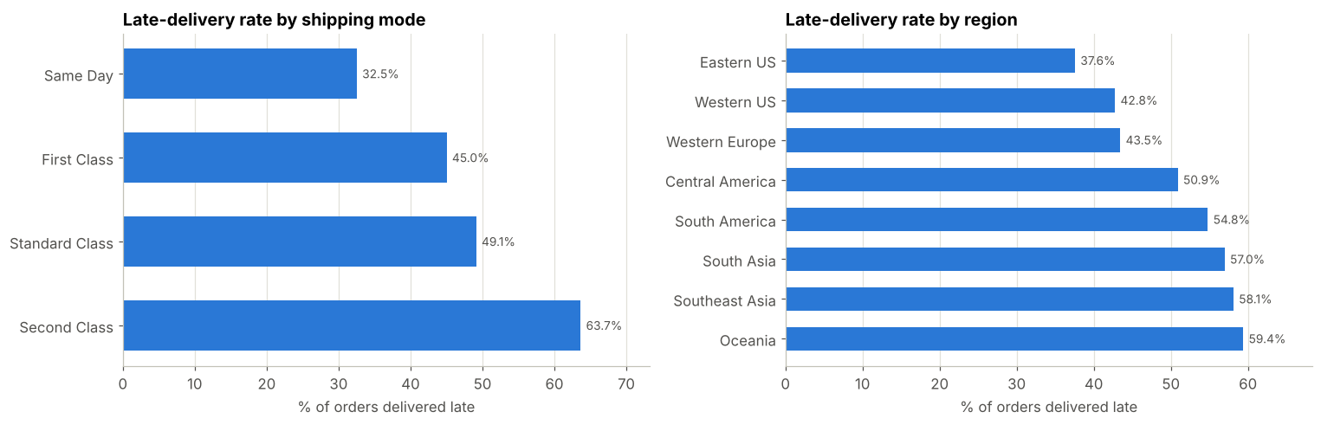
How this feeds the plan: the overall row is KPI 1, 2 and 4; the breakdowns show where to act first. With the real DataCo file, the hypothesis from Section 3.2 (Standard Class is the least reliable mode) can be confirmed or rejected right here.

6.4 Phase 3: exploratory analysis of lanes and seasonality
mode_order = ["Same Day", "First Class", "Second Class", "Standard Class"]
mode_order = [m for m in mode_order if m in orders["shipping_mode"].unique()]
lane_rate = (orders.pivot_table(index="order_region", columns="shipping_mode", values="is_late", aggfunc="mean")[mode_order] * 100)
monthly_late = orders.set_index("order_date")["is_late"].resample("MS").mean() * 100
fig, axes = plt.subplots(1, 2, figsize=(15, 5), gridspec_kw={"width_ratios": [1.1, 1.3]})
sns.heatmap(lane_rate, annot=True, fmt=".0f", cmap=SEQ, linewidths=2, linecolor="white",
cbar_kws={"label": "% late"}, ax=axes[0])
axes[0].set_title("Late-delivery rate by region and shipping mode (%)")
axes[0].set_xlabel(""); axes[0].set_ylabel("")
axes[0].tick_params(axis="x", rotation=20)
axes[0].grid(False)
axes[1].plot(monthly_late.index, monthly_late.values, color=BLUE, lw=2, marker="o", ms=4)
axes[1].set_title("Late-delivery rate by month")
axes[1].set_ylabel("% of orders late")
axes[1].yaxis.set_major_formatter(mtick.PercentFormatter(decimals=0))
peak = monthly_late.idxmax()
axes[1].annotate(f"Peak: {peak:%b %Y}", (peak, monthly_late.max()), xytext=(-85, -4), textcoords="offset points",
fontsize=10, color=INK, arrowprops=dict(arrowstyle="-", color=MUTED))
plt.tight_layout()
plt.show()
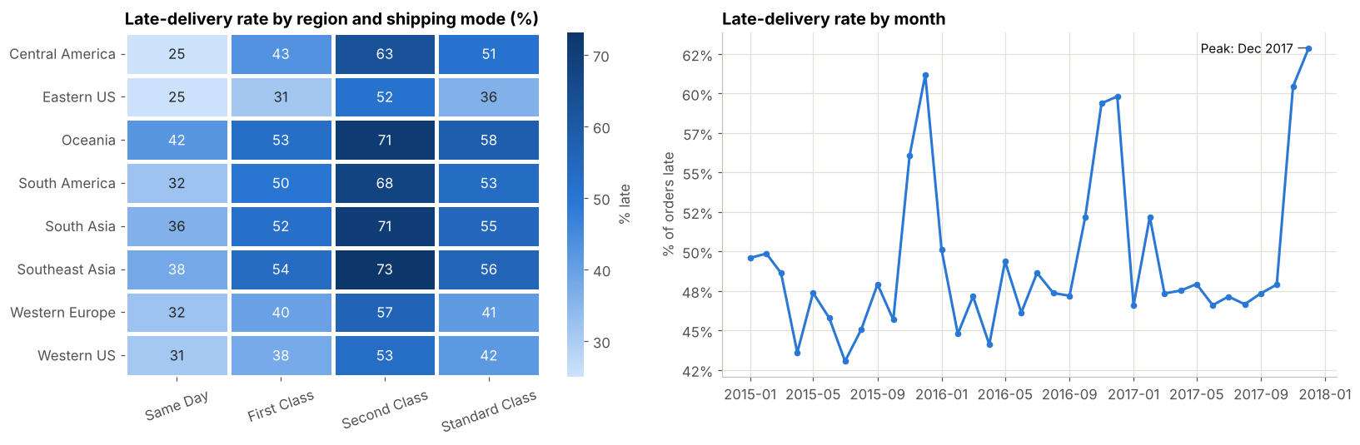
How this feeds the plan: the heatmap identifies problem lanes (Objective O2) and the monthly line shows whether lateness follows the seasonal demand peak, which would argue for seasonal capacity planning rather than a permanent fix.

6.5 Phase 4: predicting late deliveries (classification)
The business question is "Is this order likely to be late?" at the moment it is placed. Two rules keep the model honest:
- Avoid leakage. actual_days, delay_days and delivery_status are only known after delivery, so they are excluded from the features.
- Split by time. The model is trained on the earlier 80% of orders and tested on the latest 20%, as it would be used in practice.
from sklearn.compose import ColumnTransformer
from sklearn.ensemble import RandomForestClassifier
from sklearn.linear_model import LogisticRegression
from sklearn.metrics import precision_score, recall_score, roc_auc_score, roc_curve
from sklearn.pipeline import Pipeline
from sklearn.preprocessing import OneHotEncoder, StandardScaler
CAT_FEATURES = ["shipping_mode", "order_region", "category_name", "customer_segment"]
NUM_FEATURES = ["sched_days", "order_item_quantity", "sales", "order_month", "order_weekday"]
# Deliberately NOT used (leakage): actual_days, delay_days, delivery_status, late_delivery_risk
split = int(len(orders) * 0.8) # orders are already sorted by date
train, test = orders.iloc[:split], orders.iloc[split:]
X_train, y_train = train[CAT_FEATURES + NUM_FEATURES], train["is_late"]
X_test, y_test = test[CAT_FEATURES + NUM_FEATURES], test["is_late"]
prep = ColumnTransformer([("cat", OneHotEncoder(handle_unknown="ignore"), CAT_FEATURES),
("num", StandardScaler(), NUM_FEATURES)])
models = {
"Logistic regression": LogisticRegression(max_iter=1000, class_weight="balanced"),
"Random forest": RandomForestClassifier(n_estimators=200, max_depth=10, min_samples_leaf=20,
class_weight="balanced", n_jobs=-1, random_state=42),
}
results, curves, fitted = [], {}, {}
for name, clf in models.items():
pipe = Pipeline([("prep", prep), ("model", clf)]).fit(X_train, y_train)
proba = pipe.predict_proba(X_test)[:, 1]
pred = (proba >= 0.5).astype(int)
results.append({"model": name, "ROC-AUC": roc_auc_score(y_test, proba),
"precision": precision_score(y_test, pred), "recall": recall_score(y_test, pred)})
curves[name] = roc_curve(y_test, proba)[:2]
fitted[name] = pipe
print(f"Train: {len(train):,} orders | Test: {len(test):,} orders | share of late orders in test set: {y_test.mean():.1%}")
display(pd.DataFrame(results).set_index("model"))
# Which inputs matter most? Sum the random-forest importances back onto the original features
rf = fitted["Random forest"]
names = rf.named_steps["prep"].get_feature_names_out()
imp = pd.Series(rf.named_steps["model"].feature_importances_, index=names)
imp.index = [n.split("__")[1].rsplit("_", 1)[0] if n.startswith("cat__") else n.split("__")[1] for n in imp.index]
imp = imp.groupby(level=0).sum().sort_values(ascending=True)
fig, axes = plt.subplots(1, 2, figsize=(14, 4.6))
for (name, (fpr, tpr)), color in zip(curves.items(), [BLUE, ORANGE]):
axes[0].plot(fpr, tpr, color=color, lw=2, label=name)
axes[0].plot([0, 1], [0, 1], color=MUTED, lw=1, ls="--")
axes[0].set_title("ROC curve on the held-out latest 20% of orders")
axes[0].set_xlabel("False positive rate"); axes[0].set_ylabel("True positive rate")
axes[0].legend(frameon=False, loc="lower right")
bars = axes[1].barh(imp.index, imp.values, color=BLUE, height=0.6)
axes[1].set_title("What drives late-delivery risk (random forest)")
axes[1].set_xlabel("Share of total importance")
axes[1].grid(axis="y", visible=False)
for b, v in zip(bars, imp.values):
axes[1].annotate(f"{v:.2f}", (v, b.get_y() + b.get_height() / 2), xytext=(4, 0), textcoords="offset points",
va="center", fontsize=9, color=MUTED)
axes[1].set_xlim(0, imp.max() * 1.15)
plt.tight_layout()
plt.show()
Train: 16,000 orders | Test: 4,000 orders | share of late orders in test set: 53.8%
ROC-AUC precision recall
model
Logistic regression 0.63 0.61 0.72
Random forest 0.64 0.61 0.69
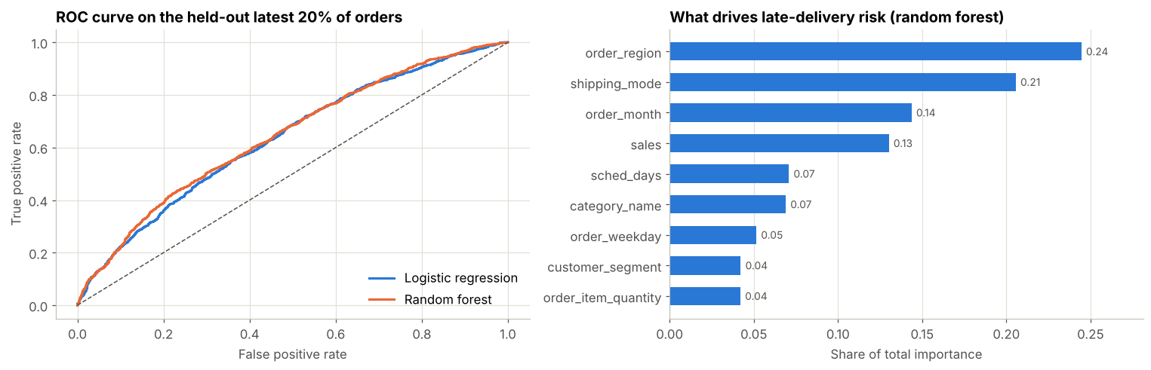
How this feeds the plan: the classifier turns the diagnosis into an early-warning score for Customer Service (late-risk orders can be expedited or the customer warned). The importance chart tells Operations which levers matter. Comparing the logistic baseline with the random forest shows whether the extra complexity is justified.

6.6 Phase 4: forecasting demand (regression)
Weekly demand is forecast from its own recent history (lags and a 4-week average) plus an annual seasonal cycle. As recommended in the forecasting literature, the model must beat two simple baselines: the naive forecast (last week repeats) and a 4-week moving average. Accuracy is measured with WAPE (KPI 3).
from sklearn.linear_model import Ridge
weekly = (orders.pivot_table(index=pd.Grouper(key="order_date", freq="W"), columns="category_name",
values="order_item_quantity", aggfunc="sum").fillna(0).iloc[1:-1]) # drop partial first/last week
weekly_total = weekly.sum(axis=1)
def make_features(series):
f = pd.DataFrame({"y": series})
for lag in (1, 2, 3, 4):
f[f"lag_{lag}"] = f["y"].shift(lag)
f["roll_4"] = f["y"].shift(1).rolling(4).mean()
week = f.index.isocalendar().week.astype(int).to_numpy()
f["sin_52"] = np.sin(2 * np.pi * week / 52)
f["cos_52"] = np.cos(2 * np.pi * week / 52)
return f.dropna()
def backtest(series, test_frac=0.2):
f = make_features(series)
cut = int(len(f) * (1 - test_frac))
train_f, test_f = f.iloc[:cut], f.iloc[cut:]
cols = [c for c in f.columns if c != "y"]
pred = pd.Series(Ridge(alpha=1.0).fit(train_f[cols], train_f["y"]).predict(test_f[cols]), index=test_f.index)
return test_f["y"], pred, test_f["lag_1"], test_f["roll_4"]
wape = lambda actual, fc: np.abs(actual - fc).sum() / actual.sum() * 100
rows = []
for name, series in [("ALL CATEGORIES", weekly_total)] + [(c, weekly[c]) for c in weekly.columns]:
a, p, naive, ma4 = backtest(series)
rows.append({"series": name, "naive WAPE %": wape(a, naive), "4-wk average WAPE %": wape(a, ma4), "Ridge WAPE %": wape(a, p)})
display(pd.DataFrame(rows).set_index("series"))
a, p, naive, ma4 = backtest(weekly_total)
fig, ax = plt.subplots(figsize=(13, 4.6))
ax.plot(a.index, a.values, color=INK, lw=2, label="Actual")
ax.plot(p.index, p.values, color=BLUE, lw=2, label="Ridge forecast")
ax.plot(naive.index, naive.values, color=ORANGE, lw=1.4, ls="--", label="Naive baseline")
ax.set_title("Weekly demand: last 20% of weeks (held-out test period)")
ax.set_ylabel("Units per week")
ax.legend(frameon=False, ncol=3, loc="upper left")
plt.tight_layout()
plt.show()
naive WAPE % 4-wk average WAPE % Ridge WAPE %
series
ALL CATEGORIES 12.57 9.54 11.13
Camping & Hiking 26.47 20.74 20.90
Cleats 22.86 17.85 20.91
Fishing 33.47 25.98 25.33
Indoor/Outdoor Games 29.93 23.04 25.73
Men's Footwear 24.97 17.56 20.37
Women's Apparel 18.31 13.87 16.80
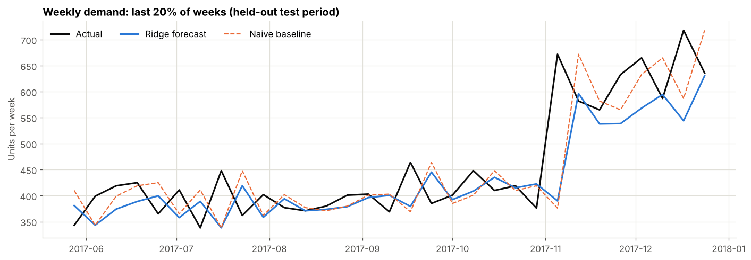
How this feeds the plan: the table is KPI 3 per category. A category is "forecastable" when the Ridge model clearly beats both baselines; categories where it does not need a different method or more data. The forecasts also supply the demand inputs for the inventory policy in 6.8.

6.7 Phase 4: grouping lanes (clustering)
A lane is one region x shipping-mode combination. Instead of managing dozens of lanes one by one, k-means groups lanes with similar behaviour so that each group gets one action plan. The number of groups is chosen with the silhouette score.
from sklearn.cluster import KMeans
from sklearn.metrics import silhouette_score
lanes = (orders.groupby(["order_region", "shipping_mode"])
.agg(orders=("order_id", "count"), late_rate=("is_late", "mean"),
avg_delay=("delay_days", "mean"), avg_sales=("sales", "mean"))
.reset_index())
lane_X = StandardScaler().fit_transform(lanes[["late_rate", "avg_delay", "avg_sales", "orders"]])
scores = {k: silhouette_score(lane_X, KMeans(k, n_init=10, random_state=42).fit_predict(lane_X)) for k in range(2, 6)}
best_k = max(scores, key=scores.get)
print("Silhouette by k:", {k: round(v, 3) for k, v in scores.items()}, "-> chosen k =", best_k)
lanes["cluster"] = KMeans(best_k, n_init=10, random_state=42).fit_predict(lane_X)
summary = lanes.groupby("cluster").agg(lanes=("cluster", "size"), orders=("orders", "sum"), late_rate=("late_rate", "mean"),
avg_delay=("avg_delay", "mean"), avg_sales=("avg_sales", "mean")).round(2)
display(summary)
fig, ax = plt.subplots(figsize=(8.5, 5))
for c in sorted(lanes["cluster"].unique()):
s = lanes[lanes["cluster"] == c]
ax.scatter(s["late_rate"] * 100, s["avg_delay"], s=s["orders"] / s["orders"].max() * 400 + 30,
color=CATEGORICAL[c % len(CATEGORICAL)], edgecolor="white", linewidth=1.5, label=f"Cluster {c}")
ax.set_xlabel("Late-delivery rate (%)"); ax.set_ylabel("Average delay (days, all orders)")
ax.set_title("Lane clusters (bubble size = order volume)")
leg = ax.legend(frameon=False)
for h in leg.legend_handles:
h.set_sizes([70]) # same marker size in the legend, so it is not mistaken for volume
plt.tight_layout()
plt.show()
Silhouette by k: {2: 0.297, 3: 0.385, 4: 0.42, 5: 0.439} -> chosen k = 5
lanes orders late_rate avg_delay avg_sales
cluster
0 5 2569 0.69 1.21 257.82
1 7 1411 0.31 0.36 267.18
2 9 3690 0.50 0.67 260.70
3 8 11934 0.49 0.67 257.81
4 3 396 0.38 0.46 243.74
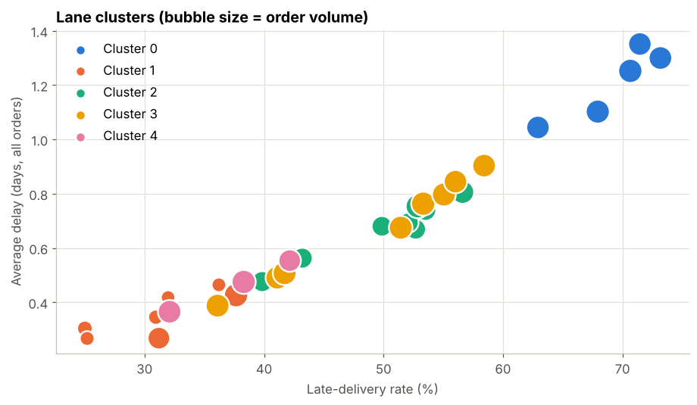
How this feeds the plan: each cluster is read from the summary table and given an action, for example "high late rate and high volume" lanes get carrier reviews first, while "reliable" lanes are left alone. Section 2's KPIs 1 and 2 are tracked per cluster.

6.8 Phase 5: optimisation (inventory policy and vehicle routing)
Inventory. For each category, the EOQ formula gives the order size that minimises ordering plus holding cost, and a safety-stock buffer protects against demand variability during the replenishment lead time:
- EOQ = sqrt(2 x D x S / H), where D is annual demand, S the cost per order and H the annual holding cost per unit
- Safety stock = z x sigma_weekly x sqrt(L), with z from the target service level and L the lead time in weeks
- Reorder point = mean weekly demand x L + safety stock
DataCo has no inventory or cost data, so the parameters below are placeholder assumptions to be replaced with company figures.
ASSUMPTIONS = {
"order_cost": 75.0, # S: fixed cost of placing one replenishment order
"holding_rate": 0.20, # H = 20% of unit cost per year
"unit_cost_ratio": 0.60, # unit cost = 60% of the average selling price
"lead_time_weeks": 2, # L
"z": 1.645, # 95% cycle service level
}
price = orders.groupby("category_name").apply(lambda g: g["sales"].sum() / g["order_item_quantity"].sum())
policy = pd.DataFrame({
"avg_weekly_demand": weekly.mean(),
"weekly_std": weekly.std(),
"avg_price": price,
})
policy["annual_demand"] = policy["avg_weekly_demand"] * 52
policy["holding_cost_per_unit"] = ASSUMPTIONS["holding_rate"] * ASSUMPTIONS["unit_cost_ratio"] * policy["avg_price"]
policy["EOQ"] = np.sqrt(2 * policy["annual_demand"] * ASSUMPTIONS["order_cost"] / policy["holding_cost_per_unit"])
policy["safety_stock"] = ASSUMPTIONS["z"] * policy["weekly_std"] * np.sqrt(ASSUMPTIONS["lead_time_weeks"])
policy["reorder_point"] = policy["avg_weekly_demand"] * ASSUMPTIONS["lead_time_weeks"] + policy["safety_stock"]
display(policy[["avg_weekly_demand", "weekly_std", "EOQ", "safety_stock", "reorder_point"]].round(0).astype(int))
avg_weekly_demand weekly_std EOQ safety_stock \
category_name
Camping & Hiking 61 22 205 50
Cleats 61 21 258 49
Fishing 46 17 141 39
Indoor/Outdoor Games 54 20 209 46
Men's Footwear 77 23 214 54
Women's Apparel 84 28 347 65
reorder_point
category_name
Camping & Hiking 173
Cleats 171
Fishing 132
Indoor/Outdoor Games 154
Men's Footwear 209
Women's Apparel 232
Routing. A capacitated vehicle routing problem (CVRP) asks: given a depot, customer stops with demands, and vehicles with limited capacity, which routes minimise total distance? The toy example below follows the OR-Tools structure (data model, distance callback, capacity dimension, search parameters) and compares the result with a naive plan in which every customer gets its own round trip. KPI 6 (Route Distance Saved) is computed from this comparison. The coordinates are random and only illustrate the method.
try:
from ortools.constraint_solver import pywrapcp, routing_enums_pb2
HAS_ORTOOLS = True
except ImportError:
HAS_ORTOOLS = False
print("OR-Tools not installed. Run: pip install ortools")
def solve_cvrp(coords, demands, n_vehicles, capacity, seconds=2):
n = len(coords)
dist_km = np.sqrt(((coords[:, None, :] - coords[None, :, :]) ** 2).sum(-1))
dist_m = np.rint(dist_km * 1000).astype(int) # OR-Tools needs integer costs
manager = pywrapcp.RoutingIndexManager(n, n_vehicles, 0) # node 0 = depot
routing = pywrapcp.RoutingModel(manager)
transit = routing.RegisterTransitCallback(lambda i, j: int(dist_m[manager.IndexToNode(i), manager.IndexToNode(j)]))
routing.SetArcCostEvaluatorOfAllVehicles(transit)
load = routing.RegisterUnaryTransitCallback(lambda i: int(demands[manager.IndexToNode(i)]))
routing.AddDimensionWithVehicleCapacity(load, 0, [capacity] * n_vehicles, True, "Capacity")
params = pywrapcp.DefaultRoutingSearchParameters()
params.first_solution_strategy = routing_enums_pb2.FirstSolutionStrategy.PATH_CHEAPEST_ARC
params.local_search_metaheuristic = routing_enums_pb2.LocalSearchMetaheuristic.GUIDED_LOCAL_SEARCH
params.time_limit.seconds = seconds
solution = routing.SolveWithParameters(params)
if solution is None:
return None, None
routes, total = [], 0.0
for v in range(n_vehicles):
idx, route = routing.Start(v), [0]
while not routing.IsEnd(idx):
nxt = solution.Value(routing.NextVar(idx))
total += dist_km[manager.IndexToNode(idx), manager.IndexToNode(nxt)]
idx = nxt
route.append(manager.IndexToNode(idx))
if len(route) > 2:
routes.append(route)
return routes, total
if HAS_ORTOOLS:
rng = np.random.default_rng(3)
n_customers = 12
coords = np.vstack([[25, 25], rng.uniform(0, 50, (n_customers, 2))]) # depot in the middle of a 50 x 50 km area
demands = np.r_[0, rng.integers(1, 6, n_customers)]
routes, total_km = solve_cvrp(coords, demands, n_vehicles=3, capacity=15)
naive_km = 2 * np.sqrt(((coords[1:] - coords[0]) ** 2).sum(1)).sum() # one round trip per customer
print(f"Customers: {n_customers} | total demand: {demands.sum()} | vehicle capacity: 15 x 3 vehicles")
print(f"Naive plan (one trip per customer): {naive_km:,.1f} km")
print(f"Optimised plan ({len(routes)} routes): {total_km:,.1f} km -> distance saved: {(1 - total_km / naive_km) * 100:.0f}%")
fig, ax = plt.subplots(figsize=(7.5, 6))
for r, color in zip(routes, CATEGORICAL):
ax.plot(coords[r, 0], coords[r, 1], color=color, lw=2, marker="o", ms=6, label=f"Vehicle load {demands[r].sum()}")
for i in range(1, len(coords)):
ax.annotate(str(i), coords[i], xytext=(5, 5), textcoords="offset points", fontsize=9, color=MUTED)
ax.scatter(*coords[0], marker="s", s=120, color=INK, zorder=3, label="Depot")
ax.set_title("Optimised delivery routes (toy example)")
ax.set_xlabel("km"); ax.set_ylabel("km")
ax.legend(frameon=False, loc="upper left", bbox_to_anchor=(1.0, 1.0))
plt.tight_layout()
plt.show()
Customers: 12 | total demand: 33 | vehicle capacity: 15 x 3 vehicles
Naive plan (one trip per customer): 425.2 km
Optimised plan (3 routes): 207.4 km -> distance saved: 51%
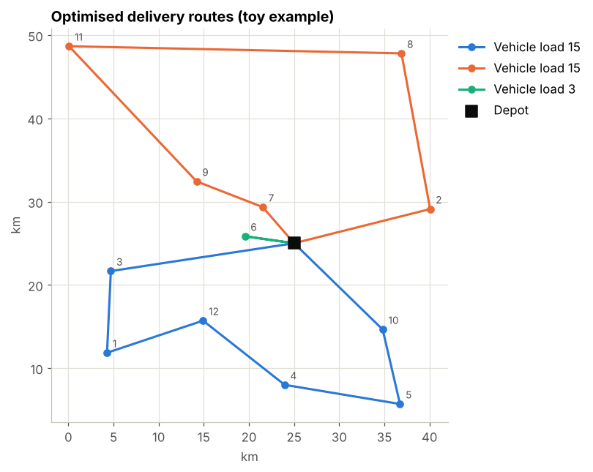
How this feeds the plan: the inventory table gives planners an order quantity and reorder point per category (KPI 5), and the routing example shows how KPI 6 will be measured. In the full project the toy coordinates are replaced by real delivery locations, for example from the Olist geolocation table.

7. Expected outcomes and impact on decision-making
Decision | Analytical input | Expected effect
Which shipping modes and regions need carrier or process fixes first? | Lane heatmap, lane clusters, KPI baseline (6.3 to 6.4, 6.7) | Effort focuses on the lanes that cause most late orders, which should raise OTD and cut average delay
Which orders deserve proactive action (expedite, notify the customer)? | Late-delivery risk score and its drivers (6.5) | Fewer unpleasant surprises for customers and lower revenue at risk
How much to stock and when to reorder? | Weekly forecasts, EOQ, safety stock and reorder point (6.6, 6.8) | Fewer stockouts without carrying surplus inventory
How to assign deliveries to vehicles? | Capacity-constrained route optimisation (6.8) | Shorter total distance and lower transport cost per order
Is the programme working? | KPI dashboard tracked over time | Evidence for continuing, adjusting or stopping initiatives
What success looks like. The measurable targets in Section 2 (for example OTD of at least 95% and forecast WAPE of at most 20%) are proposals to be confirmed once the baseline is measured on the real data. The project is successful if it delivers (1) a trusted KPI baseline, (2) a late-delivery model that beats a simple baseline on held-out recent orders, (3) forecasts that beat the naive and moving-average benchmarks, and (4) an inventory and routing method that can be applied to company data.
Caveats. The analysis is descriptive and predictive, so it shows association, not proof of cause. Recommendations should be piloted (for example on one region) before a full rollout, and the missing inventory, cost and route data identified in Section 3.2 should be collected to replace the assumptions.

8. Conclusion
This report defined a realistic outbound-logistics scenario, six KPIs, and a plan that links each business problem to a suitable data science technique: classification for late-delivery risk, regression for demand forecasting, clustering for lane segmentation, and optimisation for inventory and routing. A six-phase roadmap, a pipeline outline, a risk table and working Python illustrations show that the approach is logical and feasible with free tools and public data.
The next step (Week 2) is to download the full DataCo file, run the cleaning and KPI steps from Sections 6.2 and 6.3 on real data, and write the first data-quality log. Because every illustration already uses the dataset's own column names, no code changes are needed beyond placing the file next to this notebook.

9. References
- Constante, F., Silva, F. & Pereira, A. (2019). DataCo Smart Supply Chain for Big Data Analysis, Version 5. Mendeley Data. DOI 10.17632/8gx2fvg2k6.5. https://data.mendeley.com/datasets/8gx2fvg2k6/5
- Olist. Brazilian E-Commerce Public Dataset by Olist. Kaggle. https://www.kaggle.com/datasets/olistbr/brazilian-ecommerce
- World Bank. Logistics Performance Index. https://lpi.worldbank.org
- Rodrigue, J.-P. The Geography of Transport Systems, Logistics Performance Index 2023 summary. https://transportgeography.org/contents/chapter7/logistics-freight-distribution/logistics-performance-index/
- Google. Vehicle Routing Problem, OR-Tools documentation. https://developers.google.com/optimization/routing/vrp
- Hyndman, R. J. & Athanasopoulos, G. Forecasting: Principles and Practice (3rd ed.). OTexts. https://otexts.com/fpp3/
- Harris, F. W. (1913). How many parts to make at once. Factory, The Magazine of Management, 10(2), 135-136.
- Dantzig, G. B. & Ramser, J. H. (1959). The truck dispatching problem. Management Science, 6(1), 80-91.
- Community exploratory analysis of the DataCo dataset (Medium). https://medium.com/@ansharahinayat/exploratory-data-analysis-dataco-smart-supply-chain-dataset-da6cc74c2bee

