Task 1: File Management System using Python

Objective
Develop a menu-driven File Management System that allows users to create, read, rename, move, delete, and list files using Python.

Tools Used
Python 3.14, VS Code, OS Module, Shutil Module

Features Implemented
- Create File
- Read File
- Rename File
- Move File
- Delete File
- List Files
- Exit Program

Working Demonstration
The program successfully created a file (Alfido.txt), read its contents, renamed it to AlfidoTech.txt, moved it to another folder, attempted deletion, listed files, and exited successfully.

Output Summary
1. File created successfully.
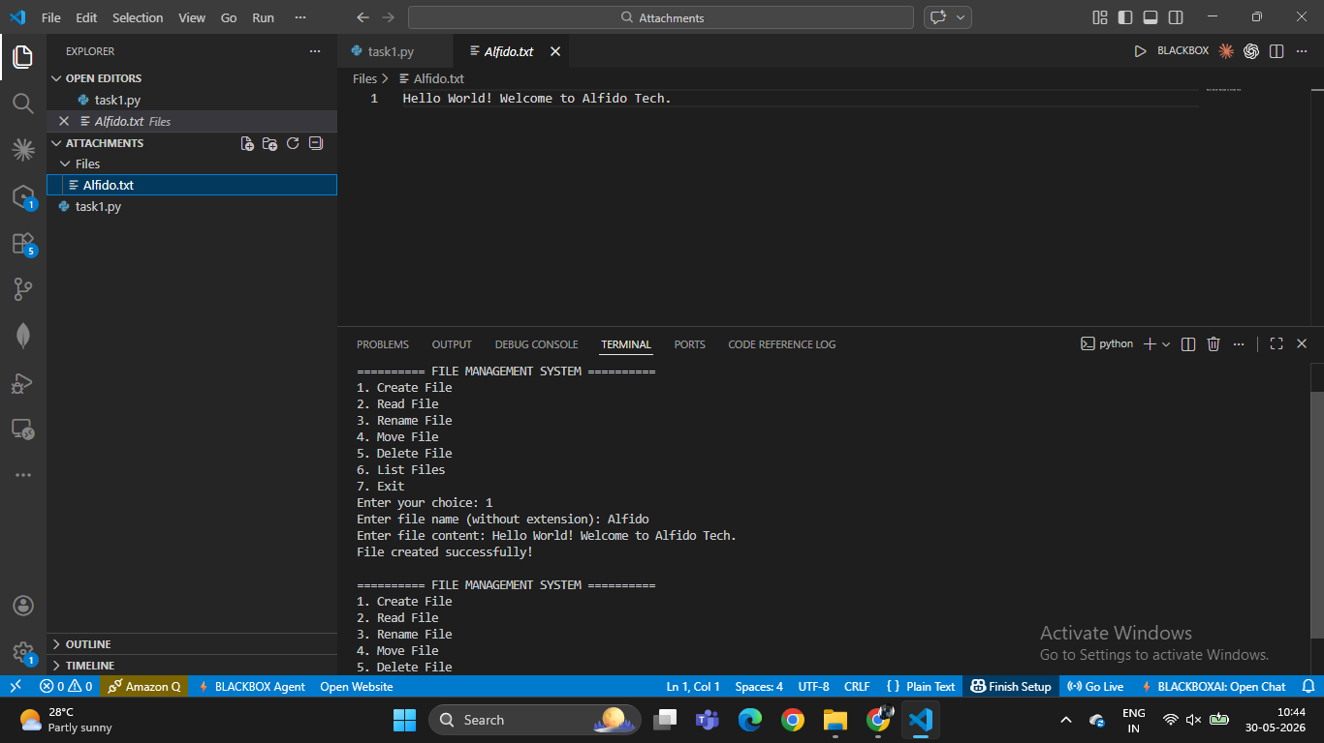
2. File content displayed correctly.
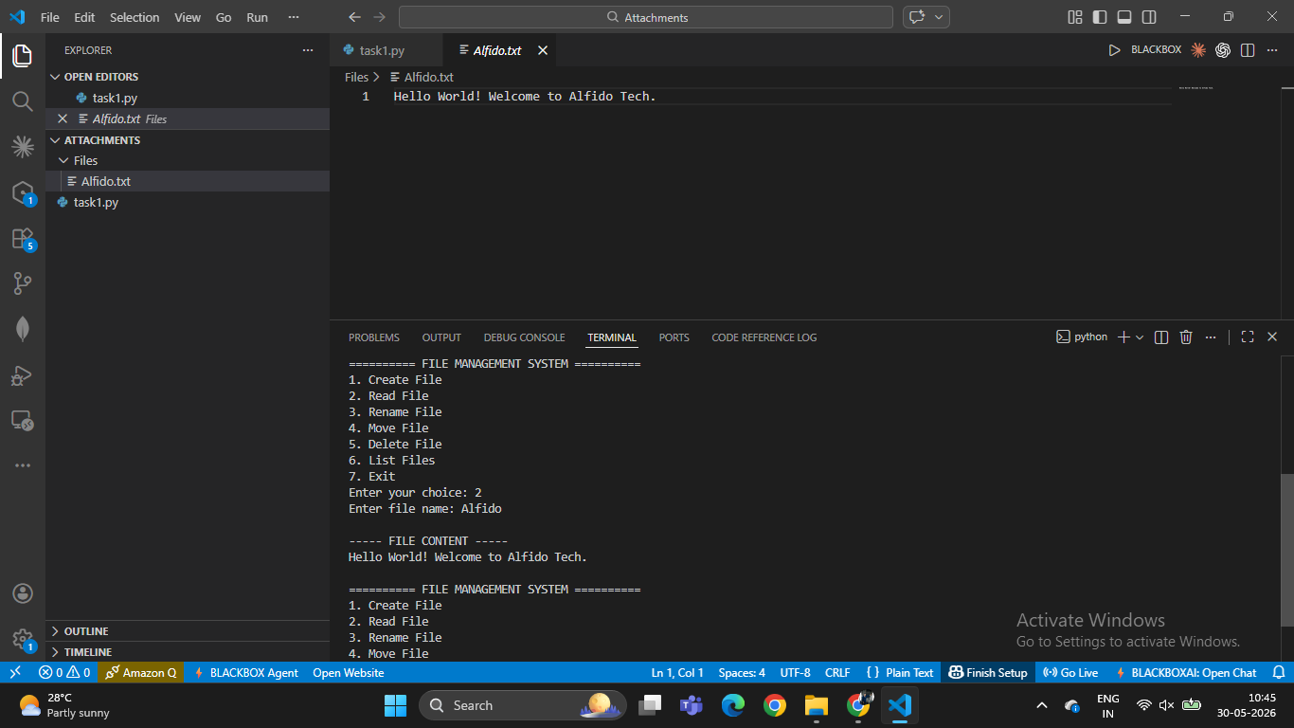

3. File renamed successfully.
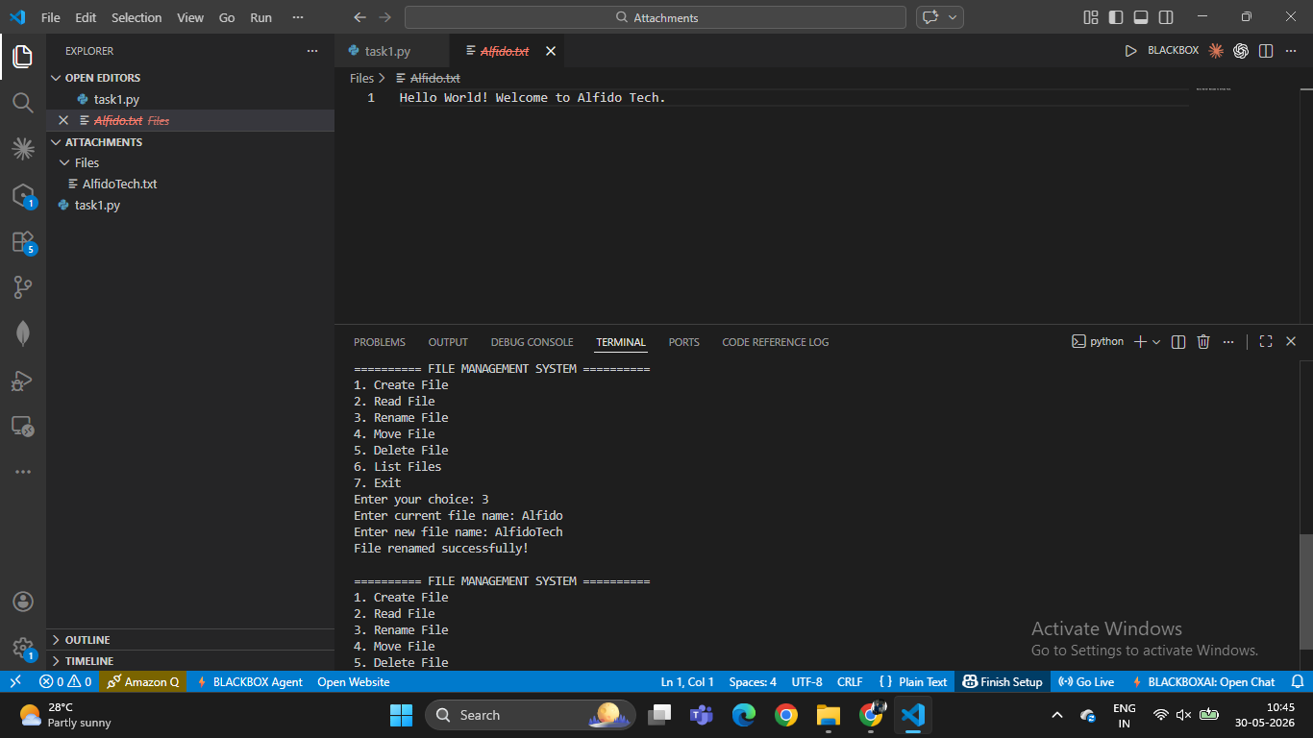
4. File moved successfully.
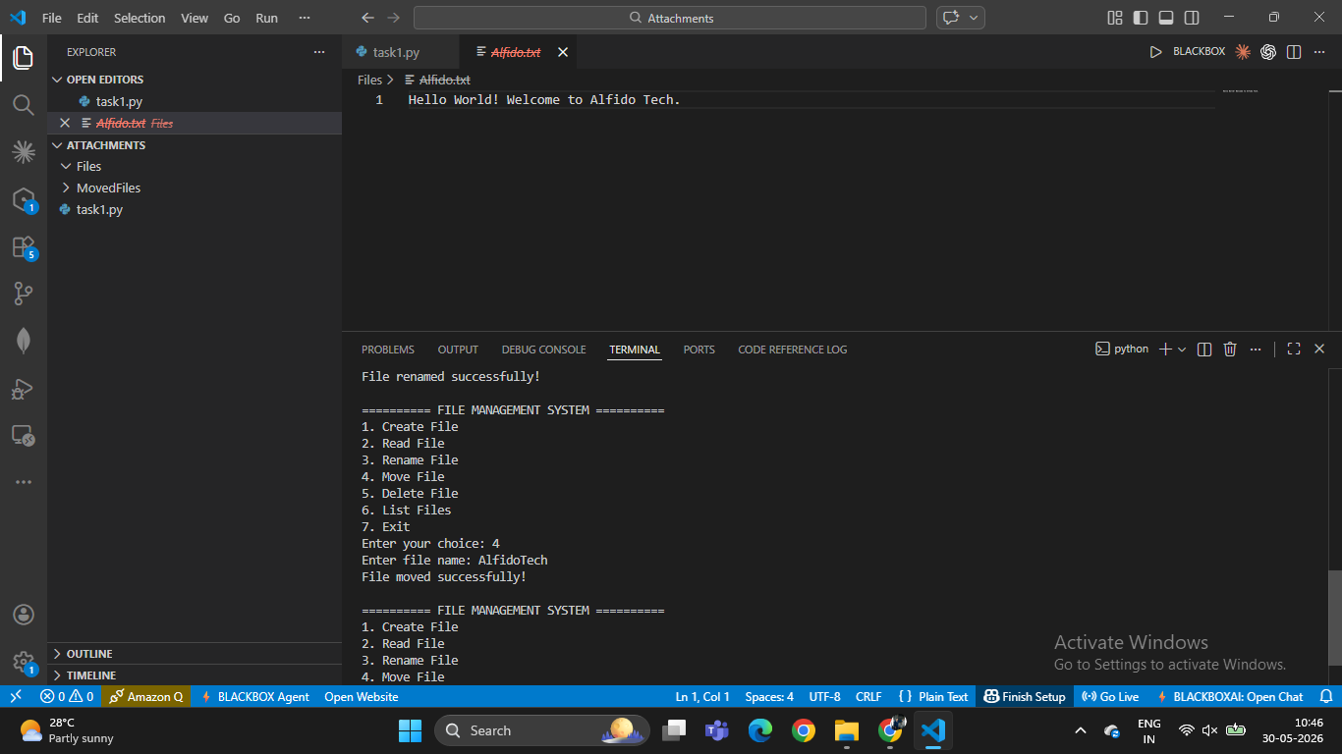

5. File Delete Successfully.
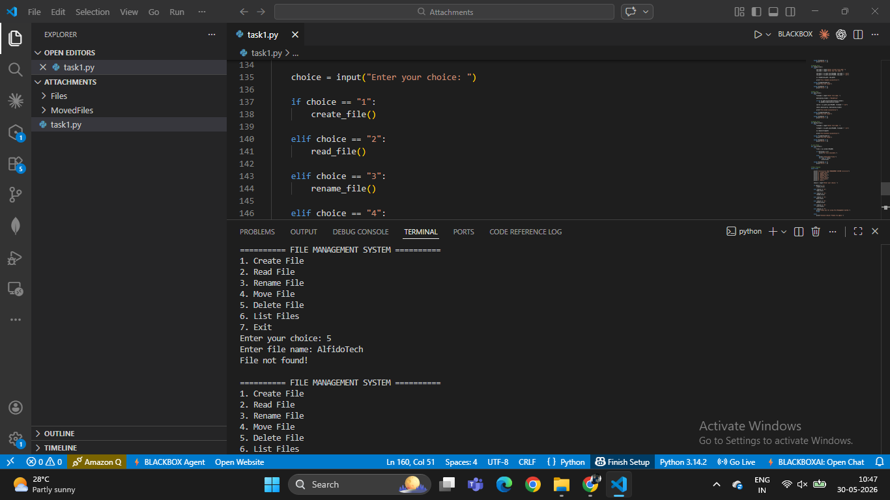
6. List of Files
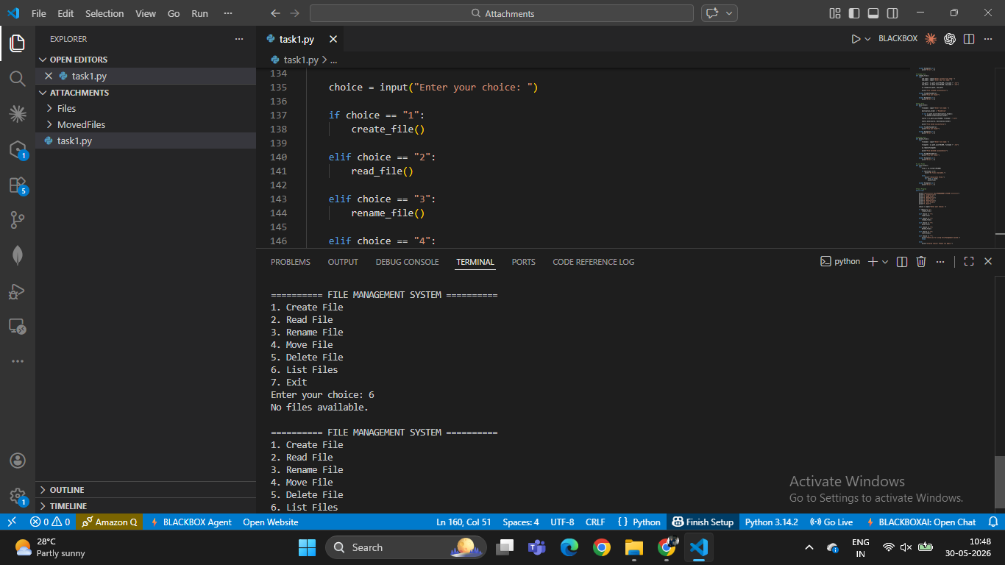

7. Exit
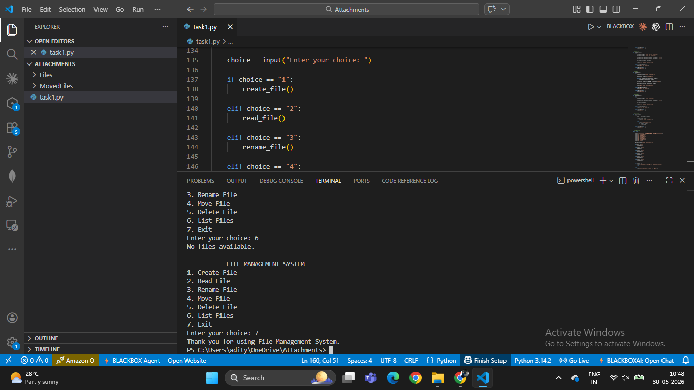

Conclusion
The File Management System was implemented successfully. The project demonstrates basic file handling operations in Python and provides a user-friendly menu interface.

