**OUTPUT 1:**

**Bresenham’s Line Drawing Algorithm.**

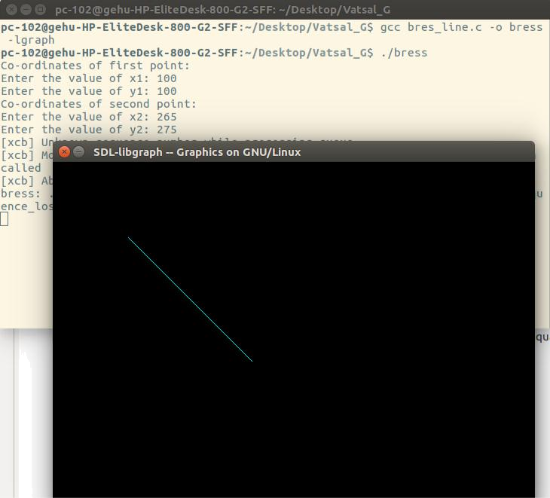

**OUTPUT 2:**

**Mid-Point Circle Drawing Algorithm.**

