**Scenario 1:**

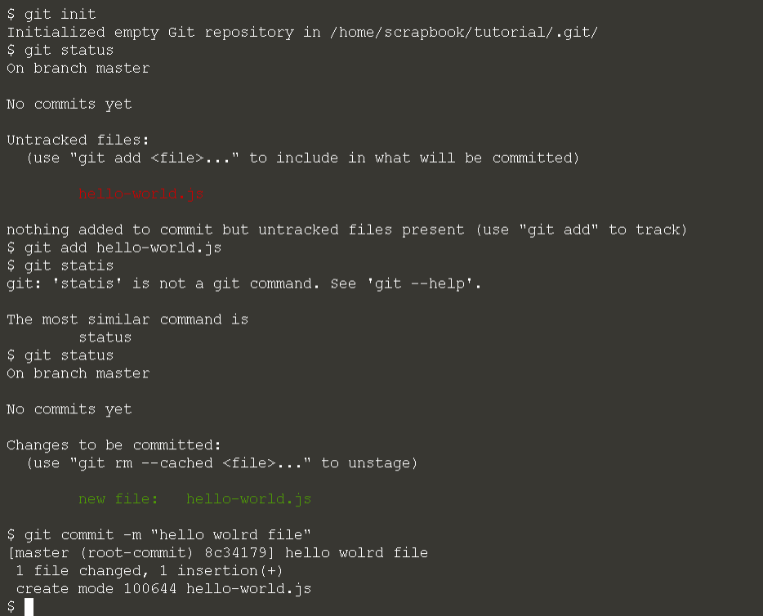

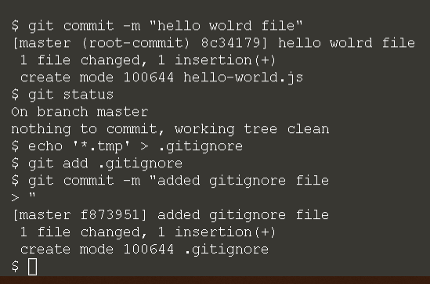

**Scenario 2:**

git diff <commit>

it is used for comparing 2 different version

output each commit on a single line the command is **git log --pretty=format:"%h %an %ar - %s"**

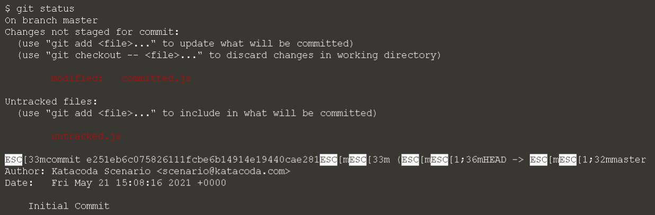

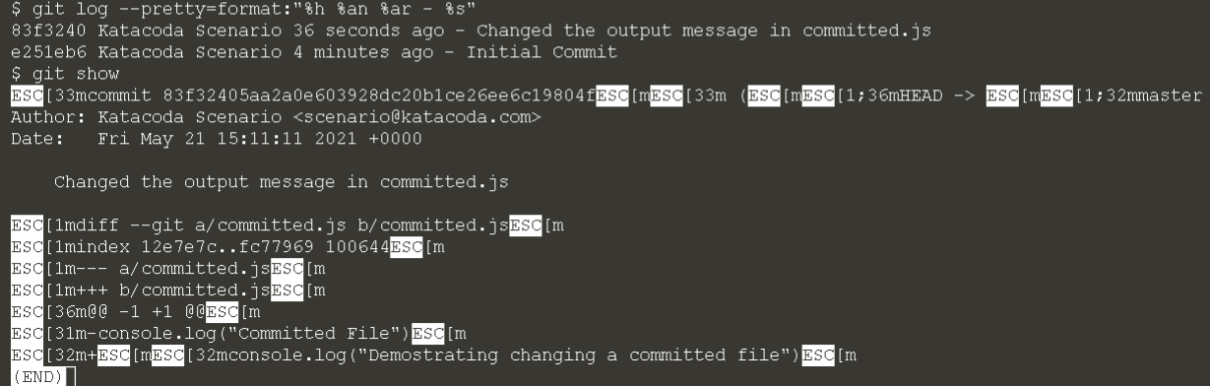

**Scenario 3:**

