**git --version** //current git version

**Configure git**

**git config --global user.name “adityaholkar”**

**git config --global user.email “aditya.holkar17@vit.edu”**

Global is used to set username and email for every repository

**Initialize git**

**git init**

Initialized empty git repo in working directory

**git status //**keep track of file which are committed and not committed.

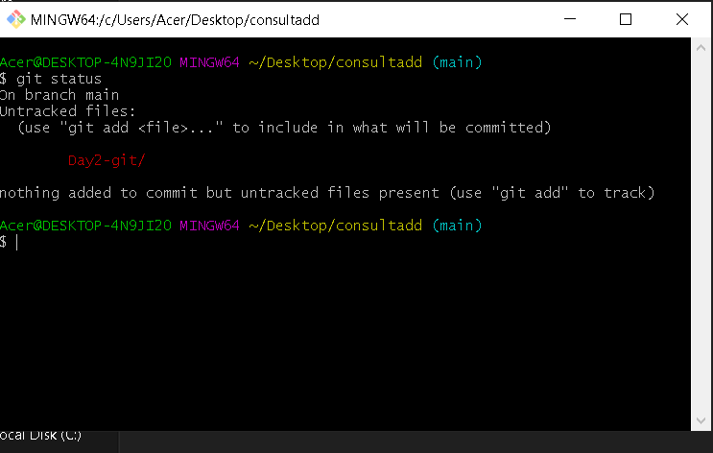

Git Staging Environment

**git add ./Day2-git/index.html**

File is staged

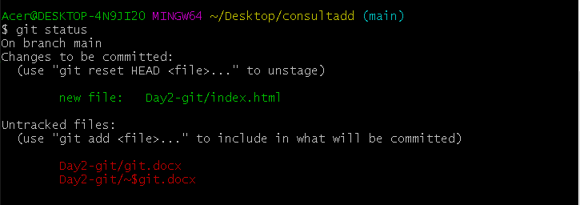

To add more than one file we use

**git add --all**

we can also use

**git add -A**

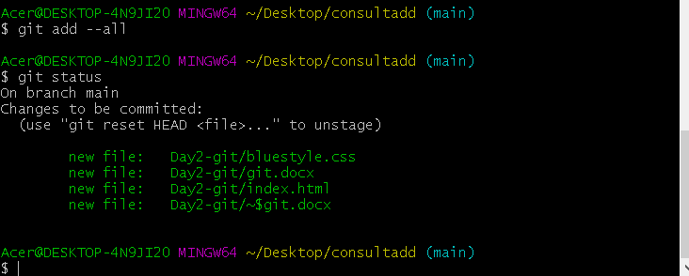

It is used to unstage file

**git rm --cached …**

git commit

git commit -m “first release of hello world!”

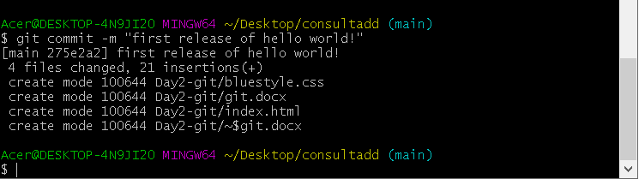

We can use -a if files are not stage and we want to commit

git commit -a -m “updated index.html with new line”

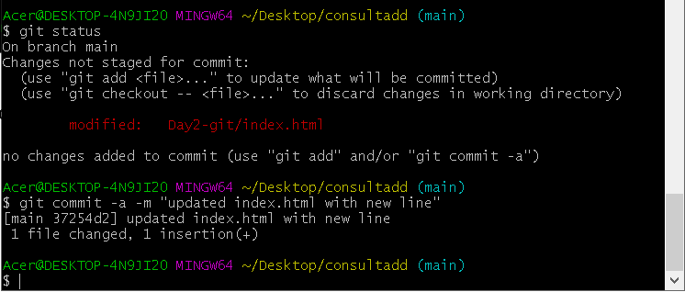

Short status flags are:

git status --short

* ?? - Untracked files
* A - Files added to stage
* M - Modified files
* D - Deleted files