Lab 01 | CS206 Database Management System

Focus of lab work in this week is to get familiarity with environment, and learn to create tables (relations) using SQL.

- Download postgreSQL from http://www.postgresql.org/download/ and install.

- Download pgAdmin if not already installed with postgres server (Latest version should have pgAdmin bundled with).

- Look at following pages and understand basics of creating tables and using
CREATE TABLE statement -
http://www.postgresql.org/docs/9.4/interactive/ddl-basics.html
http://www.postgresql.org/docs/9.4/interactive/ddl-constraints.html

- Look at following pages and learn about basic data types supported by postgreSQL
http://www.postgresql.org/docs/9.4/interactive/datatype.html
(Look at only integer, floating point, character, and date and related types)

Start pgAdmin, connect to postgreSQL server; open SQL window, and perform following actions.

- Understand various relations in company schema (a running example in Elmasri/Navathe book). Refer Schema diagram Figure-1 (below) and Data Definition Script Figure-2 (next) for the same.

- Create Schema named Company using following command in SQL window.
CREATE SCHEMA company;

- Set this as default work schema by issuing following command-
SET SEARCH_PATH TO company;

- Execute script given in figure (next)

- Add some tuples to the company database by executing statements in script http://intranet.daiict.ac.in/~pm_jat/insert_company.sql

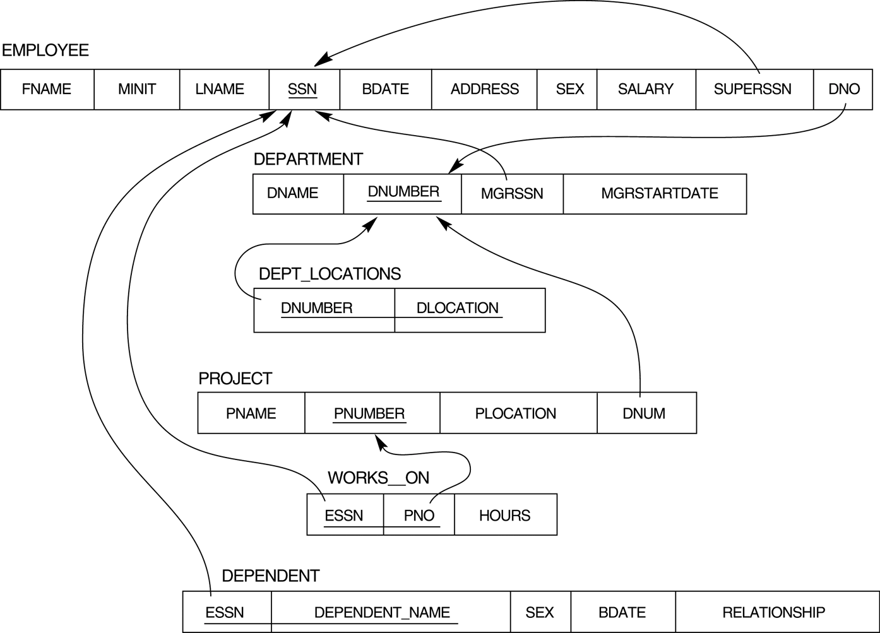
Figure-1
CREATE TABLE employee (
fname VARCHAR(20),
minit CHAR(1),
lname VARCHAR(20),
ssn DECIMAL(9,0),
bdate DATE,
address VARCHAR(30),
sex CHAR(1),
salary DECIMAL(10,0),
superssn DECIMAL(10,0),
dno SMALLINT,
PRIMARY KEY (ssn),
FOREIGN KEY (superssn) REFERENCES employee(ssn)
ON DELETE SET DEFAULT ON UPDATE CASCADE
);
CREATE TABLE department (
dname VARCHAR(20),
dno SMALLINT,
mgrssn DECIMAL(9,0),
mgrstartdate DATE,
PRIMARY KEY (dno),
FOREIGN KEY (mgrssn) REFERENCES employee(ssn)
ON DELETE SET DEFAULT ON UPDATE CASCADE);
CREATE TABLE dept_locations(
dno SMALLINT,
dlocation VARCHAR(20),
FOREIGN KEY (dno) REFERENCES department on delete cascade,
PRIMARY KEY (dno,dlocation)
);
CREATE TABLE project(
pname VARCHAR(20),
pno SMALLINT,
plocation VARCHAR(20),
dno SMALLINT,
PRIMARY KEY (pno),
FOREIGN KEY (dno) REFERENCES department(dno)
);
CREATE TABLE works_on(
essn DECIMAL(9,0),
pno SMALLINT,
hours DECIMAL(5,1),
FOREIGN KEY (essn) REFERENCES employee(ssn)
ON DELETE CASCADE ON UPDATE CASCADE,
FOREIGN KEY (pno) REFERENCES project(pno)
ON DELETE CASCADE ON UPDATE CASCADE,
PRIMARY KEY (essn,pno)
);
CREATE TABLE dependent(
essn DECIMAL(9,0),
dependent_name VARCHAR(20),
sex CHAR(1),
bdate DATE,
relationship VARCHAR(20),
FOREIGN KEY (essn) REFERENCES employee(ssn)
ON DELETE CASCADE ON UPDATE CASCADE,
PRIMARY KEY (essn,dependent_name)
);

ALTER table employee add FOREIGN KEY (dno) REFERENCES department (dno);

Figure-2

