201351010
Aditya Prakash
DC LAB-06

QUESTION 1:
ATMInterface

import java.rmi.Remote;
import java.rmi.RemoteException;

public interface ATMInterface extends Remote
{
public void deposit(int account, double amount) throws RemoteException;
public void withdraw(int account, double amount) throws RemoteException;
public double inquiry(int account) throws RemoteException;
public void CreateAcc() throws RemoteException;
}

ATMImpl

import java.rmi.*;
import java.rmi.server.*;
import java.util.*;

public class ATMImpl extends UnicastRemoteObject implements ATMInterface
{
private HashMap<Integer,Double> h = new HashMap<Integer,Double>();

public ATMImpl() throws RemoteException
{
super();
}

public void CreateAcc()
{
h.put(100,400.0);
h.put(1,300.0);
h.put(2,200.0);
h.put(3,100.0);
}

public void deposit(int account, double amount) throws RemoteException
{
h.put(account,h.get(account)+amount);
}

public void withdraw(int account,double amount) throws RemoteException
{
if(h.get(account)>0)
{
h.put(account,h.get(account)-amount);
}
}

public double inquiry(int account) throws RemoteException
{
return h.get(account);
}
}

Client

import java.io.*;
import java.rmi.Naming;
import java.util.*;

public class Client
{
public static void main(String[] args)
{

try
{
int RMIPort;
String hostName;
InputStreamReader is = new InputStreamReader(System.in);
BufferedReader br = new BufferedReader(is);
System.out.println("Enter the Host Name: ");
hostName = br.readLine();
System.out.println("Enter the Port Number: ");
String portNum = br.readLine();
RMIPort = Integer.parseInt(portNum);
String registryURL = "rmi://" + hostName + ":" + RMIPort + "/ATM";

ATMInterface h = (ATMInterface)Naming.lookup(registryURL);
System.out.println("Lookup Done.");
h.CreateAcc();
Scanner s = new Scanner(new InputStreamReader(System.in));

int num=1,acc;
double amt;
while(num !=0)
{
System.out.println("Enter 1 to deposit.\nEnter 2 to Withdraw.\nEnter 3 for balance.\nEnter 0 to end session.\n");
num = s.nextInt();
switch(num)
{
case 1:
System.out.println("Enter the Account Number: ");
acc = s.nextInt();
System.out.println("Enter amount to deposit: ");
amt = s.nextDouble();
h.deposit(acc,amt);
break;

case 2:
System.out.println("Enter the Account Number: ");
acc = s.nextInt();
System.out.println("Enter the amount to withdraw: ");
amt = s.nextDouble();
h.withdraw(acc, amt);
break;

case 3:
System.out.println("Enter the Account Number: ");
acc = s.nextInt();
System.out.println("Balance in account: " + acc + " is: " + h.inquiry(acc));
break;

case 0:
num = 0;
break;
}
}
}
catch(Exception e)
{
System.out.println("Exception: " + e);
}
}
}

Server

import java.io.*;
import java.net.MalformedURLException;
import java.rmi.*;
import java.rmi.registry.LocateRegistry;
import java.rmi.registry.Registry;

public class Server
{
public static void main(String[] args)
{
InputStreamReader is = new InputStreamReader(System.in);
BufferedReader br = new BufferedReader(is);
String portNum, registryURL, registryURL2;
try
{
System.out.println("Enter the Port Number:");
portNum = (br.readLine()).trim();
int RMIPortNum = Integer.parseInt(portNum);
startRegistry(RMIPortNum);

ATMImpl exportedObj = new ATMImpl();
registryURL = "rmi://localhost:" + portNum + "/ATM";
Naming.rebind(registryURL, exportedObj);
System.out.println("The server is registered and ready.");
listRegistry(registryURL);
}
catch(Exception e)
{
System.out.println("Exception in HelloServer.main: " + e );
}

}

private static void startRegistry(int RMIPortNum) throws RemoteException
{
try
{
Registry reg = LocateRegistry.getRegistry(RMIPortNum);
reg.list();
}
catch(RemoteException e)
{
System.out.println("Registry cannot be located at: " + RMIPortNum);
LocateRegistry.createRegistry(RMIPortNum);
System.out.println("Registry Created at: " + RMIPortNum);
}
}
private static void listRegistry(String registryURL) throws RemoteException, MalformedURLException
{
System.out.println("Registry " + registryURL + " has: ");
String[] n = Naming.list(registryURL);
for(int i=0; i < n.length; i++)
{
System.out.println(n[i]);
}
}
}

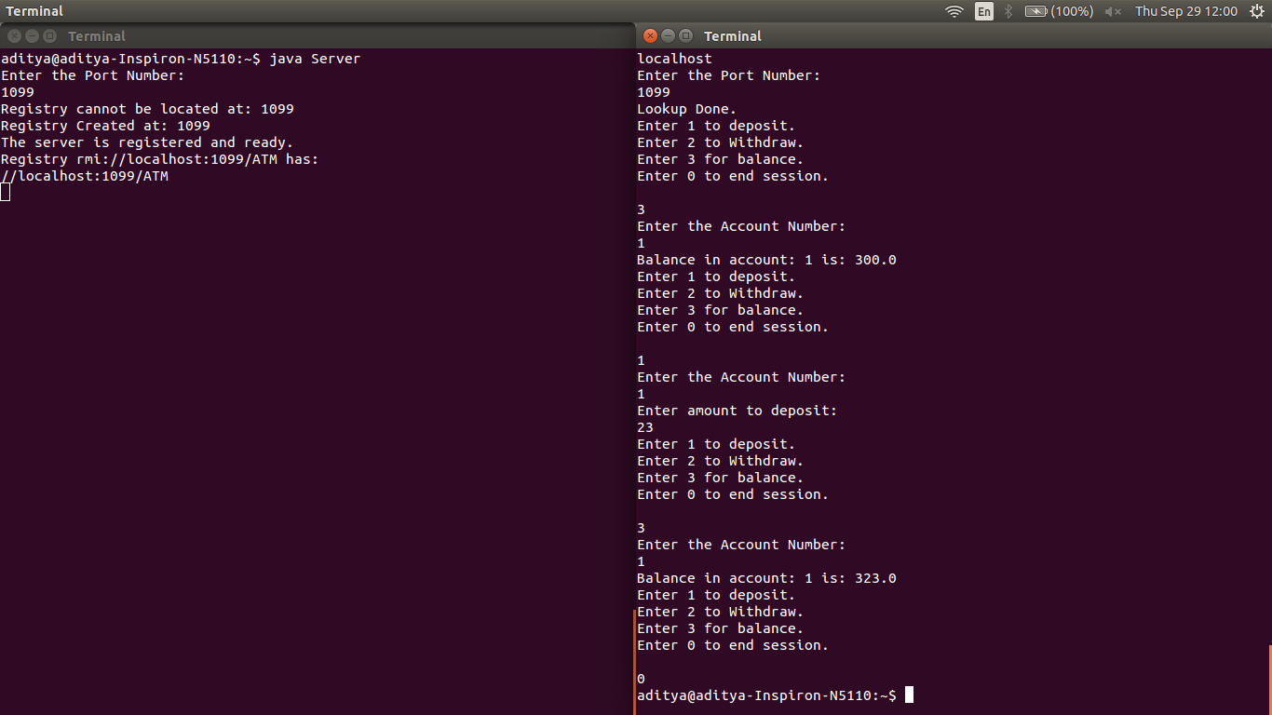

Question 2:
Client
import java.io.*;
import java.net.*;

public class Cli
{
public static void main(String[] args) throws Exception
{
Socket client = new Socket("localhost",1245);
double[] data = new double[5];

data[0] = 99;
data[1] = 88;
data[2] = 77;
data[3] = 66;
data[4] = 55;

DataOutputStream Out = new DataOutputStream(client.getOutputStream());
Out.writeInt(data.length);
for(int i=0;i<data.length;i++)
{
Out.writeDouble(data[i]);
}

DataInputStream In = new DataInputStream(client.getInputStream());
int len = In.readInt();
for(int i=0;i<len;i++)
{
data[i] = In.readDouble();
System.out.println(data[i] + "\n");
}
}
}

Server
import java.net.*;
import java.util.ArrayList;
import java.io.*;

public class Ser
{
public static void main(String[] args) throws Exception
{
ServerSocket Server = new ServerSocket(1245);
System.out.println("The server has started.");
Socket client = Server.accept();
byte[] data = null;
DataInputStream In = new DataInputStream(client.getInputStream());
int len = In.readInt();
double[] arr = new double[len];
for(int i=0;i<len;i++)
{
arr[i] = In.readDouble();
System.out.println(arr[i]+"\n");
arr[i] = Math.sqrt(arr[i]);
}
DataOutputStream Out = new DataOutputStream(client.getOutputStream());
Out.writeInt(arr.length);
for(int i=0;i<len;i++)
{
Out.writeDouble(arr[i]);
}
}
}

