**INTRODUCTION**

Internet of things (IoT): The internet of things, or IoT, is a system of interrelated computing devices, mechanical and digital machines, objects, animals or people that are provided with unique identifiers ([UIDs](https://internetofthingsagenda.techtarget.com/definition/unique-identifier-UID)) and the ability to transfer data over a network without requiring human-to-human or human-to-computer interaction.

An IoT ecosystem consists of web-enabled smart devices that use embedded processors, sensors and communication hardware to collect, send and act on data they acquire from their environments. [IoT devices](https://internetofthingsagenda.techtarget.com/definition/IoT-device) share the sensor data they collect by connecting to an IoT gateway or other edge device where data is either sent to the cloud to be analysed or analysed locally. Sometimes, these devices communicate with other related devices and act on the information they get from one another. The devices do most of the work without human intervention, although people can interact with the devices -- for instance, to set them up, give them instructions or access the data. The connectivity, networking and communication protocols used with these web-enabled devices largely depend on the specific IoT applications deployed. 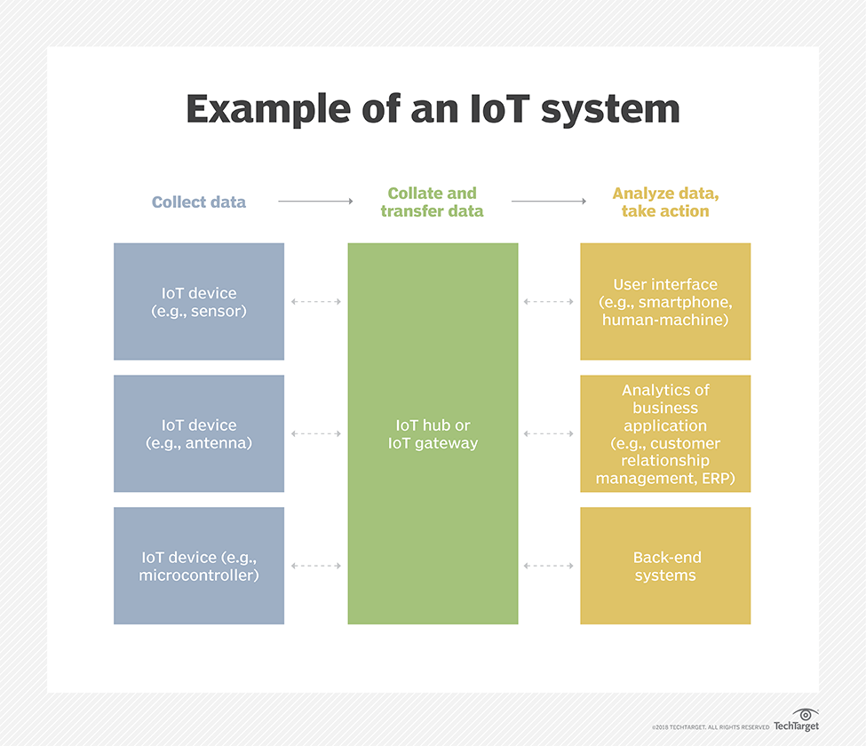

This project is derived from Consumer and enterprise IoT applications.

There are numerous real-world applications of the internet of things, ranging from consumer IoT and enterprise IoT to manufacturing and industrial IoT (IIoT). IoT applications span numerous verticals, including automotive, telco, energy and more.

In the consumer segment, for example, [smart homes](https://internetofthingsagenda.techtarget.com/definition/smart-home-or-building) that are equipped with smart thermostats, smart appliances and connected heating, lighting and electronic devices can be controlled remotely via computers, smartphones or other mobile devices.

Wearable devices with sensors and software can collect and analyse user data, sending messages to other technologies about the users with the aim of making users' lives easier and more comfortable. Wearable devices are also used for public safety -- for example, improving first responders' response times during emergencies by providing optimized routes to a location or by tracking construction workers' or firefighters' vital signs at life-threatening sites.

In healthcare, IoT offers many benefits, including the ability to monitor patients more closely to use the data that's generated and analyse it. Hospitals often use IoT systems to complete tasks such as inventory management, for both pharmaceuticals and medical instruments.

Smart buildings can, for instance, reduce energy costs using sensors that detect how many occupants are in a room. The temperature can adjust automatically -- for example, turning the air conditioner on if sensors detect a conference room is full or turning the heat down if everyone in the office has gone home.

In agriculture, IoT-based smart farming systems can help monitor, for instance, light, temperature, humidity and soil moisture of crop fields using connected sensors. IoT is also instrumental in automating irrigation systems.

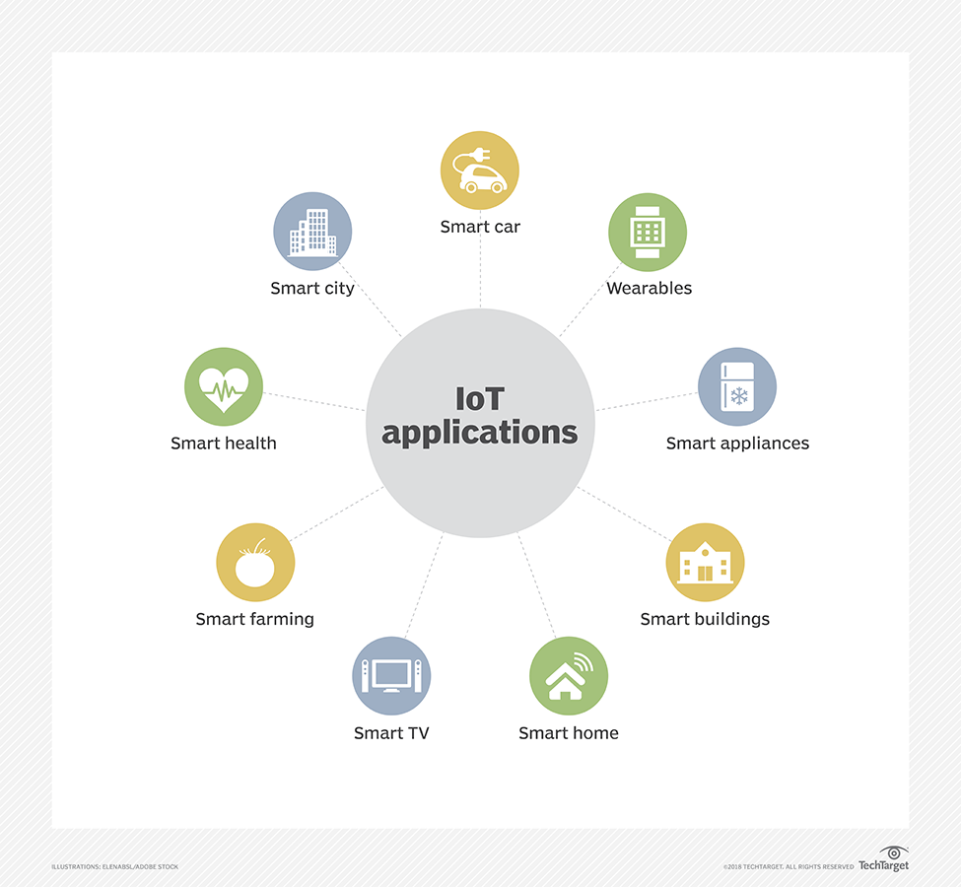

**DESIGN**

The below diagram depicts the basic flow used in the detection of fall.

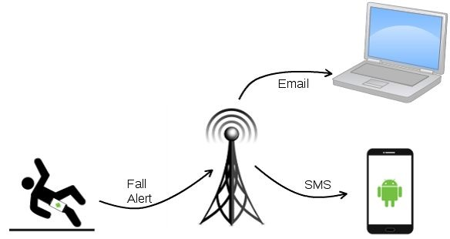

Algorithm is based off the concept that during a fall, a person experiences a momentary freefall or reduction in acceleration, followed by a large spike in acceleration, then a change in orientation.

The following steps are helpful to understand the design:

* First the data is collected from the MPU 6050 sensor.
* The data is processed in the NODEMCU.
* If free fall situation arises, then a trigger is generated i.e., Webhooks service in IFTTT receives a web request.
* After receiving a web request, the required action is takes i.e., SMS, Email, VoIP Call etc.,

Components required are:

|  |  |
| --- | --- |
| NODEMCU ESP8266 | Image result for NODEMCU ESP8266 |
| MPU6050 IMU | Image result for MPU6050 IMU |
| LED | Image result for led |
| 5V Piezo Buzzer | Image result for 5V Piezo Buzzer |
| BREADBOARD | Image result for BREADBOARD |
| JUMPER WIRES (MALE TO MALE) | Image result for male to male jumper wires |

**IMPLEMENTATION**

The connections are done in the following manner:

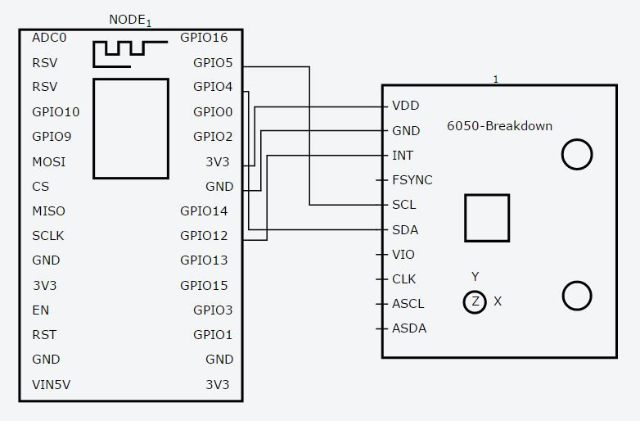

Considering the actual markings/labels on the NODEMCU,

(NODEMCU)D1 🡪 SCL (MPU 6050)

(NODEMCU)D2 🡪 SDA (MPU 6050)

(NODEMCU)D4 🡪 BUZZER/LED LONG

(NODEMCU)3V3 🡪 VCC (MPU 6050)

(NODEMCU)GND 🡪 GND (MPU 6050)

(NODEMCU)D6 🡪 INT (MPU 6050)

(NODEMCU)GND 🡪 BUZZER/LED SMALL

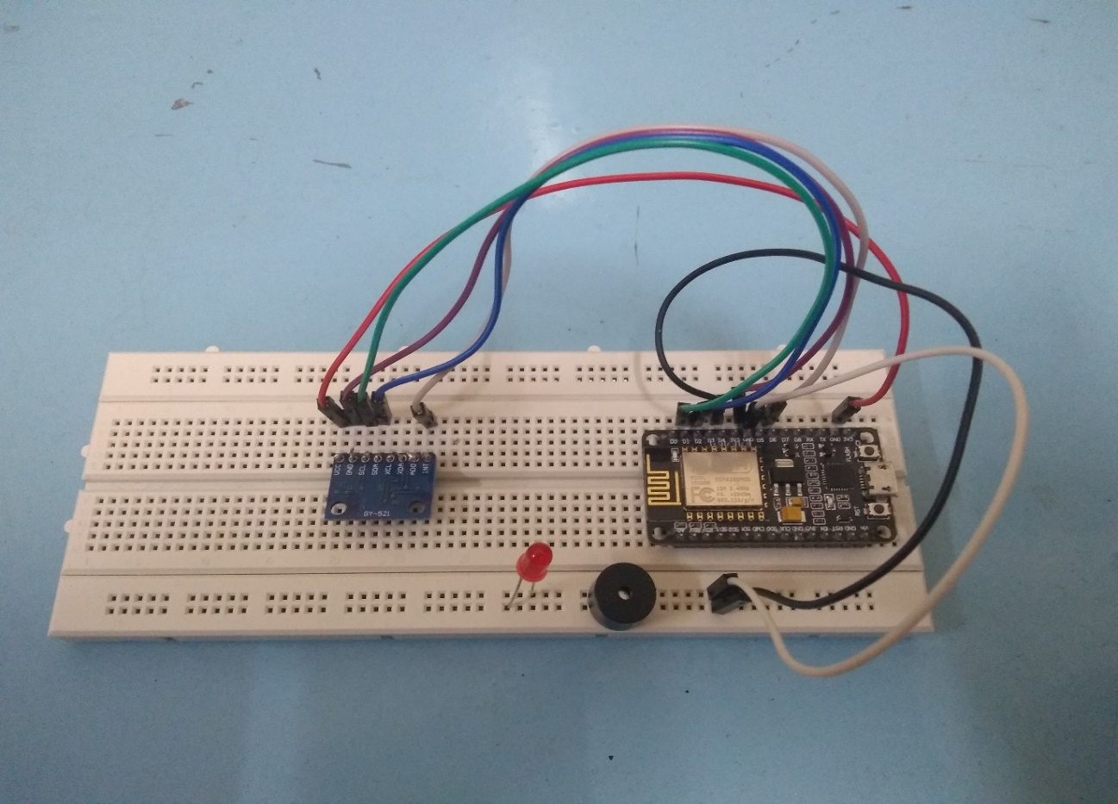

**RESULT**

The completed fall detector is shown below.

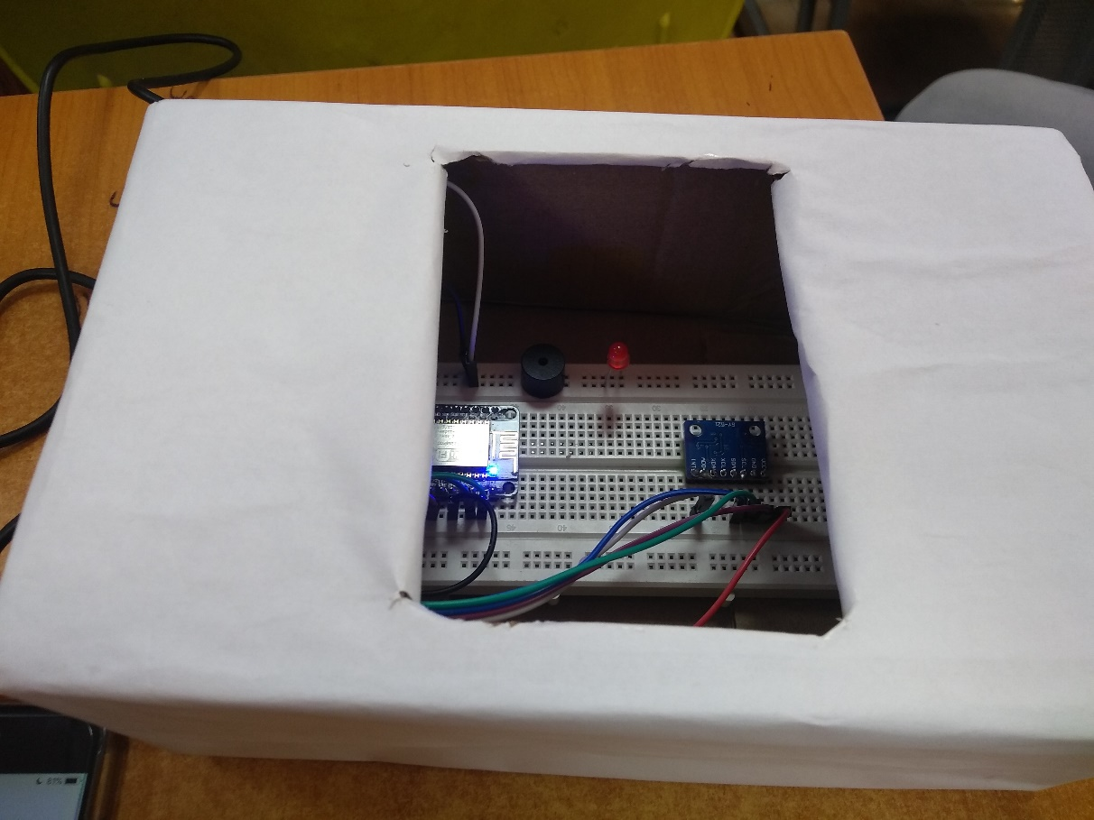

When fall is detected, on serial monitor output of the Arduino Software output 1 is observed. Otherwise 0 is printed as the data from the MPU 6050 is continuously processed.



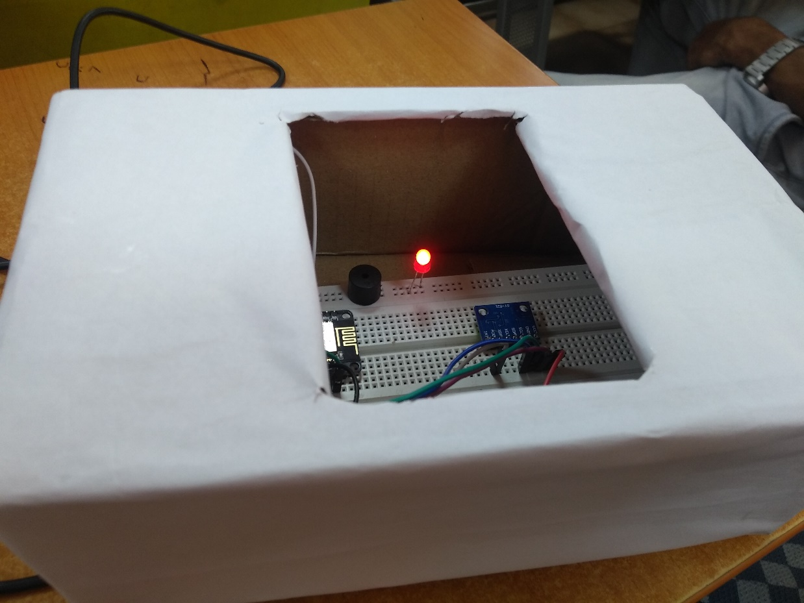

After the detection of free fall, the remaining work is done by the applet created in IFTTT and an SMS/Email is received.

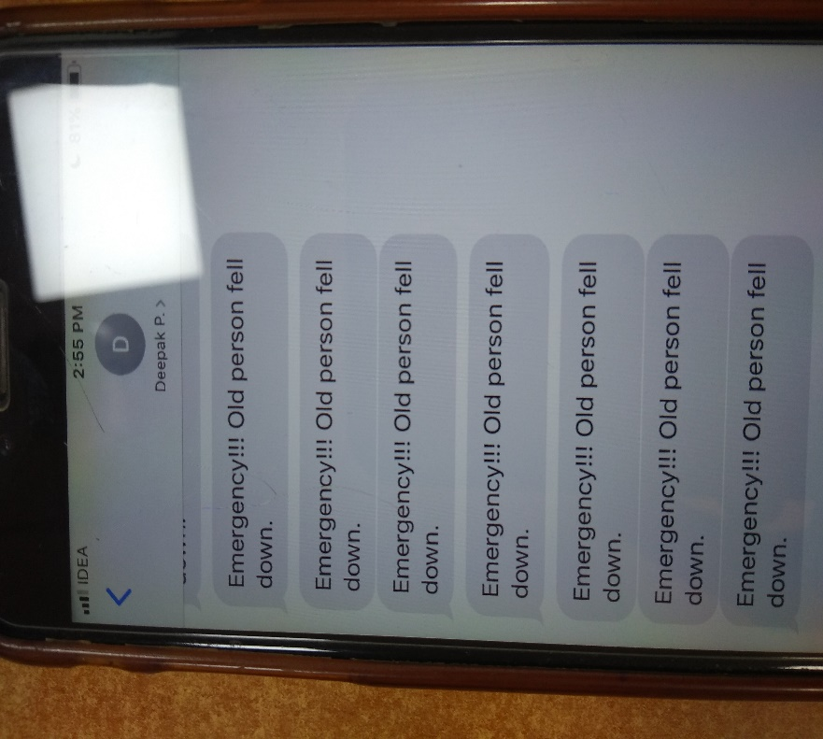

**CONCLUSION**

Growing demand on services oriented to elderly makes justified the development of improved system to help elderly live longer in their home increasing their quality of life. The product presented here represents an important step beyond the actual state of the art in services to elderly. Indeed, the service offers complete automatic fall detection on a small autonomous mobile module both for indoor and outdoor use. The system, composed by a mobile module worn by the user and a call centre/family member to analyse and save the information, has been developed as easy to use and reliable, and final user requirements have been taken into account on every stage of the development.

**REFERENCES**

1. <https://internetofthingsagenda.techtarget.com/definition/Internet-of-Things-IoT>
2. <https://www.youtube.com/watch?v=iW1FKWCrH44> (NODEMCU SMS TUTORIAL)k
3. <https://www.instructables.com/id/Fall-Detection-of-Old-Man-Using-Cayenne/>
4. <https://community.blynk.cc/uploads/default/original/2X/8/84533f57f9dbed3b757a73ef018fc0a981dac268.jpg>