*Module:-Dashboard
1) In the Dashboard module, when scrolling to the bottom section under ‘Compliance Score – Contractor’, hovering over the images displays an incorrect count for complied values.
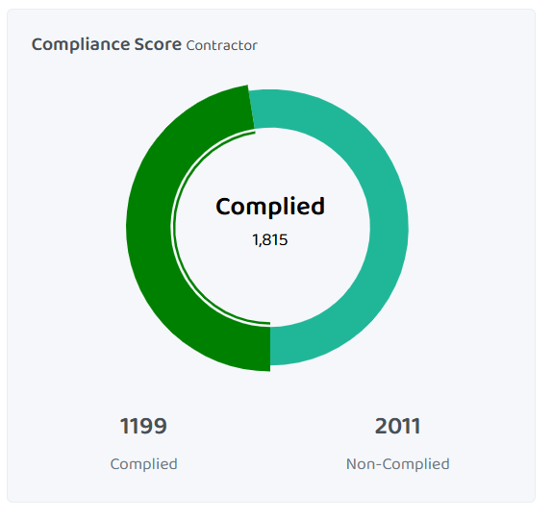
2) In the Dashboard module, the footer section is not required and should be removed.
3) In the Dashboard module, the user interface is not properly aligned and requires correction.
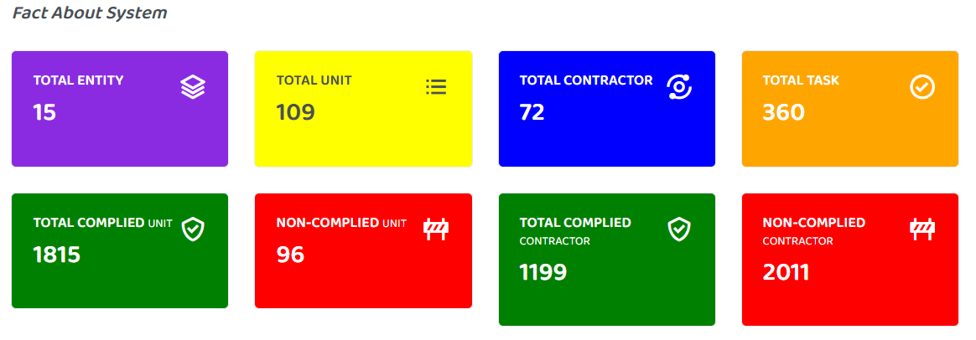
*MODULE:-USER MANAGEMENT
1) In the User Management module, under the User List section, there is a ‘Create User’ option. While creating a new user, all fields should be mandatory; however, they are currently being enforced only after form submission.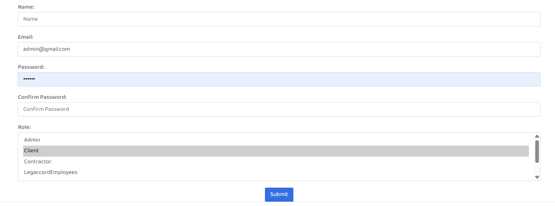
2) In the User Management module, when you delete a specific user, the system deletes the user immediately. A warning message should be displayed to inform that the user is about to be deleted.
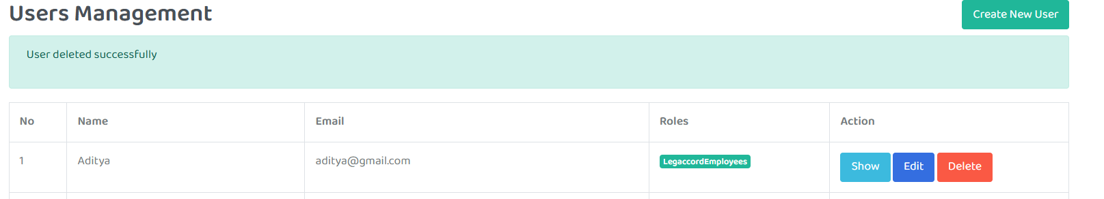
3) In the User Management module, when opening the user list, a search button should be available to allow users to search for a specific user.
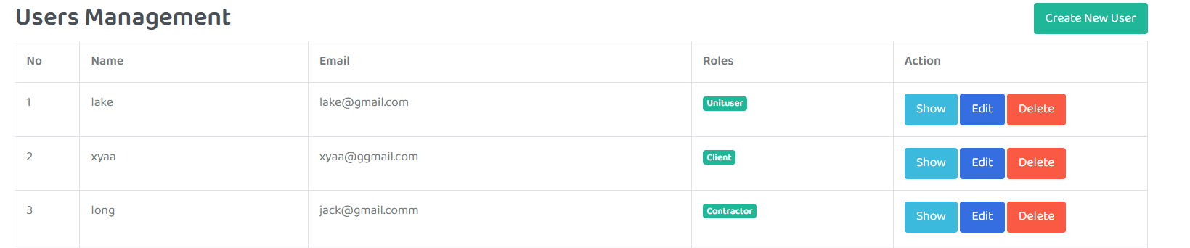
4)In User Management module, when we open the unit option there is a wrong label name, label name should be Related unit.
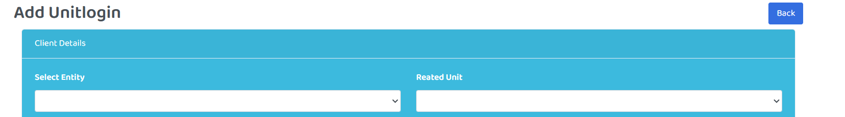
5) In the User Management module, when adding a new contractor, the contractor is successfully created. However, the success message displayed contains a spelling error (‘Contrator added successfully’). The correct message should be ‘Contractor added successfully’.
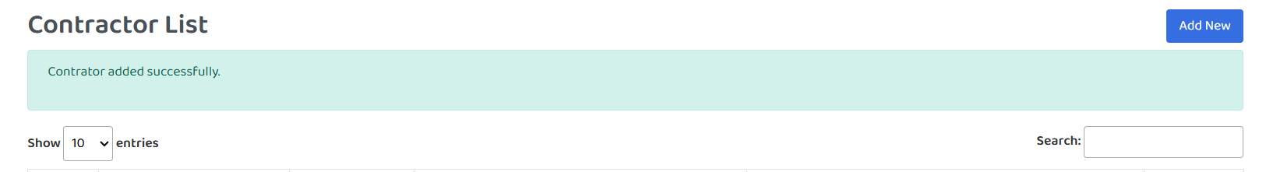
6) In the User Management module, when adding a new unit under the Unit option, the system currently accepts duplicate mobile numbers. The mobile number field should be unique and should not allow duplicate entries.
7) In the User Management module, while adding a new unit, the mobile number field currently accepts values with fewer or more than 10 digits. The system should restrict the input to exactly 10 digits only.
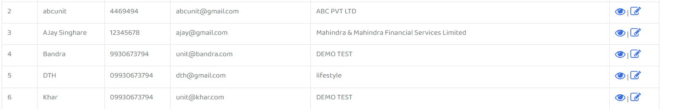

8) In the User Management module, when opening the Role option and selecting ‘Contractor’, there are spelling mistakes in options 7,10,11,14,15 and 18 where it is displayed as ‘Contrator’. The correct spelling should be ‘Contractor’.
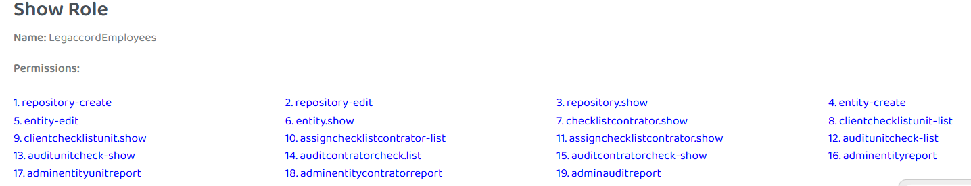
9) In the User Management module, when opening the Role option and selecting ‘Legaccord employees’, there are spelling mistakes in options 3, 4, and 5 where it is displayed as ‘Contrator’. The correct spelling should be ‘Contractor’.
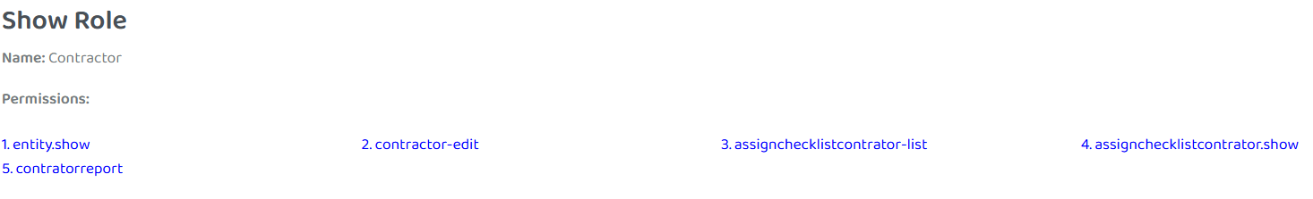
10) In the User Management module, when opening the Role option and selecting ‘client’, there are spelling mistakes in options 9 and 10 where it is displayed as ‘Contrator’. The correct spelling should be ‘Contractor’.
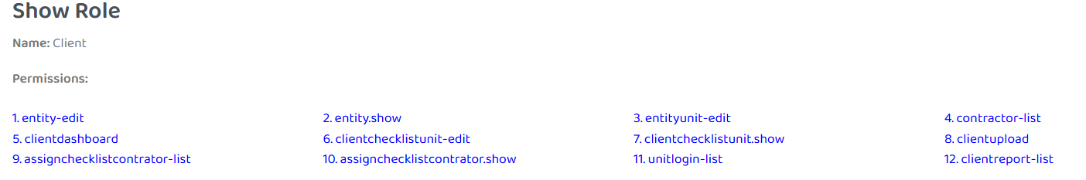
11) In the User Management module, when opening the Role option and selecting ‘SuperAdmin’, there are spelling mistakes in options 30,31,32,33 and 40 where it is displayed as ‘Contrator’. The correct spelling should be ‘Contractor’.
12)In the User Management module, when opening the Role option and selecting ‘SuperAdmin’, there are spelling mistakes in options 8,9,10 and 11 where it is displayed as ‘PerDefinedCheckList’. The correct spelling should be ‘PreDefinedCheckList’.
13) In the User Management module, when opening the Role option and selecting ‘Admin’, there are spelling mistakes in options 22,23,24 and 25 where it is displayed as ‘PerDefinedCheckList’. The correct spelling should be ‘PreDefinedCheckList’.
*Module:-Entity
1) In the Entity module, while adding or editing a record, data entered in the ‘Nature of Work’ and ‘Address’ fields is incorrectly swapped between the two fields.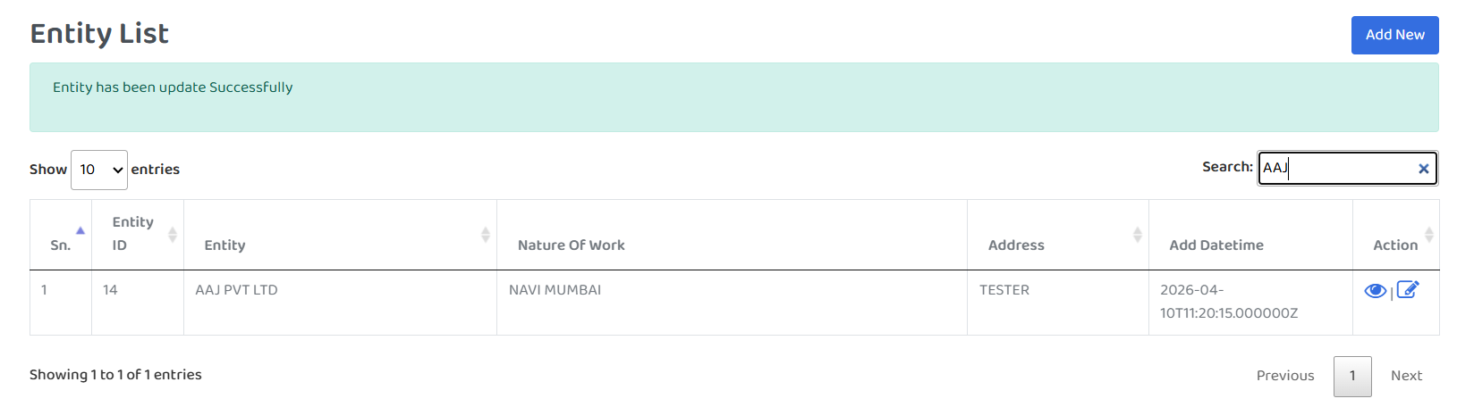

*Module:-Reporting
1) In the Reporting module, there is an option called ‘Entity’. When you open it, there is a spelling mistake: ‘Enities Reports’. It should be corrected to ‘Entities Reports’.
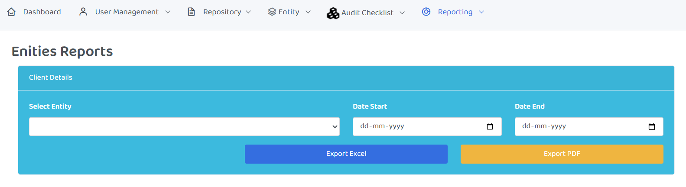
2) In the Reporting module, when you open the Entity Unit, there is a spelling mistake: ‘Enities Reports’. It should be corrected to ‘Entities Reports’.
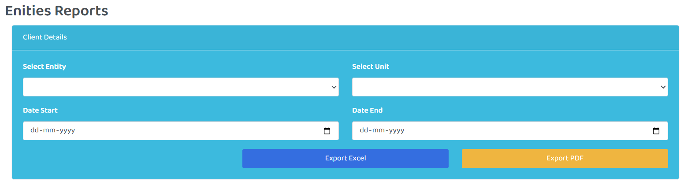

3)In the Reporting module, under the Entity Contractor section, a spelling error is displayed as ‘Contrator Reports’. The correct spelling should be ‘Contractor Reports’. Additionally, the same spelling mistake appears in the label and should be corrected.
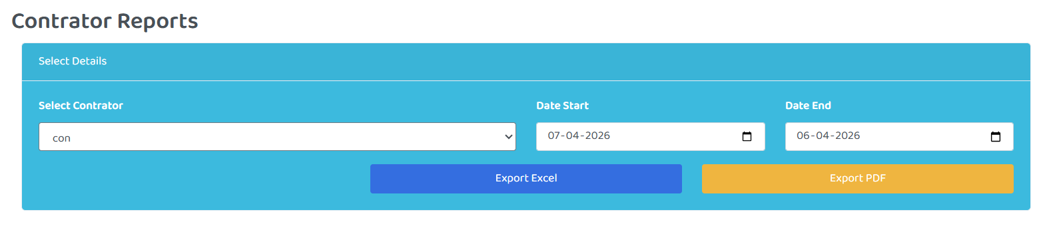
4) In the Reporting module, when you open the Auditor option, there is an incorrect label name: ‘Enities Reports’. It should be ‘Auditor Reports’. Additionally, there is an option labeled ‘Export Contrator Excel’, which contains a spelling mistake. It should be corrected to ‘Export Contractor Excel’ and ‘Export Contractor PDF’.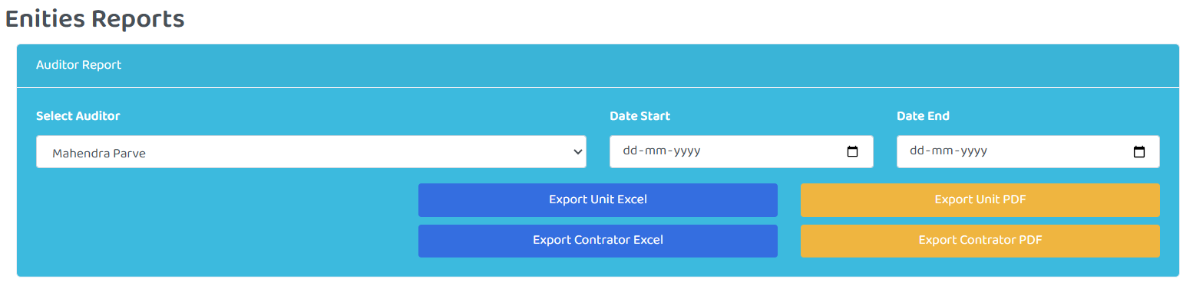
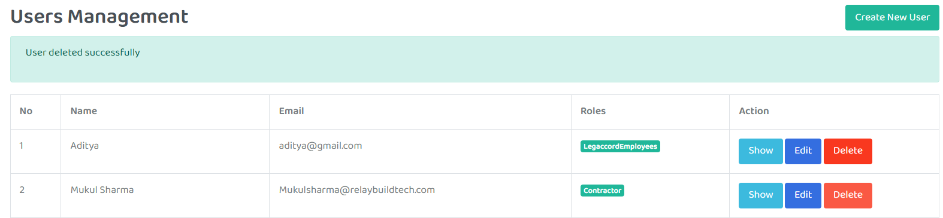
4) In the Reporting module, when selecting the Contractor entity option, the labels are incorrect: ‘Date start’ and ‘Date End’. They should be ‘Start Date’ and ‘End Date’.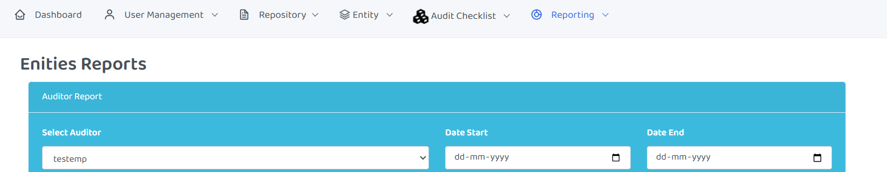

5) In the Reporting module, when selecting the Entity Unit option, the labels are incorrect: ‘Date start’ and ‘Date End’. They should be ‘Start Date’ and ‘End Date’.
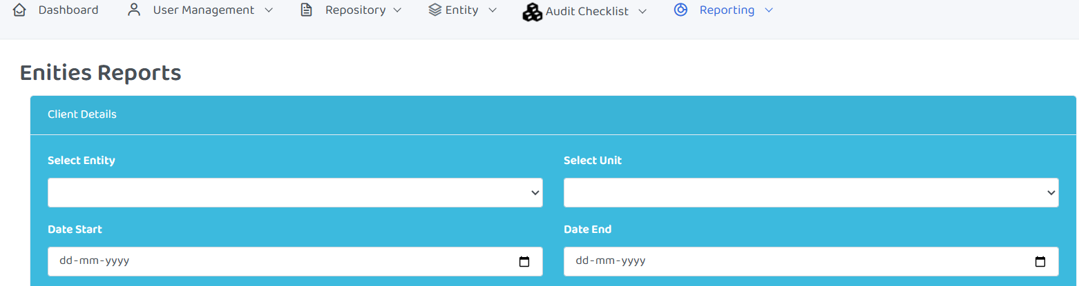
#############When you are login as a legaccord emp.########
*Module:-CheckList
1) In the Checklist module, when opening the contractor option, there is a spelling mistake. It should be corrected to "a contractor."
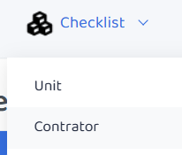

*Module:-Reporting
1) In the Reporting Module, when you select the entity option, there is a spelling mistake in the form. It currently reads "Enities Reports" and should be corrected to "Entities Report."
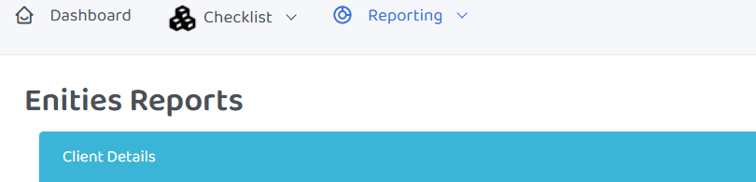
2)In the Reporting Module, when you select the entity unit option, there is a spelling mistake in the form. It currently reads "Enities Reports" and should be corrected to "Entities Report."
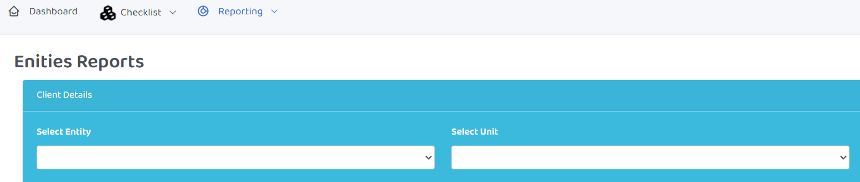

3) In the Reporting Module, when you select the entity contractor option, there is a spelling mistake in the label itself as well as in the form label, It currently reads "contrator Reports" and should be corrected to "Contractor Reports".
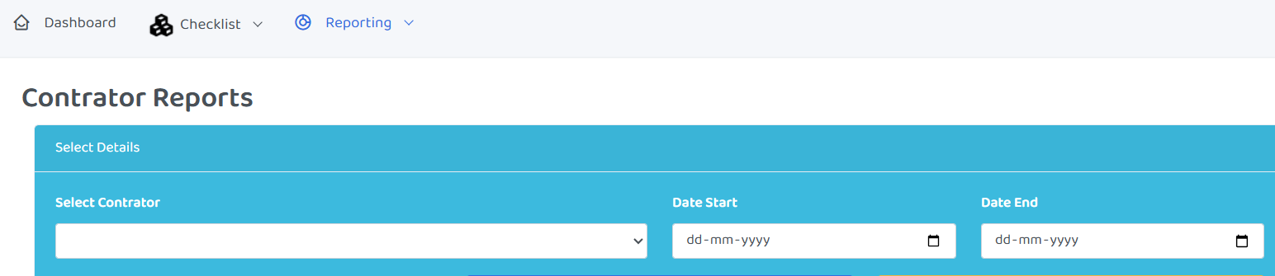

*Module:-Dashboard
1) In the Dashboard module, there is a spelling mistake: "total contrator." It should be corrected to "TOTAL CONTRACTOR".
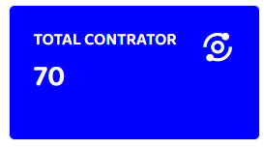
2) In the Dashboard module, there is a spelling mistake: "compliant." It should be corrected to "complied".
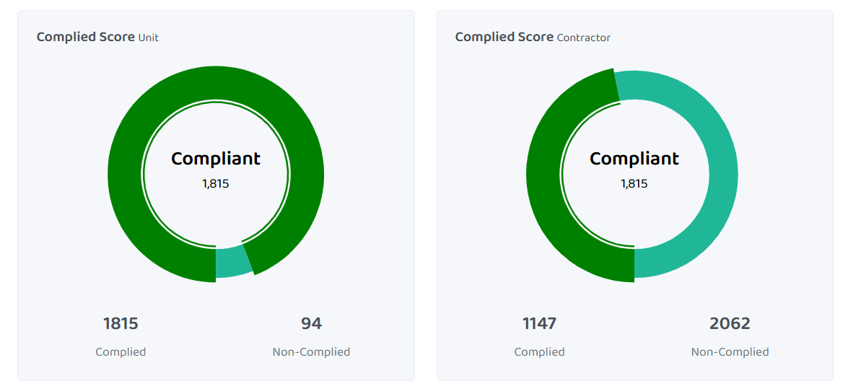

##login as a client###########
*Module:- Checklist
1) In the Checklist module, when opening the Contractor option, there is a spelling mistake where ‘locaked date’ is displayed. The correct spelling should be ‘locked date’.
*Module:-Reporting
1) In the Reporting module, when opening the Report option, a form is displayed. In this form, the labels ‘Date Start’ and ‘Date End’ are incorrect. The correct labels should be ‘Start Date’ and ‘End Date’.
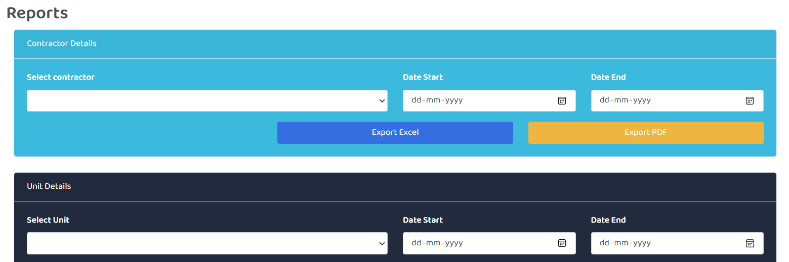

*Module:-Profile
1) In the Profile module, when scrolling to the bottom, there is an ‘Upload Image’ option. However, incorrect information is displayed. Please provide the correct information(If you upload a new image, please log out and then log in again).
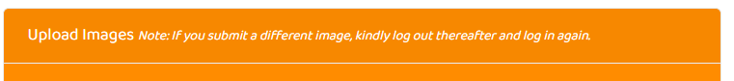

2) In the Profile module, when scrolling to the bottom, there is an ‘Upload Image’ option. In the profile image field, the placeholder text is incorrect (‘No file chosen’). It should be corrected to ‘No File Chosen’.
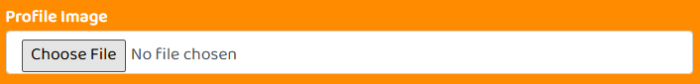
*#*3) In the Profile module, when logging out of the account, the system logs out immediately without any confirmation. A warning or confirmation message should be displayed before logging out.

##login as a Unituser###########
*Module:-Reporting
1) In the Reporting module, when we select the Unit Reports option, a spelling mistake appears after opening the selected option. ‘Date Start’ and ‘Date End’ should be corrected to ‘Start Date’ and ‘End Date’.
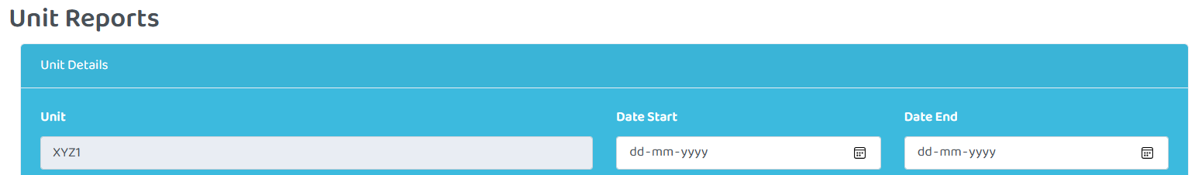
*Module:-Profile
1)In the Profile module, when scrolling to the bottom, there is an ‘Upload Image’ option. However, incorrect information is displayed. Please provide the correct information(If you upload a new image, please log out and then log in again).

2) In the Profile module, when scrolling to the bottom, there is an ‘Upload Image’ option. In the profile image field, the placeholder text is incorrect (‘No file chosen’). It should be corrected to ‘No File Chosen’.

*3*) In the Profile module, when logging out of the account, the system logs out immediately without any confirmation. A warning or confirmation message should be displayed before logging out.

##Login as a Contractor###########
*Module:-Dashboard
1) In the Dashboard module, the user interface is not properly aligned and needs to be corrected.
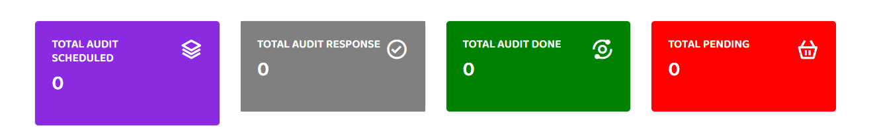
*Module:-CheckList
1) In the Checklist module, when we select the Assigned option, a spelling mistake appears after opening it. ‘Locaked Date’ should be corrected to ‘Locked Date’.
*Module:-Reporting
1) In the Reporting module, when we select the Report option, a spelling mistake appears after opening it. ‘Date Start’ and ‘Date End’ should be corrected to ‘Start Date’ and ‘End Date’.
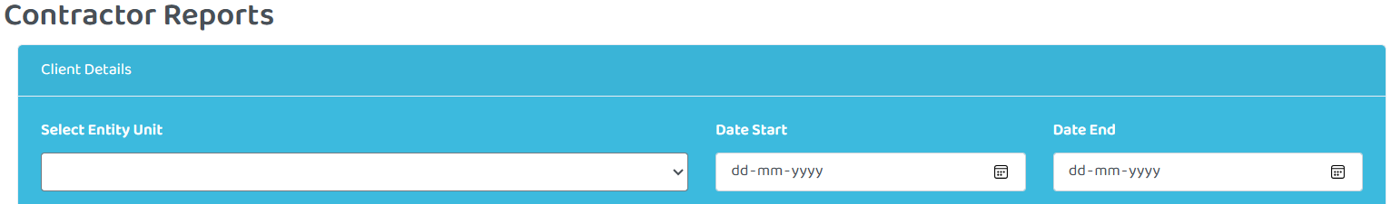

*Module:-Profile
1)In the Profile module, when scrolling to the bottom, there is an ‘Upload Image’ option. However, incorrect information is displayed. Please provide the correct information(If you upload a new image, please log out and then log in again).

2) In the Profile module, when scrolling to the bottom, there is an ‘Upload Image’ option. In the profile image field, the placeholder text is incorrect (‘No file chosen’). It should be corrected to ‘No File Chosen’.

*3*) In the Profile module, when logging out of the account, the system logs out immediately without any confirmation. A warning or confirmation message should be displayed before logging out.

