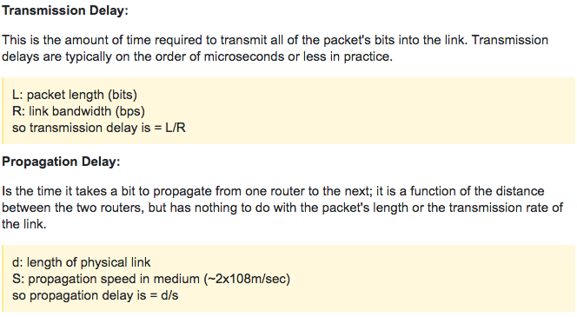

Fragment Offset is always stored after division by 8.