Video 1: Basic Properties of Switching Algebra

Idempotency: x.x=x, x+x=x

Or, and is left/right associative

(x+yz) = (x+y)(x+z)

“Dual” functions – couples where and -> or, or -> and, 1 -> 0, 0 -> 1

Video 2: Switching expressions and simplifications

Any operation using and, or and not are functionally complete.

Every occurrence of a variable in formulae is called literal.

Abosrption: x + xy = x, x(x+y) = x

X + x’y = x + y,

X.(x’ + y) = xy

Consensus theorem : xy + x’z + yz = xy + x’z

Cancellation/inverse not allowed in expressions.

Video 3: Demorgans law and simplification

(xy)’ = x’ + y’, (x+y)’ = x’y’

Video 4: Switching Functions

Video 5: Canonical Sum of Products

Also called disjunctive normal form

Need to have all variables in every product for being canonical and occurs only once.

Video 6: Canonical Product of Sums

Also called conjunctive normal form

Video 7: Examples of canonical forms

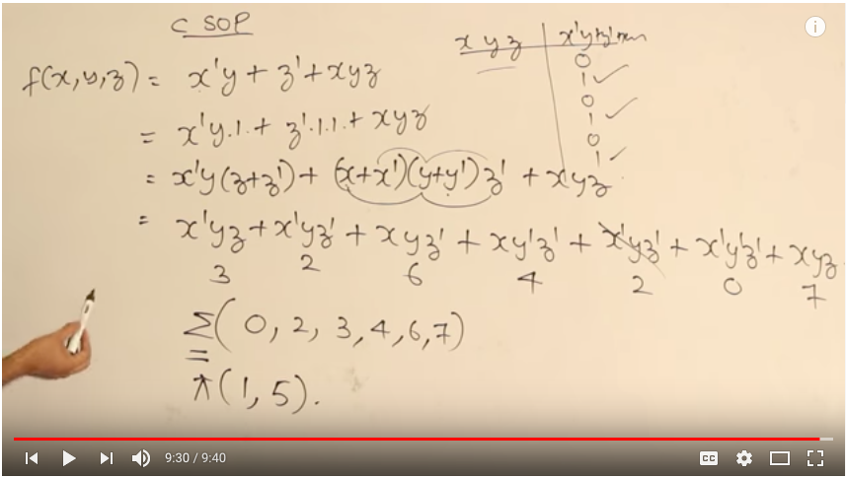

Video 8: Functional Properties

Two switching functions are equivalent iff their canonical pos/sop are same.

Video 9: Number of Functions

N bool variables- No of possible rows = 2pown, so n of functions are 2pow(2pown)

Video 10: Counting the no of functions and neutral functions

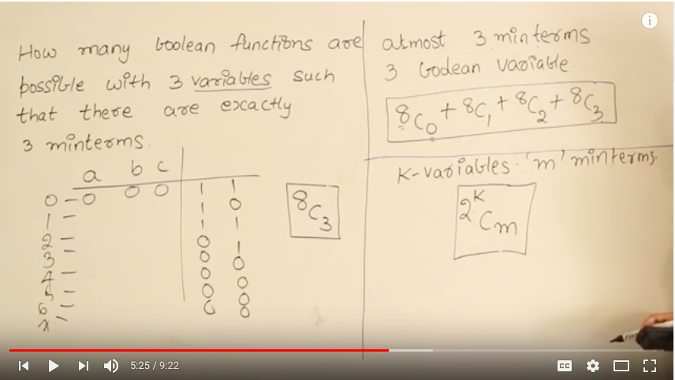

Neutral functions : No of minterms equals no of maxterms, 2pown C 2pow(n-1)

Video 11: Venn Diagram Representation

Video 12: Contact Representation

Serial Contact are performing and operation

Parallel Contact are performing or operation

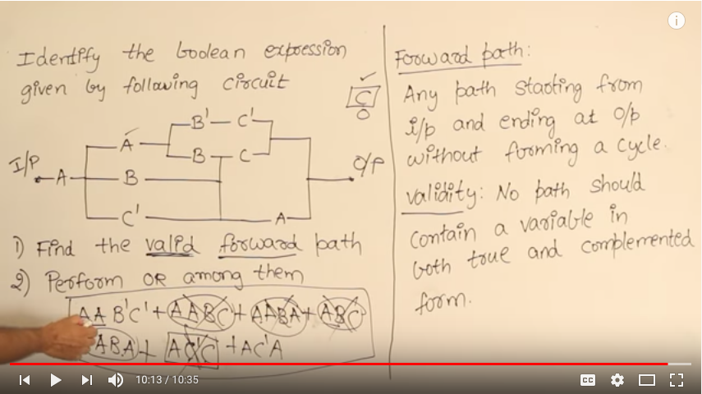

Video 13: Nested Function

Video 14: Nand Gate and Properties

Doesn’t follow identity because a nand a = a’

Follows commutative law, not follows associativity

Video 15: Nor Gate and Properties

Doesn’t follow identity, idempotent rule because a nor a = a’

Follows commutative law, not follows associativity

Video 16: EX OR Gate and Properties

Doesn’t follow identity, idempotent rule because a EXOR a = 0

Follows commutative law, follows associativity

(B EXOR C)’ = B’ EXOR C = B EXOR C’

Video 17: EX NOR Gate and Properties

Doesn’t follow identity, idempotent rule because a EXNOR a = 1

Follows commutative law, follows associativity

(B EXNOR C)’ = B’ EXNOR C = B EXNOR C’

Video 18: Functionally Completeness

Video 19: EX 1 on Functional Completeness

Video 20: EX 2 on Functional Completeness

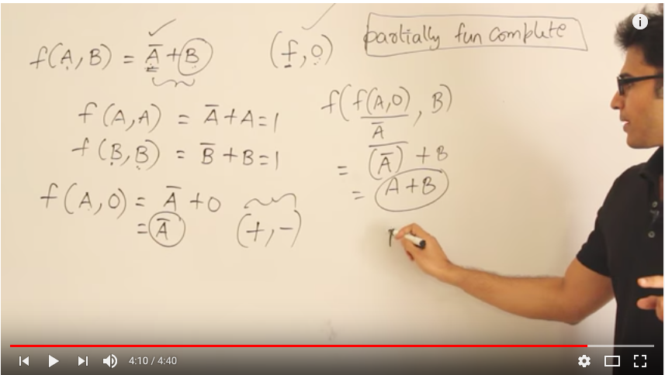

Video 21: EX 3 on Functional Completeness

Video 22: EX 4 on Functional Completeness

Not supposed to give complement as input, so AB+BC+CA can’t be functionally complete

Video 23: EX 5 on Functional Completeness

Video 24: EX 6 on Functional Completeness

Video 25: Self-Dual Functions

Should be a neutral function

Doesn’t contain two mutually exclusive terms

Video 26: Number of Self dual functions

2 pow (2 pow (n-1))

Video 27: Self-Dual functions are closed under complementation

Video 28: Introduction to electronic gates

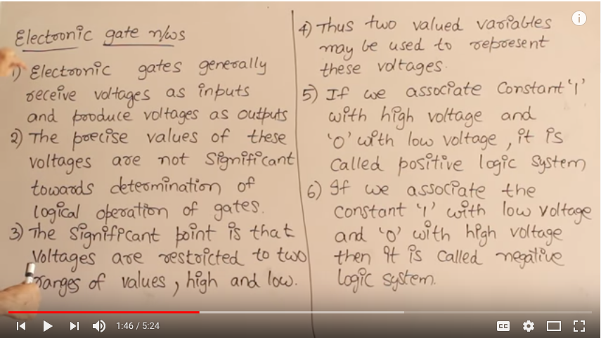

Video 29: Positive and Negative Logic Systems

Duals of each other

Video 30: Introduction of minimization of Boolean Expressions

Video 31: Irredundant or Irreducible Expressions

Minimal isn’t always unique, irreducible can’t always be minimal.

Video 32: K map Introduction

Video 33: K map Simplification

Video 34: Examples on K map

Video 35: Covering functions

A Boolean expression which can’t be reduced further is said to be in minimal form. Each term in it is called prime implicant.