# **MAULANA AZAD NATIONAL INSTITUTE OF TECHNOLOGY**

A Project on ***“ONLINE TICKET BOOKING SYSTEM FOR MULTIPLEXES”***

**Submitted By:-**

**Siddhant Patel (141112210)**

**Vipanshu Jain (141112211)**

**Shubham Gupta (141112243)**

**TABLE OF CONTENTS**

**CHAPTER NO. TITLE PAGE NO.**

1. **1.0 Introduction 1**

**1.1 Objectives**

**2. 2.0 SRS Documentation**

**2.1 DATA REQUIREMENTS**

**2.1.1 USER MODULE**

**2.1.2 ADMIN CONTROL**

**2.2 FUNCTIONAL REQUIREMENTS**

**3. 3.0 UML DIAGRAMS**

**3.1 USECASE DIAGRAM**

**3.2 ACTIVITY DIAGRAM**

**3.3 SEQUENCE DIAGRAM**

**3.4 CLASS DIAGRAM**

**4. 4.0 USER INTERFACE**

**4.1 HOME PAGE**

**4.2 LOGIN PANEL**

**4.3 REGISTRATION PANEL**

**4.4 TICKET BOOKING INTERFACE**

**5. 5.0 LANGUAGE USED**

**5.1 FRONT END**

**5.2 BACK END**

**6. 6.0 CONCLUSION**

**Chapter 1**

**1.0 INTRODUCTION**

**1.1 OBJECTIVES**

Cinema-going is one of the most popular out-of-home cultural activities, affecting a serious of social, economic and cultural phenomena in modern societies. Cinemas are considered to be an integral part of cities and they contribute to the definition of a local geography and identity. They also contribute to the preservation of the collective memory, since they constitute a significant social and cultural practice linked to a specific place, which acts as a common reference or landmark for many individuals. Through this project we present a comprehensive solution for ticket booking in multiplexes. Theatre management system, an online ticket selling software that is easy to understand, easy to use and offers the simplicity of fast point-and-click service to the customers.  
This powerful software program is specifically designed for theatre owners, to sell tickets online. This intuitive visual interface makes day-to-day aspects of selling, exchanging, refunding, and reporting fast and easy for both the user and administrators. Theatre management controls all back-end functionalities like, movie details, ticket rate and show time, customer information and sales history saved in a database, etc. Theatre admin manages the report details like counter wise report, daily, weekly, monthly report and movie report etc.

**Chapter 2**

**2.0 SRS DOCUMENTATION**

**Collection of Requirements:**

Requirements analysis is done in order to understand the problem, which is to  
be solved. That is very important activity for the development of database  
system. The requirements and the collection analysis phase produce both data requirements and functional requirements. The data requirements are used as a source of database design. The data requirements should be specified in as detailed and complete form as possible.  
In parallel with specifying the data requirements, it is useful to specify  
the known functional requirements of the application. These consist of user-defined operations that will be applied to the database (retrievals and updates).  
The functional requirements are used as a source of application software design.

**2.1** **DATA** **REQUIREMENTS**

**2.1.1 User Module:**

❖ **User Registration**  
• User Register with Name, A username (for logging in later), Password,  
 Phone Number, E-mail address.

❖ **User Login**  
• User Can Book the Ticket After Log in.  
• User Login with User Name and Password.  
• Forgot Password use for Retrieve Password.

❖ **Check Availability**  
• After Login, User, Can Search Movie From Movie List.  
• User Can Check Ticket Availability.  
• User can also check the Movie Running Hours.  
• If Ticket is Available User Can Book Ticket.

❖ **Book Ticket.**  
• User can book ticket by specifying username and Phone Number.  
• Then Select Number Of Seats to Book.  
• A conformation Message will be sent to the Given Number. The content  
 of the message is as shown below:-  
 **“Film name-Random 5 letter Code-Show Time”**

**2.1.2 Admin Control:**

❖ **Admin User Login.**  
• Admin User Login with Admin User Name and Password.

❖ **Show Manage.**  
• Admin Can Change Show Name and Show Time.

❖ **Movie Mange.**  
• Admin Can Add New Movie.  
• Admin Can Edit Old Movie Details.  
• Admin Can Delete Movie.

❖ **Schedule Manage.**  
• Admin Can Add New Movie Schedule.  
• Admin Can Edit Movie Schedule.  
• Admin Can Delete Movie Schedule.

❖ **User Manage**  
• Admin can control the signed up users  
• Admin can delete the account of users who didn't show up for the movie  
 after booking tickets.

❖ **Counter Control**  
• Counter Employee Login with Counter User Name and Password..  
• Counter Employee type the message shown by the Customer in the field  
given and confirm the user.  
• Tickets are issued from the Counter.

**2.2 FUNCTIONAL REQUIREMENTS**

1. The schedule of the movies will be generated via a query according to the  
data selected by the user.

2. A way in which users (both customer & admin) can login to the system to  
perform different operation.

3. A way in which the customer can commit order by “Point and Click”  
method.  
4. The system can verify the data before transaction.

**CHAPTER 3**

**3.0 UML DIAGRAMS**

**3.1 USECASE DIAGAM**

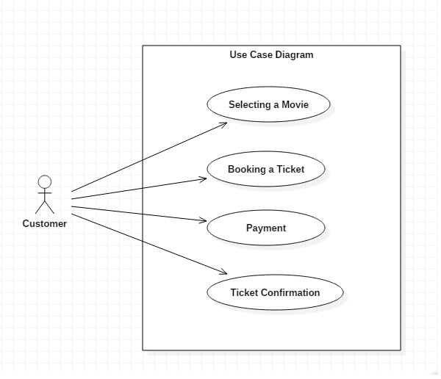

**3.2 ACTIVITY DIAGRAM**

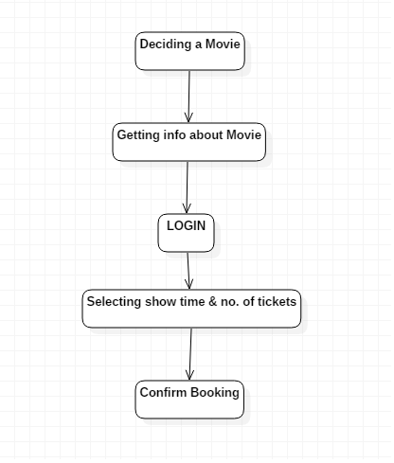

**3.3 SEQUENCE DIAGRAM**

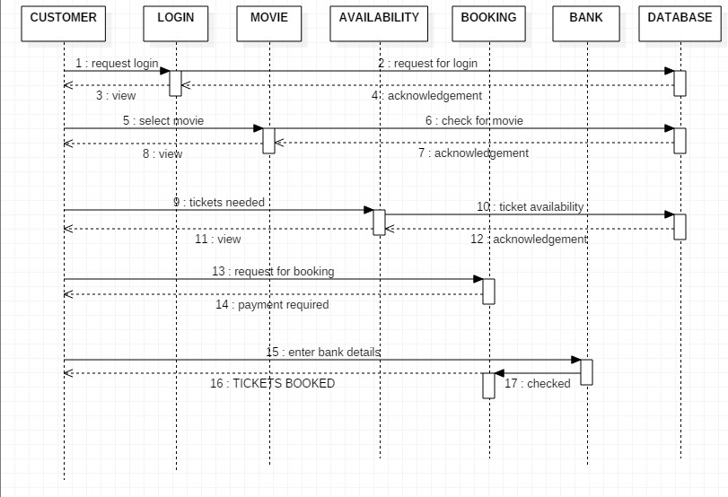

**3.4 Class Diagram**

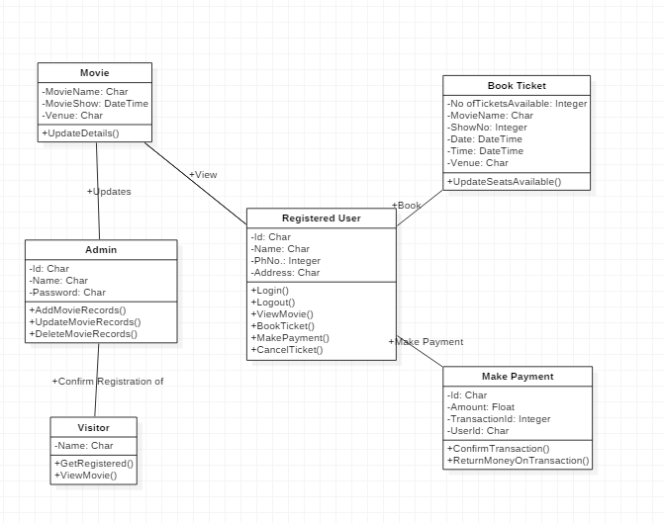

**CHAPTER 4**

**4.0 USER INTEFACE**

**4.1 HOME PAGE**

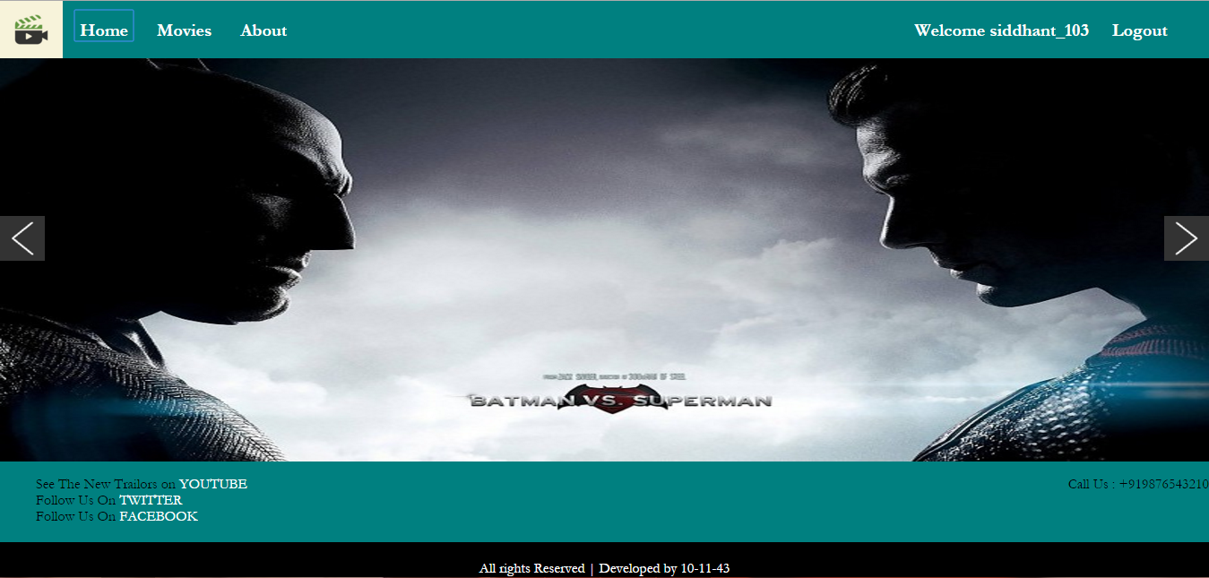

**4.2 LOGIN PANEL**

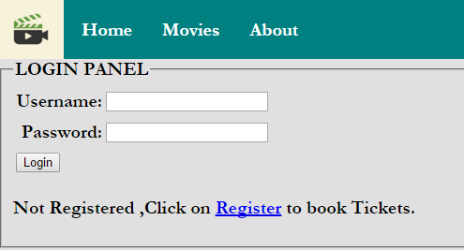

**4.3 REGISTRATION PANEL**

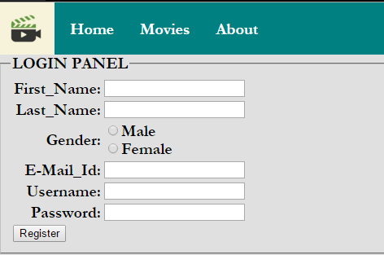

**4.4 TICKET BOOKING INTERFACE**

Here the user can select the no. of tickets for the movie, time of the movie, ticket price. The Mobile number and Email-id provided by the user will be used to send the E-TICKET to the user.

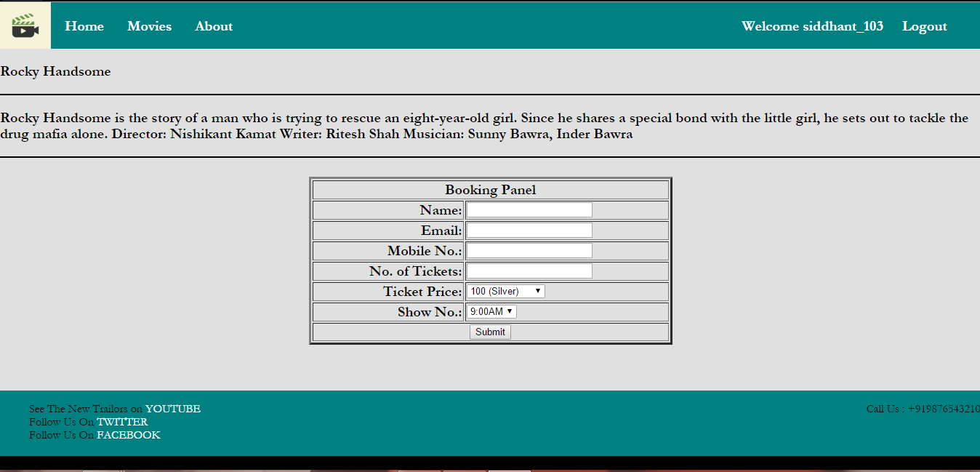

***CHAPTER 5***

***5.0 LANGUAGE USED***

***5.1 FRONT END***

HTML, CSS, JavaScript are utilized to implement the front end.

**HTML** (Hyper Text Markup Language )  
HTML is a syntax used to format a text document on the web.

**CSS** (Cascading Style Sheets)  
CSS is a style sheet language used for describing the look and formatting of a  
document written in a markup language.

***5.2 BACK END***

**PHP**  
PHP is a server-side scripting language designed for web development but also used as a general-purpose programming language. PHP code is interpreted by a web server with a PHP processor module, which generates the resulting web page: PHP commands can be embedded directly into an HTML source document rather than calling an external file to process data.

**MYSQL**  
MySQL is the world’s second most widely used open-source relational database  
management system (RDMS). The SQL phrase stands for structured query.

***CHAPTER 6***

***6.0 CONCLUSION***

Nowadays, traditional ways of ticket reservation is dying. It’s new age  
where technology dominates human life. With the software and technological  
devices, exceptions are reduced and even terminated. Also, people prefer easy,  
quick and safe way for every part of his life. This project is designed to meet the  
requirements of a cinema ticket booking system. It has been developed in PHP  
and the database has been built in My SQL server keeping in mind the  
specifications of the system.

In our project: with this cinema ticketing system; cinema companies can satisfy  
comfortable facilities to their customers. The relationship between cinema  
manager, employee, and customer satisfy a good communication to complete  
ticketing process. With this platform we developed, we are hoping to reduce time  
wasting, avoid misunderstandings, provide easy data flow, customer pleasure,  
and less hard work. We believe that we have accomplished our goals and  
satisfied with the code we developed.