

DBMS PROJECT

Library Management System



Team members

Parepalli Sumanth 17BCE7088

Aditya Jain 17BCE7066

Perumalla Ganesh 17BCE7038

**Requirement Analysis:**

## **Database Requirements**

* Books in the library are uniquely identified by their ISBNs. Details of book like its name, author, total no of books available, total no of books issued and whether its is a reference book.
* Each student is identified uniquely by his registration number and has other attributes like name, branch, email-id and a count of the number of books issued by him/her. The student can issue a max of three books.
* Record of dates of issue and return (which is 14 days after the book is issued) should be maintained and if a student fails to return the book on or before the return date, he/she shall be penalised with certain amount of fine.
* If a student wishes to use the further, he can go for a renewal for another 7 days from the previous due date
* If a student finds a book unavailable, he/she can be on a waiting list (max 10 students) and the students who are ahead in the waiting list will be given more priority than others.

## **Functional Requirements**

* Whenever a student does a transaction, he/she shall be notified with an email.
* When a student fails to return the book by due date, he/she shall be penalised by certain amount of fine that is calculated as follows:

Fine=(sysdate-duedate)*2

* If a book is not available currently, the student may join waiting list of the book and get notified when available.
* Borrower should be notified when the due date is nearby and if he/she has crossed the due date he/she shall be notified regarding that.

# **ENTITY RELATIONSHIP DIAGRAM**



# **ER – Relational Mapping**

**BOOKS**

|  |  |  |  |  |  |
| --- | --- | --- | --- | --- | --- |
| *ISBN* | *Book_Name* | *Author* | *IQty* | *OQty* | *IsReference* |

**STUDENTS**

|  |  |  |  |  |
| --- | --- | --- | --- | --- |
| *Reg.No* | *Name* | *Branch* | *Book_Cnt* | *Email_ID* |

**ISSUE**

|  |  |  |  |
| --- | --- | --- | --- |
| *ISBN* | *Reg.No* | *Issue_Date* | *Due_Date* |

**RETURN**

|  |  |  |  |
| --- | --- | --- | --- |
| *ISBN* | *Reg.No* | *Fine* | *Timestamp* |

**RENEW**

|  |  |  |
| --- | --- | --- |
| *ISBN* | *Reg.No* | *Status* |

**WAIT**

|  |  |  |  |
| --- | --- | --- | --- |
| *ISBN* | *Reg.No* | *Position* | *Emsent* |

# **FOREIGN KEY RELATIONSHIPS**

**BOOKS**

|  |  |  |  |  |  |
| --- | --- | --- | --- | --- | --- |
| *ISBN* | *Book_Name* | *Author* | *IQty* | *OQty* | *IsReference* |

**STUDENTS**

|  |  |  |  |  |
| --- | --- | --- | --- | --- |
| *Reg.No* | *Name* | *Branch* | *Book_Cnt* | *Email_ID* |

**ISSUE**

|  |  |  |  |
| --- | --- | --- | --- |
| *ISBN* | *Reg.No* | *Issue_Date* | *Due_Date* |

**RETURN**

|  |  |  |  |
| --- | --- | --- | --- |
| *ISBN* | *Reg.No* | *Fine* | *Timestamp* |

**RENEW**

|  |  |  |
| --- | --- | --- |
| *ISBN* | *Reg.No* | *Status* |

**WAIT**

|  |  |  |  |
| --- | --- | --- | --- |
| *ISBN* | *Reg.No* | *Position* | *Emsent* |

# Normalisation

* All the tables are already in Boyce Codd Normal form and hence no further normalisation is required.

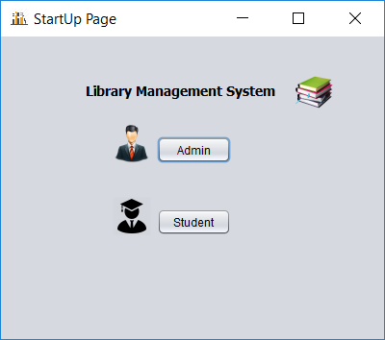

This is the page that appear on the screen as soon as the project is executed. In this frame, the user needs to select the login method.

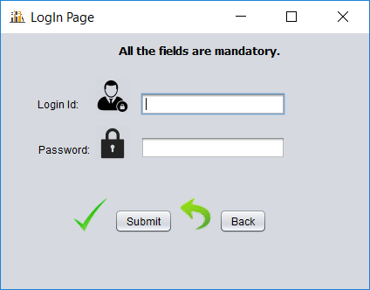

When the user clicks the admin button, it will be redirected to this page where he/she needs to enter the admin username and password to continue.

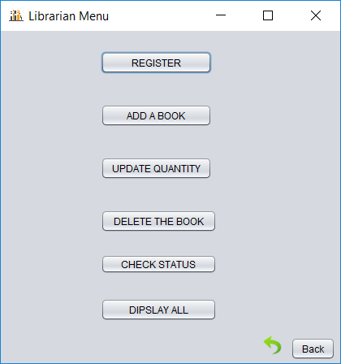

After successful login, admin can choose whatever action he wants to perform in this frame.

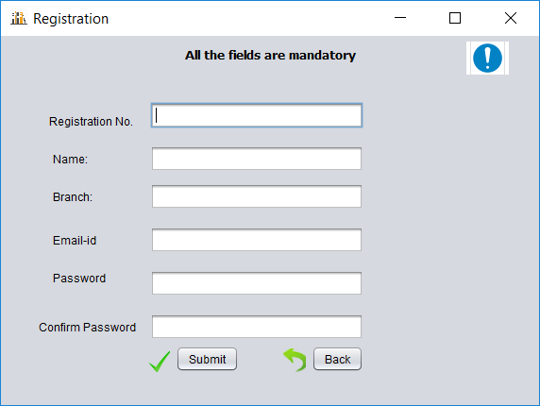

When admin chooses the register option, he/she will be redirected to this frame where he/she can add the details of the student to be registered and the student will receive an email about the registration and rules of the library.

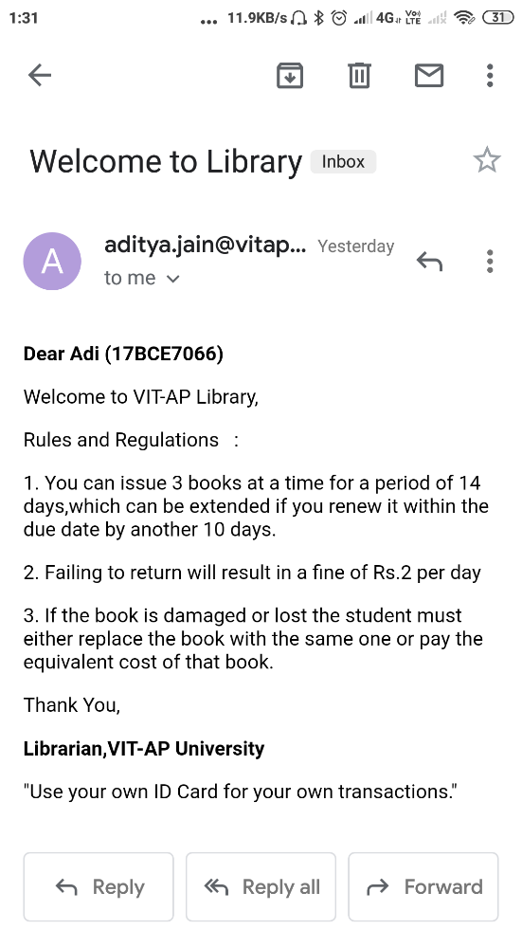

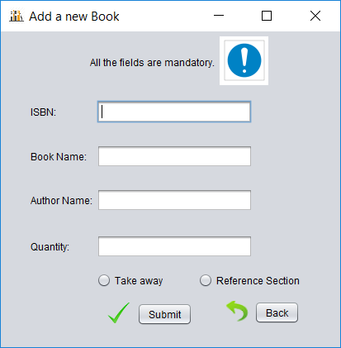When admin selects the option to add a new book, he/she will be redirected to this page. In this page he/she can add details of the book to be added.

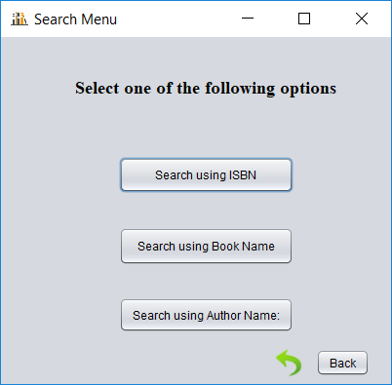

This is the search menu accessible for both admin and registered user to make the searching of the book faster and easier.

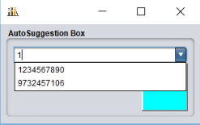

When a user selects to search by ISBN, he/she will be redirected to this frame which can help you in searching through auto suggestion feature.

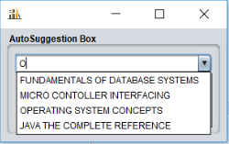

When a user selects to search by book name, he/she will be redirected to this frame which can help you in searching through auto suggestion feature.

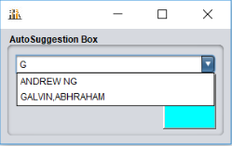

When a user selects to search by author name, he/she will be redirected to this frame which can help you in searching through auto suggestion feature.

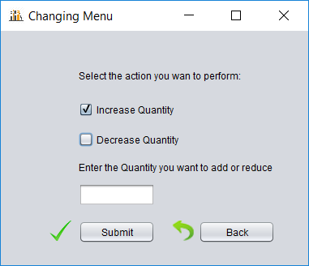

When admin selects to update the quantity, he/she will be redirected to search menu and from there he/she will be redirected to the above frame where admin can either increase or decrease quantity.

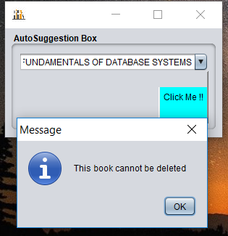

When admin selects to delete a book, he/she can use the feature of search with auto suggestion to select the book to be deleted and if the book is not issued by any of the students, the book is allowed to be deleted.

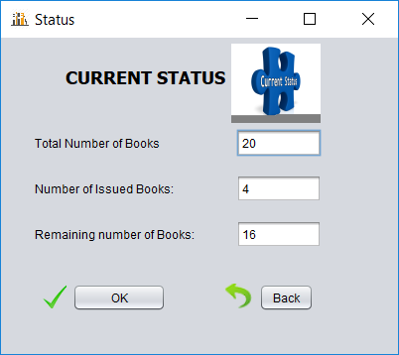

When the admin selects to check status, he/she will be redirected to the above frame where the number of books issued, available and remaining number of books in the library will be shown. This option is to give a brief summary of the library to the librarian.

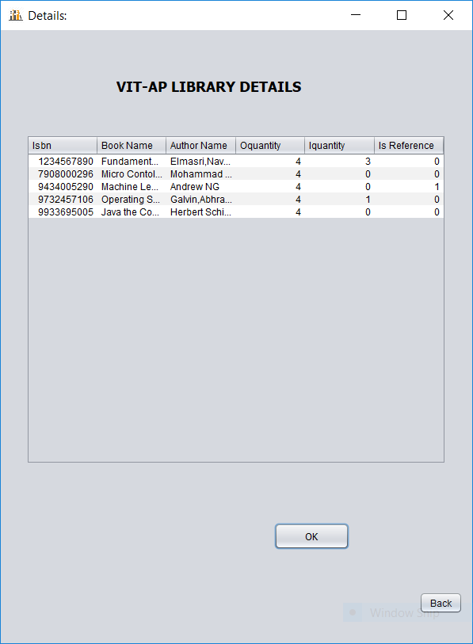

When the admin selects the Display All option in the Librarian Menu, he/she will get a detailed description of every book in the library like how many copies of that book are present in the library and how many copies of that book are issued etc.

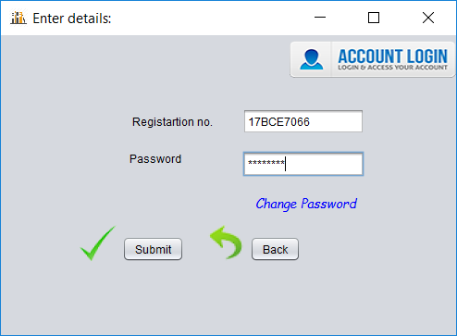

When the user selects the Student Login option in the student will be directed to the above frame. In this frame the student is required to enter the registration number and the password. On successful authentication the student will be directed to the Student Menu otherwise relevant message is displayed.

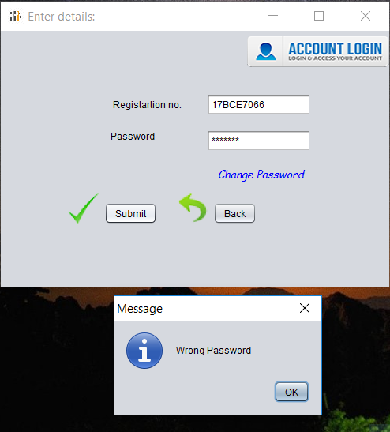

The above message is displayed if the password entered is incorrect. If the student has forgotten the password and wishes to change it then the student can choose the Change Password option.

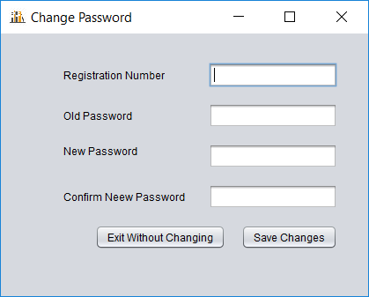

The student can fill the details in the above frame and the password will be changed

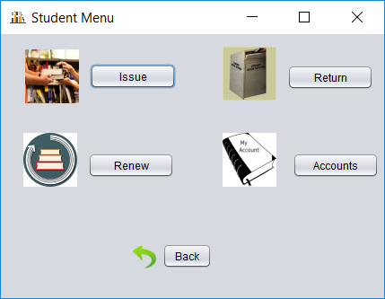

After successful authentication the above frame is shown to the student, from this frame the student can choose the required operation needed to perform.

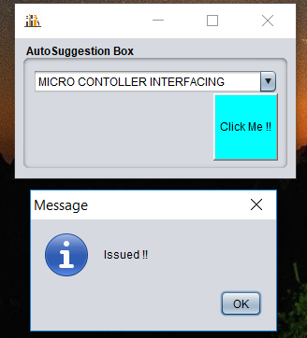

When the student selects the issue option, he/she will be re-directed to the Search Menu frame and the student can utilize the auto suggestion feature to search for the book that the student needs to issue and if the book is available the books is issued and the student will also receive an email notification about it.

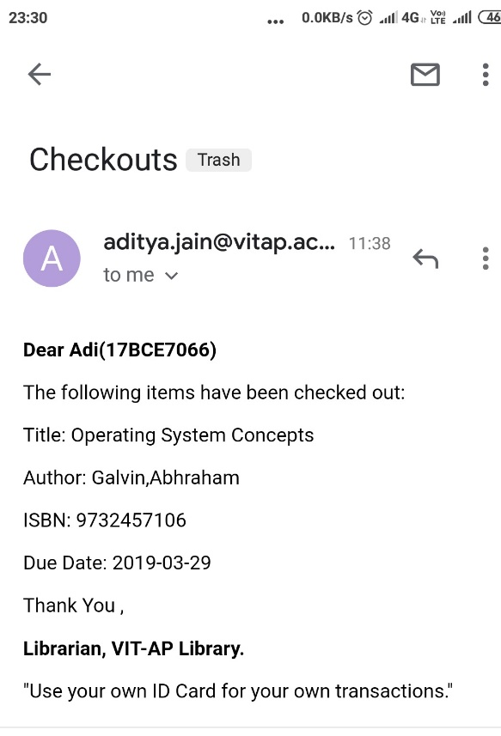

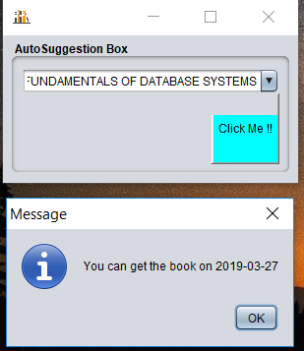

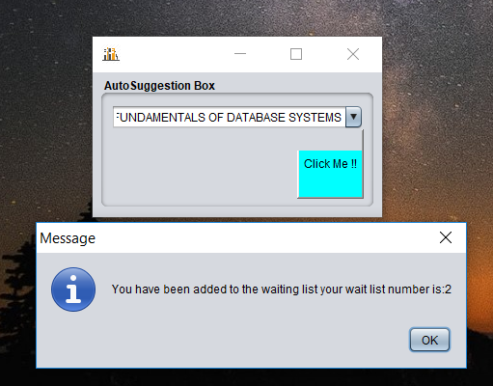

If the book which the student wants to issue is out of stock the system will show the expected date when the book will be available again and the student will also be given an option to stay on the waiting list for that book so that when that book is in stock, he/she will be given priority.

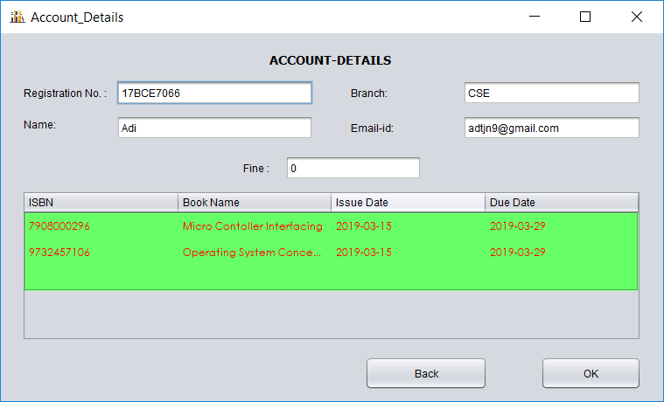

When the student selects the Account option in the Student Menu, he/she can view the information regarding the books issued, their respective due dates and fine accumulated for the student.

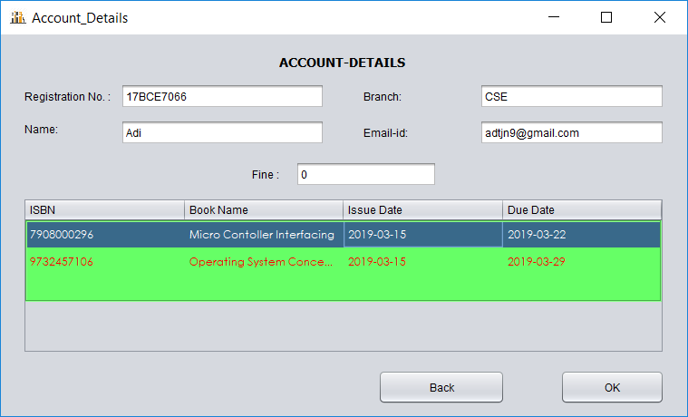

When the student selects the Renew option, a frame similar to the Account frame will appear but here the student can select the book which is to be renewed and then click on renew button and the book will be renewed and the student will be intimidated as well 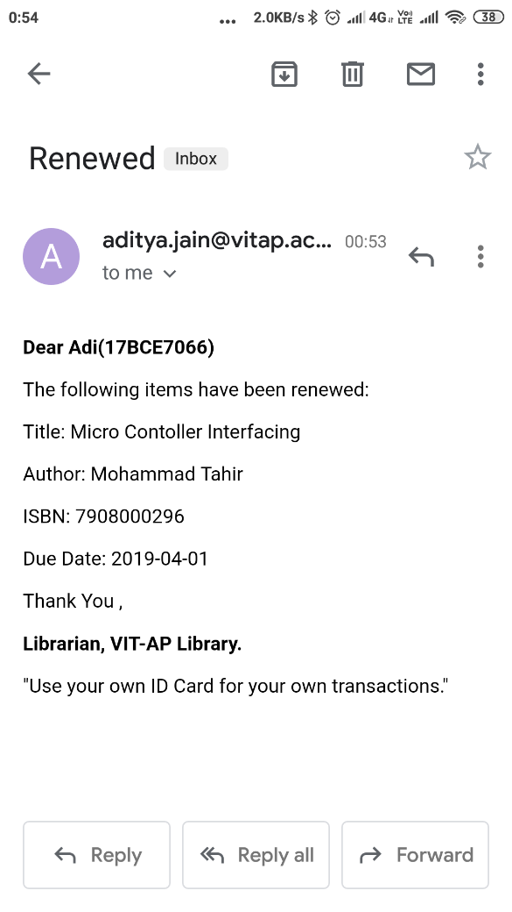

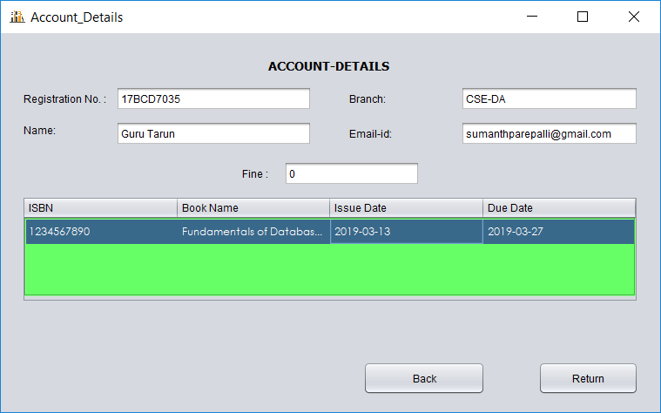

When the student selects the return option, a frame similar to the Account frame will appear but here the student can select the book which is to be returned and then click on renew button and the book will be renewed and the student will be intimidated. Here we perform another operation viz. to inform the student in the waiting list that the wait list book is now available.

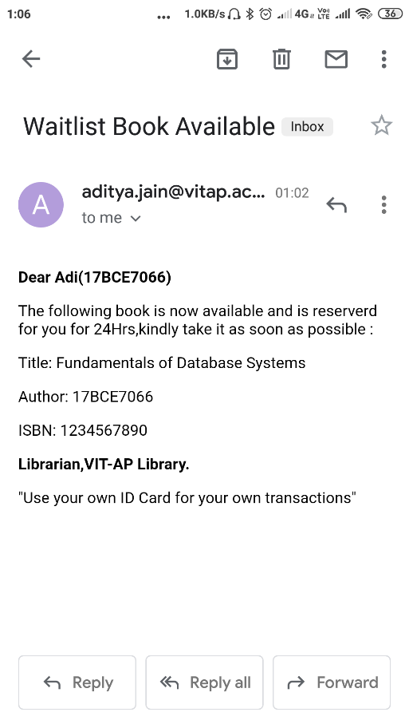

This email is for the student who is at the beginning at the waiting list for that book.

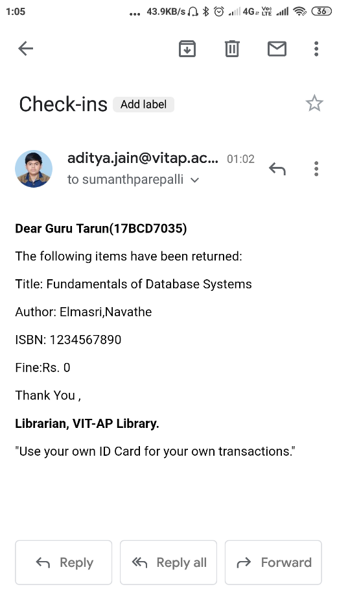

This email is for the student who returns the book

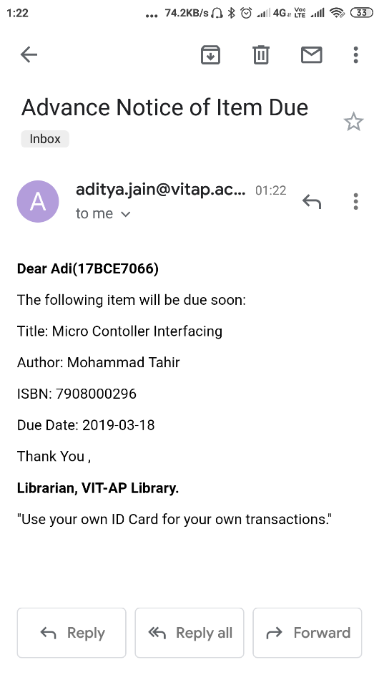

When the due date of a book for a student is nearing a reminder regarding the same will be sent to the student two days prior to the due-date. The program parses through the database and sends similar email to the students for whom the above stated condition is met. It also notifies students who have crossed the due date for their issued books but have neither returned nor renewed their books