**Acropolis Institute Of Technology And Research,**

**Indore(M.P.)**

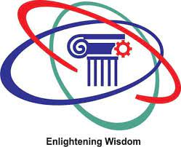

**Subject – Database Management System (DBMS)**

**(CY-405)**

**Name – Aditya Jaiswal**

**Enrollment No. - 0827CY221005**

**Branch - CS(Cyber Security)**

**Semester- 4th sem**

**Submitted To –Mrs. Nidhi Nigam Ma’am**

**Index**

|  |  |  |  |  |
| --- | --- | --- | --- | --- |
| **Sr.No.** | **Experiment** | **Date of Exp.** | **Date of sub.** | **Grade** |
| 1. | To study DBMS and RDBMS, its characteristic comparisons and study of popular DB software. | 11/03/24 | /03/24 |  |
|  |  |  |  |  |
|  |  |  |  |  |
|  |  |  |  |  |
|  |  |  |  |  |
|  |  |  |  |  |
|  |  |  |  |  |
|  |  |  |  |  |
|  |  |  |  |  |
|  |  |  |  |  |
|  |  |  |  |  |
|  |  |  |  |  |

**Experiment-1**

**AIM:-**

To study DBMS and RDBMS, its characteristic comparisons and study of popular DB software.

**Database Management System(DBMS):-**

Database Management Systems (DBMS) are software systems used to store, retrieve, and run queries on data. A DBMS serves as an interface between an end-user and a database, allowing users to create, read, update, and delete data in the database.

## **Applications of DBMS**

* **Enterprise Information:** Sales, accounting, human resources, Manufacturing, online retailers.
* **Banking and Finance Sector:** Banks maintaining the customer details, accounts, loans, banking transactions, credit card transactions. Finance: Storing the information about sales and holdings, purchasing of financial stocks and bonds.
* **University:** Maintaining the information about student course enrolled information, student grades, staff roles.
* **Airlines:** Reservations and schedules.
* **Telecommunications:** Prepaid, postpaid bills maintance.

**Features:-**

* **Data modeling:** A DBMS provides tools for creating and modifying data models, which define the structure and relationships of the data in a database.
* **Data storage and retrieval:** A DBMS is responsible for storing and retrieving data from the database, and can provide various methods for searching and querying the data.
* **Concurrency control:** A DBMS provides mechanisms for controlling concurrent access to the database, to ensure that multiple users can access the data without conflicting with each other.
* **Data integrity and security:** A DBMS provides tools for enforcing data integrity and security constraints, such as constraints on the values of data and access controls that restrict who can access the data.
* **Backup and recovery:** A DBMS provides mechanisms for backing up and recovering the data in the event of a system failure.

**Functions Of DBMS:-**

1. Data Organization
2. Data Independency
3. Data Security
4. Data Integrity

TYPES OF DBMS

There are various types of databases used for storing different varieties of data:

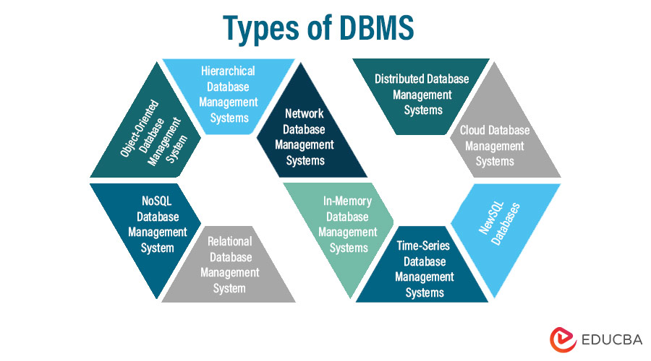

## 1) Centralized Database

It is the type of database that stores data at a centralized database system. It comforts the users to access the stored data from different locations through several applications. These applications contain the authentication process to let users access data securely. An example of a Centralized database can be Central Library that carries a central database of each library in a college/university.

## 2) Distributed Database

Unlike a centralized database system, in distributed systems, data is distributed among different database systems of an organization. These database systems are connected via communication links. Such links help the end-users to access the data easily. **Examples** of the Distributed database are Apache Cassandra, HBase, Ignite, etc.

## 3) Relational Database

This database is based on the relational data model, which stores data in the form of rows(tuple) and columns(attributes), and together forms a table(relation). A relational database uses SQL for storing, manipulating, as well as maintaining the data. E.F. Codd invented the database in 1970. Each table in the database carries a key that makes the data unique from others. **Examples** of Relational databases are MySQL, Microsoft SQL Server, Oracle, etc.

## 4) NoSQL Database

Non-SQL/Not Only SQL is a type of database that is used for storing a wide range of data sets. It is not a relational database as it stores data not only in tabular form but in several different ways. It came into existence when the demand for building modern applications increased. Thus, NoSQL presented a wide variety of database technologies in response to the demands. We can further divide a NoSQL database into the following four types:

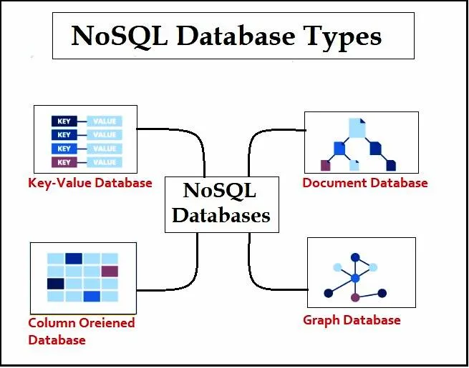

## 5) Cloud Database

A type of database where data is stored in a virtual environment and executes over the cloud computing platform. It provides users with various cloud computing services (SaaS, PaaS, IaaS, etc.) for accessing the database. There are numerous cloud platforms, but the best options are:

* Amazon Web Services(AWS)
* Microsoft Azure
* Kamatera
* PhonixNAP
* ScienceSoft
* Google Cloud SQL, etc.

## 6) Object-oriented Databases

The type of database that uses the object-based data model approach for storing data in the database system. The data is represented and stored as objects which are similar to the objects used in the object-oriented programming language.

## 7) Hierarchical Databases

It is the type of database that stores data in the form of parent-children relationship nodes. Here, it organizes data in a tree-like structure.

Data get stored in the form of records that are connected via links. Each child record in the tree will contain only one parent. On the other hand, each parent record can have multiple child records.

## 8) Network Databases

It is the database that typically follows the network data model. Here, the representation of data is in the form of nodes connected via links between them. Unlike the hierarchical database, it allows each record to have multiple children and parent nodes to form a generalized graph structure.

**Relational Database Management System(RDBMS):-**

A RDBMS is a form of DBMS that stores and manages facts in a tabular format, prepared as tables with rows and columns. It is based on the relational version proposed via Edgar F. Codd within the 1970s. RDBMS is widely used because of its simplicity, scalability, and efficiency in dealing with complicated relationships between entities.

**Functions Of RDBMS:-**

1. Data Structure
2. ACID Compliance
3. Query Language
4. Scalability

**Applications Of RDBMS:-**

1. Enterprise Applications
2. Web Applications
3. Scientific Research
4. Government Systems

**Comparison between DBMS and RDBMS:-**

|  |  |  |
| --- | --- | --- |
| **No.** | **DBMS** | **RDBMS** |
| 1. | DBMS applications store **data as file**. | RDBMS applications store **data in a tabular form**. |
| 2. | There is **no relation between the tables.** | Data values are stored in the form of tables, so a **relationship** between these data values will be stored in the form of a table as well. |
| 3. | **Does not support distributed database.** | **Supports distributed database.** |
| 4. | Deals with **small amount of data.** | Deals **with large amount of data.** |
| 5. | For **single user.** | For **multiple users.** |
| 6. | Less secure. | More Secure. |
| 7. | Data Redundancy is common. | No. Data Redundancy due to Keys and indexes. |
| 8. | Less than 7 Codd rules are satisfied. | More than 7 or all 12 Codd rules are satisfied. |
| 9. | Data fetching is slower. | Data fetching is faster. |
| 10. | Low software and hardware necessities. | Higher software and hardware necessities. |
| 11. | Ex:- Xml | Ex:- MySQL, Microsoft Access |

## **MySQL is a relational database management system**

[Databases](https://www.oracle.com/in/database/what-is-database/) are the essential data repository for all software applications. For example, whenever someone conducts a web search, logs in to an account, or completes a transaction, a database system is storing the information so it can be accessed in the future.

A [relational database](https://www.oracle.com/in/database/what-is-a-relational-database/) stores data in separate tables rather than putting all the data in one big storeroom. The database structure is organized into physical files optimized for speed. The logical data model, with objects such as data tables, views, rows, and columns, offers a flexible programming environment. You set up rules governing the relationships between different data fields, such as one to one, one to many, unique, required, or optional, and “pointers” between different tables. The database enforces these rules so that with a well-designed database your application never sees data that’s inconsistent, duplicated, orphaned, out of date, or missing.

The “SQL” part of “MySQL” stands for “Structured Query Language.” SQL is the most common standardized language used to access databases. Depending on your programming environment, you might enter SQL directly (for example, to generate reports), embed SQL statements into code written in another language, or use a language-specific API that hides the SQL syntax.

**Characteristic Comparison between SQL and NoSQL:-**

|  |  |  |
| --- | --- | --- |
| **No.** | **SQL** | **NoSQl** |
| 1. | RDBMS | Non-relational Or Distributed database system. |
| 2. | Fixed or static or pre-defined schema. | Dynamic Schema. |
| 3. | Not for hierarchical data storage. | For hierarchical data storage. |
| 4. | Follows ACID property. | Does not follows ACID property. |
| 5. | Ex:- MySQL, Oracle | Ex:-MongoDB,HBase |