STORY DESIGN FILE
India's Agricultural Crop Production Analysis
Tableau Story – Final Project

Student Name | Aditya Jathar
Branch | AI&DS
Roll No. | 26
Project Name | India's Agricultural Crop Production Analysis

Story Objective The Tableau Story presents the agricultural production analysis as a logical sequence, starting with an overall project overview and then moving through geographic, crop-wise, season-wise, state-wise, and year-wise analysis.

1. Story Overview
Purpose: To communicate the major findings from the agricultural crop production dataset through six connected Tableau story points. The story helps the viewer move from a high-level overview to detailed comparisons and trends.
Dataset coverage: The project analyzes Indian agricultural crop production data covering the years 1997–2021, with 345,408 records and 10 columns.

2. Story Structure

Story Point 1 – Agricultural Overview
Uses the completed project dashboard to provide the overall view of agricultural production and yield. It introduces the key performance indicators and the main visualizations used in the project.
- Total Agricultural Production: 325,928,229,343
- Total Agricultural Yield: 2,897,372,561
- Provides the starting point for the remaining detailed analyses.

Story Point 2 – Geographic Distribution of Agricultural Production
Uses the State-wise Production Map to show how agricultural production is distributed across Indian states. The map provides a geographic perspective and helps identify differences in production levels between states.
- State-level production varies considerably across the dataset.
- The visualization makes regional production patterns easier to compare.

Story Point 3 – Crop-wise Agricultural Production Analysis
Uses the Crop-wise Production horizontal bar chart to compare total production across crops.
- Coconut is the dominant crop in the project dataset, with approximately 306.23 billion production units.
- The horizontal bar chart makes the production difference between crops easy to interpret.

Story Point 4 – Season-wise Agricultural Production Analysis
Uses the Season-wise Production Share pie chart to examine how production is distributed among Autumn, Kharif, Rabi, Summer, Whole Year, and Winter seasons.
- Whole Year accounts for the largest share, approximately 313.13 billion production units.
- Rabi contributes approximately 4.15 billion production units.
- The remaining seasons contribute comparatively smaller shares.

Story Point 5 – State-wise Agricultural Production Comparison
Uses the Leading States by Production bar chart to compare total production among Indian states.
- Kerala is the leading state in the project analysis.
- Tamil Nadu and Karnataka follow Kerala among the leading states.
- The bar chart provides a direct ranking for state-level comparison.

Story Point 6 – Year-wise Agricultural Production Trend (1997–2021)
Uses the Year-wise Production bar chart to show how total agricultural production changes from 1997 to 2021.
- Production varies across years rather than remaining constant.
- The year-wise view helps identify higher and lower production periods.
- The separate yield trend visualization shows a noticeable yield spike around 2017.

3. Story Narrative / Flow
- Start with the Agricultural Overview to establish the total production and total yield.
- Move to the Geographic Distribution view to understand where production is concentrated.
- Analyze Crop-wise Production to identify the crops contributing most to total production.
- Analyze Season-wise Production Share to understand the seasonal distribution.
- Compare Leading States to identify the strongest producing states.
- Finish with the Year-wise Production Trend to understand changes in agricultural production over 1997–2021.

4. Key Observations
- Total agricultural production in the dataset is 325,928,229,343 production units.
- Total agricultural yield is 2,897,372,561.
- Coconut is the dominant crop in the crop-wise production analysis, contributing approximately 306.23 billion production units.
- Whole Year is the dominant season category, with approximately 313.13 billion production units.
- Kerala is the leading state by total production, followed by Tamil Nadu and Karnataka.
- Year-wise production shows considerable variation over the 1997–2021 period.
- The yield trend contains a noticeable spike around 2017.
- The story combines KPI, map, bar-chart, pie-chart, and trend-based visualizations to communicate the findings progressively.

5. Story Design and Presentation
- The story follows a logical progression from overview to detailed analysis.
- Each story point focuses on one analytical question and uses the most suitable visualization from the completed Tableau project.
- The story is designed to make complex agricultural data easier to understand for students, analysts, and other viewers.
- The dashboard acts as the entry point, while the remaining story points provide focused analytical views.

6. Activity 2 – Tableau Public Publishing
Public Tableau Story Link: To be added after publishing the final Tableau Story on Tableau Public.
Note: No Tableau Public URL has been inserted because a verified public URL was not provided.

7. Project Information for Submission
Date | 07 October 2026
Team ID | To be filled
Project Name | India's Agricultural Crop Production Analysis
Maximum Marks | 5 Marks (Story activity)
Technology | Tableau / Tableau Public

8. Conclusion
The completed Tableau Story successfully converts the agricultural production dataset into a structured analytical narrative. It begins with overall production and yield, then explains geographic distribution, crop contribution, seasonal share, state-level ranking, and year-wise changes. This sequence allows the audience to understand both the overall scale and the major patterns present in India's agricultural crop production data.

9. Screenshot Placeholders
Figure 1: Story Point 1 – Agricultural Overview
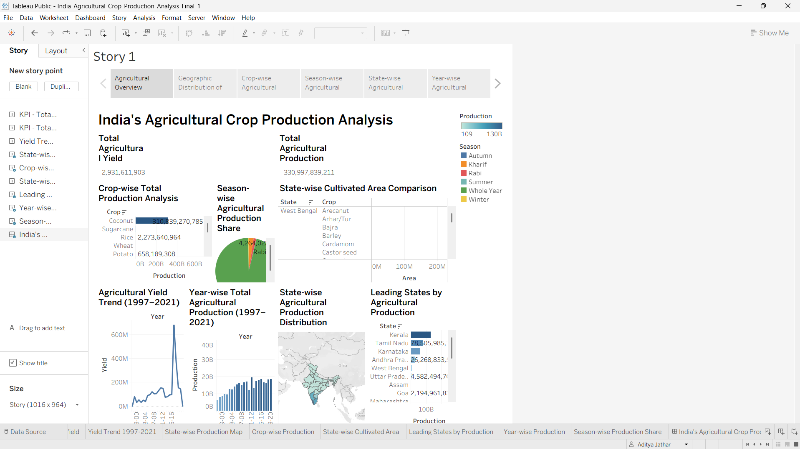 Figure 2: Story Point 2 – Geographic Distribution of Agricultural Production
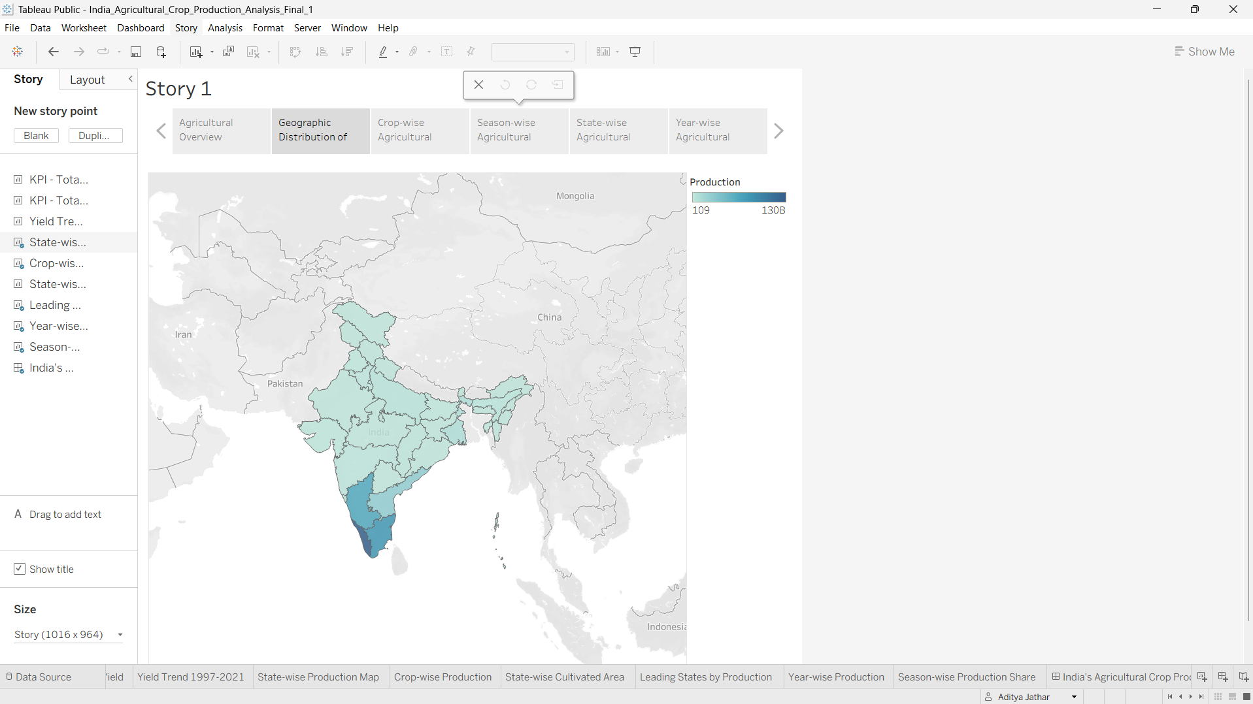 Figure 3: Story Point 3 – Crop-wise Agricultural Production Analysis
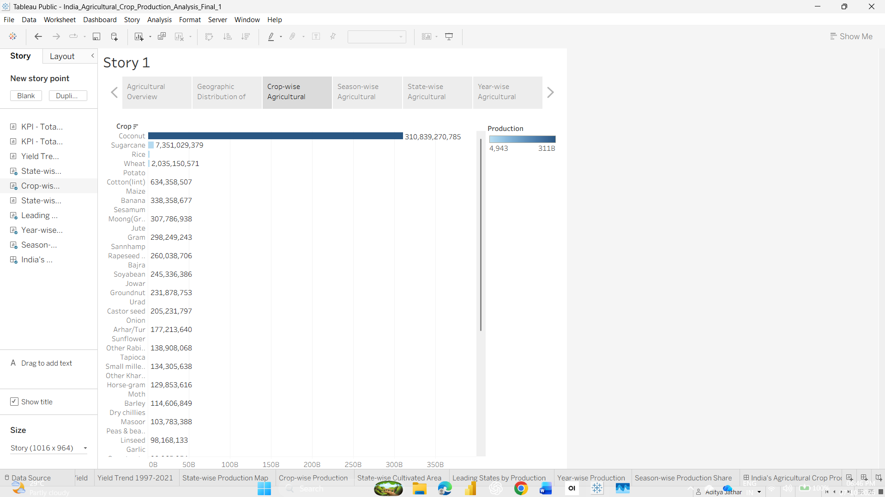 Figure 4: Story Point 4 – Season-wise Agricultural Production Analysis
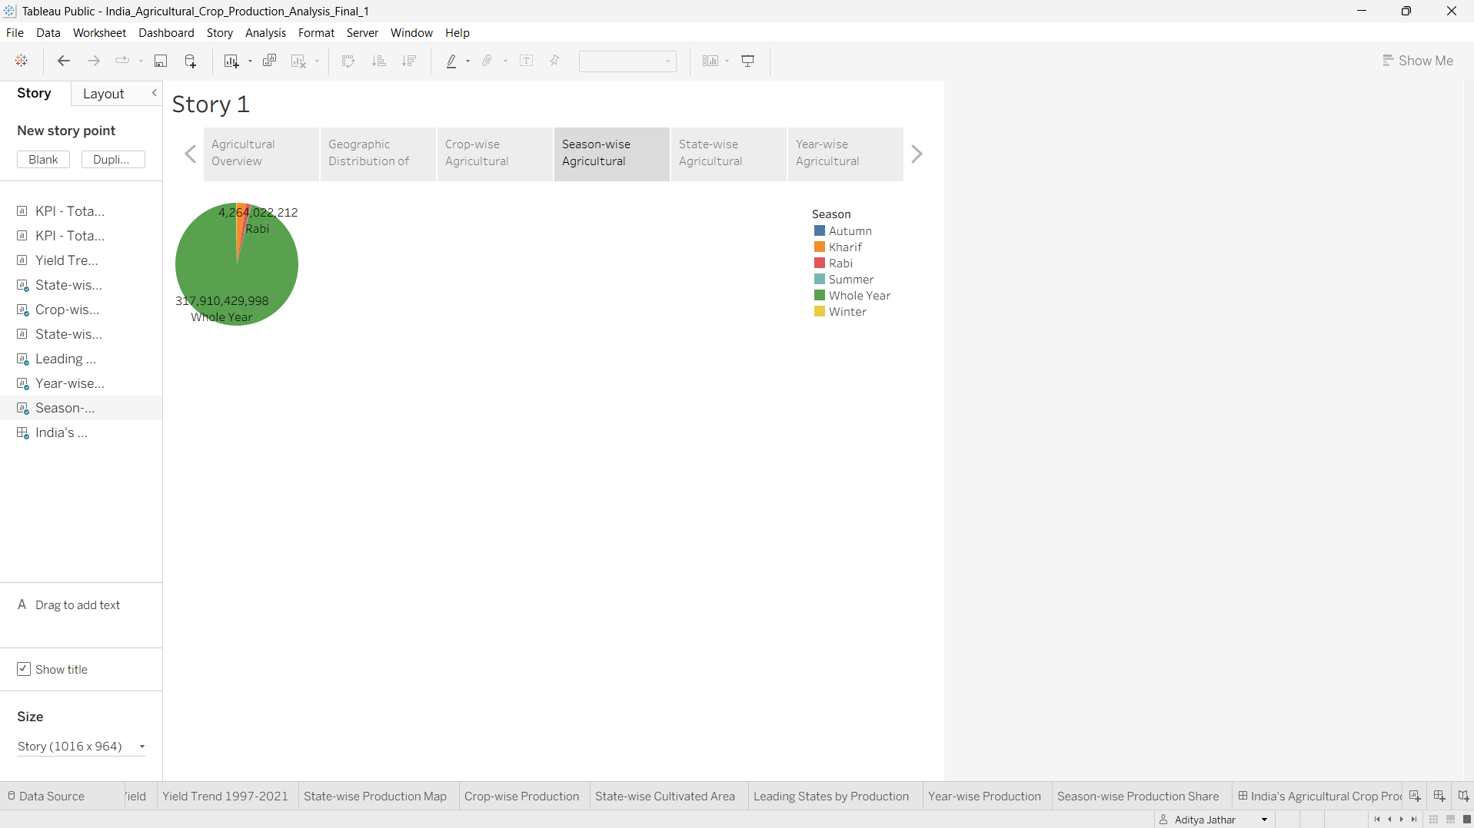 Figure 5: Story Point 5 – State-wise Agricultural Production Comparison
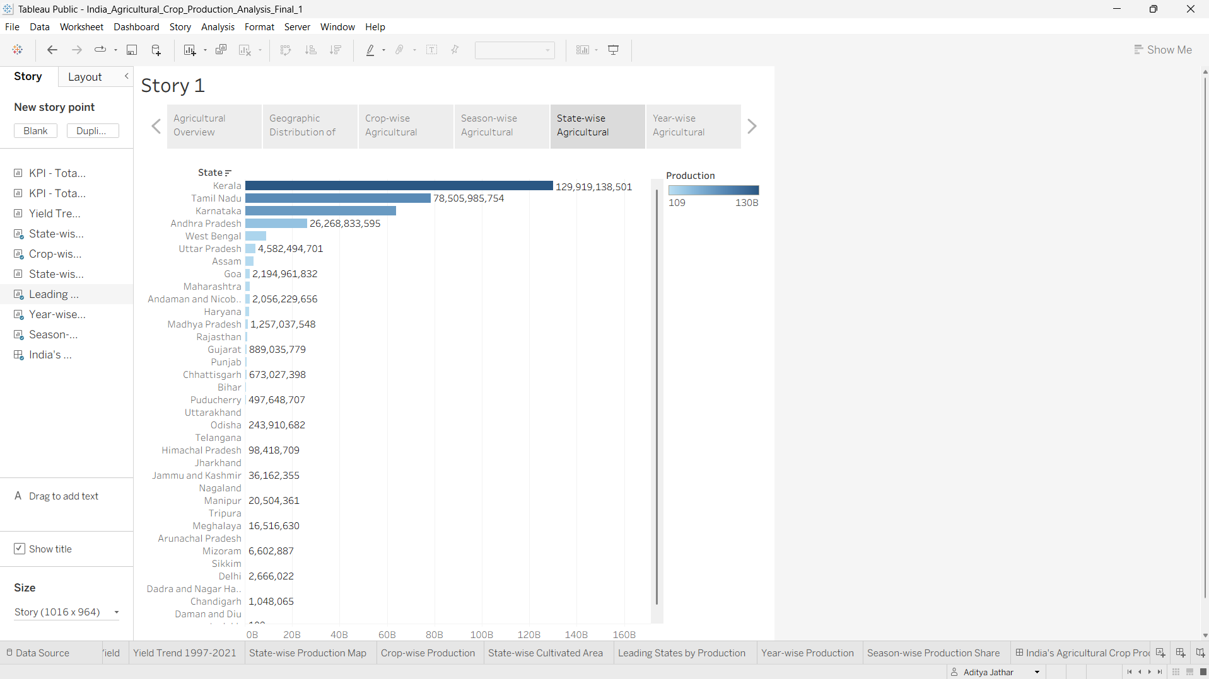 Figure 6: Story Point 6 – Year-wise Agricultural Production Trend (1997–2021)
