Date | 7 October 2026
Team ID | individual
Project Name | India's Agricultural Crop Production Analysis
Maximum Marks | 5 Marks

Story
India's Agricultural Crop Production Analysis
Story Overview
The Tableau Story for India's Agricultural Crop Production Analysis presents the project's major findings in a logical sequence. It starts with an overall agricultural overview, moves through geographic distribution, crop-wise and season-wise analysis, compares leading states, and concludes with year-wise production trends from 1997 to 2021.
Story Structure
Story Point 1 – Agricultural Overview
The complete project dashboard is used as the opening story point. It introduces the overall agricultural scale through the Total Agricultural Production and Total Agricultural Yield KPI tiles and provides the audience with the main analytical views.
[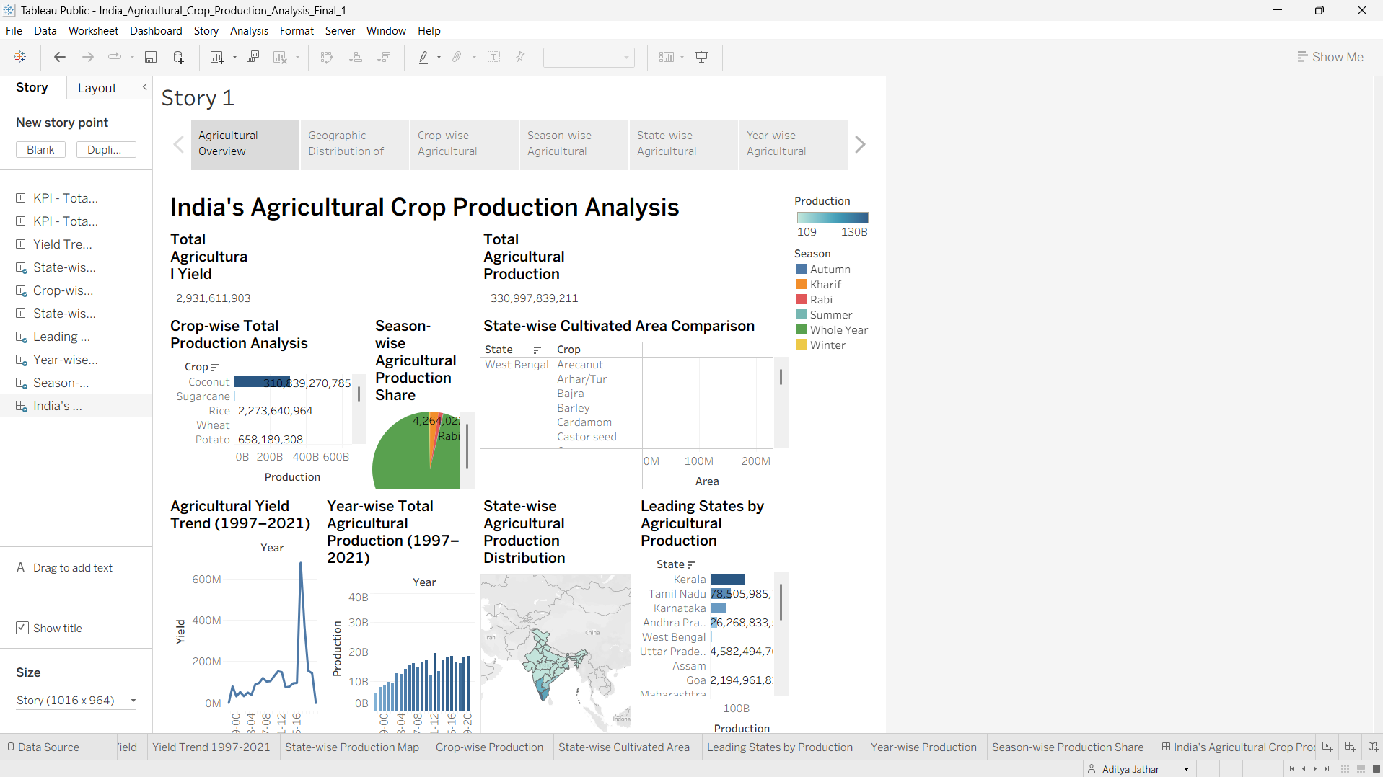Story Point 2 – Geographic Distribution of Agricultural Production
The State-wise Production Map is used to show how agricultural production is distributed across Indian states. The map provides a geographic perspective of production intensity.
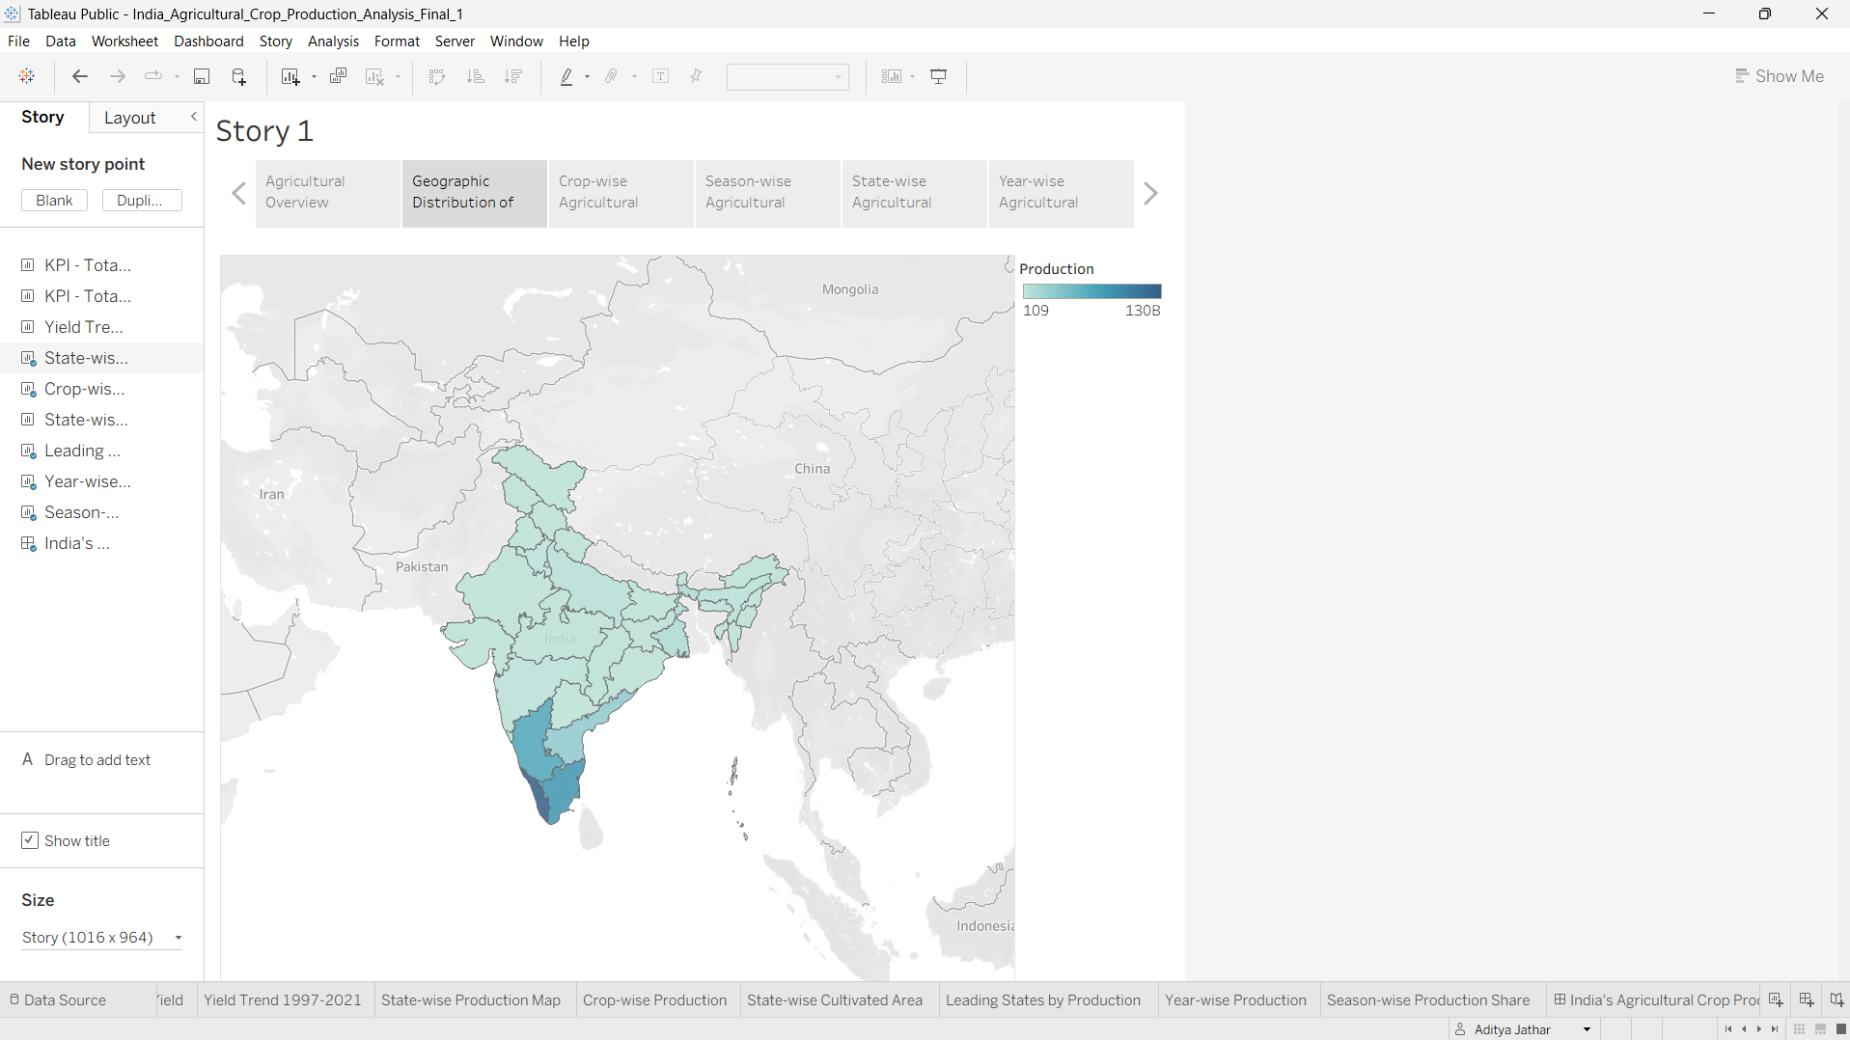
Story Point 3 – Crop-wise Agricultural Production Analysis
The Crop-wise Production horizontal bar chart compares total agricultural production across crop categories and helps identify the dominant crop contributors.
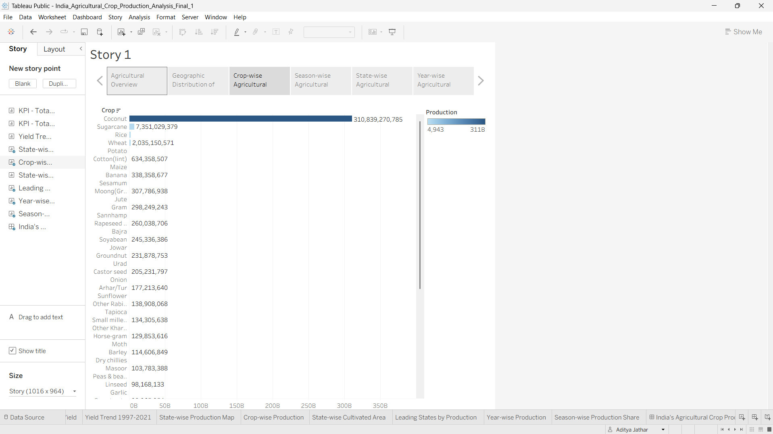 ]
Story Point 4 – Season-wise Agricultural Production Analysis
The Season-wise Production Share pie chart shows the share of total agricultural production across Autumn, Kharif, Rabi, Summer, Whole Year and Winter categories.
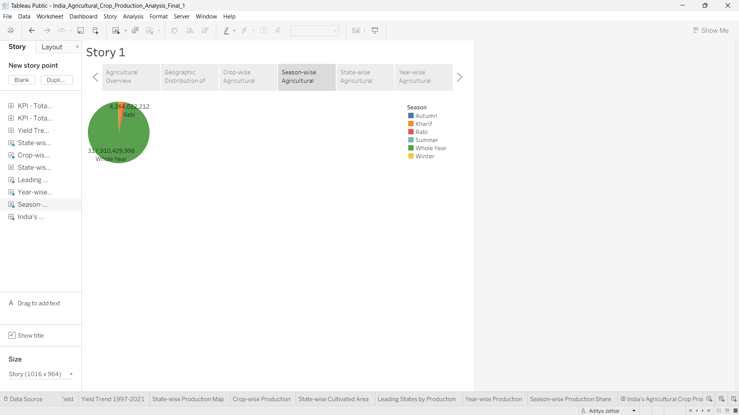
Story Point 5 – State-wise Agricultural Production Comparison
The Leading States by Production bar chart ranks states by agricultural production and allows the audience to compare the leading producing states.
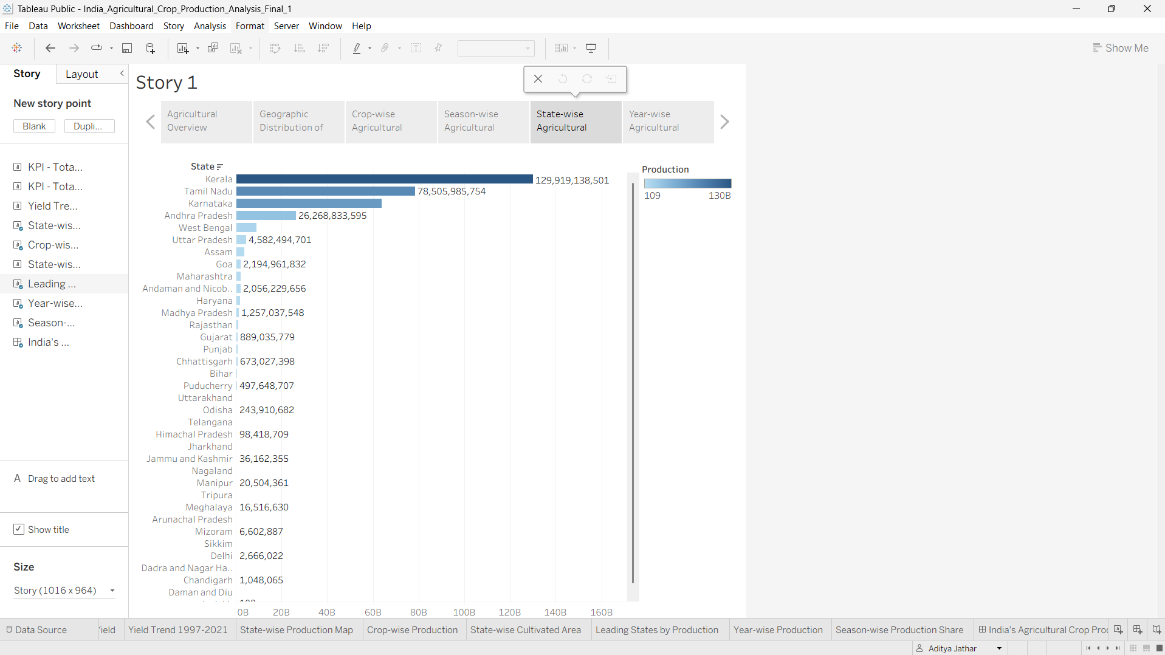
Story Point 6 – Year-wise Agricultural Production Trend (1997–2021)
The Year-wise Production bar chart concludes the story by comparing total agricultural production for each year from 1997 to 2021.
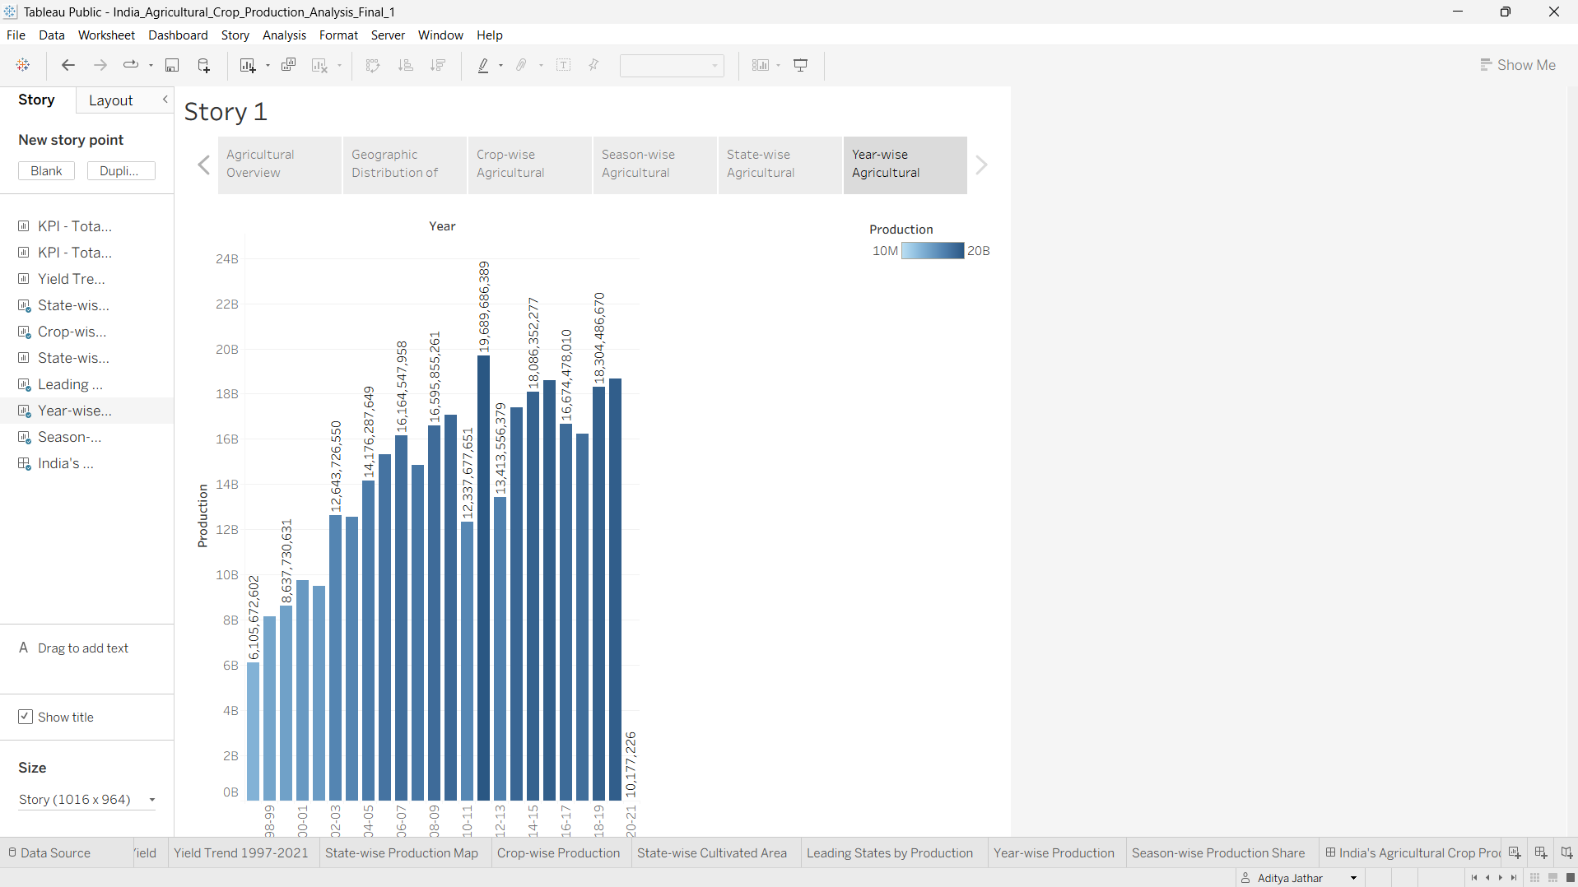
Observations
• Overall Agricultural Scale: The dashboard reports Total Agricultural Production of 325,928,229,343 and Total Agricultural Yield of 2,897,372,561.
• Geographic Distribution: The state-wise production map shows clear differences in agricultural production intensity across Indian states.
• Crop Contribution: The crop-wise production analysis identifies Coconut as the dominant crop in the displayed production comparison.
• Seasonal Distribution: Whole Year is the dominant category in the displayed season-wise production share, followed by the other seasonal categories.
• Leading States: The state comparison identifies Kerala as the leading state in the displayed production ranking, followed by Tamil Nadu and Karnataka.
• Year-wise Pattern: The year-wise production visualization shows substantial variation in total agricultural production across 1997–2021.
• Yield Pattern: The agricultural yield trend shows strong year-to-year variation, including a prominent spike around 2017.
• Interactive Exploration: State, Crop and Production filters support focused exploration of the agricultural data.
Story Narrative
The story follows a progression from broad context to detailed comparison. The first point establishes the overall scale of the agricultural dataset. The second identifies geographic differences. The third and fourth explain production by crop and season. The fifth compares state-level production, while the sixth concludes with the year-over-year production pattern. This sequence helps the audience understand the data from overview to detailed trends.
Activity 2: Publish Story on Tableau Public
Public Tableau Story link: https://public.tableau.com/app/profile/aditya.jathar/viz/India_Agricultural_Crop_Production_Analysis_Final_1/Story1?publish=yes
To be added after publishing the final Story on Tableau Public.
The supplied project materials did not include the final public Tableau Story URL, so no URL has been invented. After publishing the completed Story, paste the generated Tableau Public link here.
Conclusion
The six-point Tableau Story communicates India's agricultural production analysis through a clear narrative: overview, geography, crops, seasons, states and yearly trends. It reuses the completed visualizations rather than creating duplicate charts and provides a structured presentation of the project's key findings.

