Business Question and Visualization Report
India's Agricultural Crop Production Analysis
Date | 7 October 2026
Team ID | Individual
Project Name | India's Agricultural Crop Production Analysis
Maximum Marks | 5 Marks
1. Project Overview
This project analyzes Indian agricultural crop production using Tableau Public. The final analysis covers production, yield, cultivated area, crops, states, seasons and yearly trends for 1997–2021. The Tableau workbook contains KPI tiles, trend charts, bar charts, a geographic map, a donut chart, a pie chart, an interactive dashboard and a story.
2. Business Questions and Visualizations
The following business questions are based on the visualizations actually created in the final Tableau project. Each question identifies the corresponding visualization and its analytical purpose.
Business Question 1: What is the overall agricultural production and yield across the dataset?
Visualization: KPI tiles – Total Agricultural Production and Total Agricultural Yield.
Worksheet: KPI - Total Production & Yield and KPI - Total Yield.
Purpose: Provides an immediate high-level summary of total production and total yield.
Project result: Total Agricultural Production = 325,928,229,343; Total Agricultural Yield = 2,897,372,561.
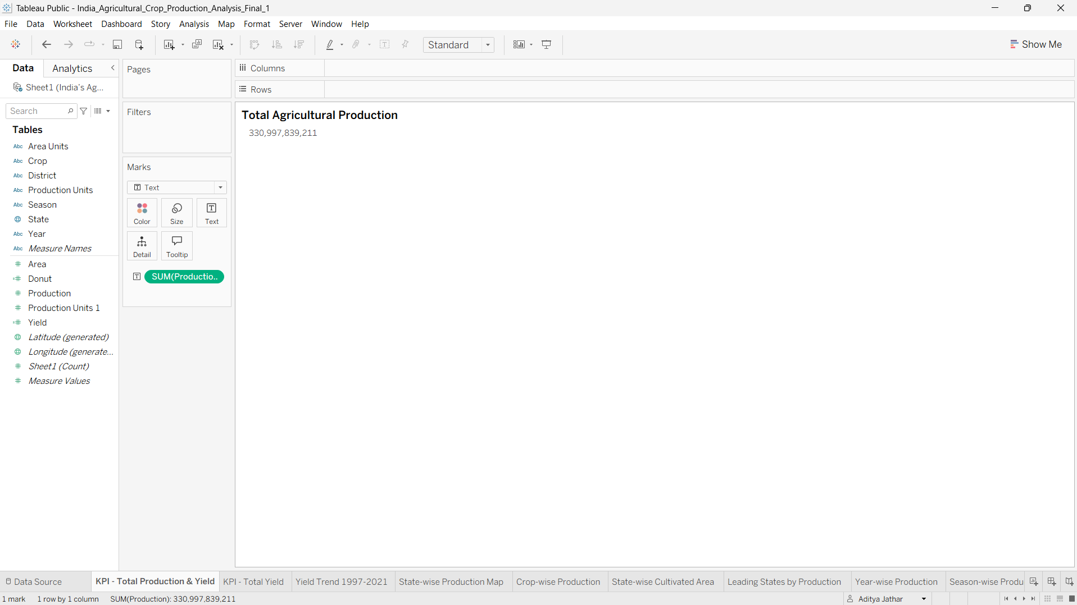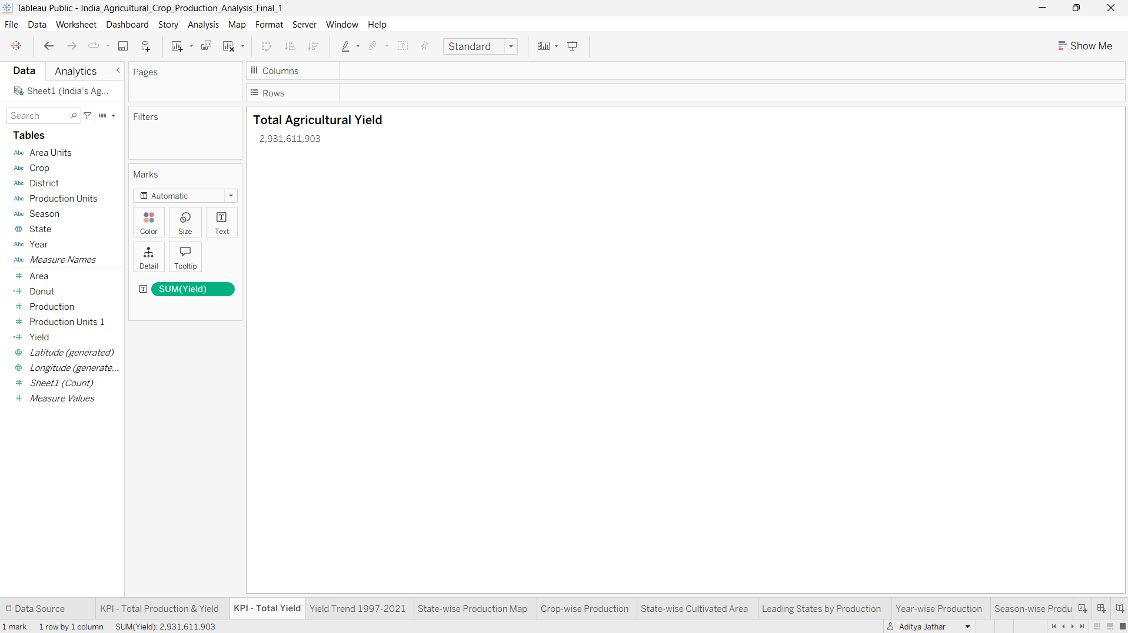

Business Question 2: How has agricultural yield changed from 1997 to 2021?
Visualization: Line chart – Agricultural Yield Trend (1997–2021).
Worksheet: Yield Trend 1997-2021.
Purpose: Shows year-wise yield movement and highlights major increases, decreases and fluctuations.
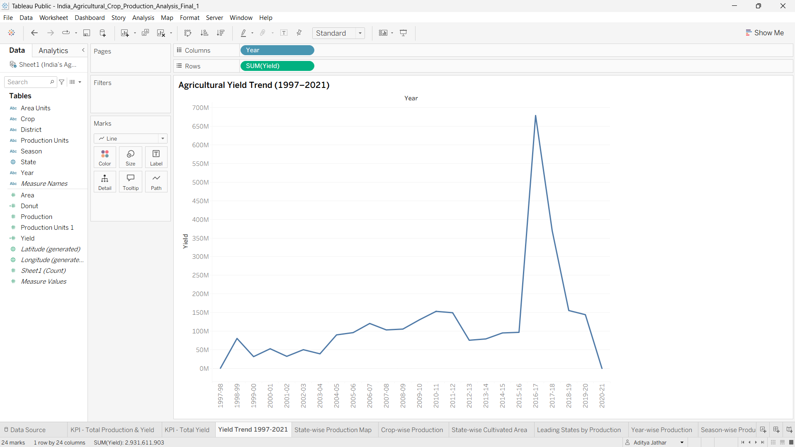

Business Question 3: How is agricultural production geographically distributed across Indian states?
Visualization: Filled geographic map – State-wise Agricultural Production Distribution.
Worksheet: State-wise Production Map.
Purpose: Uses state-level production intensity to show geographic concentration and differences in output.
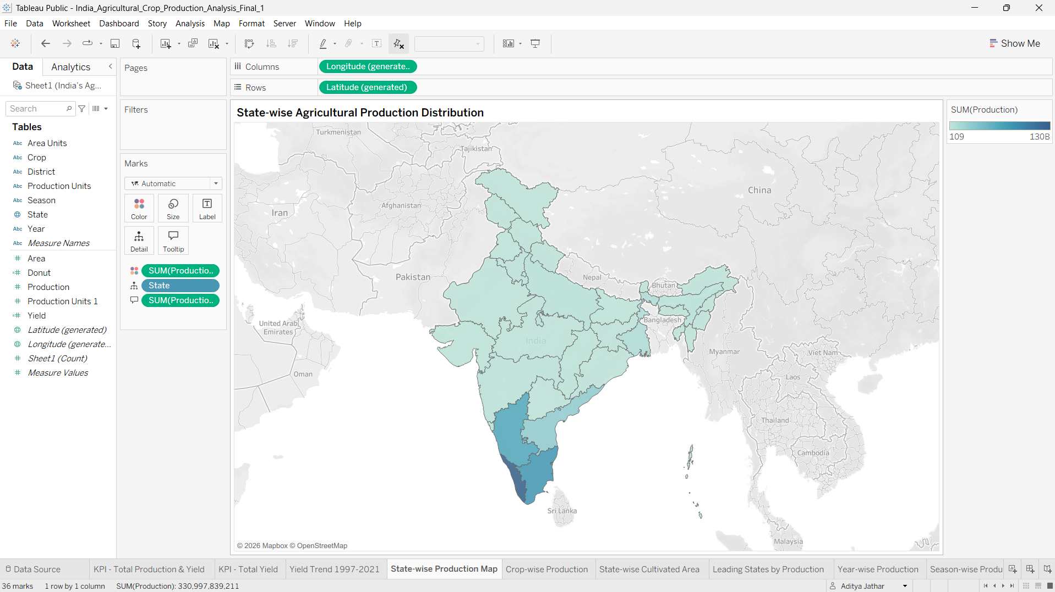

Business Question 4: Which crops contribute the most to India's total agricultural production?
Visualization: Horizontal bar chart – Crop-wise Total Production Analysis.
Worksheet: Crop-wise Production.
Purpose: Compares total production among crop categories and identifies the dominant crops.
Project result: Coconut is the dominant crop in the displayed production comparison.
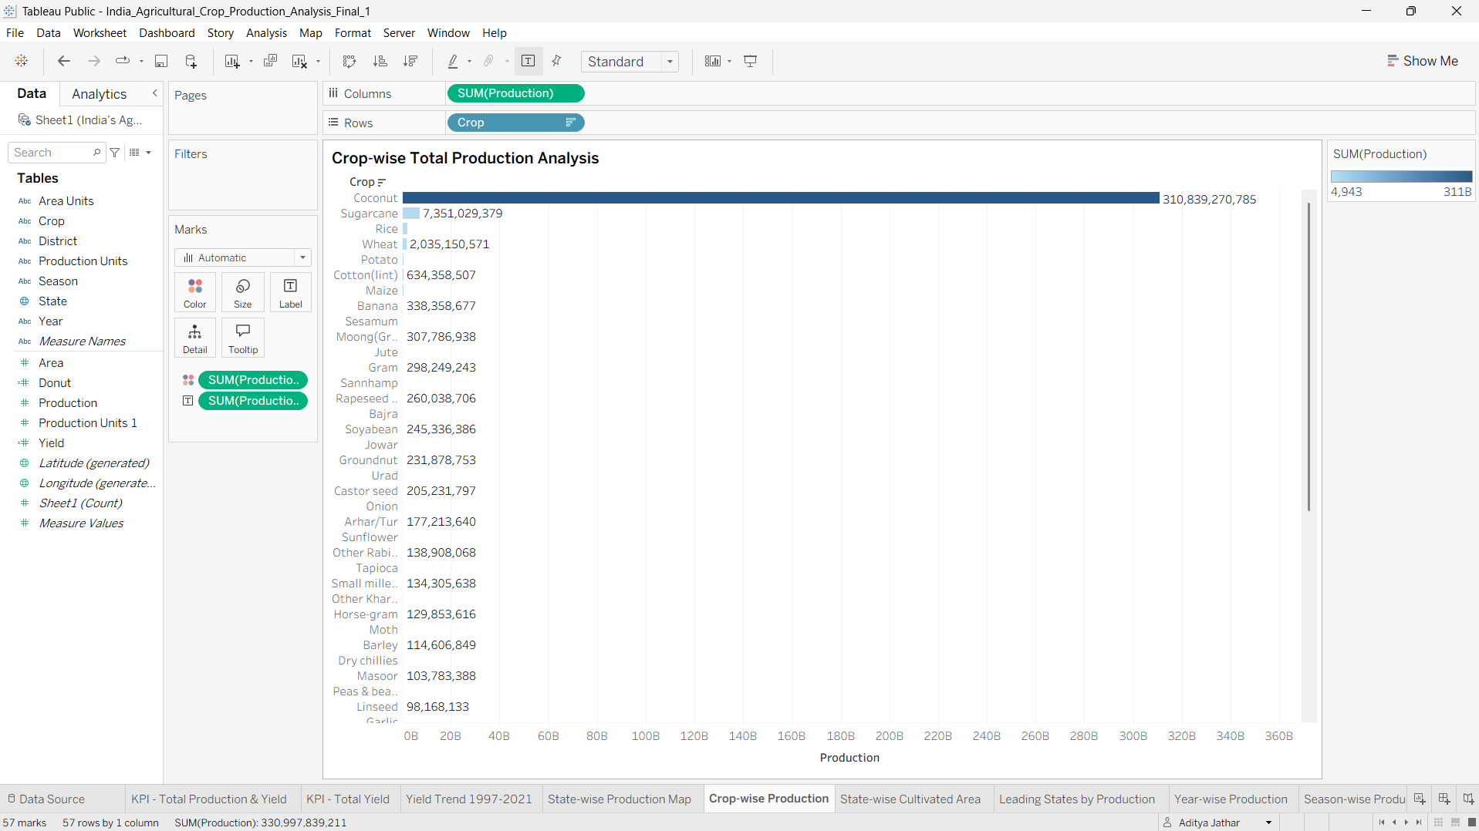

Business Question 5: How does cultivated area vary across states and crop categories?
Visualization: State-wise Cultivated Area Comparison – grouped/stacked bar view.
Worksheet: State-wise Cultivated Area.
Purpose: Compares cultivated area across states while showing crop-level composition.
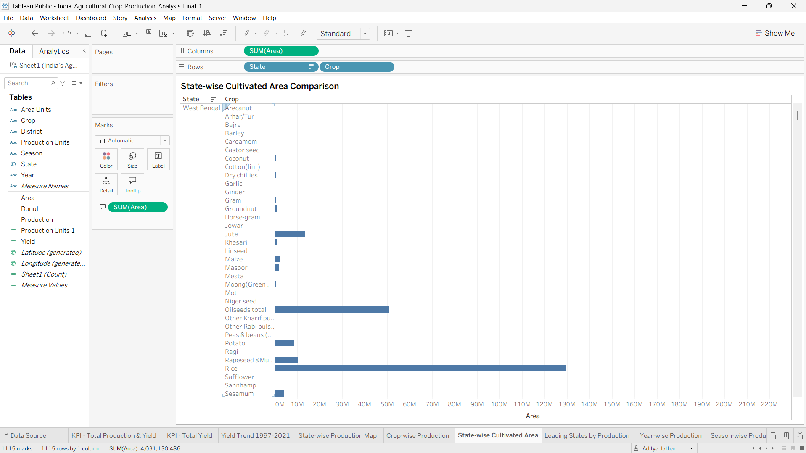

Business Question 6: Which Indian states are the leading agricultural producers?
Visualization: Ranked horizontal bar chart – Leading States by Agricultural Production.
Worksheet: Leading States by Production.
Purpose: Ranks states by total agricultural production.
Project result: Kerala is the leading state in the displayed ranking, followed by Tamil Nadu and Karnataka.
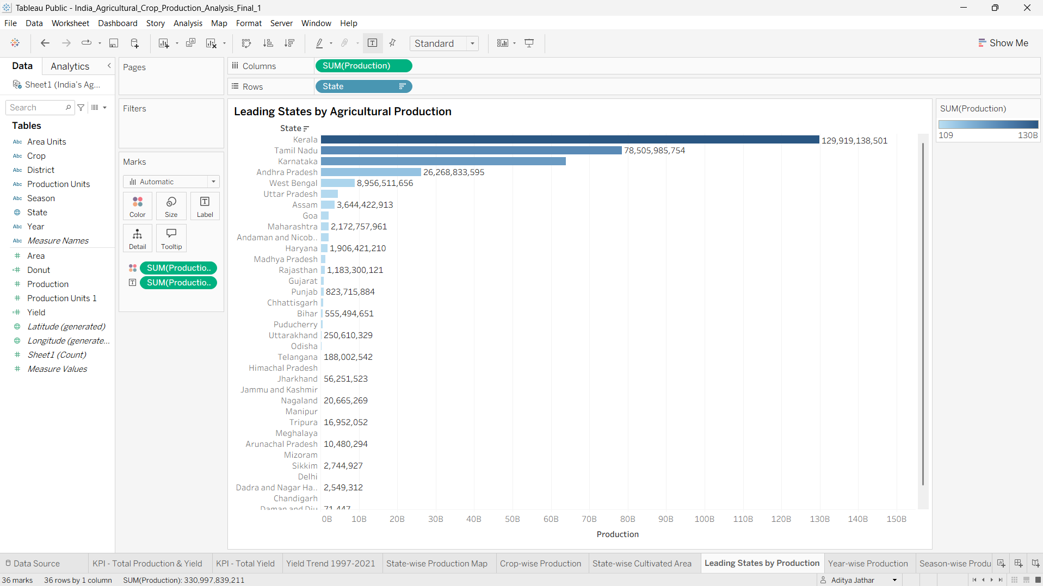

Business Question 7: How has total agricultural production changed year by year from 1997 to 2021?
Visualization: Vertical bar chart – Year-wise Total Agricultural Production (1997–2021).
Worksheet: Year-wise Production.
Purpose: Compares annual production and reveals long-term production patterns and fluctuations.
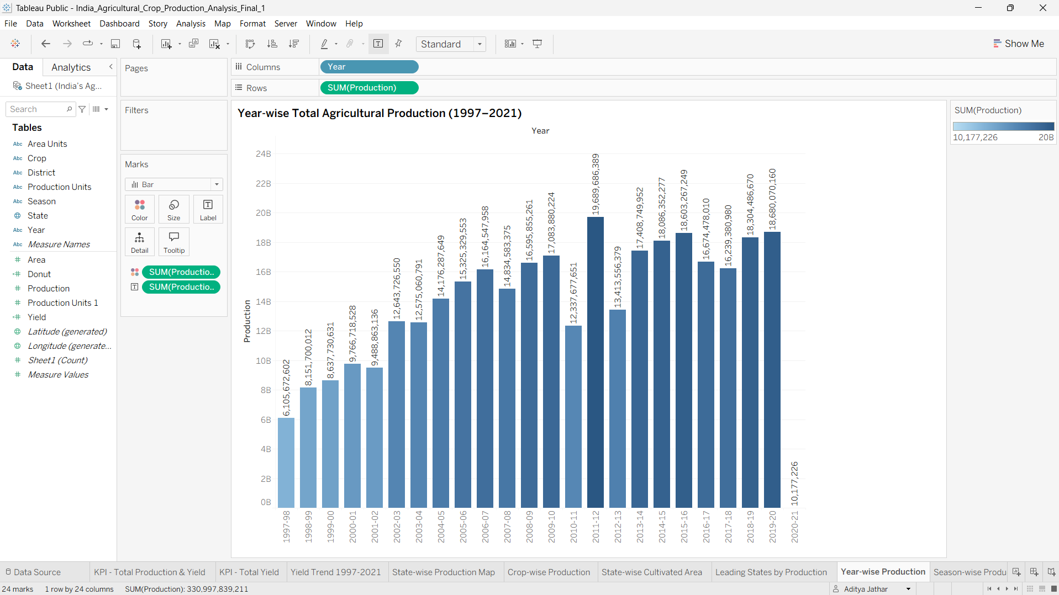

Business Question 9: What share of total agricultural production comes from each season?
Visualization: Pie chart – Season-wise Agricultural Production Share.
Worksheet: Season-wise Production Share.
Purpose: Shows the proportional contribution of Autumn, Kharif, Rabi, Summer, Whole Year and Winter.
Project result: Whole Year is the dominant category in the displayed production share.
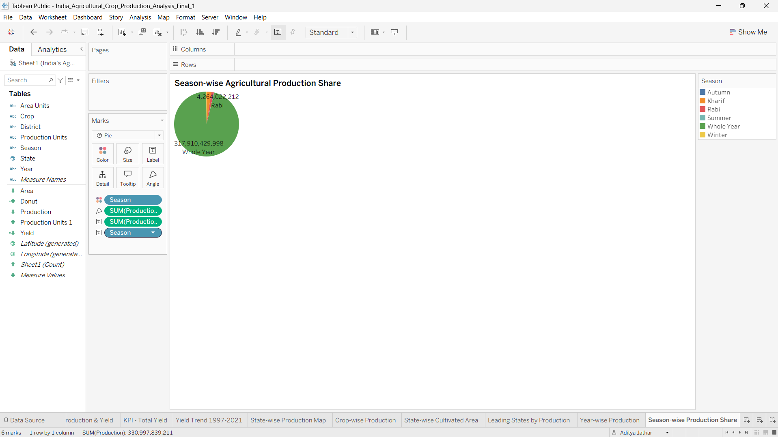

3. Dashboard and Story
The completed Tableau dashboard is titled “India's Agricultural Crop Production Analysis”. It combines the KPI cards, crop analysis, seasonal share, cultivated-area comparison, yield trend, year-wise production, geographic distribution and leading-state analysis into one dashboard. The Tableau Story presents the analysis sequentially through Agricultural Overview, Geographic Distribution, Crop-wise Agricultural, Season-wise Agricultural, State-wise Agricultural and Year-wise Agricultural story points.
4. Interactive Filters
The project documentation records interactive State, Crop and Production filters. These filters allow users to narrow the analysis to selected Indian states, selected crops or a selected production range.
5. Visualization Summary
No. | Visualization | Chart Type | Main Analytical Dimension
1 | Total Agricultural Production & Yield | KPI tiles | Overall performance
2 | Agricultural Yield Trend (1997–2021) | Line chart | Year
3 | State-wise Agricultural Production Distribution | Geographic map | State
4 | Crop-wise Total Production Analysis | Horizontal bar chart | Crop
5 | State-wise Cultivated Area Comparison | Grouped/stacked bar chart | State + Crop
6 | Leading States by Agricultural Production | Ranked bar chart | State
7 | Year-wise Total Agricultural Production (1997–2021) | Vertical bar chart | Year
8 | Production Distribution by Unit Type | Donut chart | Production Unit
9 | Season-wise Agricultural Production Share | Pie chart | Season
6. Conclusion
The visualization suite provides a comprehensive view of Indian agricultural production. The KPIs summarize overall performance, the temporal charts explain changes over the years, the map and state ranking reveal geographic differences, the crop chart identifies major crop contributors, and the seasonal and unit-type charts explain the composition of production. Together, these visualizations support interactive exploration and provide a clear analytical story of agricultural production.
Note: Screenshot placeholders are included so the final Tableau screenshots can be inserted from the completed workbook.

