A DATA VISUALIZATION PROJECT
INDIA'S AGRICULTURAL
CROP PRODUCTION ANALYSIS
Tableau Dashboard and Data Story, 1997–2021
Name | Aditya Jathar
Roll Number | 26
College Name | ICEM, Pune
Department | AI&DS
Academic Year | 2026-27

1. Introduction
Agriculture is one of the most important sectors of the Indian economy. What is grown, how much is produced and where it is produced changes from one crop, state, season and year to another. Understanding these patterns helps farmers, planners and policy makers take better decisions about crops, resources and food security.
Crop production records are usually stored as very large tables with thousands of rows covering states, districts, crops, seasons and years. Such tables are difficult to read directly, so the data has to be explored visually.
This project, India’s Agricultural Crop Production Analysis, uses Tableau to study crop production in India from 1997–98 to 2020–21. The data has been converted into two KPI cards and seven visualizations, combined into one dashboard and narrated through a six-scene Tableau Story. The work has been published on Tableau Public.

2. Problem Statement
Agricultural data is large and spread across many dimensions, which makes it hard to answer simple questions quickly: How much has India produced in total? How has production changed over the years? Which states lead in production? Which crops contribute the most? Which season produces the largest share? How is the cultivated area spread across states and crops?
There is a need for a clear, visual and interactive way to present this information. This project addresses the problem by building a Tableau dashboard and a data story that answer these questions in one place.

3. Objectives
The main objectives of this project are:
- To calculate the total agricultural production and yield from the dataset using KPI cards.
- To study the year-wise trend of agricultural production and yield from 1997–98 to 2020–21.
- To identify the leading states and show the geographic distribution of production on a map.
- To compare crop-wise production and identify the dominant crops.
- To analyse the share of each season in total production.
- To compare the cultivated area across states and crops.
- To combine the visualizations into one dashboard and present the findings as a Tableau Story.
- To publish the dashboard and story on Tableau Public.

4. Methodology / Project Workflow
The project follows the workflow below. Each step feeds into the next, starting from the raw dataset and ending with a published dashboard and story.
Step | Stage | Activity
1 | Dataset | The crop production data (Sheet1) is collected with fields such as State, District, Crop, Season, Year, Area, Production and Yield.
2 | Import into Tableau | The file is connected as a data source. Tableau classifies Crop, District, State, Season and Year as dimensions, and Area, Production and Yield as measures.
3 | Data preparation | Data types are checked. Measures are aggregated (for example SUM of Production) and State is assigned a geographic role so the map can be drawn.
4 | Worksheets | Nine worksheets are built: two KPI cards and seven charts (yield trend, state map, crop-wise production, state-wise area, leading states, year-wise production and season-wise share).
5 | Dashboard | The worksheets are arranged on one dashboard so the key indicators can be viewed on a single screen.
6 | Six-scene story | A Tableau Story is created that moves from an overview to geography, crops, seasons, states and years.
7 | Tableau Public | The workbook “India_Agricultural_Crop_Production_Analysis_Final” is published so it can be viewed and shared online.

Published link: [Paste your Tableau Public link here]

5. Dataset Description
Item | Details
Dataset | India's Agricultural Crop Production (Sheet1) [Enter file name]
Source | [Enter dataset source, e.g. Kaggle / data.gov.in]
Number of rows | [Enter row count from your file]
Time period | 1997–98 to 2020–21 (24 agricultural years)
Geographic coverage | 36 states and union territories, with district-level records
Crops covered | 57 crops (for example Coconut, Sugarcane, Rice, Wheat, Cotton, Potato)
Seasons | Autumn, Kharif, Rabi, Summer, Whole Year, Winter

Important fields
Field | Type | Meaning
State | Dimension | State or union territory of the record (used for the map and state charts)
District | Dimension | District within the state
Crop | Dimension | Name of the crop
Season | Dimension | Growing season of the crop
Year | Dimension | Agricultural year, for example 1997-98
Area / Area Units | Measure / Dimension | Cultivated area and the unit in which it is recorded
Production / Production Units | Measure / Dimension | Quantity produced and the unit in which it is recorded
Yield | Measure | Output per unit of area

Tableau also generates Latitude and Longitude fields for State, which are used to draw the production map. The overall figures for the dataset are shown below.
Indicator | Value | Source sheet
Total agricultural production | 330,997,839,211 | KPI – Total Production
Total agricultural yield (sum of Yield) | 2,931,611,903 | KPI – Total Yield
Total cultivated area (sum of Area) | 4,031,130,486 | State-wise Cultivated Area

6. Tableau Visualizations
Two KPI cards and seven visualizations were created in Tableau. Each is shown below with its purpose, a description of what is displayed and an interpretation.

KPI Cards: Total Production and Total Yield
Figure 1: KPI cards (Total Agricultural Production and Total Agricultural Yield)
Purpose: To give the headline numbers of the dataset at a glance.
Description: Two text-mark worksheets showing SUM(Production) and SUM(Yield) over the whole dataset.
Interpretation: Total recorded production is about 331 billion units (330,997,839,211) and the summed yield value is 2,931,611,903. These are raw totals across all crops and years, so they are best used as headline indicators rather than as a measure in tonnes.

Agricultural Yield Trend (1997–2021)
Figure 2: Agricultural Yield Trend (1997–2021)
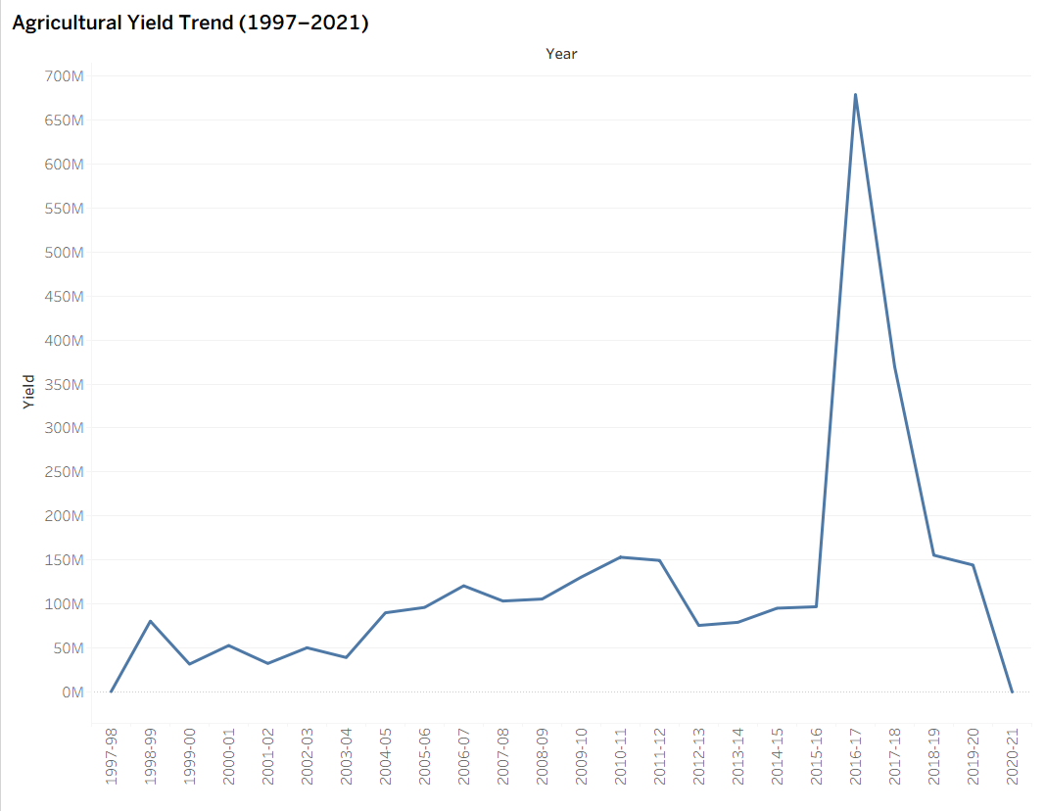
Purpose: To show how total yield has changed from year to year.
Description: A line chart with Year on the x-axis and SUM(Yield) on the y-axis.
Interpretation: Yield stays mostly below about 150 million until 2015–16. It then jumps sharply to a peak of roughly 680 million in 2016–17, falls back to about 150 million by 2018–19 and 2019–20, and drops to almost zero in 2020–21. The sudden spike and the final drop look unusual for real farming and are discussed under Limitations.

Year-wise Total Agricultural Production
Figure 3: Year-wise Total Agricultural Production (1997–2021)
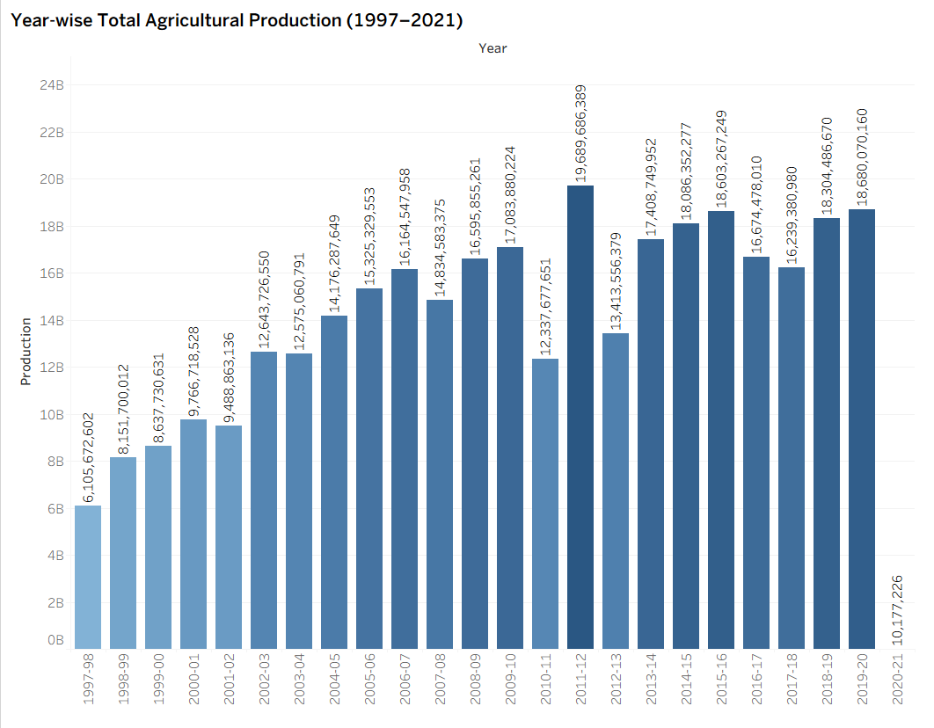
Purpose: To compare total production in each agricultural year.
Description: A bar chart with Year on the x-axis and SUM(Production) on the y-axis, with each bar labelled with its exact value and shaded by size.
Interpretation: Production grew from about 6.1 billion in 1997–98 to roughly 18.7 billion in 2019–20, an increase of about three times. The highest year is 2011–12 (about 19.7 billion). Short dips are visible in 2010–11 (about 12.3 billion) and 2012–13 (about 13.4 billion), and production stays between about 16 and 19 billion from 2013–14 onwards. The very small bar for 2020–21 (about 10 million) indicates that the data for that year is incomplete rather than a real collapse.

State-wise Agricultural Production Distribution
Figure 4: State-wise Agricultural Production Distribution (map)
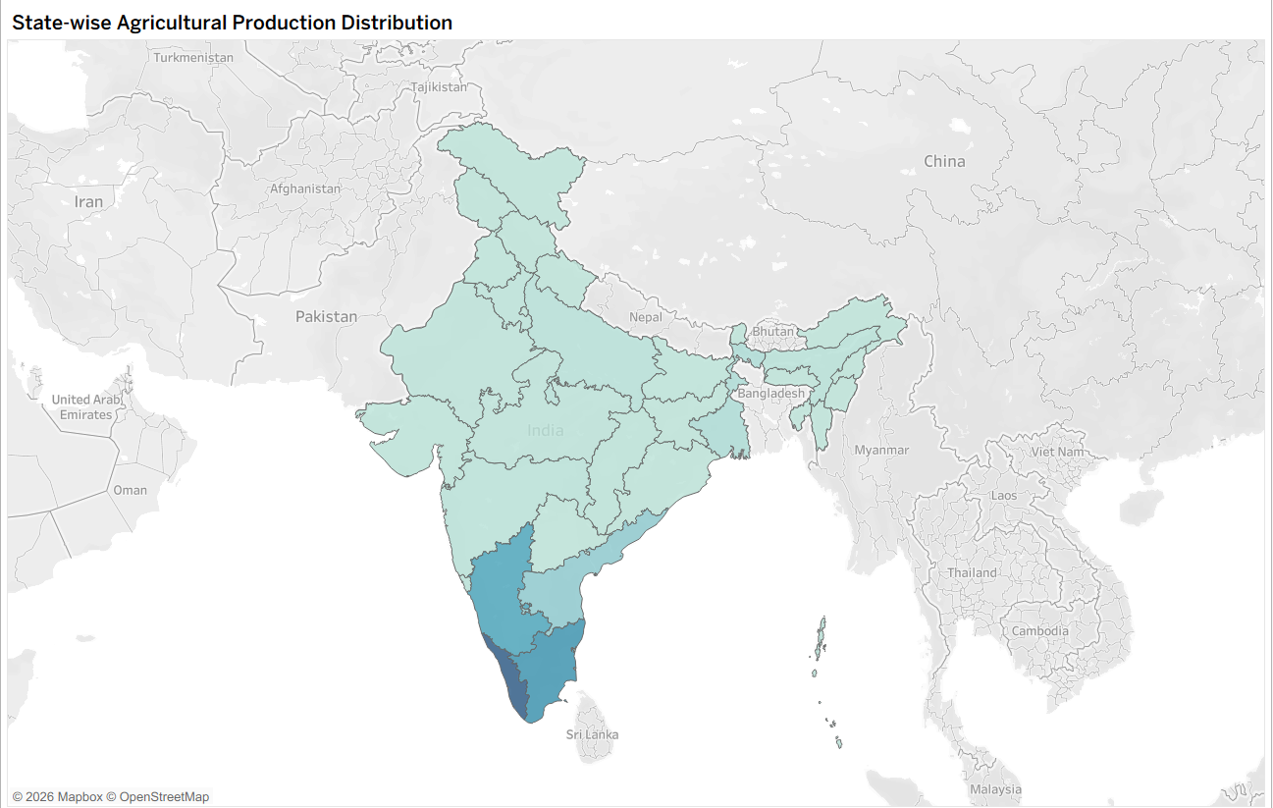
Purpose: To show where production is concentrated geographically.
Description: A filled map of India with State as the geographic dimension and SUM(Production) as the colour; darker shades represent higher production (range 109 to 130 billion).
Interpretation: The darkest shades are in the south: Kerala is the darkest, followed by Tamil Nadu and Karnataka. Most northern, central and eastern states appear in pale shades, showing much lower recorded production.

Crop-wise Total Production Analysis
Figure 5: Crop-wise Total Production Analysis
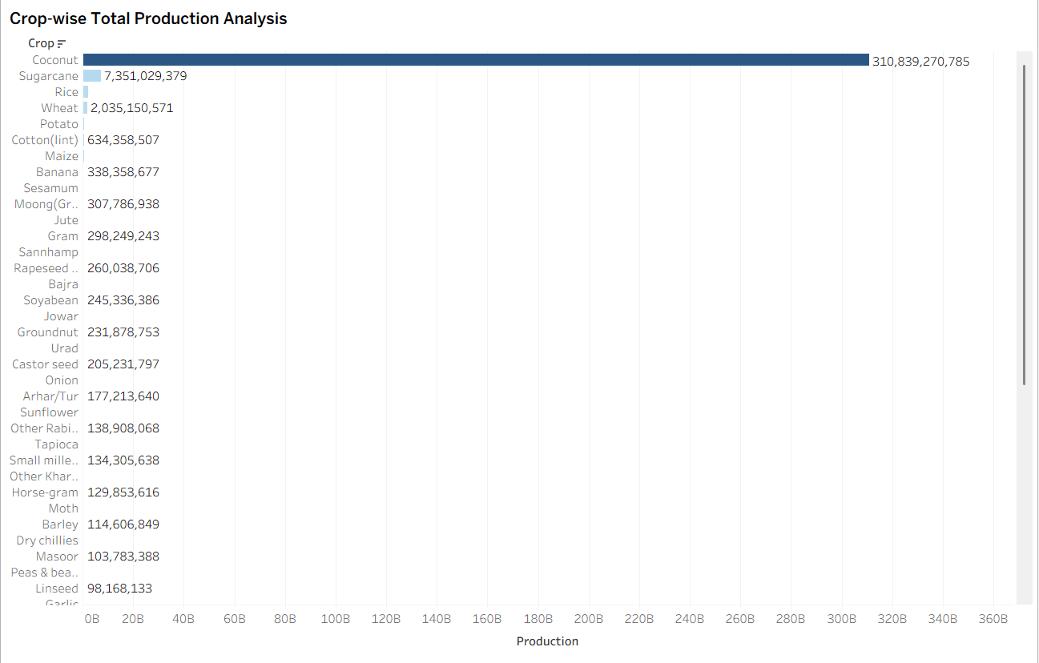
Purpose: To compare total production across the 57 crops.
Description: A horizontal bar chart with Crop on the rows and SUM(Production) on the columns, sorted from highest to lowest.
Interpretation: Coconut is far ahead of every other crop at about 310.8 billion, which is roughly 94% of the total. Sugarcane follows at about 7.4 billion, then rice (about 2.3 billion), wheat (about 2.0 billion), potato and cotton. Most other crops are too small to be seen on the same scale.

Season-wise Agricultural Production Share
Figure 6: Season-wise Agricultural Production Share
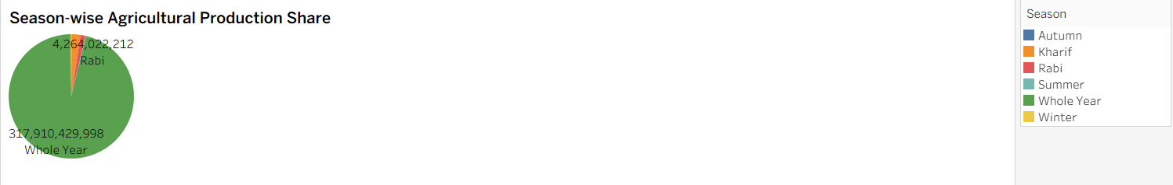
Purpose: To show how much each growing season contributes to total production.
Description: A pie chart with Season as colour and SUM(Production) as the angle. The six seasons are Autumn, Kharif, Rabi, Summer, Whole Year and Winter.
Interpretation: The “Whole Year” category accounts for about 317.9 billion, around 96% of the total. Rabi contributes about 4.3 billion (about 1.3%), and Autumn, Kharif, Summer and Winter together make up the remaining 2.7% or so. This matches the dominance of coconut, a perennial crop, in the crop-wise chart.

Leading States by Agricultural Production
Figure 7: Leading States by Agricultural Production
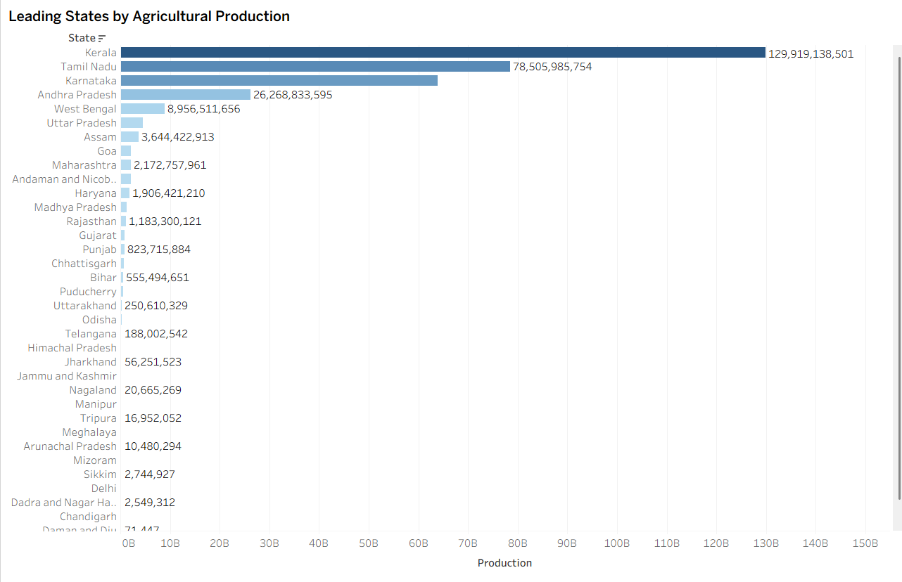
Purpose: To rank the states by total production.
Description: A horizontal bar chart with State on the rows and SUM(Production) on the columns, sorted in descending order.
Interpretation: Kerala leads with about 129.9 billion (around 39% of the total), followed by Tamil Nadu with about 78.5 billion (about 24%). Karnataka is third at roughly 64 billion and Andhra Pradesh fourth with about 26.3 billion. West Bengal (about 9.0 billion), Uttar Pradesh and Assam follow far behind. The top four states together account for roughly 90% of the total.

State-wise Cultivated Area Comparison
Figure 8: State-wise Cultivated Area Comparison
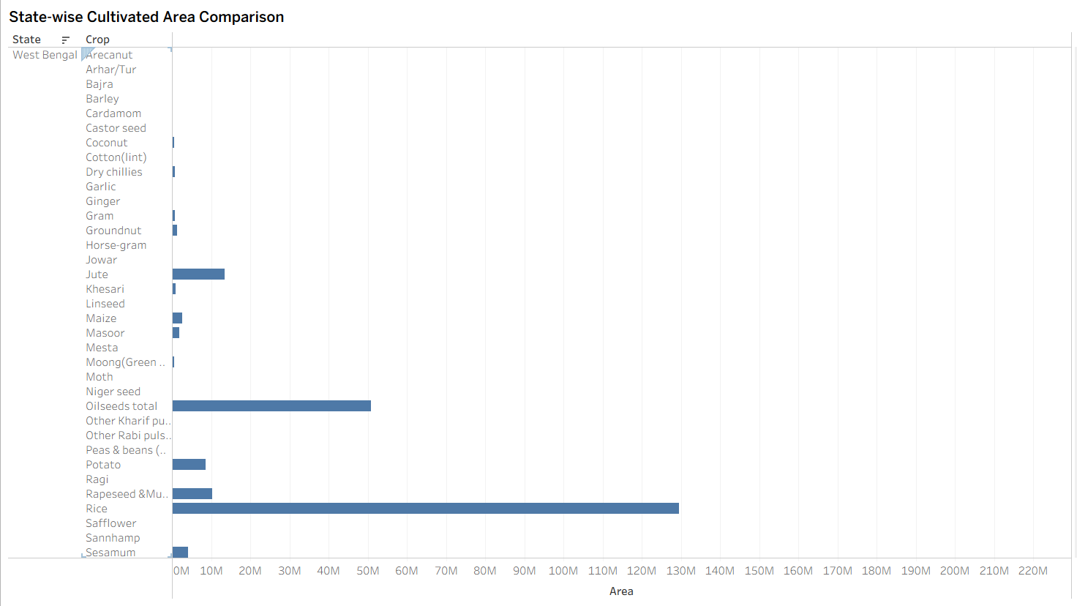
Purpose: To compare the cultivated area of each crop within each state.
Description: A bar chart with State and Crop on the rows and SUM(Area) on the columns (1,115 state–crop combinations). The view opens at West Bengal.
Interpretation: In West Bengal, rice occupies by far the largest area (about 130 million area units), followed by oilseeds (about 50 million) and jute (over 10 million), with smaller areas for potato, rapeseed and mustard, maize and sesamum. Scrolling through the chart allows the same comparison for every other state.

7. Dashboard
Figure 9: Tableau Dashboard – India’s Agricultural Crop Production Analysis
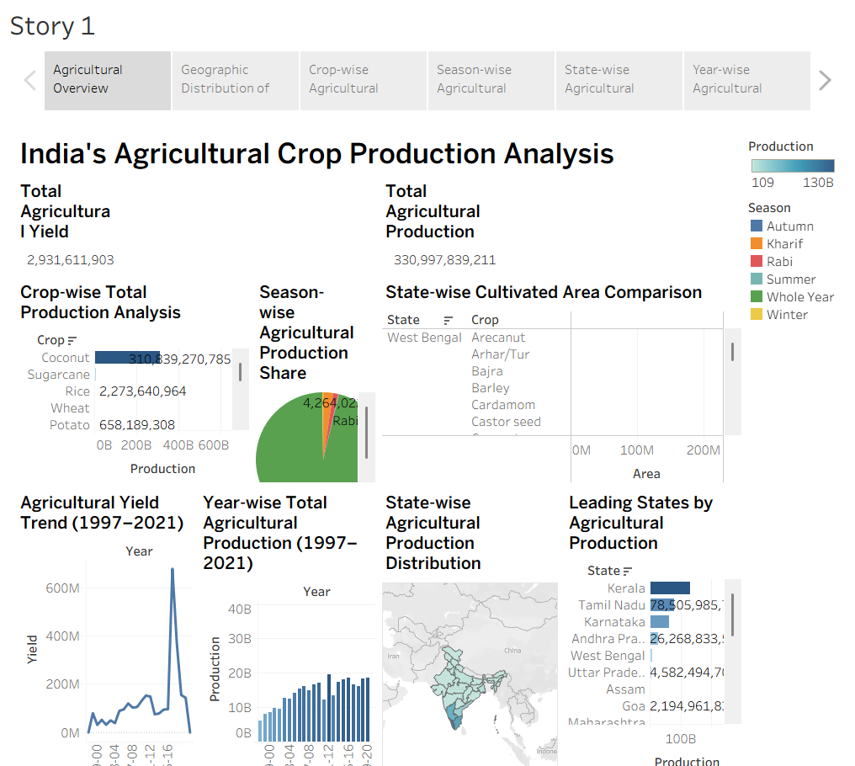
The dashboard combines the KPI cards and the visualizations into a single interface titled “India’s Agricultural Crop Production Analysis”. It is arranged in three zones:
- Top: Total Agricultural Yield and Total Agricultural Production KPI cards.
- Middle: Crop-wise Total Production Analysis, Season-wise Agricultural Production Share and State-wise Cultivated Area Comparison.
- Bottom: Agricultural Yield Trend, Year-wise Total Production, State-wise Production map and Leading States by Production.
Colour legends for Production and Season are shown on the right so that the shading in all charts can be read consistently. Hovering over any mark displays a tooltip with its exact value, and the whole dashboard is published on Tableau Public so it can be opened in a web browser.

8. Tableau Story
The Tableau Story (size 1016 × 964) arranges the analysis as six scenes, moving from an overview to the individual findings.
Figure 10: Scene 1 – Agricultural Overview
Explanation: Gives the complete picture at a glance: the two KPI cards followed by the crop, season, area, yield, year, map and leading-state charts.
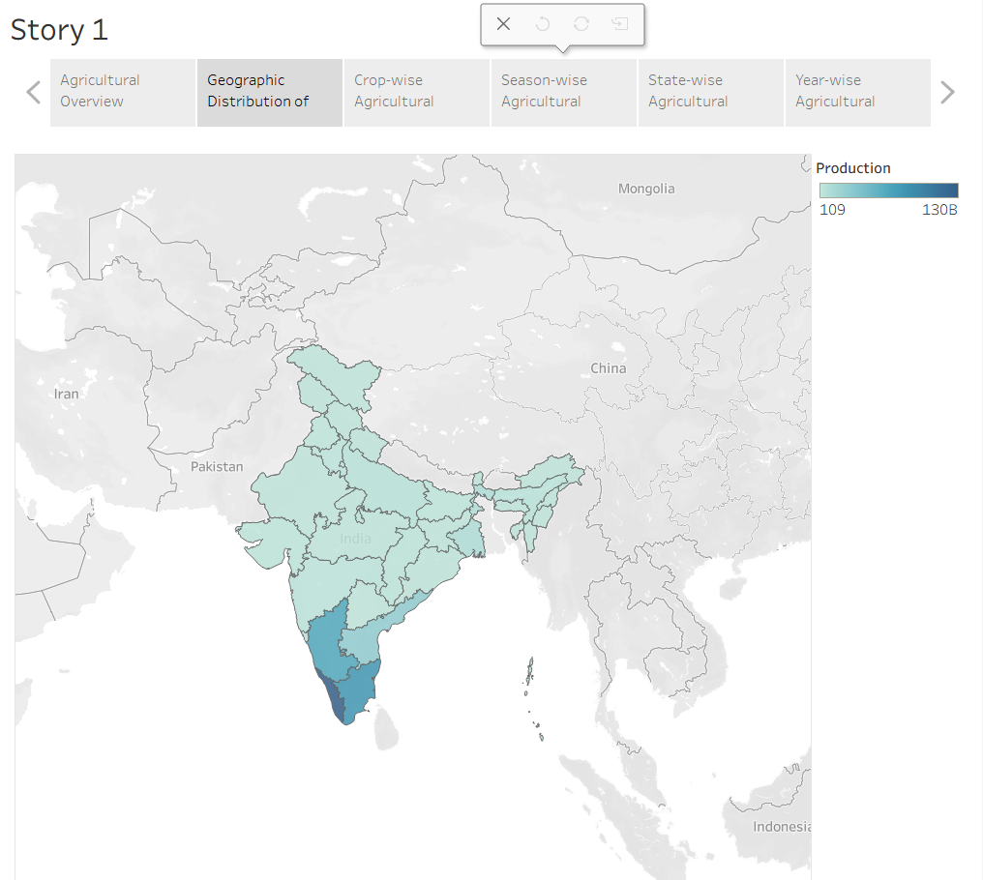 | Figure 11: Scene 2 – Geographic Distribution  Explanation: Shows the production map. The south of India, led by Kerala, Tamil Nadu and Karnataka, has the darkest shades and therefore the highest production.
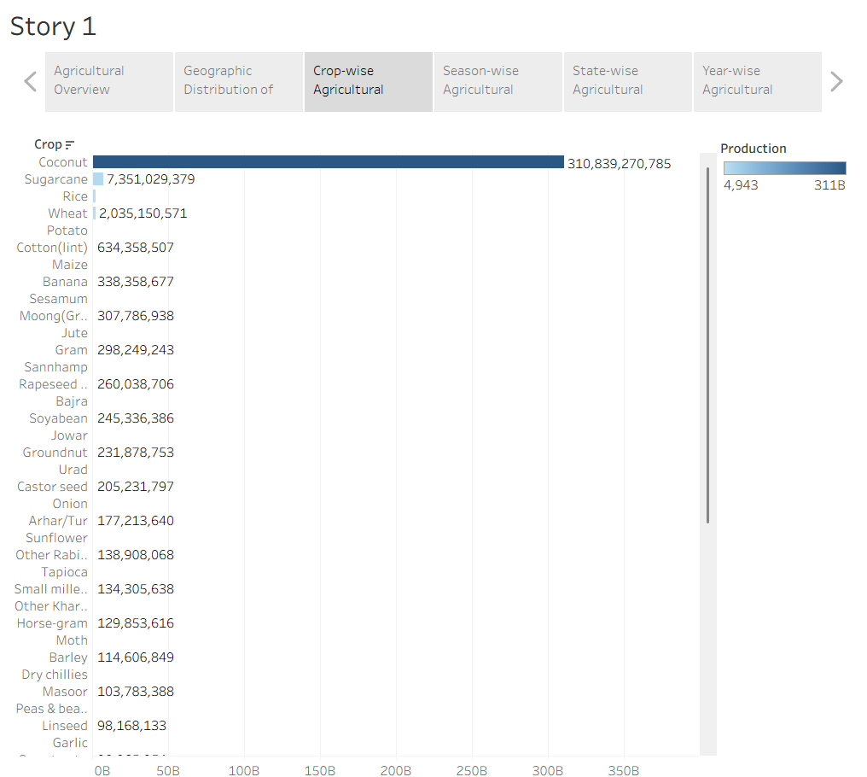 | Figure 12: Scene 3 – Crop-wise Production  Explanation: Compares all crops. Coconut dominates with about 310.8 billion, far above sugarcane, rice and wheat.
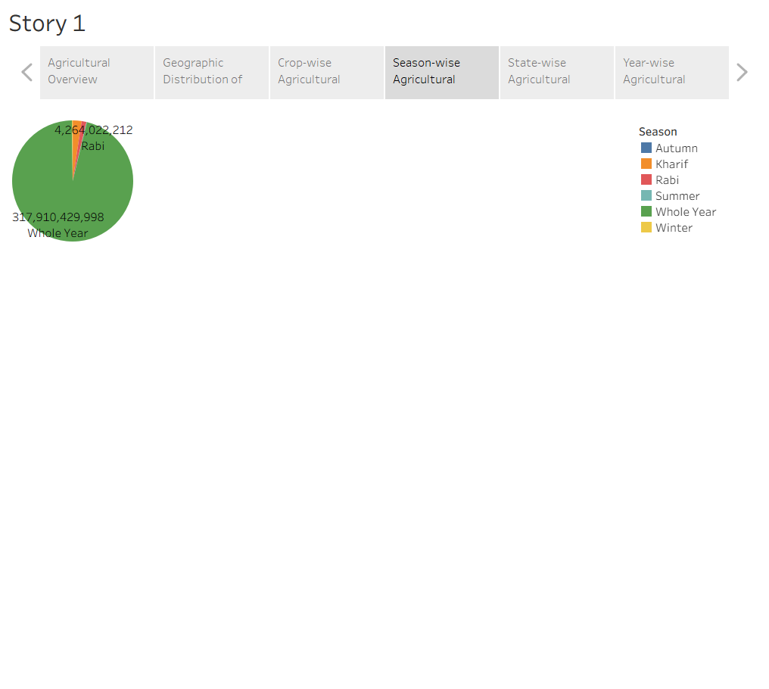 | Figure 13: Scene 4 – Season-wise Production  Explanation: Shows that “Whole Year” crops contribute about 96% of production, while Rabi and the other seasons are very small slices.
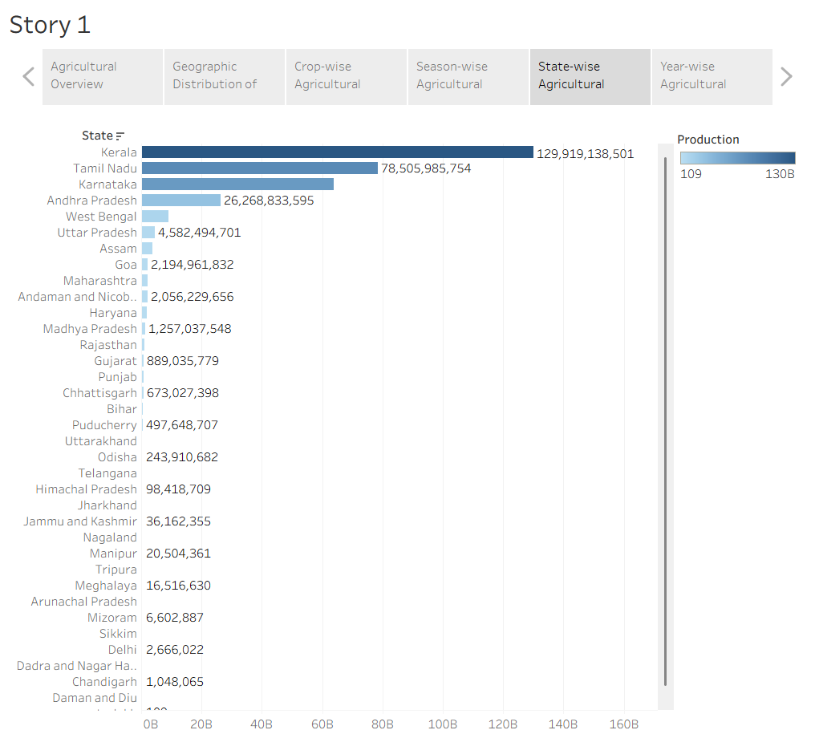 | Figure 14: Scene 5 – State-wise Production  Explanation: Ranks the states: Kerala (about 129.9 billion) and Tamil Nadu (about 78.5 billion) lead, followed by Karnataka and Andhra Pradesh.
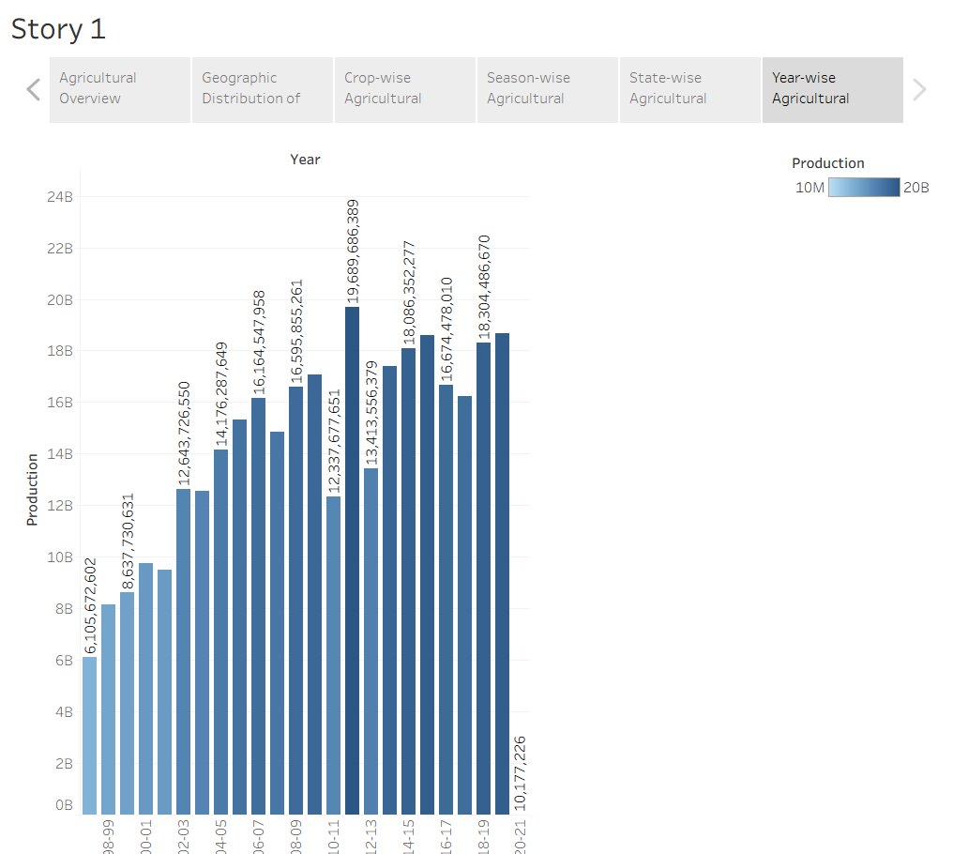 | Figure 15: Scene 6 – Year-wise Production  Explanation: Shows production rising from about 6.1 billion in 1997–98 to about 18.7 billion in 2019–20, with the incomplete 2020–21 year at the end.

9. Results / Key Insights
- Overall scale: Total recorded production is about 331 billion units, and total cultivated area is about 4.03 billion area units.
- Long-term growth: Annual production rose roughly three times, from about 6.1 billion in 1997–98 to about 18.7 billion in 2019–20, with a peak of about 19.7 billion in 2011–12.
- Regional concentration: Kerala (about 39%) and Tamil Nadu (about 24%) together contribute roughly 63% of production; the top four states contribute roughly 90%.
- Crop dominance: Coconut alone accounts for about 94% of total production, far ahead of sugarcane, rice and wheat.
- Seasonal pattern: “Whole Year” crops make up about 96% of production, while Rabi contributes about 1.3%.
- Cultivated area: In West Bengal, rice occupies the largest cultivated area by a wide margin, followed by oilseeds and jute.

10. Limitations
The findings should be read with the following limitations in mind:
- Mixed units: The Production column holds crops recorded in different units (the dataset has a separate Production Units field). Coconut, for example, is commonly recorded as a count of nuts, whereas most other crops are recorded in tonnes. Adding all values together therefore overstates coconut, and also Kerala and Tamil Nadu, and makes the crop-wise, season-wise and state-wise charts heavily skewed.
- Summed yield: The yield KPI and yield trend add up yield values from many crops and rows. A sum of ratios is not a meaningful national yield, which is why the yield trend shows an unusual spike in 2016–17.
- Incomplete final year: The 2020–21 value (about 10 million) is far below other years, which suggests that data for this year is incomplete.
- Crowded area chart: The cultivated-area chart adds area across all years and has 1,115 state–crop bars, so it needs scrolling and is hard to read as a whole.
- Scale effect: Because one crop and one season category dominate, the other crops and seasons are hard to see on the same scale.

11. Conclusion
This project presented the story of India’s crop production through Tableau. Two KPI cards and seven visualizations were designed, combined into one dashboard, and organised into a six-scene story that moves from an overview to geography, crops, seasons, states and years. The work was published on Tableau Public.
The analysis shows that recorded production has grown about three times between 1997–98 and 2019–20, that production is concentrated in a few southern states led by Kerala and Tamil Nadu, and that coconut and “Whole Year” crops dominate the totals. The project also shows how important it is to check units and data quality before aggregating, and demonstrates a complete workflow from raw data to dashboard and story.

12. Future Scope
- Filter the data to one production unit (for example tonnes) or convert units so that crops can be compared fairly.
- Calculate yield as Production divided by Area instead of summing the Yield column.
- Add Year, State, Crop and Season filters or parameters so that users can explore the dashboard interactively.
- Complete the 2020–21 data and extend the analysis to later years.
- Add district-level maps to show differences inside each state.
- Add forecasting to predict future production for major crops.
- Add rainfall, irrigation and price data to explain the changes in production.
- Embed the published dashboard and story in a web application, for example using Flask, for easy public access.

13. References
- Tableau Public – public.tableau.com (publishing and hosting the dashboard and story).
- Tableau Desktop / Tableau Public documentation – help.tableau.com.
- Dataset: India's Agricultural Crop Production (1997–2021) [Enter dataset source and link].
- Published project: “India_Agricultural_Crop_Production_Analysis_Final” by Aditya Jathar, Tableau Public.

