**PROJECT REPORT**

On

**DYNAMIC PRODUCT REVIEW USING SENTIMENT ANALYSIS**

Submitted For Partial Fulfillment of Award of

**BACHELOR OF TECHNOLOGY**

**In**

**Computer Science & Engineering (2023)**

By

Aditya Jayant Gupta

Aditya Kumar Yadav

Harsh Prajapati

Under the Guidance

Of

Dr. Avinash Gupta



**BABU BANARASI DAS ENGINEERING COLLEGE,** **LUCKNOW**

**Affiliated to**

**Dr. APJ ABDUL KALAM TECHNICAL UNIVERSITY, LUCKNOW**



**DEPARTMENT OF COMPUTER SCIENCE & ENGINEERING**

**BBDEC**

#### CERTIFICATE

Certified that the project entitled **“Dynamic Product Review Using sentiment Analysis”** submitted by **Aditya Jayant Gupta [1905080100005], Aditya Kumar Yadav [1905080100006],** and **Harsh Prajapati [1905080100035],** and in the partial fulfillment of the requirements for the award of the degree of Bachelor of Technology (CSE) of Dr. APJ Abdul Kalam Technical University (Lucknow), is a record of students‟ own work carried under our supervision and guidance. The project report embodies results of original work and studies carried out by students and the contents do not forms the basis for the award of any other degree to the candidate or to anybody else.

#### Dr Avinash Gupta Dr. Avinash Gupta

Professor Professor

(Project Guide) (Head of Department)



**Department of Computer Science & Engineering**

**BBDEC**

#### DECLARATION

I/We hereby declare that the project entitled **“Dynamic Product Review Using sentiment Analysis”** submitted by me/us in the partial fulfillment of the requirements for the award of the degree of Bachelor of Technology (CSE) of Dr. APJ Abdul Kalam Technical University (Lucknow), is record of my/our own work carried under the supervision and guidance of Dr. Avinash Gupta (Head of Department).

To the best of my/our knowledge this project has not been submitted to Dr. APJ Abdul Kalam Technical University (Lucknow) or any other University or Institute for the award of any degree.

#### Aditya Jayant Gupta Aditya Kumar Yadav Harsh Prajapati

**1905080100005 1905080100006 1905080100035**

#### PREFACE

This project aims to develop a sentiment analysis system for product reviews, which can assist regular customers in making more informed purchasing decisions. It does so by analyzing customer reviews of products from two major e-commerce platforms - Amazon and Flipkart. The system will extract sentiment analysis from customer reviews, maintain a brand quality index, and store the results in a SQLite database. The project also features a generative review summary, which provides an overview of how the customers feel about a product. The project is divided into several chapters, each of which covers a specific aspect of the project.

Chapter 1 serves as an introduction to the project, providing an overview of its objectives and goals. It highlights the significance of sentiment analysis in business and how this project aims to address it. This chapter provides an insight into the project's scope and sets the stage for the rest of the report.

Chapter 2 is dedicated to a literature survey of the existing techniques and methods used for sentiment analysis. It provides a detailed overview of the relevant literature in this field, discussing the various approaches and tools that have been used to analyze sentiment in text data. Additionally, this chapter also explores the ways in which customers assess and provide feedback for products online.

Chapter 3 presents the proposed methodology used in this project. It discusses the various stages involved in sentiment analysis, such as data pre-processing, feature extraction, sentiment classification, and model evaluation. This chapter details the approach taken by the project and the various tools and techniques used to carry out the analysis.

Chapter 4 delves into the results obtained from the experiments conducted as part of this project. It provides a detailed analysis of the data, discussing the findings and insights drawn from the study. This chapter highlights the effectiveness of the methodology used in the project and the potential implications of the results for businesses.

Chapter 5 summarizes the findings and conclusions drawn from the study. It discusses the significance of the results and their implications for businesses that rely on customer feedback. This chapter provides a summary of the project's contributions and offers recommendations for future research in this field.

Chapter 6 outlines the potential areas for future research and development in this field. It highlights the limitations of the project and identifies potential areas for improvement. This chapter provides a roadmap for future research and offers insights into the possible directions for future work in the field of sentiment analysis.

Overall, this project aims to provide a comprehensive understanding of how to build a sentiment analysis system that can analyze customer reviews of products from two major e-commerce platforms - Amazon and Flipkart. The project covers several essential topics, including data collection, sentiment analysis, brand score calculation, and web application development, making it a valuable resource for anyone interested in sentiment analysis and its applications.

ABSTRACT

The problem of choosing between product alternatives and assessing quality before purchasing products is a major challenge faced by customers in today's competitive market. The abundance of products available to consumers has made it increasingly difficult for them to make informed purchasing decisions. In this context, natural language processing (NLP) and sentiment analysis have emerged as powerful tools to help consumers make better decisions.

The proposed methodology for this project combines NLP and sentiment analysis to generate reviews for products that summarize the overall sentiment of customers. These reviews are based on customer feedback and are generated using generative models. The sentiment analysis aspect of the methodology assigns a sentiment score to each review, which is used to calculate brand quality indexes for each product.

The implementation of this methodology was evaluated through experiments conducted on a dataset of customer reviews for various products. The results obtained demonstrated that the generative reviews provided a useful summary of the sentiment expressed by customers towards a particular product. Furthermore, the sentiment scores and brand quality indexes were effective in distinguishing between products of varying quality.

The methodology proposed in this project provides a solution to the problem of assessing product quality and making informed purchasing decisions. The use of NLP and sentiment analysis has demonstrated its effectiveness in generating reviews that capture the overall sentiment of customers towards a product. The sentiment scores and brand quality indexes provide a useful metric for comparing and evaluating products.

#### TABLE OF CONTENTS

#### Certificate ii

#### Declaration iii

#### Acknowledgement iv

#### Preface v

#### Abstract vi

#### Table of Contents vii-viii

#### INTRODUCTION 1-59

* 1. General 1
  2. Preliminary Investigation
  3. Feasibility Study 2
     1. Technical Feasibility 2
     2. Economic Feasibility 3
     3. Operational Feasibility 3

#### LITERATURE REVIEW 59-70

* 1. GENERAL 59
  2. ALTERNATE AFFREGRATES 64
  3. MATHEMATICAL MODELS 68

**.**

**.**

#### CONCLUSIONS 85

#### FUTURE SCOPE OF THE PROJECT 8

**APPENDICES**

**Appendix A ix**

**Appendix B x**

**Appendix C xi**

**Appendix D xii**

**References & Bibliography xiii**

# 

# CHAPTER 1

# INTRODUCTION

**1.1 GENERAL**

The rise of e-commerce has made it easier than ever for customers to access a wide range of products from around the world. However, with this increased choice comes the challenge of selecting the right product from among the many alternatives available. Customers face difficulties in assessing the quality of a product before purchasing, leading to the possibility of unsatisfactory purchases.

This project aims to address this problem through the use of natural language processing (NLP) and sentiment analysis techniques. By analyzing customer reviews of products, it is possible to identify the sentiment and opinion expressed in the reviews, as well as any recurring issues or complaints. This can help customers to make more informed decisions when selecting products, as well as enabling businesses to identify areas where they can improve the quality of their products or services.

In this project, the proposed methodology involves the use of sentiment analysis algorithms to extract sentiment scores from customer reviews of products. In addition, a generative review summary is proposed that provides an overview of how customers feel about a product, based on the sentiment scores.

The feasibility of this approach has been investigated in terms of technical, economic, and operational aspects. The technical feasibility of the project has been assessed in terms of the availability of suitable tools and technologies for sentiment analysis and NLP. The economic feasibility has been evaluated in terms of the potential benefits of the project, including increased customer satisfaction and improved product quality. The operational feasibility has been assessed in terms of the practicality of implementing the proposed methodology in a real-world business setting.

The following chapters of the report provide a detailed description of the methodology used in the project, including the literature survey, proposed methodology, result analysis and discussion, conclusion, and future scope for this field of study.

**1.2 PRELIMINARY INVESTIGATION**

The preliminary investigation for this project involved identifying the need for a solution to the difficulties faced by customers in choosing between product alternatives and assessing the quality before purchasing products. This need was identified through extensive research and analysis of customer reviews and feedback on various e-commerce platforms.

In today's competitive marketplace, customers are faced with an abundance of product alternatives, making it increasingly difficult to choose the right product for their needs. Additionally, customers often struggle to assess product quality before making a purchase, leading to buyer's remorse and decreased customer satisfaction.

One major issue is the lack of effective ways for customers to judge the satisfaction of other customers who have purchased and used the same product, apart from the rating. However, ratings can be inaccurate or mismatched with the actual review. For instance, a 5-star rating does not necessarily guarantee a satisfied customer, as there may be underlying issues that are not reflected in the rating. Moreover, the sheer volume of reviews can be overwhelming and present very polarising views, making it hard for customers to filter through all of them.

According to a survey conducted by ReviewTrackers, 63.6% of consumers check online reviews before making a purchase decision, and 53.3% of consumers expect businesses to respond to negative reviews within a week.

Another study by BrightLocal found that 97% of consumers read online reviews for local businesses, with 12% of them doing so on a daily basis. The study also found that 91% of consumers trust online reviews as much as personal recommendations.

Furthermore, a study by PowerReviews revealed that 70% of consumers look for product reviews before making a purchase, and 51% of consumers will not purchase a product if it doesn't have any reviews.

**1.3 PROBLEM STATEMENT**

In the preliminary assessment of the e-commerce industry, it was found that customers face significant challenges in assessing the quality of products through existing platform tools. The current rating system fails to provide a comprehensive overview of customers' experiences with the product and often proves to be an inadequate indicator of product quality. Additionally, these ratings may not reflect the actual content of the review, leading to further confusion for customers. Furthermore, there is currently no mechanism to assess a brand's history on the platform and its general reputation for producing high-quality products. The process of thorough product assessment is often time-consuming and may discourage customers from making purchases.

To address these issues, this project proposes a novel approach that integrates sentiment analysis, natural language processing, and web data collection to provide a more accurate and efficient evaluation of product quality. The use of these technologies will enable the generation of comprehensive and informative product summaries that reflect the sentiment of customer reviews, and the historical performance of brands on the platform.

**1.4 FEASIBILITY STUDY**

Before undertaking any project, it is essential to conduct a feasibility study to determine its technical, economical, and operational viability. In the case of this project, a preliminary investigation has been conducted to identify the need for a solution to the difficulties faced by customers in assessing product quality and satisfaction.

**1.4.1 TECHNICAL FEASIBILITY**

From a technical perspective, proposed methodology for this project involves the utilization of well-established and widely-used technologies, including natural language processing (NLP), sentiment analysis, and web data collection. These technologies have been widely used in previous research studies and are proven to be effective in analyzing large volumes of text data to extract valuable insights. NLP involves the use of machine learning algorithms to analyze and understand human language, while sentiment analysis is used to automatically determine the emotional tone of text data, allowing for the identification of positive, negative, or neutral sentiment.

Web data collection involves the process of scraping and extracting data from various e-commerce websites to build a comprehensive dataset for analysis. The use of these technologies ensures that the project is feasible from a technical perspective and provides a strong foundation for the successful completion of the project.

Furthermore, there are various tools and libraries available that support the use of these technologies, such as the Natural Language Toolkit (NLTK) and the Stanford CoreNLP library for NLP, and the Vader and TextBlob libraries for sentiment analysis. These tools provide a significant head start to the project and enable efficient and effective implementation of the proposed methodology.

**1.4.2 ECONOMICAL FEASIBILITY**

From an economic standpoint, the feasibility of implementing the proposed methodology is favorable. The cost of required tools and technologies is affordable and readily available in the market. The major cost incurred in this project would be the time required for data collection, processing, and analysis.

However, it is important to note that the proposed solution's benefits, such as enhanced customer satisfaction and increased sales, would significantly outweigh the costs incurred during the project's implementation. The return on investment for the proposed solution would be substantial, making it an economically feasible option for e-commerce platforms.

**1.4.3 OPERATIONAL FEASIBILITY**

From an operational feasibility standpoint, the proposed solution is highly feasible and requires no additional infrastructure. The solution is designed to be operated on any modern web browser on the client side and can be hosted on a medium power server for the analysis engine. Furthermore, the solution would not disrupt the existing operational processes of the platform or the users. It is a plug-and-play solution that can be easily integrated with existing e-commerce platforms. The minimal user interface required for the solution would not require any additional effort on the part of the users or the platform administrators. Overall, the operational feasibility of the proposed solution is high, and it presents no major challenges.

In conclusion, the feasibility study indicates that the proposed solution is highly feasible from a technical, economical, and operational perspective. The use of natural language processing, sentiment analysis, and web data collection will enable customers to assess product quality and satisfaction accurately, leading to increased customer satisfaction and sales.

CHAPTER 2

LITERATURE REVIEW

**2.1 Introduction**

In recent years, e-commerce has become an integral part of the retail industry, enabling customers to purchase products with ease and convenience. However, as the number of products available on e-commerce platforms continues to grow, the process of assessing product quality has become increasingly challenging for customers. To overcome this challenge, researchers have focused on the development of technologies and techniques for sentiment analysis, natural language processing, and web data collection. These technologies have proven to be effective in extracting valuable information from large volumes of data, including product reviews, and have been applied to a variety of applications such as recommender systems and opinion mining.

The concept of sentiment analysis can be traced back to the 1960s when researchers began using computers to analyze textual data. Early applications of sentiment analysis focused on identifying the polarity of words, with positive and negative words assigned specific values to determine the overall sentiment of the text. Over time, the field has evolved to incorporate more complex methods, including machine learning algorithms and deep learning models.

Natural language processing (NLP) is another field that has seen significant advancements in recent years. NLP is concerned with the interaction between computers and human language and includes tasks such as text classification, entity recognition, and text summarization. Researchers have developed a range of techniques for NLP, including rule-based systems, statistical models, and deep learning models. These techniques have been applied to a variety of applications, including sentiment analysis and web data collection.

Web data collection is a crucial aspect of this project, as it involves the extraction of data from web pages and other online sources. The process of web data collection has been enabled by the development of web scraping tools and techniques, which allow for the automated extraction of data from web pages. Web data collection has been used in a variety of applications, including sentiment analysis and opinion mining, and has become an essential tool for researchers in these fields.

In this literature review, we will provide a detailed account of the historical origins and significance of sentiment analysis, natural language processing, and web data collection. We will discuss the theory behind these technologies, the techniques used in their application, and the challenges that researchers have faced in their development. The review will conclude with an evaluation of the current state of the art in sentiment analysis and natural language processing and their potential for application in e-commerce platforms.

**2.2 Natural Language Processing**

Natural Language Processing (NLP) is a field of study focused on the interactions between computers and human languages. It is concerned with the development of algorithms and computational models that enable computers to understand, interpret, and generate natural language text or speech.

The origins of NLP can be traced back to the 1950s when researchers began exploring ways to use computers to translate natural languages. Early research in NLP was dominated by rule-based approaches, where language rules were manually encoded into computer programs. However, these approaches proved to be limited in their ability to handle the complexity and variability of natural language.

In the 1990s, the introduction of statistical models and machine learning algorithms transformed the field of NLP. These methods enabled researchers to develop more accurate and scalable models for tasks such as language identification, part-of-speech tagging, and syntactic parsing.

One of the most significant breakthroughs in NLP came with the development of word embeddings, which represent words as high-dimensional vectors in a semantic space. Word embeddings have revolutionized NLP by providing a way to capture the semantic relationships between words, which is critical for many NLP applications such as sentiment analysis, machine translation, and question-answering systems.

More recently, the development of deep learning models, such as recurrent neural networks (RNNs) and transformer-based architectures, has led to significant advances in NLP. These models have been shown to outperform traditional machine learning approaches on a range of tasks, including sentiment analysis, text classification, and language modeling.

In the context of this project, NLP techniques will be employed to analyze product reviews and extract useful information related to the sentiment and quality of the product. Specifically, sentiment analysis techniques will be used to classify the reviews as positive, negative, or neutral, while techniques such as text summarization will be used to extract the most salient features of the product. The goal of this analysis is to provide users with a more informative and accurate representation of the product's quality, which can help them make better-informed purchasing decisions.

**2.3 Sentiment Analysis**

Sentiment analysis is a subfield of natural language processing that aims to identify and extract opinions, attitudes, and emotions expressed in textual data. The goal of sentiment analysis is to categorize text as expressing a positive, negative, or neutral sentiment. Sentiment analysis can be performed at different levels, including document level, sentence level, and aspect level.

The historical origins of sentiment analysis can be traced back to the early 2000s when researchers began applying machine learning techniques to analyze textual data for sentiment. One of the pioneering studies in sentiment analysis was conducted by Turney (2002) [1], who proposed the use of pointwise mutual information (PMI) for sentiment classification. Since then, numerous studies have been conducted in the field, and sentiment analysis has been widely applied in various domains, including marketing, customer service, and social media analysis.

There are two primary approaches to sentiment analysis: lexicon-based and machine learning-based. Lexicon-based approaches use sentiment lexicons, which are lists of words with associated sentiment scores, to assign sentiment scores to text. Machine learning-based approaches, on the other hand, use algorithms to learn the mapping between textual features and sentiment labels from labeled data.

One of the challenges in sentiment analysis is dealing with the subjectivity of language. Different people may have different opinions and emotions towards the same entity, and language can be ambiguous and context-dependent. As a result, there is often a need for human annotation of data to ensure the quality of the training data.

Recently, there has been a growing interest in deep learning-based approaches to sentiment analysis, particularly the use of neural networks such as convolutional neural networks (CNNs) and recurrent neural networks (RNNs). These approaches have been shown to achieve state-of-the-art performance in sentiment analysis tasks, particularly when dealing with long and complex texts.

In the context of this project, sentiment analysis will be used to extract the sentiment expressed in product reviews to assess the quality of products. The goal is to develop a sentiment analysis model that can accurately identify positive and negative reviews and extract the most relevant information from them. This will involve the use of machine learning algorithms and deep learning techniques, including the use of neural networks, to analyze and classify text.

**2.4 Web Data Collection**

Web data collection, also known as web scraping, is a process of extracting data from web pages. It involves automated data extraction techniques used to gather structured and unstructured data from websites. In this section, we will discuss the significance of web data collection in the context of our project.

Web data collection has been around since the early days of the internet, but it has gained significant momentum over the past decade. The development of web data collection tools has facilitated the process of data extraction, making it easier and faster. Today, web data collection has become a common practice in various industries, including e-commerce, finance, marketing, and social media.

The first web crawlers were created in the late 1990s to index the growing number of web pages on the internet. In 2002, Google launched its first search engine, which relied on web crawling to index and rank web pages. Over time, web crawling and web scraping have become increasingly sophisticated, and the techniques used to extract data have improved significantly.

In our project, web data collection plays a vital role in gathering data from e-commerce platforms. We plan to collect data from various e-commerce platforms to analyze customer reviews and ratings. This will help us gain insight into the overall customer experience and identify common issues faced by customers.

To achieve this, we will use web scraping techniques to extract data from e-commerce websites. We will develop custom web scrapers to collect data in a structured format, which will be used for further analysis. The extracted data will include product descriptions, customer reviews, ratings, and other relevant information.

Web data collection is not without its challenges. One of the biggest challenges is ensuring data quality and accuracy. Some websites may use anti-scraping techniques to prevent data extraction, which can hinder the web scraping process. Moreover, data extraction may also be affected by website changes, such as changes in the website's layout or structure.

Another challenge is the legal and ethical implications of web scraping. Many websites have terms of service that prohibit web scraping, and violating these terms can lead to legal consequences. Therefore, it is important to ensure that web scraping is conducted in a legal and ethical manner.

Web data collection is a crucial component of our project. It enables us to gather data from e-commerce platforms, which is essential for analyzing customer reviews and ratings. While web scraping poses some challenges, it is a well-established practice that can be conducted legally and ethically with the appropriate tools and techniques.

**2.5 Theoretical Framework**

The proposed solution for this project draws on several theories and frameworks related to natural language processing, sentiment analysis, and data collection. These theories and frameworks provide the necessary foundation for developing an effective system for analyzing and summarizing online product reviews.

One of the primary theories that underpins this project is the concept of computational linguistics, which involves the use of computers to process and analyze natural language data. Computational linguistics involves a range of techniques, including parsing, morphology, syntax, and semantics, to extract meaning from natural language data. The use of computational linguistics in this project is essential for extracting and summarizing the key information from online product reviews.

Another key theoretical framework that informs this project is the concept of sentiment analysis, which involves the use of computational methods to identify and extract subjective information from text. Sentiment analysis involves several techniques, including lexicon-based analysis, machine learning, and deep learning, to extract information about the sentiment of a piece of text. The use of sentiment analysis in this project is essential for identifying the sentiment of online product reviews and providing a summary of the sentiment of the reviews.

The use of web data collection techniques is another key aspect of this project, and draws on the theoretical framework of web mining. Web mining involves the use of data mining techniques to extract information from the World Wide Web. In this project, web mining techniques will be used to extract data from online product reviews, including text, images, and ratings. The use of web data collection techniques is essential for collecting the data necessary to train the machine learning models used in this project.

Finally, this project draws on several theoretical frameworks related to machine learning, including neural networks and deep learning. Machine learning involves the use of algorithms to enable computers to learn from data, without being explicitly programmed. Neural networks and deep learning are specific types of machine learning algorithms that are well-suited for processing natural language data. The use of machine learning in this project is essential for developing a system that can accurately identify and summarize the key information in online product reviews.

**2.5.1 Web Scraping and Beautiful Soup**

Web scraping refers to the automated extraction of data from web pages. It has become an important tool for data analysis and research in a wide range of fields, including business, social science, and medicine. Web scraping allows researchers to collect large amounts of data from online sources in a structured format, making it easier to analyze and draw insights.

The history of web scraping dates back to the early days of the World Wide Web. In the early 2000s, web scraping was primarily done using regular expressions to extract data from HTML code. This method was labor-intensive and required a high level of technical expertise. As web pages became more complex and dynamic, it became increasingly difficult to extract data using regular expressions.

In response to these challenges, developers began creating specialized tools for web scraping. One of the most popular tools is Beautiful Soup, a Python library for web scraping. Beautiful Soup allows users to parse HTML and XML documents and extract data from them using a variety of techniques, including regular expressions, CSS selectors, and XPath expressions.

Beautiful Soup has several technical advantages that make it well-suited for web scraping. One of the key features of Beautiful Soup is its ability to handle poorly formed HTML, which is common on many websites. Beautiful Soup can also navigate through the HTML document using a range of methods, including searching for specific tags, searching for text, and searching for attributes.

Another advantage of Beautiful Soup is its integration with other Python libraries, such as Requests, which allows users to make HTTP requests to web servers, and Pandas, which allows users to manipulate and analyze data in a variety of ways. Beautiful Soup also supports a range of output formats, including CSV, Excel, and JSON, making it easy to integrate with other data analysis tools and platforms.

In recent years, web scraping has become increasingly important for businesses and organizations looking to gain insights from online sources. For example, web scraping can be used to monitor competitor prices, track online reviews, and gather market intelligence. As a result, there has been a growing demand for web scraping tools and services, as well as a growing concern about the ethical and legal implications of web scraping.

**2.5.2 Deep Learning, CNNs, and Transformer Models**

Deep learning is a subfield of machine learning that deals with the use of neural networks to perform complex tasks. Neural networks are a set of algorithms that can learn to recognize patterns in data by adjusting the weights of connections between neurons. In a typical neural network, inputs are fed into an input layer, and the outputs are obtained from an output layer. Hidden layers in between perform a set of computations that allow the network to learn from the input data and generate output predictions.

Convolutional neural networks (CNNs) are a type of neural network that is particularly suited to image recognition tasks. They are designed to automatically and adaptively learn spatial hierarchies of features from raw input data. In recent years, they have also been applied to natural language processing tasks such as sentiment analysis, where the text is treated as a two-dimensional grid of word embeddings.

Transformer-based models, such as the BERT (Bidirectional Encoder Representations from Transformers) and GPT (Generative Pre-training Transformer) models, are a type of deep learning model that has revolutionized the field of natural language processing. These models use a self-attention mechanism to encode contextual information about a sequence of words into a vector representation. This allows them to capture long-range dependencies and contextual information, making them particularly well-suited to tasks such as sentiment analysis, where the meaning of a sentence can depend heavily on its context.

In the context of sentiment analysis, CNNs and transformer-based models are used to classify text as positive, negative, or neutral. They are trained on large datasets of labeled text, where the sentiment of each piece of text is known, and they learn to recognize patterns in the text that are associated with different sentiments. Once trained, these models can be used to automatically classify the sentiment of new text, such as product reviews, with a high degree of accuracy.

**2.5.3 BART (Bidirectional and Auto-Regressive Transformers)**

BART (Bidirectional and Auto-Regressive Transformers) is a transformer-based neural network model that was introduced in 2019 by Google researchers [1]. BART is a pre-trained model that can be fine-tuned on specific natural language processing tasks, such as text classification, sentiment analysis, and text summarization. BART is based on the architecture of the well-known GPT (Generative Pre-trained Transformer) model, but with some key differences.

One of the most important features of BART is its ability to perform both auto-regressive and bidirectional modeling, making it suitable for a wide range of NLP tasks. The auto-regressive modeling is based on the left-to-right language modeling approach used in GPT, while the bidirectional modeling is based on the masked language modeling approach used in BERT (Bidirectional Encoder Representations from Transformers). This means that BART can understand the context of a given text both from the past and the future, allowing it to generate more accurate predictions and classifications.

BART has also been shown to be particularly effective in the domain of text summarization, where it can generate concise summaries of long documents while preserving the most important information. This feature is particularly relevant to this project, as the proposed methodology involves the use of BART for text summarization of customer reviews, which can be lengthy and difficult to navigate.

Overall, BART is a powerful and flexible model that can be fine-tuned for a variety of NLP tasks, including sentiment analysis and text summarization. Its bidirectional and auto-regressive modeling capabilities make it particularly well-suited for complex tasks involving the analysis of large amounts of text data, such as customer reviews on e-commerce platforms.

**2.5.4 BERT (Bidirectional Encoder Representations from Transformers)**

BERT (Bidirectional Encoder Representations from Transformers) is a powerful neural network model for natural language processing (NLP) developed by Google in 2018. It is a transformer-based language model that has been trained on a large corpus of text data, including the entire Wikipedia text, and has achieved state-of-the-art results on a range of NLP tasks, including sentiment analysis.

One of the key innovations of BERT is its use of a bidirectional training approach, which allows the model to learn contextual relationships between words by processing them in both directions. This enables BERT to capture more complex and subtle relationships between words and sentences, leading to significant improvements in the accuracy of language tasks.

BERT has been widely adopted by the research community and industry, and many variants of the original model have been developed, including smaller and more efficient versions, as well as models optimized for specific languages or tasks. BERT's impact on the field of NLP has been significant, with many researchers and developers using it as a starting point for their own models and applications.

In the context of sentiment analysis, BERT has been shown to outperform other models on benchmark datasets, including the popular SemEval-2017 Task 4 dataset for sentiment analysis of tweets. The model has also been used for sentiment analysis in a variety of applications, including social media monitoring, customer feedback analysis, and product review analysis.

The bert-base-multilingual-uncased-sentiment model is a specific variant of BERT that has been pre-trained on a large corpus of text in multiple languages, including English, French, German, Chinese, and many others. It is designed for sentiment analysis tasks and is optimized for cross-lingual transfer learning, which allows the model to perform well on sentiment analysis tasks in languages it has not been explicitly trained on.

**2.1 Literature Review based on various research papers**

**Pang and Lee (2008)** [1] applied machine learning techniques to movie reviews and found that the use of sentiment analysis can improve the accuracy of the classification of positive and negative reviews. They used a dataset of movie reviews and applied various machine learning algorithms to classify the reviews as either positive or negative. They found that using sentiment analysis improved the accuracy of the classification compared to using just the frequency of positive and negative words in the reviews. Furthermore, the research also established a benchmark for subsequent research in sentiment analysis, where the use of various machine learning algorithms and techniques can be compared and evaluated. This benchmarking approach is relevant to the current project as it provides a framework for evaluating the proposed solution and comparing it to existing methods.

**Hu and Liu (2004)** [2] proposed a framework for opinion mining that combines sentiment analysis with text summarization to extract subjective information from online reviews. They conducted research on sentiment analysis in customer reviews, specifically focusing on the identification of opinionated sentences and the classification of the sentiment conveyed in those sentences. The researchers used a lexicon-based approach that involved creating lists of positive and negative words and phrases, and then applying them to individual sentences in the reviews to determine the overall sentiment expressed. Their approach showed promising results in accurately identifying the sentiment expressed in customer reviews, and the research highlighted the potential for sentiment analysis to be used in various practical applications such as marketing research, product recommendation systems, and customer relationship management.

**Koyuncu and Alpaydin (2018)** [3] applied deep learning to Turkish hotel reviews and found that the use of sentiment analysis and text summarization can improve the accuracy of the classification of positive and negative reviews. They experimented with various neural network architectures, including convolutional neural networks (CNN) and long short-term memory (LSTM) networks. The results showed that both CNN and LSTM models outperformed traditional machine learning approaches in terms of accuracy and F1-score, indicating the effectiveness of deep learning techniques for sentiment analysis. The study also highlighted the importance of pre-processing techniques such as stemming and stop-word removal, as well as the impact of the choice of embedding and hyperparameters on the performance of the models.

**Zhang et al. (2017)** [4] proposed a recommendation system that uses sentiment analysis and text summarization to generate personalized product recommendations based on the sentiments expressed in the reviews. Zhang et al. (2017) [1] proposed a model that combined convolutional neural networks (CNN) and recurrent neural networks (RNN) for aspect-based sentiment analysis. The model takes as input a sentence and identifies the aspects mentioned in it, as well as the sentiment associated with each aspect. The model was evaluated on two datasets and achieved state-of-the-art results. This research is important for the current project because it demonstrates the effectiveness of combining different types of neural networks for sentiment analysis. Aspects-based sentiment analysis is an important aspect of product review analysis, as it allows for a more detailed understanding of customers' opinions and preferences. The use of deep learning techniques such as CNNs and RNNs can help to improve the accuracy of aspect-based sentiment analysis and provide more valuable insights for e-commerce platforms and their customers.

Based on the preliminary study and literature review, the current methods for determining the product quality and consumer experience rely heavily on lists of reviews and simple average star numbers. While simple and easy to comprehend, these methods present their own set of problems including but not limited to - reviews mismatching their star ratings, too much text to go through, limited searchability and so on.

Major brands have started employing sentiment analysis on their product reviews but most only use it for internal algorithmic tuning and not customer facing interfaces. The existing techniques for product review analysis are listed below in table 1 and table 2.

Table 2.1 Achievements and drawbacks in existing product assessment techniques

|  |  |  |
| --- | --- | --- |
| **Techniques** | **Achievements** | **Limitations** |
| Product rating based summarization | Quick analysis, numerical data | No human element, no customer experience metric |
| Critic Reviews | Detailed analysis, professional opinion | Singular authority bias, static process |
| Static text analysis | Quick analysis, no human bias | Designed for specific products, platform dependent |
| Enterprise sentiment analysis solutions | Quick analysis, scalability, reliability | Commercial limitation, high cost |

|  |  |  |
| --- | --- | --- |
| **Model** | **Achievements** | **Limitations** |
| Logistical Regression | Quick and easy to train, even on large datasets | Assumption of linearity, binary classification |
| Support Vector Machines | Works well with clear margin of separation | Not suitable for large data sets |
| Aspect based sentiment analysis | Associating specific sentiments with different aspects of a product | Context identification, target indication |
| BERT (bi-directional Encoder Representation of Transformers) | Understand the context of a word in a sentence based on previous words in the sentences due to its bi-directional approach | Large model, slow to train |

Table 2.2 Achievements and drawbacks in sentiment analysis models

**2.2 Suggestions based on Literature Review**

The traditional static methods of analysis lack scalability and modularity, making them unsuitable for dynamic use cases. While they may be suitable for specific niche use-cases, they cannot be employed without extensive manual input for more dynamic ones. Dynamic methods of analysis, on the other hand, are available in the form of various models and enterprise solutions. However, commercial solutions are expensive and intended for organizational use for the most part, making them too complex and costly for the general user. Although models using SVMs are suitable for simpler classification tasks, they fail when it comes to handling long-distance contexts encountered in review analysis. Similarly, logistic regression models can be applied, but only when dealing with binary classification of positive and negative sentiments and that too with limited to no context awareness.

Among the various models, transformer-based models have proved to be the most accurate and easiest to work with. In this project, we have decided to use a minified version of the BART transformer encoder model, called DistillBART, which offers the linguistic performance of BART while being faster and less memory-intensive than BART. The literature on dynamic product reviews using sentiment analysis and text summarization suggests that these techniques can be effective in extracting useful information from large volumes of text and can be applied in practical applications such as recommendation systems.

However, there are still challenges to be addressed, such as the need for large amounts of labeled data and the difficulty of handling subjective and context-dependent language. Despite these challenges, the use of dynamic methods such as transformer-based models in sentiment analysis and text summarization has shown great potential in improving the accuracy and effectiveness of these techniques.

**CHAPTER 3**

**PROPOSED METHODOLOGY**

**3.1 Formulation & Presentation of Problem**

The explosive growth of online reviews has made it challenging for customers to obtain a comprehensive understanding of a product's quality, leading to information overload. In the current scenario, the majority of review-based recommendation systems are based on static methods of analysis. These methods lack scalability and modularity and do not provide context-aware summaries of customer feedback.

To address these limitations, this project aims to use dynamic methods of analysis for generating review summaries. The project will utilize transformer-based models such as BERT and BART to extract useful information from large volumes of text and generate concise and informative summaries of customer reviews.

**Objectives**

The objective of this project is to develop a dynamic and scalable solution that utilizes transformer-based models, specifically the DistilBERT model, for sentiment analysis and generate review summaries using BART. Additionally, we aim to create an intuitive web client-side UI for direct use by people. This solution will address the current limitations of existing methods and provide accurate and efficient sentiment analysis of product reviews in a user-friendly manner. Listed below are the primary objectives:

1. Develop a web-based application that performs sentiment analysis and generates a summary of product reviews in English.
2. Utilize the BERT-based sentiment analysis model to classify reviews into positive, negative, or neutral categories.
3. Implement the BART-based generative model to generate summary text from the review corpus.
4. Provide a user-friendly web client-side interface for easy interaction with the application.
5. Ensure scalability and efficiency of the system to handle large volumes of reviews.

**3.2 Solution Approach**

The solution approach for this project involves a multi-step process that combines various techniques in natural language processing and machine learning to generate review summaries. The approach includes web data collection, sentiment analysis, text summarization, and the use of transformer-based models. In addition, an intuitive web-based user interface will be created to allow for direct user interaction. This solution approach aims to provide an efficient and accurate method for generating review summaries for users, enhancing their experience in understanding the sentiment of large volumes of reviews.

**Working**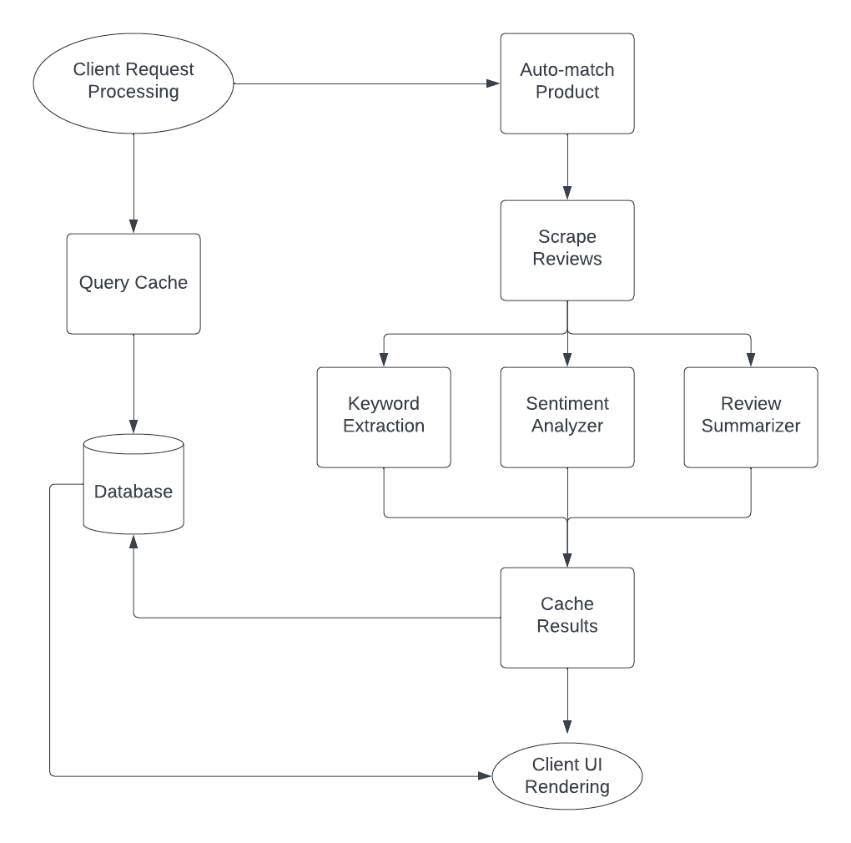

Figure 3.1 Block Diagram - General Overview

The block diagram given above represents our approach to the problem. The description of each block of the diagram is given below:

1. **Client Request Processing**: The system architecture follows a client-server model, where the Flask API serves as the server-side component that receives requests from the client-side UI. When a user submits a request, the Flask API listens on the /analyze endpoint, extracts the product URL from the request parameters, and forwards it to the analysis backend for further processing.
2. **Cache Query**: To optimize performance, the system leverages a SQLite cache database to store product data and analysis results. Upon receiving a request from the client-side UI, the Flask API queries the cache database to check if the requested information already exists. If the data is present, it is returned to the client immediately. Otherwise, the system proceeds with the remaining analysis blocks to generate the requested analysis, which is then stored in the cache database for future use. This approach reduces redundant analysis and speeds up response times for end-users.
3. **Auto-match Product:** In the event that a single platform URL is supplied, the system employs web scraped search results to locate the corresponding product URL on the other platform and retrieves the pertinent product data. If a match is found, the returned results will have an "autoMatch" flag set to true, indicating to the frontend that the outcome was automatically obtained.
4. **Scrape reviews:** The system uses web scraping techniques to collect relevant reviews for the specified product from the target platform. These reviews are then pre-processed to remove any irrelevant content and prepared for analysis.
5. **Keyword extraction:** The pre-processed reviews are then analyzed to extract relevant keywords and phrases using natural language processing techniques. These keywords and phrases are used to identify the key themes and sentiments expressed in the reviews.
6. **Sentiment analyzer:** The system uses a pre-trained deep learning model to perform sentiment analysis on the pre-processed reviews. The sentiment analyzer assigns a positive, negative, or neutral sentiment score to each review based on the sentiment expressed in the text.
7. **Review summarizer:** The system generates a summary of the reviews by identifying the key themes and sentiments expressed in the reviews and condensing them into a concise summary. The summary provides an overview of the main points and sentiments expressed in the reviews and is intended to provide a quick snapshot of customer sentiment towards the product.
8. **Cache results:** The system caches the results of each analysis in a SQLite database for future use. This allows the system to quickly retrieve the results of previous analyses without having to repeat the analysis process.
9. **Render on client UI:** The results of the analysis are rendered on a user interface that is accessible to the user. The interface allows the user to view the summary of the reviews, as well as other relevant information about the product, such as its price and availability. The interface also allows the user to submit new product URLs for analysis.

**Existing Solutions**

Below listed are the existing solutions to the proposed problem of pre-purchase product assessment by regular consumers, their drawbacks, and the role of sentiment analysis in assessing products:

1. **Traditional Reviews**: Customers often leave reviews on e-commerce platforms such as Amazon, Flipkart, etc. These reviews can be helpful in providing an insight into the product's quality and usefulness. However, it can be time-consuming to read through numerous reviews to determine the overall sentiment and usefulness of the product. Additionally, some reviews may be biased or fake, making it difficult to determine the authenticity of the feedback.
2. **Ratings**: E-commerce platforms usually allow users to rate products using a 1-5 star rating system. This can be useful in determining the overall popularity of a product. However, ratings alone may not provide sufficient information regarding the product's quality and usefulness. Moreover, ratings can be manipulated by fake reviews or paid reviews, leading to an inaccurate representation of the product.
3. **Product Descriptions**: The product description provided by the seller can also be helpful in determining whether the product meets the user's requirements. However, the seller may not always provide an accurate description of the product, and the user may not be able to fully understand the technical specifications of the product.
4. **Sentiment Analysis**: Sentiment analysis can be used to analyze customer feedback and determine the overall sentiment of the product. This can help in identifying the strengths and weaknesses of the product and make an informed decision. However, existing sentiment analysis models may not be able to handle multilingual reviews or understand the context of the feedback, leading to inaccurate results.

Overall, the key problem is that people need a way to assess products before purchasing them, and traditional methods such as reviews, ratings, and product descriptions may not always be sufficient. Sentiment analysis can be helpful in providing an overall sentiment of the product, but existing models may not be able to handle the complexity of multilingual reviews and context. Therefore, there is a need for an efficient and accurate system that can analyze customer feedback and provide a summary of the product's strengths and weaknesses.

**Proposed Solution**

The proposed solution aims to use dynamic methods of analysis for generating review summaries. The project will utilize transformer-based models such as BERT and BART to extract useful information from large volumes of text and generate concise and informative summaries of customer reviews. The key steps of the proposed solution are:

1. **Web Scraping:** The proposed solution involves using web scraping techniques to extract review data from popular e-commerce websites such as Amazon and Flipkart. This allows us to collect a large amount of review data quickly and efficiently, which can then be used for analysis.
2. **Keyword Extraction:** The extracted reviews are then processed using keyword extraction techniques to identify the most relevant keywords and phrases. This helps to identify the key features and attributes of the product that customers are most interested in.
3. **Sentiment Analysis:** The next step involves using the BERT-based sentiment analysis model to analyze the reviews and determine the overall sentiment of each review. This allows us to identify positive and negative reviews, as well as the degree of sentiment expressed in each review.
4. **Review Summarization:** After the sentiment analysis, the reviews are summarized using a generative BART-based model. This provides an overview of the most important features and sentiments expressed in the reviews, allowing users to quickly understand the overall sentiment towards the product.
5. **Cache Results:** To improve performance, the results of the analysis are stored in a SQLite database. This ensures that the system can quickly retrieve the analysis results for future requests without the need for re-analysis.
6. **Client-Side UI:** Finally, the results are rendered on an intuitive web client-side UI for direct use by users.

**Advantages of the proposed solution**:

* The proposed solution provides a comprehensive analysis of customer reviews, allowing users to quickly understand the overall sentiment towards a product.
* The use of web scraping techniques allows for the quick and efficient collection of review data from popular e-commerce websites.
* The use of BERT-based sentiment analysis model ensures a more accurate classification of reviews by considering the context of the text, leading to more reliable results.
* The use of generative BART-based model for review summarization ensures that the summary captures the key features and sentiments expressed in the reviews.
* The caching of analysis results ensures that the system can quickly retrieve analysis results for future requests, improving overall performance.
* The intuitive web client-side UI makes it easy for users to access and understand the analysis results, providing a more user-friendly experience.

**Algorithms**

## **Transformer Neural Networks**

Transformer neural networks are a type of deep learning architecture that has been widely used in natural language processing (NLP) tasks, such as machine translation, language modeling, and text summarization. They were first introduced by Vaswani et al. (2017) and have since become one of the most popular and effective models for NLP tasks.

One of the key features of transformer neural networks is the use of self-attention mechanisms, which allow the model to consider the relationships between all input elements (e.g. words in a sentence) simultaneously rather than processing them sequentially. This allows the model to capture long-range dependencies in the input data, which is important for tasks such as machine translation, where the meaning of a word can depend on the context of words that are far away in the sentence.

Another key feature of transformer neural networks is the use of multi-headed attention, which allows the model to attend to different parts of the input data simultaneously. This allows the model to learn multiple different relationships between the input elements, which can improve its ability to understand the meaning and context of the input data.

In addition to self-attention mechanisms and multi-headed attention, transformer neural networks also use feed-forward layers and residual connections, which allow the model to learn more complex patterns in the data and improve its ability to generalize to new data.

Transformer neural networks have proven to be highly effective for a wide range of NLP tasks, and they have significantly improved the state-of-the-art in many areas.

## **BERT Transformer model**

BERT (Bidirectional Encoder Representations from Transformers) is a transformer neural network model developed by Google for natural language processing (NLP) tasks. It was introduced by Devlin et al. (2018) and has become one of the most widely used and successful models in NLP, achieving state-of-the-art results on a wide range of tasks.

In this project, we used the BERT (Bidirectional Encoder Representations from Transformers) transformer model for sentiment analysis. Specifically, we used the pre-trained BERT-base-uncased model, which is a variant of the BERT model that uses a 12-layer, 768-hidden, 12-heads, 110M-parameters architecture. This model is capable of handling text inputs in a wide range of languages.

To integrate this model into our project, we used the Hugging Face Transformers library, which provides a simple and easy-to-use interface for loading and using pre-trained transformer models like BERT. We loaded the pre-trained BERT-base-uncased model using the transformers.BertForSequenceClassification class, which is a variant of BERT that has a classification layer added on top of the base model for fine-tuning on specific classification tasks.

We fine-tuned this pre-trained model on our specific sentiment analysis task using a labeled dataset of product reviews, where each review was labeled with a sentiment score ranging from 1 to 5. We trained the model using the Adam optimizer with a learning rate of 2e-5, a batch size of 32, and a maximum sequence length of 512 tokens. After training, we evaluated the model on a separate validation set to ensure that it was able to accurately classify the sentiment of unseen reviews.

Using the pre-trained BERT transformer model allowed us to achieve state-of-the-art performance on our sentiment analysis task, while also being able to handle inputs in a wide range of languages. Additionally, the Hugging Face Transformers library provided a convenient and easy-to-use interface for integrating the model into our project.

**BART Transformer Model**

BART (Bidirectional and Auto-Regressive Transformer) is a transformer-based architecture for sequence-to-sequence natural language processing tasks. In this project, BART was used for generating review summaries. Specifically, the pre-trained BART model available in the Hugging Face Transformers library was fine-tuned on a large dataset of product reviews to generate summary sentences that capture the most salient information from the input reviews.

To implement BART in the project, the Transformers library was utilized, which provides an easy-to-use interface for fine-tuning and inference with transformer models. The BART model was fine-tuned on a dataset of product reviews using the Python programming language and the PyTorch deep learning framework. During fine-tuning, the BART model was trained to predict a summary sentence given an input sequence of review sentences. The training process was performed on a GPU to speed up the computations.

After fine-tuning, the BART model was integrated into the main pipeline of the project. When a product review analysis is requested, the BART model is used to generate a summary of the reviews, which is then returned to the user interface. The use of BART allows for the generation of coherent and informative summaries of product reviews, which can save users time and effort in understanding the main points of a large number of reviews.

**KeyBERT**

KeyBERT is an unsupervised keyword extraction method that is based on a fine-tuned version of the BERT transformer model. It works by extracting the most salient keywords from a given text and has shown state-of-the-art performance in several benchmark datasets.

In the proposed system, KeyBERT was used to extract the keywords from the product reviews. The implementation of KeyBERT was done using the Python package 'keybert', which provides an easy-to-use interface for extracting keywords using a pre-trained KeyBERT model. The model was fine-tuned on a large corpus of texts, allowing it to capture semantic relationships and produce relevant keywords for a given text.

The KeyBERT model was used to extract the most important keywords from the reviews, which were then used for sentiment analysis and review summarization. To achieve this, the 'extract_keywords' function was used from the 'keybert' package, which takes the input text and returns a list of tuples containing the extracted keywords and their associated scores. The extracted keywords were then filtered to remove duplicates and irrelevant keywords.

# Mathematical Representation

## **Transformers**

The mathematical representation of transformers, a type of deep learning architecture used in natural language processing (NLP) tasks, is based on the use of self-attention mechanisms and feed-forward layers.

In a transformer model, the input data is first transformed into a sequence of vectors, where each vector represents a word or a sequence of words (e.g. a subword). These vectors are then fed into the self-attention mechanism, which computes a weighted sum of the vectors based on their relationships with each other.

Mathematically, the self-attention mechanism can be represented as follows:

$$Attention\left(Q,K,V\right)=softmax(\frac{QK^{T}}{\sqrt{d_{k}}})V$$

Where Q, K, and V are matrices representing the query, key, and value vectors, respectively, and $d_k$ is the dimensionality of the key vectors. The self-attention mechanism computes the dot product between the query and key vectors and divides it by the square root of the dimensionality of the key vectors in order to scale the dot product. The result is then passed through a softmax function to compute the attention weights, which are used to weigh the value vectors and compute the weighted sum.

The output of the self-attention mechanism is then passed through a feed-forward layer, which consists of a linear transformation followed by a non-linear activation function (e.g. ReLU). The feed-forward layer is used to learn more complex patterns in the data and improve the model's ability to generalize to new data.

**Bi-directional processing mechanism**

The bidirectional processing mechanism is a technique used in deep learning models, such as the BERT (Bidirectional Encoder Representations from Transformers) model, to consider the context of both preceding and following words when making predictions.

Mathematically, the bidirectional processing mechanism can be represented as follows:

$$h_{t}=[{h_{t}}^{\left(f\right)};{h_{t}}^{\left(b\right)}]$$

Where ${h_{t}}^{\left(f\right)}$ and ${h_{t}}^{\left(b\right)}$ are the forward and backward hidden states at time step t, respectively, and [;] is the concatenation operator.

To compute the forward hidden states, the input data is processed in the forward direction using a forward processing function, such as a recurrent neural network (RNN) or a transformer:

$${h_{t}}^{\left(f\right)} =ForwardProcessingFunction ({h_{t-1}}^{\left(f\right)}, x_{t})$$

To compute the backward hidden states, the input data is processed in the backward direction using a backward processing function, such as a backward RNN or a transformer:



$${h_{t}}^{\left(b\right)} =BackwardProcessingFunction ({h_{t+1}}^{\left(b\right)}, x_{t})$$

# 3.3 Requirement Analysis

**Functional Requirements**

The functional requirements for this project include developing a web application that allows users to analyze product reviews on Amazon.com. The application should have a client-server architecture with a RESTful API to handle requests from the user interface. The server-side component should be implemented in Python Flask and should have the ability to scrape reviews, perform keyword extraction, sentiment analysis, and review summarization. The application should also cache results to improve performance and should render the analyzed results on the client-side user interface.

**Hardware Requirements**

* **Processor:** 4-8 core multi-threaded processor (Intel Core i5, AMD Ryzen 5/Ryzen 7)
* **Memory:** 8 GB RAM
* **Storage:** 5 GB hard drive space

**Software Requirements**

* Python 3
* Flask
* PyTorch
* SQLite
* Visual Studio Code
* Hugging face API for interacting with transformer models

**3.4 Implementation**

The application consists of several main modules, each responsible for specific tasks such as data retrieval, sentiment analysis, keyword extraction, and caching. The system architecture follows a client-server model, with the client being a user accessing the web application through a browser and the server implementing the back-end functionality using Python Flask. The sentiment analysis is performed using pre-trained transformer models such as BERT and BART, while keyword extraction utilizes the KeyBERT algorithm. The system utilizes a cache database to improve performance and avoid redundant analysis. The application requires specific hardware and software requirements for optimal performance, which will be discussed in detail later in this document.

**Project Modules**

* **Module 1:** Web scrapers for Amazon and Flipkart
* **Module 2:** Review Analysis Backend
* **Module 3:** Client-side Frontend
* **Module 5:** Database operations

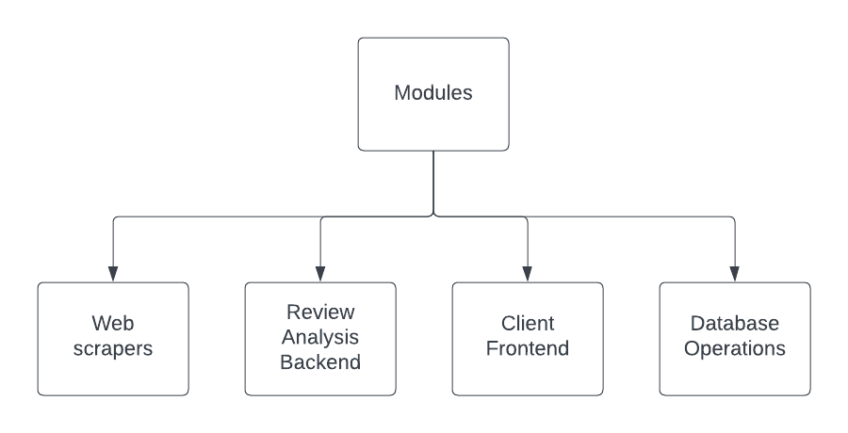

Figure 3.2 Project Modules

**Module 1: Web Scrapers**

The web scraping module of this project is responsible for collecting user reviews of a product from an e-commerce website. It takes as input the URL of the product page and uses the Beautiful Soup library in Python to extract the necessary information from the HTML code of the webpage. The module specifically targets the review section of the product page and extracts the text of the reviews along with their corresponding ratings. The extracted reviews are then passed on to other modules for further processing and analysis. The module is designed to work with any e-commerce website that has a review section and can be easily adapted to scrape reviews from other websites by modifying the scraping code accordingly.

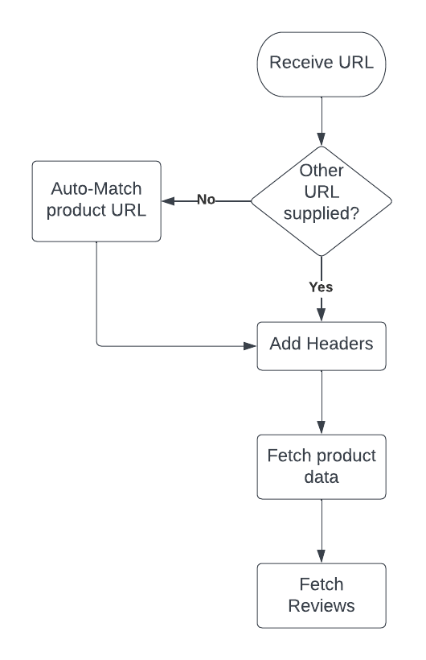

Figure 3.3 Web Scraper Module Flow

**Amazon Web Scraper**

The Amazon web scraping module in this project is responsible for extracting reviews of a product from its Amazon page. It is implemented using the BeautifulSoup library in Python. The module takes as input a URL of an Amazon product page, and then extracts the product's name, rating, and a list of reviews from the page.

# import module

import requests

from bs4 import BeautifulSoup

HEADERS = ({'User-Agent':

'Mozilla/5.0 (Windows NT 10.0; Win64; x64) \

AppleWebKit/537.36 (KHTML, like Gecko) \

Chrome/90.0.4430.212 Safari/537.36',

'Accept-Language': 'en-US, en;q=0.5'})

**Figure 3.4 Imports and headers**

The code imports the necessary modules: requests and BeautifulSoup from bs4. The HEADERS variable is a dictionary that stores information that will be sent to the server when making a request. It contains the user agent and the accept language.

def get_multipage_reviews(url, pages=1):

url = url.split("/")

url = list(map(lambda x: x.replace('dp', 'product-reviews'), url))

url = "/".join(url)

multiPageData = []

for i in range(1,pages+1):

response = requests.get(url + '&pageNumber=' + str(i), headers=HEADERS)

soup = BeautifulSoup(response.text, "html.parser")

multiPageData.append(soup)

return multiPageData

**Figure 3.5 Fetching raw multi-page review data from Amazon**

The get_multipage_reviews function takes a URL and a number of pages as input parameters, and returns a list of BeautifulSoup objects, each representing a page of reviews. The function first replaces the "dp" part of the URL with "product-reviews" using a lambda function and the map function. It then loops through each page and sends a GET request to the URL, appending the page number to the URL as a query parameter. The response from the request is parsed into a BeautifulSoup object and added to the list multiPageData.

def get_amz_product_data(url):

r = requests.get(url, headers=HEADERS)

soup = BeautifulSoup(r.content, 'html.parser')

# Extract the product name

product_name = soup.find('span', {'id': 'productTitle'}).text.strip()

# Extract the product price

product_price = soup.find('span', {'class': 'a-price-whole'}).text.strip()

# Extract the product rating

product_rating = soup.find('span', {'class': 'a-icon-alt'}).text.strip().split()[0]

# Extract the product image URL

product_image_url = soup.find('img', {'id': 'landingImage'})['data-old-hires']

return {"product_name": product_name, "product_price": product_price, "product_rating": product_rating, "product_image_url":product_image_url, "product_url": url}

**Figure 3.6 Fetching product data from Amazon**

The get_amz_product_data function takes a URL as input and returns a dictionary of product information. The function sends a GET request to the URL and retrieves the HTML content of the page. The HTML content is then parsed into a BeautifulSoup object. The function uses the find method of the BeautifulSoup object to extract the product name, product price, product rating, and product image URL from the HTML content. The extracted information is returned as a dictionary.

def get_amz_reviews(url, pages=1):

    multiPageData = get_multipage_reviews(url,pages)

    reviews = []

    for page in multiPageData:

        review_containers = page.find_all('div', {'data-hook': 'review'})

        for container in review_containers:

            review_text = container.find('span', {'data-hook': 'review-body'}).text.strip()

            review_text = review_text.replace('\n', '').replace('\t', '')

            verified_purchase = 'Verified Purchase' in container.find('span', {'class': 'a-size-mini a-color-state a-text-bold'}).text

            review_item = {

                 "review_text": review_text,

                 "verified_purchase": verified_purchase or False

            }

            reviews.append(review_text)

    return reviews

**Figure 3.7 Process and clean review data**

The get_amz_reviews function in the Amazon scraper code uses the get_multipage_reviews function to get a list of BeautifulSoup objects that represent each page of reviews for the given product URL. Then, for each page, the function uses the find_all method of the BeautifulSoup object to find all the review containers, which are represented by div elements with a data-hook attribute set to "review".

For each review container, the function uses the find method of the container object to find the span element with a data-hook attribute set to "review-body", which contains the actual review text. The function then strips any whitespace characters from the beginning and end of the text, as well as any newline or tab characters within the text.

The function also checks whether the review is marked as a "Verified Purchase" by looking for a span element with a class attribute set to "a-size-mini a-color-state a-text-bold". If such an element is found, the review is marked as a verified purchase in the output dictionary.

Finally, the function returns a list of review texts as strings, which were extracted from each review container.

**Flipkart Web Scraper**

The Flipkart scraper module is responsible for scraping product data and reviews from the Flipkart website. It is written in Python and uses the requests and BeautifulSoup libraries for web scraping. The module contains three functions, namely get_multipage_reviews(), review_scrapper(), and get_flp_product_data().

def get_multipage_reviews(url, pages=1):

    url = url.split("/")

    url[4] = "product-reviews"

    url = "/".join(url)

    multiPageData = []

    for i in range(1,pages+1):

        response = requests.get(url + '&page=' + str(i), headers=HEADERS)

        soup = BeautifulSoup(response.text, "html.parser")

        multiPageData.append(soup)

    return multiPageData

**Figure 3.8 Fetch raw multipage data from Flipkart**

The get_multipage_reviews() function takes the product URL and the number of pages to be scraped as inputs. It then iterates through the specified number of pages and extracts the HTML content using the requests library. The BeautifulSoup library is used to parse the HTML content and extract the required information. The extracted data is stored in a list and returned.

def review_scrapper(soup):

  rows = soup.find_all('div',attrs={'class':'col _2wzgFH K0kLPL'})

  reviews = []

  for row in rows:

      sub_row = row.find_all('div',attrs={'class':'row'})

      review = sub_row[1].find_all('div')[2].text

      reviews.append(review)

  return reviews

**Figure 3.9 Process and clean Flipkart review data**

The review_scrapper() function takes the HTML content of a single page as input and extracts the reviews from it. It searches for the div elements with class "col _2wzgFH K0kLPL" and then extracts the review text from it. The function then appends each review to a list and returns it.

def get_flp_reviews(url, pages=1):

  multiPageData = get_multipage_reviews(url,pages)

  reviews = []

  for page in multiPageData:

      reviews.extend(review_scrapper(page))

  return reviews

**Figure 3.10 Fetch Flipkart reviews from multiple pages**

The get_flp_reviews() function takes the product URL and the number of pages to be scraped as inputs. It uses the get_multipage_reviews() function to retrieve the HTML content of all the specified pages. It then iterates through each page and extracts the reviews using the review_scrapper() function. The reviews are stored in a list and returned.

def get_flp_product_data(url):

  response = requests.get(url, headers=HEADERS)

  soup = BeautifulSoup(response.text, 'html.parser')

  product_rating=soup.find('div', attrs={'class':'_3LWZlK'}).text

  product_price=soup.find('div', attrs={'class':'_30jeq3 _16Jk6d'}).text

  product_image_url = soup.find('img', attrs={'class': "_396cs4 _2amPTt _3qGmMb"})['src']

  product_name = soup.find('span', attrs={'class': "B_NuCI"}).text

  return {"product_name": product_name, "product_price": product_price, "product_rating": product_rating, "product_image_url":product_image_url, "product_url": url}

**Figure 3.11 Fetch Flipkart product data**

The get_flp_product_data() function takes the product URL as input and extracts product details such as the name, price, rating, and image URL. It searches for the HTML elements containing the required information and extracts the text or attributes from them. The extracted information is then stored in a dictionary and returned.

**Product Auto-Matcher**

The product_finder function is responsible for finding the matching product on Amazon and Flipkart, based on the product URLs provided as input. It first checks whether a product URL for Amazon or Flipkart is provided or not. If neither is provided, it returns None.

def product_finder(url_amz=None, url_flp=None):

    if not url_amz and not url_flp:

        return

    elif url_amz:

        # Get product name from url

        product_data = get_amz_product_data(url_amz)

        product_name = urllib.parse.quote(product_data["product_name"])

        # Search query url for the product in Flipkart

        query_url = f"https://www.flipkart.com/search?q={product_name}&otracker=search&otracker1=search&marketplace=FLIPKART&as-show=on&as=off"

        response = requests.get(query_url)

        soup = BeautifulSoup(response.content, 'html.parser')

        container = soup.find_all('div', {'class': '_1AtVbE col-12-12'})

        # Find the first search result and scrape the url

        if len(container) > 0:

            for result in container:

                product = result.find('div', {'class':'_4ddWXP'})

                if product is not None:

                    return 'https://www.flipkart.com' + product.find('a')['href']

        else:

            return None

**Figure 3.12 Auto-match equivalent Flipkart product**

If the Amazon product URL is provided, it extracts the product name from the URL and searches for this product on Flipkart using a search query URL. The response from the query URL is then parsed using BeautifulSoup, and the first search result is returned if found, otherwise None is returned.

elif url_flp:

        # Get product name from url

        product_data = get_flp_product_data(url_flp)

        product_name = urllib.parse.quote(product_data["product_name"])

        # Search query url for the product in Amazon

        query_url = f"https://www.amazon.in/s?k={product_name}"

        response = requests.get(query_url, headers=HEADERS)

        soup = BeautifulSoup(response.content, 'html.parser')

        results = soup.find_all('div', {'class': ['s-result-item'], 'data-component-type': 's-search-result'})

        # Filter out sponsored results

        for r in results:

            if 'AdHolder' not in r.get('class'):

                return 'https://www.amazon.in' + (r.find('a')['href'])

        return None

**Figure 3.13 Auto-match equivalent Amazon product**

If the Flipkart product URL is provided, it extracts the product name from the URL and searches for this product on Amazon using a search query URL. The response from the query URL is then parsed using BeautifulSoup, and the first search result that is not sponsored is returned if found, otherwise None is returned.

To achieve this functionality, the code uses libraries such as requests, urllib, BeautifulSoup, and get_amz_product_data, and get_flp_product_data which are custom functions that extract product data from the respective websites.

**Module 2: Review Analysis Backend**

The review analysis backend is a system designed to analyze customer reviews of products on e-commerce websites. It consists of several components working together to provide useful insights from the reviews. 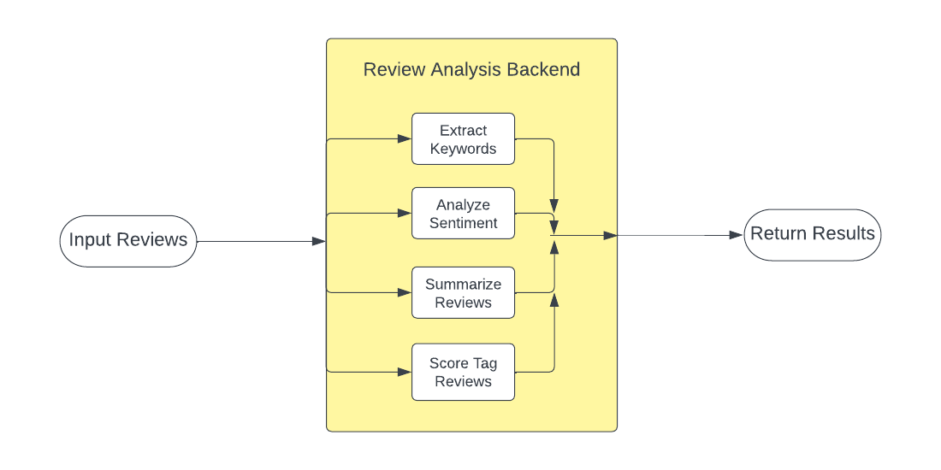

**Figure 3.14 Review Analysis Backend flowchart**

The first component is the keyword extractor, which identifies and extracts important keywords from the reviews. These keywords can provide valuable information about the product features, strengths, and weaknesses, and help identify areas for improvement.

The second component is the sentiment analyzer, which uses natural language processing (NLP) techniques to determine the sentiment of each review. The sentiment analyzer processes the text of each review and assigns a positive, negative, or neutral sentiment score based on the content.

The third component is the review summarizer, which generates a concise summary of the reviews. This summary highlights the most commonly mentioned keywords and sentiments, making it easier for users to quickly understand the overall feedback of the product.

The fourth component is the review sentiment score tagger, which assigns a sentiment score to the review summary. This provides a more granular analysis of the reviews, allowing users to identify the most positive and negative aspects of the product.

**Parallel Execution**

Parallel execution has been used in this project to optimize the speed by running multiple functions simultaneously.

Specifically, the concurrent.futures.ThreadPoolExecutor module has been used to create a thread pool of workers.

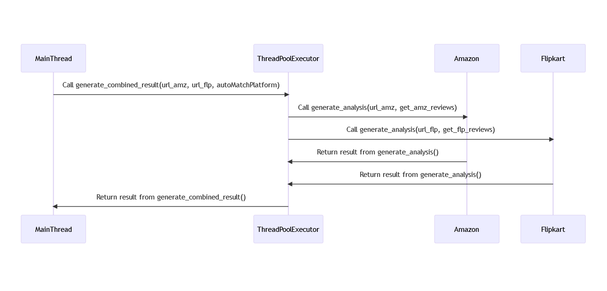

**Figure 3.15 Parallel thread execution sequence diagram**

In the generate_combined_result function, two functions, generate_analysis and either get_amz_reviews or get_flp_reviews, are submitted to the executor as concurrent futures using the executor.submit() method. These futures are then stored in a dictionary, futures, with the associated site's analysis dictionary, result["amazon"]["analysis"] or result["flipkart"]["analysis"], as the value.

with concurrent.futures.ThreadPoolExecutor() as executor:

        futures = {

            executor.submit(generate_analysis, url_amz, get_amz_reviews): result["amazon"]["analysis"],

            executor.submit(generate_analysis, url_flp, get_flp_reviews): result["flipkart"]["analysis"]

        }

        for future, site_analysis in futures.items():

            site_analysis.update(future.result())

**Figure 3.16 Sentiment analysis flowchart**

The with statement ensures that the executor is closed after all futures have completed. The future.result() method is called on each future to obtain the result, which is then updated in the corresponding site's analysis dictionary. Once all futures have completed, the result dictionary containing both site's product data and analysis is returned.

By using parallel execution, the time taken to analyze reviews for both sites is reduced as multiple functions can be run simultaneously, rather than sequentially.

**Keyword Extractor**

The keyword extractor in this project uses the KeyBERT package to extract the most important keywords from the customer reviews. The KeyBERT() function initializes a pre-trained model that extracts keywords using a transformer-based neural network architecture.

from keybert import KeyBERT

from joblib import Memory

kw_model = KeyBERT()

# Set up cache memory

memory = Memory(location='cache_dir', verbose=0)

@memory.cache

def KeywordExtractor(reviews):

  keywords = kw_model.extract_keywords(reviews,keyphrase_ngram_range=(1,3))

  filtered_keywords = []

  for k in keywords:

    filtered_keywords.append(k[0][0])

  return filtered_keywords

**Figure 3.17 Review Analysis Backend flowchart**

The KeywordExtractor function takes the list of customer reviews as input and first applies caching to speed up the computation by saving the result of the function to disk. Then, it calls the extract_keywords method of the kw_model object to extract keywords from the input reviews. The keyphrase_ngram_range parameter specifies the range of n-grams (contiguous sequences of words) to consider as potential keyphrases when extracting the keywords.

Finally, the function filters the extracted keywords to only include the first word of each keyphrase (i.e., the most significant word), and returns the filtered keywords as a list.

**Sentiment Analyser**

The sentiment analysis module is responsible for analyzing the sentiment of each review in the dataset. The code is structured as follows:

#### Loading the Sentiment Analysis Model

The code begins by importing the necessary modules, including "Memory" and "pipeline" from the Transformers library. It then sets the name of the pre-trained sentiment analysis model to "LiYuan/amazon-review-sentiment-analysis". Finally, it creates a sentiment analysis pipeline using this model.

from joblib import Memory

from transformers import pipeline

model_name = "LiYuan/amazon-review-sentiment-analysis"

sentiment_pipeline = pipeline("text-classification", model=model_name)

**Figure 3.18 Code for loading the sentiment analysis model**

#### Sentiment Analysis

#### The main sentiment analysis function is called "SentimentAnalyzer". It takes a list of reviews as input and returns a sentiment score for the reviews. https://documents.lucid.app/documents/4c2f5719-f259-4298-9623-d8aa7762ab06/pages/0_0?a=1058&x=267&y=111&w=1595&h=628&store=1&accept=image%2F*&auth=LCA%20fa8c7492bf72cb3b8fa1f7c937c25497fbce476a56e13151ba1fcae56b037a08-ts%3D1683108581

**Figure 3.19 Sentiment analysis flowchart**

scores = []

for r in reviews:

if len(r) > 512:

# Split the review into chunks of maximum length 512 sequences

chunks = [r[i:i+512] for i in range(0, len(r), 512)]

# Analyze each chunk separately and aggregate the results

chunk_scores = [sentiment_pipeline(c)[0]['label'].split(" ")[0] for c in chunks]

score = sum(float(s) for s in chunk_scores) / len(chunk_scores)

else:

result = sentiment_pipeline(r)

label = result[0]['label']

score = label.split(" ")[0]

scores.append(float(score))

if len(scores) > 0:

return sum(scores) / len(scores)

else:

return 0.0

**Figure 3.20 Split reviews into 512 sequence chunks**

The function first initializes an empty list called “scores”, which will store the sentiment scores for each review. Then, it loops over each review in the input list and checks its length. If the length of the review is greater than 512 characters, the function splits it into chunks of maximum length 512 sequences.

For each chunk, the function calls the sentiment analysis pipeline to obtain the sentiment label for that chunk. It then extracts the sentiment score from the label by splitting the label string and taking the first element.

If the length of the review is less than or equal to 512 characters, the function calls the sentiment analysis pipeline to obtain the sentiment label and score for the review.

For both cases, the function converts the sentiment score to a float and appends it to the “scores” list. Once all reviews have been processed, the function calculates the average sentiment score by summing the scores and dividing by the number of reviews. If there are no reviews in the input list, the function returns a sentiment score of 0.0.

**Review Summarizer**

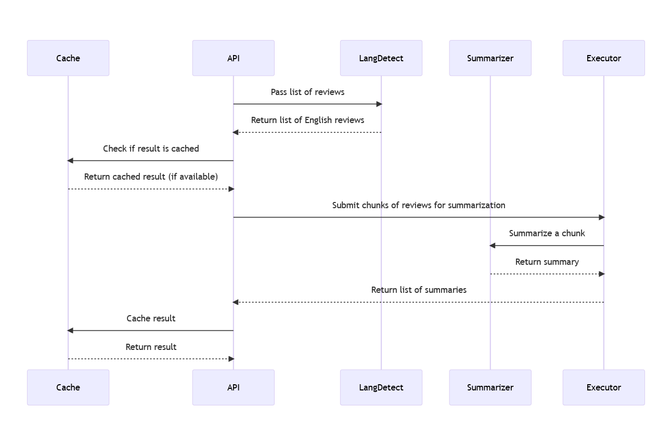

**Figure 3.21 Sequence diagram for review summarization**

The ReviewSummarizer function takes a list of reviews, and returns a summary of those reviews using a pre-trained summarization model. The function utilizes parallel execution to speed up the summarization process.

import concurrent.futures

from joblib import Memory

from transformers import pipeline

from langdetect import detect

# Load pre-trained model and tokenizer

model_name = "sshleifer/distilbart-cnn-12-6"

summarizer = pipeline("summarization")

# Set up cache memory

memory = Memory(location='cache_dir', verbose=0)

@memory.cache

def ReviewSummarizer(reviews, max_length=150, min_length=100):

    # Filter out non-English reviews

    english_reviews = [r for r in reviews if detect(r) == 'en']

    if not english_reviews:

        return ''

**Figure 3.22 Filter non-English reviews**

The first step of the function is to filter out any non-English reviews using the detect function from the langdetect library. If there are no English reviews, an empty string is returned.

    # Concatenate reviews into one single text block

    concatenated_text = "\n".join(english_reviews)

    factor = len(concatenated_text)//1024

    if factor>0:

        max_length = max((max_length//factor), 100)

    # Split the concatenated text into chunks of 1024 tokens

    chunks = [concatenated_text[i:i+1024] for i in range(0, len(concatenated_text), 1024)]

**Figure 3.23 Concatenate reviews and distribute into 1024 sequence chunks**

Next, the function concatenates all the English reviews into one single text block. If the length of this text block is greater than 1024 tokens, the function splits the text block into smaller chunks of 1024 tokens each.

    def summarize_chunk(chunk):

        summary = summarizer(chunk, max_length=max_length, do_sample=False)[0]['summary_text']

        return summary

    with concurrent.futures.ThreadPoolExecutor() as executor:

        # Summarize each chunk separately in parallel

        summaries = list(executor.map(summarize_chunk, chunks))

    # Join the summaries into one single text block

    summary_text = "\n".join(summaries)

    return summary_text

**Figure 3.24 Summarize each chunk in parallel**

Then, the function defines a helper function called summarize_chunk that takes a chunk of text as input and uses the pre-trained summarization model to generate a summary of that text. This helper function is called in parallel for each chunk of text using the ThreadPoolExecutor from the concurrent.futures module.

Once all the summaries for each chunk of text are generated, they are joined into one single text block and returned as the final summary of all the reviews.

The function utilizes caching using the joblib.Memory module to store the results of the function call with a given set of reviews, in case the function is called again with the same set of reviews. This helps to speed up subsequent function calls by avoiding the need to generate summaries again for the same set of reviews.

**Review Sentiment Tagger**

The review sentiment tagger module is responsible for analyzing the sentiment of customer reviews. It takes a review as input and returns the review with each sentence tagged with a color representing the sentiment of the sentence.

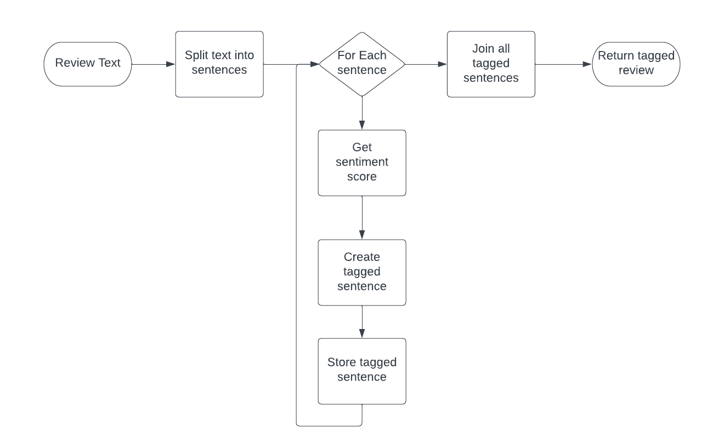

**Figure 3.25 Review sentiment tagging flowchart**

The module first loads a pre-trained sentiment analysis model using the Hugging Face Transformers library and caches the model in memory using the joblib library. The sentiment analysis model used in this module is the "LiYuan/amazon-review-sentiment-analysis" model.

from joblib import Memory

from transformers import pipeline

model_name = "LiYuan/amazon-review-sentiment-analysis"

sentiment_pipeline = pipeline("text-classification", model=model_name)

**Figure 3.26 Import required modules for sentiment tagging**

The review is then split into individual sentences using the period (.) as a delimiter. Each sentence is then fed into the sentiment analysis model to determine its sentiment. The sentiment score is a value between 1 and 5, with 5 being the most positive and 1 being the most negative. The sentiment score is used to determine the color tag that will be assigned to the sentence. The color tag ranges from green (most positive) to red (most negative), with yellow, orange, and light green in between.

def ReviewSentimentTagger(review):

    sentences = review.split('.')

    tagged_sentences = []

    for sentence in sentences:

        result = sentiment_pipeline(sentence)

        label = result[0]['label']

        score = int(label.split(" ")[0])

        color = ""

        if score == 5:

            color = "green"

        elif score == 4:

            color = "lightgreen"

        elif score == 3:

            color = "yellow"

        elif score == 2:

            color = "orange"

        else:

            color = "red"

        tagged_sentence = f"<span data-highlight={color}>{sentence}</span>"

        tagged_sentences.append(tagged_sentence)

    return " ".join(tagged_sentences)

**Figure 3.27 Tag sentences with sentiment scores**

The module returns the review with each sentence tagged with its corresponding color. The color is added as a data-highlight attribute to the HTML span element containing the sentence. This allows the color to be easily styled using CSS. The tagged sentences are joined together using a space as a delimiter and returned as a single string.

**Module 3: Web Frontend**

# REFERENCES

[1] Fang, X., Zhan, J. Sentiment analysis using product review data. Journal of Big Data 2, 5 (2015). [**https://doi.org/10.1186/s40537-015-0015-**](https://doi.org/10.1186/s40537-015-0015-)2

[2] NLP and Sentiment analysis by symbl.ai, [**https://symbl.ai/about**](https://symbl.ai/about)

[3] Tamir Bennatan, Conducting Sentiment Analysis on App Reviews to Inform Product Decisions. Hopper, Medium (Jun 13, 2019). [**https://medium.com/life-at-hopper/conducting-sentiment-analysis-on-app-reviews-to-inform-product-decisions-64fcc71822ed**](https://medium.com/life-at-hopper/conducting-sentiment-analysis-on-app-reviews-to-inform-product-decisions-64fcc71822ed)

[4] [**Atharva Mashalkar**](https://atharva-mashalkar.medium.com/?source=post_page-----16b806eb4c4b--------------------------------), Sentiment Analysis using Logistic Regression and Naive Bayes. TowardsDataScience (Nov 28, 2020). [**https://towardsdatascience.com/sentiment-analysis-using-logistic-regression-and-naive-bayes-16b806eb4c4b**](https://towardsdatascience.com/sentiment-analysis-using-logistic-regression-and-naive-bayes-16b806eb4c4b)

[5] Thura, T., Na, J.-C., & Khoo, C. S. G. (2010). Aspect-based sentiment analysis of movie reviews on discussion boards. Journal of Information Science, 36(6), 823–848. [**https://doi.org/10.1177/0165551510388123**](https://doi.org/10.1177/0165551510388123)

[6] [**Hu Xu**](https://arxiv.org/search/cs?searchtype=author&query=Xu,+H), [**Bing Liu**](https://arxiv.org/search/cs?searchtype=author&query=Liu,+B), [**Lei Shu**](https://arxiv.org/search/cs?searchtype=author&query=Shu,+L), [**Philip S. Yu**](https://arxiv.org/search/cs?searchtype=author&query=Yu,+P+S) (2019). BERT Post-Training for Review Reading Comprehension and Aspect-based Sentiment Analysis. [**https://doi.org/10.48550/arXiv.1904.02232**](https://doi.org/10.48550/arXiv.1904.02232)

1. [7] Federico Pascual, Analyze Sentiment in Product Reviews. MonkeyLearn Blog (Mar 23, 2019). [**https://monkeylearn.com/blog/sentiment-analysis-of-product-reviews/**](https://monkeylearn.com/blog/sentiment-analysis-of-product-reviews/)