**TASK 2. Static Website Hosting:**

**1. Enable static website hosting for your S3 bucket.**

**2. Access the static website using the provided endpoint.**

**To enable static website hosting for the bucket:**

1. Go to the properties of the bucket and scroll down to the last and you will see the Static website hosting section click on “Edit”

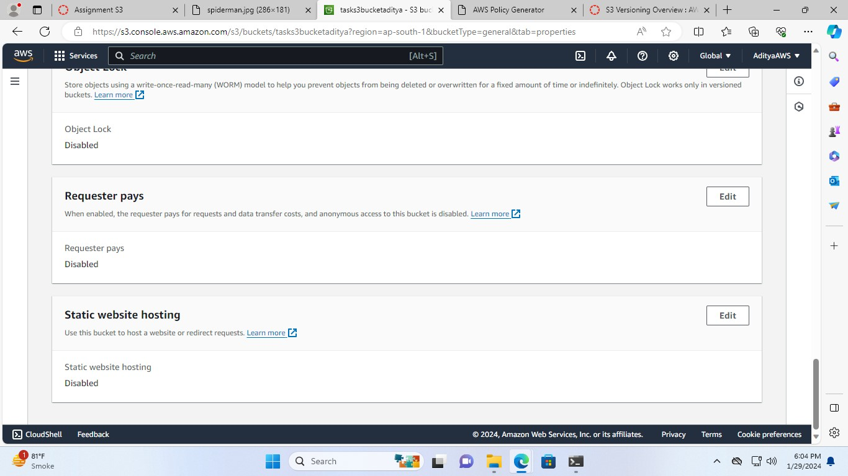

1. Now, enable the static website hosting and in hosting type select “Host a static website”.

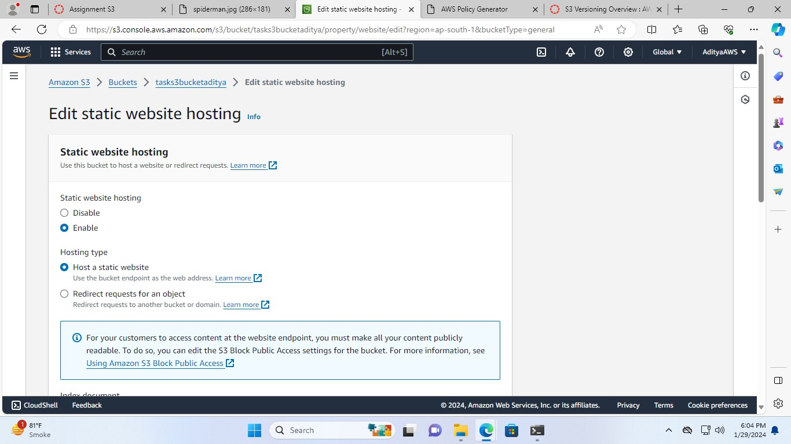

1. Name the index document as “index.html” and click on “Save changes”

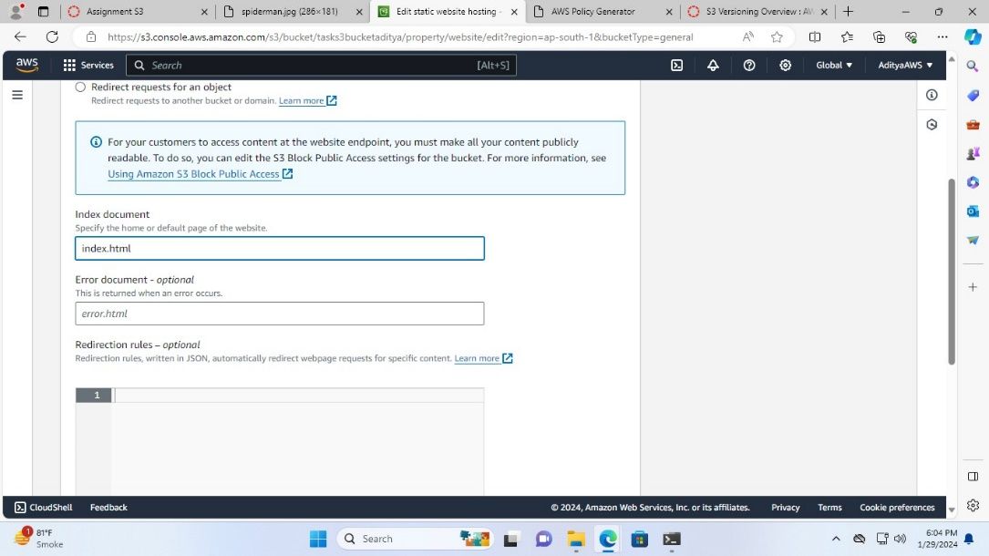

1. I have uploaded the index.html file

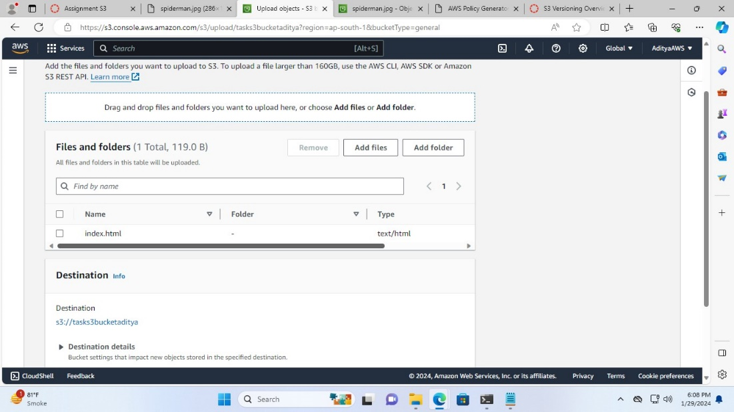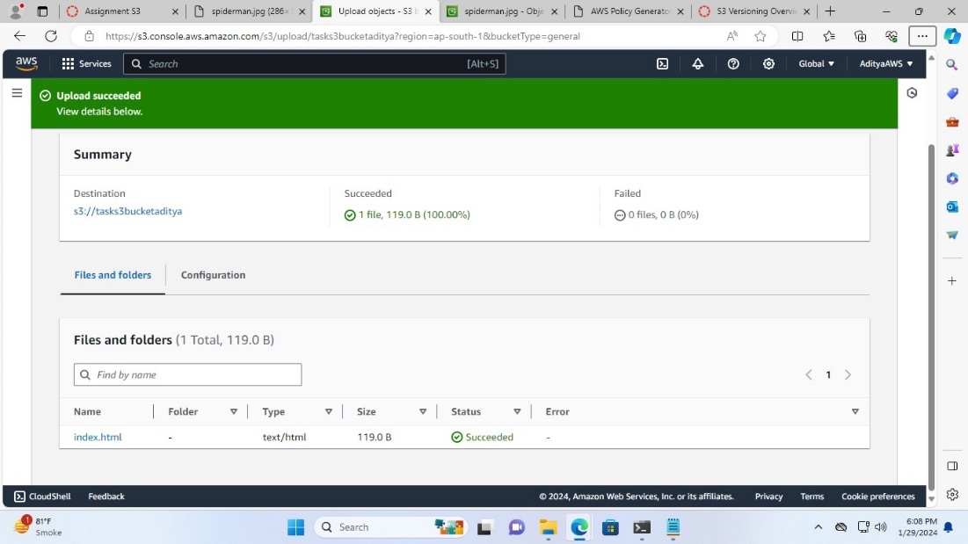

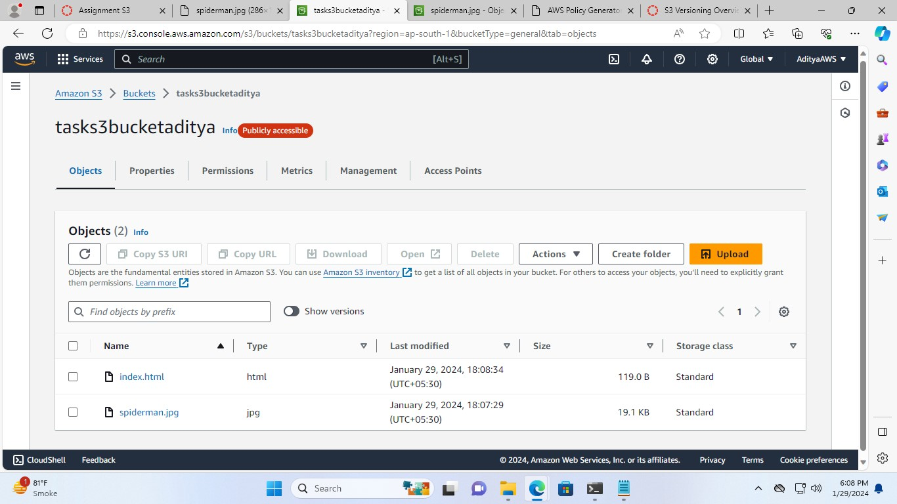

**Now, in order to access the website using provided endpoint:**

1. Go to the properties of the bucket and scroll down to the last, in the “Static website hosting” section there will be a bucket website endpoint “<http://tasks3bucketaditya.s3-website.ap-south-1.amazonaws.com>”

Click on the link

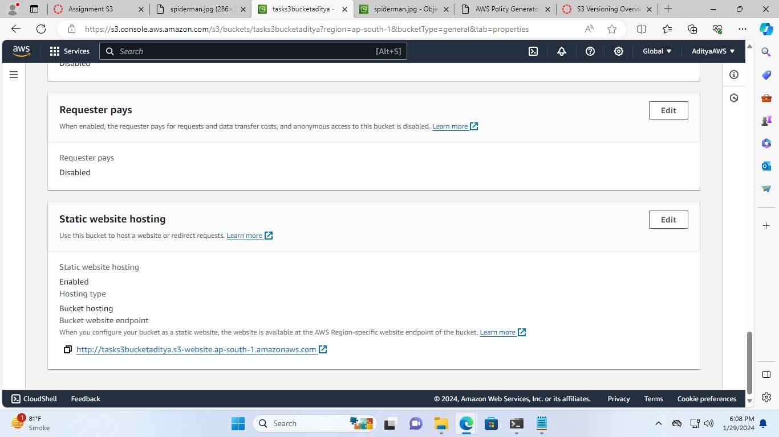

And access the website

