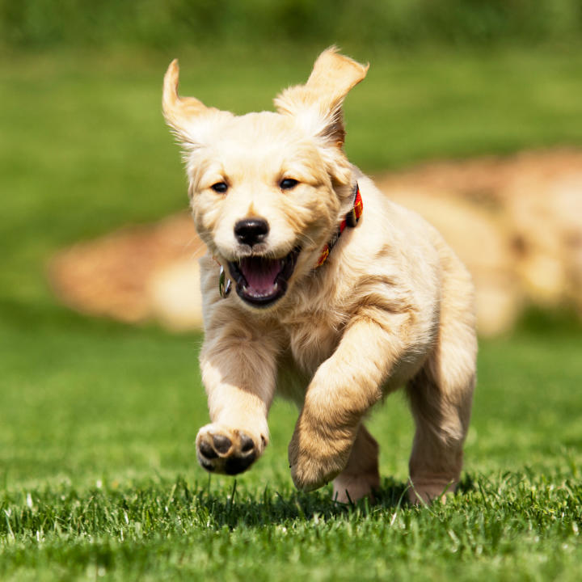
This is a doggie

This is a good doggie.....

