Analysis of OFDMA, Modulation and Coding in Wi-Fi 6/6E Networks: A Lecture-Hall Capacity Study
Aditya Joshi  Department of Electronics and Telecommunication Engineering  Shah & Anchor Kutchhi Engineering College  Mumbai, India  Roll No. 30 · Reg. 124BTEX1019 | Bhavya Kundhadia  Department of Electronics and Telecommunication Engineering  Shah & Anchor Kutchhi Engineering College  Mumbai, India  Roll No. 35 · Reg. 124BTEX1005

Abstract—Dense wireless LANs are limited by airtime rather than by headline PHY rate. This paper analyses how orthogonal frequency-division multiple access (OFDMA), high-order quadrature amplitude modulation (QAM) and forward-error-correction (FEC) coding jointly determine capacity, latency and reliability in IEEE 802.11ax (Wi-Fi 6) and its 6 GHz extension (Wi-Fi 6E). A 120-seat lecture hall is used as the running design scenario. We derive the 802.11ax data-rate relation and tabulate the 12 HE-MCS rates for 20–160 MHz channels, evaluate analytical uncoded BER curves for 16- to 1024-QAM under AWGN, model link adaptation with a representative SNR-threshold set, and build a transparent airtime-overhead model that contrasts single-user OFDM round-robin with trigger-based OFDMA. The analytical model shows OFDMA completing four 200-byte uplink/downlink exchanges in 370 µs against 848 µs for round-robin (2.3×), with a break-even at two stations, while 1024-QAM needs roughly 34 dB Es/N0 to reach BER 10⁻³ versus 16.5 dB for 16-QAM. A reproducible MATLAB-based simulation methodology and design guidelines for a mixed 5/6 GHz deployment are presented. Curves labelled illustrative originate from the project draft and are not measured results.
Index Terms—Wi-Fi 6, Wi-Fi 6E, IEEE 802.11ax, OFDMA, resource unit, QAM, MCS, coding rate, SNR, BER, goodput, link adaptation.
I. INTRODUCTION
Wireless local-area networks have moved from best-effort convenience to the primary access medium for teaching, collaboration and cloud services. In such venues the number of simultaneously associated devices, rather than the peak rate of any single link, decides the user experience. IEEE 802.11ax (Wi-Fi 6) was therefore specified as a High Efficiency amendment whose goal is better per-area throughput in dense deployments [1]–[3]. Its principal mechanisms are uplink and downlink OFDMA, uplink and downlink MU-MIMO, 1024-QAM, BSS colouring for spatial reuse, and Target Wake Time (TWT) for scheduled channel access and power saving (Fig. 1). Wi-Fi 6E applies the same 802.11ax technology in the 6 GHz band where regulators permit it.
Running scenario. Consider a 120-seat lecture hall. About 120 student devices plus the instructor and audiovisual equipment share one dense radio environment. Traffic is bursty and mixed: short control messages, learning-management-system (LMS) requests, file downloads, cloud collaboration and occasional video. Under these conditions airtime, not headline speed, is the bottleneck. The engineering question is how scheduling, MCS selection and 6 GHz spectrum change useful capacity, latency, retries and edge-user experience.
Contributions. This paper (i) explains OFDM, OFDMA and the resource-unit (RU) hierarchy and quantifies per-RU rates; (ii) derives the HE-MCS rate table and relates QAM order, code rate and SNR; (iii) presents an airtime-overhead model that isolates when OFDMA helps; (iv) defines a reproducible simulation methodology and metric set; and (v) gives lecture-hall design guidance. The study is deliberately explicit about evidence quality: analytical results are computed here, whereas draft curves inherited from the earlier project stages are labelled illustrative.

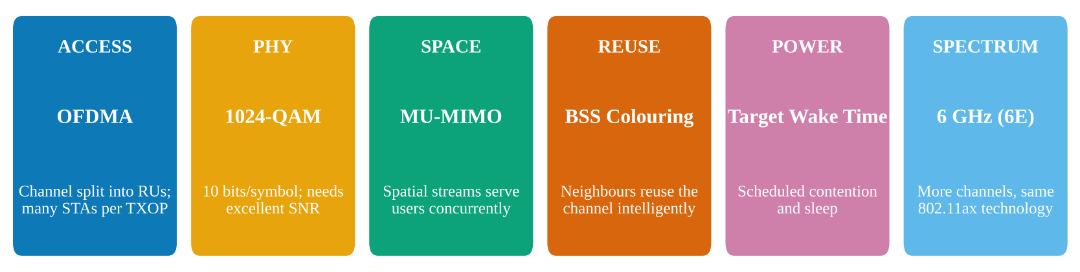
Fig. 1. Wi-Fi 6/6E feature set. OFDMA and MU-MIMO coordinate frequency and space; 1024-QAM raises bits per symbol; BSS colouring and TWT address reuse and contention; the 6 GHz band adds spectrum without changing the 802.11ax technology.

II. BACKGROUND
A. From OFDM to OFDMA
OFDM divides a channel into closely spaced orthogonal subcarriers, which makes the receiver robust to multipath [4]. In earlier Wi-Fi generations a transmission opportunity belongs to a single station, so every short packet pays the full cost of channel contention, preamble and acknowledgement. OFDMA, introduced to Wi-Fi in 802.11ax, groups subcarriers into resource units so that the access point (AP) can serve several stations within one coordinated interval. In the downlink the AP transmits to several users together; in the uplink it sends a trigger frame and the stations respond simultaneously with time- and frequency-aligned HE trigger-based PPDUs [1], [2].
The 802.11ax subcarrier spacing is 78.125 kHz (OFDM symbol 12.8 µs plus a 0.8, 1.6 or 3.2 µs guard interval), four times finer than 802.11ac, which allows the RU granularity shown in Fig. 2. A 20 MHz channel can hold up to nine 26-tone RUs, four 52-tone RUs, two 106-tone RUs or one 242-tone RU, and wider channels aggregate these into 484-, 996- and 2×996-tone RUs.
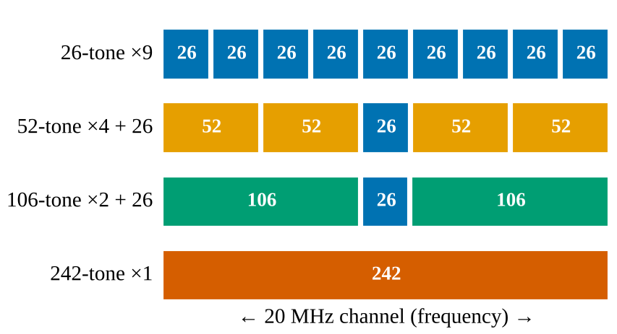
Fig. 2. RU hierarchy of a 20 MHz HE channel (schematic, tone counts shown). The central 26-tone RU sits between the larger RUs.
B. Per-RU data rate
The nominal HE PHY rate of an allocation with N_{SD} data subcarriers is
R = N_{SD} · log₂(M) · R_{c} · N_{SS} / (T_{DFT} + T_{GI}) (1)
where M is the QAM order, R_{c} the FEC code rate, N_{SS} the number of spatial streams, T_{DFT} = 12.8 µs and T_{GI} the guard interval. Using T_{GI} = 0.8 µs and one stream, a full 80 MHz channel (N_{SD} = 980) at MCS 11 gives 600.5 Mb/s, and 160 MHz gives 1201.0 Mb/s. Table I shows that the same relation applied to an individual RU yields the rate a single station receives when it holds only a part of the channel. This is the fundamental OFDMA trade-off: each user's instantaneous rate is lower, but many users are served at once.
TABLE I
PER-RU RATE, 1 SPATIAL STREAM, 0.8 µs GI
RU size (tones) | N_{SD} | MCS 7 (Mb/s) | MCS 11 (Mb/s)
26 | 24 | 8.8 | 14.7
52 | 48 | 17.6 | 29.4
106 | 102 | 37.5 | 62.5
242 | 234 | 86.0 | 143.4
484 | 468 | 172.1 | 286.8
996 | 980 | 360.3 | 600.5

C. Wi-Fi 6E spectrum
Wi-Fi 6E adds spectrum, not a new modulation system. In the United States the 6 GHz band spans 5.925–7.125 GHz (1200 MHz), providing 59 non-overlapping 20 MHz channels, 14 at 80 MHz and 7 at 160 MHz, compared with six 80 MHz and two 160 MHz channels at 5 GHz (Fig. 3). Operation is subject to regional rules, and 6 GHz clients must use WPA3 or OWE security. The 6 GHz signal has shorter practical reach and weaker wall penetration, so it favours small cells. Very wide channels also reduce frequency reuse between neighbouring APs, so wider is not automatically better in dense deployments.
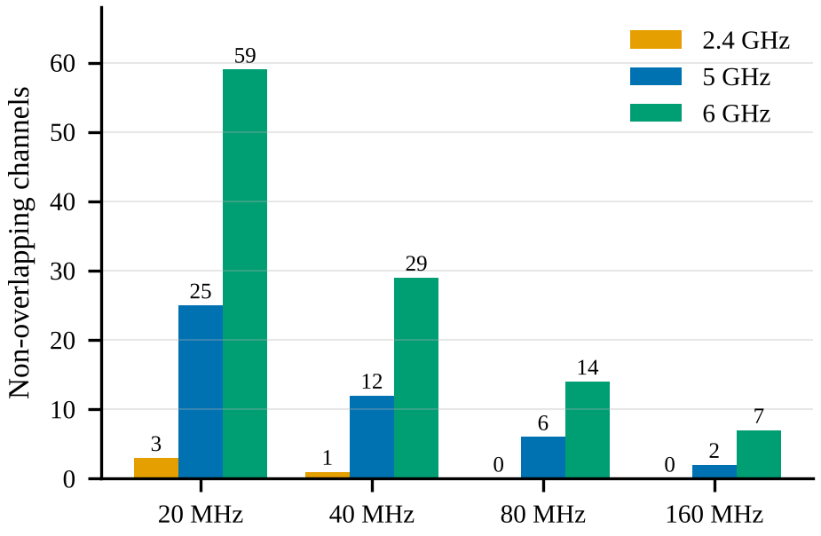
Fig. 3. Non-overlapping channel counts by width (US channelisation). 6 GHz roughly doubles the 80 MHz and triples the 160 MHz channel inventory of 5 GHz.
III. MODULATION, CODING AND LINK ADAPTATION
A. QAM constellations
QAM maps groups of bits onto amplitude–phase constellation points: 16-QAM carries 4 coded bits per symbol, 64-QAM 6, 256-QAM 8 and 1024-QAM 10 [5]. Doubling the bits per axis shrinks the minimum distance between points, so detection becomes more sensitive to noise, phase error, interference and channel-estimation error. Fig. 4 shows the same noise level degrading denser constellations; the Es/N0 used for each panel is 6 dB higher per added bit pair, yet 1024-QAM still has points that are nearly indistinguishable from their neighbours.

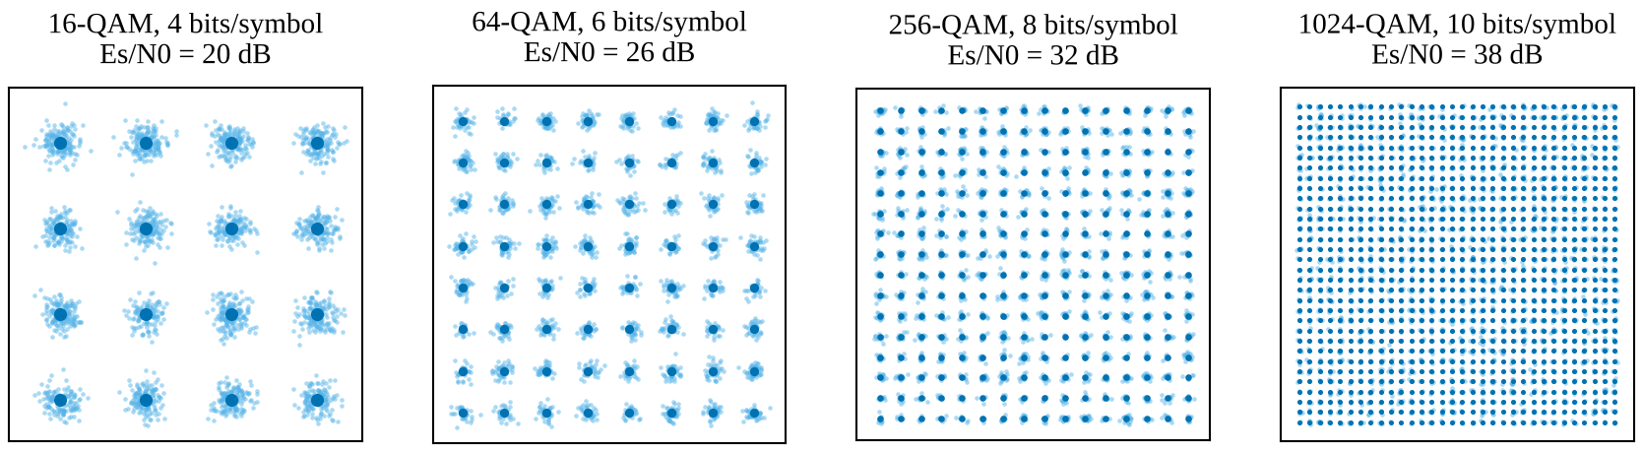
Fig. 4. Square QAM constellations with simulated AWGN samples (light blue) around the ideal points (dark blue). Each panel uses an Es/N0 large enough to show structure; denser constellations need progressively higher SNR to keep clusters separable. Generated by simulation for this paper.

B. Analytical error performance
For Gray-coded square M-QAM in AWGN, the bit error probability at symbol SNR γ = E_{s}/N₀ is closely approximated by
P_{b} ≈ (4/log₂M)(1 − 1/√M) Q(√(3γ/(M − 1))) (2)
Fig. 5 evaluates (2) for 16- to 1024-QAM. To reach an uncoded BER of 10⁻³ the required Es/N0 is 16.5 dB (16-QAM), 22.5 dB (64-QAM), 28.4 dB (256-QAM) and 34.3 dB (1024-QAM): each step of two bits per symbol costs roughly 6 dB. Real 802.11ax links apply convolutional or LDPC coding, interleaving and channel estimation, which shift these curves leftward; (2) is therefore a conservative, uncoded bound that exposes the relative SNR cost of each modulation order.
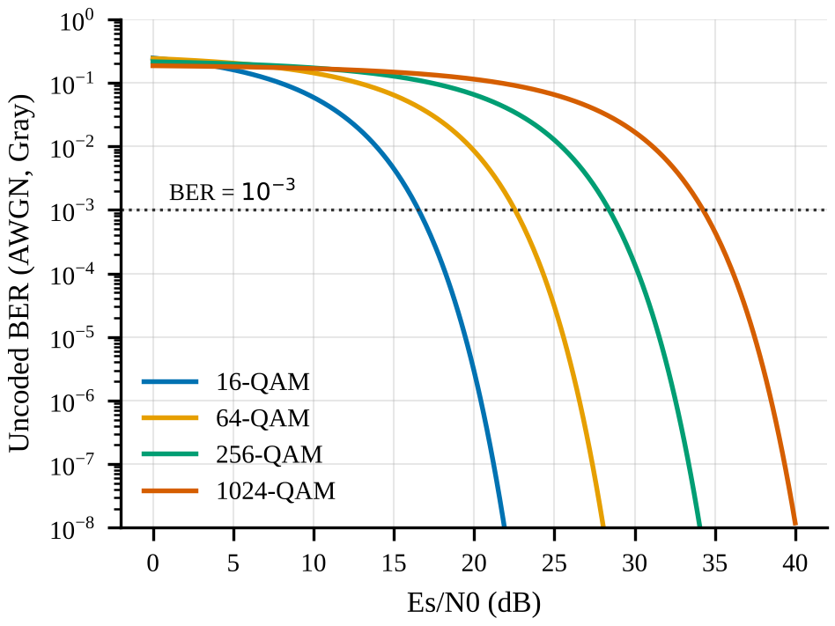
Fig. 5. Analytical uncoded BER versus Es/N0 for Gray-coded square QAM in AWGN, from (2).
C. The MCS table
802.11ax defines MCS 0–11 by pairing a modulation with a code rate; MCS 10 and 11 add 1024-QAM at rates 3/4 and 5/6. Fig. 6 gives the resulting PHY rate for one spatial stream and 0.8 µs guard interval from (1). A lower coding rate adds redundancy and improves robustness at the price of payload efficiency; MCS 7 and MCS 8 differ only in modulation, whereas MCS 9 versus MCS 10 shows 256-QAM 5/6 being replaced by 1024-QAM 3/4.
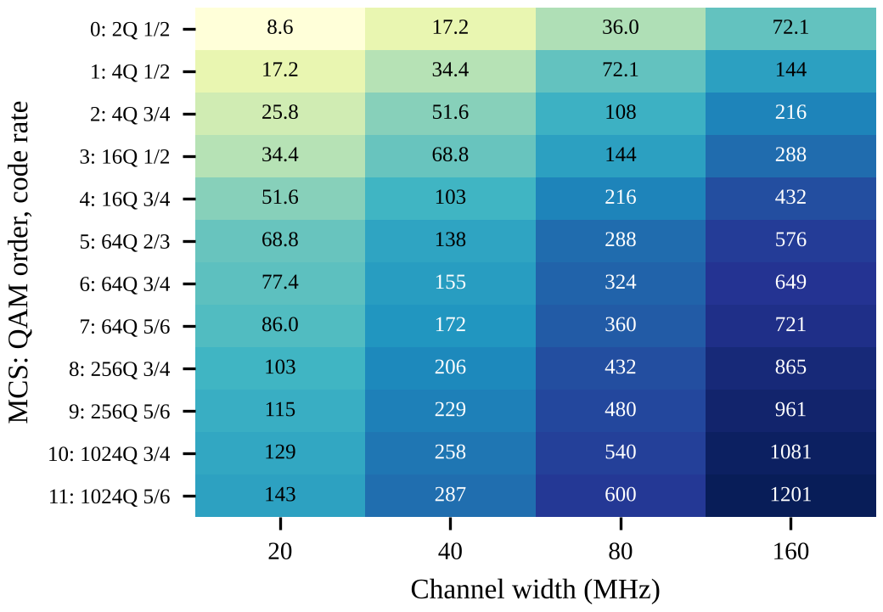
Fig. 6. HE PHY rate (Mb/s) for MCS 0–11, one spatial stream, 0.8 µs GI, computed from (1).
D. Link adaptation
The highest MCS is not always the fastest delivered result. As SNR rises, higher MCS values become usable; when the link degrades, stepping from 1024-QAM down to 256-QAM or 64-QAM reduces retries and can raise useful throughput. We model each MCS by its PHY rate multiplied by a logistic packet-success curve whose midpoint is a representative minimum SNR (2, 5, 9, 11, 15, 18, 20, 25, 29, 31, 34 and 36 dB for MCS 0–11). These thresholds are assumed values chosen to be representative of commonly published guidance, not measurements. The rate adaptation algorithm in the AP selects the upper envelope in Fig. 7: the delivered rate is a staircase in SNR, and MCS 11 pays off only above about 35 dB. Evaluating successful payload per unit time, not the MCS label or peak PHY rate, is the correct metric.
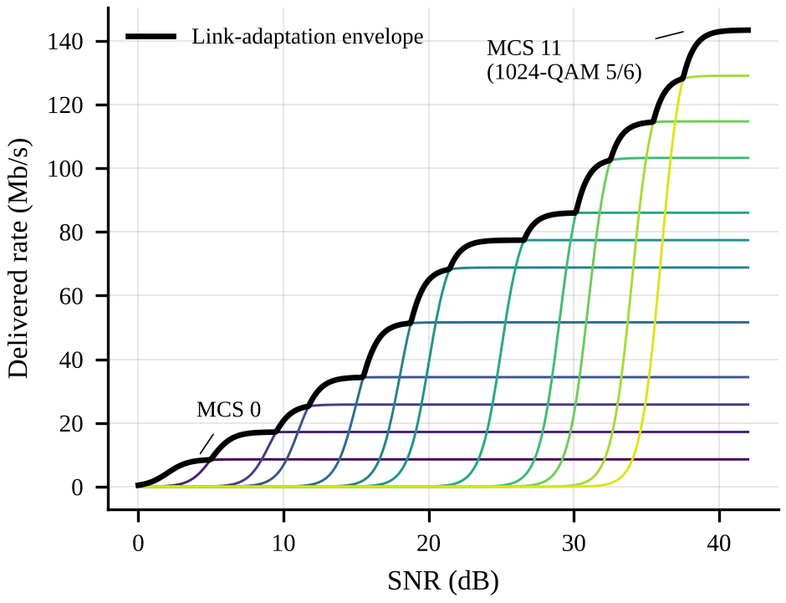
Fig. 7. Delivered rate versus SNR for MCS 0–11 (20 MHz, 1 SS) using assumed SNR thresholds; the bold line is the ideal link-adaptation envelope. Conceptual model.
IV. SYSTEM MODEL AND METHODOLOGY
A. Processing chain
The end-to-end chain used throughout the study is shown in Fig. 8: application data enters MAC queues and the scheduler, which selects RUs and MCS; the payload is FEC-encoded, QAM-mapped, placed on subcarriers, transformed by an IFFT and framed with a guard interval into an HE PPDU. After the wireless channel, the receiver performs synchronisation and channel estimation, FFT and equalisation, QAM demapping and FEC decoding, and records statistics. A practical simulator must capture the PHY waveform and the MAC-level scheduling separately.

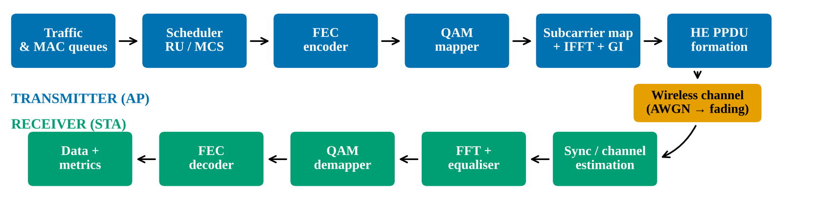
Fig. 8. Proposed processing chain for the simulation study. The AP schedules RUs and MCS; the station chain reconstructs the data and the metrics block records BER/PER, goodput, latency and fairness.

B. Simulation setup
The preferred platform is MATLAB with WLAN Toolbox for 802.11ax PHY waveform and link-level studies [9], and Wireless Network Toolbox / WLAN system-level examples for multi-node scenarios with traffic, throughput, latency and packet-loss statistics [6]–[8]. If these licensed toolboxes are unavailable, a Python analytical model, as used here, can demonstrate trends but must not be described as a full 802.11ax implementation. Table II lists the proposed configuration; the single-user OFDM round-robin baseline and the OFDMA case share traffic, channel, transmit power and duration.
TABLE II
PROPOSED SIMULATION CONFIGURATION
Parameter | Setting | Reason
Standard | IEEE 802.11ax HE | Wi-Fi 6/6E PHY
Bandwidth | 20 MHz base; 40/80 optional | Manageable baseline
Stations | 4, mixed short/bursty DL | Multi-user scheduling
Access modes | SU OFDM round-robin vs OFDMA | Compare scheduling
Modulation | 16-, 64-, 1024-QAM | Robustness vs efficiency
Channel | AWGN first; indoor fading next | Separate noise and multipath
SNR sweep | 0–20 dB, 2 dB steps (initial) | Observe error trends
Metrics | BER/PER, goodput, latency, loss, fairness | Comprehensive assessment
Repeatability | Fixed seed; multiple runs | Reduce variance

C. Procedure and metrics
1) Configure the 802.11ax HE scenario and record toolbox version, bandwidth, guard interval, MCS, coding and spatial streams.
2) Build the SU OFDM round-robin baseline with identical offered traffic per station.
3) Build the OFDMA case with identical traffic, channel, transmit power and duration.
4) Sweep SNR per MCS with the same channel model and packet length; record BER/PER.
5) Repeat with multiple seeds; report means and variation (confidence intervals where practical).
6) Export waveform, RU allocation, BER/PER, throughput, latency and packet-loss plots.
TABLE III
PERFORMANCE METRICS
Metric | Definition | Purpose
BER | Bit errors / bits sent | PHY sensitivity
PER | Errored packets / sent | Reliability
Goodput | Useful payload per second | Application rate
Aggregate throughput | Sum over stations | Delivery rate
Latency | Generation→delivery time | Responsiveness
Packet loss | Undelivered / offered | Load reliability
Fairness | Spread across stations | Detects starvation

V. RESULTS AND ANALYSIS
A. Airtime overhead: when does OFDMA help?
The benefit of OFDMA for short packets arises from amortising per-opportunity overhead. We model a 20 MHz, MCS 7, one-stream link (86.0 Mb/s). Round-robin pays, for every packet, an access delay of 101.5 µs (DIFS plus mean back-off), a 44 µs preamble, SIFS (16 µs) and a 32 µs block acknowledgement. OFDMA pays one access delay, a 52 µs HE-MU preamble, SIFS, a 40 µs trigger, a second SIFS and a 70 µs multi-station block-ack, then sends all payloads in parallel on separate RUs. These timing values are assumed, representative figures stated so that the model can be audited or replaced.
Fig. 9 shows four 200-byte packets: round-robin occupies 848 µs, OFDMA 370 µs, a 2.3× reduction in channel time. Fig. 10 sweeps the number of stations for three packet sizes. For 1500-byte packets at N = 9 the model gives 69.6 Mb/s for OFDMA versus 36.0 Mb/s for round-robin; for 300-byte packets 39.5 versus 10.8 Mb/s; for 100-byte packets 19.0 versus 3.9 Mb/s. At N = 1 round-robin wins for every size because OFDMA's trigger overhead is not repaid, and the break-even point is N = 2. This reproduces the qualitative claim that OFDMA is not automatically faster in every condition.
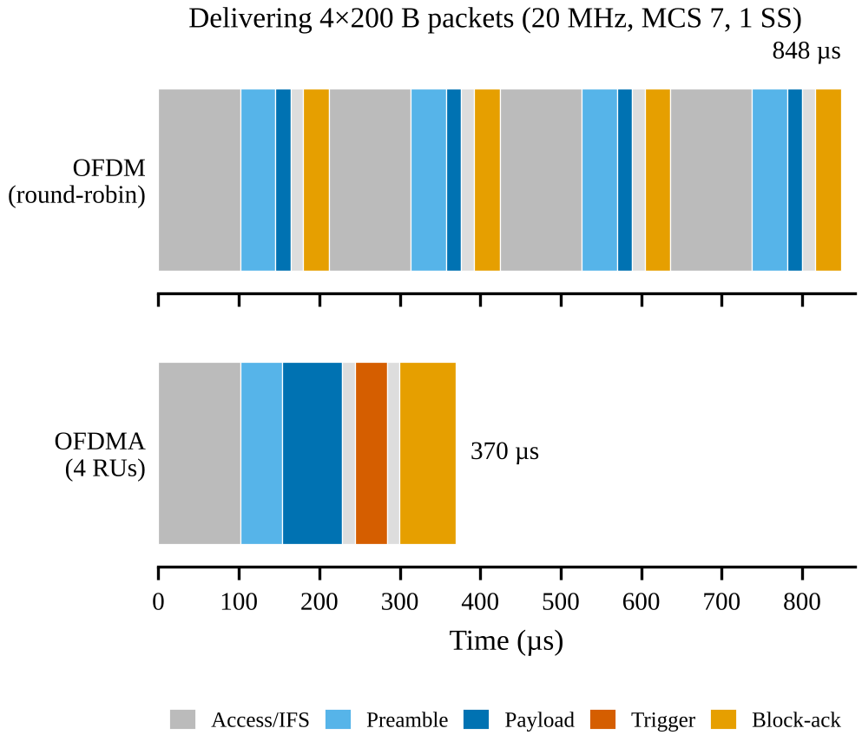
Fig. 9. Channel-time comparison for four 200-byte packets (analytical model, assumed MAC timings).
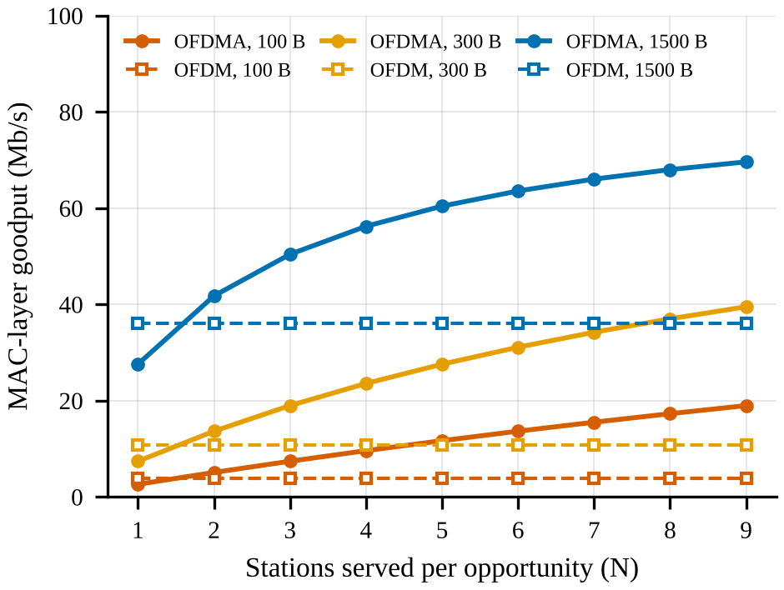
Fig. 10. Goodput versus stations served per opportunity for 100, 300 and 1500-byte packets. Solid: OFDMA; dashed: round-robin OFDM. Analytical model, no contention among multiple BSSs, no aggregation.
B. Error performance versus the draft values
Table IV compares the analytical uncoded BER from (2) with the illustrative values in the project draft. The draft values are markedly lower than uncoded AWGN theory, for example 1024-QAM at 20 dB is 3.5×10⁻⁴ in the draft but 0.11 analytically. Such values would be plausible only with strong coding or a different SNR definition, which confirms that the draft table must be replaced by simulator output before any result is claimed.
TABLE IV
ANALYTICAL BER (DRAFT ILLUSTRATIVE VALUE IN BRACKETS)
Es/N0 (dB) | 16-QAM | 64-QAM | 1024-QAM
6 | 0.140  (2.8×10⁻²) | 0.193  (6.3×10⁻²) | 0.177  (1.05×10⁻¹)
10 | 0.059  (2.1×10⁻³) | 0.143  (1.5×10⁻²) | 0.167  (4.8×10⁻²)
14 | 9.4×10⁻³  (1.2×10⁻⁵) | 0.080  (1.0×10⁻³) | 0.152  (1.3×10⁻²)
18 | 1.4×10⁻⁴  (1.0×10⁻⁹) | 0.024  (4.0×10⁻⁶) | 0.129  (1.5×10⁻³)
20 | 2.9×10⁻⁶  (1.0×10⁻¹²) | 8.5×10⁻³  (2.0×10⁻⁸) | 0.114  (3.5×10⁻⁴)

C. Draft goodput comparison
The Stage-2 draft proposed a synthetic goodput comparison for 1–16 active stations (Fig. 11), with OFDMA gains growing from 11% at one station to 91% at sixteen. The trend, not the magnitude, is the useful content: it agrees in direction with the airtime model of Fig. 10, in which advantage grows with the number of stations served, but the values themselves are not experimental findings.
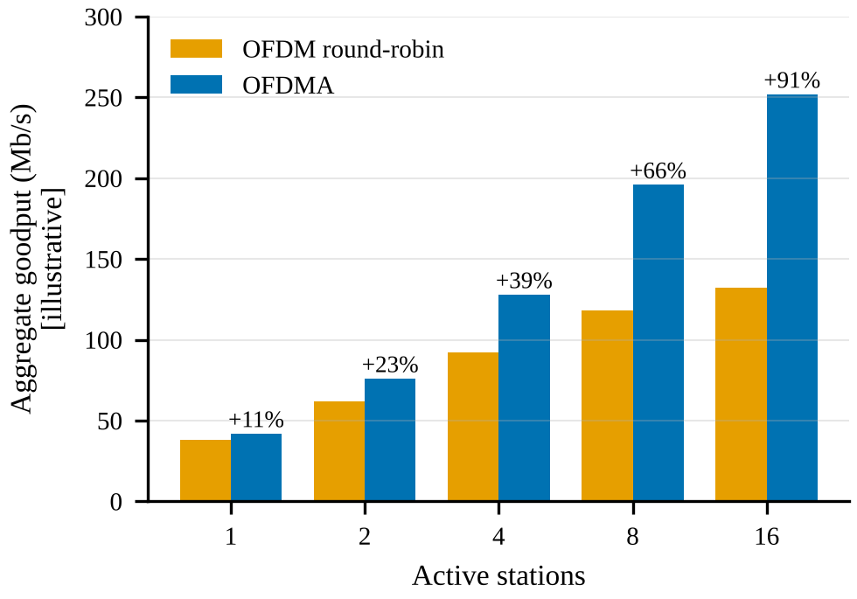
Fig. 11. Illustrative aggregate goodput from the project draft (synthetic values; gain percentages computed from them).
D. Evidence status
To keep the findings defensible, results are tagged by provenance. Computed: MCS rates, RU rates, analytical BER, channel counts. Assumed-parameter models: link-adaptation thresholds and airtime timings. Illustrative: draft BER and goodput tables. Replacing the last two classes with simulator output is the principal remaining work.
VI. LECTURE-HALL DESIGN GUIDELINES
The analysis supports a coordinated mixed-band design planned for capacity rather than maximum coverage (Fig. 12). As an illustrative sizing: if 120 devices are present and roughly one in four is active at any instant, about 30 stations contend; with four ceiling APs this is about 8 per AP, which matches the nine 26-tone RUs available in a 20 MHz allocation. This is an assumption-based example, not a site survey.
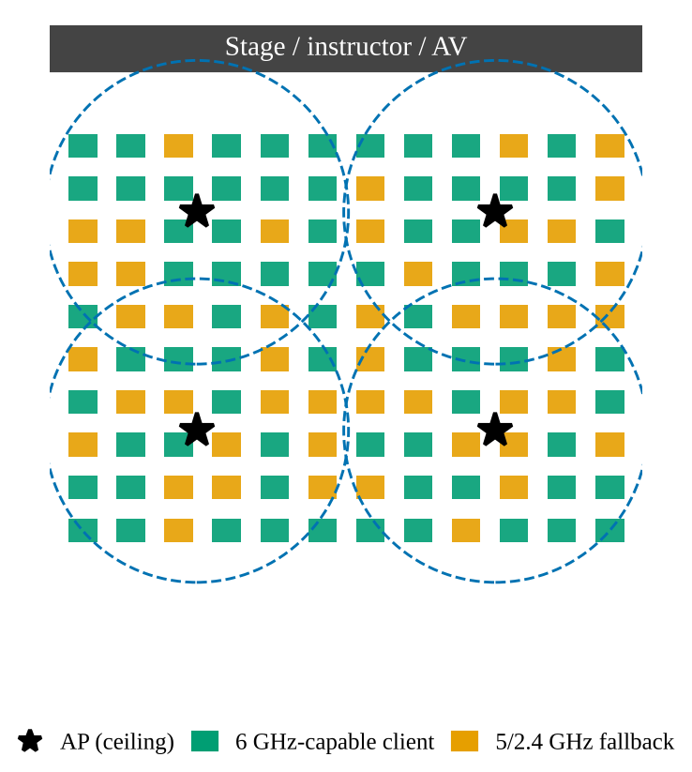
Fig. 12. Top-down lecture-hall schematic: four ceiling APs with overlapping cells; green seats denote 6 GHz-capable clients steered to 6 GHz, orange seats fall back to lower bands. Illustrative client mix.
• Use OFDMA for dense mixed traffic, and validate both downlink and uplink behaviour, since uplink needs trigger-based coordination.
• Adapt, do not force, the MCS. Let link adaptation select the rate per user; never fix one modulation order for all seats.
• Place APs for capacity and reuse, keep channel widths moderate (20–80 MHz) so neighbouring cells can reuse spectrum, and steer capable clients to 6 GHz while keeping a lower-band fallback.
• Measure airtime utilisation, median and 95th-percentile latency, retry rate, aggregate goodput, fairness and edge-user experience.
Table V summarises where each tool helps and stops helping, and Fig. 13 gives a qualitative scoring (the authors' engineering judgement, 1 = poor, 5 = good).
TABLE V
DECISION MATRIX
Technique | Helps | Stops helping
Smaller RUs | Many short bursts | Less bandwidth per user
Wider channels / larger RUs | Higher per-user rate | Reduced reuse; interference
Higher-order QAM | Spectral efficiency | Needs strong SNR
Lower coding rate | Robustness | Lower net payload rate
OFDMA + MU-MIMO | Frequency and space tools combine | Complementary, not substitutes

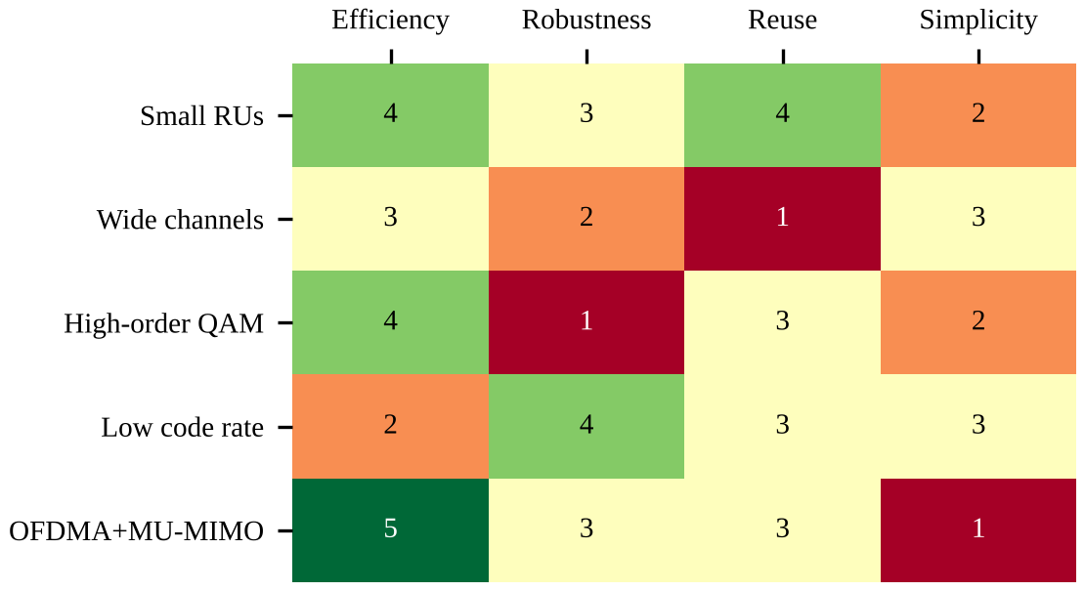
Fig. 13. Qualitative trade-off scores for design techniques (authors' assessment, not measured).
Comparison with single-user OFDM
TABLE VI
SU OFDM VERSUS OFDMA
Feature | SU OFDM | OFDMA
Resource use | One STA per opportunity | RUs serve several STAs
Short packets | Repeated overhead | Overhead amortised
Complexity | Simpler scheduling | RU allocation, coordination
Guarantee | Depends on rate and overhead | Not faster in every case
Best fit | Few users, large transfers | Many active, bursty users

VII. LIMITATIONS
• Draft BER and goodput tables are synthetic; the analytical models use assumed MAC timings and SNR thresholds.
• Generic QAM theory omits 802.11ax coding, preamble, pilots, channel estimation and receiver implementation.
• A fair comparison must hold traffic, packet size, channel, power, MCS policy and duration constant, and report repeated runs.
• The airtime model ignores inter-BSS contention, aggregation, retransmissions and rate-adaptation dynamics.
• Wi-Fi 6E behaviour depends on client and AP support and national 6 GHz regulations.
VIII. CONCLUSION
OFDMA, modulation and coding must be analysed jointly. OFDMA improves airtime efficiency by serving several stations per transmission opportunity, and the analytical model shows a 2.3× reduction in channel time for four short packets, with the benefit growing as more stations are served and vanishing for a single station. Higher-order QAM raises spectral efficiency but demands roughly 6 dB more SNR per two additional bits per symbol; link adaptation therefore decides the delivered rate, and 1024-QAM is conditional rather than universal. Wi-Fi 6E contributes channel opportunity but not a new modulation system. For a lecture hall the guiding rule is to schedule intelligently, adapt continuously and validate empirically.
IX. FUTURE WORK
• Run full 802.11ax link- and system-level simulations and replace all illustrative figures with exported results.
• Evaluate 20/40/80 MHz widths and multiple RU allocations; add indoor fading, interference, mobility and multiple APs.
• Compare OFDMA, MU-MIMO and their combination; report latency percentiles, fairness and mixed voice/video/data traffic.
• Validate trends against IEEE 802.11ax evaluation scenarios and explain differences.
APPENDIX: RESULT-LOG TEMPLATE
TABLE VII
RESULT LOG (TO BE FILLED FROM SIMULATOR OUTPUT)
Run | Mode | Stations | Recorded outputs
1 | SU OFDM baseline | 4 | Goodput, PER, latency
2 | OFDMA | 4 | Goodput, PER, latency
3 | OFDMA PHY sweep, low MCS | 1 | PER vs SNR
4 | OFDMA PHY sweep, high MCS | 1 | PER vs SNR

REFERENCES
[1] IEEE Standard for Information Technology—Telecommunications and Information Exchange between Systems—Local and Metropolitan Area Networks—Specific Requirements—Part 11: Wireless LAN MAC and PHY Specifications—Amendment 1: Enhancements for High-Efficiency WLAN, IEEE Std 802.11ax-2021.
[2] E. Khorov, A. Kiryanov, A. Lyakhov and G. Bianchi, “A tutorial on IEEE 802.11ax high efficiency WLANs,” IEEE Commun. Surveys Tuts., vol. 21, no. 1, pp. 197–216, 1st Quart. 2019.
[3] B. Bellalta, “IEEE 802.11ax: High-efficiency WLANs,” IEEE Wireless Commun., vol. 23, no. 1, pp. 38–46, Feb. 2016.
[4] R. van Nee and R. Prasad, OFDM for Wireless Multimedia Communications. Boston, MA, USA: Artech House, 2000.
[5] J. G. Proakis and M. Salehi, Digital Communications, 5th ed. New York, NY, USA: McGraw-Hill, 2008.
[6] MathWorks, “802.11ax downlink OFDMA multinode system-level simulation,” WLAN Toolbox documentation. [Online]. Available: https://www.mathworks.com/help/wlan/ug/802-11ax-downlink-ofdma-multinode-system-level-simulation.html
[7] MathWorks, “802.11ax downlink OFDMA and multi-user MIMO throughput simulation,” WLAN Toolbox documentation. [Online]. Available: https://www.mathworks.com/help/wlan/ug/802-11ax-downlink-ofdma-and-multi-user-mimo-throughput-simulation.html
[8] MathWorks, “Get started with WLAN system-level simulation in MATLAB,” documentation. [Online]. Available: https://www.mathworks.com/help/wlan/ug/getting-started-with-wlan-system-level-simulation-in-matlab.html
[9] MathWorks, “802.11ax (Wi-Fi 6) link-level simulation,” WLAN Toolbox documentation. [Online]. Available: https://www.mathworks.com/help/wlan/802.11ax-link-level-simulation.html

