2D map generating bot

Aditya Karnam

Racherla Prabhat

Pratik Kapasi

Project Guide : Prof. Sridhar

Design Docs

Rapberry Pi Interfacing with GPS Breakout v3 Circuit

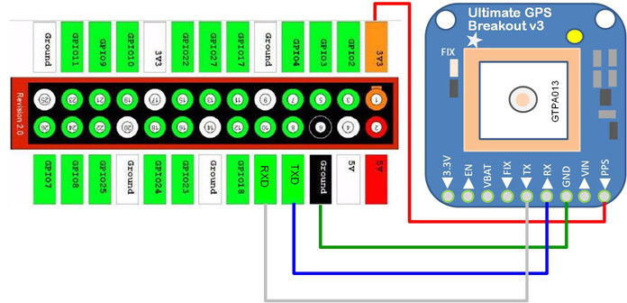

Raspberry Pi interfacing with L293D Motor Driver

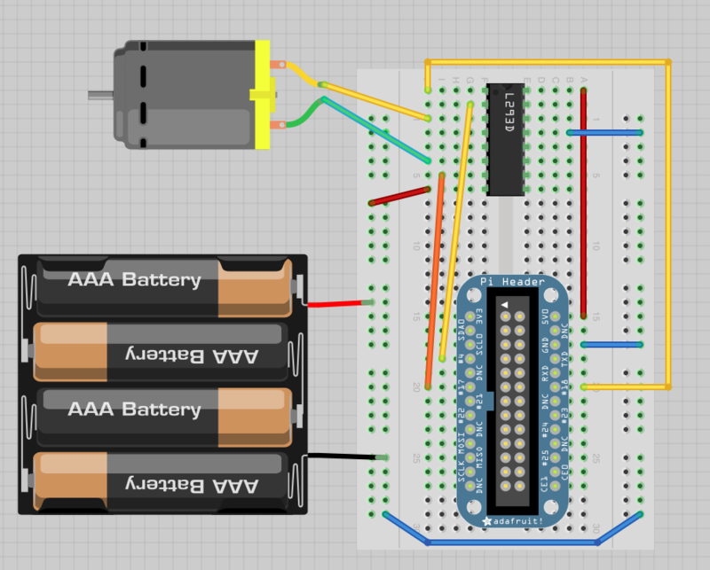

Raspberry Pi with Ultrasonic Sensor

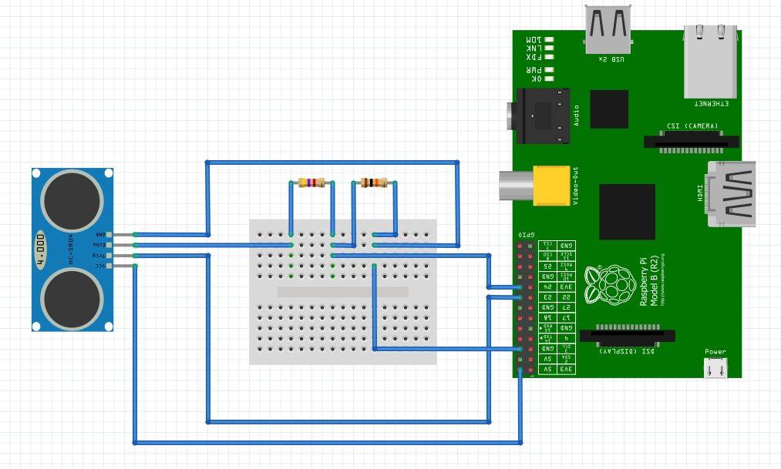

Resistance for Ultrasonic Sensor

The ECHO output is of 5v. The input pin of Raspberry Pi GPIO is rated at 3.3v. So 5v cannot be directly given to the unprotected 3.3v input pin. Therefore we use a voltage divider circuit using appropriate resistors to bring down the voltage to 3.3V.

We fix R1 = 4.7k.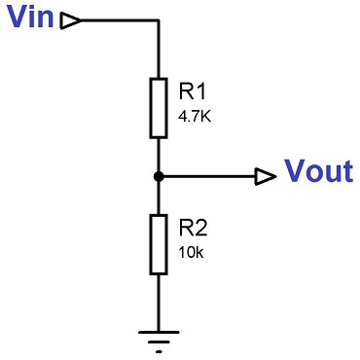

“Vout = Vin x R2/(R1+R2)”

3.3 = 5 * R2/(4.7k+R2)

0.66 = R2/(4.7k+R2)

0.66*4.7k + 0.66R2 = R2

3102 = 0.34R2

R2 = 3102/0.34 = 9123 ~= 10000 = 10k

# Distance Calculation

Time taken by pulse is actually for to and fro travel of ultrasonic signals, while we need only half of this. Therefore Time is taken as Time/2.

Distance = Speed * Time/2

Speed of sound at sea level = 343 m/s or 34300 cm/s

Thus, Distance = 17150 * Time (unit cm)

PWM(Pulse Width Modulation using L293D Motor Driver), GPS, Ultrasonic

Complete Circuit

