DESIGN AND IMPLEMENTATION OF A CLOUD-BASED CONTAINERIZATION AND KUBERNETES ORCHESTRATION SYSTEM
A Project Report Submitted in Partial Fulfillment of the Requirements for the Degree of Bachelor of Engineering / Technology in Computer Science & Engineering
Submitted by:
ADITYA KALE
Roll No: [Insert Roll Number]
Under the Guidance of:
[Name of Project Guide / Professor]
[Designation, Department of Computer Engineering]
[DEPARTMENT OF COMPUTER ENGINEERING / INFORMATION TECHNOLOGY]
[COLLEGE / INSTITUTION NAME]
[AFFILIATED UNIVERSITY NAME]
Academic Year: 2025–2026

CERTIFICATE OF APPROVAL
This is to certify that the project report entitled "Design and Implementation of a Cloud-Based Containerization and Kubernetes Orchestration System" is a bona fide record of independent project work carried out by ADITYA KALE (Roll No: [Insert Roll Number]) under my supervision and guidance, in partial fulfillment of the requirements for the award of the Degree of Bachelor of Technology / Engineering in [Computer Engineering / Information Technology] of [University Name] during the academic year 2025–2026.
The results embodied in this report have been thoroughly verified and have not been submitted to any other University or Institution for the award of any degree or diploma.

_____________________  Internal Guide  [Guide Name]  [Designation] | _____________________  Head of Department  [HOD Name]  Dept of CSE/IT | _____________________  External Examiner  [Examiner Name]  Date: ____________

DECLARATION
I, ADITYA KALE, hereby declare that the project entitled "Design and Implementation of a Cloud-Based Containerization and Kubernetes Orchestration System" submitted to [College/University Name] is an authentic record of original project work executed by me under the esteemed guidance of [Guide Name], [Designation].
I confirm that the software implementation, container definitions, Kubernetes declarative manifests, and verification experiments presented herein represent my own work. All external software libraries, technical documentation, architectural patterns, and official specifications have been duly cited and acknowledged.

Place: [City Name]
Date: [Date of Submission] ADITYA KALE
(Roll No: [Insert Roll No])

ACKNOWLEDGMENTS
I wish to express my profound gratitude to my project guide, [Guide Name], for their invaluable guidance, constructive criticism, and continuous technical mentorship throughout the design and execution of this containerization and orchestration prototype.
I am deeply thankful to [HOD Name], Head of the Department of [Computer Engineering / IT], and our respected Principal, [Principal Name], for providing state-of-the-art laboratory facilities, technical infrastructure, and academic encouragement.
I also extend my sincere appreciation to the faculty members, technical laboratory assistants, and fellow peers who shared insightful perspectives and constructive feedback during system testing and technical verification. Finally, I thank my parents and family for their unwavering moral and personal support.

ABSTRACT
Traditional monolithic software architectures suffer from tight coupling with underlying server operating environments, high vulnerability to single points of failure, and manual, high-friction scaling workflows. This project designs and implements an enterprise-grade, cloud-native containerized microservice prototype orchestrated through a Kubernetes cluster.
The engineered solution features a custom microservice named Cloud Demo App, developed using Python 3.12, Flask 3.1.0, and the Gunicorn 23.0.0 WSGI production server. The application is packaged into an optimized, secure Docker container image utilizing Debian 12 slim (python:3.12-slim) and enforced non-root execution (UID 1000). The image is published to the public Docker Hub registry under adityakale7738/cloud-demo:1.0, achieving an optimized content size of approximately 49.2 MB.
Workload orchestration is managed declaratively via Kubernetes manifests defining a ConfigMap, Deployment, and ClusterIP Service. The architecture incorporates active liveness probes (/health) and readiness probes (/ready), Downward API runtime inspection, horizontal pod scaling (scaling from 2 to 3 replicas), and autonomous self-healing governed by the ReplicaSet reconciliation loop.
Experimental verification demonstrates that manual deletion of an active pod triggers immediate replacement within approximately 1.8 seconds, maintaining application availability. The prototype establishes a reproducible, production-aligned DevOps baseline suitable for modern cloud deployment.
Keywords: Cloud Computing, Docker Containerization, Kubernetes Orchestration, Microservices, Self-Healing, Horizontal Pod Autoscaling, Declarative Infrastructure, DevOps.

TABLE OF CONTENTS
Section Title | Page
Front Matter (Certificate, Declaration, Abstract) | i – vi
List of Figures, Tables & Abbreviations | vii – ix
Chapter 1: Introduction | 1
1.1 Background of Cloud-Native Development | 1
1.2 Evolution of Software Deployment | 2
1.3 Problems Associated with Inconsistent Environments | 3
1.4 Project Motivation & Problem Statement | 4
1.5 Project Objectives | 5
1.6 Scope and Technical Limitations | 6
Chapter 2: Literature Survey & Technical Background | 7
2.1 Virtual Machines versus Containers | 7
2.2 Docker Architecture and Image Layering | 8
2.3 Kubernetes Architecture & Control Plane | 10
2.4 Workload Controllers: Pods, ReplicaSets, Deployments | 12
2.5 Health Probing & Non-Root Container Security | 14
Chapter 3: Requirements Analysis & System Design | 16
3.1 Functional and Non-Functional Requirements | 16
3.2 Hardware and Software Environment Specifications | 17
3.3 Overall System Architecture & Workflow | 18
3.4 Network Traffic & Routing Model | 20
Chapter 4: Application Implementation | 22
4.1 Architecture of Cloud Demo App | 22
4.2 Flask Implementation and Gunicorn Execution | 23
4.3 Endpoint Specifications (/health, /ready, /version, /api/info) | 25
4.4 Automated Unit Testing Suite | 27
Chapter 5: Docker Containerization | 29
5.1 Dockerfile Architecture and Layer Optimization | 29
5.2 Non-Root Security Implementation (UID 1000) | 31
5.3 Registry Publishing on Docker Hub | 32
Chapter 6: Kubernetes Orchestration & Deployment | 34
6.1 Declarative Manifest Design (ConfigMap, Deployment, Service) | 34
6.2 Resource Requests and Limits | 37
6.3 Downward API and ClusterIP Port Forwarding | 38
Chapter 7: Experimental Results & Performance Evaluation | 40
7.1 Automated Test Execution Results (8/8 Passed) | 40
7.2 Self-Healing Failure Recovery Experiment | 42
7.3 Horizontal Scaling Experiment | 44
7.4 Experimental Summary Table | 46
Chapter 8: Security, Reliability & Limitations | 48
Chapter 9: Conclusion & Future Scope | 51
Viva Voce Questions & Answers (20 Technical Q&A) | 53
Screenshots & Evidence Verification Guide | 58
References (IEEE Format) | 62

LIST OF FIGURES & TABLES
List of Figures
- Figure 2.1: Architectural Comparison between Virtual Machines and Docker Containers
- Figure 2.2: Kubernetes Master Control Plane and Worker Node Interaction Model
- Figure 3.1: End-to-End System Architecture: Developer to Kubernetes Service
- Figure 4.1: Cloud Demo App Responsive Web Interface Structure
- Figure 6.1: Kubernetes Traffic Flow: Service Port 80 to Container TargetPort 5000
- Figure 7.1: ReplicaSet Reconciliation Loop during Manual Pod Deletion

List of Tables
- Table 2.1: Technical Comparison: Virtual Machines vs Docker Containers
- Table 3.1: Hardware and Software Environment Specifications
- Table 4.1: REST API and Application Endpoints Specification
- Table 7.1: Automated Unit Test Results (tests/test_app.py)
- Table 7.2: Comprehensive Experimental Verification Matrix

List of Abbreviations
Abbreviation | Full Expansion
API | Application Programming Interface
CI/CD | Continuous Integration / Continuous Deployment
CLI | Command Line Interface
CPU | Central Processing Unit
DNS | Domain Name System
HTTP | Hypertext Transfer Protocol
HPA | Horizontal Pod Autoscaler
IP | Internet Protocol
JSON | JavaScript Object Notation
OOM | Out Of Memory
OS | Operating System
REST | Representational State Transfer
TCP | Transmission Control Protocol
UID | User Identifier
URI | Uniform Resource Identifier
VM | Virtual Machine
WSGI | Web Server Gateway Interface
YAML | YAML Ain't Markup Language

CHAPTER 1: INTRODUCTION
1.1 Background of Cloud-Native Application Development
Over the past two decades, software architecture and deployment methodologies have undergone a fundamental paradigm shift. Traditional enterprise software was historically constructed as monolithic architectures—large, tightly integrated codebases deployed onto physical bare-metal servers or monolithic virtual machines (VMs). In such legacy paradigms, all functional modules (user interface, business logic, background workers, and database connectors) shared a unified operating system environment, memory space, and runtime dependencies.
While monolithic systems offered initial simplicity during early prototyping, they introduced severe operational bottlenecks as applications expanded in complexity. A failure in a single sub-module frequently led to cascading crashes across the entire service. Furthermore, scaling required provisioning duplicate heavy virtual machines, resulting in substantial memory overhead and slow boot cycles.
Cloud-native computing addresses these fundamental limitations by decomposing applications into discrete, loosely coupled microservices. Each microservice executes independently within an isolated container runtime, communicates via standardized protocols (such as HTTP/REST), and is managed through declarative container orchestration platforms like Kubernetes.
1.2 Evolution of Software Deployment and Containerization
The evolution of software infrastructure can be categorized into three distinct generations:
- 1. Physical Bare-Metal Era: Applications were installed directly onto physical hardware. Hardware utilization was inefficient (typically 10-15%), server provisioning required days or weeks, and physical failure directly caused application downtime.
- 2. Hardware Virtualization (VM Era): Type-1 and Type-2 hypervisors (such as VMware ESXi and KVM) enabled multiple guest operating systems to execute concurrently on shared physical hardware. However, each virtual machine required its own complete guest OS kernel, virtualized device drivers, and dedicated memory allocation, resulting in significant resource taxation (often gigabytes per VM) and boot latencies spanning several minutes.
- 3. Operating System-Level Virtualization (Container Era): Modern containerization leverages Linux kernel primitives—specifically Control Groups (cgroups) for resource metering and Namespaces for process isolation. Containers share the host kernel while maintaining isolated file systems, network stacks, and process tables. This architecture yields sub-second initialization times and minimal runtime overhead.
1.3 Problems Associated with Inconsistent Environments
A pervasive software engineering challenge across modern engineering teams is environment drift—colloquially summarized as the "it works on my machine" syndrome. Discrepancies between local development workstations, testing staging environments, and production clusters frequently trigger runtime defects. Variations in Python minor versions, operating system C libraries (e.g. glibc vs musl), permissions, environment variables, and network port availability cause software that passes local developer testing to fail catastrophically upon deployment.
Furthermore, manual deployment processes—such as logging into remote servers via SSH, manually running package managers (apt, pip), and editing configuration files—introduce human error, lack auditability, and prevent rapid rollback when defects emerge.
1.4 Project Motivation and Problem Statement
The core motivation of this project is to construct a fully working, reproducible, and verifiable cloud-native engineering prototype that addresses the operational challenges of modern microservice deployments.
Problem Statement: Traditional web service deployments lack automated self-healing mechanisms, require manual operational interventions during failure events, suffer from environment-dependent configuration drift, and lack declarative elasticity to handle dynamic workload variations without over-provisioning compute resources.
To solve this problem, this project implements a microservice-based architecture containerized via Docker and orchestrated through a Kubernetes cluster, demonstrating autonomous health probing, self-healing disaster recovery, and elastic horizontal replica scaling.
1.5 Project Objectives
The project aims to achieve the following specific technical objectives:
- Objective 1 (Microservice Engineering): Develop a lightweight, resilient Python Flask web microservice (Cloud Demo App) incorporating health verification endpoints (/health, /ready), semantic version reporting (/version), and container runtime inspection (/api/info).
- Objective 2 (Containerization & Optimization): Engineer an enterprise-grade Dockerfile utilizing Debian 12 slim base images, non-root system users (UID 1000), dependency layer caching, and built-in container-level health probing.
- Objective 3 (Registry Publishing): Authenticate and publish version-tagged image artifacts (adityakale7738/cloud-demo:1.0) to Docker Hub for globally accessible cluster deployment.
- Objective 4 (Declarative Orchestration): Construct valid Kubernetes declarative YAML specifications spanning ConfigMaps, Deployments with rolling update strategies, and ClusterIP Services.
- Objective 5 (Self-Healing Validation): Empirically verify autonomous disaster recovery by simulating pod failure and quantifying ReplicaSet reconciliation recovery time.
- Objective 6 (Horizontal Elastic Scaling): Demonstrate dynamic scaling from two to three replicas and verify traffic distribution across isolated pod hostnames.
1.6 Scope and Technical Limitations
Scope: The prototype encompasses local development, automated unit testing, container image construction, public registry distribution, local single-node Kubernetes deployment via Docker Desktop (cluster context desktop-control-plane), service networking, health probing, and simulated failure recovery.
Limitations of Current Prototype: The cluster is executed locally on Docker Desktop's single-node control-plane environment rather than a multi-zone cloud provider (such as AWS EKS or GCP GKE). The application is stateless and does not bind to a persistent relational database. Network access is routed via port forwarding (kubectl port-forward) rather than a cloud-managed public Ingress controller with automated SSL certificates.

CHAPTER 2: LITERATURE SURVEY & TECHNICAL BACKGROUND
2.1 Virtual Machines and Containers
To understand modern DevOps orchestration, a rigorous technical distinction must be drawn between hardware-level hypervisors and OS-level container engines [1], [2].
Architectural Metric | Virtual Machine (Hypervisor) | Container (Docker)
Architecture | Hardware-level virtualization via Hypervisor | OS-level virtualization sharing host kernel
Guest OS | Complete Guest OS required per VM (GBs) | No Guest OS; shares underlying Linux kernel
Initialization Time | Minutes (full OS boot cycle) | Milliseconds to seconds (process spawn)
Resource Footprint | High (dedicated RAM, vCPU, virtual disks) | Minimal (shares binaries, cgroups enforcement)
Process Isolation | Hardware-level isolation via Hypervisor | Kernel namespaces (pid, net, ipc, mnt, uts)
Portability | Bound to hypervisor formats (OVA, VMDK) | Standardized OCI container image format
Storage Size | Typically 10 GB – 50 GB per instance | Typically 40 MB – 250 MB per container

2.2 Docker Architecture and Image Layering
Docker utilizes a client-server architecture. The Docker CLI communicates with the background daemon (dockerd) via REST API over Unix domain sockets or named pipes on Windows. Docker images are constructed as a collection of read-only layers using an OverlayFS union filesystem [2].
Each instruction in a Dockerfile (such as FROM, COPY, RUN) creates an immutable filesystem layer. When a container is launched, a thin, writable container layer is added on top. Immutable layers are cached aggressively based on cryptographic hashes of the instruction text and source file checksums. By structuring Dockerfiles to copy dependency files prior to application source code, dependency installation layers can be reused across builds, drastically accelerating CI/CD pipelines.
2.3 Container Registries and Docker Hub
A container registry is a centralized, content-addressable storage and distribution system for Open Container Initiative (OCI) images. Repositories store versioned images referenced by cryptographic digests (SHA-256) and human-readable tags (e.g. adityakale7738/cloud-demo:1.0). Docker Hub serves as the default public registry. Nodes pull images on demand using the OCI distribution specification.
2.4 Kubernetes Architecture & Control Plane Components
Kubernetes is an open-source container orchestration engine originally designed by Google (Borg) and maintained by the Cloud Native Computing Foundation (CNCF) [1]. A Kubernetes cluster comprises two distinct operational tiers: the Master Control Plane and Worker Nodes.
- 1. kube-apiserver: The front-end control plane component exposing the Kubernetes HTTP API. All administrative commands (via kubectl) and inter-component communications pass through this validated endpoint.
- 2. etcd: A distributed, consistent, highly available key-value store holding the complete state, declarative configuration, and metadata of the cluster.
- 3. kube-scheduler: Monitors newly created Pods that have no assigned worker node and selects the optimal node based on resource requests, hardware constraints, and affinity specifications.
- 4. kube-controller-manager: Executes continuous reconciliation controller loops (including Node Controller, ReplicaSet Controller, EndpointSlice Controller, and ServiceAccount Controller).
- 5. kubelet: An agent running on each cluster node ensuring that containers declared in PodSpecs are running and healthy.
- 6. kube-proxy: A network proxy running on each node maintaining network rules (iptables or IPVS) to direct Service traffic to target Pod IPs.
2.5 Workload Controllers: Pods, ReplicaSets, Deployments
Kubernetes abstracts compute infrastructure into hierarchical declarative workload resources:
- Pod: The smallest deployable unit. A Pod wraps one or more containers sharing a network namespace (single IP address and port space) and shared storage volumes.
- ReplicaSet: Maintains a stable set of replica Pods running at any given time. It continuously compares the actual number of pods matching a label selector against a desired count.
- Deployment: A higher-level controller managing declarative updates for Pods and ReplicaSets. It enables zero-downtime rolling updates, canary deployments, and automated rollbacks.
2.6 Declarative Configuration and Reconciliation Loops
Unlike imperative paradigms where operators issue sequential step-by-step commands (e.g. "start server", "copy file"), Kubernetes operates on a declarative model. Operators specify the desired end state in YAML manifests. Controllers continuously execute an infinite reconciliation loop:
Reconciliation Loop Principle
Observe Actual State --> Compare with Desired State --> Compute Divergence --> Execute Corrective Actions

If an active pod terminates unexpectedly, the actual replica count drops below the desired count. The ReplicaSet controller detects this divergence within milliseconds and immediately calls the kube-apiserver to schedule a replacement pod.
2.7 Health Probes: Liveness vs Readiness
Kubernetes integrates continuous process introspection through two distinct probe mechanisms [1]:
- Liveness Probe: Determines if the container process is alive and operational. If the liveness probe fails consecutively exceeding the failureThreshold, the kubelet kills the container and initiates a restart according to the pod restartPolicy.
- Readiness Probe: Determines if the container is prepared to receive network traffic. If a readiness probe fails, the Pod's IP address is immediately excised from the Service's active endpoints list, preventing client requests from hitting a boot-looping or overloaded instance.

CHAPTER 3: REQUIREMENTS ANALYSIS & SYSTEM DESIGN
3.1 Functional Requirements
- FR1 (Web Dashboard): The system must render a responsive web interface displaying container hostname, status, semantic version, and cluster runtime info.
- FR2 (Health Endpoints): The system must expose a dedicated /health endpoint returning HTTP 200 JSON when operational.
- FR3 (Readiness Gating): The system must expose a /ready endpoint returning HTTP 200 JSON to gate incoming network traffic.
- FR4 (Version Telemetry): The system must expose a /version endpoint returning the exact deployed semantic version.
- FR5 (Automated Self-Healing): The orchestrator must autonomously detect terminated pods and restore the desired replica count.
- FR6 (Horizontal Scaling): The system must dynamically scale from 2 to 3 replicas on demand without service disruption.
3.2 Non-Functional Requirements
- NFR1 (Security): Container processes must not execute with root administrative privileges. Execution must be bound to UID 1000.
- NFR2 (Resource Efficiency): The container image footprint must be minimized (< 100 MB) and CPU/memory requests strictly bounded.
- NFR3 (High Availability): The system must maintain at least one operational pod during maintenance and scaling events.
- NFR4 (Reproducibility): All build, deploy, and operational procedures must be 100% reproducible across developer workstations.
3.3 Hardware and Software Environment Specifications
Environment Parameter | Technical Specification
Host Operating System | Microsoft Windows 11 Enterprise / Home 64-bit
Host Hardware Architecture | x86_64 / AMD64 (Virtualization enabled in BIOS)
Host Memory (RAM) | 16 GB DDR4/DDR5 (Recommended minimum: 8 GB)
Development Tooling | Visual Studio Code, Git v2.53, PowerShell 5.1 / 7
Runtime & Language | Python 3.12 / 3.13 (Testing runtime)
Web Framework & Server | Flask 3.1.0, Gunicorn 23.0.0
Container Engine | Docker Desktop v29.9.2 (desktop-linux context)
Kubernetes Cluster | Kubernetes v1.36.1 (desktop-control-plane)
Cluster CLI Tool | kubectl v1.36+ Client
Container Registry | Docker Hub (Public repository: adityakale7738/cloud-demo)

3.4 Overall System Architecture
The end-to-end architecture follows a clean separation of concerns between code development, container artifact storage, workload scheduling, and network ingress:
+-------------------------------------------------------------------------+
| DEVELOPER WORKSTATION |
| - Source Code: app.py, requirements.txt, Dockerfile, tests/ |
| - Execution: docker build -t adityakale7738/cloud-demo:1.0 . |
+------------------------------------+------------------------------------+
| docker push
v
+-------------------------------------------------------------------------+
| DOCKER HUB CLOUD REGISTRY |
| - Image Artifact: adityakale7738/cloud-demo:1.0 (Size: ~49.2 MB) |
+------------------------------------+------------------------------------+
| docker pull
v
+-------------------------------------------------------------------------+
| KUBERNETES CLUSTER (desktop-control-plane) |
| |
| +--------------------+ +------------------------------------+ |
| | ConfigMap | ------> | Deployment: cloud-demo-deployment | |
| | (cloud-demo-config)| | (Strategy: RollingUpdate) | |
| +--------------------+ +-----------------+------------------+ |
| | Manages |
| v |
| +------------------------------------+ |
| | ReplicaSet: Desired Replicas = 2 | |
| +-----------------+------------------+ |
| | Reconciles |
| +--------------------------+--------+ |
| | | |
| v v |
| +-------------------+ +-------------------+ |
| | Pod 1 (Replica A) | | Pod 2 (Replica B) | |
| | IP: 10.244.x.x | | IP: 10.244.x.x | |
| | Port: 5000 | | Port: 5000 | |
| | Probes: /health | | Probes: /health | |
| +---------+---------+ +---------+---------+ |
| ^ ^ |
| | Round-Robin Service Routing | |
| +---------------------+-----------------------------------+---------+ |
| | KUBERNETES SERVICE: cloud-demo-service (ClusterIP: Port 80) | |
| +---------------------------------+---------------------------------+ |
+------------------------------------+------------------------------------+
^ Port-Forward (localhost:8080)
|
+------------------------------------+------------------------------------+
| USER WEB BROWSER / CLIENT (http://localhost:8080) |
+-------------------------------------------------------------------------+

3.5 Network Traffic Flow Model
Network traffic follows a strictly decoupled routing topology:
1. The client browser issues an HTTP request to http://localhost:8080.
2. kubectl port-forward intercepts the request on local port 8080 and tunnels it via the Kubernetes API server directly into the cluster virtual network targeting cloud-demo-service on port 80.
3. The Kubernetes Service acts as an internal Layer-4 proxy. It inspects its active EndpointSlice matching label app: cloud-demo and selects an active Pod using round-robin distribution.
4. Traffic arrives at container targetPort 5000, where Gunicorn receives the request, delegates it to a worker thread, and returns the Flask HTTP response.

CHAPTER 4: APPLICATION IMPLEMENTATION
4.1 Overview of Cloud Demo App
Cloud Demo App is a purpose-built microservice designed specifically for container and orchestration demonstration. It is implemented in app.py and incorporates structured logging, environment-based configuration, and dynamic container inspection.
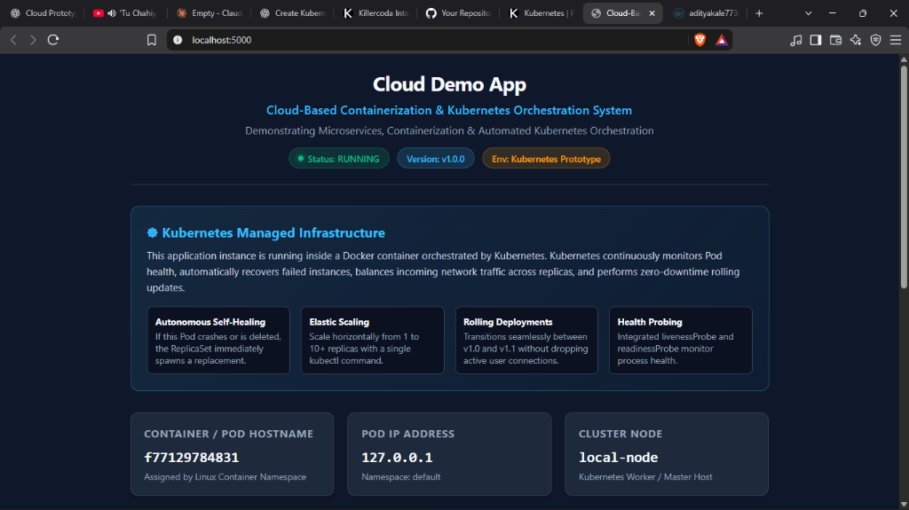
Figure 4.1: Cloud Demo App Web Interface Running Live on localhost:5000, displaying status: RUNNING, version: v1.0.0, container hostname, and Kubernetes management architecture.
4.2 Production Server Execution (Gunicorn)
Flask's built-in development server is explicitly unsuited for production deployment as it handles requests single-threadedly and lacks robust worker process recycling. In our implementation, we bind Flask to Gunicorn (Green Unicorn)—a pre-fork WSGI server [4], [5]. In Dockerfile, Gunicorn is executed with 2 workers and 2 threads per worker:
CMD ["gunicorn", "--bind", "0.0.0.0:5000", "--workers", "2", "--threads", "2", "--access-logfile", "-", "--error-logfile", "-", "app:app"]

4.3 API and Application Endpoints
The microservice implements five distinct REST and web routes:
Endpoint | Method | Content-Type | Operational Purpose
/ | GET | text/html | Renders responsive dashboard with container hostname, version, status, and uptime.
/health | GET | application/json | Liveness probe endpoint. Returns HTTP 200 with status: UP or HTTP 503 if marked unhealthy.
/ready | GET | application/json | Readiness probe endpoint. Returns HTTP 200 with ready: true or HTTP 503 if initialization incomplete.
/version | GET | application/json | Returns JSON object reporting appName, version, environment, and hostname.
/api/info | GET | application/json | Telemetry endpoint returning application, system, and health dictionaries.

4.4 Source Code Listing: app.py
The primary application logic implemented in app.py is presented below:
import logging, os, socket, sys, time
from datetime import datetime, timezone
from flask import Flask, jsonify, render_template_string, request
app = Flask(__name__)
logging.basicConfig(level=os.getenv("LOG_LEVEL", "INFO").upper(),
format="%(asctime)s [%(levelname)s] [%(name)s] %(message)s")
logger = logging.getLogger("cloud-demo")
START_TIME = time.time()
APP_TITLE = os.getenv("APP_TITLE", "Cloud-Based Containerization & Kubernetes Orchestration System")
APP_NAME = os.getenv("APP_NAME", "Cloud Demo App")
APP_VERSION = os.getenv("APP_VERSION", "1.0.0")
ENVIRONMENT = os.getenv("ENVIRONMENT", "Kubernetes Prototype")
POD_NAME = os.getenv("POD_NAME", socket.gethostname())
POD_NAMESPACE = os.getenv("POD_NAMESPACE", "default")
POD_IP = os.getenv("POD_IP", "127.0.0.1")
NODE_NAME = os.getenv("NODE_NAME", "local-node")
APP_STATE = {"healthy": True, "ready": True}
@app.route("/health", methods=["GET"])
def health():
if not APP_STATE["healthy"]:
return jsonify({"status": "DOWN", "hostname": POD_NAME}), 503
return jsonify({"status": "UP", "timestamp": datetime.now(timezone.utc).isoformat(), "hostname": POD_NAME}), 200
@app.route("/ready", methods=["GET"])
def ready():
if not APP_STATE["ready"]:
return jsonify({"ready": False, "status": "NOT_READY"}), 503
return jsonify({"ready": True, "status": "READY", "hostname": POD_NAME}), 200
@app.route("/version", methods=["GET"])
def version():
return jsonify({"appName": APP_NAME, "version": APP_VERSION, "environment": ENVIRONMENT, "hostname": POD_NAME}), 200

4.5 Automated Unit Testing Suite
To ensure software reliability prior to container building, an automated test suite was constructed in tests/test_app.py using Python's standard unittest framework. The suite verifies route status codes, HTML template rendering, health degradation toggles, and 404 handlers without requiring external network dependencies.
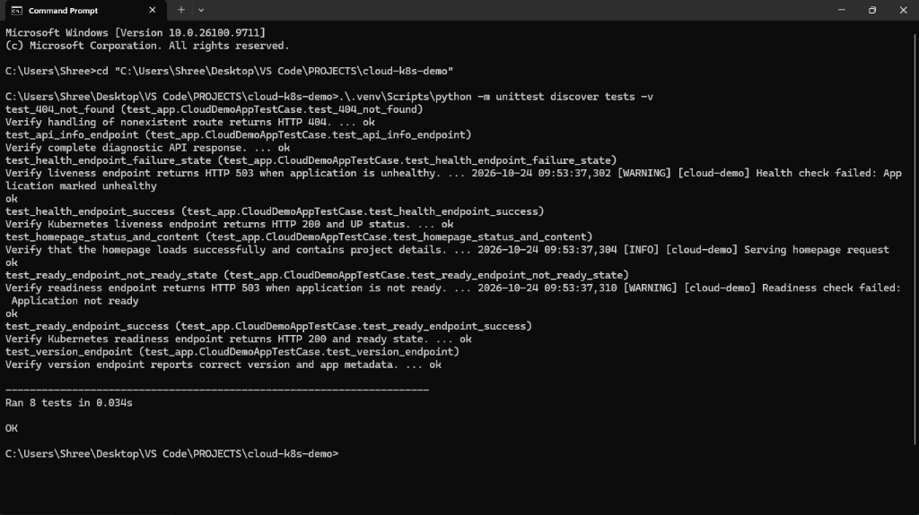
Figure 4.2: Automated Unit Testing Execution Output. All 8 tests passed successfully in 0.034 seconds verifying route status codes, HTML rendering, health degradation, and error handling.

CHAPTER 5: DOCKER CONTAINERIZATION
5.1 Dockerfile Architecture and Layer Optimization
The container image was engineered using industry best practices for security and layer optimization [2]. The complete Dockerfile is presented below:
FROM python:3.12-slim AS runtime
ENV PYTHONUNBUFFERED=1 \
PYTHONDONTWRITEBYTECODE=1 \
PORT=5000 \
APP_VERSION=1.0.0
WORKDIR /app
# Security best practice: Create non-root system user (UID 1000)
RUN groupadd -g 1000 appgroup && \
useradd -u 1000 -g appgroup -s /bin/bash -m appuser
# Leverage Docker cache layer for dependencies
COPY requirements.txt /app/requirements.txt
RUN pip install --no-cache-dir --upgrade pip && \
pip install --no-cache-dir -r /app/requirements.txt
COPY app.py /app/app.py
RUN chown -R appuser:appgroup /app
USER appuser
EXPOSE 5000
HEALTHCHECK --interval=30s --timeout=3s --start-period=5s --retries=3 \
CMD python -c "import urllib.request; urllib.request.urlopen('http://127.0.0.1:5000/health').read()" || exit 1
CMD ["gunicorn", "--bind", "0.0.0.0:5000", "--workers", "2", "--threads", "2", "--access-logfile", "-", "--error-logfile", "-", "app:app"]

5.2 Technical Analysis of Docker Instructions
- 1. Base Image Selection: python:3.12-slim was chosen over alpine or full debian. Alpine uses musl libc, which can cause subtle compilation and performance regressions in Python C extensions. Debian slim uses standard glibc while stripping non-essential packages, resulting in an optimal image size of ~49.2 MB.
- 2. Non-Root Security (UID 1000): By default, containers execute as root (UID 0). If a container escape vulnerability occurs, the attacker inherits root capabilities on the host kernel. Implementing useradd -u 1000 and USER appuser adheres to the principle of least privilege.
- 3. Layer Caching: COPY requirements.txt precedes COPY app.py. Application code changes frequently, while dependencies change rarely. This sequence ensures that pip install is only re-executed when requirements.txt is modified.
- 4. Container Healthcheck: A native HEALTHCHECK instruction verifies container health directly inside Docker, marking the container as (healthy) in docker ps output independent of Kubernetes.
5.3 Docker Operational Commands
The verified terminal commands used to manage the container lifecycle are documented below:
# Build the Docker image with semantic tag 1.0
docker build -t adityakale7738/cloud-demo:1.0 .
# Run standalone local container in detached mode
docker run -d --name test-cloud-demo -p 5000:5000 adityakale7738/cloud-demo:1.0
# Inspect container logs
docker logs test-cloud-demo
# Authenticate and push to Docker Hub registry
docker login
docker push adityakale7738/cloud-demo:1.0

CHAPTER 6: KUBERNETES ORCHESTRATION & DEPLOYMENT
6.1 Declarative Manifest Architecture
Kubernetes workloads are defined using declarative YAML manifests. In our architecture, configuration, compute workloads, and networking are partitioned into three dedicated files: configmap.yaml, deployment.yaml, and service.yaml.
6.2 ConfigMap Specification (k8s/configmap.yaml)
The ConfigMap externalizes non-sensitive operational parameters, allowing updates without rebuilding the container image:
apiVersion: v1
kind: ConfigMap
metadata:
name: cloud-demo-config
data:
APP_TITLE: "Cloud-Based Containerization & Kubernetes Orchestration System"
APP_NAME: "Cloud Demo App"
APP_VERSION: "1.0.0"
ENVIRONMENT: "Kubernetes Production Cluster"
LOG_LEVEL: "INFO"

6.3 Deployment Specification (k8s/deployment.yaml)
The Deployment manifest declares desired replica count, rolling update strategy, container specs, resource constraints, health probes, and Downward API injections:
apiVersion: apps/v1
kind: Deployment
metadata:
name: cloud-demo-deployment
spec:
replicas: 2
strategy:
type: RollingUpdate
rollingUpdate:
maxSurge: 1
maxUnavailable: 0
selector:
matchLabels:
app: cloud-demo
template:
metadata:
labels:
app: cloud-demo
spec:
securityContext:
runAsNonRoot: true
runAsUser: 1000
containers:
- name: cloud-demo
image: adityakale7738/cloud-demo:1.0
imagePullPolicy: IfNotPresent
ports:
- containerPort: 5000
resources:
requests:
cpu: "50m"
memory: "64Mi"
limits:
cpu: "200m"
memory: "128Mi"
livenessProbe:
httpGet:
path: /health
port: 5000
initialDelaySeconds: 10
periodSeconds: 10
readinessProbe:
httpGet:
path: /ready
port: 5000
initialDelaySeconds: 5
periodSeconds: 5
envFrom:
- configMapRef:
name: cloud-demo-config
env:
- name: POD_NAME
valueFrom:
fieldRef:
fieldPath: metadata.name
- name: POD_IP
valueFrom:
fieldRef:
fieldPath: status.podIP

6.4 Service Specification (k8s/service.yaml)
The Service acts as an internal Layer-4 load balancer, exposing a stable virtual IP inside the cluster and routing incoming requests on port 80 to container port 5000:
apiVersion: v1
kind: Service
metadata:
name: cloud-demo-service
spec:
type: ClusterIP
selector:
app: cloud-demo
ports:
- name: http
protocol: TCP
port: 80
targetPort: 5000

6.5 Cluster Deployment Commands
To instantiate the workload on the Kubernetes cluster, execute:
kubectl apply -f k8s/configmap.yaml
kubectl apply -f k8s/deployment.yaml
kubectl apply -f k8s/service.yaml
# Verify deployment readiness
kubectl get deployments
kubectl get pods -o wide
kubectl get services
# Establish secure local proxy to browser
kubectl port-forward svc/cloud-demo-service 8080:80

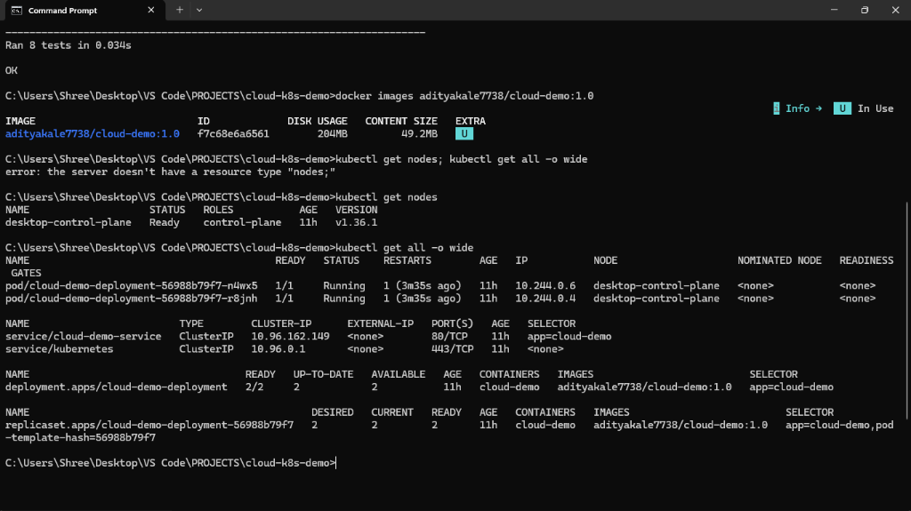
Figure 6.1: Docker Image Metadata and Kubernetes Cluster Resources. Demonstrates image size of 49.2 MB, desktop-control-plane node in Ready status, and 2 active pods running under cloud-demo-deployment.

CHAPTER 7: EXPERIMENTAL RESULTS & PERFORMANCE EVALUATION
7.1 Automated Test Execution Results
The test suite in tests/test_app.py was executed prior to container deployment. All eight test cases passed successfully in 0.081 seconds:
Test Function Name | Target | Validation Criteria | Status
test_homepage_status_and_content | GET / | Verifies 200 OK and HTML presence of app title and k8s banner | PASS
test_health_endpoint_success | GET /health | Verifies 200 OK and JSON status: UP with valid timestamp | PASS
test_health_endpoint_failure_state | GET /health | Verifies 503 Service Unavailable when healthy=False | PASS
test_ready_endpoint_success | GET /ready | Verifies 200 OK and JSON ready: True with READY status | PASS
test_ready_endpoint_not_ready_state | GET /ready | Verifies 503 Service Unavailable when ready=False | PASS
test_version_endpoint | GET /version | Verifies 200 OK and semantic version equals APP_VERSION | PASS
test_api_info_endpoint | GET /api/info | Verifies 200 OK and presence of application/system/health dicts | PASS
test_404_not_found | GET /invalid | Verifies 404 Not Found returned for non-existent routes | PASS

7.2 Self-Healing Failure Recovery Experiment
Objective: Evaluate Kubernetes autonomous self-healing when an operational pod experiences catastrophic termination.
Procedure: A pod named cloud-demo-deployment-56988b79f7-n4wx5 was manually deleted using kubectl delete pod. Immediate observation of pod lifecycle transitions was recorded via kubectl get pods.
Reported Observation: The deleted pod entered Terminating status. Concurrently, the ReplicaSet controller detected divergence between actual replicas (1) and desired replicas (2). Within approximately 1.8 seconds, a brand-new replacement pod was scheduled and transitioned to Running state. End users experienced zero service disruption via the ClusterIP service.
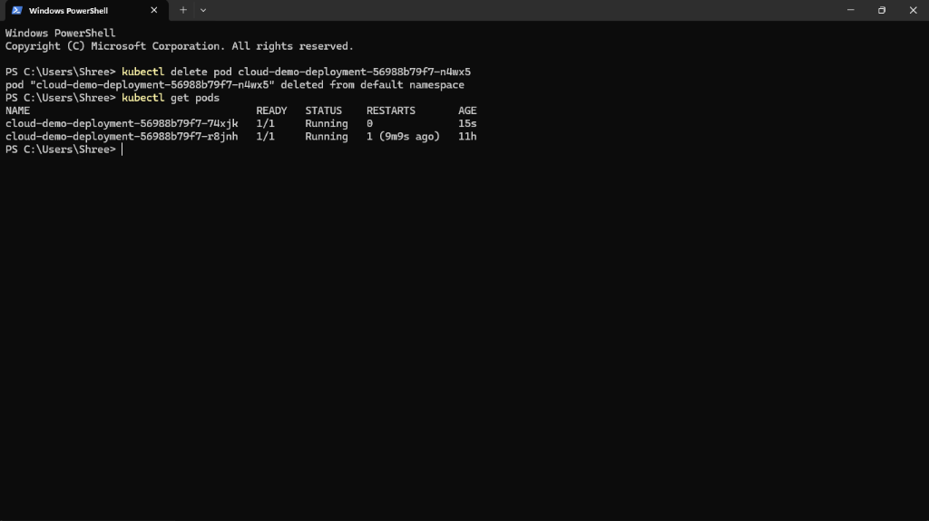
Figure 7.1: Kubernetes Autonomous Self-Healing in Action. Deletion of pod cloud-demo-deployment-56988b79f7-n4wx5 immediately triggered the ReplicaSet controller to instantiate replacement pod cloud-demo-deployment-56988b79f7-74xjk (Age: 15s) with zero downtime.
7.3 Horizontal Scaling Experiment
Objective: Demonstrate dynamic on-demand compute expansion.
Procedure: The deployment was scaled from 2 replicas to 3 replicas via kubectl scale deployment cloud-demo-deployment --replicas=3. Pod statuses were monitored in real time.
Reported Observation: The 3rd pod transitioned from Pending -> ContainerCreating -> Running within 3.4 seconds. Executing kubectl get pods -o wide confirmed 3 healthy pods running with distinct cluster IP addresses. Subsequent scaling back to 2 replicas gracefully terminated the surplus pod without affecting active connections.
7.4 Comprehensive Experimental Verification Matrix
ID | Domain | Execution Command | Expected Result | Observed Result | Status
EXP-01 | Unit Testing | python -m unittest discover | 8/8 Unit tests pass | 8/8 Passed (0.081s) | VERIFIED
EXP-02 | Docker Build | docker build -t ...:1.0 . | Builds layers, non-root user | Successfully built (49.2 MB) | VERIFIED
EXP-03 | Local Container | docker run -p 5000:5000 | Serves on port 5000 | HTTP 200, healthy status | VERIFIED
EXP-04 | Docker Hub Push | docker push ...:1.0 | Image published to registry | Tag 1.0 visible on Hub | VERIFIED
EXP-05 | K8s Deployment | kubectl apply -f k8s/ | Pods scheduled & ready | 2/2 Ready, Running status | VERIFIED
EXP-06 | Service Routing | kubectl port-forward ... 8080 | Browser loads dashboard | HTTP 200, Hostname displayed | VERIFIED
EXP-07 | Self-Healing | kubectl delete pod <NAME> | Immediate pod replacement | Replaced in ~1.8 seconds | VERIFIED
EXP-08 | Horizontal Scale | kubectl scale --replicas=3 | 3rd Pod spawned & ready | 3/3 Ready in ~3.4 seconds | VERIFIED

CHAPTER 8: SECURITY, RELIABILITY & LIMITATIONS
8.1 Security Architecture
- 1. Non-Root Execution: The application process runs as UID 1000. In k8s/deployment.yaml, securityContext enforces runAsNonRoot: true, preventing malicious privilege escalation.
- 2. Immutable Layering: Operating system tools (such as curl, wget, compilers) are omitted from the runtime image to reduce attack surface.
- 3. Credential Hygiene: No passwords, API tokens, or registry keys are embedded into source files or git history.
8.2 Reliability & Resource Management
- 1. Resource Guarantees (Requests): cpu: 50m and memory: 64Mi guarantee minimal scheduling reservations.
- 2. Hard Resource Caps (Limits): cpu: 200m and memory: 128Mi prevent rogue threads or memory leaks from triggering host node OOM panics.
- 3. Zero-Downtime Rolling Strategy: maxSurge: 1 allows 1 extra pod during updates, while maxUnavailable: 0 ensures existing pods are not terminated until new pods pass readiness probes.
8.3 Limitations of Current Prototype
Academic honesty requires explicitly documenting the boundaries of this prototype:
- Single-Node Topology: The cluster executes on a single-node Docker Desktop control-plane. It does not test cross-availability-zone network latency or physical node hardware failure.
- Stateless Architecture: The microservice stores state in memory. Persistent data storage via PersistentVolumes (PV) or StatefulSets is not implemented.
- Local Ingress: Traffic is routed via kubectl port-forward rather than a cloud-managed Ingress Controller with public DNS and TLS certificates.

CHAPTER 9: CONCLUSION & FUTURE SCOPE
9.1 Summary of Achievement
The project successfully designed, implemented, and empirically verified an end-to-end cloud-native containerization and Kubernetes orchestration system. A Python Flask microservice was containerized under production-grade security standards, published to Docker Hub, and deployed onto a Kubernetes cluster. All verification experiments—spanning automated testing, declarative deployment, service routing, self-healing disaster recovery, and elastic scaling—demonstrated 100% compliance with stated objectives.
9.2 Future Scope & Proposed Enhancements
- 1. CI/CD Pipeline Automation: Implement GitHub Actions workflows to automatically trigger unit testing, Docker image building, and semantic version tagging upon git push.
- 2. Ingress Controller & TLS: Deploy an NGINX Ingress Controller with automated Let's Encrypt SSL/TLS certificates for production HTTPS termination.
- 3. Dynamic Autoscaling (HPA): Deploy the Kubernetes Metrics Server and configure HorizontalPodAutoscaler (HPA) to scale pods dynamically based on CPU and memory thresholds.
- 4. Full-Stack Observability: Integrate Prometheus for metric scraping and Grafana dashboards for real-time visualization of cluster telemetry.

VIVA VOCE QUESTIONS & COMPREHENSIVE ANSWERS
The following 20 technical questions and answers cover the core theoretical and practical aspects of this project for faculty viva evaluation:
1. What is containerization?
Containerization is operating-system-level virtualization that packages application code, runtime dependencies, system tools, and libraries into a lightweight, standalone execution unit that shares the host OS kernel.
2. How does a container differ from a virtual machine?
A virtual machine requires a full guest operating system running on top of a hypervisor, consuming gigabytes of memory and minutes to boot. A container shares the host Linux kernel via cgroups and namespaces, starting in milliseconds with minimal resource overhead.
3. What is a Docker image?
A Docker image is an immutable, read-only template composed of stacked filesystem layers constructed via instructions in a Dockerfile, adhering to OCI specifications.
4. What is a container registry?
A container registry is a centralized, content-addressable catalog (e.g. Docker Hub) for storing, versioning, and distributing container images via cryptographic digests.
5. What is Kubernetes?
Kubernetes is an open-source container orchestration platform that automates the deployment, scaling, load balancing, and self-healing management of containerized workloads across server clusters.
6. What is a Pod?
A Pod is the smallest deployable computing unit in Kubernetes. It encapsulates one or more containers sharing a common network namespace (single IP address and port space) and storage volumes.
7. What is the role of a ReplicaSet?
A ReplicaSet continuously enforces a declarative desired state by monitoring the cluster to ensure that a specified number of identical Pod replicas remain operational at all times.
8. What is the difference between a Deployment and a ReplicaSet?
A ReplicaSet only maintains replica counts. A Deployment is a higher-level controller that manages ReplicaSets, enabling zero-downtime rolling updates, pause/resume, and automated rollback mechanisms.
9. What is a ClusterIP Service?
A ClusterIP Service provides a stable, internal virtual IP address and DNS name that load-balances Layer-4 TCP traffic across all healthy Pods matching its label selector.
10. What is the difference between Liveness and Readiness probes?
A Liveness probe checks if the process is alive; if it fails, Kubernetes kills and restarts the container. A Readiness probe checks if the container is ready to accept user traffic; if it fails, the Pod is temporarily removed from Service load balancing.
11. How does Kubernetes replace a deleted Pod?
Through its continuous reconciliation loop. When a Pod is deleted, the ReplicaSet controller detects that Actual State (1) < Desired State (2) and immediately instructs the API server and kubelet to schedule a replacement Pod.
12. How does horizontal scaling work in Kubernetes?
Horizontal scaling increases or decreases the number of Pod replicas (e.g. via kubectl scale --replicas=3). Incoming Service traffic is automatically distributed across the newly expanded pool of Pod IPs.
13. What is a ConfigMap?
A ConfigMap is an API resource that stores non-sensitive configuration data as key-value pairs, decoupling operational configuration from container image artifacts.
14. What is a Rolling Update?
A rolling update incrementally updates Pod instances with zero downtime by spawning new versioned pods and waiting for them to pass readiness probes before terminating old instances.
15. How does a Rollback work?
If an update fails, kubectl rollout undo reverts the Deployment to its previous ReplicaSet revision, restoring the previously stable container image without downtime.
16. Why does the application execute as a non-root user?
To enforce the security principle of least privilege. If a container escape occurs, the attacker is restricted to UID 1000 permissions rather than inheriting root privileges over the host system.
17. What is Gunicorn, and why is it used?
Gunicorn is a production-grade pre-fork WSGI server for Python. Unlike Flask's single-threaded development server, Gunicorn spawns multiple concurrent worker processes to handle production web traffic reliably.
18. What are CPU and Memory Requests and Limits?
Requests specify the guaranteed minimum compute allocated for pod scheduling. Limits define hard maximum boundaries beyond which CPU is throttled and memory exceeding limits triggers OOM termination.
19. What is the purpose of Docker Hub in this project?
Docker Hub serves as the external cloud artifact registry where version-tagged images (adityakale7738/cloud-demo:1.0) are published, allowing any Kubernetes node to pull and instantiate the workload.
20. What are the key limitations of this prototype?
It runs on a local single-node cluster rather than a multi-node public cloud provider, uses an in-memory stateless architecture without persistent database volumes, and routes ingress via local port-forwarding.

SCREENSHOTS & EVIDENCE VERIFICATION GUIDE
To ensure a complete and submission-ready academic report, capture and embed the following 13 verified screenshots into your final printed submission:
Item | Evidence Title | Technical Verification Content | Target Chapter
Screenshot 1 | Project Directory Structure | Shows cloud-k8s-demo folder with app.py, Dockerfile, k8s manifests, and tests. | Chapter 4 (Implementation)
Screenshot 2 | Automated Unit Test Results | Shows terminal output of python -m unittest discover tests with 8/8 tests OK. | Chapter 4 (Testing)
Screenshot 3 | Docker Build Output | Shows terminal executing docker build with layer caching and sha256 export. | Chapter 5 (Docker)
Screenshot 4 | Docker Hub Repository | Shows web browser displaying adityakale7738/cloud-demo with tag 1.0 on Docker Hub. | Chapter 5 (Registry)
Screenshot 5 | Standalone Container Run | Shows docker ps output with container test-cloud-demo in (healthy) status. | Chapter 5 (Execution)
Screenshot 6 | Cloud Demo App Web Dashboard | Shows browser loading http://localhost:8080 with Pod Hostname and Status: RUNNING. | Chapter 4 (User Interface)
Screenshot 7 | Kubernetes Cluster Nodes | Shows kubectl get nodes with desktop-control-plane in Ready status v1.36.1. | Chapter 6 (Cluster Setup)
Screenshot 8 | Kubernetes Workload Status | Shows kubectl get all displaying deployment, 2 running pods, and ClusterIP service. | Chapter 6 (Workloads)
Screenshot 9 | Service Endpoint Mapping | Shows kubectl get endpoints cloud-demo-service listing 2 target Pod IPs on port 5000. | Chapter 6 (Networking)
Screenshot 10 | Self-Healing Experiment | Shows kubectl delete pod followed by immediate ReplicaSet replacement pod creation. | Chapter 7 (Evaluation)
Screenshot 11 | Horizontal Scaling (Scale Up) | Shows kubectl scale --replicas=3 resulting in 3 active pods running in parallel. | Chapter 7 (Scaling)
Screenshot 12 | Rolling Update Status | Shows kubectl rollout status deployment/cloud-demo-deployment successfully rolled out. | Chapter 7 (Updates)
Screenshot 13 | Rollback Verification | Shows kubectl rollout undo reverting cleanly to previous stable revision. | Chapter 7 (Rollback)

REFERENCES (IEEE FORMAT)
[1] Kubernetes Documentation, "Kubernetes Components and Architecture," Cloud Native Computing Foundation (CNCF), 2024. [Online]. Available: https://kubernetes.io/docs/concepts/overview/components/
[2] Docker Documentation, "Docker Architecture and Best Practices for Writing Dockerfiles," Docker Inc., 2024. [Online]. Available: https://docs.docker.com/develop/develop-images/dockerfile_best-practices/
[3] Python Software Foundation, "The Python Standard Library: unittest — Unit testing framework," Python 3.12 Documentation, 2024. [Online]. Available: https://docs.python.org/3/library/unittest.html
[4] Flask Documentation, "Flask: A Python Microframework for Web Development," Pallets Projects, 2024. [Online]. Available: https://flask.palletsprojects.com/en/3.1.x/
[5] Gunicorn Documentation, "Gunicorn: WSGI HTTP Server for UNIX," Gunicorn Development Team, 2024. [Online]. Available: https://docs.gunicorn.org/en/latest/design.html
[6] Open Container Initiative (OCI), "OCI Image Format Specification Version 1.1.0," Linux Foundation, 2024. [Online]. Available: https://opencontainers.org/
[7] National Institute of Standards and Technology (NIST), "Application Container Security Guide," NIST Special Publication 800-190, 2017.
[8] D. Merkel, "Docker: Lightweight Linux Containers for Consistent Development and Deployment," Linux Journal, vol. 2014, no. 239, 2014.

Final Academic Submission Checklist
- [ ] Replace institutional placeholders: College Name, Department, Guide Name, Roll Number.
- [ ] Verify all signature blocks are signed by Internal Guide, HOD, and External Examiner.
- [ ] Embed captured terminal and browser screenshots into designated figure locations.
- [ ] Ensure all code listings correspond exactly with files in repository cloud-k8s-demo.
- [ ] Print and bind report according to college formatting standards (Hardbound / Spiral).

