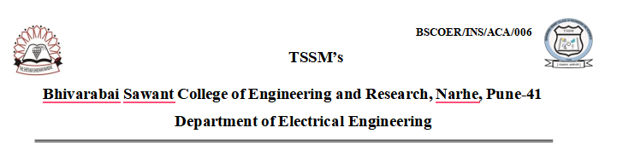
Internship Process
The Internship component is an integral part of the curriculum for students under the SPPU 2019 Course. It aims to provide experiential learning, industry exposure, and hands-on skills aligned with program outcomes (POs) and program-specific outcomes (PSOs). The internship serves as a bridge between theoretical coursework and real-world engineering practice.

Objectives of the Internship
The internship is designed to achieve the following educational objectives:
- Provide students with exposure to industrial practices, real-time problem-solving, and project development.
- Strengthen understanding of professional ethics, teamwork, communication, and project management.
- Enhance skills related to innovation, research, entrepreneurship, and societal responsibilities.
- Enable students to apply classroom knowledge in real-world environments, thus promoting experiential learning.

Duration of Internship
As per SPPU guidelines:
- The internship commence after the completion of Semester V examinations.
- Students complete the internship before the beginning of Semester VI.
- The duration of the internship is 4 to 6 weeks.
- The assessment and evaluation of the internship is conducted in Semester VI through presentation, report submission, and Viva-Voce.
This scheduling ensures that students utilize the vacation period effectively and begin Semester VI with enriched exposure.

Internship Identification and Allotment Process

Student Preparedness and Guidance
During Semester V, the department ensures that all students are made aware of the importance of undertaking an internship. The Department Training and Placement Cell (TPC) conducts structured orientation sessions to explain the objectives, benefits, expected outcomes, and university guidelines related to internships. Students are guided regarding industry expectations, available domains, online/onsite modes, and the relevance of internships in enhancing employability, professional skills, and exposure to real-world engineering practices. This early awareness helps students proactively identify suitable internship opportunities and complete the internship within the prescribed timeline.
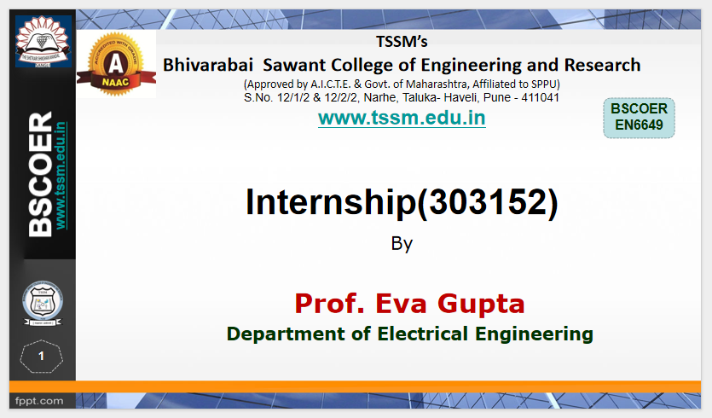 | 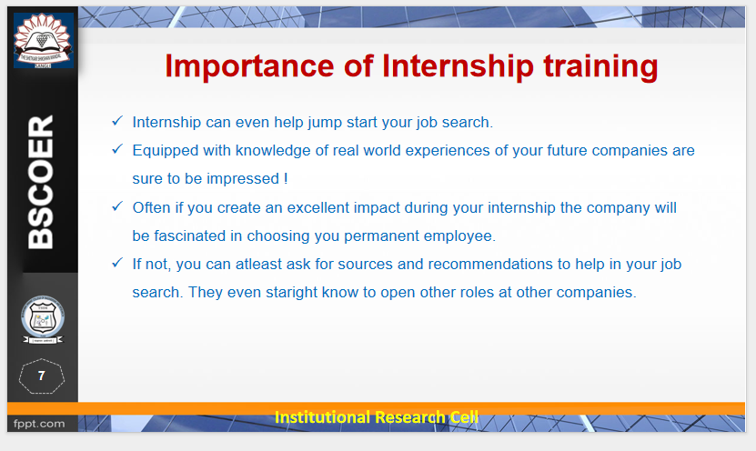
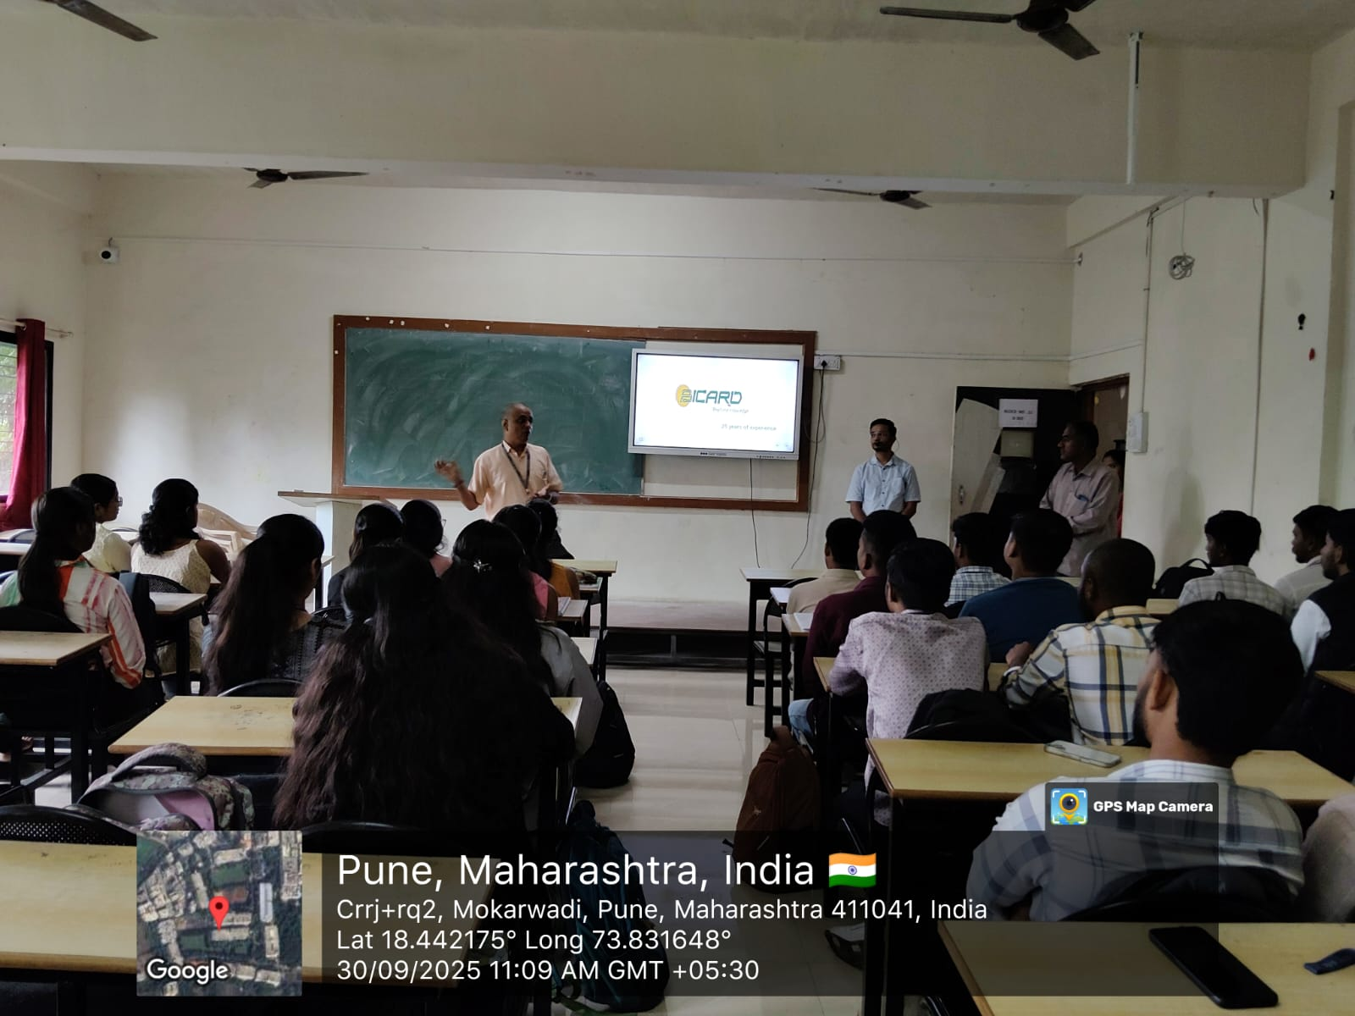 | 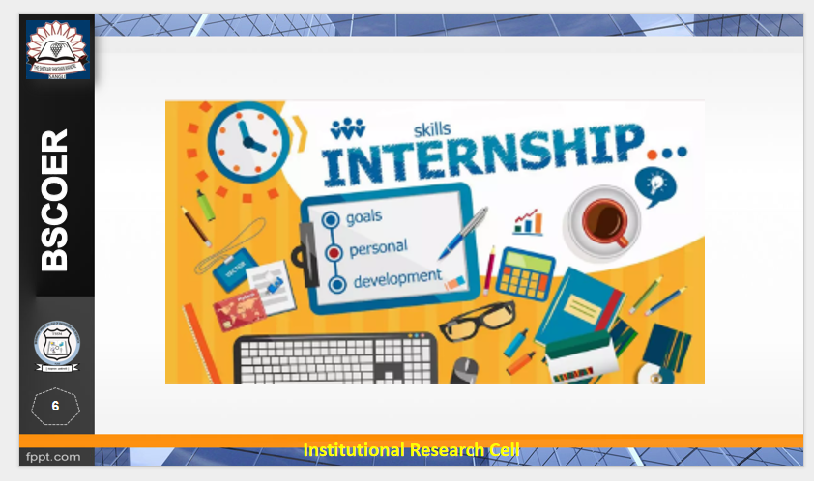
This ensures early awareness and structured preparation.

Identification and Selection of Internship
One Faculty Two Industry:

One faculty two industry is the best practice followed by department. Each faculty identify at least two industry and will take some activities like, seminar, expert talk, visit, project sponsorships, Internship for students.
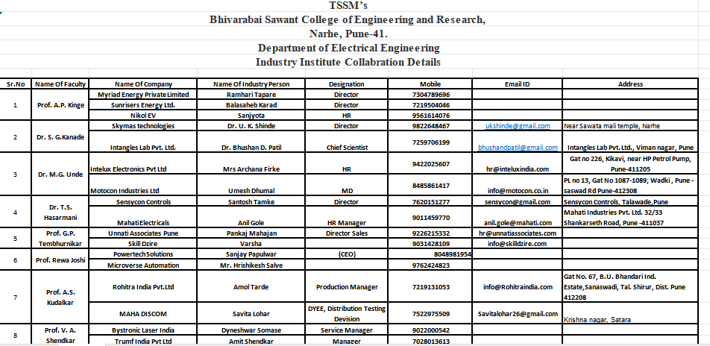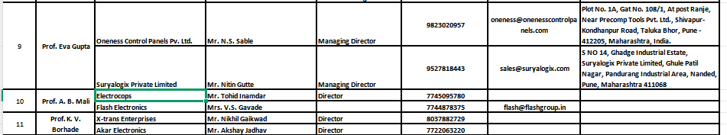Students are encouraged to explore internships in:
- Industries (manufacturing, service, electrical domain)
- Government organizations
- NGOs and social welfare sectors
- Micro, Small, and Medium Enterprises (MSMEs)
- Startups, Incubation, Innovation, and Entrepreneurship Centers
- Institutes of National Importance (IISc, IITs, NITs)
- Organizations working in rural development, IPR, or entrepreneurship
Students undertake internships in online or onsite mode depending on the nature of the project and organizational availability.

Departmental Approval
After identifying a potential internship, students submit details (organization, duration, nature of work, expected outcomes) and Department provide the Internship letter .
The committee verifies:
- Relevance of the internship to Electrical Engineering
- Alignment with POs and PSOs
- Appropriateness of duration and work scope
Only upon formal approval can the student begin the internship.

Types of Internship Work Permitted
Students may engage in any of the following approved activities:
- Working on consultancy or funded research projects in the department/institute
- Contributing to Innovation, Incubation, Entrepreneurship Cells, or Institutional Innovation Council
- Working in department laboratories on lab development, modernization, prototyping, or model development
- Undertaking industry-based project work (full/partial project)
- Internships through recognized platforms such as Internshala, AICTE portals, government schemes
- In-house product development or research under research groups/labs
- Problem-solving projects for MSMEs
- Research internships at IISc/IITs/NITs/R&D organizations
- Social, NGO-based, or rural internships with engineering relevance
This diversity ensures holistic exposure across technical, social, research, and entrepreneurial domains.

Monitoring and Support Mechanism
- Each student is assigned a faculty mentor who monitors progress.
- Students maintain a daily logbook/internship diary documenting tasks and learning outcomes.
- Periodic communications (email/meetings) with industry mentors ensure alignment between institute and organization expectations.

Evaluation and Assessment (Semester VI)
The assessment is carried out as per SPPU norms, comprising:
- Internship Report documenting objectives, methodology, tasks completed, learning outcomes, and reflections
- Completion Certificate from the host organization
- Presentation and Viva-Voce conducted by a panel of department faculty
Evaluation criteria emphasize technical competence, Problem-solving ability, Professional skills (communication, teamwork, ethics), Application of engineering knowledge, Contribution to project outcomes
The final grade is recorded as part of the Semester VI academic evaluation.

Contribution to Program Outcomes (POs) and PSOs
The internship process directly contributes to key POs/PSOs, particularly:
- PO1–PO4: Engineering knowledge, problem analysis, design and investigation
- PO5: Modern tool usage
- PO6–PO7: Engineer and society, environment and sustainability
- PO8: Ethics
- PO9–PO10: Individual and teamwork, communication
- PO11: Project management and finance
- PO12: Life-long learning
- PSO1–PSO3: Domain-specific competency, electrical system operation, and emerging technology awareness

Continuous Improvement
Feedback is collected from students, industry mentors, and faculty evaluators.
Based on feedback, the institute periodically improves:
- Internship guidelines
- Industry collaborations
- Student training/orientation
- Monitoring and evaluation mechanisms

Course Outcomes (CO):
Statement
CO1 Understand the working culture and environment of the Industry and get familiar with various departments and practices in the industry

CO2 Operate various meters, measuring instruments, tools used in industry efficiently and develop technical competence.

CO3 Apply internship learning in other course completions and final year project management, i.e. topic finalization, project planning, hardware development, result interpretations, report writing, etc.

CO4 Create a professional network and learn about ethical, safety measures, and legal practices.

CO5 Appreciate the responsibility of a professional towards society and the environment.

CO6 Identify career goals and personal aspirations.

Correlation between the Courses Outcomes (COs) and the Program Outcomes (POs)

C0 | PO1 | PO2 | PO3 | PO4 | PO5 | PO6 | PO7 | PO8 | PO9 | PO10 | PO11 | PO12
CO1 | - | - | - | - | - | 2 | - | 1 | 2 | 1 | 1 | -
CO2 | 2 | 1 | 2 | - | 3 | - | - | - | - | - | - | -
CO3 | 1 | - | 2 | 2 | - | - | - | - | - | 1 | 3 | -
CO4 | - | - | - | - | - | 2 | 2 | 3 | 2 | 1 | - | -
CO5 | - | - | - | - | - | 3 | 3 | 2 | - | - | - | -
CO6 | - | - | - | - | - | - | - | - | 1 | 1 | - | 3

