Simple queries on Joins:
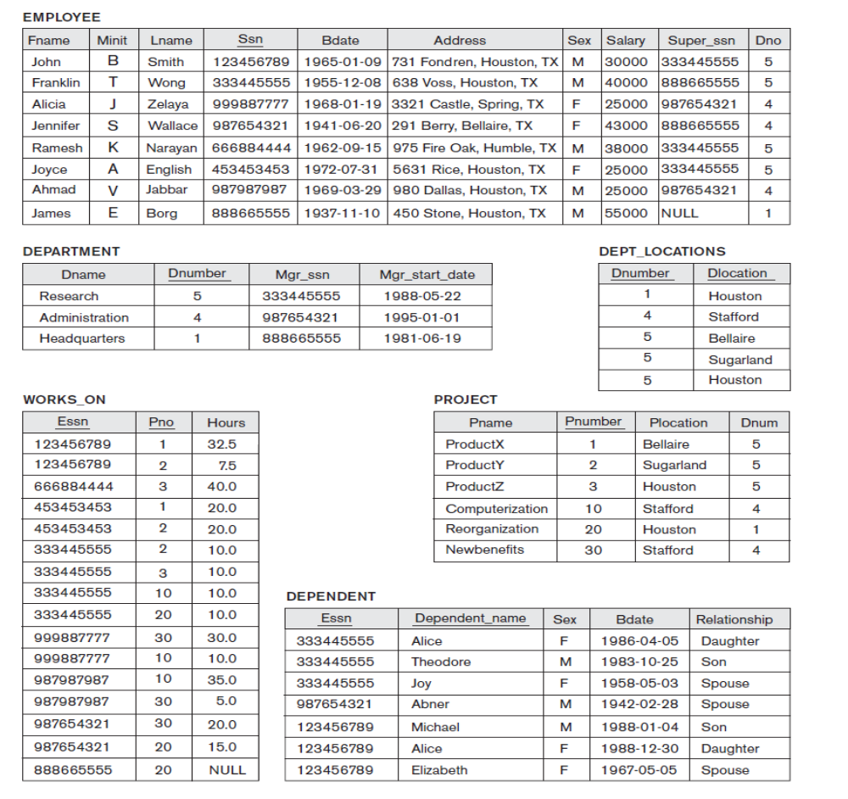
- Retrieve the name, birthdate and address of every employee who works for the ‘administration’ department.

- Find the sum of the salaries of all employees of the ‘Research’
department, as well as the maximum salary, the minimum salary, and the average salary in this department.

- Retrieve the number of employees in the ‘administration’ department

- For each project, retrieve the project number, the project name, and the number of employees who work on that project.

- For each project, retrieve the project number, the project name, project location and the number of employees from department 5 who work on the project.

- For every project located in ‘Houston’, list the project number, the controlling department number, and the department manager’s last name, address.

- Retrieve a list of employees and the projects they are working on, ordered by department and, within each department, ordered alphabetically by the first name then by last name.

- Retrieve the names of all employees who do not have supervisors.

- Retrieve the names of all employees whose supervisor’s supervisor has ‘987654321’ for Ssn.

- Retrieve the department name, manager name, and manager salary for every department.

- Retrieve the employee name, supervisor name, and employee salary for each employee who works in the ‘Research’ department.

- Retrieve the project name, controlling department name, number of employees, and total hours worked per week on the project for each project.

- Retrieve the project name, controlling department name, number of employees, and total hours worked per week on the project for each project with more than one employee working on it.

- Find the names of employees who work on all the projects controlled by department number 5.

- Retrieve the names of all employees in department 5 who work more than 10 hours per week on the ProductX project.

- List the names of all employees who have a dependent with the same first name as themselves.

- Find the names of all employees who are directly supervised by ‘Franklin Wong’.

- For each project, list the project name and the total hours per week (by all employees) spent on that project.

- Retrieve the average salary of all female employees.

